


GENIE ELECTRONIC NOMINAL MERGE FORM

USER GUIDE

Background

If you come across records on GENIE that you believe belong to the same person then a nominal merge may be required in order to ensure that only one record for that person exists.

From 1st April 2014 the way in which these nominals on GENIE are reported will be changing. They will no longer need to be emailed to the ICT Servicedesk and the current link to the C06 Nominal Merge Word Document on GENIE will be removed. In order to request a nominal merge an electronic form will need to be completed

New Process

The nominal merge form requires the user to select the nominal they believe to be the correct record and subsequent duplicate nominals for merging.

The electronic form can be accessed from the actions drop down box from the Nominal details Screen on GENIE.

Please see below for guidance on completing the form.

From Nominal Details Screen

When you are within the nominal record you believe is correct click on the actions drop down list and select ‘Submit Nominal Merge’

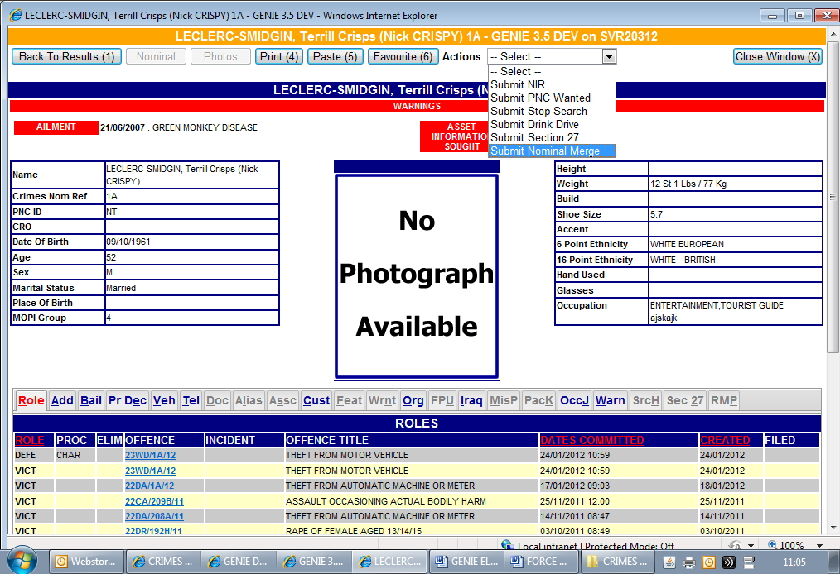

When the merge request form is accessed via the actions drop down list on the nominal details screen GENIE will auto populate the correct nominal selection in the form as shown below:

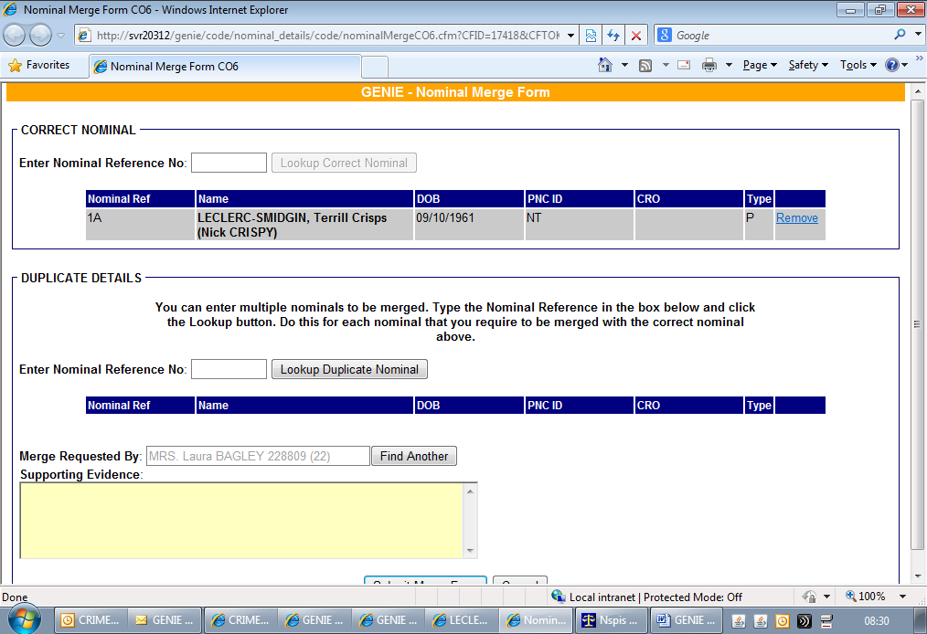

Once the nominal record that you believe is the correct record is displayed
you can then use the ‘Duplicate Details’ selection to enter the records you believe may be duplicates. To display the duplicate records add the nominal reference of the duplicate record(s) and click the ‘Lookup Duplicate Nominal’. You can add multiple duplicate records if required by repeating this action.

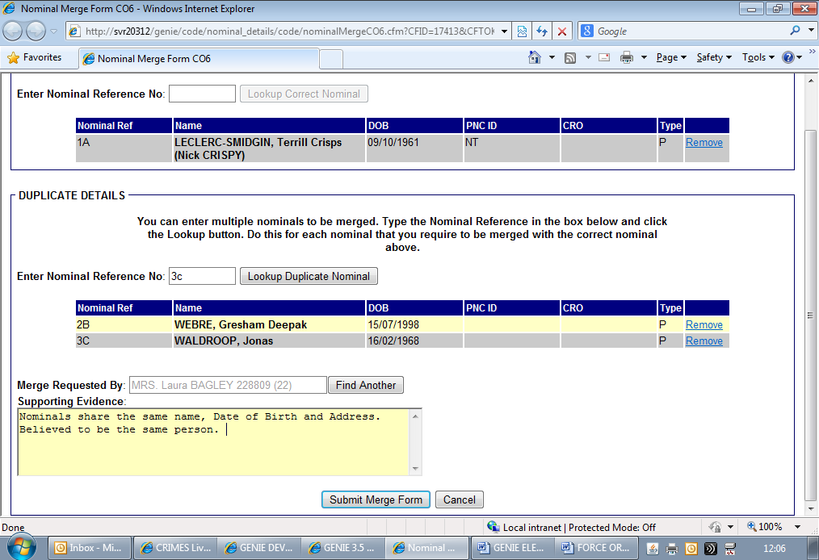

Please note that should you enter the nominal reference of a nominal incorrectly whilst completing the form then you can click on the ‘Remove’ link which will remove the selected nominal from the form.

Once satisfied that the nominal’s displayed on the form are those that you believe should be merged you must enter supporting evidence as to why you are requesting the merge. This field is mandatory. The ‘Merge Requested by’ field will automatically default to your name and collar number. Should the merge have been requested by another user you can use the ‘Find another’ button to find the requesting user. You can search using Surname, Collar Number or User Id.

Once the supporting evidence has been added the form is now ready to be submitted. Click on the ‘Submit Merge form’. Once submitted a reference number is issued to the submitting user.

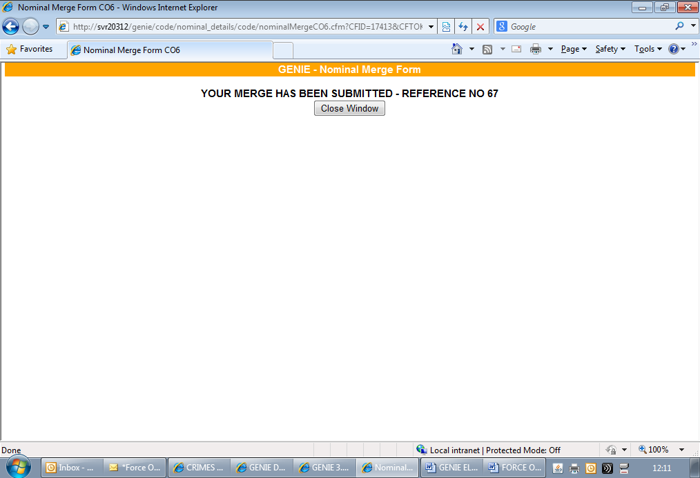

The form can now be accessed and processed by the Data Management Team and any necessary merges as well as addition of alias details to the correct nominal record will be completed on a case by case basis.

Please note the nominal merge form can also be accessed from the Person Search Screen. The actions drop down list will only be displayed once a nominal search has been completed however you do not need to click into a nominal record to access the form this way.

