S.T.e.P (Electronic Packages)

Supervisor/OIC User Guide – General overview

The aim of this document is provide information to enable supervisors and OIC’s to effectively use the S.T.e.P system. The system is easy to use and will allow for the effective administration of electronic packages. In essence the system has been designed to track packages given to officers/staff and allows for updates to be provided electronically, similar to our standard crime management processes on CRIMES.

The system is initially accessed through the Sessions menu on the Force Desktop


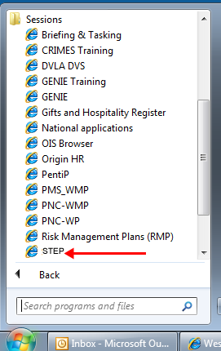

Upon access you will be presented with the following S.T.e.P homepage screen, simply clicking on the package number will take you into the Package detail.


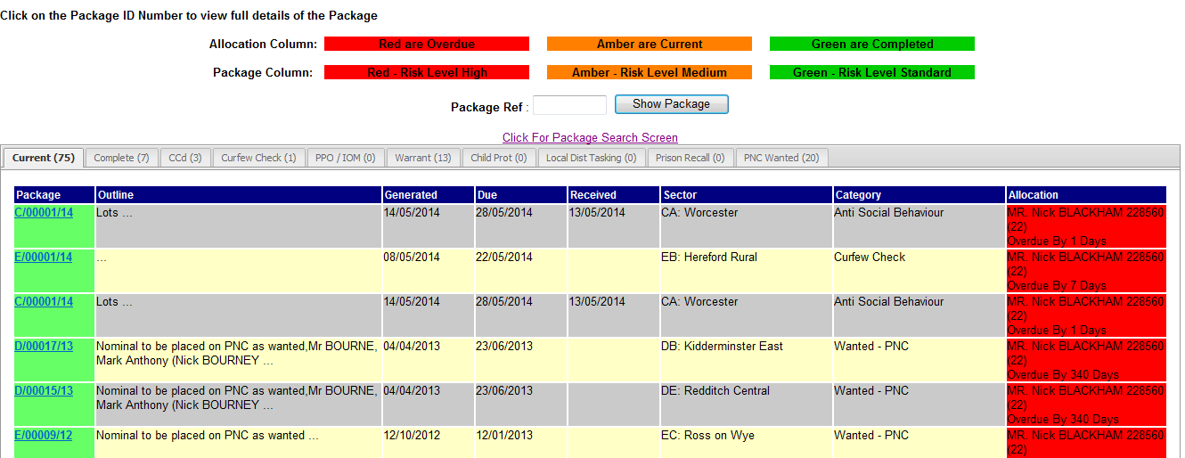

Legend:

Red = Overdue Package

Amber = Allocated Package which is still within date Green = Package Completed
Blue = Package Outstanding (e.g. Subject is circulated on PNC)

From this screen you can:

See your Outstanding Packages in order to action them and provide updates
See your Completed packages
Check the Division’s Curfew Check, Prison Recall, PNC Wanted, Warrant, IOM Packages and action them, if applicable.
Enter a Package number, if known, to research a specific package.
Supervisor/OIC User Guide

On clicking a Package number you will be presented with the following screen. Hyperlinks at the very top will take you to the relevant section in order to read the detail and provide updates. Scrolling down will also provide the same result.

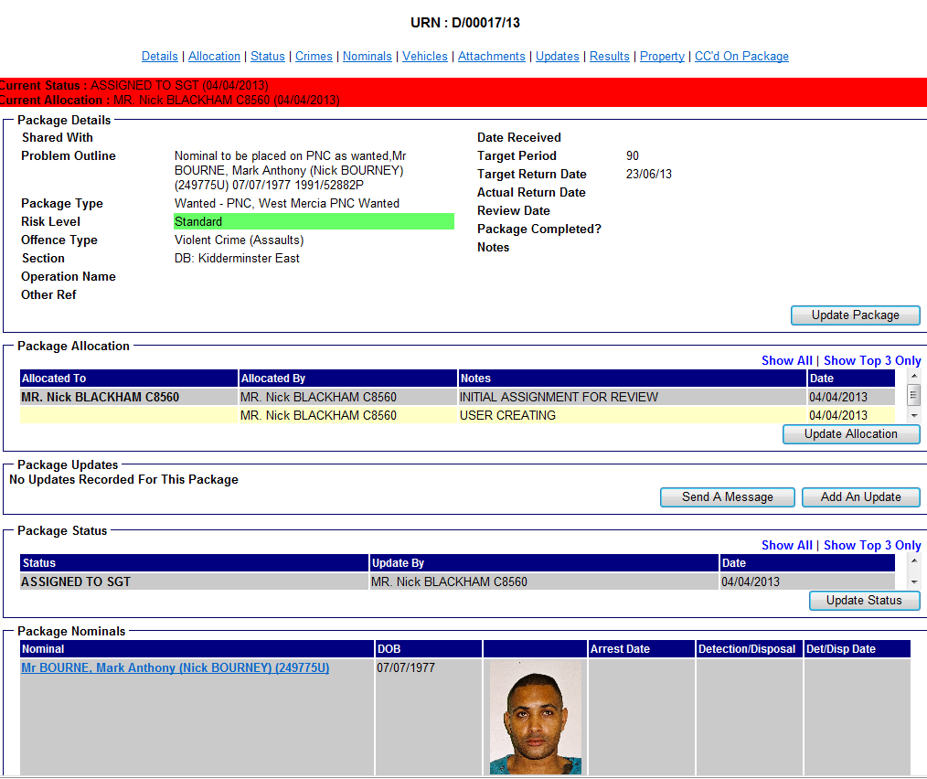

At the top of the screen the current status will appropriate colour i.e. Red, Amber or Green. be displayed i.e. PC 123 Bloggs.
be displayed along with the The current allocation will also

Certain sections displayed will allow for updates to be performed by clicking on the appropriate sections. These are as follows:

Update Allocation - This allows a supervisor to forward the electronic package to an OIC and vice versa. The supervisor will still see the package on their package homepage but the current allocation will display the current officer/staff in charge of the case.
For example, all packages will be assigned to an Inspector in the first instance or, in their absence, their deputy (Sgt rank). The Inspector can allocate to a Sergeant who can, in turn, allocate it to an OIC. Both the Inspector and Sergeant will still be able to see the package within their queue in order to check progress.

Each allocation change allows for a note to be added within the ‘Notes’ field. This will automatically create an email with the package link and notes to the relevant officer/member of staff. An example of this is displayed below:

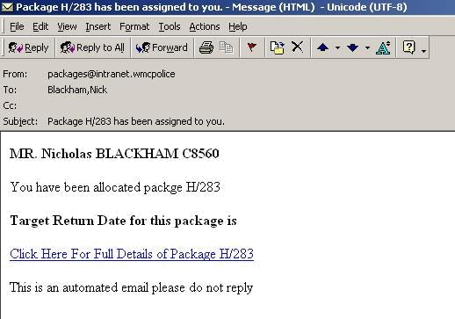

Please note – On completing available enquiries relating to the package, the OIC must use the allocation screen in order to pass the package back to the Sergeant or Inspector. Only Supervisors can return the package to the administrator for the set reasons (Completed, Subject circulated on PNC or Further report date needed)

Update Status (Supervisors Only) - This allows Supervisors to return the package to the originator (Administrator). There are three choices from the drop down menu which are shown in the below image. The administrator is the only individual who can show the package as completed (Green). The package will remain either Red or Amber until this final process has been completed. Completing the status will email the administrator who will deal with the package according to instruction. Further report dates will be provided if provided with sound reasoning in the ‘Package Update’ field.


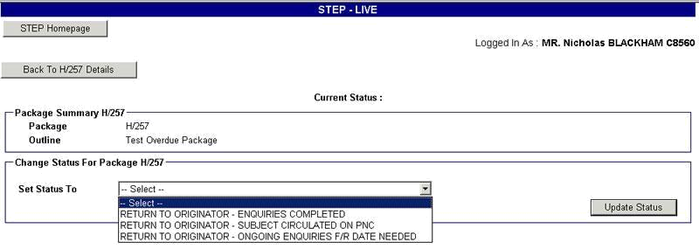

Add An Update – This allows for Supervisors/OIC’s to add free text updates to the package. This enables all involved in the Package to see a sequential commentary on the progress made to date. This is especially important when asking administrators for further report dates who will check to see what enquiries have been made.
Please Note – When dealing with a Package which has crime links, it is vital that the main crime record is updated with significant entries. This is clearly managed through the typical CRIMES management screens.

See below for example of update screen (Wording will show Update rather than Action):

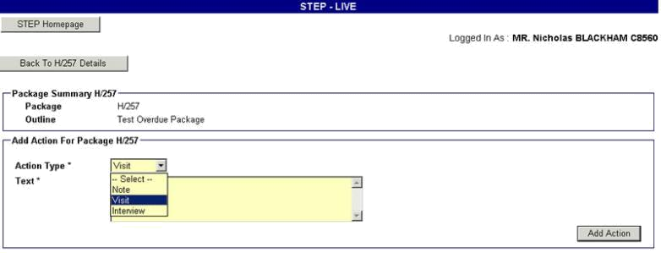
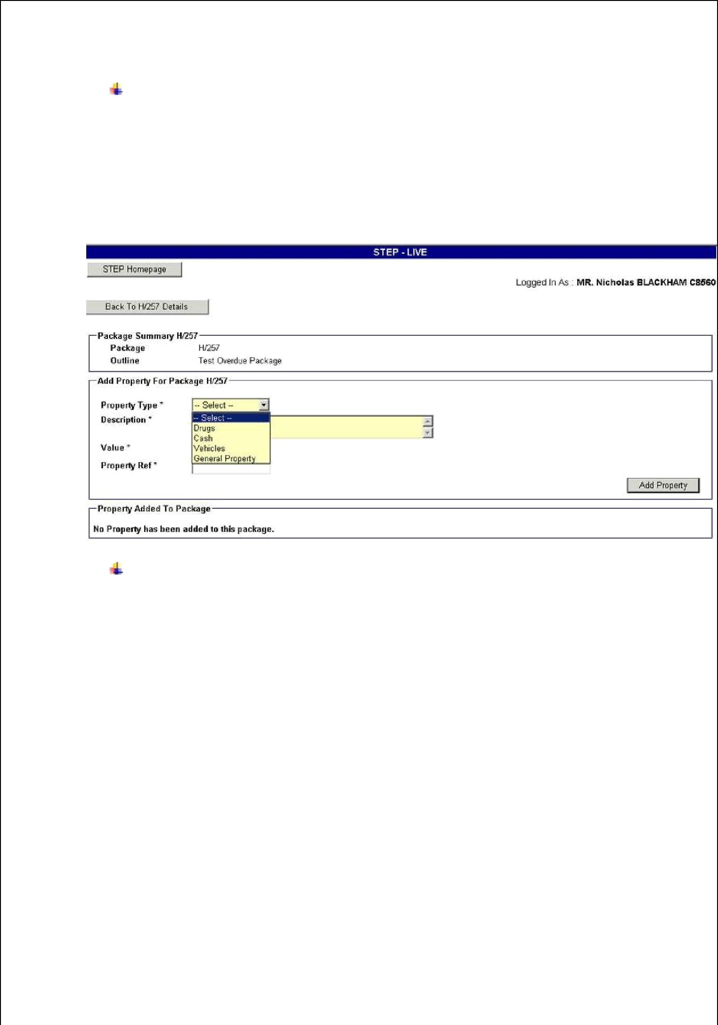
Update Property – The system will also allow for any property seized to be recorded against the Package. This, in no way, avails Supervisors/OIC’s from the need to enter and record any property onto the Property Management System (PMS). Entries here allow for proper Package results recording and allow for feedback to other departments i.e. Crimestoppers.

See Below for example of Property Screen:

Update Results – The update results field is as the name suggests. This allows you to enter into a number of statistical fields relating to NIR’s, Arrests, Encounters and whether, as is the case with DNA or Fingerprint Packages, an evaluation form has been completed and submitted.

There is also a free text ‘Outcomes’ box which allows for a full de-brief regarding the Package to be entered. Finally a simple drop down successful/unsuccessful field which must be completed.

See below for example Update screen:
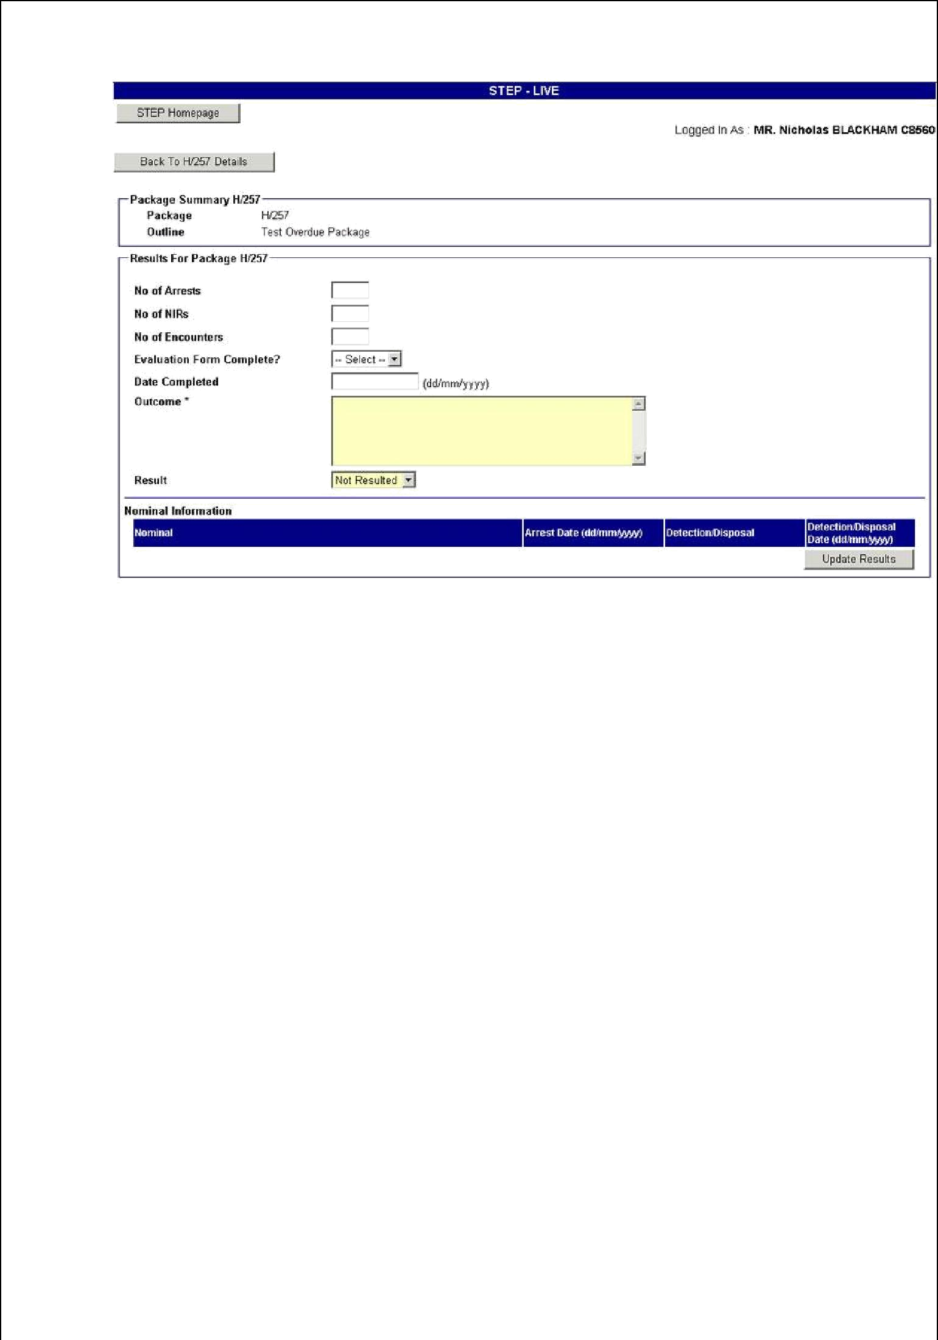

There are no further fields to complete. As with all things it will take some time to get used to but it is an important tool to track and deal with Packages.

For any queries regarding the system please call PNSB.

