

GENIE Version 4.0 – Release Notes

Overview of Changes in GENIE Version 4

Author: Nick Blackham

Last updated: 31 December 2014

Version Control

1.0 | Initial version – Nick Blackham | 31/12/14

CONTENTS

Upgrade for PSN (Public Service Network) Compliance 3
Look and Feel Changes 3
Home Screen 3
Personalisation Options 4
Main Menu 5
Enquiry Screens 6
Nominal Screen 9
Requests For Change 12
RFC 9818 – Changes to Data Protection Reason entry. 12
RFC 10024 – Address Enquiry, rollover data on Offences, Nominals, Intel and Organisation number counts 14
RFC 10026 – Changes to intelligence package printing. 15
RFC 10084 - Nominal Screen, Roles Tab. Rows where the person is an outstanding suspect are highlighted red. 16
RFC 10091 - Paste to OIS Functionality. Ability to paste a nominal’s vehicles are now available 17

Upgrade for PSN (Public Service Network) Compliance

GENIE has had to be upgraded as part of the PSN project to ensure the Hardware and Software it uses is compliant. This has meant that the look and feel of GENIE has changed. These changes are detailed below. It should be noted that the data that GENIE uses has stayed the same, but may be displayed in a different location.

Look and Feel Changes

Initially GENIE will open for every user with default colours and font sizes. This can be changed by clicking on the My Settings link at the top right of the screen. See the Accessibility Options section.

Home Screen
The Genie Homescreen remains largely unchanged, see screenshot below.

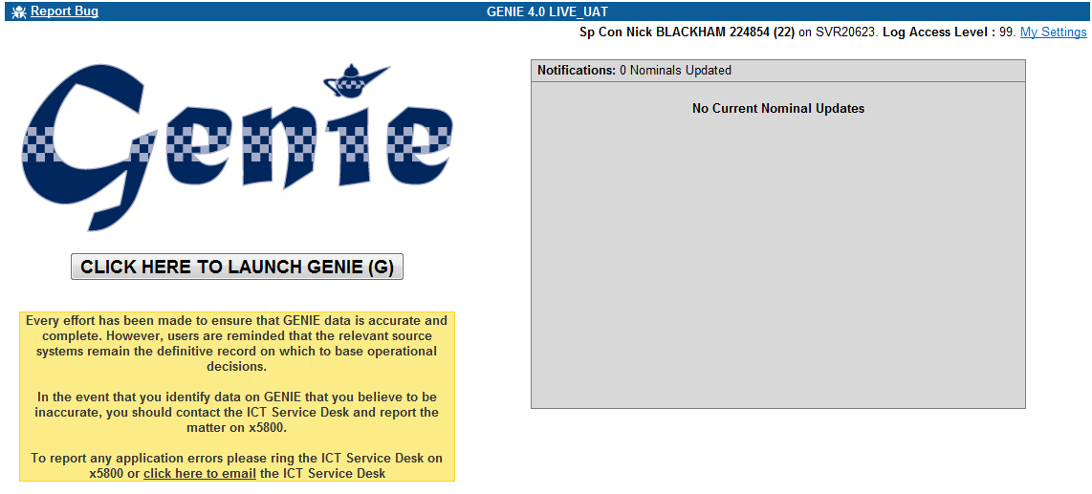

Personalisation Options

The Personalisation Options screen is accessed via the `My Settings` link available on all GENIE pages via a link in the top right hand corner of the screen. On this screen you can change Font Face, Font Size and Colour Scheme. Once you have made your changes click the `Save My Settings` button and then the `Back to Genie Page` link to start using Genie with the changes you have made.

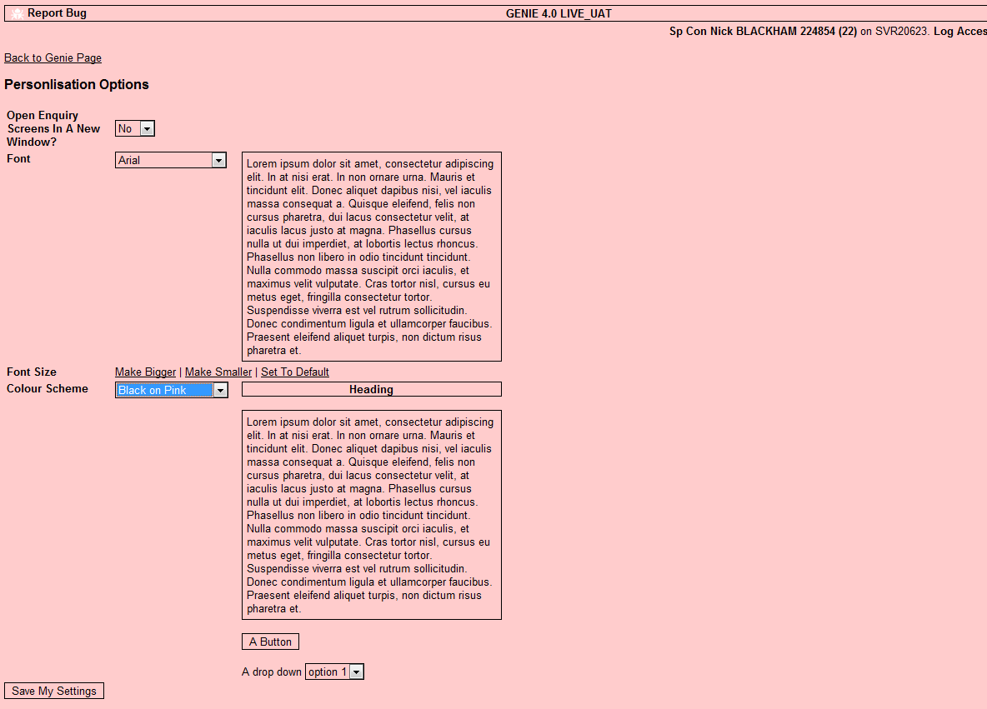

Main Menu

The main menu still contains the same menu items as before. The `Nominals of Interest` tab has been renamed `Favourite Nominals`.

Any Enquiry Screen can be clicked on to open it. Quick keys can also be used. Hold the ALT key down and the letter key corresponding to the Underlined letter on the item. Eg Person Enquiry – ALT + P, Address Enquiry ALT + A.

Tabs can be clicked on to open them or the arrow keys can be used to open the tab to the left or right of the currently open tab.

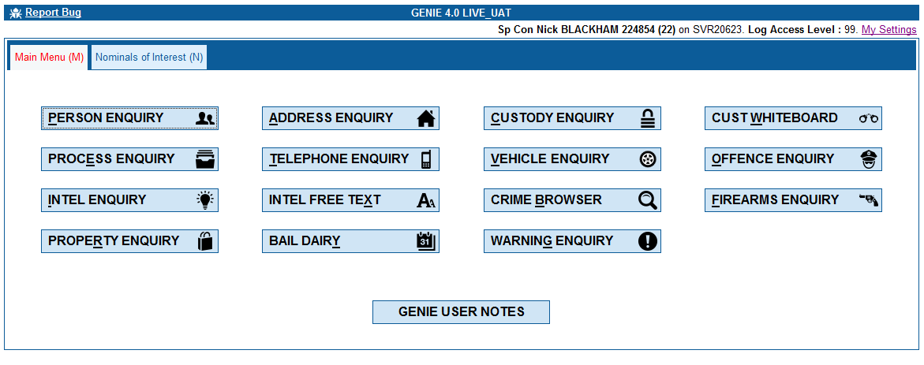

Enquiry Screens

DPA Reason

When opening an enquiry screen you will be asked for your Data Protection Act Reason. You cannot continue to the Enquiry Screen without completing this box. If you open an enquiry screen in error then click the Red Cross in the top right corner to close the enquiry screen. There is no need to complete the DPA information if you have opened the screen in error.

The DPA Reason box requires you to enter 3 pieces of data.

- Requestor. If you are doing this on behalf of another person (eg. Comms Op doing a check for an officer over the radio) you must complete the details of the person you are completing the enquiry for. Enter their details (eg collar no or surname) and tab out of the box to complete the details. If the enquiry is for you personally then pressing CTRL+M will default your details into the field, or you can search on your surname or collar no.
- Reason. Enter the Reason code or select the Reason from the drop down list. Completing either Reason code or selecting from the list will automatically populate the adjacent field.
- Details. Free text field for information on why you are conducting the enquiry
- *** OCC Users Only. PNC Paste.

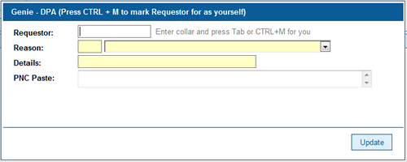

DPA Reason Timeout

On every enquiry screen once a search has been conducted a countdown begins until the DPA Reason you have entered times out. The default period for this is 5 minutes as requested by the Professional Standards Department. Certain roles in the organisation have a longer timeout period.

Once the timeout period has expired the START SEARCH button on each enquiry screen is removed. When this happens the user must click the NEW ENQUIRY button and enter their DPA Reason again before conducting the next search. Whilst the START SEARCH button is still available users can continue to conduct as many searches as they like. However, should their DPA reason need to change they must click NEW ENQUIRY to enter new DPA details.

All Enquiry Screens are now in 2 panes. The upper pane is the search pane and once a search has been requested the lower pane is the results pane.

The search pane may be split into sections if multiple search options are available. For example the Person Enquiry has 4 sections (Data Sources, Reference Nos, Name / DOB, Additional). The most used sections will be expanded by default. Sections can be expanded and collapsed by clicking on them. When in their collapsed state the section will display any data that has been entered in it.

Search Pane sections can also be expanded or collapsed by clicking the Expand All | Expand All Data | Collapse all links at the top of the Search Pane. Clear Form reverts the search form to the state it was in when you first opened the enquiry screen.

Initially Opened Person Enquiry
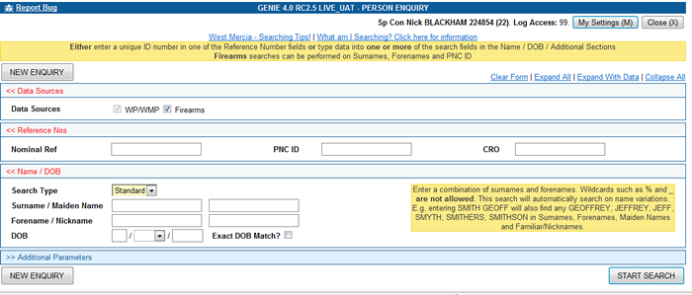

Person Enquiry With Results Shown

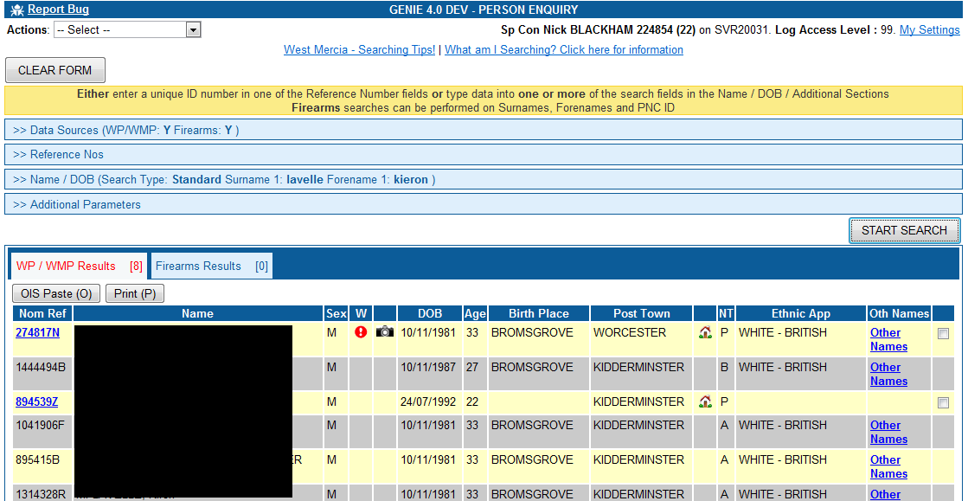

Special Fields

Date Fields

Date fields are now masked so that you can only enter date format data. An example of a date field is on the Custody Enquiry, Date of Arrest. When you enter the field the text dd/mm/yyyy will be displayed. You can type a valid date into the field just by typing the numeric characters eg for 01/01/2015 just type 01012015.

Time Fields

Time fields are now masked so that you can only enter time format data into them. An example if a time field is on the Custody Enquiry, Date of Arrest. You can just type the numeric characters of a time in, eg. 07:30 type 0730. You can also use the up and down arrows to change the hour / minute values and the left and right arrows to move between the hour / minute values.

Lookup Fields (Previously known as LOV List of Values)

Lookup fields allow you to type some text into them and will then search for what you have entered. The search will commence 1 second after you have stopped typing. An example of a lookup field is on the Property Enquiry, Category field.

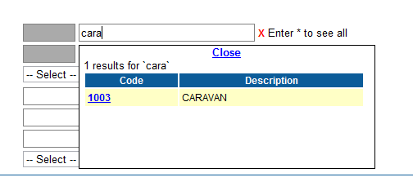

Once the options have appeared click a link within the results to select the option. This will then be selected in the search field.



To clear a lookup field click the Red X next to the field.

Nominal Screen

The nominal screen has been slightly rearranged. The nominal photo is now on the left, nominals personal details and special markers in the middle and any warnings on the right. The tabs for the nominals associated data remain underneath.

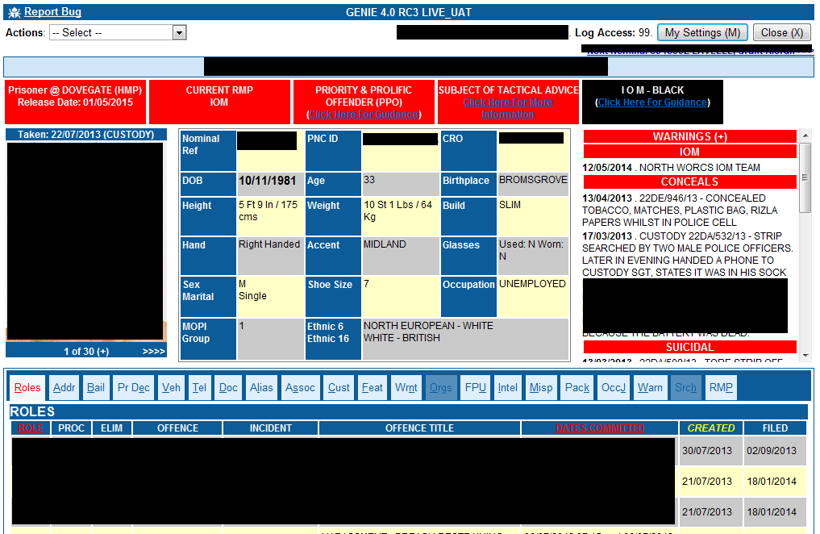

Any area that displays the + symbol means there is more information available which can be accessed by clicking on the +

Clicking (+) in the nominal photo area shows all photos related to the nominal.
Clicking (+) in the warnings area shows the warnings in a bigger screen area.
Clicking (+) in the employment section shows more employment details if available.

You can switch between the information tabs on a nominal by clicking the tab or by pressing the key of the letter that is underlined on that tab.

Photos can be scrolled through if more than 1 photo existing by clicking the forward and back arrows underneath the photo.

Warnings

The order of the warnings has been changed. Warnings are now grouped. For example if a nominal has 3 Violent Markers these will be displayed under one Violent header. The most recent warnings Group Header will be at the top of the list with ALL warnings for that Group below it. Then the next most recent warnings Group Header, example shown below.

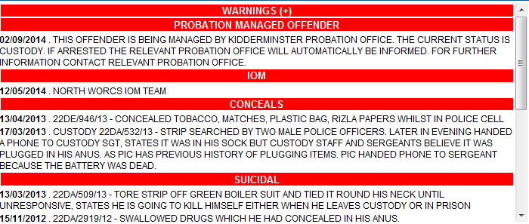

If the word WARNINGS has a (+) after it it means you can click it to display the warnings in a larger area. As shown below.

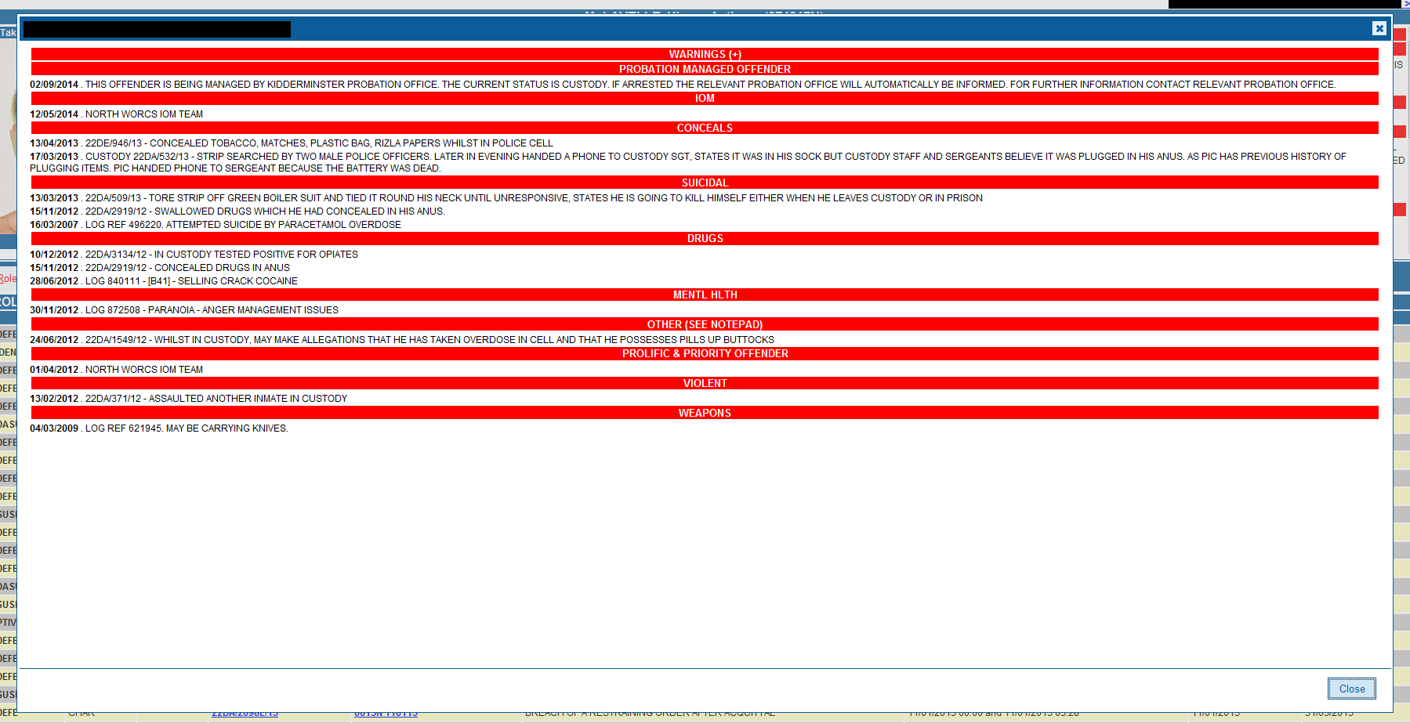

Photos

To view all nominal photos click the (+) link underneath the nominals photos. All nominal photos are then displayed as shown below.

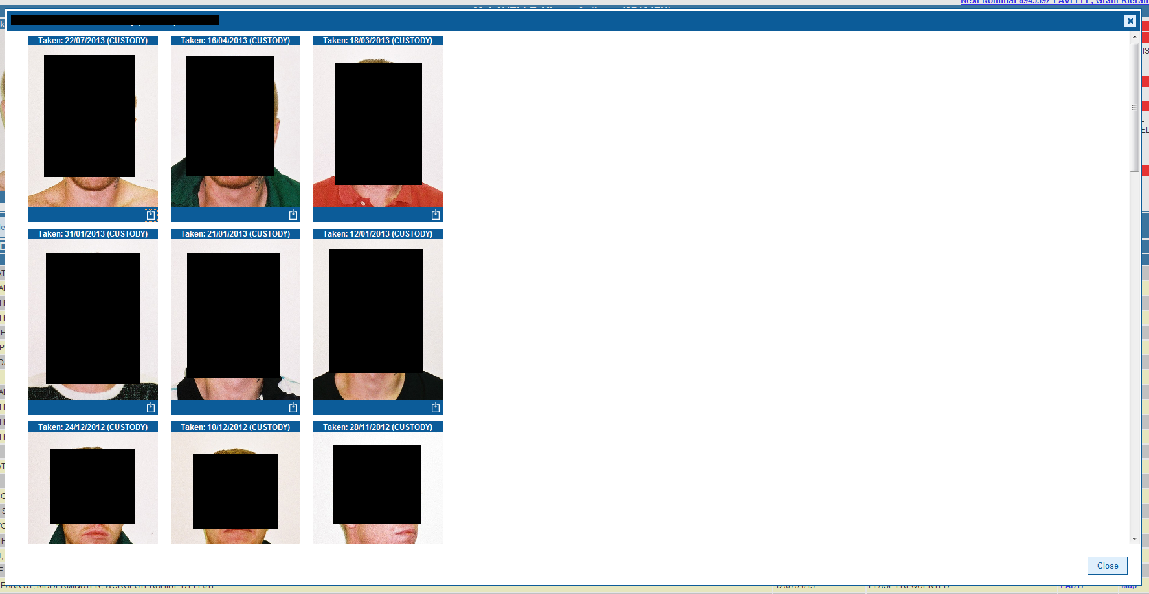

To download a photo click the download icon at the bottom right of each photo.

Only photos from Warwickshire and West Mercia Custody are downloadable.

Requests For Change

- RFC 9818 – Changes to Data Protection Reason entry
- RFC 10024 – Address Enquiry, rollover data on Offences, Nominals, Intel and Organisation number counts
- RFC 10026 – Changes to intelligence package printing
- RFC 10084 – Nominal Screen, Roles Tab. Rows where the person is an outstanding suspect are highlighted red.
- RFC 10091 – Paste to OIS Functionality. Ability to paste a nominal’s vehicles are now available

RFC 9818 – Changes to Data Protection Reason entry.

In GENIE 4 the position of the data protection reason box has changed. The box will now appear every time an Enquiry Screen is opened. All boxes must be completed before the search enquiry can be accessed. Your DPA reasons then remain valid for a timeout period, this is 5 minutes for most users, some users have an longer timeout period due to the nature of their role. After the timeout period (5 minutes or longer) the ‘START SEARCH’ button is not available and you must press the ‘NEW ENQUIRY’ button to start a new search. Pressing the ‘NEW ENQUIRY’ button shows the DPA dialog box will be shown again. If at any point you wish to change your DPA reasons click the ‘NEW ENQUIRY’ button.

DPA Reason – Empty Form

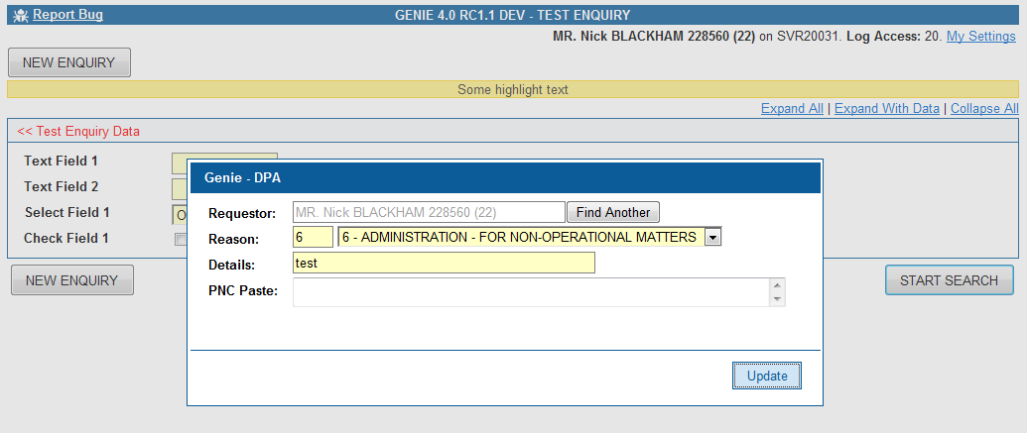

DPA Reason – Search Form is available

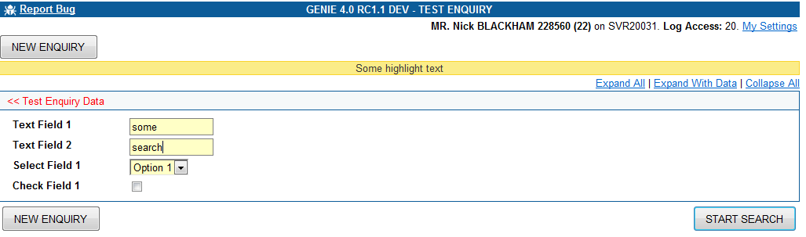

DPA Reason – 5 minutes expired (longer for certain roles), START SEARCH button removed

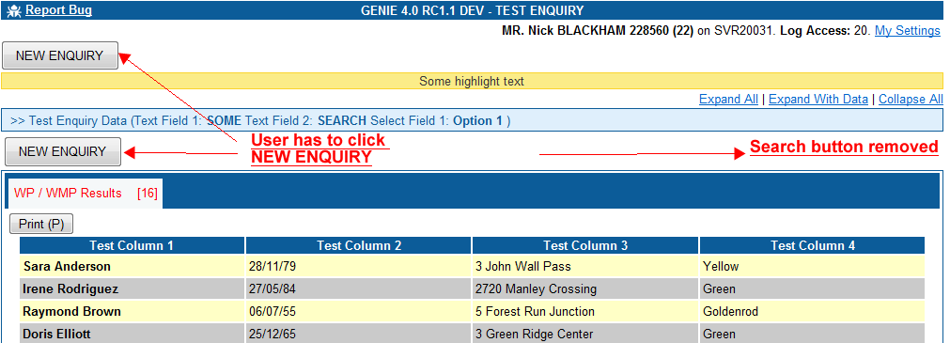

RFC 10024 – Address Enquiry, rollover data on Offences, Nominals, Intel and Organisation number counts

On the Address Enquiry screen once the search results have been displayed you can now move the mouse over the counts for Nominals, Offences, Organisations and Intel. This will pop up a summary of the nominals, offences, orgs or intel for that corresponding address. The 10 most recent entries are displayed if more than 10 are available.

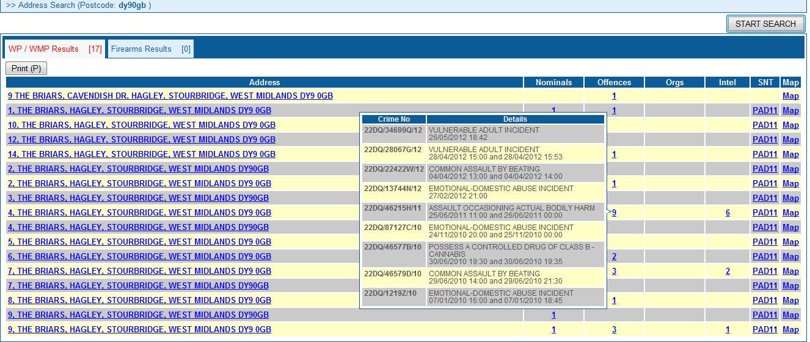

RFC 10084 - Nominal Screen, Roles Tab. Rows where the person is an outstanding suspect are highlighted red.

Nominal Screen. Roles tab. If the Crime is undetected and not filed then it is highlighted in red.

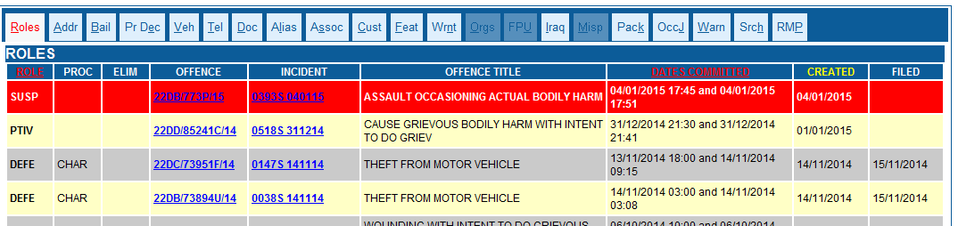

RFC 10091 - Paste to OIS Functionality. Ability to paste a nominal’s vehicles are now available

An additional option is now available from the OIS Paste options for a nominal’s vehicles.

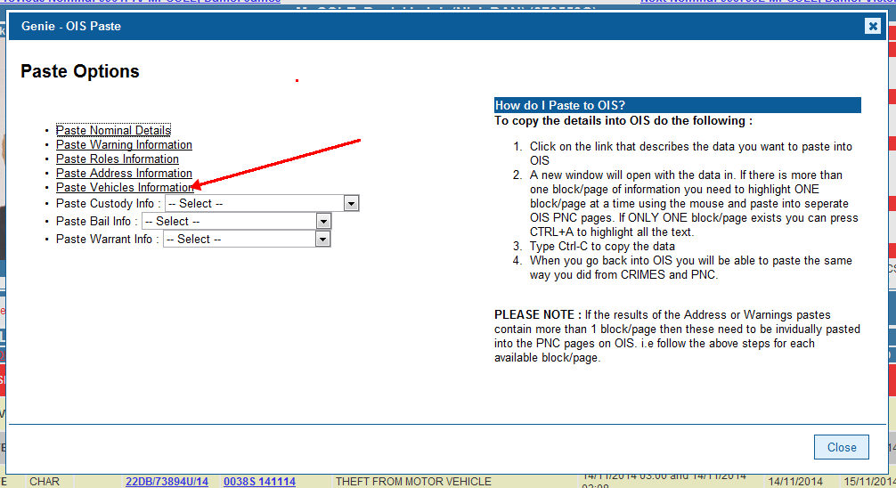

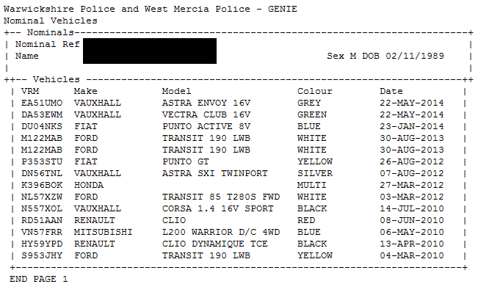

New Functionality

Pasting PNC Searches (Person Enquiry, Vehicle Enquiry). (OCC Users Only)

Users with access to this function can now copy and paste PNC searches into GENIE Person Enquiry and Vehicle Enquiry and have the search run automatically.

The process is as follows.

1. Complete PNC Search Details and then Copy and Paste

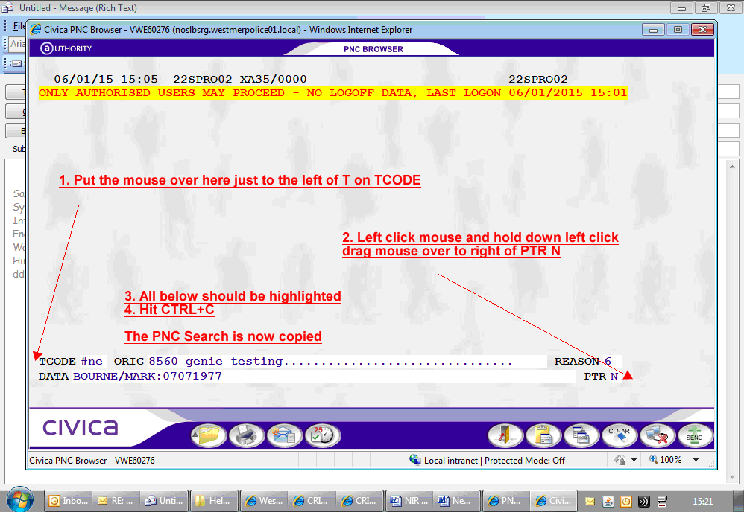

The PNC Search ORIG must be in the following format

Officers Collar <space> Officers Location
2. Open Person Enquiry / Vehicle Enquiry. (if you are already in either of these screens click NEW EQUIRY).

In the DPA Dialog box move into the PNC Data field.

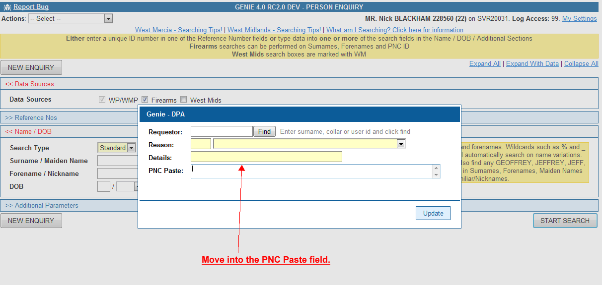

Press CTRL+V and PNC Data will appear in the field

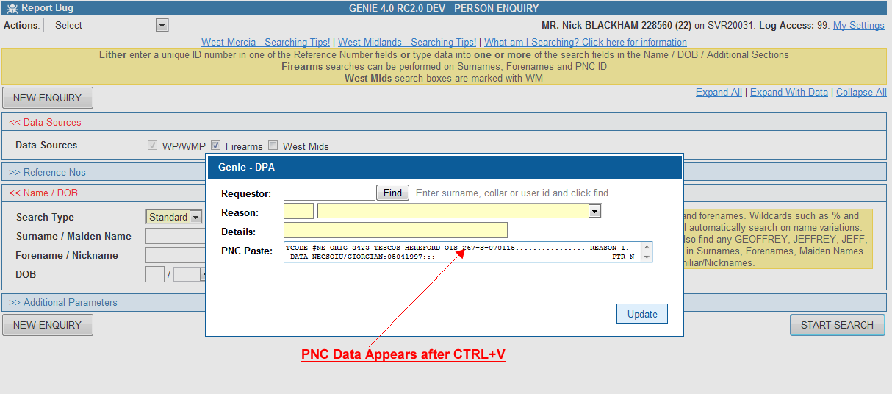

Press CTRL+U or click Update.

If the PNC Data is of a valid format then DPA data and Search Form data will completed for you and the search automatically run.

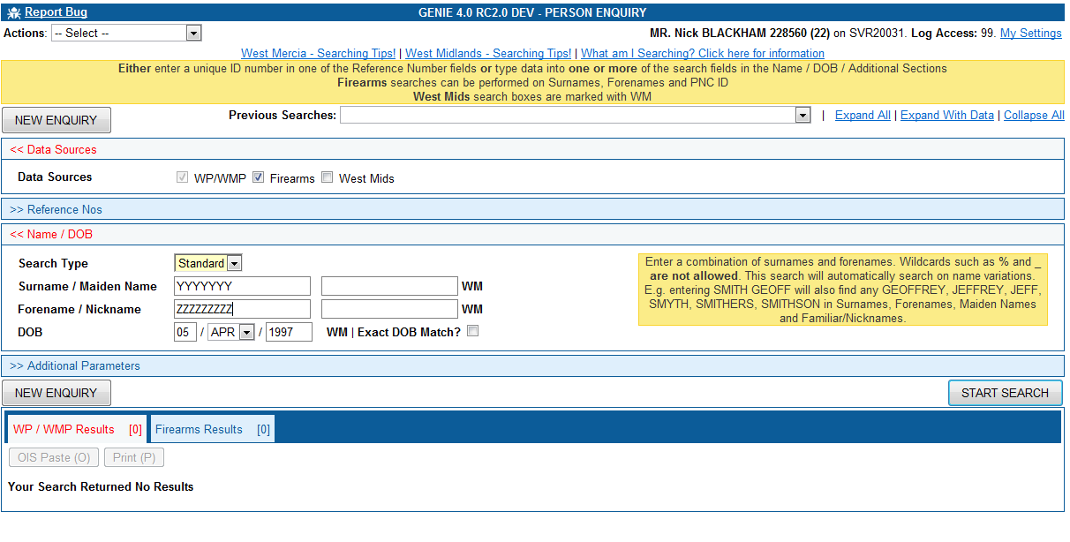

Previous Searches Drop Down Box

Every time you click ‘START SEARCH’ on an Enquiry Form and a valid search is run the details of the search are recorded in the `Previous Searches` drop down box.

The most recent search you have run will appear at the top of the list.

Searches are only stored here whilst the Enquiry Screen is open. When the Enquiry Screen is closed, the previous search data is lost.

Click on a previous search to have the search form populated with the search and the search will then run automatically.

If the DPA timeout has expired then Previous Searches are not shown until DPA information has been entered again by clicking `NEW ENQUIRY`.

