The Chess Club
Benji Altman

- Executive Summary
The chess club is a program that manages chess clubs. My mother runs two or three chess clubs and often puts in many hours doing tedious calculations and work. This is all so that the students may various statistics like a rating and ranking. Upon seeing the amount of time she spent, I thought there had to be a better way, and as a programmer I knew how to make that happen.
Originally my mother had been keeping track of everything in a single Google sheet (figure 1). I wrote a script, set up a new Google sheet, and moved the old data into the new Google sheet for her. The new system was completely automated. She only put in the results of each game and then pressed update and the new standings for the club with be printed. (figure 2 is new standings and figure 3 is the input)
(figure 1)
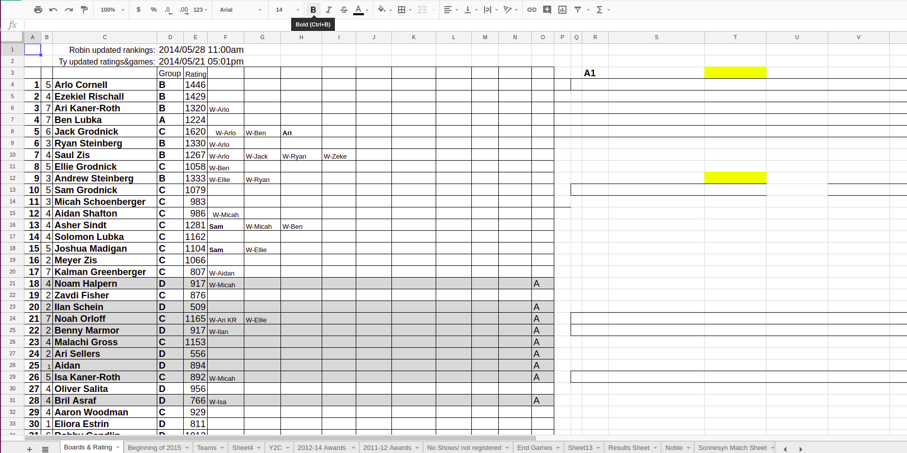
The new system worked well for about a year however eventually she needed to change players that were in the club and the program was poorly designed and couldn’t handle change. Additionally it was easy to break and using it for another club or modifying it was rather difficult without knowing how it worked. The new version will be a fully user friendly application running either as a web-page or on the desktop.

(figure 2)
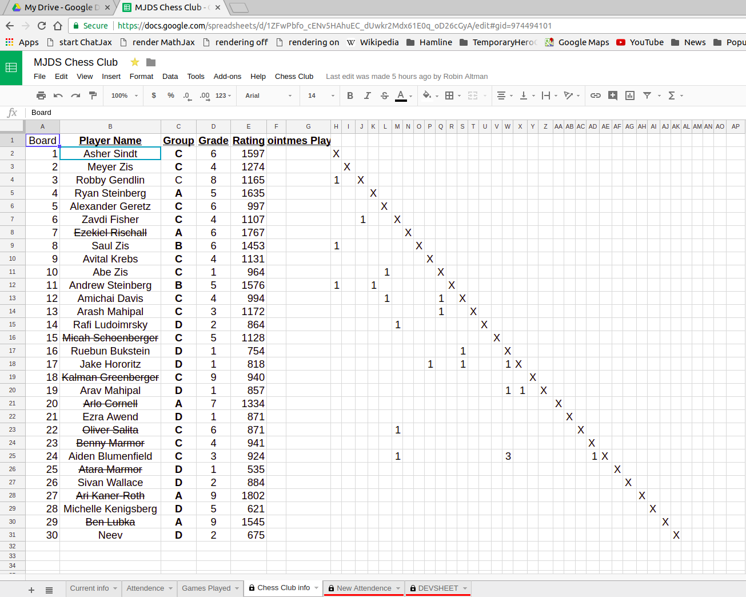
(figure 3)
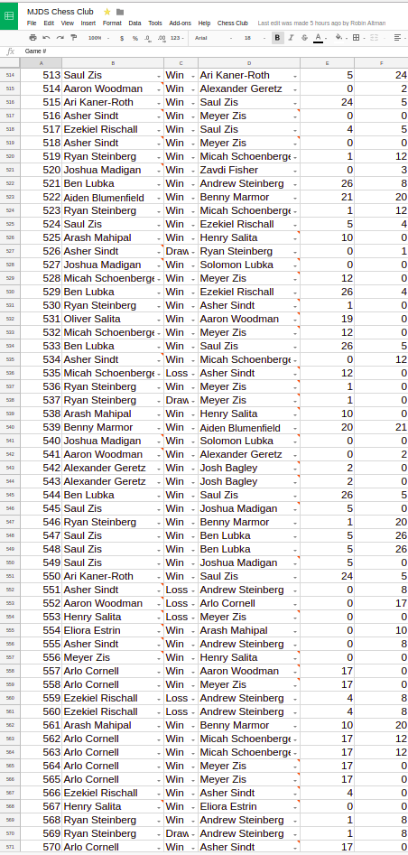

- Problem
The original problem being addressed was rather specific as it pertained only to my mother’s needs. The program simply worked for what she needed in exactly one club. However it quickly broke when expanded to multiple clubs. The program also needed rather constant support as my mother would keep finding new inventive ways to accidentally break my program.
The larger problem that exists however is that my mother isn’t the only person running a chess club. Her chess club had 30 students, however I’ve participated in a club with well over 100. As you can see from (figure 3) with only about 30 students we already have close to 600 games being played. For every game being played we need to recalculate ratings and possibly board ranking and maybe more depending on how the club is run. This means an enormous amount of work being put in by volunteer parents. Some people aren’t up to this and the club can be a mess for the students and staff. Sometimes people are up to this and spend their weekends tending to a club rather then their families, work, or other personal endeavors.

- Customer Segments
Established clubs may be rather set in their way and not desire to try a new product such as this, at least not until some traction is gained. The solution to this is three-fold.
- My mother runs multiple well established chess clubs. Her use of my product and her recommendation of my product will carry a lot of weight and will influence other larger chess clubs to consider using my product.
- My family runs a fairly large chess organization within the twin cities. I have access to all the coaches in the area every two weeks at our tournaments. It also could be advertised for free on our website which is viewed by both coaches and parents.
- My program will be made accessible by new clubs and help to give those who might not know how to really run a chess club a clear model that they may follow as they see fit.
With the publicity gained through my mother and my family’s organization I should be able to reach people starting new chess clubs. The program will sold very cheaply ($10 per year) as to encourage any new people to try out the program without feeling committed to using it or even starting a chess club.
Once the new clubs start adopting my program it will only be a mater of time before established clubs start adopting it as well. Chess people are tend to be smart, but also fairly reserved. They tend not to like adopting a new systems, so it will take a while before they start to migrate to my program. There will come a time though for most coaches where they decide they are spending to much time maintaining their club, and they will adopt my software at that point.
I expect it to take about three years for the twin cities clubs to start adopting my program, however once it starts gaining popularity it will start to receive attention outside of the twin cities. Many people who run chess clubs in the twin cities have chess friends around the country. This will help to support the program’s stature. It will be around this time that I will want to expand into running tournaments.
Current tournament software costs about $60 and it looks like it hasn’t been used since the 90’s. I’ll release a free open source tournament software with a much sleeker design. It will take a fairly long time for this to penetrate the market as the current tournament software is very well established, and as stated before chess people are slow to change.
The free software obviously won’t make money as there won’t be any adds or micro-transactions. The fact that it is both free and open source will serve to get it a fair amount of attention. It’s existence and all attention it gets will bolster the reputation of the chess club software and help for it to preform in a national market.
The size of the market and the financial aspects will be addressed later.

- Unique Value Proposition
This is the only product out there that works specifically for a coach to automate the maintenance of their chess club, and it’s easy to use.
There really is no competition for this product. Currently every club I’ve ever seen has used some sort of spreadsheet application. The spreadsheet is actually a fairly good way of doing this, however it still requires a fair amount of tedious work, and it doesn’t help any newcomers to determine how to run a club from scratch.
The only foreseeable competition would be another programmer, like me, starting a similar program as a hobby project. There are three likely causes of this:
- The other programmer doesn’t like the fact that you have to pay a subscription and resolves to write their own open source version
- The other programmer is unaware of my program and would like to run their own club or help a friend/family member run a club.
- The other programmer simply thinks it would be fun.
I don’t see any of these to be particularly likely, however I have a leg up on any competition in my deep connections to the chess community. This will help me not only to get my program to those who will use it, but also to get feedback. My program should be more helpful then any competing software because of this.

- Solution
My product is easy and nice to use, it’s highly customizable to support your unique club, and if you’re new to coaching it gives a nice layout for how other successful clubs of similar size have been run.

- Financial Plan/Data
The program will take about 2-3 weeks to write, and during this time it will really be considered a hobby project, and thus I will not try and compensate myself for this time. After the initial 2-3 weeks I will only be working on the project intermittently as new features become requested and bugs are reported. As this is simply a hobby project, I won’t be spending any money on it.
The following is projected sales for the first few years:
Year: | Subscriptions sold: | Total profit: | Notes:
1 | 3 | 30 | Initial introduction
2 | 5 | 80
3 | 8 | 160 | Start to gain popularity  Introduce tournament software at this point
5 | 20 | 460
10 | 60 | 1660 | National notice in chess comunity

- Conclusion
This program while not revolutionary, will make life easier for those who use it. It will help promote the introduction of chess to schools and young people.
The program is primarily targeted at new clubs and will help to promote their expansion and growth. There is no other product like this for chess clubs and while it’s adoption by chess clubs may be slow they will soon appreciate it greatly.

- Bibliography
- HMJDS chess club (figures 1-3) are from their club.
- School Chess Association (SCA) website: www.schoolchess.org
- United States Chess Federation (USCF) website: https://new.uschess.org/home/

