TECHNICAL EVIDENCE DOSSIER
Inclusive Credit Evaluation Platform
Architecture, specifications, model development, fairness testing, and implementation evidence
Repository: credit-evaluation-platform
Evidence status: Reference implementation; synthetic-data demonstration; not production approved

Contents
- Executive package overview
- 1. System Architecture
- 2. Technical Specifications
- 3. Component Documentation
- 4. Model Development and Testing
- 5. Fairness and Bias Testing
- 6. Evidence Index
- 7. Risk Register and Completion Roadmap
- 8. Architecture Diagram Catalog
Evidence convention. Implemented claims are separated from scaffolding and planned capabilities. This dossier does not treat roadmap commitments as completed work.

Inclusive Credit Evaluation Platform — Technical Evidence Package
Repository assessed: /Users/andy/credit-evaluation-platform

Purpose
This folder is a consolidated, audit-oriented description of the open-source alternative-data credit modeling framework and the real-time responsible-AI platform described in Mr. Wang's project plan. It documents the architecture, technical specifications, implemented components, model-development and testing approach, fairness and bias controls, and evidence currently available in the repository.

Evidence-status convention
- Implemented and verified means corresponding source code exists and was exercised by an automated test or reproducible command during this review.
- Implemented, not independently verified means source code exists but was not exercised in this evidence run.
- Scaffold / partial means interfaces or baseline behavior exist but production controls remain incomplete.
- Planned means the capability appears in the project description or roadmap but is not evidenced as complete in this repository.
The package deliberately avoids treating roadmap commitments as completed work. The current repository is a reference implementation and synthetic-data demonstration, not a production-approved lending system.

Package contents
- 01_SYSTEM_ARCHITECTURE.md — context, logical, deployment, data-flow, trust-boundary, and lifecycle design.
- 02_TECHNICAL_SPECIFICATIONS.md — APIs, schemas, quality attributes, security, privacy, storage, observability, deployment, and acceptance criteria.
- 03_COMPONENT_DOCUMENTATION.md — component-by-component responsibilities, interfaces, dependencies, failure modes, and status.
- 04_MODEL_DEVELOPMENT_AND_TESTING.md — data/model lifecycle, reproducibility, evaluation, tests, stress testing, validation, and release gates.
- 05_FAIRNESS_AND_BIAS_TESTING.md — fairness definitions, test plan, metrics, thresholds, mitigation, reporting, and governance.
- 06_EVIDENCE_INDEX.md — implementation traceability, test results, generated model artifacts, UI evidence, limitations, and reproduction commands.
- 07_RISK_REGISTER_AND_ROADMAP.md — prioritized gaps and a regulator-oriented completion roadmap.
- 08_ARCHITECTURE_DIAGRAMS.md — figure catalog with engineering interpretation and control implications.
- diagrams/ — six rendered architecture figures in SVG and PNG, plus editable Mermaid sources.
- evidence/ — machine-readable artifacts generated from the current codebase.
- Inclusive_Credit_Platform_Technical_Dossier.docx — consolidated, professionally formatted version of this package.

Executive assessment
The repository demonstrates a credible early reference architecture: alternative-data feature contracts; synthetic-data training; logistic-regression scoring; reason-code generation; subgroup fairness metrics; model registry metadata; JSONL/SQLite audit primitives; FastAPI endpoints; privacy redaction; and a React demonstration console. Three automated tests passed in this review, covering training, scoring, explanation, feature-contract publication, fairness analysis, portfolio analysis, and API behavior.
The strongest evidence is engineering scaffolding and end-to-end integration. The most important limitations are synthetic-only data, modest baseline discrimination (ROC-AUC 0.56588288 in the evidence run), a convergence warning at 200 iterations, no independent validation, no production authentication/authorization proof, no tamper-evident audit sealing, no verified live lender pilot, and no legally approved adverse-action mapping. These limitations are appropriate for a demo but must be closed before consequential credit use.

Intended audience
Engineering reviewers, model-risk managers, compliance counsel, responsible-AI reviewers, potential community-lender partners, grant or immigration evidence reviewers, and open-source contributors.

Non-reliance notice
This package is technical documentation, not legal advice, a model-validation opinion, or authorization to use the system for credit decisions. Production deployment requires lawful data sourcing, consumer consent, lender-specific policy review, independent validation, security testing, and counsel review under applicable federal and state law.

1. System Architecture

1.1 Mission and system boundary
The platform is designed to help regulated or mission-driven lenders evaluate thin-file and credit-invisible applicants using consumer-permissioned alternative data, while preserving explainability, fairness measurement, auditability, and human oversight. It has two architectural planes:
- Offline model and governance plane: data validation, feature transformation, training, evaluation, fairness analysis, registry publication, approval, monitoring, and retraining.
- Online decision-support plane: authenticated requests, schema validation, feature transformation, versioned inference, decision policy, reason codes, audit events, and monitoring-event ingestion.
The current implementation is a reference system. It does not include a production data provider, identity verification, loan-origination system, bureau integration, consent portal, appeals case-management system, or a completed approval workflow.

1.2 Stakeholders and actors
- Applicant / borrower: supplies or authorizes access to rent, utility, and cash-flow information; receives notices and explanations through the lender.
- Lender system: sends scoring requests and consumes score, decision recommendation, reason codes, model version, and request identifier.
- Underwriter: reviews borderline or exception cases and may apply documented policy overrides.
- Compliance / fair-lending reviewer: reviews data provenance, reason codes, subgroup metrics, thresholds, and adverse-action support.
- Model developer: maintains data pipelines, features, models, evaluation reports, and model cards.
- Independent validator: challenges data, methodology, implementation, outcomes, stability, and limitations.
- Platform operator: manages credentials, deployments, logging, incident response, availability, and rollback.
- Auditor / regulator: reconstructs what model, data contract, threshold, and reasons produced a decision.

1.3 Logical architecture
flowchart LR
A[Applicant and permissioned data] --> B[Lender / LOS]
B --> C[API gateway and authentication]
C --> D[Request validation]
D --> E[Feature contract and transforms]
E --> F[Versioned model inference]
F --> G[Decision policy]
F --> H[Explanation and reason codes]
G --> I[Response assembler]
H --> I
I --> B
D --> J[Privacy-aware audit event]
F --> J
G --> J
H --> J
J --> K[(JSONL / SQLite audit store)]
K --> L[Fairness, performance, and drift monitoring]
M[Offline training pipeline] --> N[Evaluation and fairness reports]
N --> O[Model registry and approval gate]
O --> F
L --> P[Governance review]
P --> O

1.4 Primary online scoring sequence
- The lender creates a unique application identifier and obtains any required consent.
- The lender sends an API request containing the application identifier, alternative-data feature values, and optional sensitive attributes separated for monitoring.
- Authentication and authorization controls establish the calling institution and permitted operation. The demo includes API-key-oriented scaffolding; production-grade identity and tenant authorization remain deployment work.
- Pydantic request schemas reject malformed or unexpected fields.
- The feature-contract layer validates ranges, missingness, names, and ordering, then transforms the payload into the model vector.
- The serving layer loads the approved current model and registry metadata, computes a probability-like score, and applies a configured threshold.
- The explanation layer ranks feature contributions or deterministic reason-code rules and maps them to human-readable statements.
- The response includes application/request identifiers, score, recommendation or decision, reason codes, and model metadata.
- The audit layer persists a privacy-minimized event. Applicant identifiers can be hashed or removed; payload keys are allowlisted.
- Outcome events may later be ingested to calculate performance, calibration, error rates, and subgroup metrics.

1.5 Offline model lifecycle
flowchart TD
A[Source registration and consent basis] --> B[Immutable data snapshot]
B --> C[Data-quality and leakage checks]
C --> D[Train / validation / test split]
D --> E[Feature pipeline fit on training data]
E --> F[Candidate model training]
F --> G[Performance and calibration evaluation]
G --> H[Fairness and subgroup evaluation]
H --> I[Explainability and reason-code review]
I --> J[Stress, sensitivity, and robustness tests]
J --> K[Independent validation]
K --> L{Approval gate}
L -- reject --> C
L -- approve --> M[Immutable registry publication]
M --> N[Controlled deployment]
N --> O[Monitoring and outcome collection]
O --> P{Drift or fairness trigger?}
P -- yes --> B
P -- no --> O

The repository implements a simplified path from synthetic data to a scikit-learn logistic-regression artifact, JSON registry entry, API loading, scoring, explanation, and monitoring calculations. Independent validation, immutable storage, approval attestations, and production retraining controls are not yet complete.

1.6 Data architecture

Input categories
- Rental-payment consistency, e.g. 12-month on-time rate.
- Utility-payment consistency.
- Verified cash-flow aggregates, such as average monthly income, balance, volatility, NSF events, and overdrafts.
- Stability indicators, such as months at current address.
- Sensitive or proxy attributes held separately for lawful fairness monitoring, not default prediction.
- Later performance outcomes, such as repayment or delinquency indicators.

Data minimization
The design avoids raw transaction narratives and direct identifiers in the model feature vector. Audit defaults hash applicant identifiers and retain only allowlisted outcome, explanation, and fairness fields. Production implementations should tokenize identity upstream, separate monitoring data from inference data, encrypt at rest and in transit, define retention schedules, and record consent/provenance per source.

Lineage identifiers
Every released model should link: source-data snapshot ID, extraction timestamp, consent basis, transform-code commit, feature-schema hash, training configuration, random seed, artifact digest, evaluation report, fairness report, validator approval, and deployment version. The current registry includes model name/version, artifact path, creation time, threshold, feature-schema hash, metrics, notes, and fairness placeholder.

1.7 Deployment topology

Reference local topology
- React/Vite frontend at port 5173.
- FastAPI service at port 8000.
- Local model artifact loaded from the filesystem.
- JSON model registry and report files.
- Append-only-style JSONL and optional SQLite audit store.
- Docker and Compose definitions for repeatable packaging.

Recommended production topology
- CDN/WAF for static UI; lender-facing traffic through an API gateway.
- OAuth2 client credentials or mutual TLS, tenant-scoped authorization, rate limits, and request-size limits.
- Stateless scoring containers across multiple availability zones.
- Signed, encrypted model artifacts in versioned object storage; approved version referenced by registry.
- Managed relational or append-only event store with encryption, retention, integrity checks, and restricted query roles.
- Separate batch environment for training and monitoring, isolated from online serving.
- Secrets manager, centralized logging, SIEM alerts, metrics/traces, backup/restore testing, and deployment rollback.
- Private network connections to approved alternative-data sources and lender systems.

1.8 Trust boundaries and security architecture
- External lender boundary: validate caller identity, tenant, schema, freshness, and replay protection.
- Inference boundary: only approved artifacts may load; verify digest/signature and feature-schema compatibility.
- Sensitive-monitoring boundary: sensitive attributes require stricter role access and must not silently enter prediction.
- Audit boundary: logs are security-sensitive records; prevent raw payload leakage and unauthorized modification.
- Training boundary: source data and code execution can contaminate artifacts; isolate jobs, pin dependencies, scan inputs, and sign outputs.
- Administrative boundary: registry promotion, threshold changes, and rollback require dual control and recorded approval.
Key threats include unauthorized access, feature/schema abuse, data exfiltration, model inversion, registry tampering, audit-log tampering, replay, denial of service, dependency compromise, and insider misuse. Current mitigations include strict schemas, configurable API-key checks, hashing/redaction, version metadata, and append-only conventions. TLS termination, WAF, robust tenant isolation, tamper-evident hash chains, artifact signing, secret rotation, and penetration testing are deployment or roadmap items.

1.9 Availability and failure behavior
- Fail closed when the model artifact, schema hash, or registry entry is absent or inconsistent.
- Never silently switch to an unapproved model.
- Return a correlation/request ID and non-sensitive error body.
- Route borderline scores, missing-data cases, and monitoring anomalies to manual review.
- Make audit writes durable; if policy requires synchronous audit persistence, reject scoring when the audit store is unavailable. If asynchronous, use a durable queue with back-pressure and reconciliation.
- Separate model recommendation from lender policy decision so operational policy can be reviewed independently.
- Maintain a last-known-good artifact and tested rollback runbook.

1.10 Architecture decisions
Decision | Rationale | Trade-off / required control
Logistic regression as baseline | Interpretable, stable, common challenger/baseline | Limited nonlinear capacity; compare with constrained and ensemble candidates
Sensitive attributes excluded from prediction | Reduces direct discrimination risk | Fairness monitoring still needs lawful, separated collection
Versioned feature contract | Prevents training-serving skew | Requires strict migration and backwards-compatibility rules
Reason codes in response | Supports transparency and review | Codes must be accurate, specific, stable, and counsel-approved
JSONL/SQLite reference audit store | Simple, inspectable local implementation | Production integrity, scaling, retention, and access controls are incomplete
FastAPI/Pydantic | Typed API and automatic schema publication | Must add gateway, identity, tenancy, rate limits, and hardened deployment
Synthetic demonstration data | Reproducible and privacy-safe | Cannot establish real-world efficacy or fairness

1.11 Intended-use boundaries
Permitted current use: development, education, architecture evaluation, integration prototyping, synthetic-data demonstrations, and controlled research. Prohibited current use: autonomous production lending decisions, consumer eligibility determinations, legal compliance claims, or fairness claims based solely on synthetic results.

2. Technical Specifications

2.1 Platform stack
Layer | Current technology | Production expectation
Core language | Python 3.10+ | Supported, patched runtime; pinned lockfile/SBOM
API | FastAPI, Pydantic 2, Uvicorn | Gateway, OAuth2/mTLS, tenant RBAC, TLS, rate limits
Modeling | NumPy, pandas, scikit-learn, joblib | Reproducible environments; artifact signing and scanning
Optional responsible-AI tools | Fairlearn; SHAP; LIME; Great Expectations extras | Version-qualified validation and approved configurations
Frontend | React, TypeScript, Vite, React Query, React Hook Form | CSP, HTTPS, secure proxy for credentials, accessibility testing
Audit/storage | JSONL and SQLite reference implementations | Managed encrypted store, append-only integrity, retention and legal hold
Packaging | Docker, Docker Compose, setuptools | Image signing, vulnerability scans, SBOM, hardened base image
Testing | pytest, FastAPI TestClient | Unit/integration/contract/security/load/model-validation suites

2.2 API contract

Current principal endpoints
Method and path | Purpose | Evidence status
GET /health | Runtime and model/audit health | Implemented and tested
GET /v1/models/current | Current model metadata | Implemented
GET /v1/features/contract | Published model input definitions | Implemented and tested
POST /v1/score | Score, decision/recommendation, reasons, audit event | Implemented and tested
POST /v1/explain | Feature contributions and explanation payload | Implemented and tested
POST /v1/audit/events | Ingest outcomes for monitoring | Implemented
POST /v1/audit/fairness | Compute group metrics from labeled rows | Implemented and tested
POST /v1/portfolio/analyze | Batch/portfolio outcome and explanation summary | Implemented and tested

Representative score request
{
"application_id": "app_123",
"features": {
"rent_on_time_rate_12m": 0.95,
"utility_on_time_rate_12m": 0.90,
"avg_monthly_income_6m": 5200,
"cashflow_volatility_6m": 0.18,
"avg_daily_balance_6m": 2100,
"nsf_events_12m": 0,
"overdraft_events_12m": 0,
"months_at_current_address": 24
},
"sensitive_attributes": {
"age_band": "25-34"
}
}

Response requirements
- Stable request/application correlation identifiers.
- Score with documented semantic meaning and bounded range.
- Recommendation or policy decision with threshold/version.
- Ordered, non-duplicative reason codes and plain-language descriptions.
- Model name and version; feature-contract version or hash.
- No raw sensitive attribute or unapproved feature echo.
- Explicit manual-review state where configured.
- Deterministic error code, safe message, and correlation ID on failure.

HTTP behavior
- 200 valid result; 400/422 malformed or contract-invalid request; 401 missing/invalid authentication; 403 unauthorized tenant/action; 409 schema/model version conflict; 429 rate limit; 503 approved model or required audit dependency unavailable.
- Idempotency key should be supported for lender retries. Duplicate requests must not create contradictory decisions.
- OpenAPI schema should be versioned and contract-tested; breaking changes require a new API version.

2.3 Feature contract
Each feature definition should specify name, type, units, allowed range, missing-value policy, source, lookback window, transform, monotonic expectation, data-quality rules, consumer-consent basis, and reason-code mapping. The current code publishes and validates named alternative-data features and provides a schema hash.
Required production rules:
- Reject unknown features and non-finite numbers.
- Distinguish unavailable, not applicable, and zero.
- Prevent impossible ratios, negative counts, future timestamps, and inconsistent lookback windows.
- Validate freshness and data-provider provenance.
- Lock feature order and transform parameters to the approved artifact.
- Detect training-serving skew via schema/hash comparison.
- Version changes with compatibility and backfill analysis.

2.4 Decision policy specification
The model estimates a defined outcome probability; a separate policy converts it into approve, deny, or manual-review recommendation. The threshold is model/version metadata and must not be changed outside governance.
Production policy should define:
- Target outcome and performance horizon.
- Thresholds for approve/review/deny and economic rationale.
- Missing-data and low-confidence handling.
- Overrides, authority levels, required rationale, and monitoring.
- Maximum permissible latency and timeout behavior.
- Prohibition on sensitive attributes entering the score.
- Policy/fairness trade-off analysis for every threshold change.

2.5 Explainability specification
The explanation system provides deterministic reason statements and optional contribution-based explanations. A compliant implementation must ensure fidelity to the actual decision, stable ordering, absence of sensitive information, sufficient specificity, and understandable language.
Reason-code controls:
- Maintain a versioned feature-to-code dictionary.
- Specify whether a reason is adverse, positive, informational, or manual-review related.
- Test sign correctness: a cited adverse factor must genuinely reduce the score relative to the documented reference.
- Test completeness: top material factors should be represented.
- Prevent contradictory or duplicate codes.
- Record explanation method/version in the audit event.
- Require legal/compliance approval before borrower-facing use.

2.6 Security specifications
Control family | Minimum production requirement
Identity | OAuth2 client credentials or mTLS; unique institution and environment identity
Authorization | Tenant isolation, least privilege, role separation for scoring, audit, model promotion, and admin
Transport | TLS 1.2+; secure headers; private connectivity where feasible
Secrets | Managed vault; rotation; no frontend/API keys in source or static bundle
Input security | Strict schemas, size/range limits, rate limiting, replay/idempotency controls
Artifact security | Signed immutable models, digest verification, malware/dependency scans
Logging | No raw payloads by default; structured security events; correlation IDs
Storage | Encryption at rest, backup encryption, key separation, access logging
Audit integrity | Append-only permissions, hash chaining or immutable/WORM storage, periodic sealing
SDLC | Branch protection, review, SAST/SCA/secret scanning, SBOM, patch SLAs
Operations | WAF, DDoS protection, monitoring, alerting, incident runbooks, recovery tests

2.7 Privacy specifications
- Data inventory and purpose limitation for every field.
- Consent and authorization records linked to source transactions.
- Separate raw source, engineered features, sensitive monitoring attributes, and audit metadata.
- Hash or remove applicant identifiers in analytics/audit views.
- Allowlist persisted payload fields; truncate strings and cap arrays.
- Configurable retention and deletion workflows, including backups.
- Access reports, data-subject dispute/reconsideration routing, and breach response.
- Prohibit production request-body logging unless explicitly approved and protected.
The implemented PIIRedactor hashes applicant IDs by default, filters payload keys, truncates strings, and caps list sizes. Its hash salt must be unique and secret in production; unsalted hashes are vulnerable to guessing.

2.8 Audit record specification
Minimum decision event:
- event ID, UTC timestamp, tenant/lender identifier, request ID, tokenized application ID;
- model name/version/artifact digest, feature-contract hash, policy version, threshold;
- score, recommendation/decision, reason codes, explanation version;
- feature hash or governed minimal feature snapshot;
- manual-review/override state and actor where applicable;
- software release/commit and environment;
- write-integrity/seal information.
Outcome events should link to the tokenized application identifier and specify outcome type, observation date/horizon, value, provenance, correction status, and event version.

2.9 Performance and reliability objectives
These are proposed acceptance objectives, not measurements demonstrated by the repository:
- Availability: 99.9% monthly for the scoring API, excluding scheduled maintenance.
- Latency: p50 under 100 ms, p95 under 250 ms, p99 under 500 ms within the service boundary for single-record scoring.
- Error rate: under 0.1% platform-caused 5xx responses over a rolling hour.
- Recovery: RTO 60 minutes; RPO 5 minutes for decision audit events, subject to lender requirements.
- Capacity: documented sustained and burst rates per tenant; load test to at least 2x forecast peak.
- Determinism: identical approved model, policy, and canonical input produce identical result.
- Audit durability: no acknowledged decision without the configured durable audit guarantee.

2.10 Observability
Metrics should include request count/latency/error by endpoint and tenant; model load/version; score and decision distributions; missingness and range violations; reason-code frequency; audit-write failures; drift metrics; calibration; subgroup selection/TPR/FPR; override and appeal rates. Logs must remain privacy-minimized. Distributed traces should carry request IDs but not raw financial data.
Alert examples:
- approved-model load failure or schema mismatch;
- p95 latency or 5xx rate breach;
- abrupt decision-rate, score, or missingness shift;
- subgroup metric below approved threshold;
- explanation distribution change without model release;
- audit lag, integrity failure, or rejected writes;
- repeated authentication failure or tenant-boundary violation.

2.11 Configuration and environments
Use separate development, test, validation, pilot, and production environments. No production data in development. Configuration must be environment-specific, typed, centrally managed, and recorded with release evidence. Model promotion must reference an immutable artifact and be distinct from application deployment.

2.12 Definition of done for production readiness
- Real, lawfully sourced representative data and complete data lineage.
- Independent model validation with resolved findings.
- Performance, calibration, stability, fairness, and explanation acceptance criteria met.
- Legal/compliance approval of intended use, features, notices, and reason codes.
- Threat model, penetration test, dependency scan, and remediation complete.
- Load, failover, backup/restore, and rollback tests pass.
- Tenant identity/authorization, encryption, secrets, and audit integrity demonstrated.
- Human review, override, dispute, and incident workflows exercised.
- Pilot entry/exit criteria approved and monitored.

3. Component Documentation

3.1 Repository organization and implementation families
The repository contains three partially overlapping Python namespaces:
- src/ice/: the architecture described by the README and the main end-to-end test; includes features, models, fairness, explainability, audit, and training pipeline.
- services/api/: FastAPI serving layer paired with ice and exercised end to end.
- src/flg/: a second compact implementation with its own data, ML, fairness, explainability, governance, and API path; exercised by the smoke test.
- src/mie_credit_platform/: privacy-oriented modeling, audit, governance, API, settings, and CLI implementation; includes a richer redactor and alternative model package lifecycle.
- frontend/: React/Vite demonstration console.
This duplication demonstrates experimentation but creates ownership and consistency risk. A production plan should choose one canonical namespace, migrate unique controls, deprecate the others, and enforce a single feature vocabulary.

3.2 Component catalog

A. Synthetic data generation
Locations: scripts/generate_synth_data.py, src/flg/data/synthetic.py, src/mie_credit_platform/modeling/synthetic_data.py
Responsibility: generate privacy-safe, reproducible alternative-data records and synthetic labels for demos/tests.
Inputs/outputs: sample size and seed → pandas DataFrame with feature values, group labels where applicable, and binary outcome.
Dependencies: NumPy/pandas.
Status: implemented and used by tests/training.
Limitations: synthetic relationships do not represent actual borrowers, selection mechanisms, measurement error, macroeconomic regimes, or historical discrimination. Synthetic fairness results cannot validate real-world equity.

B. Feature contract
Locations: src/ice/features/contract.py, src/ice/features/transform.py, src/flg/features/schema.py, src/mie_credit_platform/modeling/schemas.py
Responsibility: define accepted feature names, types, bounds, ordering, and transformation into model inputs.
Interfaces: API request schemas; feature-contract endpoint; model pipeline.
Status: implemented and tested through contract publication and scoring.
Failure modes: naming divergence (utility vs utilities, differing lookback periods), missingness ambiguity, schema drift, unit mismatch.
Required hardening: canonical data dictionary, compatibility tests, provider provenance/freshness, explicit null semantics, transform versioning, and monotonicity review.

C. Training pipeline
Locations: src/ice/pipelines/train.py, src/flg/ml/train.py, src/mie_credit_platform/modeling/train.py, scripts/train_baseline.py
Responsibility: split data, fit preprocessing/model pipeline, evaluate, serialize artifact, write registry metadata and report.
Current model: standardized logistic regression baseline.
Status: implemented and exercised.
Observed evidence: model sklearn_logreg_baseline version 0.0.1, schema hash a991402390c9a9aa, ROC-AUC 0.56588288; convergence warning at max_iter=200.
Required hardening: leakage-safe time/out-of-time splits, hyperparameter protocol, calibration, confidence intervals, class weighting review, reproducible environment lock, artifact digest/signature, independent validation.

D. Model abstraction and serialization
Locations: src/ice/models/base.py, src/ice/models/sklearn_logreg.py, src/mie_credit_platform/modeling/model_io.py
Responsibility: stable prediction interface, feature ordering, score generation, persistence/loading.
Status: implemented.
Risks: joblib/pickle artifacts execute Python during deserialization; only load signed artifacts from trusted storage. Enforce scikit-learn/runtime compatibility and smoke-test after loading.

E. Model registry
Locations: src/ice/models/registry.py, src/mie_credit_platform/governance/registry.py
Responsibility: model name/version, artifact location, creation time, threshold, feature hash, metrics, fairness metadata, notes, and current-version pointer.
Status: basic JSON registry implemented; generated evidence included.
Production gap: no immutable registry backend, signed approval, role-separated promotion, rollback attestation, or artifact digest enforcement demonstrated.

F. Scoring and decision policy
Locations: services/api/api.py, src/flg/api/main.py, src/mie_credit_platform/modeling/scoring.py
Responsibility: validate request, transform features, score model, apply threshold, return decision/recommendation.
Status: implemented and tested.
Design note: model score and lender policy should remain distinct. The platform should prefer recommendation language until lender authority and automation conditions are approved.

G. Explainability and reason codes
Locations: src/ice/explain/explainer.py, src/ice/explain/reason_codes.py, src/flg/explainability/reason_codes.py
Responsibility: compute feature contributions and translate material negative factors into human-readable reasons.
Status: implemented baseline; explanation endpoint and contribution presence tested.
Limitations: repository documentation describes SHAP/LIME as optional integration points; their production integration, explanation fidelity study, borrower comprehension study, and legal approval are not evidenced.

H. Fairness metrics
Locations: src/ice/fairness/metrics.py, src/ice/fairness/monitor.py, src/flg/fairness/metrics.py, src/mie_credit_platform/modeling/fairness.py
Responsibility: compute group counts, selection rates, TPR/FPR, demographic-parity difference, equal-opportunity difference, and related ratios.
Status: implemented and unit/integration tested.
Limitations: small-sample confidence intervals, intersectional analysis, calibration-by-group, statistical significance, multiple-testing control, mitigation algorithms, and lawful protected-class data governance need fuller implementation.

I. Audit events and storage
Locations: src/ice/audit/events.py, src/ice/audit/store.py, src/mie_credit_platform/audit.py, services/api/storage.py
Responsibility: decision/outcome event schemas, JSONL append, optional SQLite storage, querying, pagination, and export.
Status: implemented reference primitives; scoring flow verifies an audit event is created.
Limitations: "append-only" is a convention in local files, not cryptographic immutability. Production needs access separation, sealing/hash chains or immutable storage, retention, reconciliation, backups, and integrity monitoring.

J. Privacy redaction
Locations: src/mie_credit_platform/audit.py, src/mie_credit_platform/settings.py, docs/PRIVACY_AND_REDACTION.md
Responsibility: hash/remove applicant IDs, allowlist payload keys, hash selected fields, truncate strings, and limit list sizes before persistence.
Status: implemented in the mie_credit_platform path; documentation indicates privacy-first defaults.
Integration concern: verify the canonical ice/services scoring path consistently uses the same redaction policy; duplicated stacks can drift.

K. API security and middleware
Locations: services/api/security.py, src/mie_credit_platform/api/security.py, src/mie_credit_platform/api/middleware.py
Responsibility: API-key checks, request context, security-related service behavior.
Status: scaffold/partial.
Production gap: institution identity, OAuth2/mTLS, tenant-scoped authorization, key rotation, replay protection, WAF/rate limits, and formal security tests are not evidenced.

L. Frontend demonstration console
Locations: frontend/src/App.tsx and components including ScoreForm, FairnessPanel, ExplainabilityPanel, AuditTable, PortfolioWorkbench, and ProgramRoadmap.
Responsibility: demonstrate alternative-data inputs, decisions, explanations, fairness summaries, portfolio exploration, and redacted audit records.
Status: implemented source; local Vite server starts when invoked with the bundled modern Node runtime. Browser capture was blocked by the in-app browser's loopback policy, so no live screenshot is claimed.
Production gap: authenticated session, accessibility conformance, secure credential proxy, CSP/security headers, error/empty states, user research, and borrower-facing notice validation.

M. Telemetry and logging
Locations: src/mie_credit_platform/telemetry.py, src/ice/logging.py, src/flg/logging.py
Responsibility: operational logs and tracing hooks.
Status: scaffold/partial.
Required hardening: standardized structured fields, privacy classification, metric dashboards, trace sampling, SIEM integration, SLO alerts, and monitoring runbooks.

N. Packaging, community, and security policy
Locations: Dockerfile, docker-compose.yml, pyproject.toml, LICENSE, NOTICE, CONTRIBUTING.md, CODE_OF_CONDUCT.md, SECURITY.md.
Responsibility: repeatable build, open-source governance, contribution rules, license, and vulnerability reporting.
Status: present.
Required hardening: pinned dependency lock, SBOM, image signing, vulnerability scan evidence, release provenance, supported-version policy, maintainer approval rules.

3.3 Cross-component contracts
Producer | Consumer | Contract | Principal risk
Data source | Feature pipeline | names, units, ranges, provenance, consent, freshness | silent semantic drift
Feature pipeline | Model | ordered transformed vector + schema hash | training-serving skew
Model registry | API | approved artifact, digest, threshold, feature hash | unauthorized promotion
Model | Decision policy | calibrated score definition | threshold misuse
Model/explainer | Reason mapper | contribution sign/magnitude, code version | inaccurate adverse reasons
API | Audit store | minimal decision event + integrity metadata | PII leakage or missing evidence
Outcome ingestion | Monitoring | outcome definition/horizon/linkage | biased or delayed labels
Monitoring | Governance | metrics, uncertainty, trigger status | metric-only governance without action

3.4 Recommended canonicalization
- Select ice + services/api as the canonical core because the main end-to-end test follows it.
- Port PIIRedactor, query/export capabilities, and useful CLI functions from mie_credit_platform into canonical modules.
- Compare and migrate any unique flg tests/features, then deprecate flg behind a documented compatibility period.
- Publish one canonical feature dictionary and migration map for naming/lookback differences.
- Consolidate settings, artifact layout, registry schema, audit schema, reason-code dictionary, and API schemas.
- Add architecture decision records documenting the consolidation.

4. Model Development and Testing Documentation

4.1 Current model-development evidence
The demonstrated training pipeline generates synthetic alternative-data records, separates features and a binary good-outcome label, fits a scikit-learn logistic-regression baseline, computes ROC-AUC, serializes the model, records a feature-schema hash, writes a JSON report, and updates the current model registry. The evidence run produced:
- Model: sklearn_logreg_baseline
- Version: 0.0.1
- Feature-schema hash: a991402390c9a9aa
- Decision threshold: 0.5
- ROC-AUC: 0.56588288
- Data: synthetic/demo only
- Warning: lbfgs reached the 200-iteration maximum without convergence
This is valid demonstration evidence, not evidence of production model fitness. An AUC only modestly above random and an unresolved optimization warning require investigation before further claims.

4.2 Required development protocol

Problem formulation
Document the decision being supported, target population, credit product, outcome definition, performance horizon, unit of analysis, observation window, exclusion rules, policy decision, and costs of false approval/false denial. Confirm the model supports rather than silently replaces lender policy.

Data acquisition and governance
For every source record data owner, provider, consent/authorization, permissible purpose, collection method, coverage, time range, refresh cadence, retention, known errors, dispute mechanism, and protected/proxy relationships. Freeze immutable development snapshots and produce row/feature reconciliation counts.

Data-quality tests
- Schema/type, allowed range, uniqueness, and required-field checks.
- Missingness overall and by subgroup/time/provider.
- Duplicate, stale, conflicting, and future-dated records.
- Distribution shift and provider-specific anomalies.
- Label completeness, censoring, maturation, and correction.
- Leakage checks, including post-decision information and target-derived fields.
- Outlier handling and transform stability.

Sampling and splits
Use borrower-level separation to prevent entity leakage. Prefer time-based development, validation, and out-of-time test sets; reserve a locked test set. Where lender/provider/geography generalization matters, conduct leave-one-context-out tests. Record seed and split hashes.

Feature development
Each feature requires business rationale, formula, units, lookback, missing policy, expected direction, stability analysis, correlation/redundancy review, proxy-risk assessment, reason-code mapping, and version. Fit preprocessing only on training data. Review monotonic constraints for features where a direction is economically and legally expected.

Candidate models
At minimum compare:
- Policy-only or simple statistical benchmark.
- Regularized logistic regression baseline.
- Monotonic generalized additive model where appropriate.
- Tree ensemble candidate with constraints and explainability review.
- Fairness-constrained candidate if justified.
Complex models must deliver material, stable benefit after calibration and fairness/explanation costs. Neural networks should not be introduced merely for novelty.

4.3 Evaluation metrics

Predictive performance
- ROC-AUC and precision-recall AUC with confidence intervals.
- Brier score and log loss.
- Calibration intercept/slope and reliability curves.
- Sensitivity/specificity, false-positive/false-negative rates at operating thresholds.
- Approval rate, bad rate, expected loss, and error cost by policy band.
- Lift/gain by score decile.

Stability and robustness
- Metrics by time, lender, data provider, geography, product, score band, thin-file depth, and missingness pattern.
- Population/feature drift using PSI, Jensen-Shannon divergence, KS or approved alternatives.
- Sensitivity to plausible perturbations, rounding, missing feeds, provider outage, and threshold shifts.
- Macroeconomic scenarios: unemployment/income shocks, payment deterioration, volatility increase, and label delays.
- Bootstrap confidence intervals and small-sample warnings.

Explainability quality
- Local fidelity to the scored model.
- Sign correctness and stability under small perturbations.
- Top-reason completeness and duplication rate.
- Consistency across equivalent inputs.
- Human readability and borrower comprehension.
- Reason-code coverage and mapping approval.

4.4 Automated test evidence
The review executed .venv/bin/python -m pytest -q. Result: 3 tests passed. One convergence warning occurred in the end-to-end training flow.
Covered behaviors include:
- flg model training, artifact save/load, API score response, decision state, and audit ID.
- ice synthetic data generation and training.
- Model registry/report/artifact creation.
- API health, scoring, explanation, published feature contract.
- Fairness endpoint group metrics and counts.
- Portfolio analysis over multiple applications.
- Direct fairness metric calculations.
Not demonstrated by the current three-test suite:
- Authentication failure/success, role/tenant isolation, replay/rate limiting.
- Malformed fields, all feature range boundaries, NaN/infinity, oversized payloads.
- Audit-store failure and recovery, concurrency, corruption, integrity sealing.
- Explanation correctness/stability and legal reason-code semantics.
- Calibration, subgroup confidence intervals, intersectional fairness, mitigation.
- Model artifact signature/digest verification or malicious artifact handling.
- Load, soak, failover, backup/restore, penetration, dependency, and accessibility testing.

4.5 Test pyramid and required suites

Unit tests
Feature definitions and transforms; decision thresholds; reason-code ordering; fairness equations and zero denominators; redaction recursion; audit serialization; configuration validation; registry promotion; error mapping.

Contract tests
OpenAPI snapshot compatibility; JSON request/response golden cases; feature-schema hash compatibility; model artifact/runtime compatibility; audit-event schema evolution; reason-code dictionary versioning.

Integration tests
Train → register → approve → load → score → explain → audit → ingest outcome → monitor. Exercise real database/object-store substitutes, authentication middleware, retries, and failure injection.

Model tests
Reproducibility; convergence; leakage; performance/calibration; subgroup metrics; uncertainty; stability; stress scenarios; explainability fidelity; challenger comparison; threshold trade-offs.

Security and privacy tests
SAST/SCA/secret scanning; API fuzzing; authn/authz/tenant tests; request-size and rate-limit tests; injection/schema abuse; log/trace PII scans; artifact tampering; dependency/image scans; penetration test.

Operational tests
Load/soak, autoscaling, audit back-pressure, model hot/cold load, zone failure, rollback, backup restore, monitoring alert delivery, on-call runbooks.

User and accessibility tests
Underwriter task completion; compliance review reconstruction; borrower comprehension; keyboard navigation; screen-reader semantics; contrast; responsive layouts; multilingual content review.

4.6 Release gates
Gate | Required evidence | Approver
Data readiness | lineage, consent, quality, leakage, representativeness | Data owner + compliance
Development complete | reproducible artifact, code review, metrics, model card | Model development lead
Fairness review | subgroup results, uncertainty, mitigation analysis | Fair-lending / responsible-AI lead
Independent validation | challenge report and closed critical findings | Independent validator
Security readiness | threat model, pen test, scans, remediation | Security lead
Compliance readiness | intended use, feature/reason review, notices | Compliance/legal
Pilot readiness | controls, training, monitoring, rollback, support | Product/risk committee
Production promotion | signed approvals and immutable artifact reference | Authorized governance committee

4.7 Convergence-warning remediation plan
- Reproduce with fixed data/split and capture iteration count, gradient/solver status, coefficients, and scale.
- Confirm preprocessing actually standardizes all continuous features and handles constant/near-constant columns.
- Increase max_iter only after diagnosing; compare solvers and regularization strengths.
- Check multicollinearity, separation, class balance, extreme values, and numerical precision.
- Require successful convergence as a training gate; fail the pipeline instead of publishing a warning artifact.
- Re-run performance, calibration, coefficient stability, explanation, and fairness tests after correction.

4.8 Model-card minimum content
Model identity/version; owner; intended users/use; prohibited uses; population/product/geographies; training/validation data; features; target/horizon; algorithms/hyperparameters; performance/calibration; subgroup/fairness results; explanation method; thresholds; limitations; security/privacy considerations; monitoring triggers; retraining criteria; validation findings; approval signatures; change history.

5. Fairness and Bias Testing Materials

5.1 Fairness objective
Fairness is a governed, context-dependent property—not a single score. The platform should seek equitable access and error behavior for legally protected and operationally relevant groups while maintaining safety, credit-risk control, explanation accuracy, and lawful data handling. Sensitive attributes should normally be excluded from prediction but may be collected in a separated, access-controlled monitoring environment when lawful and appropriate.

5.2 Current implemented metrics
The repository contains functions/endpoints for group counts, selection rates, true-positive rates, false-positive rates, disparate-impact-style ratios, demographic-parity difference, and equal-opportunity difference. Tests verify direct calculations and an API fairness analysis over labeled group rows.
The evidence is functional implementation evidence only. It does not demonstrate favorable real-world outcomes because inputs are synthetic or test fixtures, sample sizes are tiny in endpoint tests, and no production population is analyzed.

5.3 Pre-test governance checklist
- Define credit product, population, outcome, horizon, favorable decision, and operating threshold.
- Obtain legal/compliance approval for protected-class data or proxy methodology.
- Establish data separation, access roles, retention, encryption, and reporting aggregation.
- Define reference groups based on lawful analytical purpose; avoid treating majority group as inherently normative.
- Pre-register primary metrics, practical thresholds, confidence methods, intersections, and escalation rules.
- Confirm label quality/maturation and selection-bias limitations.
- Ensure small cells are suppressed or flagged and results cannot re-identify applicants.

5.4 Required metrics

Allocation/outcome metrics
- Selection rate by group: approved / evaluated.
- Adverse-action rate by group.
- Selection-rate ratio and difference relative to documented reference.
- Manual-review and override rates by group.
- Terms/limit/pricing distributions where the system influences them.

Error and opportunity metrics
- TPR/sensitivity by group among borrowers with favorable realized outcomes.
- FNR by group.
- FPR by group and related loss impact.
- Equal-opportunity difference and equalized-odds gaps.
- Positive/negative predictive value by group.

Calibration and score quality
- Calibration curves, intercept/slope, Brier score, and observed bad rate by score band and group.
- AUC/PR-AUC by group with confidence intervals.
- Score/feature/missingness distributions by group.

Process and explanation metrics
- Data availability/provider coverage by group.
- Reason-code frequency, coverage, contradiction, and stability by group.
- Override, appeal, reconsideration, and correction outcomes by group.
- Time-to-decision and manual-review burden by group.

5.5 Statistical protocol
- Report numerator, denominator, point estimate, confidence interval, and observation period for each metric.
- Use stratified/bootstrap confidence intervals or justified analytical methods.
- Flag unstable estimates; do not replace missing denominators with misleading certainty.
- Define minimum cell size and privacy suppression.
- Assess practical and statistical significance.
- Control false discovery where many groups, thresholds, features, and time windows are tested.
- Analyze intersections (e.g., age band × geography) subject to lawful use and adequate sample size.
- Repeat across train, validation, locked out-of-time test, stress scenarios, and pilot monitoring.

5.6 Thresholds and triggers
A selection-rate ratio below 0.80 is a common screening signal, not a universal legal safe harbor or automatic finding. Governance should use multiple metrics and context. Proposed illustrative triggers:
Trigger | Initial action
Selection-rate ratio < 0.80 with adequate sample | Freeze promotion; investigate data, policy, threshold, and alternatives
Absolute TPR/FPR gap > approved tolerance | Analyze harm, uncertainty, and mitigation trade-offs
Material calibration gap | Recalibrate or segment only with documented justification
New subgroup metric deteriorates beyond control band | Incident review and possible rollback
Small/unstable sample | Suppress public conclusion; collect more evidence or use hierarchical methods
Explanation distribution changes without release | Investigate data/implementation drift
Provider missingness differs materially by group | Review coverage bias and alternative handling

Final tolerances must be product-, population-, risk-, and counsel-approved.

5.7 Bias source taxonomy
- Historical bias: labels reflect past access and treatment.
- Selection bias: only previously approved borrowers develop repayment labels.
- Measurement bias: rent/utility/cash-flow coverage differs by provider or group.
- Proxy bias: geography, stability, or cash-flow variables may correlate with protected classes.
- Aggregation bias: one global model may perform poorly for subpopulations.
- Temporal bias: economic change affects groups unequally.
- Automation bias: users over-trust score/reasons and underuse review.
- Feedback loops: approvals determine future labels and training composition.
- Explanation bias: reason codes may be less actionable or accurate for certain groups.

5.8 Mitigation evaluation
Mitigation must begin with root cause and lawful product design. Candidate approaches:
- Data-level: improve provider coverage, correct quality issues, reweight samples, address missingness, collect representative outcomes, reject tainted features.
- Feature-level: remove/refine proxies, cap unstable variables, use monotonic transforms, document missingness treatment.
- Training-level: regularization, sample weights, fairness constraints, robust objectives, calibrated interpretable models.
- Post-processing: threshold or deferral policies only after legal review; group-specific thresholds may be prohibited or inappropriate in some settings.
- Process-level: manual review, additional-data pathway, reconsideration, adverse-action quality review, override monitoring.
For each mitigation compare predictive performance, calibration, selection/error metrics, uncertainty, stability, explanation quality, operational complexity, and legal risk. Never optimize one fairness metric while hiding deterioration elsewhere.

5.9 Fairness test cases
- Metric arithmetic: known confusion matrices, zero denominators, one group, missing group, nonbinary labels, and positive-label changes.
- Sample stability: bootstrap intervals at small/medium/large group sizes.
- Threshold sweep: plot selection, TPR/FPR, calibration, and expected loss over plausible thresholds.
- Missingness: remove each data feed and compare outcome/fairness changes.
- Counterfactual invariance: where legitimate, vary only monitoring attributes and confirm identical model score; recognize proxy effects require broader analysis.
- Provider/geographic coverage: compare feature availability and errors across sources and contexts.
- Temporal stress: recession/income shock and payment-behavior shift.
- Explanation parity: compare fidelity, top-reason stability, and code frequency across groups.
- Human process: compare manual-review, override, and appeal outcomes.
- Regression: approved fairness baselines become automated release checks with tolerances.

5.10 Fairness report template
Every version should publish:
- Executive conclusion and approval status.
- Intended use, population, product, dates, outcome, and threshold.
- Data sources, protected/proxy methodology, privacy controls, sample exclusions.
- Group counts and data-quality/missingness analysis.
- Metrics with confidence intervals and threshold sweeps.
- Intersectional, temporal, provider, and geographic analyses.
- Calibration and explanation results.
- Identified bias mechanisms and root-cause findings.
- Mitigations tested and trade-off table.
- Residual risks, limitations, monitoring triggers, and owners.
- Reviewer/validator sign-off and change history.

5.11 Monitoring cadence
- Near real time: data-quality, missingness, score/decision distribution, service anomalies.
- Weekly during pilot: subgroup selection and manual-review rates, reason-code changes, overrides.
- Monthly or when labels mature: performance, calibration, error rates, fairness with uncertainty.
- Quarterly: governance committee review, provider coverage, appeals, thresholds, policy changes.
- Event-driven: model/data/provider/policy release, macroeconomic shock, complaint spike, suspected incident.

5.12 Human and borrower safeguards
Provide meaningful manual review for borderline, incomplete, or anomalous cases; clear notices; specific reason statements; additional-data and reconsideration paths; dispute/correction workflow; staff training; override documentation; and monitoring of human outcomes. Fairness testing is incomplete if it stops at the model and ignores downstream policy and operations.

6. Evidence Index

6.1 Review scope
The repository was inspected and exercised locally without asserting production deployment or partner-lender use.

6.2 Automated test evidence
Command:
.venv/bin/python -m pytest -q

Observed result:
... [100%]
3 passed

Observed warning: the end-to-end logistic-regression training reached the configured 200-iteration maximum. This is tracked as a model-development finding.

Test-to-capability traceability
Test | Capability evidenced
tests/test_smoke.py | Train/save/load flg model; score through API; validate score/decision; create audit ID
tests/test_end_to_end.py | Generate synthetic data; train/register model; health; score; explain; feature contract; fairness; portfolio analysis; audit flow
tests/test_fairness_metrics.py | Fairness metric arithmetic

6.3 Reproducible training evidence
Command:
PYTHONPATH=. .venv/bin/python scripts/train_baseline.py

Observed output:
Trained sklearn_logreg_baseline v0.0.1
Registry: artifacts/registry/model_registry.json
Report: artifacts/reports/latest_train_report.json

Machine-readable copies in this folder:
- evidence/model_registry.json
- evidence/latest_train_report.json
Key values: schema hash a991402390c9a9aa; threshold 0.5; ROC-AUC 0.56588288; synthetic/demo note; empty fairness object in registry.
The serialized baseline.joblib is intentionally not duplicated into this documentation package: pickle/joblib files can execute code when loaded, and the documentation evidence is stronger when represented by the registry/report plus reproducible command. The source repository contains the generated artifact at artifacts/models/baseline.joblib.

6.4 Source implementation evidence
Capability | Primary source evidence | Status
Alternative-data feature contract | src/ice/features/contract.py, src/ice/features/transform.py | Implemented/tested
Baseline training | src/ice/pipelines/train.py, scripts/train_baseline.py | Implemented/exercised
Model interface | src/ice/models/base.py, src/ice/models/sklearn_logreg.py | Implemented/exercised
Registry/versioning | src/ice/models/registry.py | Implemented/exercised
Real-time API | services/api/app.py, services/api/api.py, services/api/schemas.py | Implemented/tested
Reason codes/explanations | src/ice/explain/ | Implemented/tested at endpoint level
Fairness metrics/monitor | src/ice/fairness/ | Implemented/tested
Audit events/store | src/ice/audit/, services/api/storage.py | Implemented/tested in flow
Privacy redaction | src/mie_credit_platform/audit.py, settings/docs | Implemented in alternate stack
Frontend demo | frontend/src/ components and API client | Implemented source
Container packaging | Dockerfile, docker-compose.yml, docker/Dockerfile | Present, not exercised in this review
Governance/compliance docs | docs/*.md | Present
Open-source governance | License, notice, contributing, code of conduct, security policy | Present

6.5 Frontend/demo evidence
The React source includes dedicated views/components for scoring, explanation, fairness, redacted audit records, portfolio analysis, metrics, and the program roadmap. The Vite development server started with the bundled current Node runtime. The system-installed Node runtime failed because its crypto API was too old for the installed Vite version; this is a reproducibility/environment finding.
Live screenshot capture was attempted through the in-app browser, but its security policy blocked http://127.0.0.1:5173 with ERR_BLOCKED_BY_CLIENT. Therefore, this package does not label any generated graphic as a live screenshot. The diagrams and source traceability are provided as “other evidence,” consistent with the request.
For a reviewer with a normal local browser:
cd frontend
/path/to/modern/node node_modules/vite/bin/vite.js --host 127.0.0.1
# open http://127.0.0.1:5173

Suggested screenshots to capture in a follow-on evidence run:
- Full dashboard landing view with privacy/responsible-AI messaging.
- Completed scoring form and returned score/decision/reason codes.
- Explainability panel with feature contributions.
- Fairness panel showing group counts and selection/TPR/FPR metrics.
- Portfolio workbench summary and top reasons.
- Redacted audit table showing hashed identifier and allowlisted payload.
- API /docs OpenAPI page and /health response.

6.6 Documentation evidence
Existing source documentation includes architecture, fairness, governance, threat model, compliance mapping, privacy/redaction, project brief, and frontend notes. This package expands them into a unified system-design and validation dossier and reconciles claims against code/test evidence.

6.7 Current evidence limitations
- No real borrower or lender data.
- No external/independent validation report.
- No production deployment or availability/load evidence.
- No partner-lender pilot agreement, results, or stakeholder feedback.
- No complete model card/fairness report for a real model.
- No penetration test, SBOM, artifact signature, or immutable audit proof.
- No legally approved adverse-action reason-code document.
- No live-browser screenshots due to the stated loopback restriction.
- Pre-existing uncommitted frontend changes were not modified by this documentation work.

6.8 Reproduction checklist
python -m venv .venv
source .venv/bin/activate
pip install -e ".[api,dev,fairness]"
PYTHONPATH=. python scripts/train_baseline.py
python -m pytest -q
uvicorn services.api.app:app --port 8000

Then call /health, /v1/features/contract, /v1/models/current, /v1/score, /v1/explain, /v1/audit/fairness, and /v1/portfolio/analyze, saving timestamped request/response transcripts with secrets and identifiers removed.

7. Risk Register and Completion Roadmap

7.1 Prioritized risk register
ID | Risk / evidence | Severity | Required response
R1 | Synthetic-only development evidence cannot establish real-world performance or fairness | Critical | Obtain lawful representative data; document lineage/consent; independently validate
R2 | Baseline ROC-AUC 0.56588288 is modest | High | Diagnose signal/label quality; compare candidates; calibrate; define minimum benefit
R3 | Logistic regression did not converge at 200 iterations | High | Make convergence a hard gate; fix scaling/solver/regularization; rerun all evaluations
R4 | Three overlapping code families can drift in schema, privacy, and policy | High | Select canonical stack; migrate controls; deprecate duplicates
R5 | Fairness registry field is empty; no real fairness report | Critical | Implement full protocol with lawful data, uncertainty, intersections, and sign-off
R6 | Reason codes not shown to be legally sufficient or fidelity-tested | Critical | Build versioned dictionary; test sign/fidelity/stability; counsel and user review
R7 | API identity/authorization and tenant isolation are scaffolding | Critical | OAuth2/mTLS, RBAC/ABAC, tenant tests, rate/replay controls, pen test
R8 | Local JSONL/SQLite is not tamper-evident | High | Immutable managed store or hash-chain sealing, role separation, reconciliation
R9 | Joblib artifact loading is unsafe without provenance | High | Signed immutable artifacts, digest verification, trusted storage, runtime pinning
R10 | Sensitive-attribute governance and proxy method are incomplete | High | Legal basis, separation, access/retention, methodology validation, privacy review
R11 | No load/failover/backup-restore evidence | High | Performance test, chaos/failover, RTO/RPO and recovery exercise
R12 | No production pilot or human-process evidence | High | Controlled pilot with monitoring, training, overrides, appeals, exit criteria
R13 | Runtime reproducibility issue: default Node too old for Vite | Medium | Pin supported Node version; CI build; containerize frontend; document toolchain
R14 | Source project brief includes impact statistics without citations in repo | Medium | Add authoritative sources or remove quantitative claims from evidence materials

7.2 Workstream roadmap

Stage 0 — Repository consolidation
- Designate canonical namespace/API and feature vocabulary.
- Migrate strongest privacy/audit controls from alternate implementations.
- Add architecture decision records and deprecation notices.
- Pin Python/Node dependencies; CI build/test; SBOM and baseline scans.
- Fix convergence warning and expand unit/contract tests.
Exit evidence: clean canonical architecture, no uncontrolled duplicate decision paths, reproducible CI, successful convergence.

Stage 1 — Governed data foundation
- Data-sharing/consent agreements, data inventory, lineage, retention.
- Canonical feature dictionary, provider mappings, quality rules, immutable snapshots.
- Label definition/maturation and selection-bias analysis.
- Protected-class/proxy monitoring protocol approved by counsel.
Exit evidence: signed data governance package, quality report, representative snapshot, lineage and leakage report.

Stage 2 — Model development and fairness
- Baseline/challenger models, calibration, threshold/cost analysis.
- Out-of-time/provider/geography tests and stress scenarios.
- Full fairness protocol with uncertainty and intersectional analysis.
- Mitigation experiments; reason-code fidelity and stability tests.
Exit evidence: model card, evaluation report, fairness report, explanation report, reproducibility bundle.

Stage 3 — Independent validation and control remediation
- Independent data/method/implementation/outcome challenge.
- Security threat model and penetration test.
- Privacy impact assessment and compliance/legal review.
- Close critical/high findings or record approved compensating controls.
Exit evidence: independent validation report, issue log, approvals, signed artifact and registry entry.

Stage 4 — Production-grade platform
- OAuth2/mTLS, tenant isolation, secrets, TLS, gateway/WAF/rate limits.
- Immutable artifacts and audit integrity; monitoring dashboards and alerts.
- Load/soak/failover/backup/restore; rollback and incident exercises.
- Underwriter/compliance workflows and borrower notice/reconsideration support.
Exit evidence: operational-readiness review, security evidence, SLO/load report, recovery and rollback records.

Stage 5 — Controlled community-lender pilot
- Partner selection, policy mapping, staff training, sandbox validation.
- Limited cohort, human review, heightened monitoring, complaint/appeal channel.
- Predefined pause/rollback and pilot exit criteria.
- Stakeholder and borrower-comprehension evaluation.
Exit evidence: pilot protocol, decision/fairness/performance report, issues/overrides/appeals analysis, partner feedback, go/no-go decision.

Stage 6 — Open-source and broader adoption
- Publish reviewed code, model/data documentation, governance templates, deployment guide, tutorials, contribution and security processes.
- Do not publish sensitive data, partner secrets, exploitable security details, or unreviewed production artifacts.
- Maintain versions, vulnerability response, model updates, and public limitation notices.

7.3 Governance ownership
Area | Accountable owner | Required independent challenge
Data provenance/quality | Data owner | Compliance + validation
Model methodology | Model owner | Independent model validation
Fair lending | Compliance / responsible-AI lead | Legal and independent analysis
Security/privacy | Security and privacy officers | Pen test / privacy review
Threshold/policy | Credit risk committee | Validation + fair-lending review
Deployment | Platform owner | Operational risk / change approval
Pilot | Business/risk sponsor | Compliance, monitoring, partner governance
Open-source release | Maintainers | Security, privacy, legal/license review

7.4 Definition of credible completion evidence
Claims should be supported by immutable artifacts, reproducible commands, controlled reports, sample sizes and uncertainty, reviewer identity/role, approval status, issue disposition, and clear limitations. Screenshots are useful demonstrations but never substitute for test logs, machine-readable reports, source traceability, independent validation, or operational evidence.

8. Architecture Diagram Catalog
The figures in this section are normative design views. They are not marketing illustrations. Each figure identifies a system boundary, a control hand-off, or an evidence relationship that must be implemented and tested. The SVG files are the editable masters; PNG copies are provided for Word, email, and review systems that do not render SVG reliably.

Architecture view 1 — System context and decision boundary
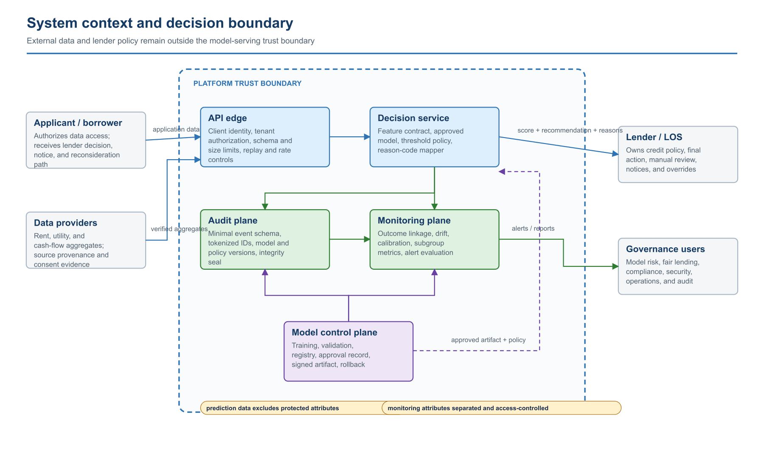
System context and decision boundary
The scoring platform does not own the lender's credit policy or final action. The lender/LOS authenticates through the API edge and supplies permissioned, validated feature aggregates. The decision service applies a specific approved model and a separately versioned threshold policy. Audit and monitoring are first-class planes rather than log side effects. The model control plane can change production behavior only through a registry approval record and a signed artifact reference.
Control consequences:
C1 — Attribute separation. Protected or proxy attributes used for monitoring do not enter the prediction vector.
C2 — Response evidence. A score response is incomplete without model, policy, explanation, and request identifiers.
C3 — Governance access. Governance users consume aggregate evidence and alerts; they do not query raw applicant payloads by default.
C4 — Change control. Model promotion, threshold changes, and reason-code changes are governed releases even when application code is unchanged.

Architecture view 2 — Online scoring transaction
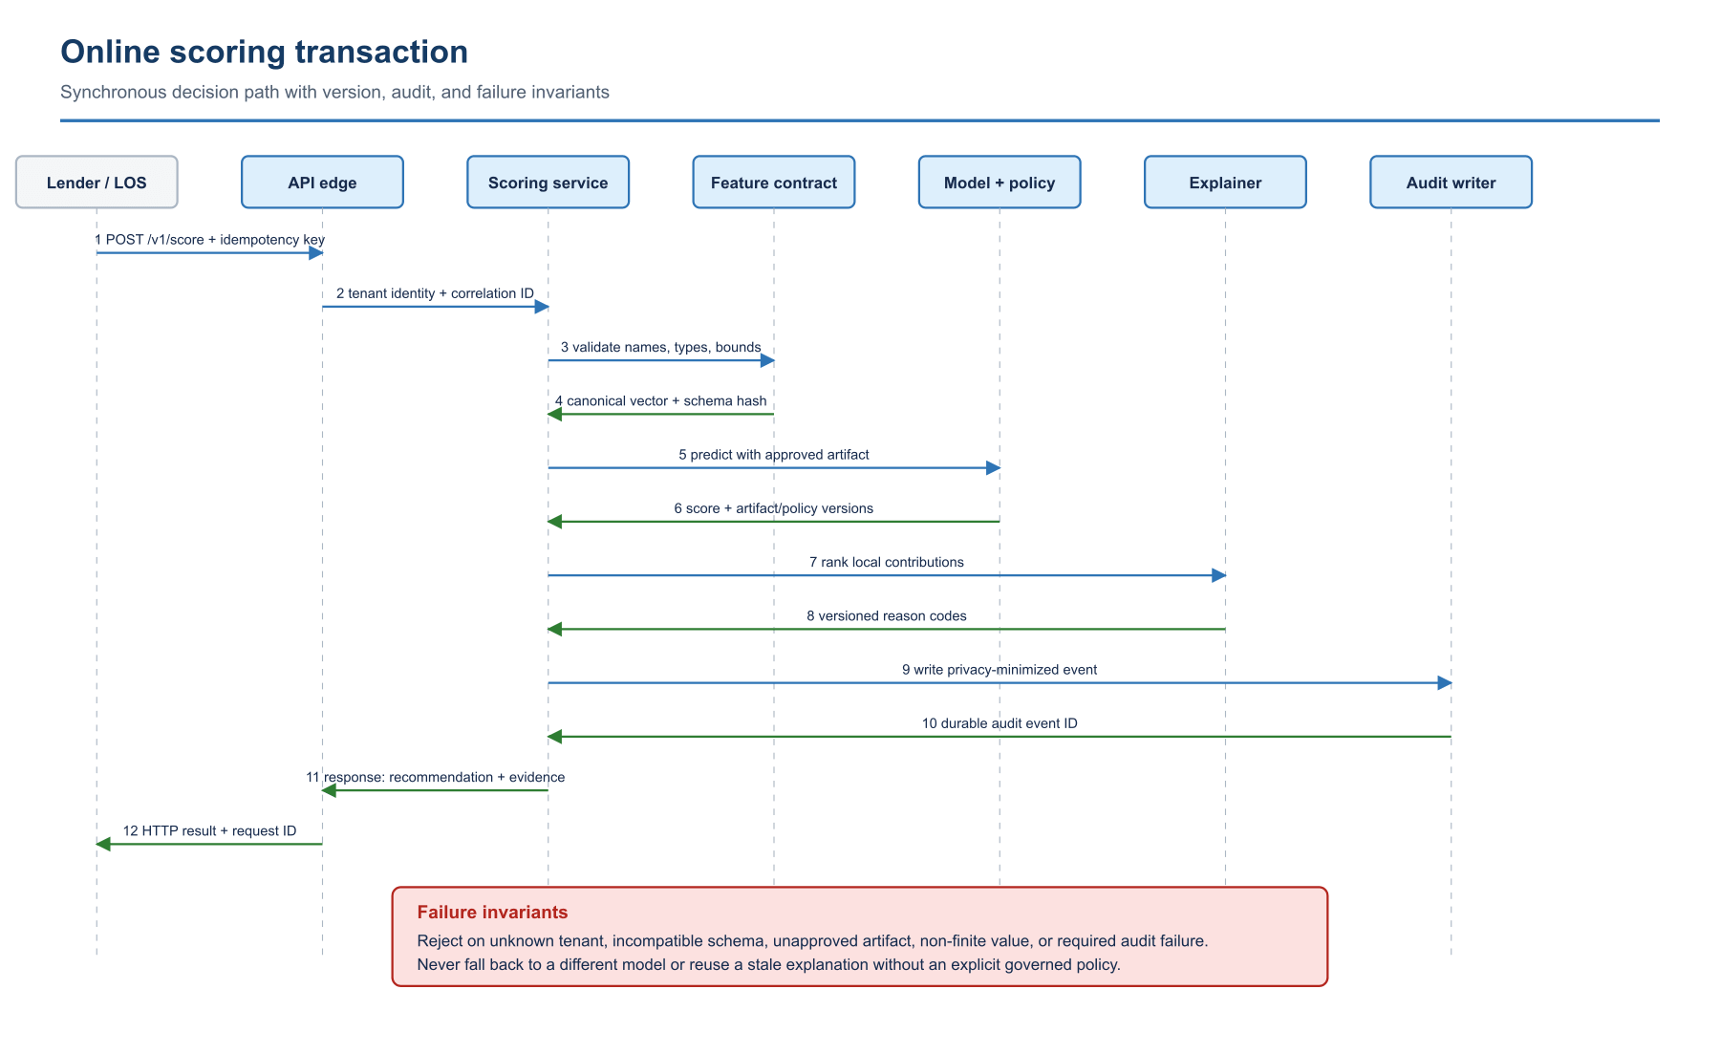
Online scoring transaction
The transaction is synchronous through durable audit acknowledgement. The feature contract returns both the canonical vector and the schema hash used to prove compatibility with the artifact. The explanation is computed from the same scored vector and approved model version; a cached or separately computed explanation would break fidelity. The response is assembled only after the audit layer returns an event identifier under the strict durability policy shown here.
Failure semantics:
F1 — Caller failure. Unknown tenant, unauthorized product, or missing endpoint scope is rejected at the edge.
F2 — Contract failure. Unknown fields, non-finite values, impossible ranges, and incompatible schema hashes are rejected; they are not replaced with model defaults.
F3 — Artifact failure. Missing or unsigned artifacts, unapproved versions, or artifact-digest mismatches make the scoring dependency unavailable.
F4 — Audit failure. A required audit write failure fails the transaction. A deployment that chooses asynchronous audit must use a durable queue, idempotent event key, dead-letter handling, and reconciliation control.
F5 — Retry behavior. Retries use the idempotency key and must reproduce the original governed result unless the caller explicitly creates a new decision transaction.

Architecture view 3 — Reference production deployment topology
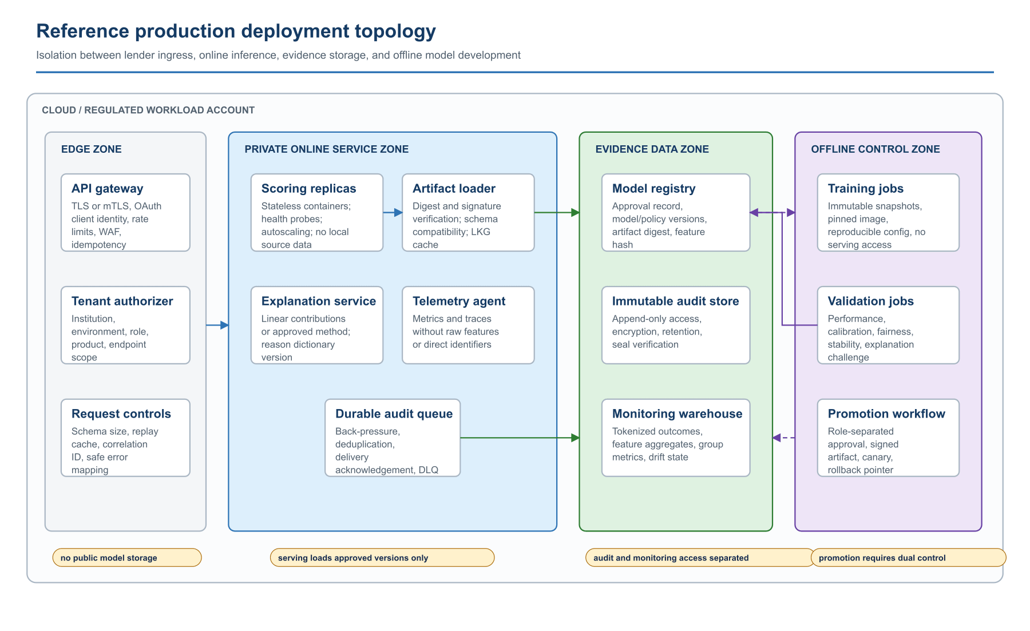
Reference production deployment topology
The topology separates four security zones. The edge zone terminates lender identity and request controls. The private online zone contains stateless scoring replicas and no raw data store. The evidence data zone holds the model registry, immutable audit records, and monitoring aggregates under different access roles. The offline control zone has access to governed snapshots and can publish only through the promotion workflow.
Deployment invariants:
D1 — Artifact source. Model artifacts are never retrieved from a public bucket or an arbitrary URL.
D2 — Activation. Serving verifies signature, digest, and feature compatibility before activating an artifact.
D3 — Training isolation. Training jobs cannot call the online scoring data plane or mutate the production registry.
D4 — Monitoring data. The monitoring warehouse receives tokenized outcomes and approved aggregates, not unrestricted request bodies.
D5 — Promotion. Promotion uses dual control, records validation and approval references, and preserves a last-known-good rollback pointer.
D6 — Telemetry. Operational telemetry excludes raw features and direct applicant identifiers.

Architecture view 4 — Model lifecycle and approval gates
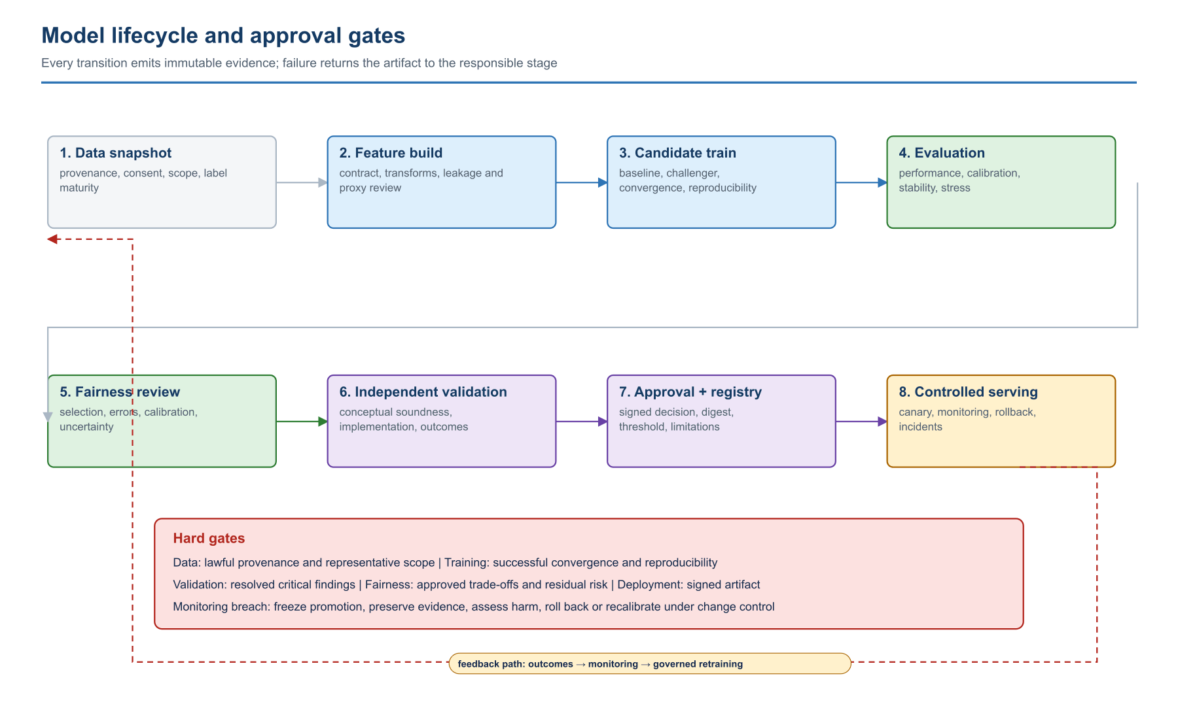
Model lifecycle and approval gates
The lifecycle is a state machine, not a sequence of notebooks. A stage transition requires a named evidence set and an accountable approver. Rejection returns the work to the stage that owns the defect. Monitoring can force a rollback or reopen data/model development even when the deployed artifact is unchanged.
Minimum transition records:
G1 — Data snapshot. Source manifest, consent/permissible-purpose evidence, checksum, exclusions, label definition, and quality exceptions.
G2 — Feature build. Contract version, transform code commit, fitted-transform digest, leakage review, proxy review, and schema hash.
G3 — Candidate training. Configuration, seed, split hash, dependency image, convergence record, coefficients or parameters, and artifact digest.
G4 — Evaluation. Locked-set metrics, calibration, error costs, uncertainty, stress cases, and challenger comparison.
G5 — Fairness review. Group definitions, denominators, metrics, confidence intervals, intersectional results, mitigation trade-offs, and residual risk.
G6 — Validation and approval. Independent findings, issue disposition, signed decision, intended-use restrictions, threshold policy, reason dictionary, and rollback target.

Architecture view 5 — Data lineage and evidence linkage
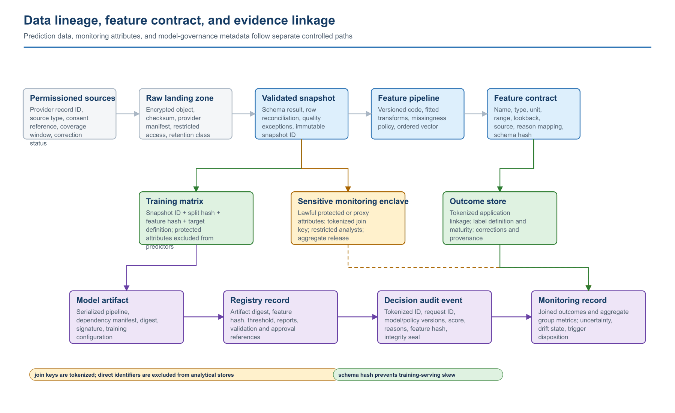
Data lineage and evidence linkage
This view separates three data classes that are frequently collapsed in prototype systems: predictor features, sensitive monitoring attributes, and realized outcomes. They may share a tokenized join key but have different permitted purposes, access roles, retention, and release rules. The feature-schema hash flows into the artifact, registry, scoring event, and monitoring record so a reviewer can detect training-serving skew and reconstruct the decision path.
Required lineage keys:
L1 — Source. Provider record and manifest identifiers.
L2 — Snapshot. Raw-object checksum and validated-snapshot identifier.
L3 — Split. Training/validation/test split hash.
L4 — Features. Feature contract and transform versions.
L5 — Artifact. Model artifact digest and signature.
L6 — Registry. Registry version, policy version, and reason-code dictionary version.
L7 — Decision. Tokenized application ID and request ID.
L8 — Outcome. Outcome definition, maturity state, correction status, and monitoring cohort ID.

Architecture view 6 — Fairness control loop
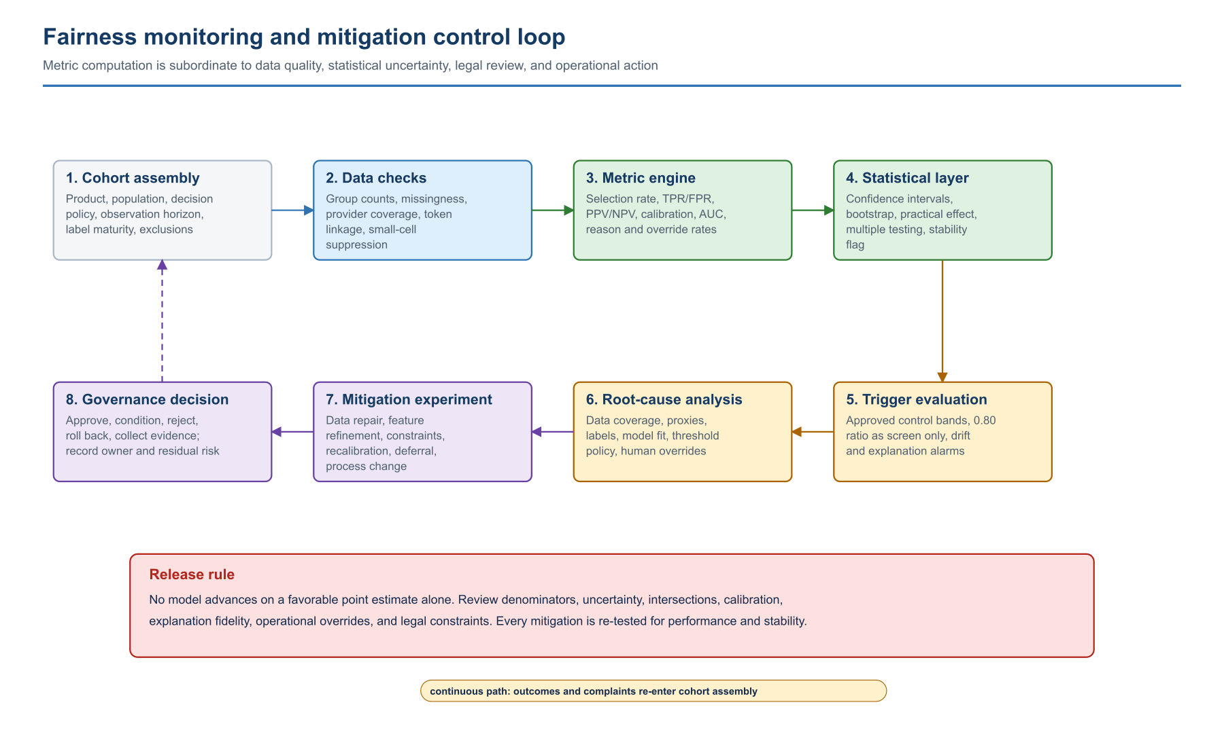
Fairness monitoring and mitigation control loop
Fairness monitoring begins with cohort construction and data sufficiency, not a dashboard ratio. Metrics pass through an uncertainty layer before trigger evaluation. A trigger initiates root-cause analysis; it does not automatically prescribe reweighting or a threshold change. Each mitigation is evaluated against performance, calibration, stability, explanation fidelity, operational burden, and legal constraints before governance disposition.
The loop must retain:
M1 — Cohort. Cohort query and population definition.
M2 — Sufficiency. Group counts, suppression rules, missingness, provider coverage, and label maturity.
M3 — Measurement. Metric implementation/version, point estimates, intervals, and practical-effect thresholds.
M4 — Trigger. Trigger rule and breach evidence.
M5 — Diagnosis. Root-cause hypothesis, analyses, and rejected alternatives.
M6 — Mitigation. Mitigation configuration and before/after trade-off matrix.
M7 — Disposition. Governance disposition, accountable owner, residual risk, and rollback condition.

