**Game Design Document**

**Fill up the Following document**

1. Write the title of your project - **MARINE NINJA**

1. What is the goal of the game?

The goal of the game is to become a Marine Ninja by preventing pollution and saving the Marine Bio-diversity.

1. Write a brief story of your game?

Marine Ninja – is a reflection of my mind when I go scuba diving. I created this game to share my pain of how we as humans destroy a world that does not belong to us. Being India’s Youngest Master Scuba Diver, I hope to increase awareness of Marine pollution and turn the tide on the plague of plastic in our Oceans.

**Level 1** - It is your duty to collect the plastic waste to prevent them from harming the Marine bio-diversity. As you keep collecting, your score increases in multiples of 5. To move to the next level, you need to score a minimum of 100 points. You have 5 lives. If you miss collecting 3 plastic wastes, you lose a life. If you exhaust your 5 lives, you will have to start over.

**Level 2** - You spot a turtle caught in a fishing net. You have to free the turtle, with your equipment by clicking on the net 5 times. You have to continue collecting plastic waste as you did in level 1. You receive hundred points for freeing 1 turtle. To move to level 3, you have to free 2 turtles and score a minimum 500 points.

**Level 3 -** You have to dodge the Jellyfish, Stingrays, Sharks and Octopi, while collecting plastic waste. You must score a minimum of 1000 points within a time frame to proceed to the next level.

You enter a cave…………

**Level 4 -** You will have to choose from one of the three exits. You will get only 2 attempts to guess the correct exit. After you exit, you see a Treasure Chest. Unlock the chest with a key you have to find.

When you open the Treasure Chest you find a Sword and a Water Headband. You then officially become a Marine Ninja. You receive a pop-up message saying, “Thank you for saving our world. You are our **MARINE NINJA!**”

1. Which are the playing characters of this game?

* Playing characters are the ones which respond to the user based on the input from the user
* Cars, monkeys, dinos, wizards etc, are the playing characters in the game.

|  |  |  |
| --- | --- | --- |
| Number | Character Name | What can this character do? |
| 1 | Scuba Diver (player) | Collect plastic waste, save animals and prevent harm by avoiding predators in the Marine World. |
| 2 |  |  |
| 3 |  |  |
| 4 |  |  |
| 5 |  |  |
| 6 |  |  |
| 7 |  |  |
| 8 |  |  |

1. Which are the Non Playing Characters of this game?

* Non Playing characters are the ones which don't have an action or a behaviour when the user interacts with the game.
* Hurdles, stones, bananas, coins, etc are non playing characters in the game.

|  |  |  |
| --- | --- | --- |
| Number | Character Name | What can this character do? |
| 1 | Plastic Waste (Hurdles) Level 1 to Level 4 | Reduce the health of the Scuba Diver |
| 2 | Clown fish, Angel fish (Level 1 to 4)  Manta Ray, Puffer fish (Level 3 and 4) | Moving around |
| 3 | Tortoise in the Fishing net (Level 2) | If not saved - Game ends. |
| 4 | Octopus, Shark, Jellyfish (Level 3) | Reduce the health of the Scuba Diver if he comes in contact with them. |
| 5 | Cave | N/A |
| 6 | Treasure Chest | Gives title of Marine Ninja |
| 7 | Key | Opens Treasure Chest |
| 8 |  |  |

Draw your imagination of this game. What does this game look like?

* Draw the game either on your computer or on paper,
* Add images of scenes of the game to show each of the playing and non-playing characters at least once.

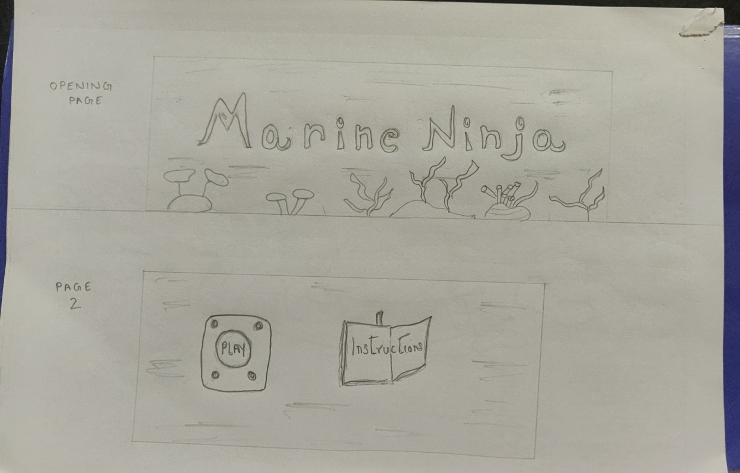

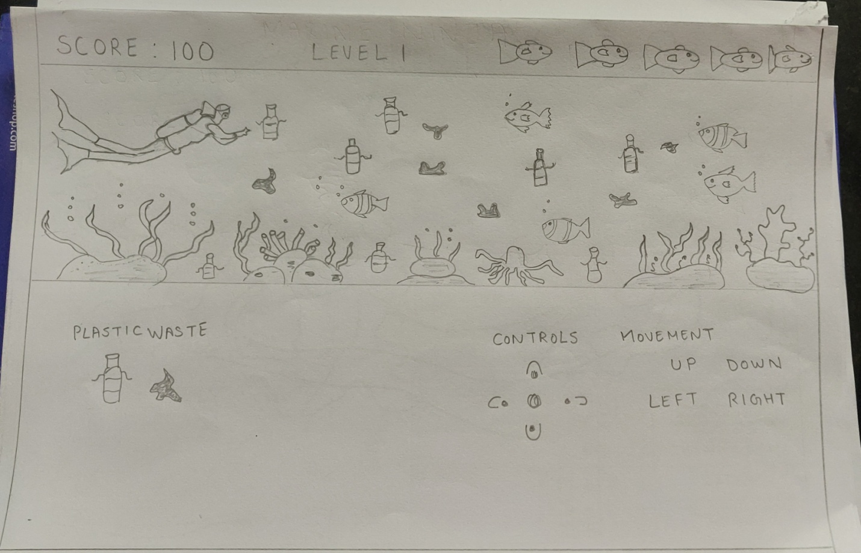

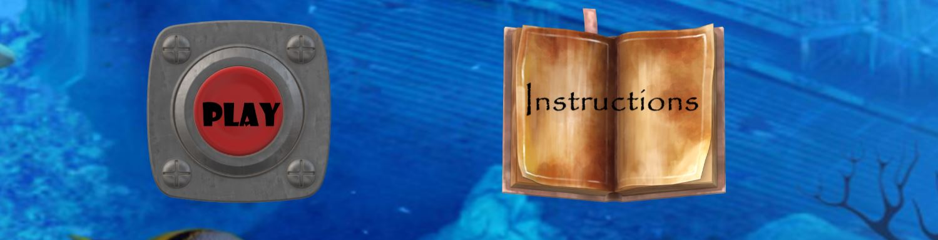

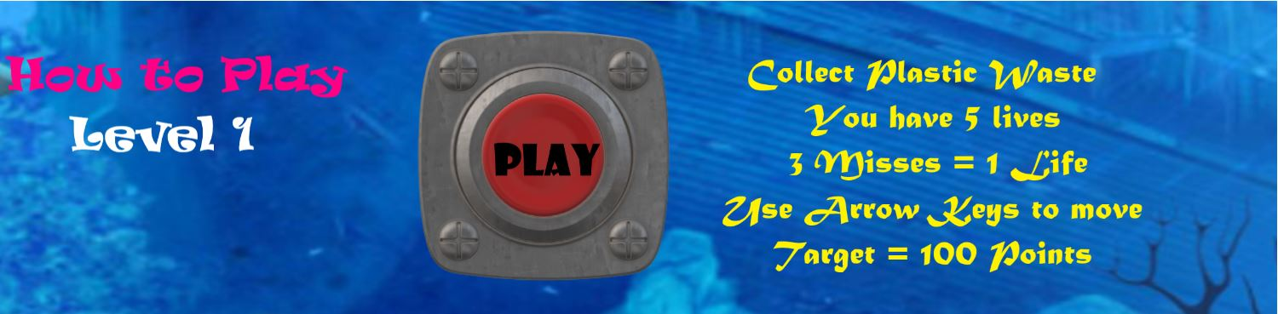

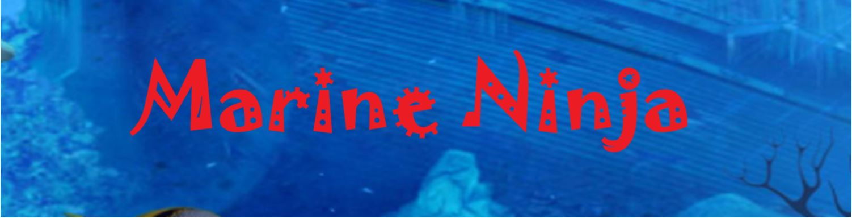

How do you plan to make your game engaging?

I plan to make my game engaging by:

Giving a realistic underwater world audio and visuals.

Challenging the diver to complete his tasks at various levels of difficulty.

Creating different scenarios for objectives to be met with.

Making it fun as well as creating awareness.