DSCC CW1 Technical Report
Django Blog Application

Student name: Khursandbek Saidov
Student ID: 00017298
Submission date: March 2026
Word count (excluding references, headings, and attachments): 1014

Live deployment: https://khursandblog.duckdns.org
Repository: https://github.com/theKhursandbek/DSCC_CW1_00017298

Contents

A. Application Overview
This project is a full‑stack Django blog application designed to demonstrate web development and DevOps deployment skills (Django, 2026). The application supports user registration and authentication, password management, and a responsive Bootstrap 5 UI. Users can browse articles, open a detailed view, and interact using a like/unlike feature (many‑to‑many relationship between users and articles). Articles include rich text content via CKEditor and optional image uploads, while each article can receive comments (many‑to‑one). Administrators manage users and content using Django Admin. The technology stack includes Django (Python 3.12), PostgreSQL 16 (PostgreSQL, 2026), Gunicorn (Gunicorn, 2026), Nginx (Nginx, 2026), Docker/Compose (Docker, 2026), WhiteNoise (WhiteNoise, 2026), and GitHub Actions (GitHub, 2026).
Database schema overview: CustomUser (extends AbstractUser with age) → Article (FK to user as author + M2M likes) → Comment (FK to article + FK to user).
Screenshot (running app):
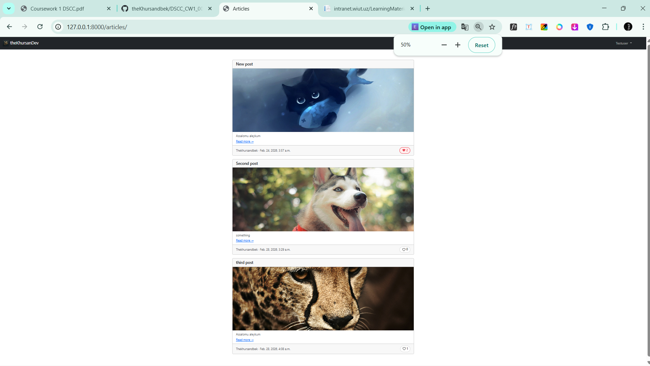
Figure 1: Article List

B. Containerization Strategy
The solution uses Docker to provide consistent environments across development, CI, and production (Docker, 2026). The Dockerfile implements a multi‑stage build to keep the final image smaller and more secure:
1) Builder stage: installs build dependencies (gcc, libpq-dev) required to compile certain Python packages (PostgreSQL drivers) and installs Python dependencies into a separate prefix (/install).
2) Production stage: starts from python:3.12-slim, installs only runtime packages (libpq5), copies dependencies from the builder stage, and runs the app as a non‑root user (appuser). This reduces attack surface and follows container best practices.
The production stack is defined in docker-compose.yml with four services:
- `db` (Postgres 16) with a persistent volume `postgres_data` and a healthcheck.
- `web` (Django + Gunicorn) pulled from Docker Hub image `thekhursandbek/dscc-cw1-00017298:latest` and mounted volumes `static_files` and `media_files` so static/media persist across restarts.
- `nginx` (reverse proxy) exposes ports 80/443, serves `/static/` and `/media/` directly from the shared volumes, and proxies dynamic traffic to `web:8000`.
- `certbot` (on‑demand) shares `certbot_www` and `certbot_conf` volumes to issue/renew Let’s Encrypt certificates.
Environment variable management is handled via .env (read by Django using environs and by Compose using env_file). This keeps secrets like SECRET_KEY, database credentials, and domain settings out of versioned source code.
Screenshots (Dockerization process):
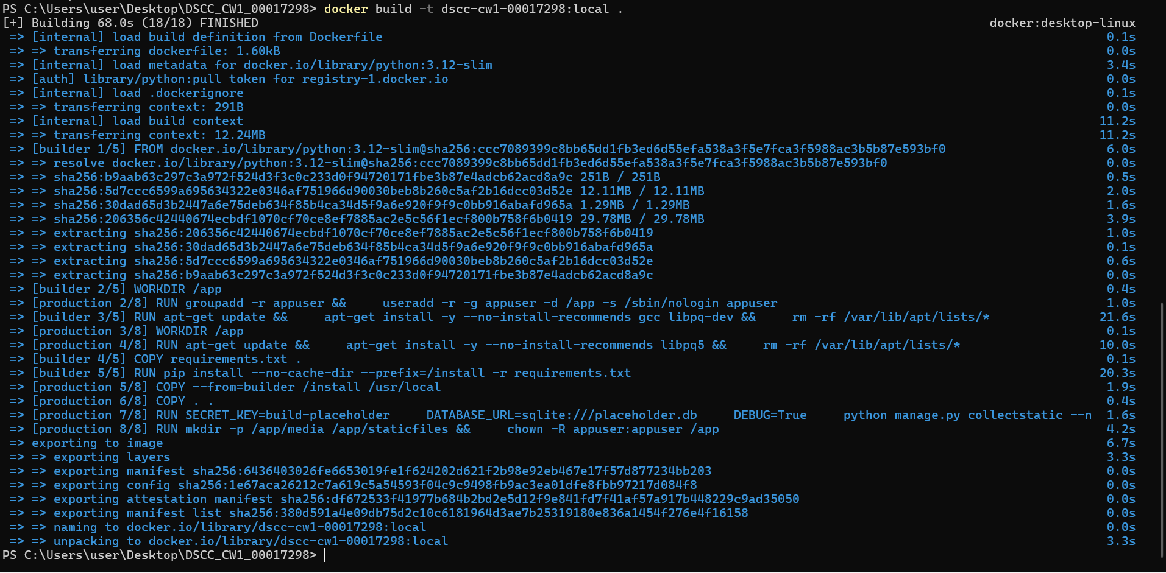
Figure 2: Docker build
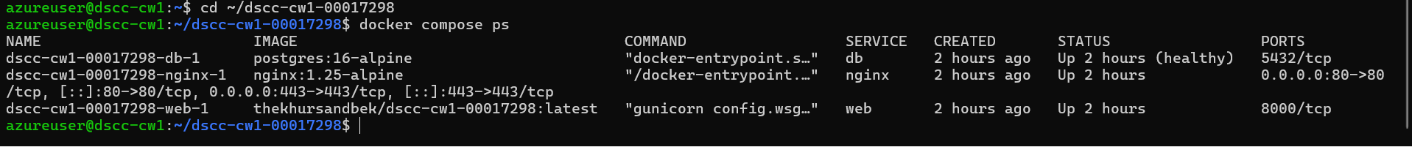
Figure 3: docker compose ps
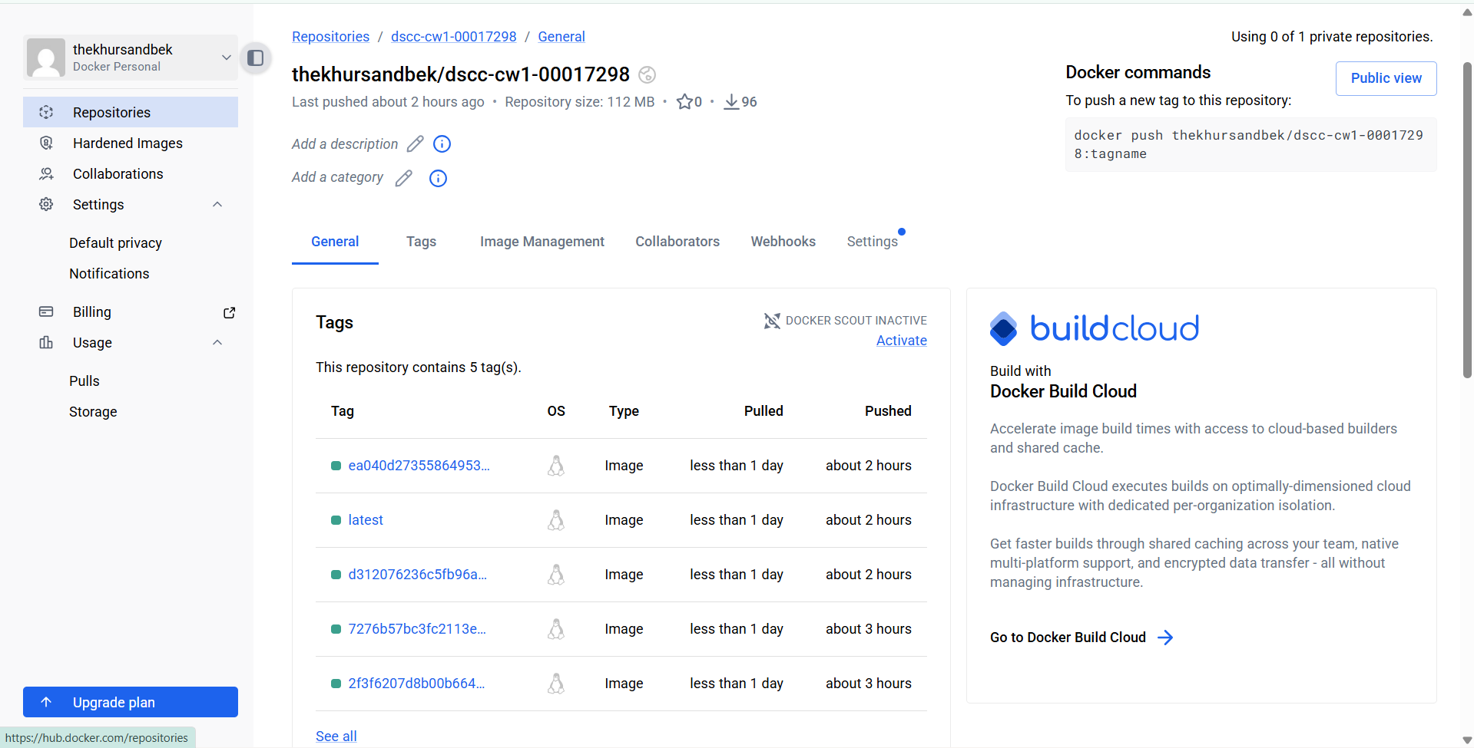
Figure 4: Docker Hub image tags

C. Deployment Configuration
The production deployment follows the “VPS server deployment” requirement (referred to as an Eskiz-style server in the coursework). In this implementation, the target is a Linux VPS on Azure (Debian 12), reachable via public IP, and bound to the domain khursandblog.duckdns.org. Required firewall ports are opened for SSH (22) and web traffic (80/443).
Nginx is configured as the public entrypoint. It serves static and media files directly for performance and proxies application traffic to Gunicorn inside the web container. Gunicorn binds internally on 0.0.0.0:8000 and is not exposed directly to the internet.
HTTPS is enabled using Let’s Encrypt with Certbot webroot validation (Let’s Encrypt, 2026; Certbot, 2026). The ACME challenge is served from the shared certbot_www volume (/.well-known/acme-challenge/). Certificates are stored in certbot_conf and mounted into the Nginx container. HTTP traffic is redirected to HTTPS via a 301 redirect. Django production security settings are enabled when DEBUG=False, including SECURE_SSL_REDIRECT, HSTS, secure cookies, and SECURE_PROXY_SSL_HEADER for correct scheme handling behind Nginx.
Security measures include: non‑root container user (appuser), secrets stored in .env / GitHub Secrets, TLS termination at Nginx, and limiting public exposure to only ports 80/443.
Screenshots (deployment):
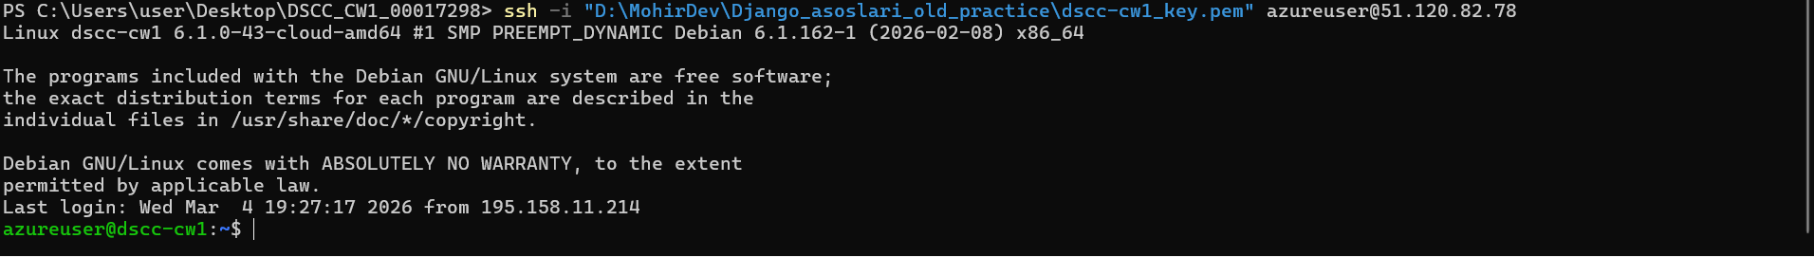
Figure 5: Server instance / SSH
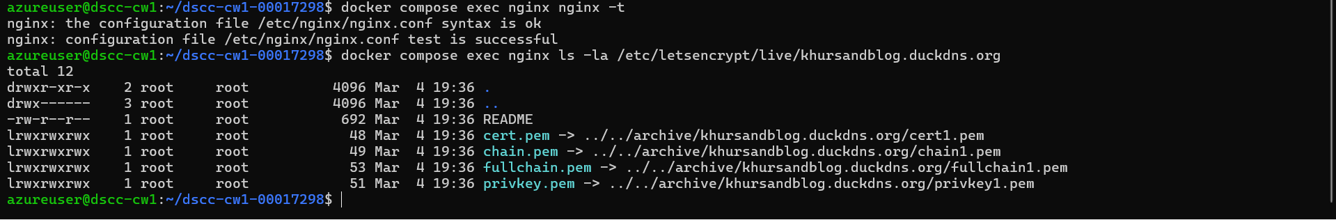
Figure 6: Nginx HTTPS running
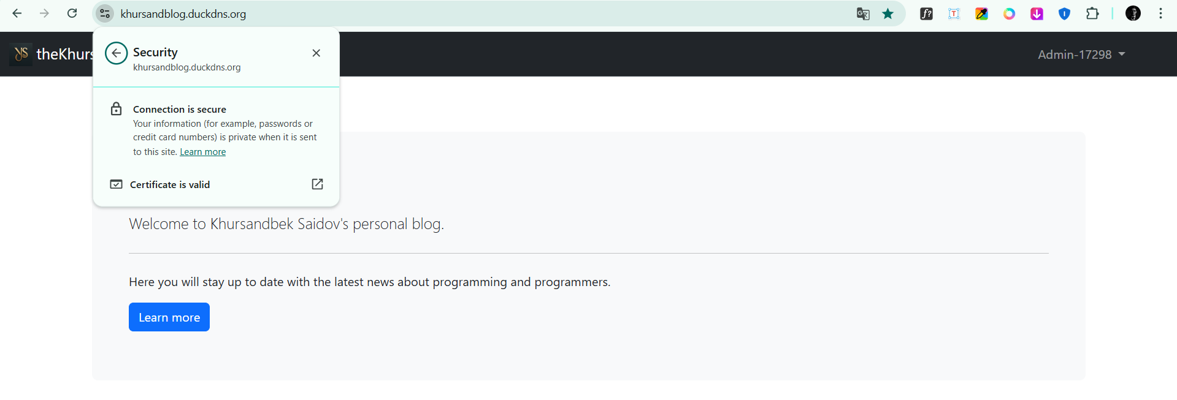
Figure 7: Live site HTTPS

D. CI/CD Pipeline
Continuous integration and deployment is implemented with a GitHub Actions workflow (.github/workflows/deploy.yml) that runs on every push to main (GitHub, 2026).
1) Test job: checks out code, installs dependencies, runs flake8 to enforce code quality, then runs pytest using a PostgreSQL service container. Environment variables are set for CI (SECRET_KEY, DATABASE_URL, DEBUG=True, and ALLOWED_HOSTS). This validates models, views, templates, and permissions before any deployment.
2) Build-and-push job: builds the Docker image using Buildx and pushes to Docker Hub with two tags: latest and the commit SHA. This provides a stable tag for production and an immutable tag for traceability.
3) Deploy job: connects to the server over SSH, updates the server checkout (git fetch + git reset --hard), ensures HTTPS Nginx config is active by copying nginx/nginx.https.conf to nginx/nginx.conf, pulls the newest Docker images, recreates containers, runs Django migrations, runs collectstatic, and prunes old images. This makes deployment repeatable and minimizes manual steps.
Secrets are stored in GitHub repository secrets (DOCKERHUB_USERNAME, DOCKERHUB_TOKEN, SSH_HOST, SSH_USERNAME, SSH_PRIVATE_KEY) so no credentials are committed.
Screenshots (CI/CD):
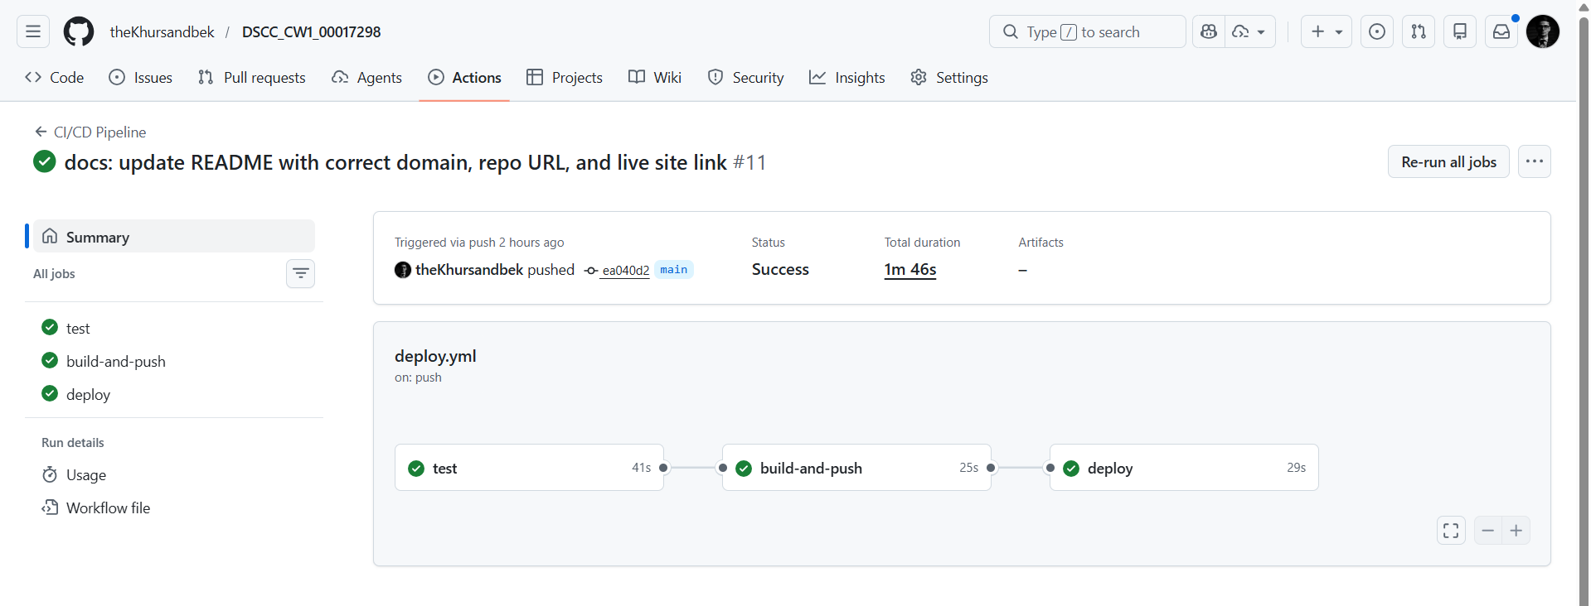
Figure 8: Actions workflow green

E. Challenges and Solutions
Challenge 1 — Domain and certificate issuance constraints. Early attempts with a different hostname/provider resulted in certificate issues (rate limits / domain restrictions). The solution was to switch to DuckDNS and issue Let’s Encrypt certificates for khursandblog.duckdns.org via Certbot webroot.
Challenge 2 — Django 400 “Bad Request”. After enabling HTTPS, the application returned 400 errors due to ALLOWED_HOSTS / CSRF origin mismatch. The fix was to update .env (ALLOWED_HOSTS, CSRF_TRUSTED_ORIGINS) and recreate containers so the new environment values were loaded.
Challenge 3 — CI deploy breaking Nginx configuration. The deploy step performs git reset --hard, which can overwrite server-side Nginx edits. This caused connection failures when the repo configuration did not match the production domain. The fix was to commit the correct domain into both Nginx configs and enforce the HTTPS config during deployment (cp nginx/nginx.https.conf nginx/nginx.conf).
Lessons learned: automate the full deployment path, treat configuration as code, and validate host/security settings immediately after domain changes.
Future improvements: introduce role-based author permissions (staff authors instead of superuser-only posting), add monitoring/backup routines, and schedule cert renewal.

GitHub Repository (Deliverables — place at end)

Public repository link
https://github.com/theKhursandbek/DSCC_CW1_00017298

Code organization
The project follows Django’s default MTV (Model–Template–View) structure (conceptually similar separation of concerns to MVVM) via separate apps (accounts, articles, pages) and keeps infrastructure concerns in dedicated folders (nginx/, .github/workflows/).

Commit history evidence
Add the following screenshots to document commit history and timestamps:
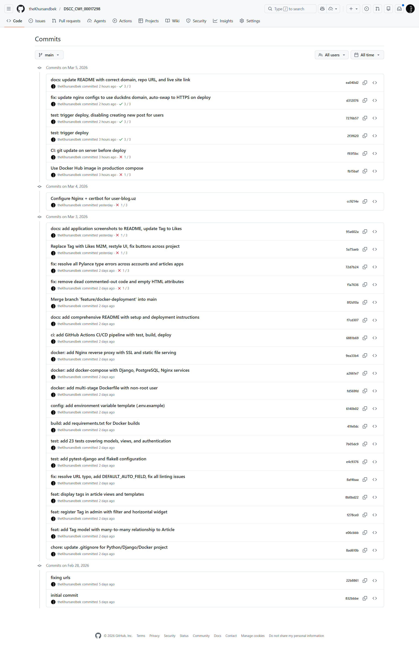
Figure 9: Commit history
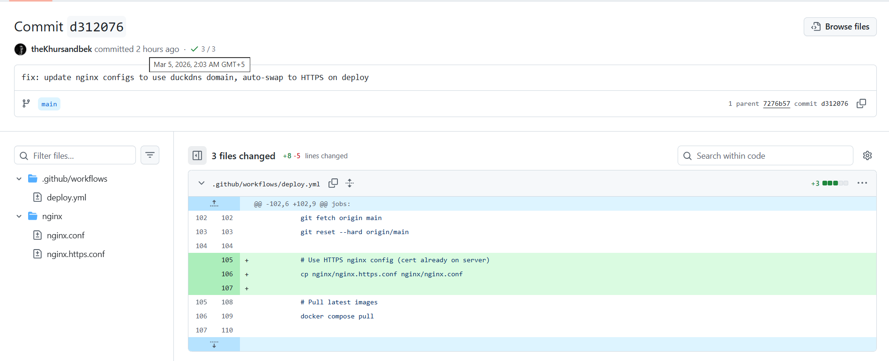
Figure 10: Commit timestamps

README
The repository contains a comprehensive README with live link, local/production setup instructions, CI/CD explanation, and UI screenshots.

References
- Certbot (2026) *Certbot documentation*. Available at: https://certbot.eff.org/ (Accessed: 5 March 2026).
- Django (2026) *Django documentation*. Available at: https://docs.djangoproject.com/ (Accessed: 5 March 2026).
- Docker (2026) *Docker documentation*. Available at: https://docs.docker.com/ (Accessed: 5 March 2026).
- GitHub (2026) *GitHub Actions documentation*. Available at: https://docs.github.com/actions (Accessed: 5 March 2026).
- Gunicorn (2026) *Gunicorn documentation*. Available at: https://docs.gunicorn.org/ (Accessed: 5 March 2026).
- Let’s Encrypt (2026) *Let’s Encrypt documentation*. Available at: https://letsencrypt.org/docs/ (Accessed: 5 March 2026).
- Nginx (2026) *NGINX documentation*. Available at: https://nginx.org/en/docs/ (Accessed: 5 March 2026).
- PostgreSQL (2026) *PostgreSQL documentation*. Available at: https://www.postgresql.org/docs/ (Accessed: 5 March 2026).
- WhiteNoise (2026) *WhiteNoise documentation*. Available at: https://whitenoise.readthedocs.io/ (Accessed: 5 March 2026).

Appendix (Attachments): Selected Configuration Snippets
These snippets are provided as supporting attachments and are excluded from the reported word count.

Appendix A1: Dockerfile (multi-stage extract)
FROM python:3.12-slim AS builder
WORKDIR /app
# build deps + pip install --prefix=/install
...
FROM python:3.12-slim AS production
# non-root user + runtime deps + gunicorn
CMD ["gunicorn", "config.wsgi:application", "--bind", "0.0.0.0:8000"]

Appendix A2: docker-compose.yml (service summary extract)
services:
db: postgres:16-alpine
web: thekhursandbek/dscc-cw1-00017298:latest
nginx: nginx:1.25-alpine
certbot: certbot/certbot
volumes:
postgres_data: {}
static_files: {}
media_files: {}

Appendix A3: GitHub Actions deploy job (extract)
- name: Deploy to server via SSH
uses: appleboy/ssh-action@v1
with:
script: |
git fetch origin main
git reset --hard origin/main
cp nginx/nginx.https.conf nginx/nginx.conf
docker compose pull
docker compose up -d --force-recreate

