Installation and use:
Step 1: Install Python on your machine.
Go to https://www.python.org/downloads/windows/ and download the latest stable version (32bit or 64bit – depending on your computer specifications)
Step 2: In VS code open the file – main.py
Step 3: Install the following packages:
/ to install the packages- copy the name of the file and paste it in Terminal window in VS Code and press “Enter”. Let the packages install.
( pip install -r requirements.txt )
Example: 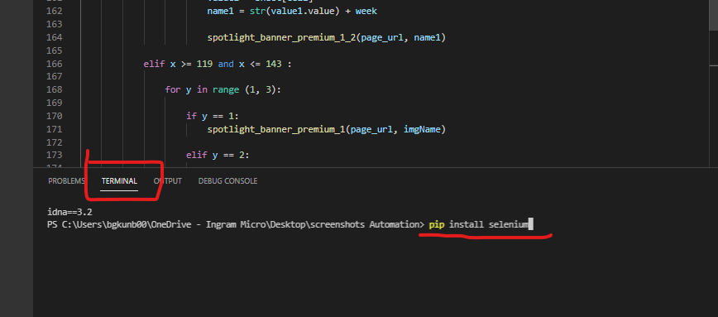

After all packages are installed you are all set.
You don’t have to install the packages again.
Step 4:
Open file “app.py”
Step 5:
Open “ http://127.0.0.1:5001/ ” in your browser or copy it from the Terminal window.
Step 6:
To exit the application, close the Terminal window.

