**The imperfect market of Twitch streaming and its fascinating microeconomics**

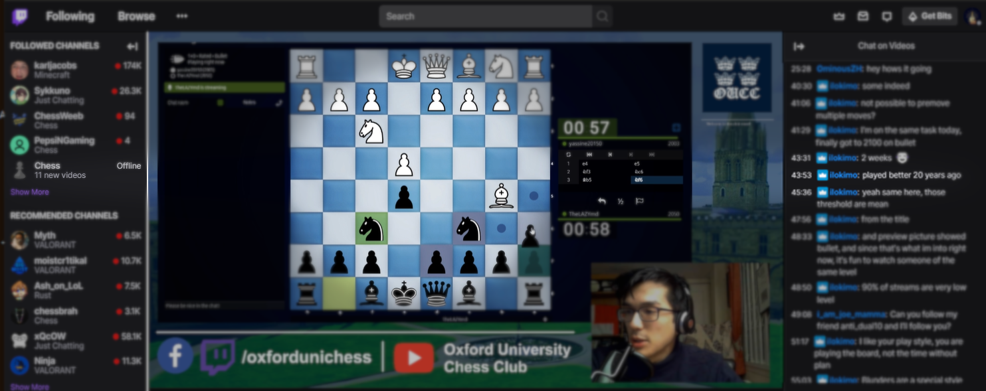

For classical economists, markets which do not fit standard mechanisms of transactions are the most interesting. The entertainment sector is one rife with peculiarities, the world of live-streaming included. On platforms such as YouTube and Twitch, subsidiaries of Google and Amazon, gamers broadcast their play and commentary in a live video for anyone to view and comment. Streaming experienced a boom during lockdown, with the most popular channels pulling in 100k+ viewers per stream. Twitch reached a valuation of [£15 billion](<https://www.cnbc.com/2020/06/16/amazon-media-assets-worth-500-billion-almost-as-much-as-aws-needham.html>). Yet for such a large, omnipresent industry, live-streaming deviates from standard market behaviour. With an economist’s eye, we notice the problems of imperfect information, free-riding, and risk aversion strongly affecting interactions between content producers and their viewers.

The most obvious peculiarity is that streamers rarely receive fixed payment, as one would for the transaction of a standard commodity. In an ordinary market, prices are set (by demand), firms sell products at those prices, and consumers evaluate if their willingness-to-pay (WTP) exceeds that price. The service sector including entertainment is even more insistent on prices because of an uncertainty in the ‘trustworthiness’ of the consumer – once delivered, a service cannot be ‘un-consumed’, leaving payment a question. Standard practice is therefore payment in advance; consider movie tickets, hiring for utility handiwork, or transport and deliveries.

Yet live-streaming neither pays in advance, nor agrees a fixed price. Live-streaming is a donation economy: consumers arrive, view the stream for an arbitrary length of time, may comment and chat, and then *optionally* choose to leave a donation to the streamer. Producers must rely on an estimated proportion of their viewers donating to fund their income. This is unlike any other service industry. Imagine if all the passengers boarding the London Underground each day were able to pay after the journey, and then only if they wanted to, any amount of their choosing.

Two reasons dictate why live-streaming works in this way: imperfect information about the producer, and a zero marginal cost per viewer. The first directly contrasts the consumer uncertainty we identified earlier – this time the consumer is unsure of the quality of entertainment they receive in choosing to spend time watching the channel. Of the latter, we note that live-streaming has fixed producer costs, which need to be amortised across consumers in some form. The usual solutions to this problem are infeasible. The zero marginal cost condition denies the idea of free trials – the later introduction of charging would be questioned; producers cannot employ universal signals because tastes are heterogenous; and the government doesn’t intervene for a ‘public good’ because there are no positive externalities and strong effect of personality on producer success. As a result, the market uses the solution of donations, which is clearly problematic.

First of all, the consumer trustworthiness problem still has not been resolved. It may be the case that consumers watch the streams, find they value the entertainment, and yet still do not donate. This is known as the ‘free-riding’ problem. Because the streamer will be supported so long as some viewers contribute, others consume without paying, despite willingness-to-pay. Much of the reliance of live-streaming on big platforms for infrastructure revolves around systems offered to encourage donations. Twitch uses “subscriptions”, where chatting permissions, the use of emotes, and advertisement-free viewing are limited unless the consumer commits to a monthly contribution. YouTube primarily employs “superchats”, where single messages on busy channels are highlighted and prominently displayed. By offering additional features aimed to enhance entertainment, the platforms incentivise giving up consumer surplus.

Which platform’s system is better? Neither at addressing free-riding – no real enforcement is made to extract willingness-to-pay for the viewing service. In reality, consumers are incentivised to consider willingness-to-pay for that specific feature that is being limited if they free-ride. Nevertheless, the Twitch system seems like an economically better response – viewers are framed like exclusive members to the stream and asked to pay a monthly ‘subscription’. By contrast, the name and associated benefit of YouTube’s superchat puts more emphasis on the surplus of chatting, rather than viewing itself. Nevertheless, YouTube’s system is far better from a business perspective in encouraging donations. Twitch’s subscriptions are a fixed cost – £5 per month. Multiple of the same cannot directly be purchased; indirectly doing so, a practice known as “gifting subs”, pays for the features for other viewers at random, removing the incentive for those viewers to purchase too. Such a model doesn’t capture consumer surplus – consider a consumer who valued the content of the stream at £100 – or indeed an income effect of any kind – richer contributors have no real mechanism by which they are incentivised to contribute more. Meanwhile, the payment for YouTube superchats is “per chat”, which might occur several times per stream, and then several streams per month, rather than once-off monthly. Superchats are tiered, meaning more money can be given for a more prominent chat, accounting for heterogenous utilities and income levels. Finally, superchats also use a minimum of £5, exploiting a behavioural economic effect of “anchoring” – consumers are flexible on the frequency of their donations, but perceive an “easy” price of donation anytime as £5. Whilst Twitch makes this their fixed cost of a monthly subscription, YouTube encourages this donation as often as possible. Thus, more microeconomic behavioural patterns are used by producers and platforms in resolving this free-riding problem.

Why would any producer prefer a lower-income subscription system as funding rather than superchats? Here, we introduce the idea of risk aversion, which states that people prefer secure incomes over riskier larger ones. Twitch subscriptions are secure – they auto-renew and are constant, whilst superchats occur per stream and are variable, increasing uncertainty. We might show this mathematically assuming a declining marginal utility of income. Model a streamer’s utility as *u(x)=x<sup>½</sup>*. Consider an exemplar choice between Twitch, which would guarantee an income of £104 / stream, and YouTube, which would fluctuate with equal probability between £64 and £144 / stream. In the long run, with equal occurrences, the total amount of income obtained with either choice is the same. However, the expected utility from each option diverges: streaming on YouTube offers ½ × £64<sup>½</sup> + ½ × £144<sup>½</sup> = 4 + 6 = 10 = 100<sup>½</sup>. This is obviously less utility from Twitch which is 1 × £104<sup>½</sup>, implying a “risk premium” of £4 under these conditions – the streamer would potentially be willing to give up £4 of potential income to avoid uncertainty. Sums of donations received by the most popular streamers reach 5 figures per stream; clearly the risk premium can grow quite sizeable.

There are other examples in the same industry of producer-side risk-avoidance. Many popular streamers collaborate to form effective “frat houses” of streamers. In exchange for a cut of their potential earnings, streaming companies such as Cloud 9, FaZe Clan, and OfflineTV offer securities such as a house, gaming equipment, and personnel to attract corporate sponsors. Some companies even permit full risk-pooling and take all a streamer’s per-stream earnings, paying in return a fixed estimated income. There are also cases of streaming “partnership deals” made with YouTube and Twitch, in which the platform pays streamers a large, fixed sum in exchange for a cut of revenue and guaranteed platform exclusivity. These all demonstrate a willingness to mitigate producer-side risk. Though streaming platforms’ incentives help encourage donations, the same underlying problem of uncertainty from free-riding is a serious industry concern.

We made two final intriguing observations. Firstly, it is likely that this model of voluntary donations could only occur because the nature of streamers lends itself towards monopolistic competition. Streamer personalities sell themselves as differentiated, provoking consumers to see them as heterogenous products. Secondly, there are network effects. Once a streamer accumulates a substantial number of followers, their viewers share their content and the platforms display their streams more prominently, inviting more viewers who might donate. Finally, there are high barriers to entry for new streamers. The consumers, rather than the products as per most industries, are rivalrous: viewers cannot watch two streams at once, they have a limited budget to donate, and watching time throughout the day is limited. Thus big streamers prosper, and little streamers drop out. This helps up build up a few certain channels that can sustain themselves through donations, despite the imperfections that should make it inviable. The market exists as monopolistic competition and the model of donations feasible.

We lastly consider the benefits of such feasibility on productivity. Consider the time allocation constraint between labour and leisure. Truthfully, economists prefer individuals engaging in the former – labour usually leads to multiplier effects such as returns to skills, saving and investment, and dynamic returns to labour. Leisure by contrast produces none of that, merely yielding individual utility. Streamed media is leisure. Usually, this criticism is made of gaming itself. [A popular 2016 economics article]( https://www.economist.com/the-economist-explains/2017/03/30/the-link-between-video-games-and-unemployment) claimed video gaming has contributed to a decline in work among young people. Watching gaming streaming is even worse: gaming can lead to returns to skills on dexterity, reactions, or planning and strategy; being a viewer improve no skills and offers no social benefits since no streaming conversation is truly two-way. It is a pure form of entertainment from which one derives personal utility. Economists are taught that preferences are sovereign and no matter if for entertainment by watching video game streamers, or an appetite for learning, they should be maximised indiscriminately. Yet acknowledging our collective constraint on resources, with currently ongoing crises that cost lives, and a widening income inequality gap, we might very much label streaming a “luxury leisure”. Perhaps it is time that economists start dividing luxurious utilities from those that are functional and positing that though the economic effects occur for some markets to exist, perhaps this it is not always a good thing. ∎