ShortFiction Publishing Company
This project is based on a fictional company with fictional data, primarily generated using Mockaroo. The goal is to demonstrate my expertise in SQL Server through a comprehensive test case. This repository includes scripts to initialize the database, alongside this document and complete solution scripts. The setup script is designed to create the database, tables, and procedures if they do not already exist. A separate database file and filegroup have been established, and set as the default filegroup, to segregate user-created tables and objects from the system tables and objects that reside in the PRIMARY filegroup. Additionally, population scripts are provided for each table to generate the same sample data contained in this document.
Scenario:
The ShortFiction Publishing Company is an online bookseller, and their database was originally developed by a contractor. They have requested the development of a stored procedure that allows querying of the Inventory and Publication tables, and to optimize the performance of the underlying tables.
The procedure should enable searches by title, genre, author, and rating. For title and author searches, partial matches should also be returned. The output should include the title, author, publication ID, rating, genre, and available quantity.
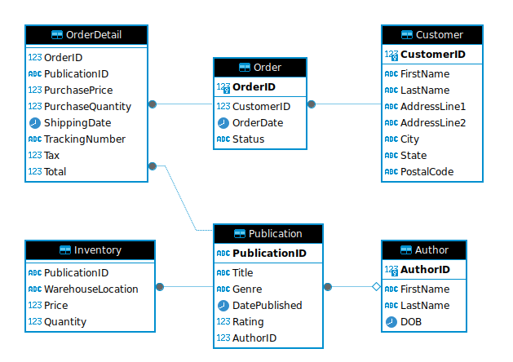

Stored Procedure Overview:
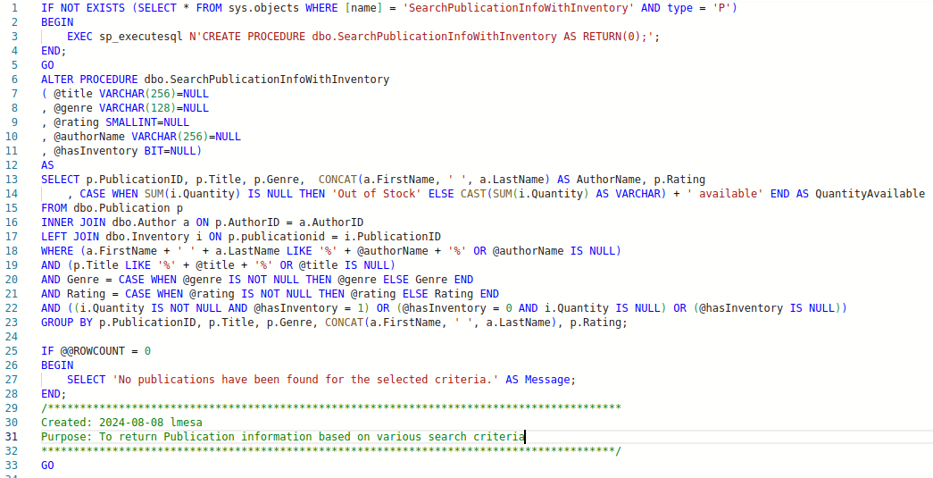
- Lines 1-5: Creates a stored procedure if it does not already exist as a blank procedure. This approach prevents disruption to ongoing customer activities, as altering an existing procedure does not interrupt processes currently executing it.
- Lines 7-11: Declare the input parameters, representing the various search criteria for the SELECT statement. The Publication table provides the Publication ID, Title, Genre, and Rating. From the Author table, the First and Last names are concatenated to form the Author Name. The query also returns the sum of the Quantity from the Inventory table, acknowledging that a publication may be stored in multiple warehouse locations. If no quantity is available, the text "Out of Stock" is returned.
- Lines 15-17: Specifies that the returned rows must exist in both the Publication and Author tables, with the possibility of NULL values in the Inventory table if no matching rows are found.
- Line 18: Starts the WHERE clause and compares the combined author name to the search input, using wildcard characters for flexible matching (partial or full names). The OR operator allows this condition to be ignored if the author name is not provided.
- Line 19: Performs a similar search for the title, without concatenation, ensuring that rows include the specified string in the title.
- Lines 20-21: Exact matches are required for Genre and Rating if these parameters are supplied.
- Line 22: Handles the HasInventory parameter, filtering results based on inventory availability.
- Line 23: Aggregates the inventory quantities with a GROUP BY clause
- Lines 25-28: Provides a message indicating no records were found. This message could alternatively be raised as an error or returned as a numeric code.
- Lines 29-32: Includes a comment section for documenting the date, purpose, and author of the stored procedure.
Sample Results:
- Supplying no parameters returns all publications, with or without inventory:
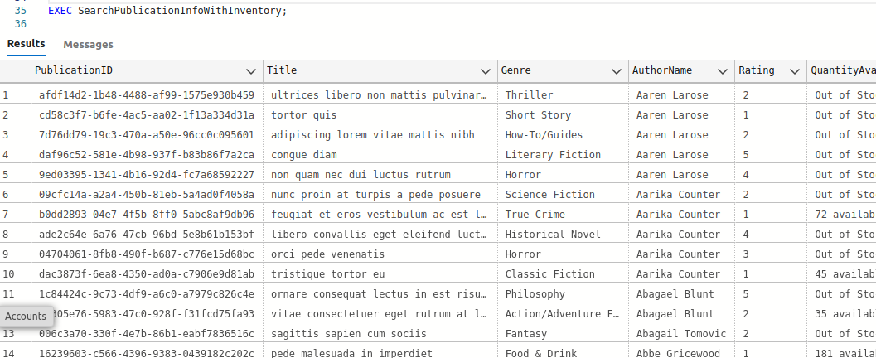
- Searching by title returns all rows containing the specified word or partial word:
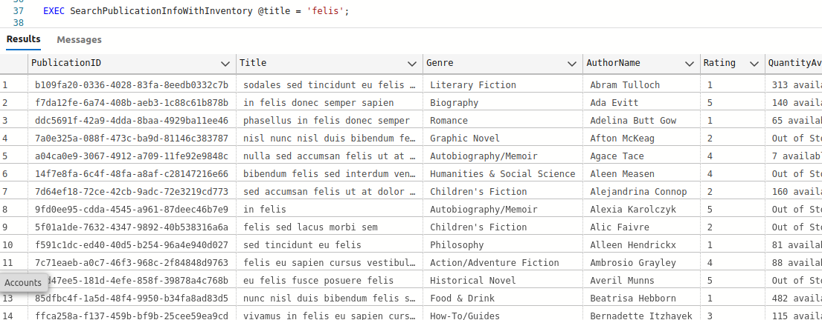
- Additional parameters can be provided for more refined searches:
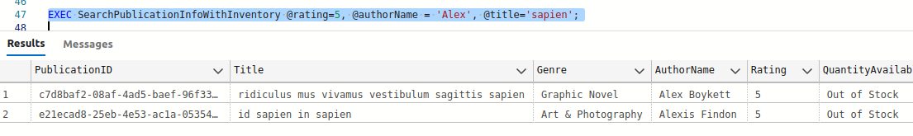
- A query that returns no matching records:
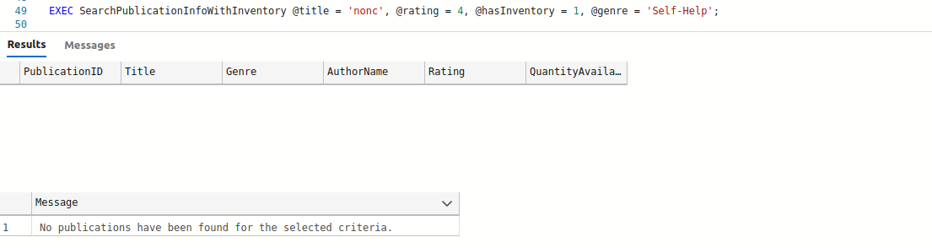
Extensive testing was conducted to ensure functionality across all parameter variations, though only a subset of the results has been presented here for the sake of brevity.
Query Plan Analysis:
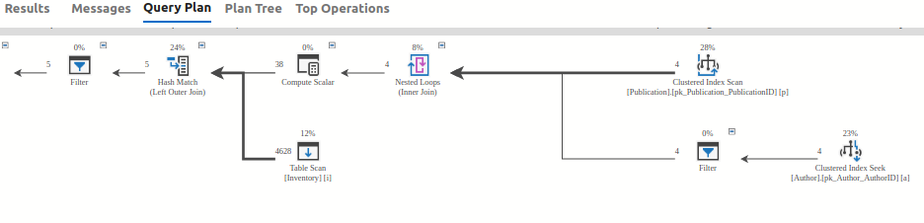
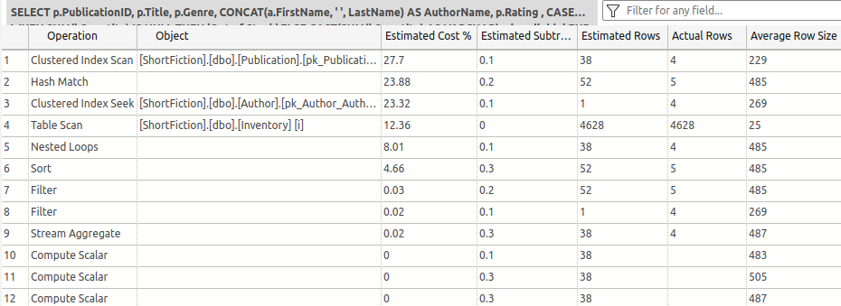
Reviewing the query plan revealed several areas for improvement:
- A full table scan of the Inventory table is performed, which is not scalable as the Inventory table grows.
- A high estimated cost was observed for the clustered index scan of the Publication table.
- The Author table exhibited a non-sargeable predicate. Testing was conducted to evaluate whether a full-text index could improve performance.
Inventory Table Optimization:
The Inventory table, initially a heap with no indexing, required optimization. While the natural key would be PublicationID and WarehouseLocation, using GUIDs as primary keys can lead to performance issues due to page splits and index fragmentation.
Two scenarios were tested:
- Using the natural key as the primary key.
- Using a surrogate identity key.
Both scenarios were analyzed for query performance and index fragmentation, with a focus on scalability.
Publication Table Optimization:
The Publication table had its primary key on a GUID column, with indexes on Genre and Rating. Due to business requirements, the GUID could not be entirely replaced. Non-clustered indexes showed heavy fragmentation even before additional rows were added.
A sequential identity integer was introduced as a surrogate key, with a non-clustered index on PublicationID. This approach was evaluated for its impact on query performance and fragmentation.
The foreign key referencing the Publication table from the Inventory table was also updated to use the new integer primary key instead of referencing the GUID. The stored procedures referencing these joins were also updated.
Author Table Optimization:
To optimize searches by Author Name, a Full-Text index was created on a computed column that concatenates the FirstName and LastName. This column was persisted to avoid performance degradation. The Full-Text index was then utilized in the search procedures.

Final Performance Review:
The optimized query plan showed significant improvements:
- Elimination of the costly hash match and full table scan of the Inventory table.
- Removal of GUIDs from joins and clustered indexes.
- Addition of a Full-Text index to the Author table.
The final result is a more efficient, scalable solution that addresses the initial performance concerns.
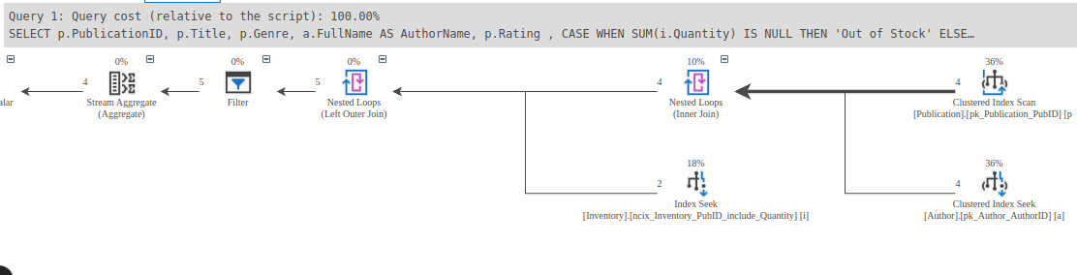
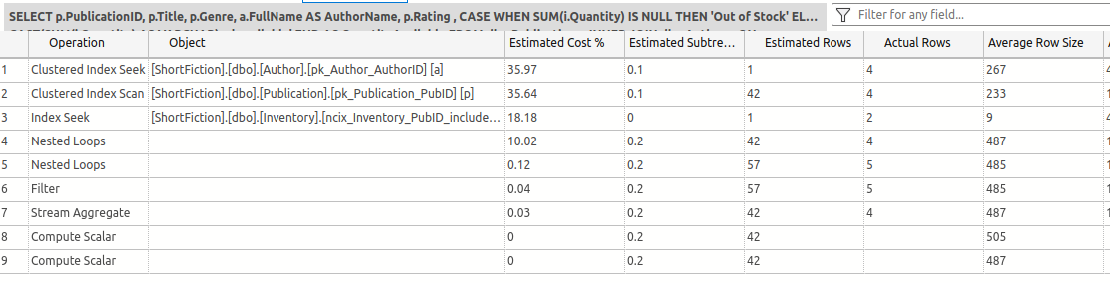

Appendix I
Here are the original table structures, changes made to the tables, final table structures, and a set of the amended stored procedures. These updates are also contained in the script, UpdatesToShortFiction.sql, available in the GitHub repository.

Inventory:
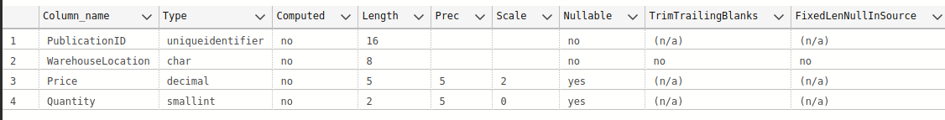
The table initially contains no indexes and lacks a primary key.
The initial testing was performed using the natural primary key of PublicationID and WarehouseLocation:
We can see that this index fragments very easily, with a snapshot of the initial fragmentation present after creating the index:
And then another snapshot of the fragmentation after inserting just 100 records (original record count in the table is 7,000):
A surrogate key (InventoryID INT IDENTITY(1,1)) was then applied, and tested for fragmentation under the same conditions.
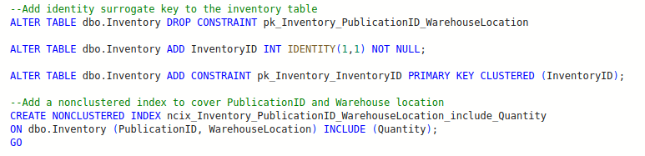
After creating the surrogate key, without any rows added:
After adding an additional 100 rows:
A lot of fragmentation occurs in the nonclustered index that contains the GUID/UNIQUEIDENTIFIER. This key in the Publication table will be addressed shortly. After that, the new integer key can be tied to the Inventory table instead of the GUID.
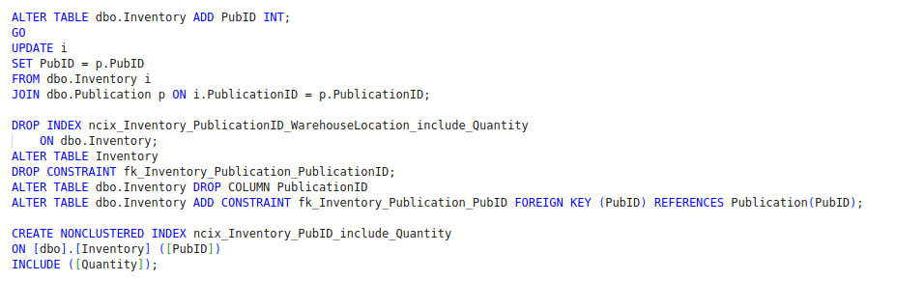
Here is the final structure of the Inventory table:
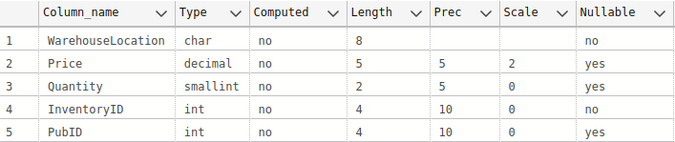
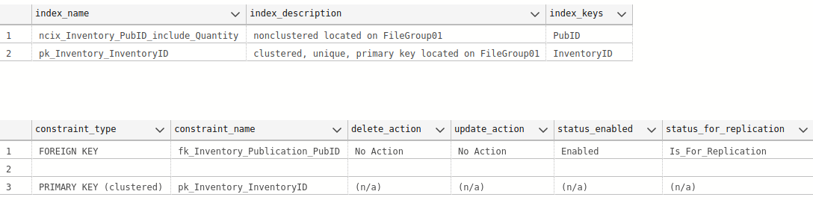

Publication
The publication table has a primary key that consists of a GUID/UNIQUEIDENTIFIER column. This column is used to sync their data with corporate, and cannot be removed in whole. Since GUIDs by definition, are not sequential, as rows are added, we see near instantaneous fragmentation, which can cause inserts to slow, and the table to function inefficiently.
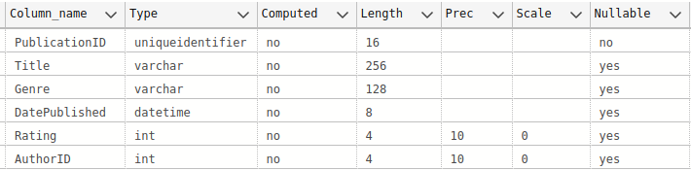
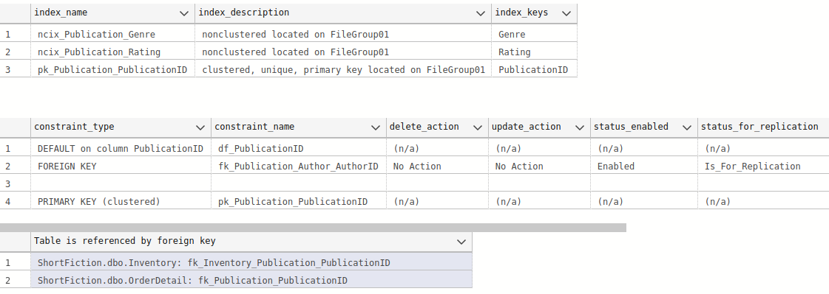
The nonclustered indexes are already extremely fragmented:
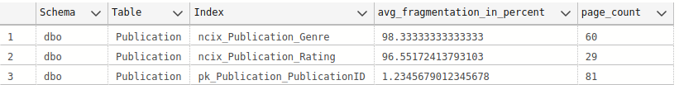
After adding an additional 100 rows, we can see that the primary key also becomes very fragmented:
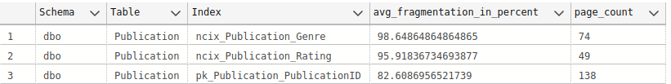
These are the steps taken to improve the functionality of this table. In order to manipulate the primary key, the foreign keys that are referencing it first must be removed. The current primary key must also be removed. Then the new column can be added and the primary key constraint added. Because we are defining this as an identity column, it will be populated on creation. A non-clustered index is then created on the previous primary key, and a covering non-clustered index. The foreign keys can then be re-instated, although these will be altered later to reference the new PubID primary key.
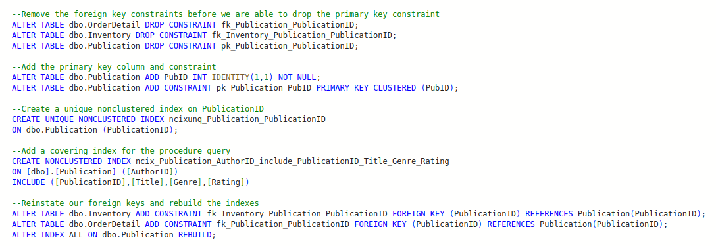
After these updates, the fragmentation is low:
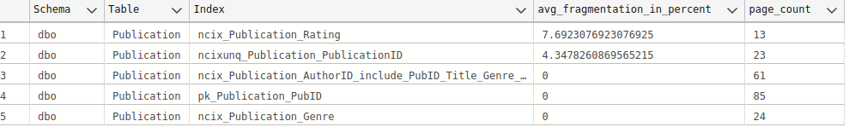
And then an additional 100 rows are added:
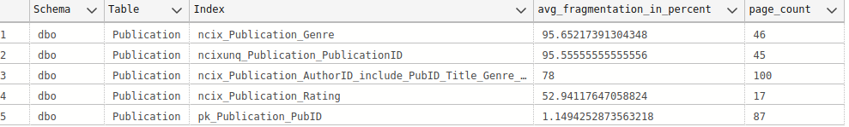
The fragmentation on some of our indexes has increased, so an index maintenance plan will be created to rebuild these nightly.

The final structure of the Publication table:
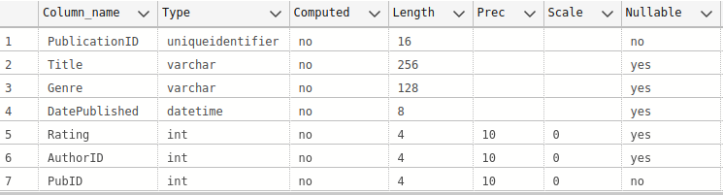
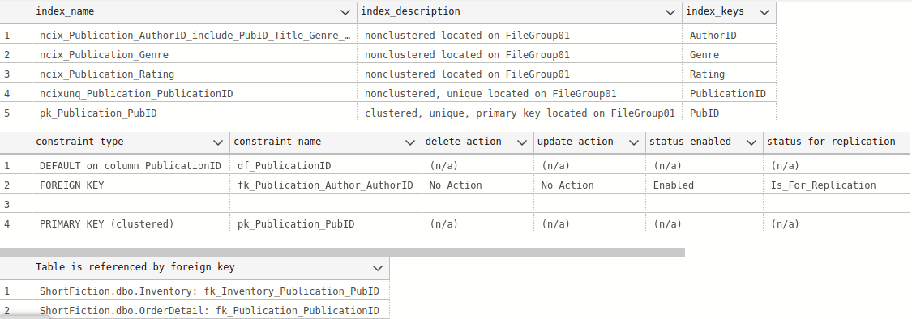

Author
The author table initially appears fairly non-problematic. One thing that can be addressed to help our queries is the fact that the name predicates in many of the queries is compared to both the first and last name, using LIKE clauses and wildcards before and after the name. This is known as a non-sargeable query, and tends to perform badly, because it cannot limit itself to a range lookup, and requires scanning the entire index.
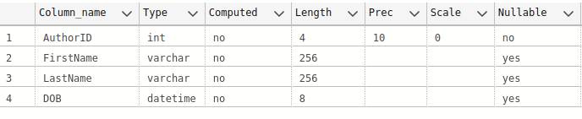
One option is to create a computed column. Since all of the inserts and updates are proceduralized, we can create a FullName column and maintain it in the CRUD procedures, without computational overhead. It would also be great to create a full text index on this table and change the queries to utilize a CONTAINS clause.

The new column is added and populated, and the stored procedures that write to this table are also updated to maintain the new column:
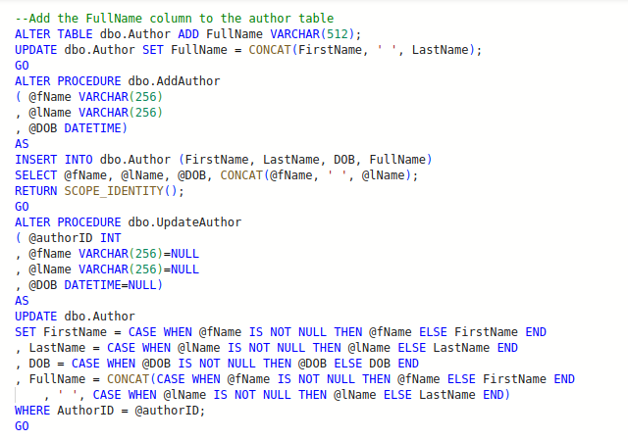
The full-text index is then added:
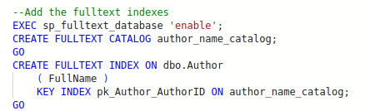
The remaining stored procedures that need to be adjusted are then address. The scripts for all of this, in a re-runnable “do no harm” script, is available in the GitHub repository. Also available are the remaining updates to the OrderDetail table to remove the PublicationID.

Appendix II
System and Tools:
This exercise was performed on a Oracle VM VirtualBox with base memory set at 8 GB, and total storage just over 60 GB. The virtual box is running Ubuntu 22.04, and querying is done through Azure Data Studio. SQL Server Developer edition was installed, along with the full-text index service.
Download for Azure Data Studio: https://azure.microsoft.com/en-us/products/data-studio
Download for Ubuntu 22.04: https://releases.ubuntu.com/jammy/
If you also need to install SSIS, you will need to use 20.04, rather than 22.04. I will note that you cannot create packages on Linux, but you can import and run packages, with some limitations. All restrictions are outlined here: https://learn.microsoft.com/en-us/sql/linux/sql-server-linux-ssis-known-issues?view=sql-server-ver16
Here are instructions for installing SQL Server and Full-Text Search on Ubuntu:
SQL Server: https://learn.microsoft.com/en-us/sql/linux/quickstart-install-connect-ubuntu?view=sql-server-ver16&tabs=ubuntu2004
Full Text: https://learn.microsoft.com/en-us/sql/linux/sql-server-linux-setup-full-text-search?view=sql-server-ver16&tabs=ubuntu
The fragmentation query, available widely on the web, author unknown:
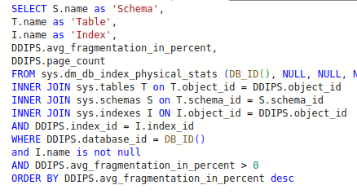
A table predicate can also be added to the where clause to only view fragmentation for a single table:
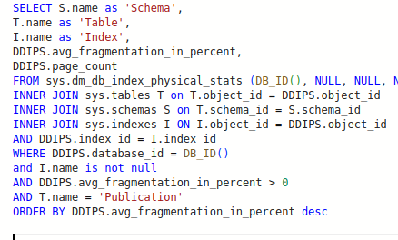

Appendix III
Setting up the ShortFiction database:
1. Run the SetUpShortFictionDB.sql script.
2. Run the population scripts in the following order:
Customer.sql
Author.sql
Publication.sql
Inventory.sql
Order.sql
OrderDetail.sql
3. The updates that I make in the body of this text are available in the files:
SearchPublicationInfoWithInventory.sql
UpdatesToShortFiction.sql
4. Extra rows can be added with the following scripts. The scripts will create a temporary table with 1000 rows, and there is a script at the bottom that will add a random 100 rows to each table:
Publication table rows: #tempPublication.sql
Inventory rows: #tempInventory.sql

