Robotics Second Project 2021

Descriptions of the files
Inside the archive you will find the src folder. Inside the src there is the package mapping_localisation that contains all of our work.
Briefly descriptions of the file in the package:

- Launch: contains the 2 launch file (gmapping.launch and acml_ekf.launch)
- Maps: contains the 2 map files (map.pgm and map.yaml) that we saved using the map_saver node after running gmapping.
- Config: contains the configuration for rviz.
- Generazione: subscribes to vettore_motori and using the gear ratio and the appareant baseline calculates the six linear and angular velocities using formulas from Differential Drive theory and posts the results on the topic twist_stamped as a geometry_msgs of type TwistStamped.
- Mesh: contains the 3D model of Wall-e (just for fun!)
- Robot: contains the .urdf file to implement the .stl file in rviz.

Descriptions of the launch files
We have written 2 launch file:

- gmapping.launch: in this launcher we implemented the gmapping node.
First we did a static tf from the scout/odom frame to the laser frame, because we noticed that the laser data was not aligned with the odometry.
Then we started the gmapping node using the laser scan data and the wheel odometry provided by the manufacturer. We tuned the parameters to get the best result and using the datasheet of the lidar sensor. Then we open rviz to visualize the map while it is generated.
- amcl_ekf.launch: first we did all the static tf needed to use correctly the sensors. Then we implemented the imu_filter_node in order to fuse the data from the mavros/IMU sensor. This node publishes the results on the topic imu/data. Then we start the node robot_localisation_ekf to do the robot localisation using the sensors mounted on the robot, knowing the map that we found with gmapping before. To find the best solution we tried different sensor configurations (see the next paragraph). This node published the result on the topic odometry/filtered and publish the tf on the frame base_link.
After computing the correct odometry using the sensors we can use that with amcl to obtain the best localisation of our robot. So we start the node amcl using the frame base_link (the one generated by ekf) as odometry. At the end we open rviz to visualize the localisation result and the manufacturer odometry moving on the generated map.

Structure of the TF tree
As you can see from the TF tree (in the next page) plotted with the rqt_tf_tree command, we have the following frames:

- “map” is the map frame linked to the map generated with gmapping.
- “/scout/odom” and “/scout/base_link” are the given frames to represent the given odometry.
- “odom” is the static frame generated by robot_localisazion node.
- “base_link” is the frame generated by the robot_localisazion node and it moves as the odometry/filtered computed by ekf_localisation.
- “laser”, “camera_accel_optical_frame” and “camera_gyro_optical_frame” are the frames of the sensors that we have used in amcl+ekf.

We didn’t modify the other frames provided in the bag because it was not needed.

- tf_tree of gmapping.launch:

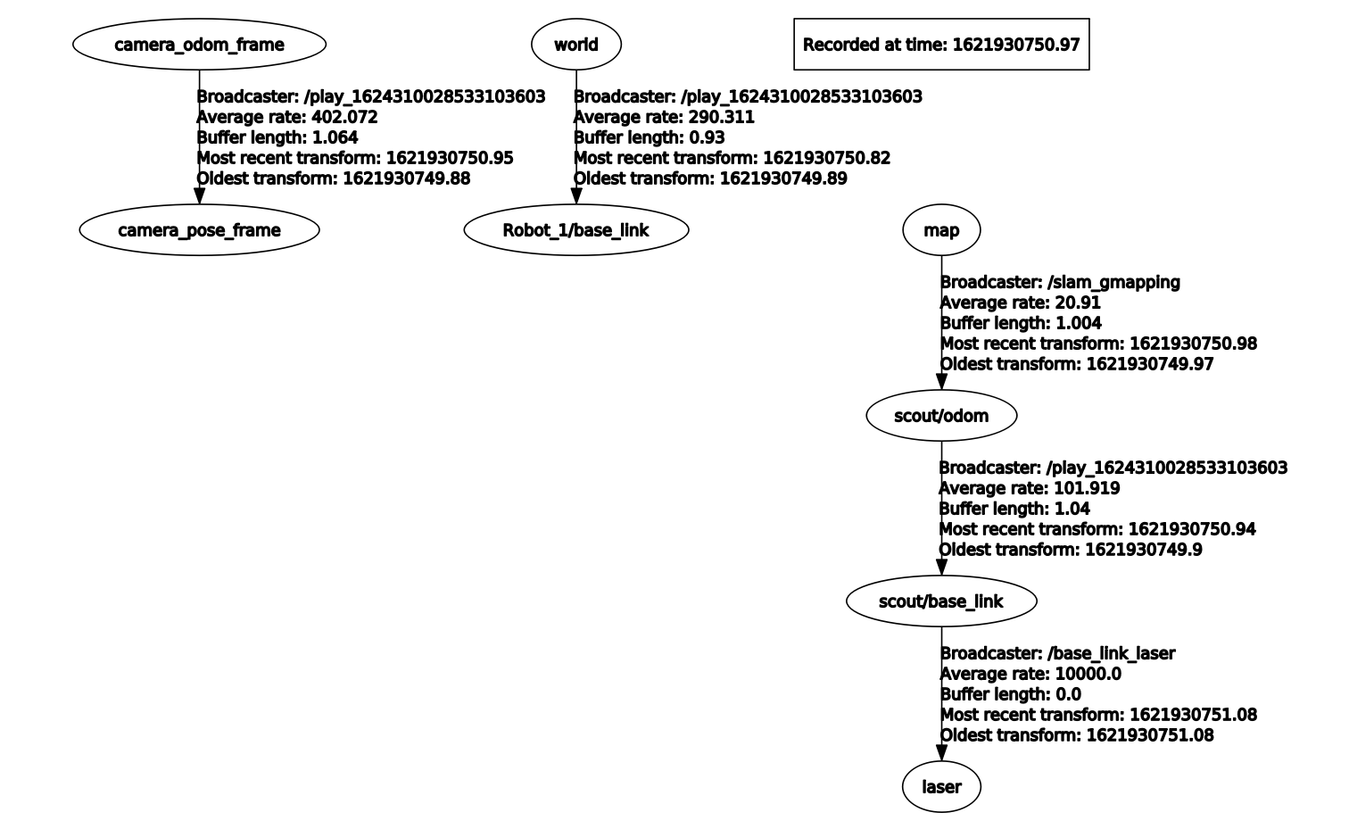

- tf_tree of amcl_ekf.launch:

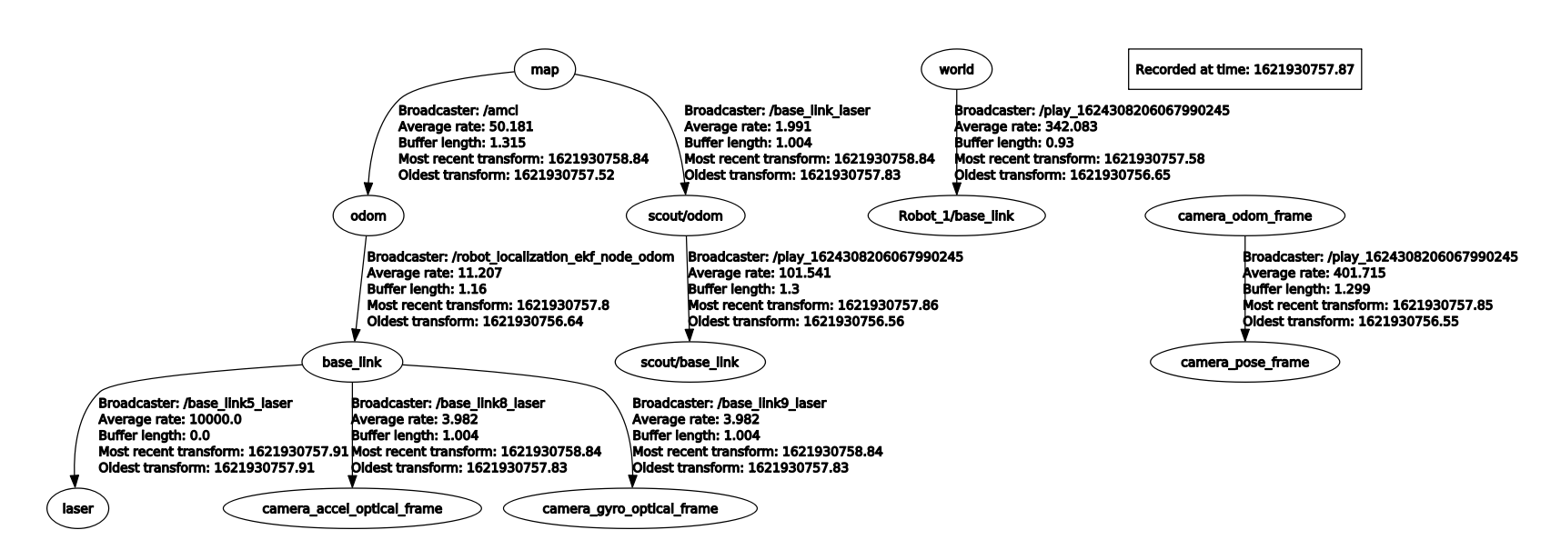

Note: we implemented the 2 static tf from map to odom and scout/odom in order to visualize both the wheels odometry and the computed odometry at the same time in rviz.

How we used the bags

To run gmapping we used the bag 1.bag
To find the right static tf needed we used the bag calib.bag
To test amcl_ekf we used the bags 2.bag and 3.bag

How to start the code

First you need to start the bag (use --clock to use the bag time as simulation time).
- To run the gmapping launcher you have to >>cd src/mapping_localisation/launch and then >>roslaunch gmapping.launch
If you want to save the map you can use the map_saver, but we have already saved it in the maps folder.
- To run amcl+ekf you need to >>roslaunch amcl_ekf.launch

Sensor choice

To get the best result out of the ekf_localisation we tried 3 different sensor configurations:
- only the mavros/imu data and manufacturer odometry
- mavros/imu and camera/accel/sample + manufacturer odometry
- mavros/imu, camera/accel/sample and camera_gyro_sample + manufacturer odometry.
- mavros/imu and camera/gyro/sample + manufacturer odometry.
To appreciate the differences of these configurations we plotted using plotjuggler the x and y pose of the manufacturer odometry and of the 3 configurations. The results are the following:

Configuration 1:

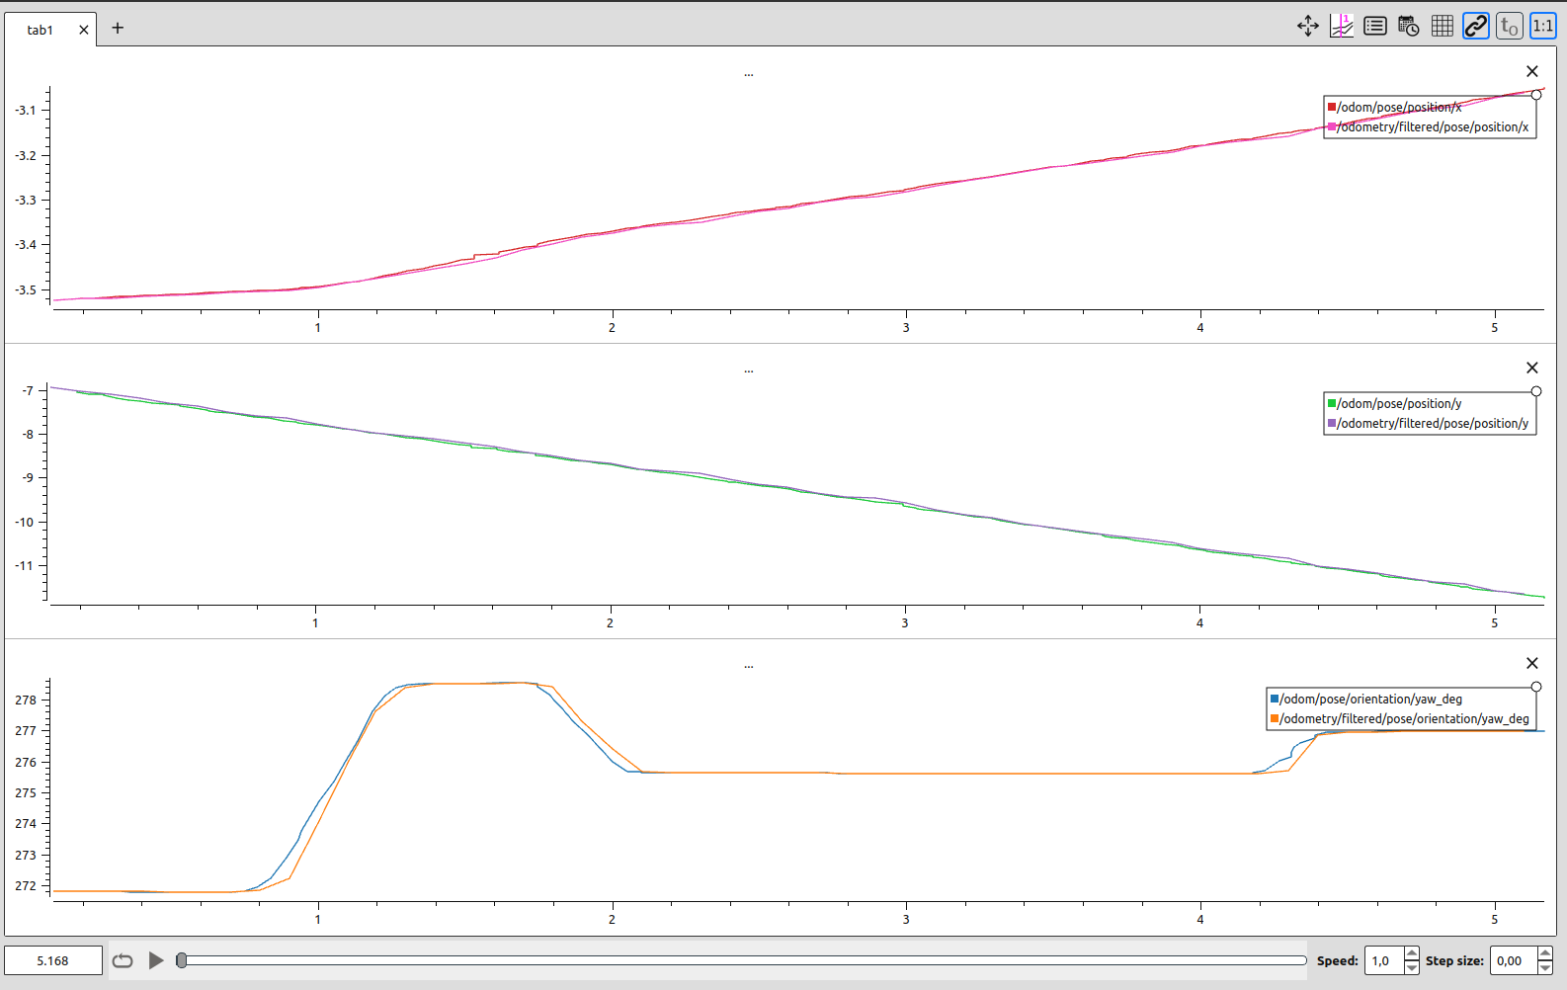

Configuration 2:

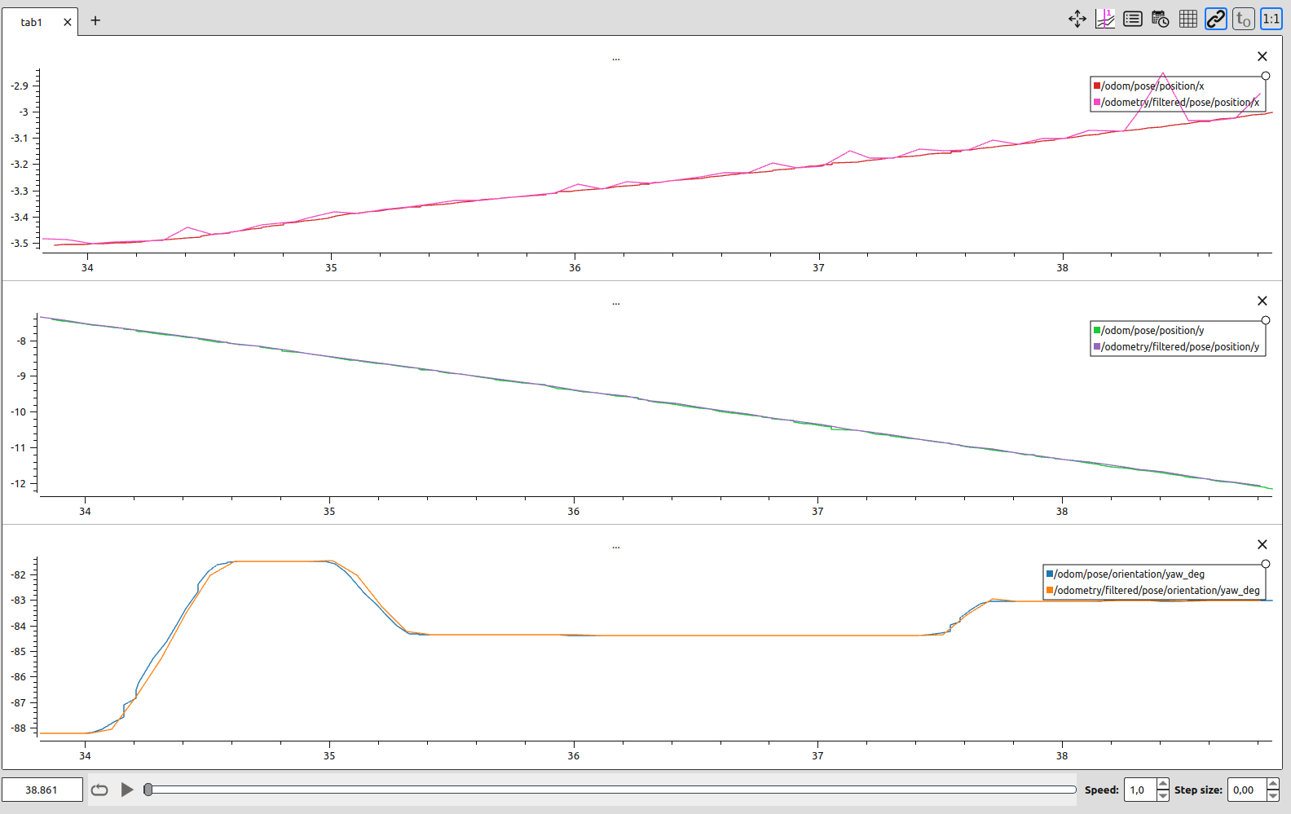

Configuration 3:

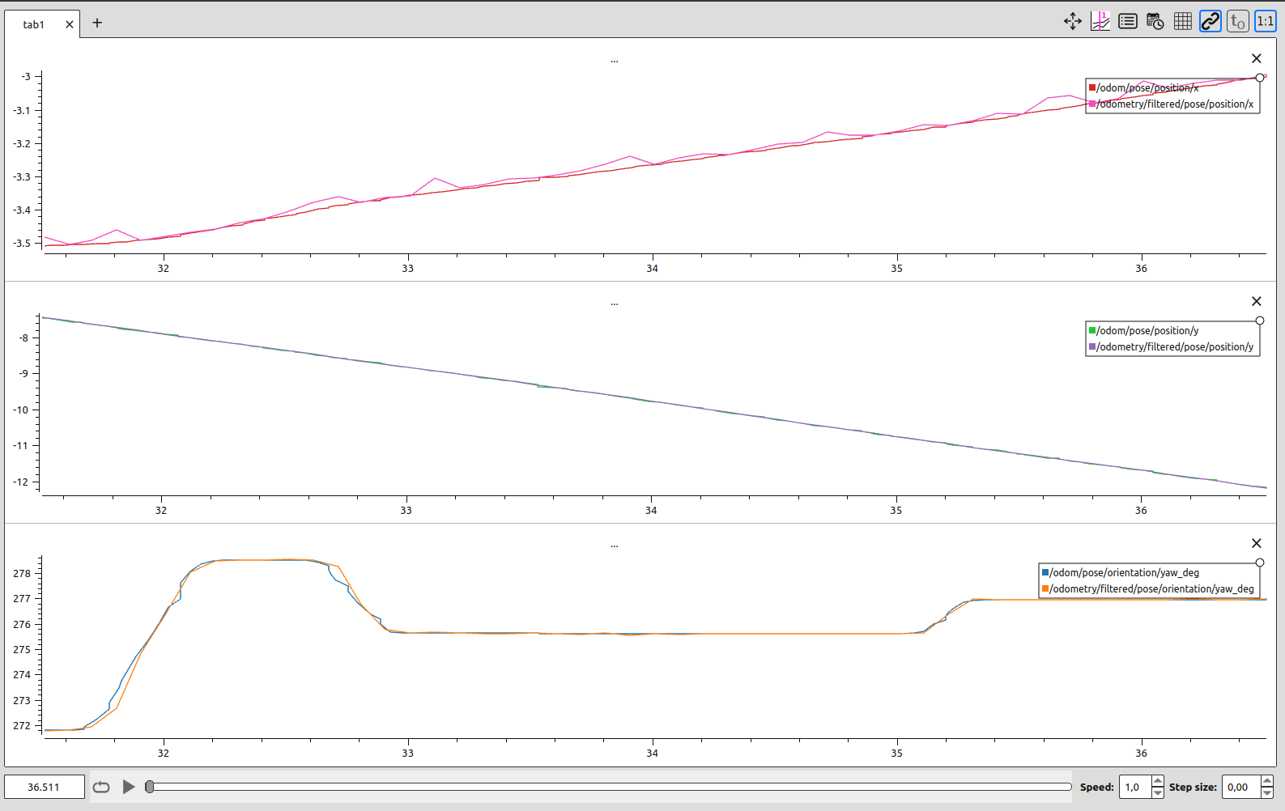

Configuration 4:
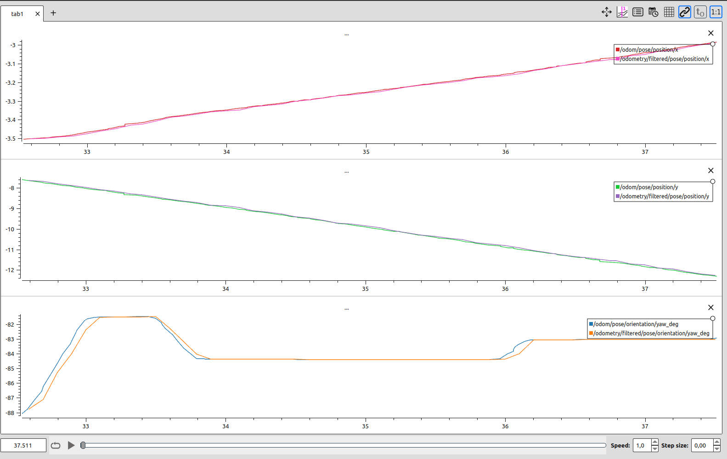

By looking at these plots it’s clear that the sensor camera/accel/sample introduces a lot of noise, so we decided not to use it in ekf. Concerning configuration 1 and 4, they are pretty similar but we decided to use configuration 4. By using 2 sensors instead of 1 we think that we can better approximate the real behaviour of the robot.

