1. Quantization formular part

a). For input, scale is 0.0039, and zero_point is -128.
But input->params.scale is 0.00 in arduino code,
and also 0.00 was received in python code.
So, I used 0.0039 to replace input->params.scale, the received value is still 0.00
it does NOT make a big difference for the predictions.

b). For output, scale is 2.02, and zero_point is -128.
And output->params.scale is indeed 2.02 in both arduino and python code.
But I calculate scale as
S = (r(max)-r(min))/(q(max)/q(min)) = (512-1)/(127-(-128))
=511/255=2.0039
So, I used 2.0039 to replace output->params.scale,
it does NOT make a big difference for the predictions.

c). The length of decoded_bytes, which are the bytes received in python, for y_pred
>> print("Length of received decoded_bytes: ", len(decoded_bytes))
are 4, 5, and 6. Which means sometimes PC end receives 4 bytes,
sometimes 5 bytes, and sometimes 6 bytes.
I did NOT find any relation between the number of bytes PC receives and correct/incorrect preds.

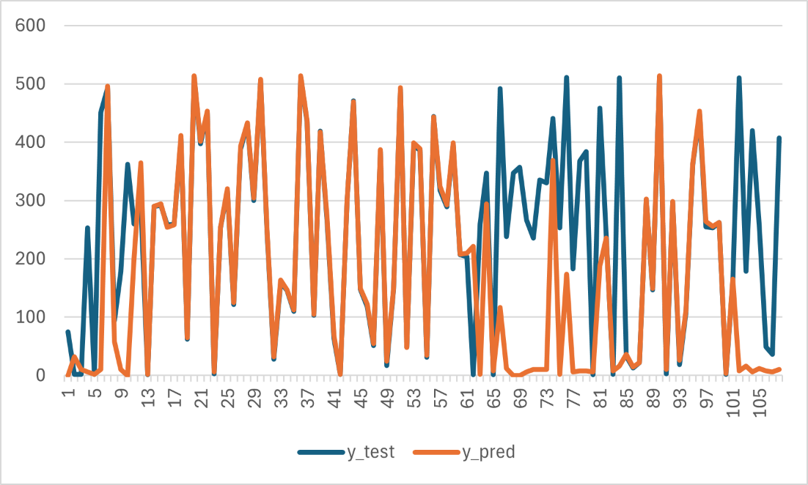

I randomly select some data from the submitted conference paper, I found out there is no patten.

###############################################################
2. Rewrite the serial communication python code for readability.

###############################################################
3. Use different random state for data and label.
I used random state (rs) = 101 at first and then I changed to rs=0 and rerun the training again. Which results in different sets of training, validation, and testing datasets.

Then, save model -> model evaluation -> convert to tflite model -> generate g_model
-> use serial communication code (python and arduino) to generate new y_preds.

Before g_model:
Error evaluation for tf_model_tar1, mae, mse, rmse, r2: , 0.7911, 1.0065, 1.0032, 1.0000
Error evaluation for tflite_no_quan_model_tar1, mae, mse, rmse, r2: , 0.7911, 1.0065, 1.0032, 1.0000
Error evaluation for tflite_model_tar1, mae, mse, rmse, r2: , 2.0390, 6.6063, 2.5703, 0.9997

The newly generated g_model is the same size of the old one (TCN for tar1), 5080.
I run the scripts three times:
- The first time I made a mistake, instead of pickling y_test_reshaped, I pickled y_train_reshaped.
- So, I pickled again for the y_test_reshaped. Then I tried to run again, however, I found out that this time, lots of y_preds values are -2.02, which I think it was a little different from the first time when I run the scripts.
- So, I decided to run another time. Surprisingly, I found out the results for the second two times are different.
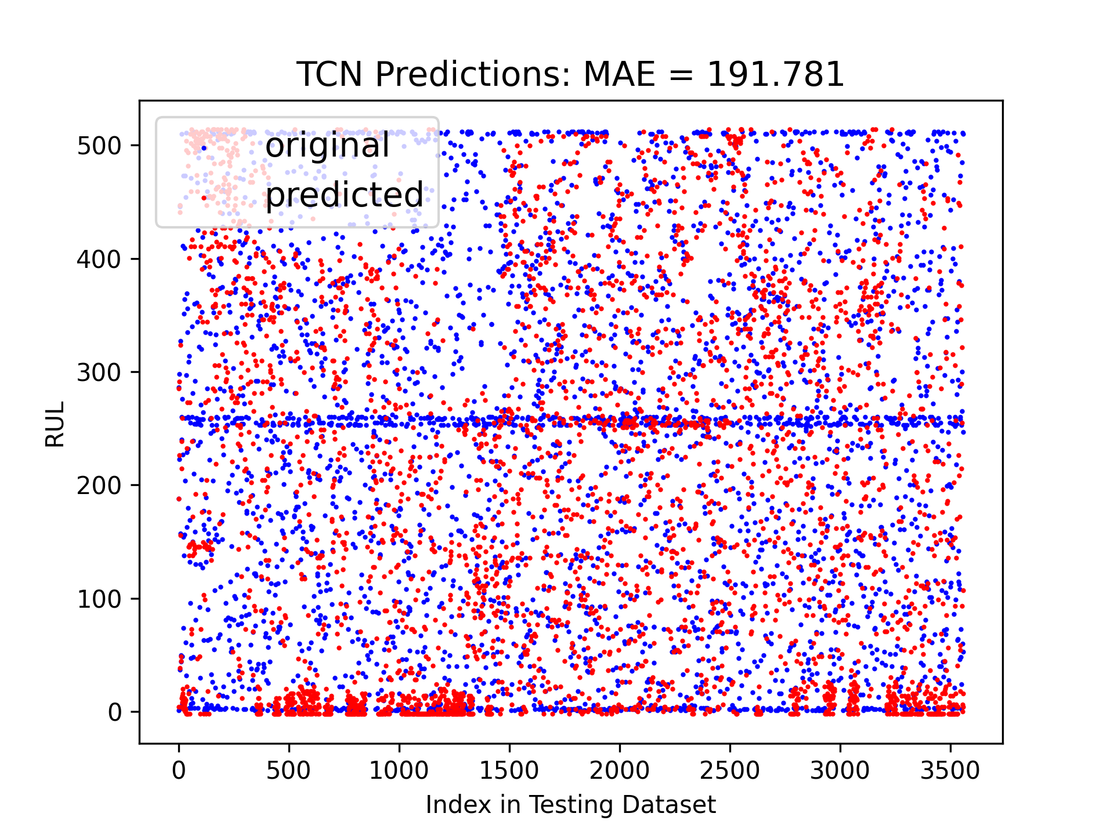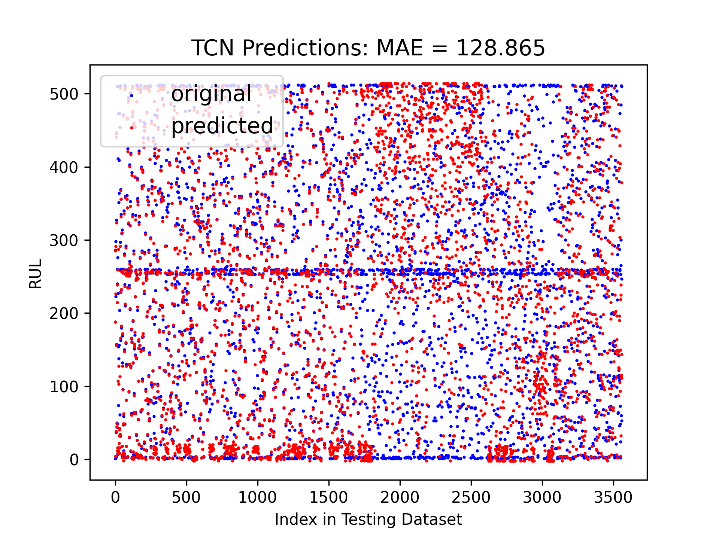
##############################################################
4. Try fix point data in Arduino code.
From 1. C and 3, I want to try feed the Arduino code (g_model) a fix point data (wrong when received in PC end using python script).
But print the y_pred in arduino serial monitor, which means without serial communication between the board and PC.
See if the value is still bad.

##############################################################
5. Using Linux system to redo the process.

Install tensorflow GPU
Currently, GPU driver version 550, CUDA 12.2
When I tried to use GPU in tensorflow, it has some compatibility errors with some libraries (11.2).
I think I need to install CUDA 11.2, which is compatible with GPU driver 460, and I did reinstalled CUDA 11.2 and I use >> sudo rm -r for the CUDA 12.2 folder, but
>> nvidia-smi still shows that my CUDA is 12.2.
TODO:
So, I think I need to uninstall the GPU driver version to 460.

Stack overflow: Predicting Multiple Outputs one after another in Tensorflow
Medium: Custom models with TensorFlow (Part-1)->Multi-output model: https://medium.com/@sthanikamsanthosh1994/custom-models-with-tensorflow-part-1-multi-output-model-c01a78e67d47
TensorFlow, sequential API and function API:
https://www.tensorflow.org/guide/keras/functional_api#models_with_multiple_inputs_and_outputs

YouTube: TinyML: Getting Started with STM32 X-CUBE-AI | Digi-Key Electronics
https://www.youtube.com/watch?v=crJcDqIUbP4

YouTube: TinyML: Getting Started with TensorFlow Lite for Microcontrollers | Digi-Key Electronics
https://www.youtube.com/watch?v=gDFWCxrJruQ

YouTube: STM32Cube.AI workshop - 9 STM32CubeMX and X-Cube-AI lab
https://www.youtube.com/watch?v=k8AAr84z27s

STM32 model zoo related:
YouTube: https://www.youtube.com/watch?v=yuSVz3x9LzE&list=PLnMKNibPkDnG9IC5Nl9vJg1CKMAO1kODW&index=5
Github:
https://github.com/STMicroelectronics/stm32ai-modelzoo

b'C:\\Users\\Oliver\\Documents\\Arduino\\libraries\\Arduino_TensorFlowLite\\src\\tensorflow\\lite\\micro\\kernels\\reshape.cpp:81 num_input_elements != num_output_elements (320 != 16)\r\n'

https://github.com/tensorflow/tensorflow/issues/58143

May 1, 2024.
Correct g_model:
CNN is in model_revised folder, TCN is in model_test folder (tar2 folder, using regular conv layers)

May 3, 2024
Untraceable function when saving the TensorFlow model:
tensorflow warning - Found untraced functions such as lstm_cell_6_layer_call_and_return_conditional_losses

One mistake:
When saving X_test_reshaped, save two of them for tar1 and tar2 since the smoothing numbers are different for the X data!

