Book Rating Predictions
Abdifatah OSMAN FARAH
BELGHAZI SEDDIK
GALVEZ VINUEZA Maha Nathalie
Vincent PINNEAU
Machine Learning with Python Labs

Definition

Project Overview
The Book Rating Prediction Model project aims to predict book ratings using a dataset from Goodreads. Multiple machine learning models, including regression and classification, as well as Artificial Neural Networks (ANN), will be employed. The project seeks to enhance user decision-making regarding book selections by providing accurate predictions.

Problem Statement

Develop a book rating prediction model using a dataset sourced from Goodreads. The objective is to accurately forecast the ratings of books based on various attributes such as title, author, publication date, and more. The model should employ a combination of regression and classification techniques, including Artificial Neural Networks (ANN), to deliver reliable predictions.

Section I: Data Analysis
Preprocessing:
Rename ‘ num pages’ column
Complete missing values based on information from Goodreads
Get rid of observations that aren’t audiobooks and have 0 pages or that have a ‘NOT A BOOK’ value
Convert all values to lowercase and check for duplicates
Fix the language column
Creation of new variables
Encoding categorical variables

Exploratory Analysis:
Check variables distributions
Check for Pearson’s correlation among variables
Find and replace outliers with the median

Feature Selection:
Created Features:
Audiobook: 1 or 0 depending on the nature of the book
Author_popularity: Amount of times an author is found in the dataset
Publisher_popularity: Amount of times an author is found in the dataset
Year: Publication year of the book
Title_length: Number or character in the title
Author_count: Amount of writers per book

Selected Features:
Author
Publisher
Num_pages
title
ratings_count
title_length
publisher_popularity
text_reviews_count
year
author_popularity
author_count
language_code

Section II: Model Training
We decided to try two approaches: regression and classification

Classification

To begin, a new column 'class' was created in the DataFrame to categorize average ratings into 'BAD', 'Medium', and 'Good' based on predefined intervals. Using the Pycaret library multiple models were compared in order to choose the one with the best performance based on metrics such as accuracy, precision, recall, and F1 score.

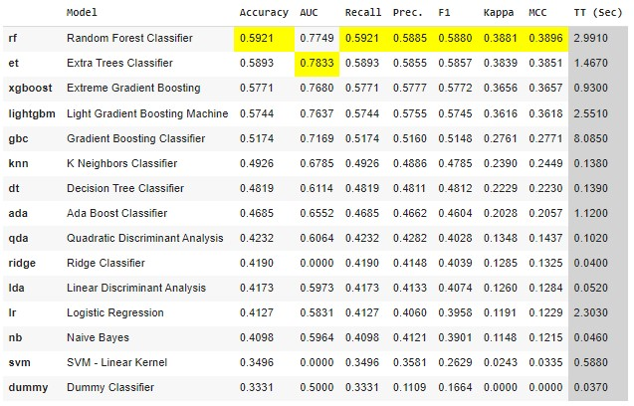
Finally, we use the tune_model() method to tune the hyperparameters of the best performing model which is Random Forest Classifier:
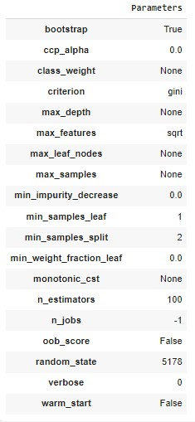

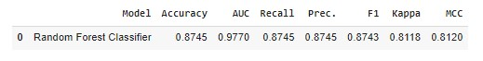

Interpretation:
Accuracy: Random Forest has the highest accuracy (0.875), indicating that it correctly predicts the target values more often than LightGBoostingMachine and Gradient Boosting .
F1 Score: Random Forest also has the highest F1 score (0.87), which considers both precision and recall.
Recall: Random Forest has the highest recall (0.874), indicating that it captures a higher proportion of true positives.
Precision: Random Forest has a precision of (0.87), indicating that it has a higher proportion of true positives among predicted positives. Random Forest appears to be the best-performing model

Feature Importance :

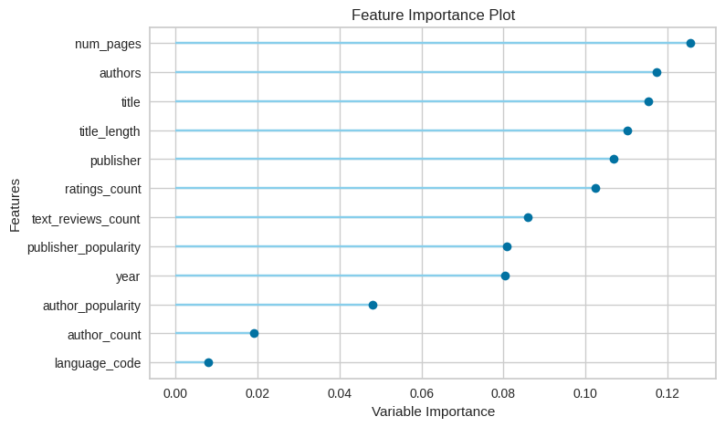

Regression
After preprocessing the data, in order to find the best-performing regression model the Pycaret library was used. It compares multiple models and returns the most fitting one. So, based on regression metrics such as MAPE, MAE and RSME, we decided to use the Light Gradient Boosting Machine model, and based on the evaluation of the model, we decided to keep the features that were relevant according to feature importance.

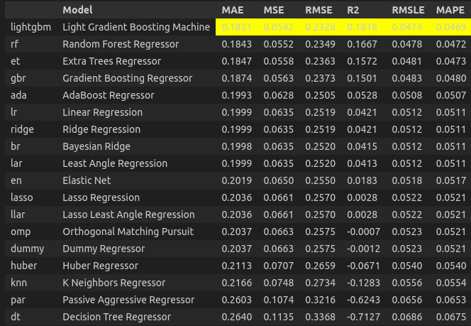
Model Comparison:

Feature Importance
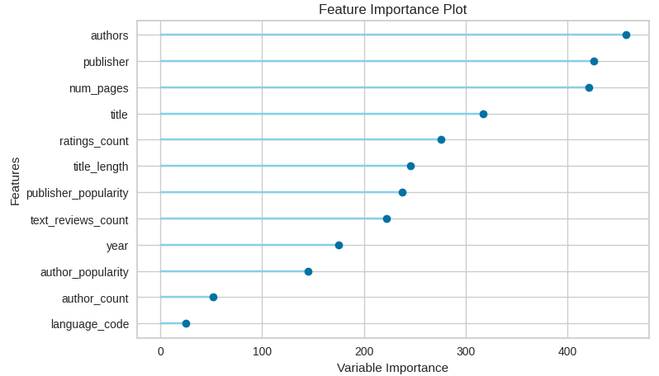

Interpretation of Results
MAE: average absolute difference between the predicted values and the actual values. In this case, the average absolute error is 0.1831.
RMSE: square root of the mean squared error, providing an interpretable measure of the average error in the original units of the data. In this case, here it is 0.2328.
MAPE: mean absolute percentage difference between predicted and actual values. It is commonly used to assess the accuracy of a forecasting method. Here it is 0.0469.
These metrics suggest a rather good performance of the model. Nevertheless, the R2 is low, which indicates that the model doesn’t explained a big share of the variance. This is not uncommon when using models such as LightGBM, that are more complex than a regular linear regression, especially when the relationship between the variables and the target is not well approximated by a linear model.

Section III: Conclusion

The aim of this project was to use data retrieved from the website Goodreads, to train a model that predicts a book's rating. The main difficulty of the project came from the average ratings we had. Indeed, the ratings, that could go from 1 to 5, were mainly concentrated around 4, with our data analysis showing a mean of 3.94 and a standard deviation of 0.29.
To try to help our model predict these small variations, we cleaned, modified, and completed the initial data we had as much as possible. This was done for example by correcting the number of pages for certain books that were reported as having no pages, even though they were not audio books, or also by counting books in English and in American English as being in the same language. The second technique we used was to try to obtain new parameters for our model by using the initial parameters we had. This allowed us to have additional information such as the popularity of authors or publishers by counting how many times each unique value appeared in our dataset.
For the choice of models we decided to test two different directions, one using our dependent variable as a categorical variable, putting the ratings into three different categories (bad, medium, good), and another one where we kept the ratings as a continuous variable. As expected, the classification model has a better accuracy because it is easier to predict correctly a range than a precise decimal number, but it does not necessarily mean that the model where we used a continuous dependent variable is worse. In fact, because the continuous model has a mean absolute error inferior to 0.20, a mean squared error inferior to 0.06 and a root mean squared error inferior to 0.25, we can say that even though it does not predict the exact average rating, it still allows us to have a better estimation of the range where the real rating will be, than our categorical model that uses large categories.
In conclusion, we can say that our models works correctly to predict the average quality of a book. If we wanted to fine-tune our models even more, we would have to add in some additional data coming from other datasets. One area that could be explored is adding, for example, a dataset that contains all the comments left by the users. This would allow us to use Natural Language Processing (NLP) techniques such as Sentiment Analysis, that would categorize the comments as negative, neutral or positive, and give us an additional parameter that should strongly influence the prediction of the average rating.

