COMP-4220-Agile Software Development

Assignment 4-Sprint1

Group Name:

AgileF20EX

Student Name:Heng Wei

ID:104952078

Date:2020.11.9

Individual Report of Lorry Wei

This individual report summary all the works that has been done by Lorry Wei. Firstly, as of the Scrum Master, the necessary step is to getting the groups member organized and allocating the appropriate tasks for everyone. To practice the pair programming, all team members has been split to pairs to start working on unique features that has been implemented in the BookStore System. For the putting together part of the assignment, The requisite of me is to helping other team members to getting the connection to the database and ensures that the project is editable for everyone.

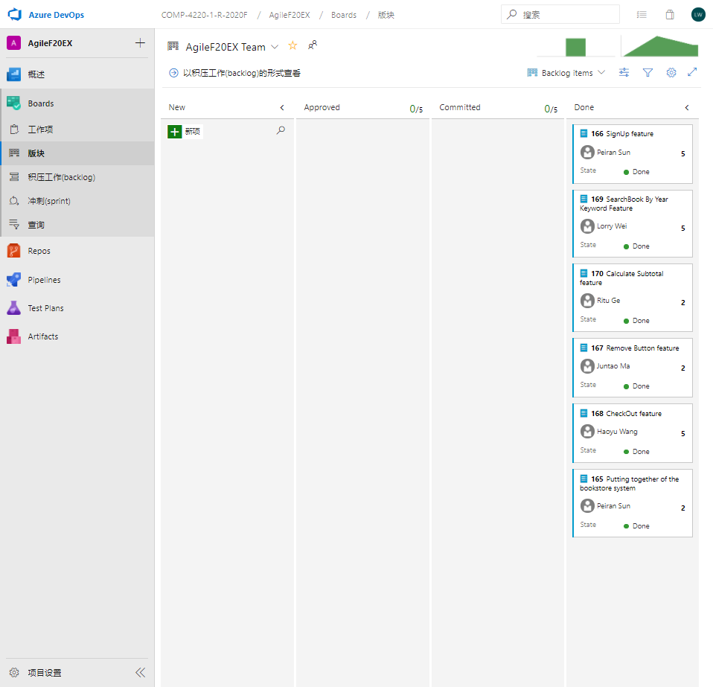

There have been eight features in total that has been decided and approved by our teams. Since our group have 10 people working on this system, we split to 5 groups to practice pair programming. The pair groups that I assigned myself is with Yang Wang, and Qingyi Ji.

We were working on the Part one of the features that including 1. Locate a book, 2. Get reference to a book,3. get detailed info of a book and 4. Search relevant books. Mostly of our implement has been go through the testing phase and works as expected.

To get the Search features added in this bookstore system, the necessary steps and goals of our groups are 1. Design the UI, 2.implement the search statement inside the code and 3. Testing connection to the database. 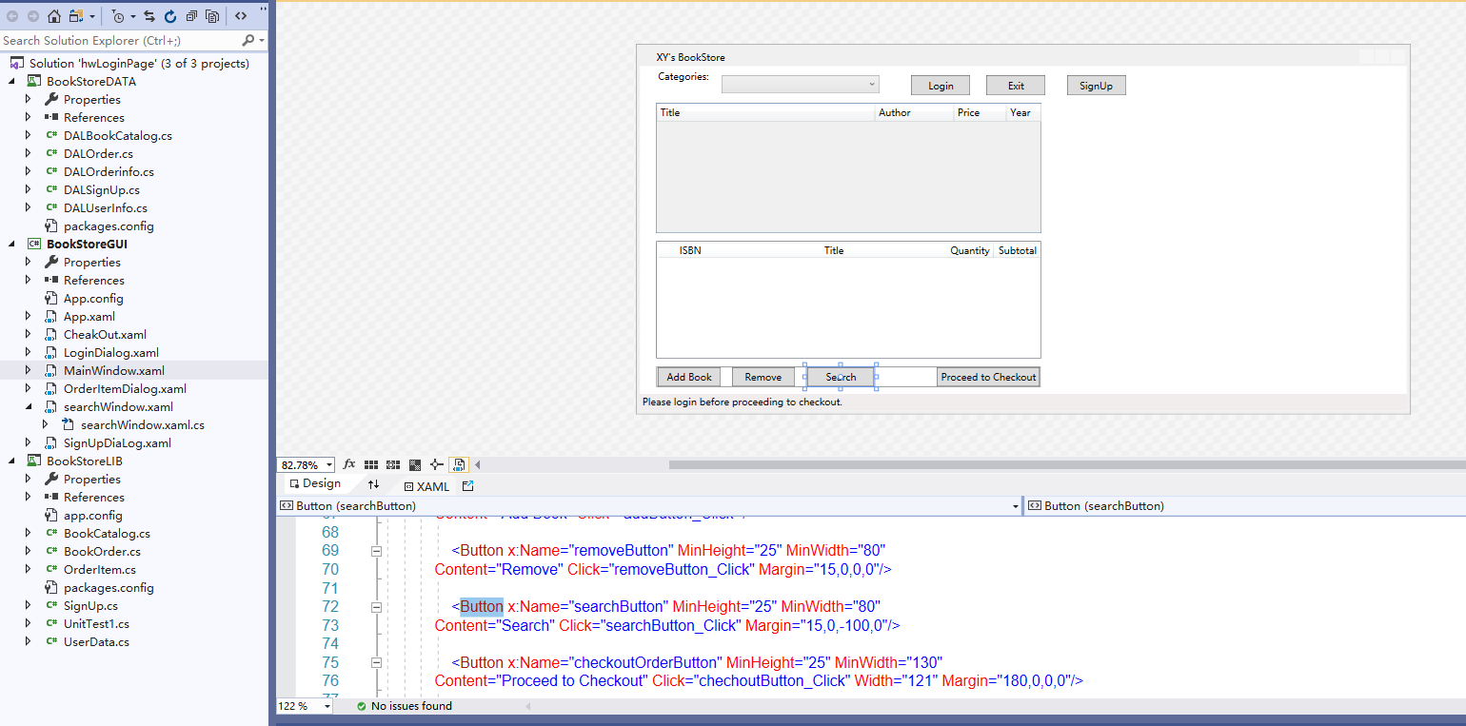

The method of our group came up with is to using the Data table method as the same method in the main window view. And inside the search function, the connection has been implemented to execute the command that retreat all the information that the search features specified. There are four buttons in the search window view to state different method of function achieved. The difference between search buttons is that the SQL execute command. Therefore, we managed to keep a data Table of each method and get the sorted list to the search view window. And all features included in the part one has gone through series of test to ensure that the user would able to search any books that inside this system without logging in with their credentials. And that is all the features that we implemented in part1.

One of another functions that I helped with is the Update Personal information features. So, there is an update Account button on the main window to letting the user update their accounts’ password. 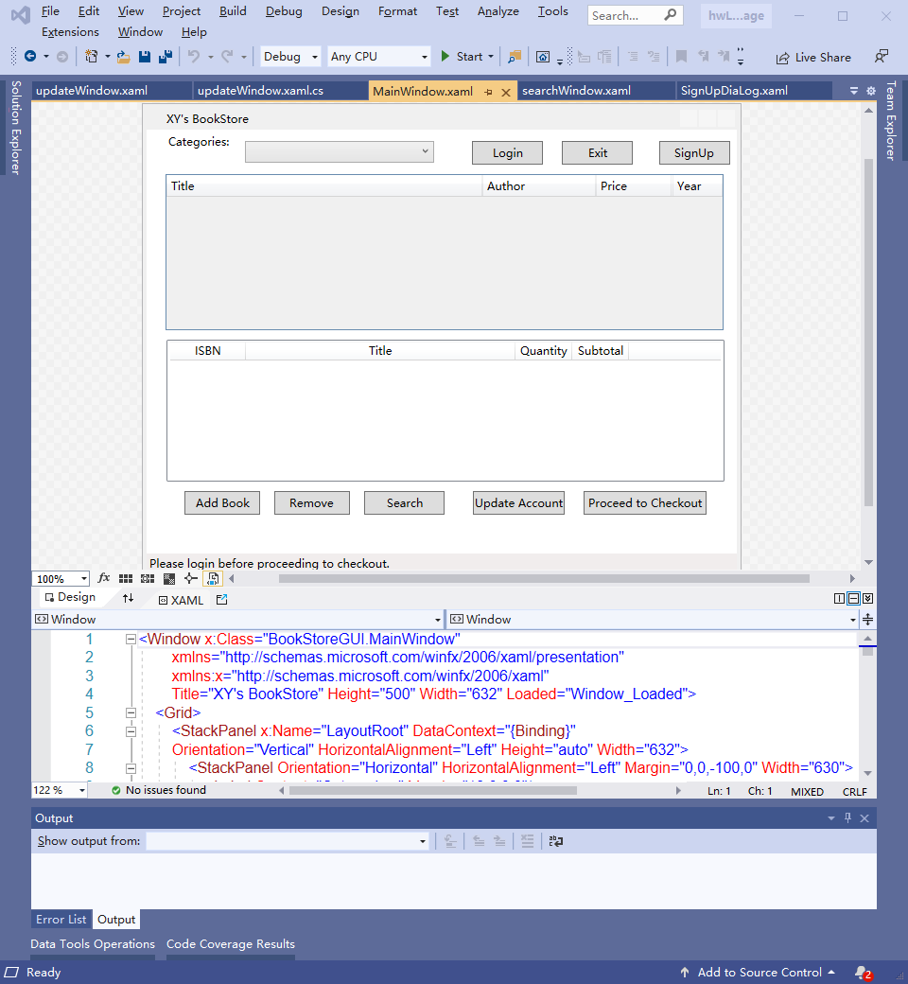

The User Interface was originally designed by my teammates Baitong, I helped with the inner implementation both in the main window and inside the update function. Therefore basically that after the user logging to the account, the button became available to the user allowing them to input the new password with their userID, It then calls each method inside different tiers to finally connection to the database, during the last tier. The Sql command has been execute and update the user’s password with the new credentials.

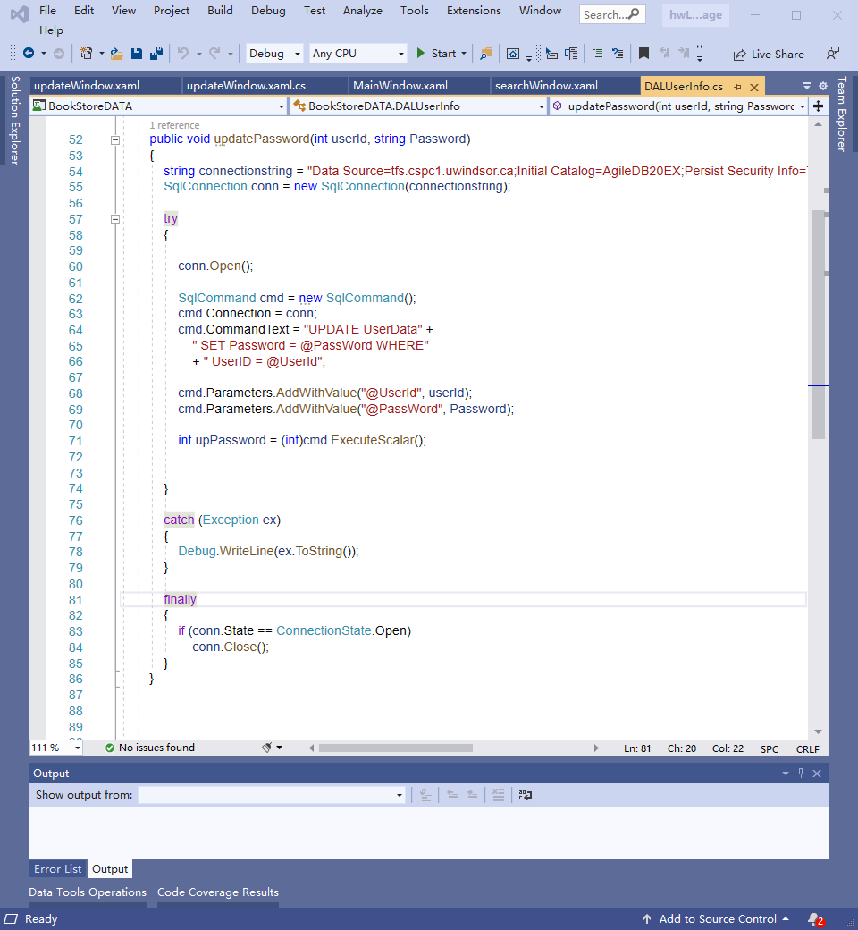

The following testing case is indicating the valid book information that has been successfully executed by the command of database.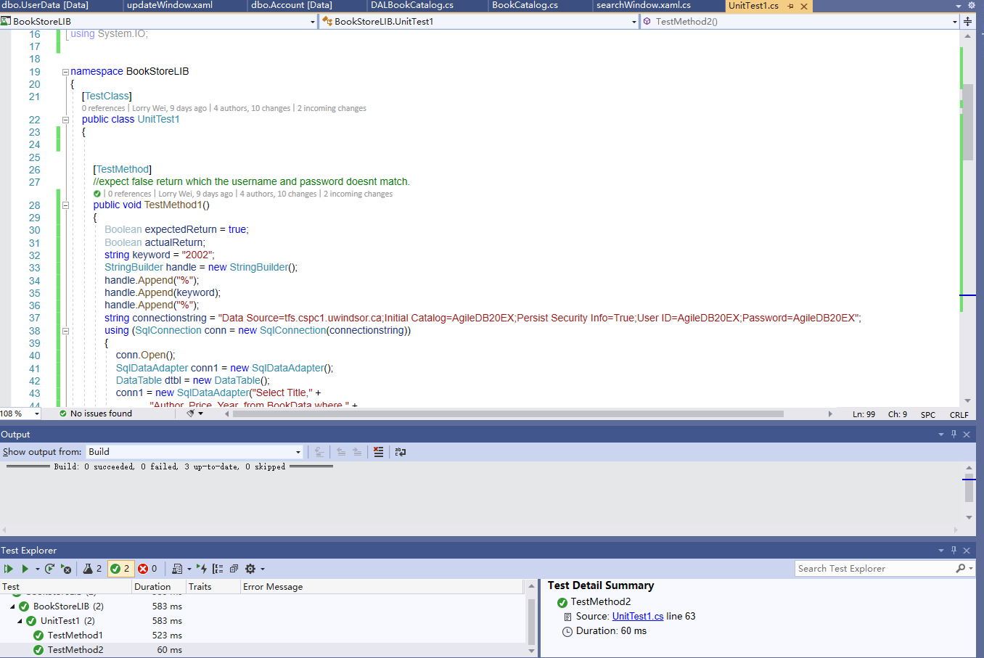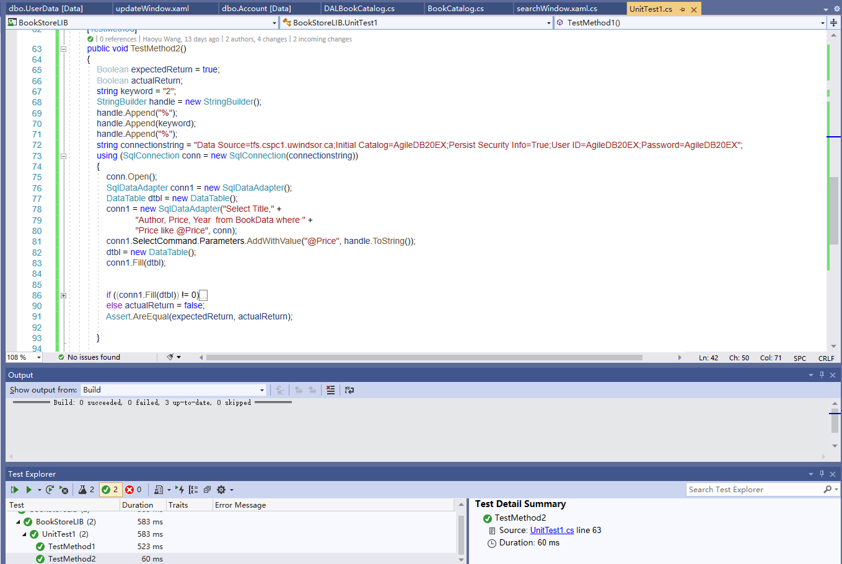

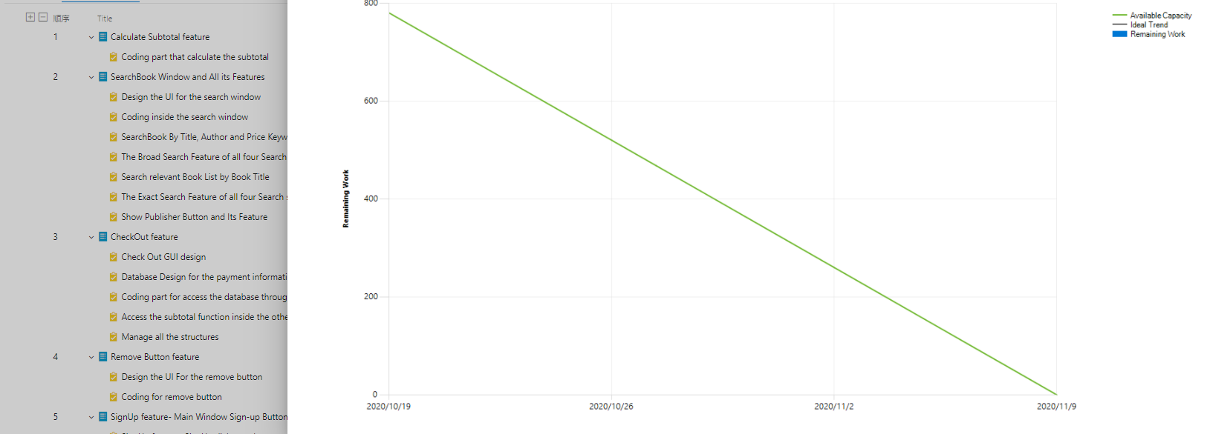

The following burndown chart is our team effort related to the features.