CMSC203 Assignment 5 Implementation (Documentation)

Class: CMSC203 CRN 30295
Program: Assignment #5
Instructor: Professor Grigoriy Grinberg
Summary of Description: This program processes store sales data stored in a 2D double array. It reads space-separated daily sales figures from a text file (one department per line, with variable column counts), then computes totals, averages, row/column sums, and highest/lowest values via static utility methods. Results are displayed in a JavaFX GUI and can be saved to a summary output file. Classes implemented: SalesDataUtility (static math utilities), SalesFileIO (file I/O), SalesAppDriver (console driver), and SalesAppFX (JavaFX GUI, provided). A JUnit test class validates all utility methods against known ragged arrays.
Due Date: 04/20/2026
Integrity Pledge: I pledge that I have completed the programming assignment independently.
I have not copied the code from a student or any source.

Part 1: UML Class Diagram:
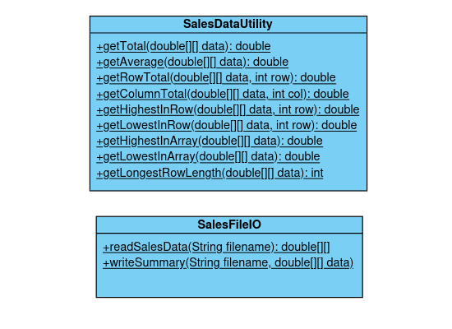

Part 2: Comprehensive Test Plan
A good test plan should be comprehensive. This means you should have a few test cases that test when the input is in and out of range, division by 0, incorrect Data type, etc. (Provide valid and invalid input)
Cases | Input | Expected Output | Actual Output | Did Test Pass?
Case 1 | Load salesdata.txt (3 rows, ragged) via Load & Process button | Total: 1322.10, Avg: 146.90, Highest: 300.00, Lowest: 50.25. Row 0: 451.25, Row 1: 170.00, Row 2: 700.85 | Total: 1322.10, Avg: 146.90, Highest: 300.00, Lowest: 50.25. Row 0: 451.25, Row 1: 170.00, Row 2: 700.85 | Yes
Case 2 | Enter a non-existent file name salesdata2.txt | GUI displays: ERROR: Input file not found. | ERROR: Input file not found. message displayed | Yes
Case 3 | Load data then click Save Summary to write sales_summary.txt | sales_summary.txt created with Total, Average, Row totals, Column totals | Output file generated with correct values matching expected | Yes

Part 3: Screenshots
- One screenshot of the application running from the command prompt line.
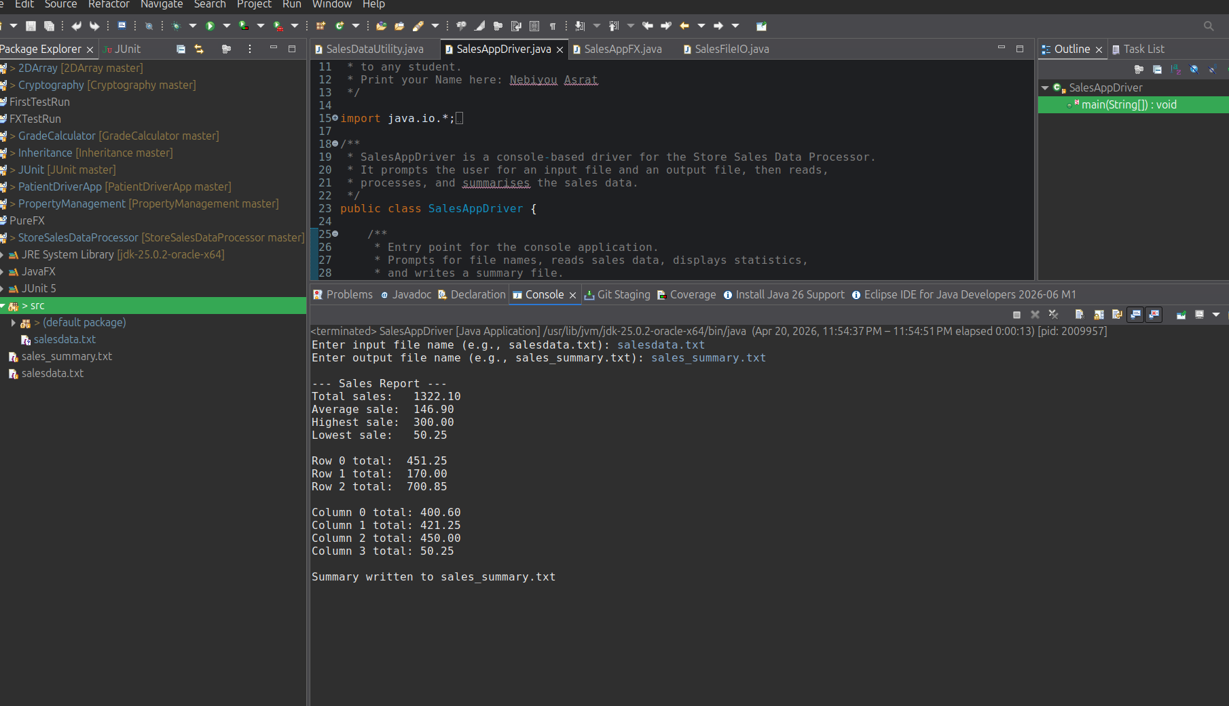
- Screenshots related to the Test Plan:
Case 1
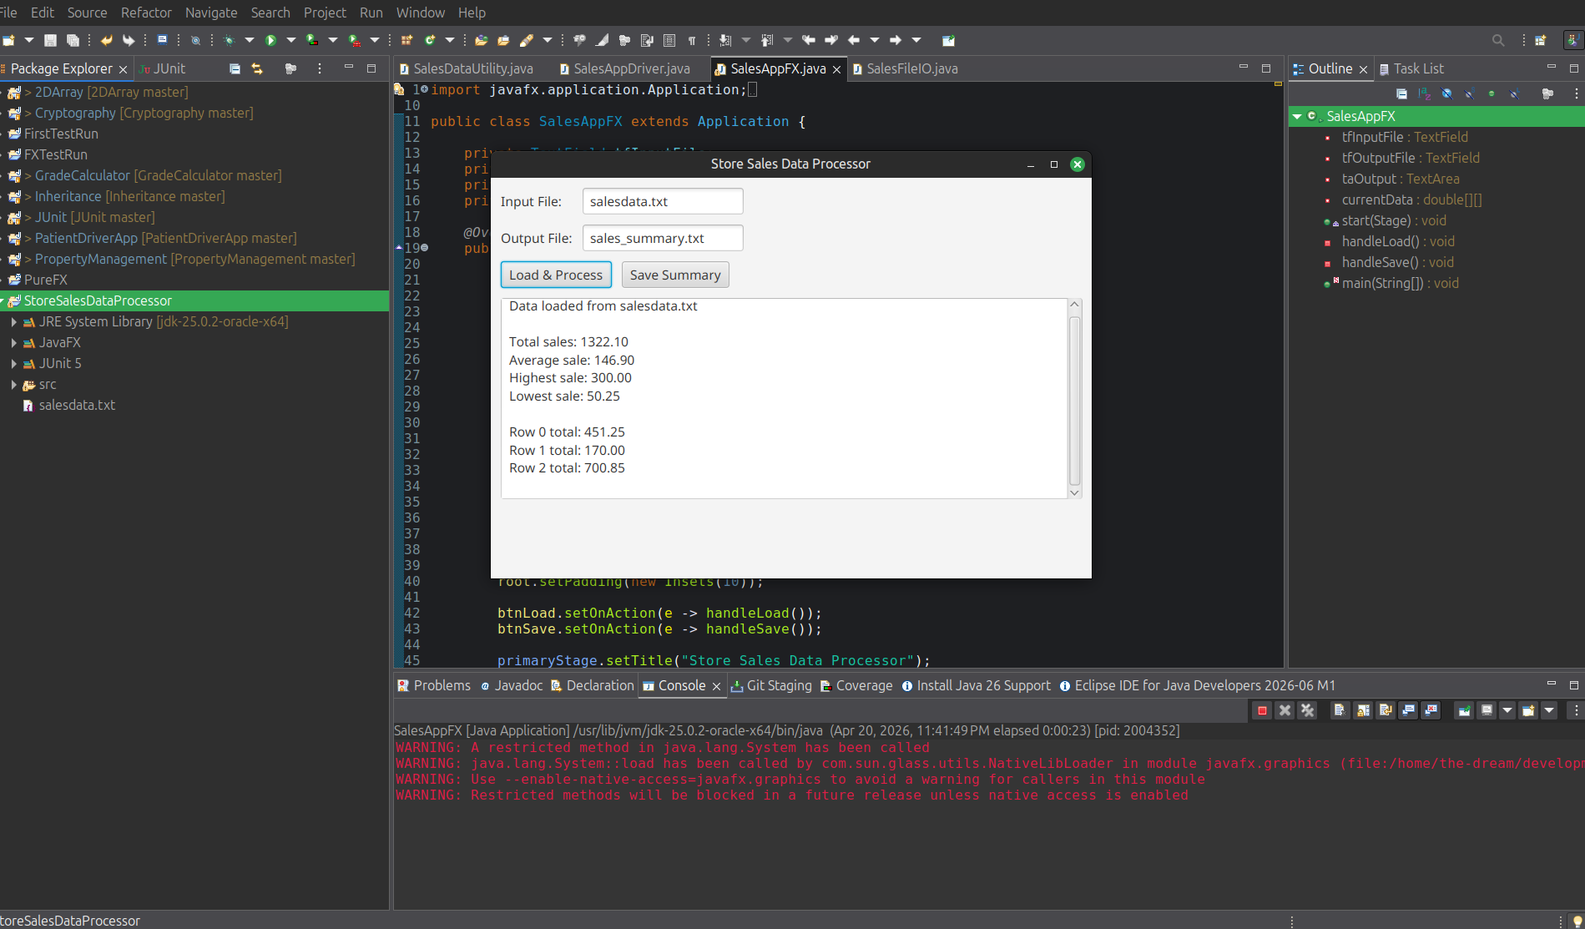
Case 2
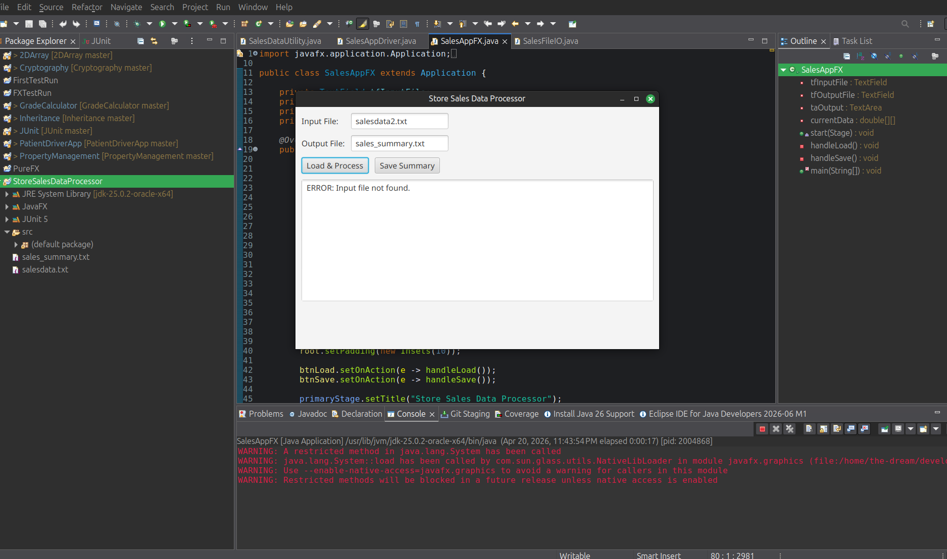

Case 3
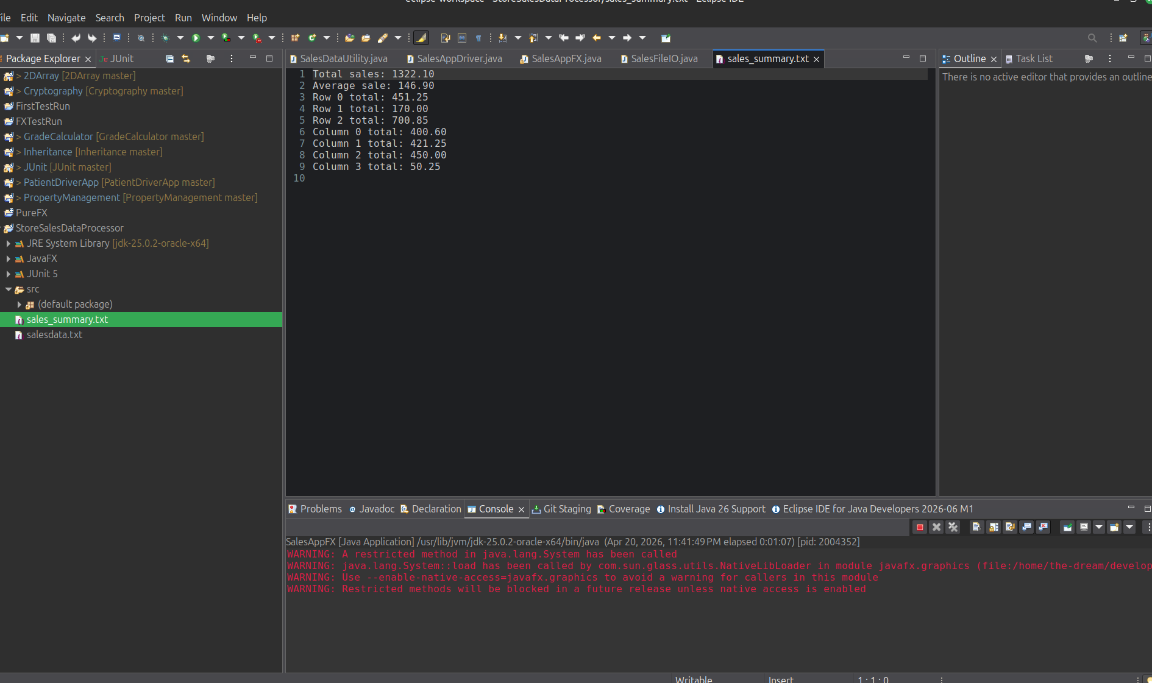

- Screenshot of Assignment5_JavaFiles.zip in your GitHub repository
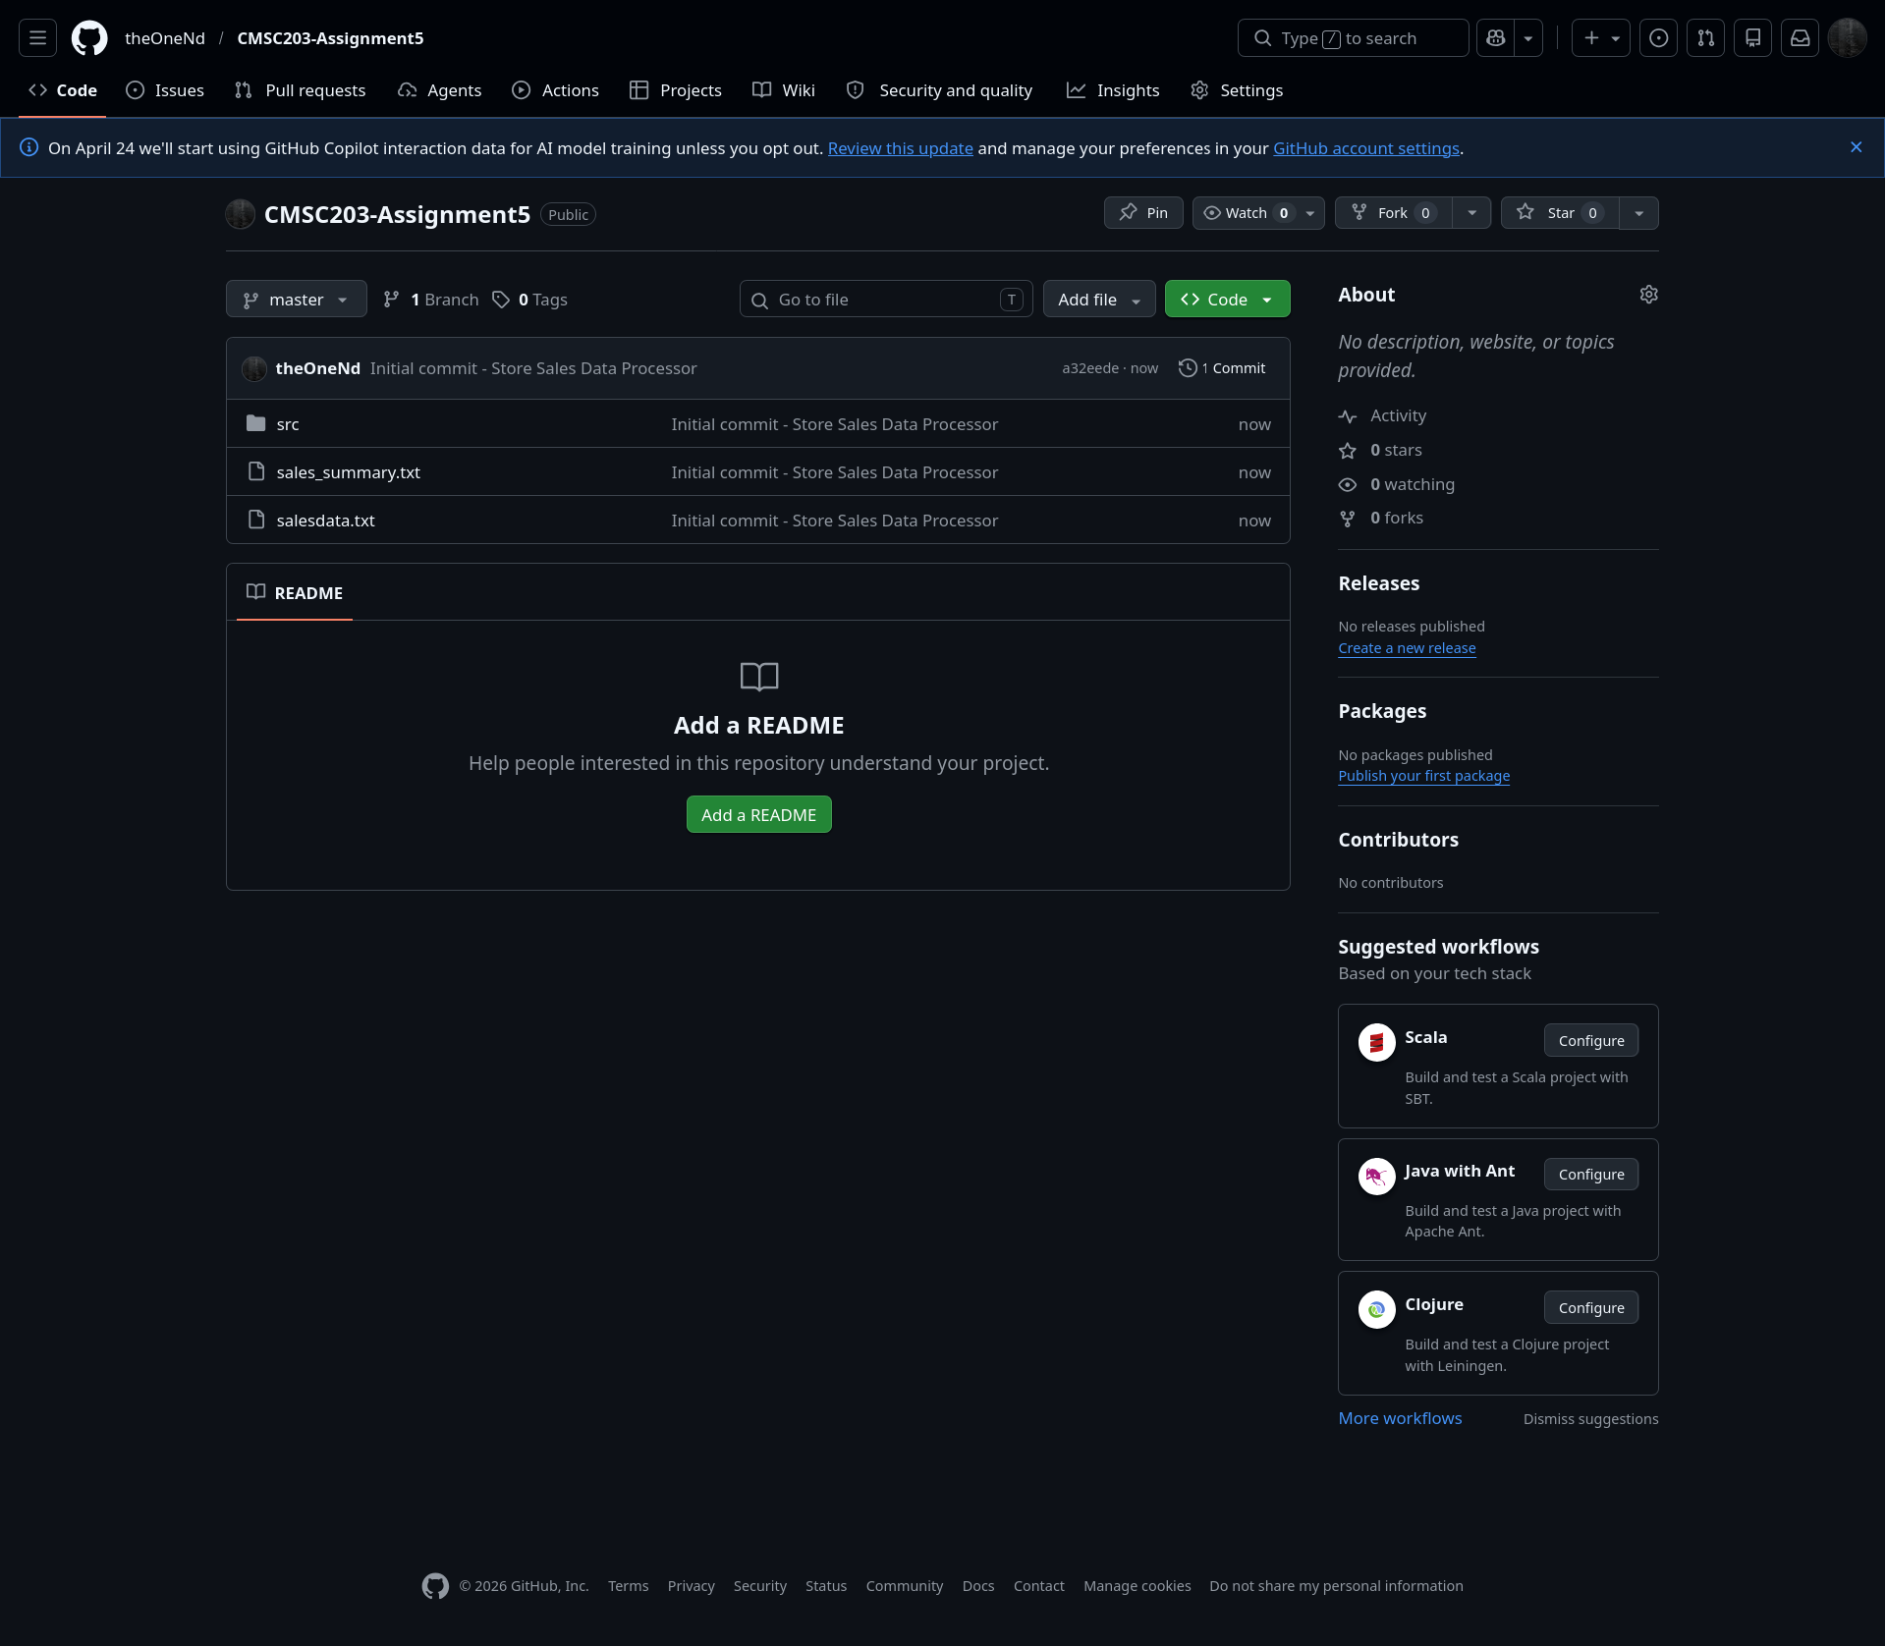
Part 4 Lessons Learned <Provide answers to the questions listed above>:

Write about your Learning Experience, highlighting your lessons learned and learning experience from working on this project.
- There wasn’t much to discover during this project, as most of it was already covered in prior assignments and quizzes.
What have you learned?
- One thing I have learned is a means to get around the column constraint you may encounter when working with ragged 2D arrays. One method is to compare the row length with a given column number and proceed with operations if the row length is lower. Not doing so would result in an index out of bounds exception.
- I learned that static methods are represented in UML diagrams using underlines.
What did you struggle with?
- There wasn’t anything I struggled with in this project.
What would you do differently on your next project?
- There is nothing I would do differently for the next project.
What parts of this assignment were you successful with, and what parts (if any) were you not successful with?
- I would say I was successful with all parts of this assignment.
Provide any additional resources/links/videos you used to while working on this assignment/project.
- All I can say is I looked up how to represent static methods for UML diagrams on Google.

Part 5: Check List: <Provide answers to the column Y/N >:

# |  | Y/N | Comments
 | Assignment files: | Y
 | - FirstInitialLastName_ Assignment5_JavaFiles.zip | Y
 | - FirstInitialLastName_Assignment5.docx/.pdf | Y
 | - Source java files | Y
 | Program compiles | Y
 | Program runs with desired outputs related to a Test Plan | Y
 | Documentation file: | Y
 | - Comprehensive Test Plan | Y
 | - Screenshots related to the Test Plan | Y
 | - Screenshots of your GitHub account with submitted Assignment 5 | Y
 | - UML Diagram | Y
 | - Lessons Learned | Y
 | - Checklist is completed and included in the Documentation | Y

