Process
Problem Statement
Food bits fall between the cracks on each side of the oven and are very difficult to remove.

Brainstorming
Print spacers to fit in the cracks. They need to be able to get warm.
Measured gap on right of oven and drafted V1:
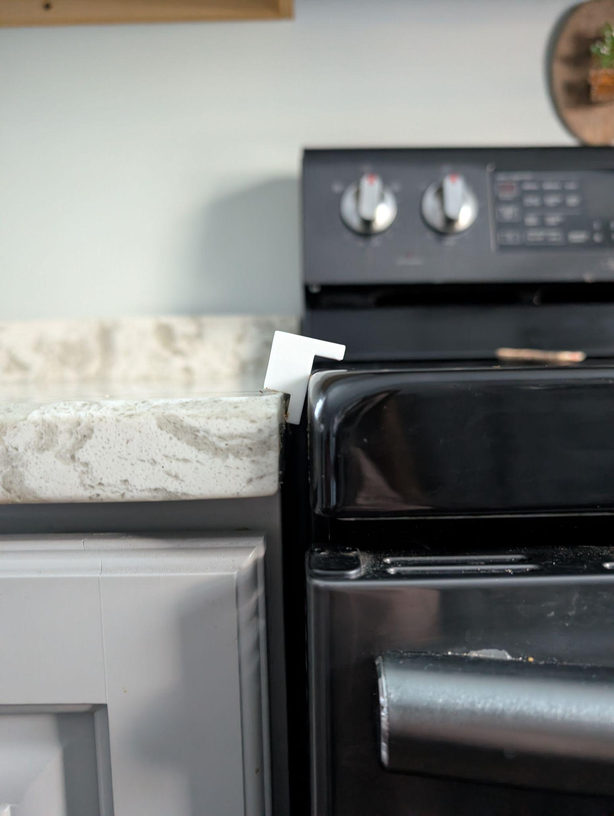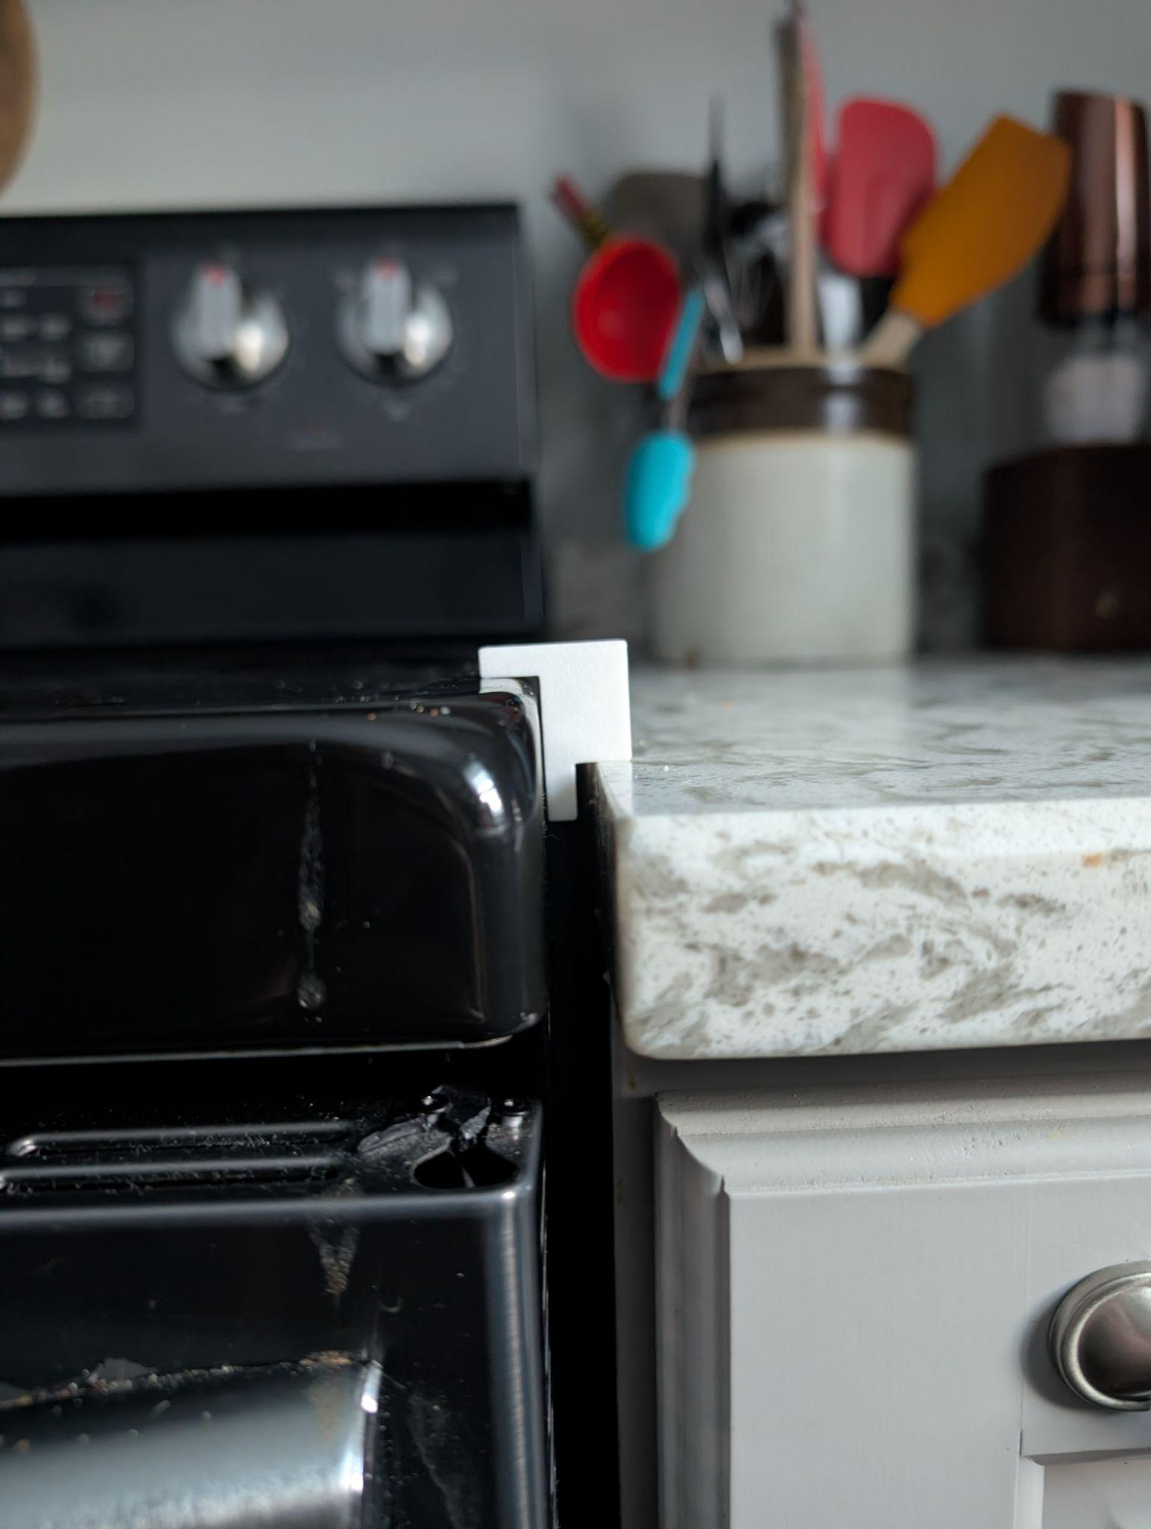
Apparently the counter is at a different height on the left! This means I’ll need slightly different parts. V1 works well on the right, so I’ll tweak it slightly and try a longer piece.
V2 works well, so I got it reviewed by Julia! She requested that the piece not be able to slide left and right. V3 has a larger, slightly tapered shim to attempt this.

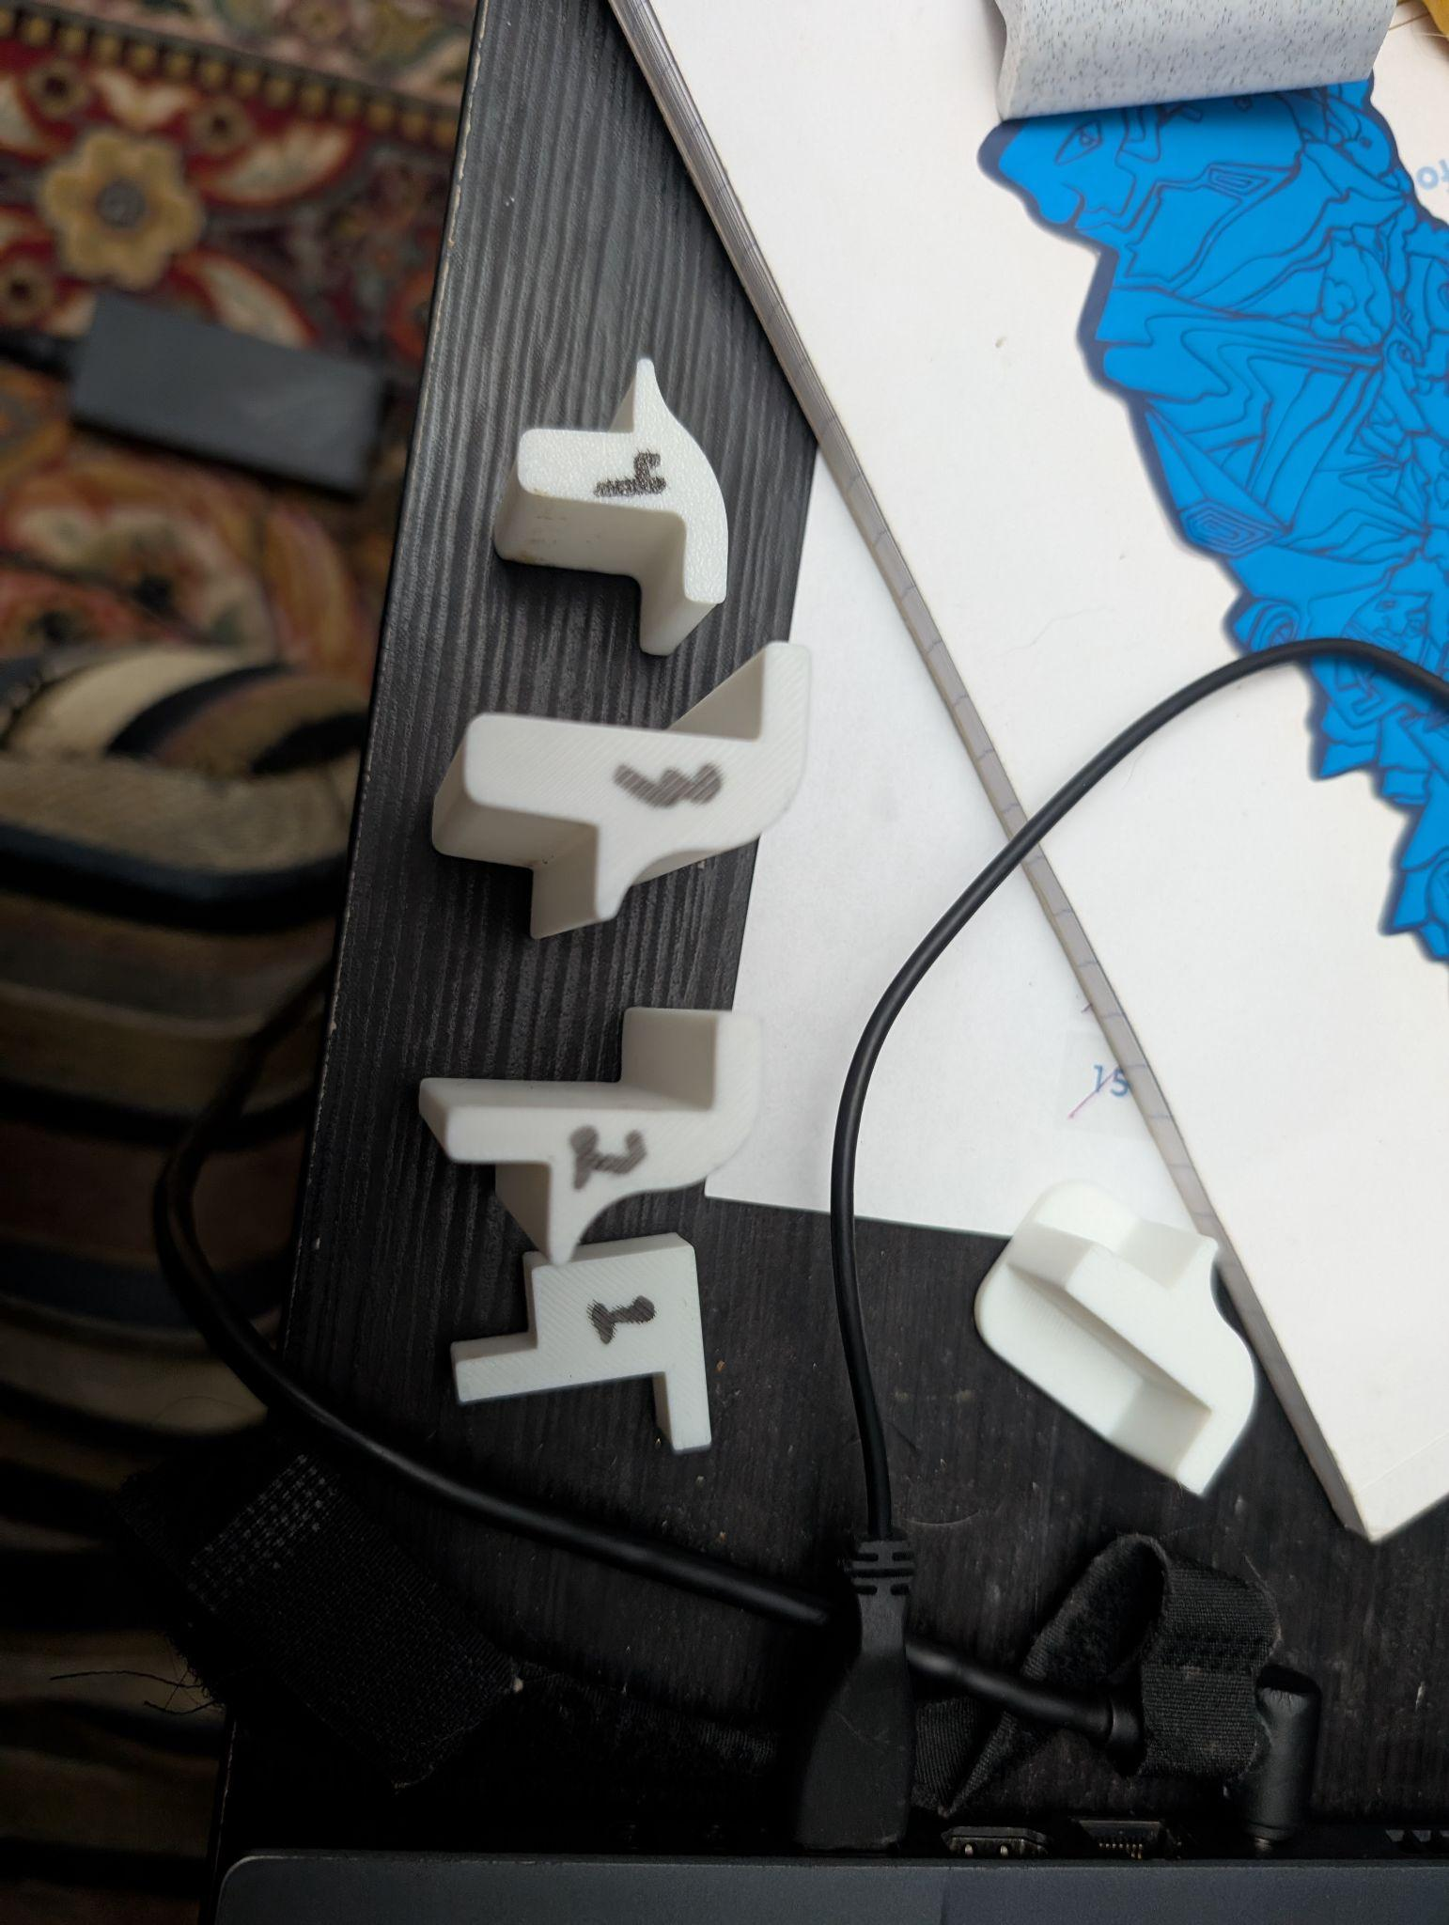

Total length: 550mm
Try 5 100mm blocks and a 50mm cap

Finished Product:

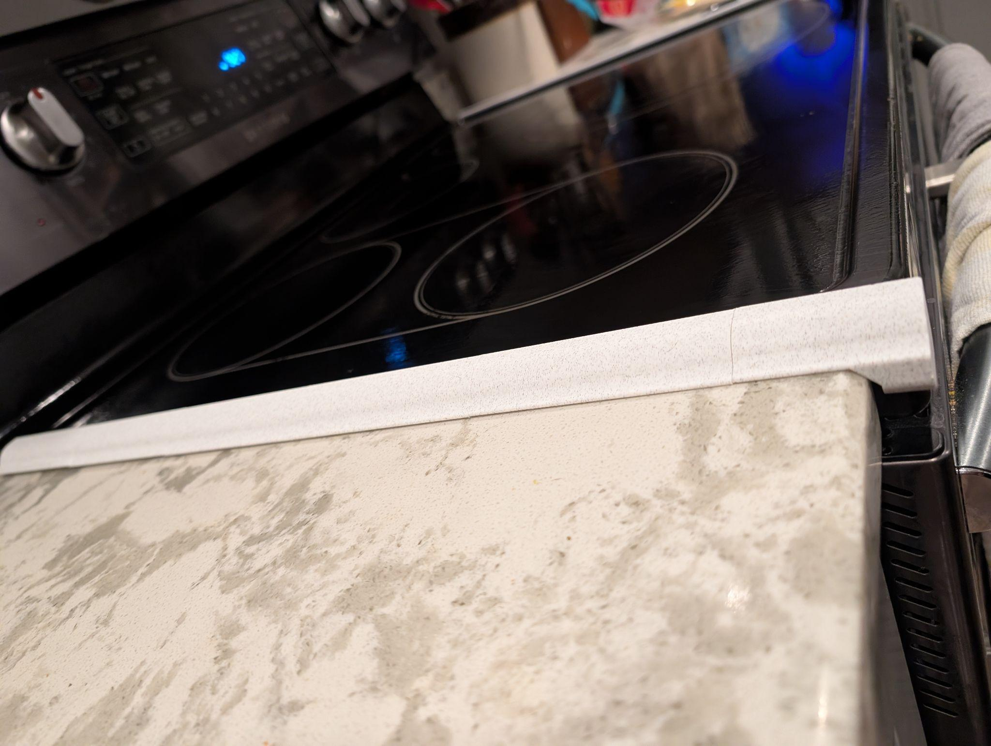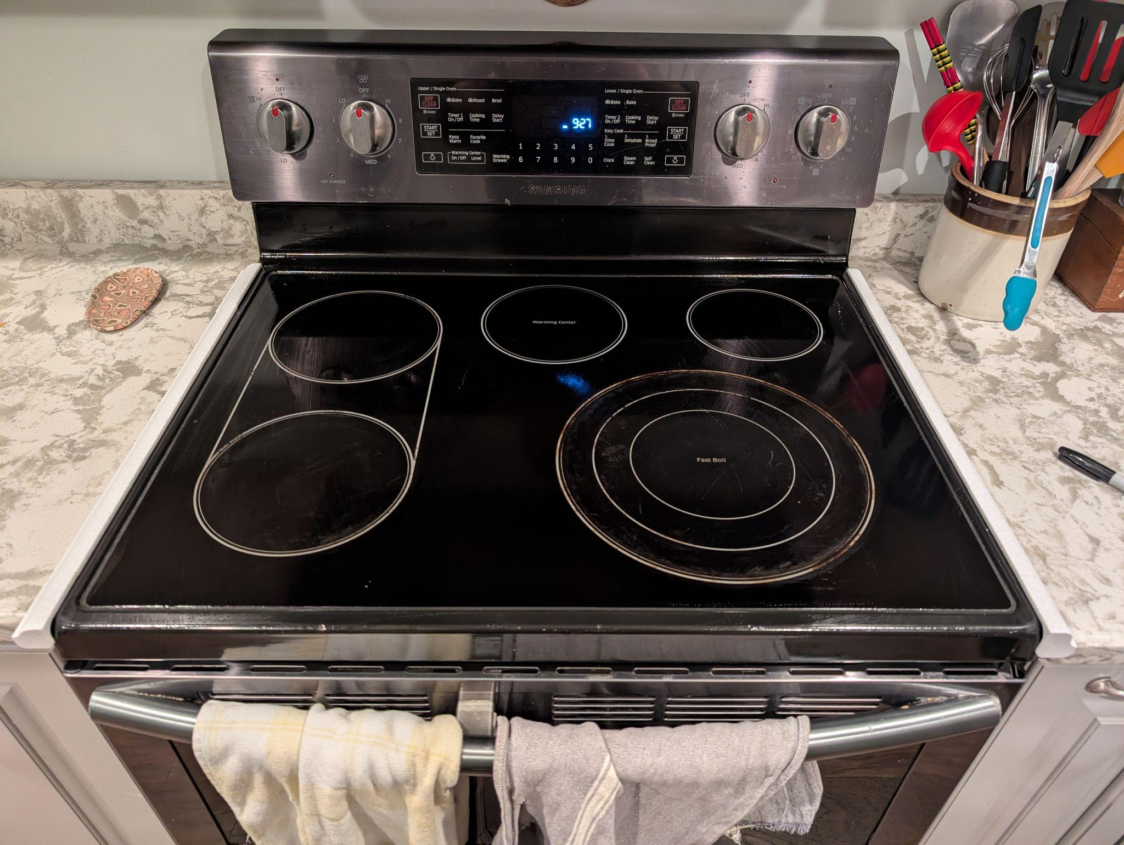

Rapid prototyping made this project a cinch! Printed with marble PLA to look nice in the kitchen, and I love the result! I’ll bag this up for Julia to open on her birthday, and then I’ll sticky tape it down.

