ASSESSING SOCIO-ECONOMIC FACTORS INFLUENCING THE SUSTAINABILITY OF PASTORALISTS MOVED FROM NGORONGORO TO MSOMERA VILLAGE, TANZANIA - A CASE STUDY OF MSOMERA VILLAGE

EMMANUEL AUGUSTINE KATO

A DISSERTATION SUBMITTED IN PARTIAL FULFILLMENT OF THE REQUIREMENTS FOR THE DEGREE OF MASTER OF ARTS NATURAL RESOURCES MANAGEMENT OF THE OPEN UNIVERSITY OF TANZANIA

2026

SUPERVISOR(S) CERTIFICATION

The undersigned certifies that he has read and does hereby recommend for acceptance by The Open University of Tanzania a dissertation titled “Assessing Socio-Economic Factors Influencing the Sustainability of Pastoralists Moved from Ngorongoro to Msomera Village, Tanzania: A Case Study of Msomera Village,” in partial fulfillment of the requirements for the degree of Master of Arts Natural Resources Management (MA NARAM) of the Open University of Tanzania.

--------------------------------------------------
Dr. Anna Wawa
(SUPERVISOR)

----------------------------------------------------
Date

COPYRIGHT

No part of this research dissertation may be reproduced, stored in any retrieval system, or transmitted in any form or by any means, be it electronic, mechanical, photocopied, recorded or otherwise without the prior permission of the author or the Open University of Tanzania in his behalf.

DECLARATION

I, Emmanuel Augustine Kato, do hereby declare to the senate of The Open University of Tanzania, that this is my own original work and that to the best of my understanding it has not been presented before, anywhere for any purpose or for a degree or similar award at any other university.

---------------------------------------------------------
Signature

---------------------------------------------------------
Date

ACKNOWLEDGEMENT

I would like to extend my thanks to all who contributed in one way or another in the successful completion of this study on the assessment of socio-economic factors influencing sustainability of pastoralists relocated from Ngorongoro to Msomera Village, Tanzania.

First of all, I would like to express my great thanks to my supervisors Dr Emmanuel Kazuva and Dr Reguli Baltazar Mushy for their attentive supervision, advice, support and constructive ideas at all stages of this project. This work was shaped and successfully completed by their support and academic guidance.

My deepest gratitude goes to the District Executive Director of Tanga District for providing me research permission, which facilitated fieldwork and smooth implementation of this study. I also wish to express my thanks to the village leaders at the visited areas for their warm reception, cooperation, and support in the field preparations, which included the organization of meeting places and mobilization of participants.

I thank all the responders in Msomera Village, especially the pastoralists who moved from Ngorongoro and other community members for their willingness to take part in the study and for providing useful information. Their comments and clarifications were important for the collecting of reliable data during talks.

I am also grateful to my research assistants, Avyalimana Athanas Sambuta, Suzana Mziray, Edwin Luvanda and Baraka Manoko, for their dedication and help in the process of data collection. Their support was critical in ensuring that fieldwork was successful and efficient.

Finally, I would appreciate all persons and institutions not mentioned by name who in one way or another contributed to the completion of this study. I thank them for their support and inputs.

ABSTRACT

This study investigated the socio-economic factors associated with the sustainability of pastoral livelihoods among households relocated from the Ngorongoro Conservation Area to Msomera Village, Handeni District, Tanzania, in response to limited empirical evidence on post-relocation livelihood outcomes. Guided by the Sustainable Livelihoods Framework and informed by pragmatism, the study used a convergent parallel mixed-methods case-study design. The achieved quantitative sample comprised 319 relocated pastoralist household respondents (100% of the 319 targeted), 51 native residents (100% of 51 targeted), and 20 officials (100% of 20 targeted), giving an overall response rate of 100% (390/390); qualitative evidence was obtained through key-informant interviews, focus-group discussions, field observation, and documentary review, using a questionnaire, interview guides, FGD prompts, and observation/document-review schedules as instruments. Quantitative data were analyzed using frequencies, percentages, chi-square goodness-of-fit tests, exact binomial tests, an independent-samples t-test, Fisher’s exact test, and multivariable binary logistic regression, whereas qualitative data were coded thematically and integrated through joint displays and narrative comparison. Livestock sales were the dominant livelihood source (281/319, 88.1%), differing significantly from an equal distribution across livelihood categories (χ²(3)=677.45, p<0.001), and most households were unwilling to diversify (200/319, 62.7%; exact binomial p<0.001). Although 242 respondents (75.9%) reported better well-being after relocation, sustainability remained uneven: 72.7% reported reliable livestock-water access, 92.2% had received extension assistance, 94.7% had received livestock training, and 37.0% reported frequent water- or grazing-related conflicts. Adequate veterinary care was associated with a higher mean livestock income/protein contribution (t=6.39, p<0.001, Cohen’s d=1.01). In the adjusted sustainability model, adequate health-clinic services (AOR=9.72, p=0.001), available education services (AOR=3.29, p=0.007), and available livestock-market services (AOR=13.84, p=0.001) were positively associated with satisfaction, while reported improvement in grazing-land availability was unexpectedly negative (AOR=0.34, p=0.047); in the well-being model, education availability (AOR=3.17, p=0.001) and improved grazing-land availability (AOR=1.93, p=0.027) were significant. Fisher’s exact test also showed a significant association between veterinary-service rating and well-being (p<0.001). Qualitative findings converged with the statistical results, identifying water reliability, veterinary support, extension services, market access, and fair prices as essential, while highlighting broken water points, inadequate market infrastructure, price exploitation, land/resource conflicts, and operational constraints involving budgets, transport, and staffing. The study concludes that pastoralism remains viable and central to household livelihoods but is institutionally and infrastructurally fragile; it recommends maintaining and repairing water infrastructure, strengthening mobile and locally accessible veterinary and extension services, improving livestock-market infrastructure and price information, expanding education and health services, securing participatory grazing and land-use arrangements, and involving relocated and host communities in planning, monitoring, and conflict-resolution mechanisms.

TABLE OF CONTENTS

SUPERVISOR(S) CERTIFICATION i
COPYRIGHT ii
DECLARATION iii
ACKNOWLEDGEMENT iv
ABSTRACT v
LIST OF TABLES xiii
LIST OF FIGURES xv
CHAPTER ONE 1
INTRODUCTION i
1.1. Background to the Research Problem 1
1.2 Statement of the Problem 2
1.3 Research Objectives 5
1.3.1 Main Research Objectives 5
1.3.2 Specific Research Objectives. 5
1.4 Research Questions 5
1.5 Significance of the study 6
1.6 Scope and Organization of the Study 6
CHAPTER TWO 7
LITERATURE REVIEW 7
2.1 Conceptual definitions 7
2.1.1 Pastoralism and pastoralists 7
2.1.2 Social-economic activities and factors 7
2.1.3 Social sustainability 8
2.2 Theoretical and Conceptual Framework 8
2.2.1 Sustainable Livelihoods Framework (main theory) 8
2.2.2 Tragedy of the Commons (supplementary theory) 9
2.3 Empirical Literature Review 10
2.3.1 Current socio-economic activities in pastoral and relocation contexts (Objective 1) 10
2.3.2 Extent of sustainability of pastoralism in relocation contexts (Objective 2) 11
2.3.3 Socio-economic factors associated with pastoral sustainability (Objective 3) 12
2.4 Conceptual framework 14
2.5 Research Gap Identified 16
CHAPTER THREE 18
RESEARCH METHODOLOGY 18
3.1 Research Philosophy 18
3.2 Research Design 18
3.3 The Research Approach 20
3.4 Variables and Measurement Procedures 20
3.5 Operationalization of Study Variables 22
3.6 Pilot Study 26
3.7 The Study Area description 26
3.8 Study population and target population 27
3.9 Sampling Design and Procedures 28
3.9.1 Sampling Frame 28
3.9.2 Sample Size Determination 30
3.9.3 Sampling Methods 32
3.9.3.1 Probability Sampling 32
3.9.3.2 Non-Probability Sampling 33
3.10 Data Collection Methods 34
3.10.1. Primary Data Collection Methods 34
3.10.1.1 Questionnaire 34
3.10.1.2 Interview 35
3.10.1.3 Focus Group 35
3.10.2 Secondary Data Collection Methods 35
3.10.2.1 Published Reports and datasets 35
3.10.2.2 Literature Review 35
3.11 Data Processing and Analysis 36
3.11.1 Quantitative data analysis 36
3.11.2 Qualitative Analysis 36
3.12 Validity and Reliability of the Study 37
3.12.1 Validity of Research Instruments 37
3.12.2 Content Validity 37
3.12.3 Construct Validity 37
3.12.4 External Validity 38
3.12.5 Triangulation 38
3.12.6 Reliability 38
3.12.7 Instrument Reliability 40
3.12.8 Data Management 40
3.12.9 Ethical Considerations 40
CHAPTER FOUR 41
FINDINGS AND DISCUSSION 41
4.1 Introduction 41
4.2 Characteristics of Respondents 41
4.2.1 Sex of Respondents 41
4.2.2 Education Level of Respondents 42
4.2.3 Household Size of Respondents 43
4.2.4 Source of Income of Respondents 44
4.3 Current socio-economic activities undertaken by relocated pastoralist households in Msomera Village 45
4.3.1 Quantitative Findings 45
4.3.2 Qualitative Findings 50
Theme 1: Pastoralism remains the primary livelihood activity 50
Theme 2: Crop cultivation complements livestock keeping 50
Theme 3: Livestock marketing provides household income 51
Theme 4: Livelihood diversification strengthens household resilience 51
4.3.3 Observation and photographic evidence 53
4.4 Extent of sustainability of Pastoralism in the area of study 57
4.4.1 Quantitative Findings 58
Table 4.11: One-Sample Proportion Test for Perceived Well-being (n=319) 59
4.4.2 Qualitative Findings 84
Theme 1: Water remains essential 84
4.5 Socio-economic factors associated with the sustainability of pastoralism in Msomera Village, Tanzania 87
4.5.1 Quantitative Findings 87
4.5.2 Qualitative Findings 96
Theme 3: Livestock markets sustain pastoral livelihoods 97
4.6 Additional Quantitative and Qualitative analysis 98
4.6.1 Quantitative Findings 98
4.6.2 Qualitative Findings 106
CHAPTER FIVE 108
SUMMARY, CONCLUSIONAND RECOMMENDATIONS 108
5.1 Introduction 108
5.2 Summary of the Study 109
5.2.1 Objective 1: Socio-economic activities in Msomera Village 109
5.2.2 Objective 2: Extent of pastoral livelihood sustainability 109
5.2.3 Objective 3: Factors associated with livelihood sustainability 110
5.3. Conclusion 110
5.3.1 Objective 1: Socio-economic activities in Msomera Village 111
5.3.2 Objective 2: Extent of pastoral livelihood sustainability 111
5.3.3 Objective 3: Factors associated with livelihood sustainability 112
5.4. Recommendations 112
5.4.1 Objective 1: Socio-economic activities in Msomera Village 112
5.4.2 Objective 2: Extent of pastoral livelihood sustainability 113
5.4.3 Objective 3: Factors associated with livelihood sustainability 113
5.5 Study Limitations 114
5.6 Recommendations for Further Research 115
REFERENCES 115
APPENDICES 121
Appendix I: Data Collection Tools 121
1. Document Review Templates: 121
2. Focus Group Discussion (FGD) Guides: 121
3. Structured Questionnaire: 121
4. Interview Guides: 121
Appendix II: Structured Questionnaire for Households 122
Appendix III: Structured Questionnaire for Native Residents (Zigua) 127
Appendix IV: Structured Questionnaire (Government & Extension Officials) 130
Appendix V: Interview Guides (Msomera Village) 133
Appendix VI: Focus Group Discussion (FGD) Prompts 135
Appendix VII. Profile of key informants (anonymized) 137
Appendix VIII: Participant Consent Form 138
Appendix IX: Participant Information Sheet 139
Appendix X: University Introduction Letter 141
Appendix XI: Qualitative Codebook, Theme Matrix, and Anonymized Evidence Extracts 142

LIST OF TABLES

Table 3.1: Operationalization of Study Variables 23
Table 3.2: Sampling Matrix 33
Table 3.3: Reliability results table 39
Table 4.1: Sex of Respondents (N=319) 41
Table 4.2: Education Level of Respondents (N=319) 42
Table 4.3: Household Size of Respondents (N=319) 43
Table 4.4: Source of Income of Respondents (N=319) 44
Table 4.5: Social Economic Activities Undertaken by Respondents (N=319) 45
Table 4.6: Main livelihood sources among pastoral households: observed vs expected frequencies and chi square test (N = 319) 46
Table 4.7: Herd Size Distribution by Respondents(N=319) 48
Table 4.8: Non Pastoral Livelihood Diversification Responses (N=319) 49
Table 4.9: Exact binomial test of livelihood diversification among relocated pastoralist households in Msomera Village, Tanzania (N = 319) 49
Table 4.10: Joint interpretation of Quantitative and Qualitative findings 51
Table 4.11: Sustainability-Related Livelihood Conditions and Perceived Wellbeing after Relocation (N=319) 58
Table 4.12: Distribution of respondents by access to extension services (N=319) 60
Table 4.13: Reliability of livestock water access among respondents in Msomera Village (N=319) 63
Table 4.14: One-Sample Proportion Test of Reliable Livestock Water Access among Relocated Pastoralists (N=319) 63
Table 4.15: Access to livestock training among respondents (N=319) 65
Table 4.16: One-Sample Proportion Test of Receipt of Livestock Extension Training among Relocated Pastoralists (N = 319) 66
Table 4.17: Frequency of Water and Grazing Resource Conflicts among Respondents in Msomera Village (N = 319) 68
Table 4.18: Frequency of Water and Grazing Resource Conflicts among Respondents in Msomera Village (N = 319) 68
Table 4.19: Respondents’ rating of veterinary animal care services in Msomera Village (N=319) 69
Table 4.20: One-Sample Proportion Test Results for Veterinary Animal-Care Service Rating (N= 319) 70
Table 4.21: Respondents’ rating of clean water as a human service in Msomera Village (N=319) 72
Table 4.22: Results of binomial test for clean water human service rating (1 = adequate, 0 = inadequate) among relocated pastoralist households (N = 319) 72
Table 4.23: Independent-Samples t-Test Comparing Mean Household Livestock Income or Protein Contribution Percentage by Veterinary Animal-Care Service Rating in Msomera Village (N=319) 74
Table 4.24: Respondents’ rating of health clinic services in Msomera Village (N=319 76
Table 4.25: Binomial Test of Health Clinic Service Rating (1 = Adequate, 0 = Inadequate) for Relocated Pastoralists in Msomera Village 76
Table 4.26: Respondents’ rating of school education services in Msomera Village(N=319) 78
Table 4.27: One-Sample Proportion Test of Positive School Education Service Rating among Relocated Pastoralists (N = 319) 78
Table 4.28: Respondents’ rating of livestock market services in Msomera Village (N=319) 80
Table 4.29: One-Sample Proportion Test of Positive Livestock Market Service Rating among Relocated Pastoralists (N = 319) 80
Table 4.30: Respondents’ frequency of government extension assistance in Msomera Village (N=319) 82
Table 4.31: Chi-Square Goodness-of-Fit Test of Government Extension Assistance Frequency among Relocated Pastoralists (N = 319) 82
Table 4.32: Joint interpretation of Quantitative and Qualitative findings 85
Table 4.33: Multivariable binary logistic regression of socio-economic factors associated with pastoral livelihood sustainability satisfaction among relocated pastoralists in Msomera Village, Tanzania (N = 319) 87
Table 4.34: Adjusted Associations Between Socio Economic Service Factors and Wellbeing After Relocation (Logistic Regression, Msomera Village, N = 319) 91
Table 4.35: Cross tabulation and Fisher’s Exact Test of Veterinary Animal Care Service Rating by Wellbeing after Relocation (N = 319) 94
Table 4.36: Key Informants’ Perceptions of the Primary Barriers to Pastoralist Sustainability in Msomera Village (N = 20) 98
Table 4.37: Key Informants’ Perceptions of Operational Barriers to Service Delivery for Relocated Pastoralists in Msomera Village (N = 20) 99
Table 4.38: Key Informants’ Rating of the Effectiveness of the National Livestock Policy in Supporting Pastoralist Sustainability in Msomera Village (N = 20) 100
Table 4.39: Key Informants’ Rating of the Effectiveness of the National Livestock Policy in Supporting Pastoralist Sustainability in Msomera Village (N = 20) 101
Table 4.40: Crop-Raiding Experience Reported by Native Residents in Msomera Village (N = 51) 102
Table 4.41: Chi-Square Goodness-of-Fit Test of Native Residents’ Perceptions of the Impact of Pastoralist Relocation on Village Services in Msomera Village (N = 51) 104
Table XI.1: Qualitative Codebook, Theme Matrix, and Anonymized Evidence Extracts 139

LIST OF FIGURES

Figure 2.1: Conceptual framework on Socio-Economic Factors Influencing the Sustainability of Pastoralists in Msomera Village 15
Figure 3.1: A map showing the Area of Interest (Green) around Msomera Village with one study village: 30
Figure 4.1: Physical settlement and livelihood environment of relocated pastoralist households in Msomera Village. 54
Figure 4.2: Water access point for livestock in Msomera Village. 54
Figure 4.3: Cultivated farm plots within the relocated pastoralist settlement area of Msomera Village 55
Figure 4.4: A household livestock enclosure (boma) in Msomera Village. 55
Figure 4.5: Livestock auction market in Msomera Village, Tanzania. 56
Figure 4.6: Village dispensary in Msomera Village, Tanzania. 56
Figure 4.7: Cattle grazing in Msomera Village, Tanzania. 57

CHAPTER ONE

INTRODUCTION

Background to the Research Problem

Pastoralism is a sustainable livestock-production system that supports millions of people, reduces poverty, enhances food security, conserves biodiversity, and maintains ecological balance in dryland areas. However, this livelihood system is increasingly threatened by land fragmentation, changing weather patterns, policy shifts, and social tensions. Across Africa, agricultural expansion, settlement growth, and fencing have fragmented rangelands, leading to reduced grazing areas, overgrazing, soil erosion, and inadequate pasture recovery. In Tanzania, and particularly in Msomera Village, these pressures have constrained access to water and pasture for both farmers and pastoralists, intensified farmer–pastoralist conflicts, and undermined livelihoods and household incomes. Empirical studies by Gwakisa et al. (2023), Hezron et al. (2023), Malipula (2024)
In Tanzania, climate change, weak land governance, and ineffective policy implementation continue to compromise pastoral sustainability. Mung’ong’o et al. (2022) reported that climate variability reduced livestock productivity and crop yields in Kiteto and Kilindi districts. Ripkey et al. (2021) similarly found that climate stress and sedentarisation hindered households in Morogoro and Tanga from accessing pasture, generating income, and securing food. Msigwa and Mvena (2014) linked forced evictions in the Ihefu Basin to livestock losses, increased poverty, and unsuccessful relocation outcomes. Mahonge et al. (2014) identified a gap between policy and implementation in Longido District, resulting in inadequate resource allocation and ineffective management of land-use policies. More recently, Mbarouk et al. (2025) demonstrated that conflicts between farmers and pastoralists in Mvomero District intensified due to insufficient resources and inadequate participation in land demarcation, leading to heightened tensions over land use and access to water.
At the policy level, Tanzania’s National Livestock Policy (2006) and Livestock Master Plan (2017) advocate for rangeland restoration, provision of extension services, construction of water infrastructure, and establishment of livestock markets. However, the relocation process of pastoralists from Ngorongoro to Msomera was characterised by limited meaningful engagement with affected communities. Consequently, many interventions do not align with traditional grazing patterns and mobility practices, reducing their relevance and effectiveness for relocated pastoralists.
Implementation gaps further undermine pastoral sustainability. The National Audit Office (2022) reported that only 30–40% of households receive extension support, and that water points frequently break down due to inadequate maintenance. Although pilot dairy projects have contributed to increased milk production, livestock sales remain low due to disease outbreaks and feed shortages. Human Rights Watch (2024) highlighted ongoing conflicts over water resources and exploitative practices by middlemen, including unfair pricing. A 2025 survey further indicated widespread dissatisfaction among pastoral households regarding service provision and livelihood conditions. These challenges underscore the need for a systematic assessment of the socio-economic sustainability of pastoralists relocated to Msomera Village. This study therefore seeks to generate evidence that can inform more participatory, context-specific, and effective interventions for relocated pastoralist communities.

1.2 Statement of the Problem
Pastoral livelihoods in Tanzania are increasingly affected by land-use change, farmer–pastoralist conflicts, climate variability, livestock disease, limited extension services, and changing policy and institutional arrangements. These pressures can restrict livestock mobility and access to grazing land and water, reduce livestock productivity, and weaken household income and food security. Drought, erratic rainfall, declining pasture availability, and water scarcity may also encourage households to adopt alternative livelihood activities, thereby increasing their vulnerability.
Tanzania has adopted policy and planning instruments intended to strengthen the livestock sector. The National Livestock Policy (2006) emphasises the development of a competitive and efficient livestock industry, improved livestock production, increased livestock-related income, improved livestock marketing, and sustainable management of natural resources. The Tanzania Livestock Master Plan (2017/2018–2021/2022) further identifies interventions for improving livestock production, livestock value chains, extension services, water infrastructure, animal health, and market access. However, the existence of these policies does not necessarily guarantee effective implementation at the local level. Access to livestock extension, veterinary services, water infrastructure, markets, and other forms of institutional support may remain inadequate or unevenly distributed. For example, the National Audit Office reported substantial shortcomings in the provision of livestock extension services, including limited access among livestock-keeping households and weaknesses in service delivery. These national findings provide important context but should not be interpreted as direct estimates of conditions in Msomera Village.
Pastoral livelihood challenges may become more complex when households are relocated. Moving from Ngorongoro to Msomera may alter access to customary grazing areas, livestock-water sources, mobility routes, markets, veterinary services, extension support, social networks, and cultural institutions. Relocation may provide access to new settlement services and infrastructure, but it may also require households to adjust to different ecological, economic, institutional, and social conditions. The relocation of Maasai pastoral communities from Ngorongoro to Msomera has been associated with conservation concerns, human–wildlife conflicts, and population pressure in the Ngorongoro Conservation Area. Reports have also documented the relocation of households and livestock to Msomera, confirming the importance of examining the livelihood conditions of the relocated population in the receiving area.
Previous studies have documented several challenges affecting pastoralists in Tanzania and East Africa. These studies have linked climate variability, declining pasture and water availability, weak land-use planning, farmer–pastoralist conflict, insecure access to land, and inadequate institutional support with reduced livelihood security and resilience (Gwakisa et al., 2023; Hezron et al., 2023; Mahonge et al., 2014; Malipula, 2024; Mbarouk et al., 2025; Mung’ong’o et al., 2022; Ripkey et al., 2021). Other studies have examined the effects of evictions, sedentarisation, market constraints, political processes, and climate stress on pastoral livelihoods (Downie & Trust, 2024; Kimaro & Hughes, 2023; Msigwa & Mvena, 2014; Woodhouse & McCabe, 2018). Although these studies provide useful evidence on general pastoral challenges, their findings do not fully explain the post-relocation livelihood outcomes of households living in Msomera Village.
The specific problem addressed by this study is the limited empirical evidence on the socio-economic sustainability of pastoralist households relocated from Ngorongoro to Msomera Village, Handeni District. In this study, sustainability after relocation refers to the capacity of relocated households to continue livestock-based livelihood activities, maintain livestock and other livelihood assets, access grazing land and livestock water, obtain livestock services and market opportunities, adapt to post-relocation challenges, and achieve acceptable livelihood wellbeing. Pastoral livelihood sustainability satisfaction is used as the primary outcome, while wellbeing after relocation is considered a complementary outcome. This approach distinguishes relocation-specific livelihood outcomes from the general challenges experienced by pastoralists in other contexts.
Despite the available literature on pastoral conflicts, drought, environmental pressures, land governance, and livestock-service challenges, limited evidence is available on the proportion of relocated households reporting satisfaction with pastoral livelihood sustainability and on the socio-economic factors associated with this outcome in Msomera Village. There is also limited integrated evidence linking household-level quantitative findings with the experiences of relocated pastoralists, native community members, local leaders, and livestock-service providers. Without such evidence, interventions relating to grazing-land planning, livestock-water access, veterinary and extension services, market access, social services, and livelihood diversification may not adequately reflect the conditions of relocated pastoralist households.
This study therefore addresses the identified gap by assessing the social and economic dimensions of pastoral livelihood sustainability among pastoralist households relocated from Ngorongoro to Msomera Village. It examines the socio-economic and livelihood conditions of relocated households, assesses the extent of pastoral livelihood sustainability, and identifies socio-economic factors associated with pastoral livelihood sustainability satisfaction. It also examines wellbeing after relocation as a complementary outcome. By integrating quantitative and qualitative evidence, the study is expected to provide context-specific information to support more participatory, relevant, and effective interventions for relocated pastoralist households in Msomera Village.

1.3 Research Objectives

1.3.1 Main Research Objectives
To examine the influence of socio-economic factors on the sustainability of Maasai pastoralism in Msomera Village, Tanzania.

Specific Research Objectives.

- To assess the current socio-economic activities undertaken by relocated pastoralist households in Msomera Village
- To determine the extent of sustainability of Pastoralism in the area of study
- To assess socio-economic factors associated with the sustainability of pastoralism in Msomera Village, Tanzania.

1.4 Research Questions
- What socio-economic activities are undertaken by pastoralist households in Msomera Village?
- To what extent is pastoral livelihood sustainable among households relocated from Ngorongoro to Msomera Village?
- Which socio-economic factors are associated with pastoral livelihood sustainability among households relocated from Ngorongoro to Msomera Village?

1.5 Significance of the study
This study provided evidence concerning the socio-economic sustainability of pastoralists relocated to Msomera Village and assisted in identifying practical solutions to the challenges they face. It illustrated the discrepancies between the objectives of the Livestock Policy (2006) and the Livestock Master Plan (2017) and the actual conditions, particularly regarding grazing land, extension services, water access, livestock health, and market participation.

The findings helped the Handeni District Council and other local authorities in comprehending the magnitude of service deficiencies and in rationalizing enhanced staffing, funding, and pastoralist involvement in planning. Furthermore, the study furnished evidence to bolster village land use plans and community dialogues aimed at enhancing grazing coordination, mitigating water conflicts, and augmenting livestock productivity. Additionally, the results informed the Tanga Regional Secretariat regarding the necessity for substantive consultation in forthcoming relocation processes.

In summary, the study provided location-specific evidence that enhanced participatory, pragmatic, and pastoralist-responsive interventions in Msomera and similar resettlement areas.

1.6 Scope and Organization of the Study
This study was limited to Msomera Village in Handeni District, Tanga Region. It focused on the socio-economic sustainability of Maasai pastoralist households relocated from the Ngorongoro Conservation Area to Msomera Village. Although environmental conditions such as grazing land and water availability form part of the broader context, this study did not directly measure or analyze environmental sustainability. Msomera was selected due to the recent influx of Maasai households, which intensified competition over natural resources and raised concerns regarding the sustainability of pastoral livelihoods.

CHAPTER TWO

LITERATURE REVIEW

2.1 Conceptual definitions

2.1.1 Pastoralism and pastoralists
Pastoralism is a livelihood system based on extensive livestock production, characterized by animal mobility and common use of natural resources in the world’s drylands (FAO, n.d.). Pastoralists are people who depend on livestock or the sale of livestock products for most of their income and consumption, whose livestock is mainly grazed on communally managed or open-access pastures, and where there is at least some propensity for households or individuals to move seasonally with livestock (Natural Resource Institute, n.d.).
In this study, a pastoralist refers to an adult member or household representative of a household whose livelihood is substantially based on livestock keeping, livestock production, and the use of grazing resources. The definition includes households that keep cattle and/or goats and obtain livelihood benefits from livestock products, livestock sales, or livestock-related activities. It also recognises seasonal livestock mobility or the intention to maintain pastoral practices where these were part of the household’s livelihood before relocation. Because relocation may have restricted mobility and encouraged livelihood diversification, current seasonal migration was not used as an essential requirement for classifying a household as pastoralist.

2.1.2 Social-economic activities and factors

In the Msomera research context, socio-economic activities refer to the livelihood strategies undertaken by households, including pastoralism, crop cultivation, small business, casual labour, and other income-generating activities. Socio-economic factors are the income, service access, and conflict-related conditions that influence these activities and their sustainability. Operationally, these include access to water, extension, veterinary, health, education, and market services; income from livestock and non-livestock sources; and experiences of land or water-related conflict. These concepts correspond to Objective 1 (description of activities) and Objective 3 (factors associated with sustainability)

2.1.3 Social sustainability
Social sustainability refers to the ability of a society to maintain and improve people’s wellbeing over time through fair access to resources, opportunities, and services (Albers, 2022). Economic sustainability refers to the ability of an economy or livelihood system to generate wealth and resources over the long term without depleting natural, human, or financial capital (Kemal et al., 2022).
In this study, sustainability of pastoralism is operationalized through indicators such as continuity of livestock keeping, self-reported wellbeing, satisfaction with socio-economic conditions, and perceived ability to meet basic needs from livestock and related activities. This operationalization supports Objective 2 (extent of sustainability) and Objective 3 (factors associated with sustainability).

2.2 Theoretical and Conceptual Framework

2.2.1 Sustainable Livelihoods Framework (main theory)

The Sustainable Livelihoods Framework (SLF) posits that households rely on five types of capital—natural, financial, human, social, and physical—to attain sustainable livelihoods (Chambers & Conway, 1992). Livelihoods are shaped by a vulnerability context (shocks, trends, seasonality) and by transforming structures and processes (policies, institutions, governance), which together influence livelihood strategies and outcomes.

In this study, the SLF is applied as follows:
Natural capital: access to grazing land and reliability of livestock water.
Physical capital: access to water points, health clinic, livestock market, and veterinary services.
Human capital: access to extension training, education level, and household health status.
Financial capital: livestock income, off-farm income, and ability to meet basic needs.
Social capital: participation in community groups, relationships with local leaders, and perceived fairness in resource allocation.

Relocation and related policies (e.g., National Livestock Policy, 2006; Livestock Master Plan, 2017) constitute part of the transforming structures and processes that shape access to these capitals. Livelihood strategies (Objective 1) include continued pastoralism, crop cultivation, and diversification into non-farm activities. Livelihood outcomes (Objectives 2 and 3) are measured as sustainability of pastoralism, self-reported wellbeing, and satisfaction with socio-economic conditions.

This framework guides Objective 1 by categorizing current socio-economic activities as livelihood strategies built on different combinations of capital. It guides Objective 2 by defining what constitutes a sustainable pastoral livelihood. It guides Objective 3 by identifying which capitals and services are expected to influence sustainability outcomes.

Strengths and limitations for this study
The SLF’s strength lies in its comprehensive view of livelihood assets and its suitability for analyzing multi-dimensional sustainability. Its limitation is that it focuses mainly on measurable resources and gives less attention to the cultural value of livestock and the government’s capacity to respond quickly to emerging needs. This study addresses this by incorporating qualitative data on pastoralists’ perceptions and experiences alongside quantitative indicators.

2.2.2 Tragedy of the Commons (supplementary theory)

The Tragedy of the Commons (Hardin, 1968) argues that shared resources such as grazing land and water may be overused when access is poorly regulated, leading to degradation and conflict. In this study, this theory is used selectively to interpret findings on grazing land pressure and water-related tensions between farmers and pastoralists in and around Msomera. It is not applied as a general explanation of all livelihood changes, but rather as a complementary lens to the SLF where resource competition and weak governance are evident.

Strengths and limitations for this study
The theory helps explain resource pressure and conflict, and it supports community-based management solutions. However, it does not fully capture traditional pastoral rules of resource sharing or the role of district institutions in responding to shortages and planning land use. Accordingly, it is used only where the data indicate clear commons-type dynamics.

  - Empirical Literature Review

2.3.1 Current socio-economic activities in pastoral and relocation contexts (Objective 1)
Pastoralism remains a major source of income for millions of people, but land fragmentation, climate change, and policy changes are making it less stable. In Tanzania, these pressures have weakened traditional pastoral systems and reduced their adaptability. Mahonge et al. (2014) found that weak implementation of the Livestock Policy (2006) in Longido District made pastoralists very vulnerable to drought and land conflicts, often forcing them to combine livestock keeping with crop cultivation and casual labour. Mbarouk et al. (2025) demonstrated that climate-induced resource scarcity exacerbates farmer–pastoralist conflicts in Mvomero District, pushing some households to diversify into non-farm activities.
Similarly, Mung’ong’o et al. (2022) discovered that climate variability diminished agro-pastoral productivity in Kiteto and Kilindi, while Ripkey et al. (2021) illustrated that sedentarisation in Morogoro and Tanga undermined livelihoods and intensified malnutrition, often leading to increased reliance on crop farming and small business. These studies offer valuable insights but inadequately represent the Msomera relocation context. They primarily concentrate on drought, conflict, or environmental degradation rather than the socio-economic activities undertaken after planned relocation. Additionally, they employ varying geographic contexts and, in some cases, distinct methodologies or livelihood systems, making direct comparison with Msomera difficult. Consequently, there is insufficient evidence regarding the current socio-economic activities undertaken by relocated pastoralists in Msomera Village. This study fills that gap by documenting the range of livelihood strategies (pastoralism, cropping, diversification) currently practiced in Msomera

2.3.2 Extent of sustainability of pastoralism in relocation contexts (Objective 2)

Msigwa and Mvena (2014) indicated that evictions in the Ihefu Basin resulted in livestock losses, poverty, and insufficient resettlement outcomes, suggesting that forced relocation can undermine the sustainability of pastoral livelihoods. Ripkey et al. (2021) similarly found that sedentarisation in Morogoro and Tanga undermined livelihoods and intensified malnutrition, indicating reduced sustainability when mobility is restricted without adequate alternative assets. The National Audit Office (2022) reported that only 30–40% of households receive extension support nationally and that water points often break down due to poor maintenance, implying systemic weaknesses that likely affect pastoral sustainability.
These studies agree that relocation and sedentarisation often reduce pastoral livelihood sustainability, but they differ in context and measurement. Some focus on forced evictions (Msigwa & Mvena, 2014), others on climate-induced sedentarisation (Ripkey et al., 2021), and others on service coverage (NAO, 2022). None specifically examine the planned relocation to Msomera Village or use quantitative measures of sustainability satisfaction and wellbeing among relocated pastoralists. Consequently, there is insufficient evidence regarding the extent of sustainability of pastoralism following planned relocation to Msomera. This study addresses that gap by assessing the extent of pastoral livelihood sustainability in Msomera using indicators such as continuity of livestock keeping, self-reported wellbeing, and satisfaction with socio-economic conditions.

2.3.3 Socio-economic factors associated with pastoral sustainability (Objective 3)
Water access and reliability
Mbarouk et al. (2025) demonstrated that climate-induced resource scarcity exacerbates farmer–pastoralist conflicts in Mvomero District, with water access a central flashpoint. The National Audit Office (2022) reported that water points often break down due to poor maintenance, implying systemic weaknesses in water service provision. Both studies point to weak infrastructure and governance as constraints on sustainable water access. However, neither focuses on the Msomera relocation site, where new water infrastructure may have altered access patterns. This study extends this literature by examining how perceived reliability of livestock and domestic water access relates to pastoral livelihood sustainability in Msomera.

Extension and training
The National Audit Office (2022) reported that only 30–40% of households receive extension support nationally, with significant gaps in staffing, funding, and transport. The National Livestock Policy (2006) and Livestock Master Plan (2017) advocate for strengthened extension services to improve livestock productivity. These sources agree on the importance of extension but differ on actual coverage, reflecting variations in location, measurement, and time. There is limited evidence on extension access and training participation among relocated pastoralists in Msomera. This study addresses that gap by analyzing the association between extension access, training participation, and sustainability outcomes.
Veterinary, health, education, and market services
The National Audit Office (2022) noted that pilot dairy projects increased milk production, but livestock sales remain low due to disease and lack of feed, suggesting gaps in veterinary and market systems. Human Rights Watch (2024) reported that middlemen exploit pastoralists and that conflicts over water persist, indicating broader service and governance challenges. These studies highlight the importance of veterinary, health, and market services but do not quantify their relationship with livelihood sustainability in relocation sites. This study contributes by examining how ratings of veterinary, health, education, and market services relate to sustainability satisfaction among relocated pastoralists in Msomera.
Relocation, policy, and livelihood experiences
Mahonge et al. (2014) documented a gap between policy and implementation in Longido District, with inadequate resource allocation and weak land-use management undermining pastoral livelihoods. Msigwa and Mvena (2014) linked forced evictions in the Ihefu Basin to livestock losses, poverty, and unsuccessful relocation. These studies suggest that top-down interventions with limited participation tend to produce poor livelihood outcomes. The National Livestock Policy (2006) and Livestock Master Plan (2017) advocate for rangeland restoration, extension services, water infrastructure, and livestock markets, yet the relocation process in many areas has allowed little meaningful interaction with pastoralists, resulting in interventions that do not align with traditional grazing and mobility patterns.

However, there is limited evidence on the Msomera relocation process itself, particularly regarding how pastoralists perceive service provision, participation, and livelihood change in the new site. A 2025 survey cited in the literature review indicated that most people were unhappy with relocation outcomes in some contexts, but Msomera-specific evidence is sparse. This study addresses that gap by exploring how relocated pastoralists in Msomera experience and interpret changes in services, resources, and livelihoods, and how these experiences shape their assessment of sustainability.
Overall, existing studies highlight the importance of water, extension, veterinary, health, education, and market services for pastoral livelihoods, but there is limited quantitative evidence on how these services jointly influence pastoral livelihood sustainability among relocated households in Msomera.

Conceptual framework

A conceptual framework describes the key variables in a study and shows how they are related to one another (Johnson and Heffernan, 2024).
The conceptual framework illustrates the relationship between selected socio-economic factors and livelihood outcomes among pastoralists relocated from Ngorongoro to Msomera Village, Tanzania. It is guided by the Sustainable Livelihoods Framework, which explains how households use available assets, services, and livelihood strategies to achieve sustainable livelihood outcomes.
The independent variables are socio-economic factors grouped into human capital, natural capital, livestock and financial assets, physical and institutional support, and livelihood strategies. Human capital includes health clinic and school education service ratings. Natural capital includes livestock water access reliability and changes in grazing-land availability. Herd size and source of income represent livestock and financial assets. Livestock market services and clean-water services represent physical capital, while veterinary services and government extension assistance represent institutional support. Non-pastoral livelihood diversification represents a household livelihood strategy.
The dependent variables are pastoral livelihood sustainability satisfaction and wellbeing after relocation. Pastoral livelihood sustainability satisfaction is the primary indicator of sustainability and is coded as 1 = satisfied and 0 = not satisfied. Wellbeing after relocation is a complementary livelihood outcome and is coded as 1 = better and 0 = not better.
The framework assumes that better access to grazing land, livestock water, veterinary care, markets, extension support, education, health services, livestock assets, and diversified income opportunities is associated with higher likelihoods of pastoral livelihood sustainability satisfaction and improved wellbeing after relocation. However, because the study uses cross-sectional data, these relationships are interpreted as associations rather than causal effects. The framework therefore supports two separate multivariable binary logistic regression models: one for pastoral livelihood sustainability satisfaction and another for wellbeing after relocation.
Independent Variable Dependent Variable
Social-Economic Factors
- Health clinic service rating
- School education service rating

- Livestock water access reliability
- Grazing land availability change

- Herd size
- Source of income

- Livestock market service rating
- Clean water service rating

- Veterinary service rating

- Government extension assistance

- Non pastoral livelihood diversification

Livelihood Outcomes

- Pastoral livelihood sustainability satisfaction
- Wellbeing after relocation

Human Capital

Natural Capital

Livelihood outcome
Financial/Livestock Asset/Capital

Physical Capital

Physical/institutional support

Human capital and institutional process

Livelihood strategy

Figure 2.1: Conceptual framework on Socio-Economic Factors Influencing the Sustainability of Pastoralists in Msomera Village

  - Research Gap Identified

Prior research, including Mahonge et al. (2014), examined the execution of Livestock Policy (2006) in Longido District, indicating that inadequate policy implementation rendered pastoralists susceptible to droughts and reliant on mobility, notwithstanding land disputes with conservation areas. Nonetheless, the study was confined to Longido District and utilized solely qualitative methods, thereby constraining its capacity to offer a comprehensive and nuanced insight into pastoralist sustainability in alternative relocation contexts.

Mbarouk et al. (2025) investigated the effects of climate change on resource scarcity and the conflicts between farmers and pastoralists in Mvomero District. Their research employed a mixed-methods design encompassing 391 households. (2025) investigated the effects of climate change on resource scarcity and the conflicts between farmers and pastoralists in Mvomero District. The study utilized a mixed-methods approach involving 391 households. Although the research provided significant insights into land tenure and conflict dynamics, it predominantly concentrated on farmer-pastoralist relations, rather than the particular sustainability challenges encountered by relocated pastoralists. Additionally, it did not address the post-Ngorongoro resettlement context of Msomera Village.

Msigwa and Mvena (2014) demonstrated that evictions in the Ihefu Basin resulted in livestock losses, poverty, and ineffective resettlement outcomes. However, the study was confined to Mbarali District and focused on eviction rather than planned relocation, rendering it less relevant to the Msomera case. Furthermore, its qualitative design failed to deliver a comprehensive quantitative and qualitative evaluation of the socio-economic factors influencing pastoralist sustainability.

Mung’ong’o et al. (2022) discovered that climate variability diminished agro-pastoral yields in Kiteto and Kilindi Districts, with challenges such as disease and delayed inputs impacting household resilience. However, the study concentrated on agro-pastoralists rather than exclusively pastoralists and was geographically restricted to Kiteto and Kilindi, thus failing to address the specific socio-economic and relocation-related pressures experienced by pastoralists relocated from Ngorongoro to Msomera Village.

Ripkey et al. (2021) showed that sedentarization, drought, and land pressure were weakening pastoral livelihoods in Morogoro and Tanga, with households shifting toward less sustainable diets and livelihoods. The study was regional and did not focus on the Msomera relocation experience, which includes pastoralists dealing with problems after moving, cultural disruption, service gaps, and conflicts with nearby communities.

However, existing studies overlook the unique context of Msomera Village, where pastoralists relocated from Ngorongoro are experiencing top-down sedentarization, cultural disruption, limited access to services, poor water infrastructure, weak market access, and conflicts with the Zigua community. Data also shows that only 30–40% of households receive extension support, water points are poorly maintained, dairy initiatives have limited market success, and dissatisfaction among households is high. These realities are not fully captured in the earlier studies because they did not examine the combination of relocation, service gaps, market barriers, and land-use tensions in Handeni District.

This study intends to fill these gaps by conducting a detailed mixed-methods analysis of the socio-economic factors influencing the sustainability of pastoralists moved from Ngorongoro to Msomera Village. It provides localized evidence on how education access, youth migration, grazing land availability, market access, institutional support, and land tenure security shape pastoralist sustainability, thereby offering Handeni District Council evidence-based recommendations that are more context-specific than those found in the existing literature

CHAPTER THREE

RESEARCH METHODOLOGY

3.1 Research Philosophy

This study utilized a Pragmatic Research Philosophy owing to the intricate nature of the sustainability of pastoralists transitioning from Ngorongoro to Msomera Village, which required both quantitative and qualitative insights. Pragmatism was appropriate as it enabled the amalgamation of numerical data, including the extent of service deficiencies, market accessibility, and grazing land scarcity, with qualitative data obtained from the lived experiences of pastoralists, reflecting cultural disruption, youth migration, and conflicts over land and resources.

Pragmatism fit this study because the problem is not explained by numbers alone or by experiences alone. Quantitative data showed the scale of socio-economic challenges affecting pastoralist sustainability, while qualitative data explained why these challenges exist and how they shaped daily livelihood decisions after relocation. This combination gave a better picture of what was happening in Msomera Village.

3.2 Research Design
This study employed a mixed-methods case study design to examine socio-economic factors associated with the sustainability of pastoral livelihoods among households relocated from Ngorongoro to Msomera Village, Tanzania. Msomera Village was treated as a single bounded case because the study focused on a specific geographical location, population, relocation experience, and livelihood context. The case study design was appropriate because it enabled an in-depth examination of pastoralists’ post-relocation conditions within their real-life setting, including access to grazing land, livestock water, markets, education, health services, veterinary services, government extension support, and non-pastoral livelihood opportunities. Case-study research allows the use of multiple sources of evidence, including household surveys, interviews, field observations, and relevant documents, to develop a detailed understanding of a defined setting.

The study used a convergent parallel mixed-methods approach. Quantitative data were collected from relocated pastoralist households using structured questionnaires, while qualitative data were collected through key-informant interviews, field observations, and document review. The quantitative component assessed the extent of pastoral livelihood sustainability and wellbeing after relocation and examined socio-economic factors associated with these outcomes using descriptive statistics and multivariable binary logistic regression. The qualitative component explored pastoralists’ experiences of relocation, access to grazing land and livestock water, livestock-production challenges, availability of social and livestock services, livelihood diversification, and institutional support.

Quantitative and qualitative data were analyzed separately and subsequently integrated using a joint integration approach. The integration process involved bringing quantitative results and qualitative themes together in joint displays and integrated narrative discussion. Specifically, statistical findings on the proportions of households reporting pastoral livelihood sustainability satisfaction and improved wellbeing after relocation, together with the socio-economic factors associated with these outcomes, were compared with interview, observation, and documentary evidence. Areas where the findings converged, complemented each other, or differed were identified and interpreted. For example, where reliable livestock-water access, improved grazing-land availability, veterinary care, market services, or extension assistance showed an association with livelihood outcomes, qualitative evidence was used to explain how and why these factors affected livestock production, household income, food security, and pastoral livelihood sustainability.

The joint integration approach strengthened the interpretation of results by linking measurable household-level outcomes with pastoralists’ lived experiences and the institutional and environmental conditions of Msomera Village. An experimental design was not appropriate because relocation conditions, natural-resource access, service provision, and household livelihood circumstances could not ethically or practically be manipulated. Since the study was cross-sectional and observational, the results are interpreted as associations rather than causal effects.

3.3 The Research Approach
This research employed a mixed-methods approach, integrating both quantitative and qualitative methodologies to analyze the socio-economic factors affecting the sustainability of pastoralists relocated from Ngorongoro to Msomera Village. The quantitative part measured the extent of challenges such as grazing land scarcity, education access, youth migration, market access, and service gaps, while the qualitative part explored the lived experiences of pastoralists and explained how these factors affect their sustainability.

The mixed-methods approach was suitable as it offered both quantitative evidence and comprehensive insights. Quantitative data demonstrated the scale of the issue, while qualitative data clarified the reasons behind pastoralists' decisions, challenges, and adaptive strategies post-relocation.

3.4 Variables and Measurement Procedures

The variables in this study were selected to align with the three research objectives: (1) to assess the current socio-economic activities undertaken by relocated pastoralist households in Msomera Village; (2) to determine the extent of sustainability of pastoralism in the area of study; and (3) to assess socio-economic factors associated with the sustainability of pastoralism in Msomera Village, Tanzania.

Socio-economic factors
Socio-economic factors include household income sources and levels, education, age, sex, household size, and other demographic characteristics. These variables were measured using structured household questionnaires and supplemented by in-depth interviews with key informants. They were used to describe the socio-economic activities of relocated pastoralist households (Objective 1) and to examine their association with the sustainability of pastoralism (Objective 3).

Land conversion
Land conversion refers to changes in land use over time, particularly the transformation of forest, woodland, or communal land into grazing areas, cropland, or settlements. This was measured by asking respondents about historical and current land-use patterns and by observing areas where grazing and cultivation had intensified. Land conversion was used as an indicator of changes in the natural resource base underlying pastoral livelihoods and thus contributed to assessing the sustainability of pastoralism (Objectives 2 and 3).

Population growth and poverty
Population growth and poverty were examined through household size, dependency ratios, income levels, asset ownership, and respondents’ perceptions of how demographic pressure and economic constraints affect land pressure and livestock-related challenges. These variables helped to explain pressures on grazing land and other resources and were used to assess their relationship with the sustainability of pastoralism (Objectives 2 and 3).

Policy and institutional factors
Policy and institutional factors include government policies, land tenure arrangements, market forces, local rules, and institutions that influence land use and livestock production. These were assessed through key informant interviews with district and village officials, community leaders, and service providers, as well as through review of relevant policy documents and land-use plans. These factors were used to understand the institutional context within which pastoral activities are carried out and to assess their influence on the sustainability of pastoralism (Objectives 1, 2, and 3).

Livestock population
Livestock population refers to the number and types of livestock owned by each household, measured by asking respondents to report the number of animals they owned by species (e.g., cattle, goats, sheep, donkeys, and poultry). Livestock holdings are a core component of pastoral socio-economic activities and were used both to describe current livelihood strategies (Objective 1) and as an indicator of the extent and sustainability of pastoralism (Objectives 2 and 3).

Sustainability of pastoralism (outcome variable)
The sustainability of pastoralism was operationalized using indicators derived from livestock population trends, access to key resources (grazing land, water, markets, extension services), and household perceptions of the continuity and viability of pastoral livelihoods after relocation. These indicators were combined to form a measure of pastoral livelihood sustainability, which served as the main outcome variable for Objectives 2 and 3.

3.5 Operationalization of Study Variables

Operationalization refers to the process of translating study objectives and abstract concepts into measurable variables, indicators, questionnaire items, response categories, coding procedures, and analytical methods. In this study, the operationalisation process ensured that the instruments and analysis were directly linked to the objectives of assessing socio-economic activities, determining the extent of pastoralism sustainability, and examining socio-economic factors associated with pastoral livelihood sustainability in Msomera Village.

The quantitative dataset used for household-level analysis contained 319 valid observations for each of the listed variables, with no missing values. The two outcome variables were Wellbeing_Rating_After_Relocation and Pastoral_Livelihood_Sustainability_Satisfaction. Both were coded as binary variables, where a value of 1 represented the positive outcome and 0 represented the comparison category. The independent variables included household livelihood characteristics, livestock ownership, service access, water reliability, grazing-land conditions, extension support, conflict experiences, and livelihood diversification.

Table 3.1: Operationalization of Study Variables

Objective 1: To assess the current socio-economic activities undertaken in Msomera Village

Study Variables | Indicators | Questionnaire | Scale and coding | Analysis
Main_Source_of_Income | Household’s primary source of income | What is the main source of income for your household? | Nominal: 0 = livestock sales; 1 = crop farming; 2 = petty trade; 3 = other | Frequencies and percentages, chi-square goodness-of-fit test
Non_Pastoral_Livelihood  _Diversification | Household involvement in non-pastoral activities | Has your household diversified into non-pastoral livelihood activities after relocation? | Binary: 1 = yes; 0 = no | Frequencies, percentages and binomial test

Objective 2: To determine the extent of sustainability of pastoralism in the study areain Msomera Village

Study Variables | Indicators | Questionnaire /Item | Scale and coding | Analysis
Wellbeing_Rating  _After_Relocation | Respondent’s self-rated wellbeing after relocation | Compared with your life before relocation, how would you rate your wellbeing in Msomera Village? | Binary: 1 = better; 0 = not better | Frequencies, percentages, and binomial test
Pastoral_Livelihood  _Sustainability_Satisfaction | Satisfaction with sustainability of pastoral livelihood | Overall, are you satisfied with the sustainability of your pastoral livelihood since moving to Msomera Village? | Binary: 1 = satisfied; 0 = not satisfied | Frequencies, percentages and binomial test
Livestock_Water  _Access_Reliability | Reliability of water access for livestock | How reliable is access to water points for your livestock throughout the year? | Binary: 1 = yes, always; 0 = sometimes/seasonal | Frequencies percentages and binomial test
Livestock_Income_Protein  _Contribution_Percentage | Adequacy of veterinary services | How would you rate veterinary and animal-care services available to your household? | Binary: 1 = adequate; 0 = inadequate | Independent-Samples t-Test
Livestock_Extension  _Service_Received | Access to livestock extension services | Have you received livestock extension services during the past 12 months? | Binary: 1 = yes; 0 = no | Frequencies, percentages and binomial test
Livestock_Extension  _Training_Received | Receipt of livestock extension training | Have you received livestock extension training during the past 12 months? | Binary: 1 = yes; 0 = no | Frequencies, percentages and binomial test
Veterinary_Animal  _Care_Service_Rating | Adequacy of veterinary services | How would you rate veterinary and animal-care services available to your household? | Binary: 1 = adequate; 0 = inadequate | Frequencies, percentages and binomial test
Health_Clinic  _Service_Rating | Adequacy of health-clinic services | How would you rate health-clinic or dispensary services available to your household? | Binary: 1 = adequate; 0 = inadequate | Frequencies, percentages and binomial test
School_Education  _Service_Rating | Availability of education services | Are school or education services available to your household? | Binary: 1 = available; 0 = not available | Frequencies, percentages and binomial test
Livestock_Market  _Service_Rating | Availability of livestock-market services | Are livestock market services available to your household? | Binary: 1 = available; 0 = not available | Frequencies, percentages and binomial test
Main_Grazing  _Land_Challenge | Primary grazing-land challenge | What is the main challenge affecting access to grazing land in Msomera Village? | Nominal: 0 = poor quality pasture; 1 = conflict with other users; 2 = distance to grazing areas; 3 = scarcity of land | Frequencies, percentages and chi-square goodness-of-fit
Water_Grazing  _Conflict_Frequency | Frequency of conflicts over water or grazing resources | How often do conflicts over water or grazing | Binary: 0 = rarely; 1 = frequently | Frequencies, percentages and binomial test

Objective 3: To assess socio-economic factors associated with the sustainability of pastoralism in Msomera Village, Tanzania

Study Variables | Indicators | Questionnaire /Item | Scale and coding | Analysis
Clean_Water  _Human_Service  _Rating | Adequacy of household clean-water services | How would you rate clean-water services for household use? | Binary: 1 = adequate; 0 = inadequate | Multivariable logistic regression
Health_Clinic  _Service_Rating | Adequacy of health-clinic services | How would you rate health-clinic or dispensary services available to your household? | Binary: 1 = adequate; 0 = inadequate | Multivariable logistic regression
School_Education  _Service_Rating | Availability of education services | Are school or education services available to your household? | Binary: 1 = available; 0 = not available | Multivariable logistic regression
Livestock_Market  _Service_Rating | Availability of livestock-market services | Are livestock market services available to your household? | Binary: 1 = available; 0 = not available | Multivariable logistic regression
Government  _Extension_Assistance | Regularity of government extension assistance | How often does your household receive assistance from government extension officers? | Binary: 1 = regularly; 0 = rarely | Multivariable logistic regression
Grazing_Land  _Availability_Change | Change in grazing-land availability | Compared with your previous location, how has grazing-land availability changed? | Binary: 1 = better; 0 = same | Multivariable logistic regression
Veterinary_Animal  _Care_Service_Rating | Adequacy of veterinary services | How would you rate veterinary and animal-care services available to your household? | Binary: 1 = adequate; 0 = inadequate | Fishers’s test

3.6 Pilot Study

A pilot study was conducted before the main survey to assess the clarity, relevance, cultural suitability, sequencing, and feasibility of the questionnaires, interview guides, and focus-group discussion prompts. The study report indicates that the research instruments were pre-tested with 25 respondents before the main data collection.

3.7 The Study Area description
This study was conducted in Msomera Village, Misima Ward, Handeni District, Tanga Region, Tanzania. Msomera Village was selected because it is a new settlement area that accommodates pastoralist households relocated from the Ngorongoro Conservation Area. The village was treated as one bounded case for examining socio-economic factors associated with pastoral livelihood sustainability and wellbeing after relocation.

Msomera Village is located in a semi-arid environment characterised by seasonal rainfall, savanna vegetation, grasslands, and variable access to water resources. These conditions are important for pastoral livelihoods because livestock production depends on access to grazing land and reliable livestock-water sources. The village includes both households relocated from Ngorongoro and native or non-relocated residents. However, the main focus of the study was pastoralist households relocated from Ngorongoro because the study examined post-relocation pastoral livelihood sustainability and wellbeing.

Msomera Village was treated as one geographical study unit. Since it is a relatively new settlement area and no separate hamlets or other geographical strata were used in this study, the quantitative household sampling was undertaken from one village-wide household register. The study area provided an appropriate setting for examining how grazing-land availability, livestock-water access, livestock services, market access, extension support, household assets, and livelihood diversification were associated with pastoral livelihood outcomes after relocation.

3.8 Study population and target population
The study population comprised relocated pastoralist households, native residents, and relevant government and local officials in Msomera Village. These groups participated in both the quantitative and qualitative components of the study because they provided complementary information on pastoral livelihoods, public services, resource use, local governance, and relationships between relocated pastoralists and the host community.

The target population was relocated pastoralist households that had moved from the Ngorongoro Conservation Area to Msomera Village. This was the main population to which the study aimed to apply its conclusions on pastoral livelihood sustainability and wellbeing after relocation. A target population is the wider group to which a study seeks to generalize its findings, while the study population is the accessible group from which participants are selected.

Native residents were included because they are members of the host community and share land, water sources, public services, and other local resources with relocated pastoralists. Their participation provided information on resource-sharing arrangements, access to services, farmer–pastoralist relations, and the wider effects of relocation in Msomera Village. Government and local officials were included because they had knowledge of the relocation process, local administration, livestock and veterinary services, agricultural extension, water services, land-use management, and public-service delivery.

The quantitative component included relocated pastoralists, native residents, and officials. However, the main quantitative analysis of pastoral livelihood sustainability satisfaction and wellbeing after relocation was restricted to the 319 relocated pastoralist household respondents because these outcomes specifically concerned households relocated from Ngorongoro. Native residents and officials were included in descriptive and contextual analyses where the questions applied to them, but they were excluded from logistic regression analyses of post-relocation wellbeing and pastoral livelihood sustainability satisfaction.

The qualitative component used purposive sampling and involved relocated pastoralist leaders, native Zigua community representatives, and relevant government and local officials. Some participants also completed the structured questionnaire. Questionnaire data were analyzed quantitatively, while interview data were analyzed separately through thematic analysis. The quantitative and qualitative findings were then integrated during interpretation to provide a fuller understanding of the socio-economic sustainability of relocated pastoralists in Msomera Village.

3.9 Sampling Design and Procedures
The study used a mixed-methods design in which quantitative and qualitative data were collected from partially overlapping but analytically distinct samples. The quantitative component used simple random sampling to select eligible relocated pastoralist households for the structured questionnaire survey. The qualitative component used purposive sampling to select key informants and selected relocated pastoralists with relevant knowledge and experiences.

Some relocated pastoralists participated in both components. Their questionnaire responses were included in the quantitative analysis, while their interview accounts were analyzed thematically as qualitative data. The two datasets were first analyzed separately and then integrated during interpretation through comparison of quantitative results and qualitative themes. This approach enabled the qualitative findings to explain, complement, or contextualize patterns observed in the household survey.

3.9.1 Sampling Frame

The sampling frame for the quantitative component consisted of the verified register of all eligible pastoralist households relocated from the Ngorongoro Conservation Area and residing in Msomera Village, together with government officials and native residents. The register was obtained from Misima Ward Office, Handeni District, Tanga Region, Tanzania. Because Msomera Village is currently treated as a single settlement village without geographical strata for this study, the complete register of eligible households was used as a village-wide sampling frame, with role-based status (relocated pastoralists, native residents, and officials) used as strata.
The qualitative component used separate purposive participant lists. These included district officials, ward and village leaders, livestock, agricultural and veterinary extension personnel, pastoralist elders, selected native Zigua community representatives, and selected relocated pastoralist households. Some of the relocated pastoralist participants had also completed the quantitative questionnaire. Their selection for qualitative interviews was based on their ability to provide detailed and relevant information, rather than on random selection or their survey participation alone.
Native Zigua community representatives were purposively included because they are members of the host community living alongside relocated pastoralists in Msomera Village. They have direct knowledge of local land and water use, access to public and livestock-related services, resource-sharing arrangements, community relations, and any farmer–pastoralist interactions or conflicts that may occur after relocation. Their inclusion enabled the study to obtain host-community perspectives on how the relocation process affects shared resources and local livelihoods, thereby providing contextual information that could complement and explain the accounts of relocated pastoralist households. This was particularly important because access to land and water, resource competition, land-use arrangements, and relations between farmers and pastoralists can shape pastoral livelihood sustainability

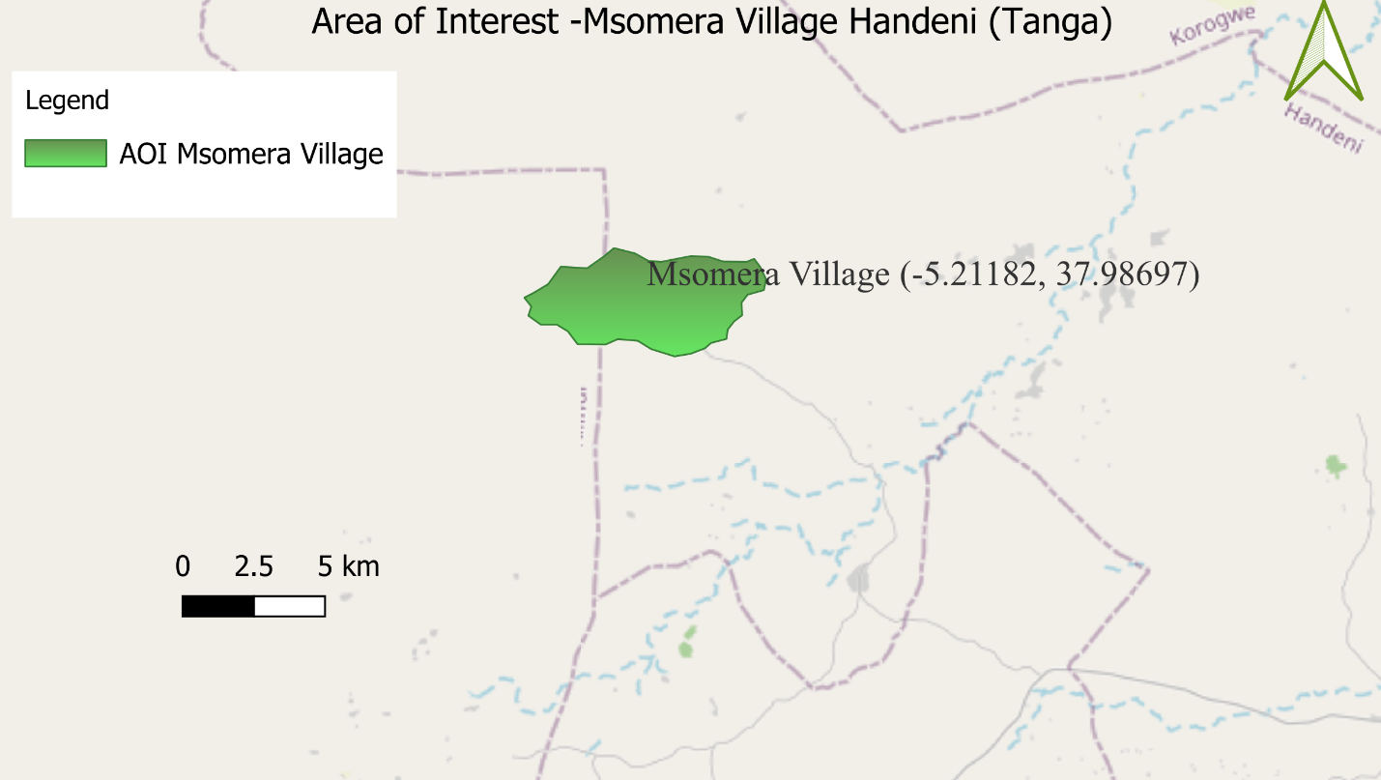

Figure 3.1: A map showing the Area of Interest (Green) around Msomera Village with one study village: The map includes a title, legend, scale bar(0-5km), and north arrow per cartographic standards

3.9.2 Sample Size Determination
The total population of Msomera Village was 15,566 persons, distributed across approximately 2,685 households. For the purpose of determining the quantitative sample size, the study treated individual persons as the population units because data were collected from individual adult respondents. Therefore, the total population of 15,566 persons was used in the initial sample-size calculation using Yamane’s formula. The household was used mainly to identify and locate respondents, while one adult respondent from each selected household provided information on livelihood activities, livestock production, access to services, resource use, and experiences after relocation.
The quantitative study included relocated pastoralists, native residents, and relevant government or local officials. However, the main analysis of pastoral livelihood sustainability satisfaction and wellbeing after relocation was restricted to 319 respondents from relocated pastoralist households because these outcomes specifically measured the experiences of households relocated from the Ngorongoro Conservation Area. Native residents and officials provided additional contextual information on local services, resource use, community relations, and the relocation process, but they were not included in the logistic regression analyses of post-relocation wellbeing and pastoral livelihood sustainability.
Yamane's formula at a 5% level of precision. Accordingly, the required sample size was calculated as follows

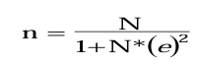

Where
n= Required sample size
N=Total known population size
e=Margin error (5%) or Precision level of 5%

then,
N=15,566 (2,685 Households). The total known population size (Msomera Village)
n=15,566/(1+15,566*0.05²)
n= 390

Required sample size(n)=390 people

3.9.3 Sampling Methods

Sampling involved selecting a manageable number of respondents from the study population to obtain information relevant to the study objectives. Probability sampling was used for the quantitative component to enhance the representativeness of the household survey, while non-probability sampling was used for the qualitative component to identify participants with relevant knowledge and experience of the relocation process and pastoral livelihood conditions.

3.9.3.1 Probability Sampling

Probability sampling was employed for the quantitative component of the study. Specifically, proportionate stratified random sampling was used to ensure representation of the main social and institutional groups relevant to the study. The population was stratified according to social role and residential status into three groups: relocated pastoralists, native residents, and local officials. The overall required sample size was subsequently distributed proportionately across the three strata based on their respective population sizes using the following formula:

Where
n_{h}​ = sample size allocated to stratum
N_{h} = population size of stratum
N = total population across all strata
n = overall required sample size (390)

Table 3.2: Sampling Matrix

Stratum | Population N_{h} | Proportion | Allocated Sample
Relocated pastoralists | 12,732 people | = (12,723/15,566) *390 | 319
Native residents | 2,036 people | = (2,036/15,566) *390 | 51
Officials | 798 People | = (798/15,566) *390 | 20
Total |  |  | 390

Following the proportional allocation, the calculated sample for each stratum was obtained by multiplying the proportion of the stratum's population by the overall sample size of 390. Within each stratum, respondents were subsequently selected using simple random sampling from the verified sampling frame.

3.9.3.2 Non-Probability Sampling

Purposive sampling was used for the qualitative component. Participants were selected on the basis of their knowledge and experience of the Ngorongoro–Msomera relocation process, pastoral livelihood conditions, livestock production, access to social and livestock services, natural-resource management, land-use issues, and relationships between relocated pastoralists and native residents.

The qualitative participants included district officials, ward and village leaders, livestock, agricultural and veterinary extension personnel, pastoralist elders, selected native community representatives, and selected relocated pastoralist household members. Some relocated pastoralist participants had previously completed the household questionnaire and were purposively selected for follow-up interviews because they could provide richer explanations of quantitative findings. For example, participants were selected when they had direct experience of water access challenges, grazing-land changes, livestock markets, veterinary services, extension support, or changes in wellbeing after relocation.

The qualitative sample was determined by the relevance and depth of information obtained from participants, rather than by Yamane’s formula. The qualitative findings were analyzed thematically. Quantitative and qualitative findings were then integrated through joint displays and narrative comparison to identify areas of convergence, complementarity, and divergence.

3.10 Data Collection Methods

3.10.1. Primary Data Collection Methods

The researcher gathered primary data for this study through questionnaires, in-depth interviews, and focus group discussions with pastoralists relocated from Ngorongoro to Msomera Village, as well as with native residents and prominent local leaders. This data aimed to illustrate the pastoralists' lifestyle, their socio-economic conditions, and the challenges in policy implementation that may hinder their continued residence in Msomera Village.

The primary objective of gathering primary data was to obtain information from 387 individuals in the study area on the factors associated with the long-term sustainability of pastoral livelihoods, including the availability of grazing land, access to education, market accessibility etc.

3.10.1.1 Questionnaire

Structured questionnaires were administered to the selected respondents to collect quantitative data on grazing land availability, education access, market access, and other socio-economic factors affecting the sustainability of pastoralists moved from Ngorongoro to Msomera Village. This method allowed for easy data collection and statistical analysis of patterns and relationships.

3.10.1.2 Interview
Semi-structured interviews were conducted with key informants such as village leaders, ward leaders, district officers, extension staff, elders, and other relevant officials. These interviews provided detailed insights into policy implementation challenges, land-use management, service delivery, and the lived experiences of pastoralists in Msomera Village.

3.10.1.3 Focus Group
Focus group discussions were held with selected community members in order to explore shared experiences, local norms, common challenges, and possible solutions related to pastoralist sustainability, grazing land pressure and community relations in Msomera Village.

3.10.2 Secondary Data Collection Methods

Secondary data obtained from sources that were previously collected by other organizations, government agencies, and researchers. These data provided historical background, baseline information, and support the validation of primary findings in the study.

3.10.2.1 Published Reports and datasets

Published reports and datasets included information from forest monitoring systems, land-use reports, and other official or research-based databases. These sources provided evidence on changes in grazing land, settlement patterns, and resource pressure in Msomera Village.

3.10.2.2 Literature Review

The literature review synthesized previous studies, concepts, and theories related to pastoralist sustainability, relocation, land scarcity, education, market access etc. It also helped to guide variable selection and support triangulation between primary and secondary data.

3.11 Data Processing and Analysis
Data processing and analysis organized, cleaned, and interpret quantitative and qualitative data from Msomera Village. Quantitative questionnaire data was coded and statistically analyzed to identify patterns in grazing land, education, market access, and other socio-economic factors impacting pastoralist sustainability.

3.11.1 Quantitative data analysis
Python version 3.12.2 was used to analyse quantitative data from the household questionnaires. Descriptive statistics, including frequencies, percentages, and means, were used to summarize key factors such as the availability of grazing land, access to education, market accessibility, veterinary and animal care service ratings, clean water service ratings for human use, health clinic service ratings, government extension assistance, and the frequency of water- and grazing-related conflict. Inferential statistics were then applied to determine whether these independent variables were significantly associated with the long-term sustainability of pastoral livelihoods.

Multiple linear regression was involved to look at how different socio-economic factors like the size of the livestock population, access to extension services, the pressure on grazing land, access to education and clinic, market accessibility, and land tenure security affect the sustainability of pastoralists who moved from Ngorongoro to Msomera Village. T Test, Binomial Test, Chi-square, test of independence and goodness of fit was involved to compare patterns across different groups

3.11.2 Qualitative Analysis

Qualitative data from key informant interviews and focus group discussions were analyzed manually using thematic analysis. Transcripts were read repeatedly to identify initial codes, which were then grouped into categories and broader themes such as water scarcity, policy gaps, livelihood changes, conflict, and institutional challenges. These themes were used to explain and enrich the quantitative findings, providing deeper context and interpretation of the statistical patterns.

3.12 Validity and Reliability of the Study

3.12.1 Validity of Research Instruments

Validity refers to the extent to which a research instrument measures what it is intended to measure. In this study, content validity, construct validity, face validity, and methodological triangulation were considered.

3.12.2 Content Validity

Content validity was enhanced by aligning the questionnaire, interview guide, and focus-group discussion guide with the study objectives, conceptual framework, and relevant literature on pastoralism, livelihood sustainability, service access, grazing-land conditions, water access, livestock health, market access, institutional support, and farmer-pastoralist conflict. The questionnaire content was reviewed by the research supervisor. The reviewers assessed the relevance, clarity, completeness, and appropriateness of the questions. Their comments were used to improve the wording, remove duplicated questions, eliminate ambiguous expressions, and align response categories with the intended analysis

3.12.3 Construct Validity

Construct validity was enhanced by defining each major concept in measurable terms. For example, pastoral livelihood sustainability was measured through respondents’ satisfaction with pastoral livelihood sustainability, coded as 1 = satisfied and 0 = not satisfied. Wellbeing after relocation was measured as 1 = better and 0 = not better. Service-access variables were measured as adequate or inadequate, while livestock-water access reliability was measured as 1 = yes, always and 0 = sometimes or seasonal. The operationalization table provides a direct link between objectives, variables, indicators, questionnaire items, scales, coding, and methods of analysis. This strengthened consistency between what the study intended to measure and what was analyzed.

3.12.4 External Validity

By selecting respondents from the relevant villages and key stakeholder groups in Msomera Village, the study improved the likelihood that the findings reflect the wider situation of pastoralist relocation contexts with similar socio-economic conditions

3.12.5 Triangulation

The study used methodological triangulation by combining household questionnaires, questionnaires for native residents and officials, key-informant interviews, focus-group discussions, field observations photos. The use of different data sources enabled comparison of quantitative patterns with participants’ experiences and institutional perspectives. The research report states that the study used a mixed-methods case-study design and multiple sources of evidence.

3.12.6 Reliability

Reliability was enhanced through the use of standardized instruments, clearly defined response options, pilot testing, careful questionnaire revision. The study used consistent coding procedures in the quantitative dataset. Binary variables were coded as 1 for the presence of an outcome or favorable condition and 0 for the absence or comparison category. The dataset used for analysis had valid observations and no missing values for the listed variables. Research assistants were trained before data collection on the study objectives, participant rights, informed consent, the meaning of questionnaire items, translation procedures, neutral interviewing, and correct recording of responses. The researcher supervised field data collection and checked completed questionnaires daily to identify omissions or inconsistencies.

Table 3.3: Reliability results table

Reliability procedure | Action taken | Result
Pilot testing | Instruments pre-tested with 25 respondents | Questions were clarified and duplicate or unclear items were revised
Standardisation | Structured questionnaires, fixed response categories, and coding manual used | Improved consistency of data collection and analysis
Research-assistant training | Assistants oriented on consent, neutrality, question meaning, and recording | Improved consistency in questionnaire administration
Data cleaning | Questionnaires and dataset checked for completeness and coding accuracy | Final coded household dataset contained valid observations and 0 missing values per listed variable
Triangulation | Questionnaires, interviews, FGDs, observations photos, and documents used | Findings compared across multiple sources

3.12.7 Instrument Reliability

The questionnaire was standardized, and data collectors were trained to use the instruments in a consistent way. Participants were given clear instructions to help them understand and answer the questions.

3.12.8 Data Management
Before analysis, all collected data were carefully checked for completeness and consistency. Any discrepancies or errors found during data processing was corrected through follow-up verification

3.12.9 Ethical Considerations
This study followed ethical standards, including informed consent, confidentiality, anonymity, and academic integrity. Participants were informed about the study's purpose and objectives before voluntary consent is obtained, and the required research permits was secured from the university and relevant authorities. All information given were kept private and only used for school work. All sources were cited in Harvard style to avoid plagiarism

CHAPTER FOUR

FINDINGS AND DISCUSSION

4.1 Introduction

This chapter presents, analyzes, and discusses the findings obtained from questionnaires, interviews, focus group discussions, observation, and document review. The discussion is organized according to the research objectives and research questions to provide evidence on the socio-economic factors influencing the sustainability of pastoralists moved from Ngorongoro to Msomera Village, Tanzania.

4.2 Characteristics of Respondents

The demographic characteristics of the respondents and their family relationship patterns are presented in this section. These characteristics are important as they provide background information that helps explain respondents’ perceptions and experiences on socio-economic factors affecting the sustainability of pastoralists moved from Ngorongoro to Msomera Village, Tanzania

4.2.1 Sex of Respondents

Table 4.1: Sex of Respondents (N=319)
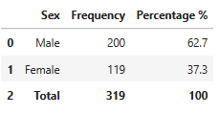
Source: Field Research Data (2026) Key: N=Number of respondents (Pastoralists relocated from Ngorongoro).
The sex distribution of respondents shows that males accounted for the largest share of the sample with 200 respondents (62.7%) and females were 119 respondents (37.3%) making a total of 319 respondents. The imbalance may reflect the fact that men are more likely to head households, to participate in livestock-related decision-making and to be directly involved in relocation and livelihood activities of the pastoralist context of Ngorongoro and Msomera.
Overall, the sex distribution suggests that the sample captured both male and female perspectives, although male respondents were more dominant. This helps the study reflect the realities of household livelihood organization in Msomera Village, where gender roles may influence access to livestock, income opportunities, and adaptation to resettlement conditions, thereby making the findings more relevant to the research title on socio-economic factors influencing the sustainability of pastoralists moved from Ngorongoro to Msomera Village, Tanzania.

4.2.2 Education Level of Respondents

Table 4.2: Education Level of Respondents (N=319)
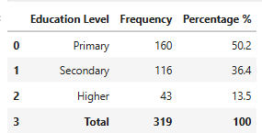
Source: Field Research Data (2026) Key: N=Number of respondents (Pastoralists relocated from Ngorongoro).
The distribution of education level indicated that most of the respondents had a primary education level with 160 respondents (50.2%) followed by secondary education level with 116 respondents (36.4%). Respondents with higher education were 43 (13.5%), making the total sample 319 respondents

In general, the results imply that most of the respondents had primary or secondary education, indicating generally moderate educational background in the study area. This is important for the research because education level may influence respondents’ understanding of relocation, access to alternative livelihoods, awareness of government support services, and ability to adapt to the socio-economic conditions affecting the sustainability of pastoralists moved from Ngorongoro to Msomera Village, Tanzania.

4.2.3 Household Size of Respondents

Table 4.3: Household Size of Respondents (N=319)
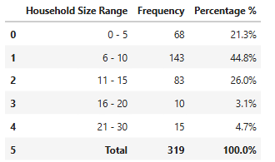

Source: Field Research Data (2026) Key: N=Number of respondents (Pastoralists relocated from Ngorongoro).

The household size distribution shows that the majority of respondents had households in the 5–10 range, accounting for 143 respondents or 44.8%, followed by the 11–15 range with 83 respondents or 26.0%. Smaller households of 0–5 members comprised 68 respondents or 21.3%, while larger households of 16–20 members were 10 respondents or 3.1%, and those of 21–30 members were 15 respondents or 4.7%.

4.2.4 Source of Income of Respondents

Table 4.4: Source of Income of Respondents (N=319)

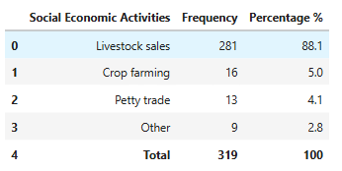

Source: Field Research Data (2026) Key: N=Number of respondents (Pastoralists relocated from Ngorongoro).

For the majority of respondents, the main source of income was through livestock sales (281 respondents, 88.1%) followed by crop farming (16 respondents, 5.0%). Petty trade accounted for (13 respondents, 4.1%) and others (9 respondents, 2.8%). Total 319 respondents.

In general, the findings indicate that livestock continues to be the dominant livelihood activity for relocated pastoralists in Msomera Village. This is highly relevant to the study as the sustainability of these households is greatly determined by livestock performance, access to grazing land, water availability, market opportunities, and a conducive socio-economic environment following their relocation from Ngorongoro.

The specific objectives of this study were to assess the current socio-economic activities undertaken by relocated pastoralist households in Msomera Village; to determine the extent of pastoral livelihood sustainability among households relocated from Ngorongoro to Msomera Village; and to assess the socio-economic factors associated with pastoral livelihood sustainability among relocated pastoralist households in Msomera Village, Tanzania.

4.3 Current socio-economic activities undertaken by relocated pastoralist households in Msomera Village

4.3.1 Quantitative Findings

This section presents the findings for the first specific objective of the study, which was to assess current socio-economic activities undertaken in Msomera Village. The discussion focuses on the main livelihood activities reported by respondents.

Table 4.5: Social Economic Activities Undertaken by Respondents (N=319)

Table 4.5 shows the main socio-economic activities of respondents in Msomera Village and gives an indication of the extent to which households depend on livestock keeping and other income-generating activities after relocation.

Table 4.6: Main livelihood sources among pastoral households: observed vs expected frequencies and chi square test (N = 319)

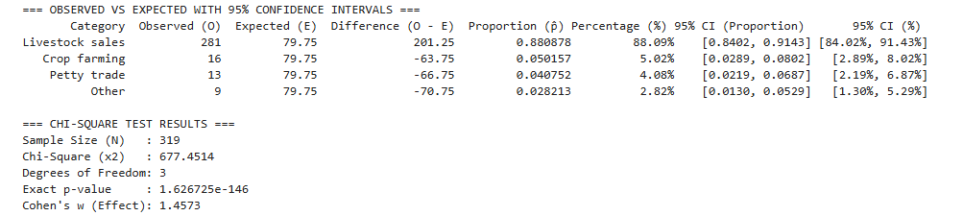

Source: Field Research Data (2026) Key: N=Number of respondents (Pastoralists relocated from Ngorongoro).

Table 4.5 summarizes the main socio-economic activities reported by pastoral households in Msomera Village (N = 319). Livestock sales were overwhelmingly the dominant livelihood source, reported by 281 households (88.1%). Crop farming, petty trade, and other activities were reported as the main livelihood source by only 16 households (5.0%), 13 households (4.1%), and 9 households (2.8%), respectively.

A chi-square goodness-of-fit test in Table 4.6, indicated that the observed distribution of livelihood sources differed significantly from an equal distribution across the four activity categories, χ²(3, N = 319) = 677.45, p = 1.63 × 10⁻¹⁴⁶. The effect size was very large (Cohen’s w = 1.46), confirming that the concentration of households in livestock sales represents a substantial and meaningful pattern rather than a minor variation among livelihood options.

These results address the first research objective, which examined the socio-economic activities undertaken in Msomera Village. They show that livestock-based production and sales remained the principal socio-economic activity and primary income source for relocated pastoralist households. Although a small proportion of households relied mainly on crop farming, petty trade, or other activities, these alternatives played a comparatively minor role. Overall, the findings indicate that pastoralism remained central to household survival and income generation following relocation from Ngorongoro.

This pattern aligns with natural capital within Sustainable Livelihoods Theory, which recognizes livestock as a key livelihood asset for pastoral households. In this context, livestock function as both productive natural-resource-based assets and financial capital because households can sell animals and animal products to obtain income for food, health care, education, and other essential needs. The dominance of livestock sales therefore indicates that pastoralism continued to be the main livelihood strategy after relocation. The smaller contribution of crop farming, petty trade, and other activities suggests that some households use diversification to supplement income and reduce vulnerability, but these activities complement rather than replace livestock keeping.

In general, the results show that the livelihood structure in Msomera Village is still predominantly based on livestock keeping. The dependence implies that any problems affecting grazing, water, livestock health or access to markets are likely to have direct consequences on household income and welfare. Consequently, the sustainability of pastoralists in the study area is still closely linked to the performance of livestock-based economic activities.

Table 4.7: Herd Size Distribution by Respondents(N=319)

The table shows the distribution of respondents by herd size in Msomera Village. The results provide an indication of the number of livestock owned by households and the extent to which pastoralism remains the dominant livelihood activity after relocation.
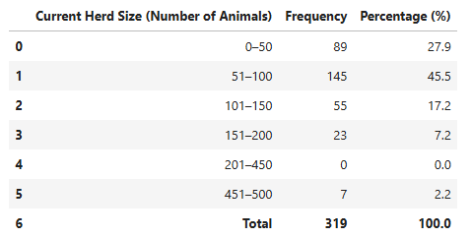
Source: Field Research Data (2026) Key: N=Number of respondents (Pastoralists relocated from Ngorongoro).

Table 4.7 shows that livestock keeping was the main economic activity among respondents in Msomera Village. The largest group of households kept between 51 and 100 animals (145 respondents, 45.5%), followed by those keeping 0–50 animals (89 respondents, 27.9%). A further 55 respondents (17.2%) kept 101–150 animals, and 23 respondents (8.1%) kept 151–200 animals. Only 7 respondents (2.2%) reported herds of 451–500 animals, and no households were recorded in the 201–450 range.

Overall, the distribution indicates that livestock ownership was widespread, but most households maintained moderate herd sizes rather than very large herds. This pattern confirms that livestock keeping remained a dominant livelihood activity and a major source of income for relocated pastoralists in Msomera Village. It also points to a largely livestock-dependent economy in which household well-being is closely linked to herd size and livestock performance.
Within Sustainable Livelihoods Theory, herd size is an indicator of natural capital, reflecting the stock of productive livestock assets available to each household. Larger herds generally provide greater potential for milk, meat, offspring, and sales income, thereby strengthening financial capital and enhancing resilience to shocks such as drought, disease, or market fluctuations. The concentration of households in the 51–100 and 0–50 categories suggests that many pastoralists rely on moderate-sized herds to meet daily needs, while the small number of very large herds indicates that only a limited proportion of households hold extensive livestock assets.

Table 4.8: Non Pastoral Livelihood Diversification Responses (N=319)
The table examines whether respondents had diversified beyond pastoralism after relocation to Msomera Village. The results provide an indication of the extent to which households were engaging in non-pastoral income-generating activities and adapting to the new settlement conditions.
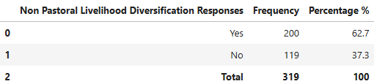
Table 4.9: Exact binomial test of livelihood diversification among relocated pastoralist households in Msomera Village, Tanzania (N = 319)
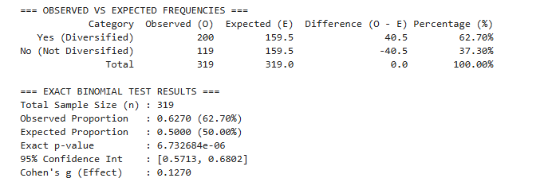
Source: Field Research Data (2026) Key: N=Number of respondents (Pastoralists relocated from Ngorongoro).

Table 4.8 presents respondents’ willingness to engage in non-pastoral livelihood diversification among relocated pastoralist households in Msomera Village (N = 319). Most respondents, 200 (62.7%), reported that they did not want to diversify into other economic activities, while 119 respondents (37.3%) reported willingness to diversify. The proportion who did not want diversification was significantly higher than the expected 50% proportion (exact binomial test, p = 0.0000067; 95% CI: 57.1%–68.0%; Cohen’s g=0.127g = 0.127g=0.127).
The findings indicate that pastoralism remained the preferred and dominant socio-economic activity among most relocated households in Msomera Village. The relatively smaller proportion willing to undertake non-pastoral activities suggests limited interest in, or uptake of, alternative income sources such as crop farming, petty trade, wage employment, or other small businesses. This pattern reflects households’ continued reliance on livestock keeping as their principal livelihood activity after relocation.

4.3.2 Qualitative Findings

Theme 1: Pastoralism remains the primary livelihood activity
Participants described livestock keeping as the central socio-economic activity in Msomera Village. Cattle, goats, and sheep provide food, income, savings, and social security for pastoral households.
“Livestock keeping is our main work; animals provide us with milk, meat, and money when we sell them.” (KI-01)

Theme 2: Crop cultivation complements livestock keeping
Participants reported engaging in crop production alongside livestock keeping to improve household food availability and diversify income. Cultivation provides an additional livelihood option, especially when livestock income is insufficient.
“We keep animals, but we also cultivate crops so that the family can have food.” (KI-01)

Theme 3: Livestock marketing provides household income
Participants identified the sale of livestock and livestock products as an important source of cash income. Earnings are used to meet daily household needs, school expenses, health costs, and livestock-related expenditures.
“When we need money for food or school, we sell an animal at the market.” (KI-01)

Theme 4: Livelihood diversification strengthens household resilience
Some households undertake small businesses, casual labour, or other income-generating activities in addition to pastoralism. These activities help households meet basic needs and cope with fluctuations in livestock production or market income.
“When livestock income is not enough, some people do small businesses to support their families.” (KI-01)

Table 4.10: Joint interpretation of Quantitative and Qualitative findings

Quantitative finding | Qualitative theme | Joint interpretation
Livestock sales were the dominant main livelihood source, reported by 281 households (88.1%). Crop farming, petty trade, and other activities accounted for 5.0%, 4.1%, and 2.8%, respectively. The distribution differed significantly from an equal distribution: χ²(3, N = 319) = 677.45, p = 1.63 × 10⁻¹⁴⁶, Cohen’s w = 1.46. | Theme 1: Pastoralism remains the primary livelihood activity | Convergent: The quantitative and qualitative findings consistently show that livestock keeping remained the main socio-economic activity and economic foundation for relocated pastoralist households in Msomera Village.
Livestock sales were the principal livelihood source for 88.1% of respondents. | Theme 3: Livestock marketing provides household income | Participants explained that livestock and livestock-product sales provide cash for food, school expenses, health care, and other household and livestock needs. This explains the dominance of livestock sales in the quantitative findings
Crop farming was the main livelihood source for 5.0% of respondents. | Theme 2: Crop cultivation complements livestock keeping | Crop cultivation was practiced by some households to improve food availability and supplement livestock income, but it was generally a complementary activity rather than the main livelihood source.
Petty trade and other activities were the main livelihood source for 4.1% and 2.8% of respondents, respectively. | Theme 4: Livelihood diversification strengthens household resilience | Small businesses, casual labour, and other income-generating activities provided supplementary support for some households, particularly when livestock income was insufficient. However, their small proportions show that they had not replaced pastoralism as the primary household economic activity.
Two hundred households (62.7%) reported that they did not want to diversify into non-pastoral livelihood activities, compared with 119 households (37.3%) who were willing to diversify. The proportion not willing to diversify was significantly greater than 50%: exact binomial test p = 0.0000067, 95% CI = 57.1%–68.0%, Cohen’s g = 0.127. | Themes 1 and 4: Pastoralism remains the primary livelihood activity; livelihood diversification strengthens household resilience | Although some households used crop farming, petty trade, or other activities to supplement income, most preferred to remain dependent on pastoralism. Diversification was therefore limited and mainly complementary rather than a shift away from livestock-based livelihoods.

Overall, the joint findings indicate that pastoralism remained the principal socio-economic activity and main source of household income among relocated pastoralists in Msomera Village. Livestock keeping and sales provided food, cash income, savings, and economic security, while crop cultivation, petty trade, casual labour, and other activities mainly served as supplementary livelihood strategies.

4.3.3 Observation and photographic evidence

Direct observation and photographic documentation showed that relocated pastoralist households in Msomera Village lived in a predominantly rural environment characterized by residential houses, household compounds, cultivated farms, and surrounding open land. The presence of crop fields near households indicates that farming forms part of the local livelihood setting alongside pastoralism. The observed settlement environment also reflects households’ efforts to establish homes and livelihood activities following relocation.
The photographs provide contextual evidence of the physical setting in which pastoralist households pursue livestock keeping and farming. They should be interpreted as descriptive observation evidence and used to complement, rather than replace, participants’ interview and survey responses.

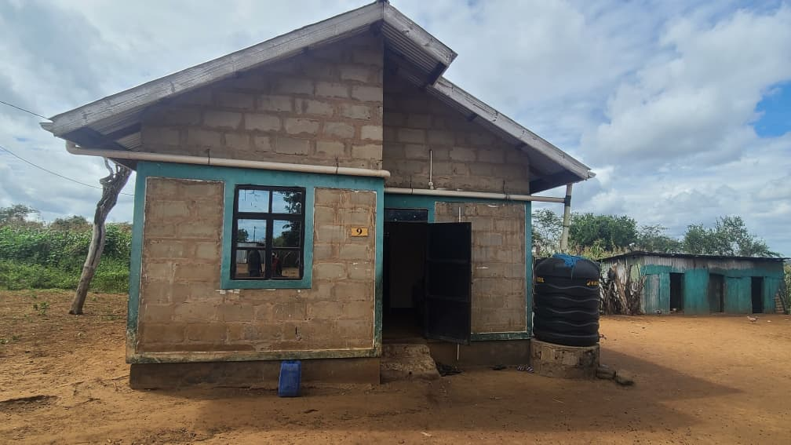
Figure 4.1: Physical settlement and livelihood environment of relocated pastoralist households in Msomera Village.

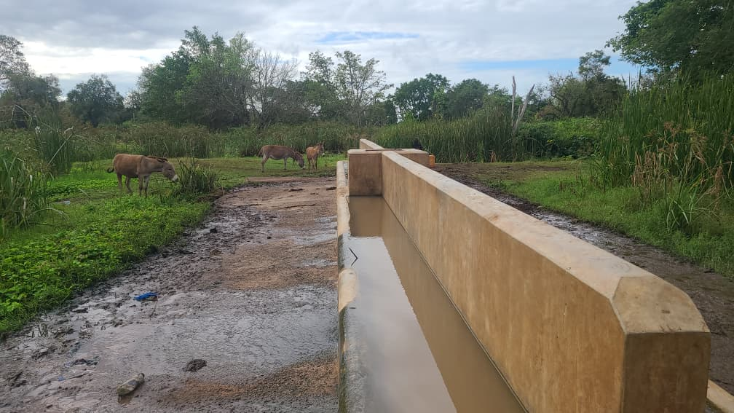
Figure 4.2: Water access point for livestock in Msomera Village.

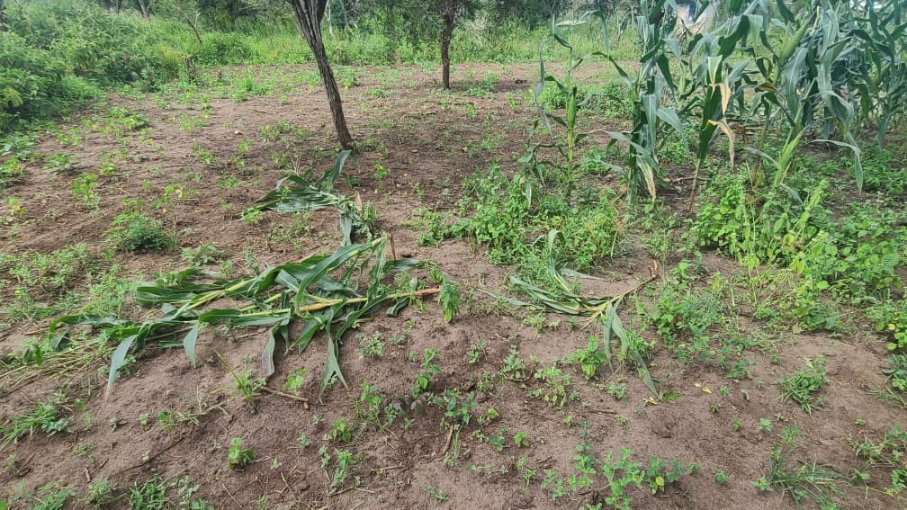

Figure 4.3: Cultivated farm plots within the relocated pastoralist settlement area of Msomera Village
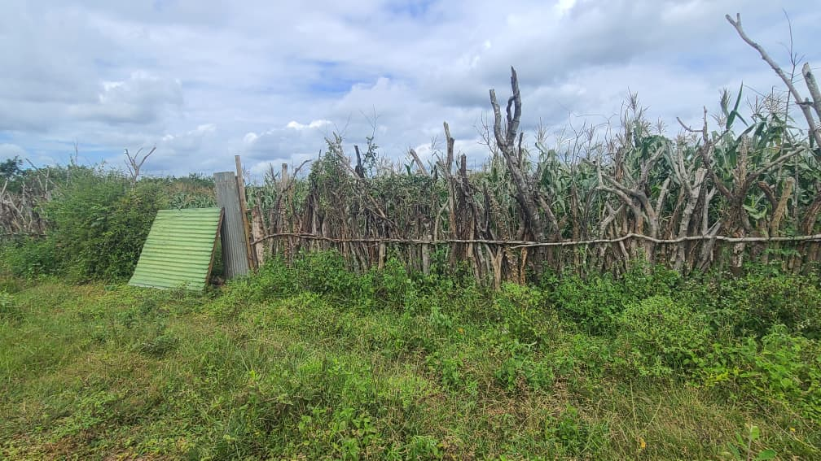
Figure 4.4: A household livestock enclosure (boma) in Msomera Village.

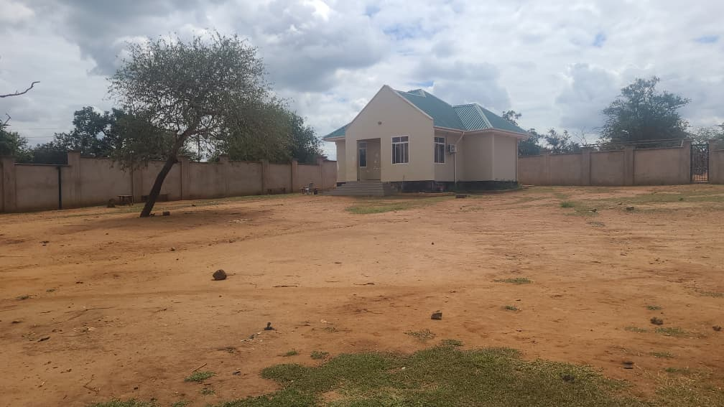
Figure 4.5: Livestock auction market in Msomera Village, Tanzania.
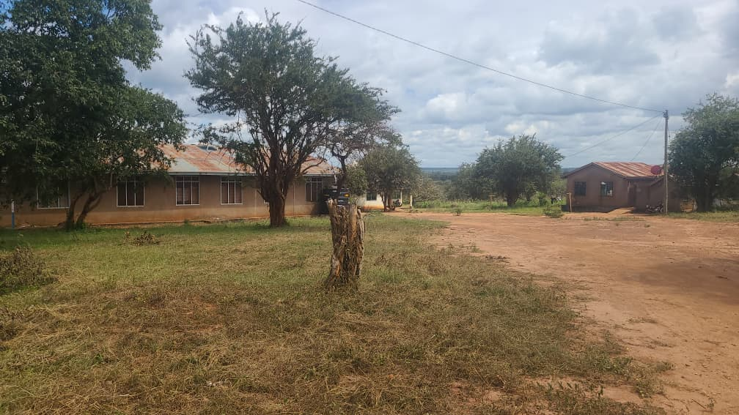
Figure 4.6: Village dispensary in Msomera Village, Tanzania.

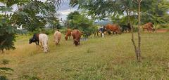
Figure 4.7: Cattle grazing in Msomera Village, Tanzania.

4.4 Extent of sustainability of Pastoralism in the area of study
This section presents findings for the second specific objective of the study, which was to determine the extent of sustainability of pastoralism in the study area. The assessment considers sustainability-related livelihood conditions in Msomera Village, including livestock ownership, livestock-derived household income and protein contribution, access to reliable water and grazing land, veterinary and extension support, livestock training, access to clean water, health, education and livestock-market services, resource-related conflict, livelihood diversification, and respondents’ perceived wellbeing after relocation. The discussion is based on data collected from study participants.
The assessment was guided by the Sustainable Livelihoods Theory, which considers sustainable livelihoods to depend on access to natural, financial, human, physical, and social assets. In this study, grazing land and livestock water represent natural assets; herd size and livestock-related income/protein contribution represent financial and productive assets; veterinary care, extension services, training, health services, and education represent human and institutional support; water points and markets represent physical support; while water and grazing-resource conflict reflects the social conditions affecting pastoral livelihood continuity.
However, the results should be interpreted with caution. The study assessed sustainability through several related indicators but did not construct a validated multidimensional pastoral sustainability index. In addition, the measures of wellbeing after relocation and satisfaction with pastoral livelihood sustainability were self-reported and retrospective. Therefore, the findings indicate the extent of sustainability-related livelihood conditions and respondents’ perceived wellbeing after relocation, rather than providing conclusive evidence that pastoralism is highly sustainable in the long term

4.4.1 Quantitative Findings

Table 4.11: Sustainability-Related Livelihood Conditions and Perceived Wellbeing after Relocation (N=319)
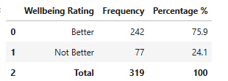

Table 4.11: One-Sample Proportion Test for Perceived Well-being (n=319)
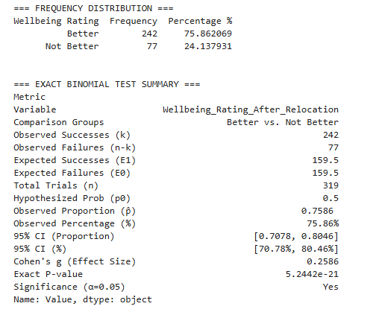

Source: Field Research Data (2026) Key: N=Number of respondents (Pastoralists relocated from Ngorongoro).

Table 4.10 presents the self-reported wellbeing of relocated pastoralists in Msomera Village (N = 319). Of these, 242 respondents (75.9%) indicated that their wellbeing was better after relocation, while 77 respondents (24.1%) reported that it was not better. Table 4.11 shows the results of a one-sample proportion test, which examined whether the proportion reporting better wellbeing differed from 50%. The observed proportion was 0.76, and the exact p-value was 5.24 × 10⁻²¹, which is far below the 0.05 significance level. Consequently, the null hypothesis that 50% of respondents would report better wellbeing was rejected. These results demonstrate that a clear majority of relocated pastoralists perceived an improvement in their wellbeing following relocation.
However, this finding reflects respondents’ perceptions of overall wellbeing and does not establish that pastoralism alone caused the improvement, nor does it demonstrate long-term pastoral sustainability. Wellbeing is influenced by multiple factors, including access to land, water, markets, health services, education, and other livelihood opportunities beyond livestock keeping. In relation to the second research objective on the extent of pastoralism sustainability, the findings suggest that livestock keeping, within the broader relocation context, continues to support many households in Msomera Village to maintain their pastoral way of life and report improved welfare. They do not, however, provide a multidimensional or objective measure of sustainability over time.
Within Sustainable Livelihoods Theory, improved self-reported wellbeing can be understood as a positive livelihood outcome that may result when households are able to access and combine livelihood assets effectively. These assets include natural capital (grazing land and water), financial capital (income from livestock sales), human capital (health, education, and extension knowledge), physical capital (infrastructure such as water points, clinics, schools, and markets), and social capital (peaceful relations with host communities and resource-sharing arrangements). The high proportion of respondents reporting better wellbeing therefore indicates that, for many households, the relocation setting provided conditions under which pastoral livelihoods could remain viable and contribute to improved household welfare. Nonetheless, because this measure is based on a single self-reported item and lacks a pre-relocation baseline or a composite sustainability index, it should be interpreted as perceived wellbeing rather than definitive evidence that pastoralism in Msomera is highly sustainable. Accordingly, the study concludes that many relocated pastoralists perceive their wellbeing to have improved, but it does not claim to have directly established long-term pastoral sustainability.

Table 4.12: Distribution of respondents by access to extension services (N=319)
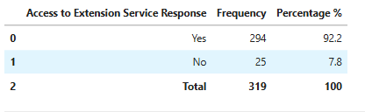
Source: Field Research Data (2026) Key: N=Number of respondents (Pastoralists relocated from Ngorongoro).

Table 4.13: One-Sample Proportion Test of Livestock Extension Training Received among Relocated Pastoralists

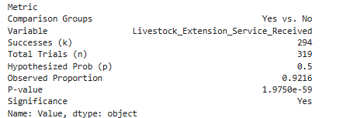

Table 4.12 shows that 294 of 319 respondents (92.2%) in Msomera Village reported receiving livestock extension services, while 25 (7.8%) did not. This indicates that extension services reached the vast majority of pastoral households after relocation. The finding contrasts with national evidence cited in the literature review: The National Audit Office (2022) reported that only about 30–40% of households receive extension support, with many pastoral areas remaining underserved. National policy documents, including the National Livestock Policy (2006) and Livestock Master Plan (2017), also highlight persistent gaps in extension coverage, staffing, funding, and transport to reach remote pastoralists. The much higher access in Msomera likely reflects the specific context of a relocated, settled community that is easier to reach, as well as differences in how "access" is defined and measured (any contact vs. regular, adequate support) and the timing of data collection relative to targeted interventions.

To assess whether this high level of access is statistically significant, a one-sample proportion test was conducted at the 5% significance level, using 50% as the hypothesized proportion. Among 319 respondents, 294 reported receiving livestock extension services (observed proportion = 0.92). The test produced a p-value of 1.98 × 10⁻⁵⁹, far below 0.05, leading to rejection of the null hypothesis. This confirms that the proportion of households reporting extension access in Msomera is statistically significantly higher than 50%, supporting the conclusion that extension services are widely available in the study area. Within the Sustainable Livelihoods Framework, extension services are part of the transforming structures and processes that shape access to livelihood assets. They strengthen human capital (knowledge and skills in animal health, breeding, feeding, marketing), can enhance social capital (links to groups and markets), and influence livelihood strategies by supporting improved practices and risk management. In this sense, the high reported access aligns with the study's finding that pastoralism remains the primary livelihood and with policy intentions in the National Livestock Policy (2006) and Livestock Master Plan (2017) to use extension to improve livestock productivity and pastoral livelihoods.

However, the result should not be taken as unconditional proof of high-quality or sustainable support. Theme 1 (Government officials): Government officials highlighted several operational barriers that constrain service delivery, including shortages of transport and fuel, limited operational budgets, language and cultural differences with pastoral households, and high household-to-staff ratios. These constraints were reported to delay outreach activities and weaken the overall effectiveness and timeliness of support services to relocated pastoral communities. Key informants stated that "sometimes services are delayed because there is no transport or fuel to reach the community," showing that access does not guarantee timely or adequate advice. The literature reviews further notes that pilot dairy projects helped increase milk production, but livestock sales remain low due to disease and lack of feed, and that conflicts over water and exploitative middlemen persist. This suggests that extension, where present, can be generic and poorly tailored to pastoral mobility and local conditions. The 7.8% without access may include the most marginalized households, potentially widening inequalities.

Overall, the 92.2% access figure agrees with policy goals for wide extension coverage [National Livestock Policy, 2006; Livestock Master Plan, 2017], disagrees numerically with national estimates of low coverage (30–40%) [National Audit Office, 2022], and fits within the Sustainable Livelihoods Framework as a positive institutional process that can enhance human capital and support more resilient pastoral livelihoods, provided other assets (water, land, markets, health, education) are adequate and operational barriers are addressed.

Table 4.13: Reliability of livestock water access among respondents in Msomera Village (N=319)
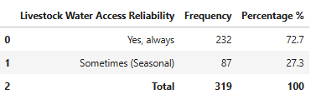
Table 4.14: One-Sample Proportion Test of Reliable Livestock Water Access among Relocated Pastoralists (N=319)
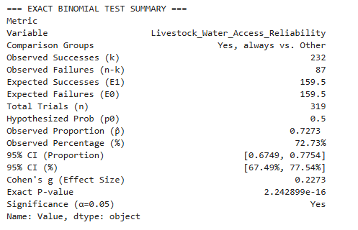
Source: Field Research Data (2026) Key: N=Number of respondents (Pastoralists relocated from Ngorongoro).
Table 4.14 presents the findings on the reliability of livestock water access among respondents in Msomera Village, in relation to the objective on the extent of sustainability of pastoralism. The results show that 232 respondents (72.7%) reported that water was always available for livestock, while 87 respondents (27.3%) stated that water was available only sometimes, mainly depending on the season. These findings suggest that most respondents had relatively reliable access to water for their livestock, which is an important condition for sustaining pastoral livelihoods. However, the fact that more than one-quarter of respondents reported seasonal water access indicates that availability was not consistent for all households. This may create pressure during dry periods, especially for families whose livestock depend heavily on regular water supply for survival and productivity.

To support these findings, a one-sample proportion test was conducted at the 5% significance level, using 50% as the hypothesized proportion. The observed proportion of respondents reporting always-available water was 0.73, and the p-value was 2.24 × 10⁻¹⁶, which is far below 0.05. Therefore, the null hypothesis was rejected, indicating that the proportion of respondents reporting reliable livestock water access was statistically significantly higher than 50%. In relation to the objective on the extent of sustainability of pastoralism, the results suggest that keeping livestock in Msomera Village is supported by generally reliable water access, which helps many households to maintain and sustain their pastoral livelihoods after relocation.

The finding that 72.7% of respondents reported reliable water access both supports and contrasts with the existing literature. It aligns with Theme 1 (relocated pastoralists) in the study’s qualitative data, where a key informant stated, “Water is life for both people and animals. When it is reliable, life is smoother.” (KI-01). This underscores the centrality of dependable water supplies for household and livestock wellbeing and reinforces the view that water access remains a critical determinant of livelihood sustainability in the relocation context. It also aligns with policy intentions in the National Livestock Policy (2006) and Livestock Master Plan (2017), which prioritize water infrastructure for livestock. However, it disagrees with evidence cited in the literature review that water points often break down due to poor maintenance (National Audit Office, 2022) and that conflicts over water between farmers and pastoralists have intensified in several districts, including Mvomero, where insufficient resources and inadequate participation in land demarcation have led to increased tensions and disputes over land use and access to water resources (Mbarouk et al., 2025). The higher reliability reported in Msomera may be explained by several factors: the relocated settlement may have benefited from new or rehabilitated water points as part of the relocation package; the concentration of households may make water infrastructure easier to manage and maintain compared to more dispersed pastoral areas; and the survey question captured perceived reliability rather than technical functionality or conflict incidence. Thus, while Msomera appears to perform better than the broader national picture, the 27.3% with seasonal access suggests that maintenance and conflict risks identified in the literature may still emerge if infrastructure is not sustained and if competition over water increases with population growth.
Within the Sustainable Livelihoods Framework, reliable water access functions as both natural and physical capital, underpinning livestock productivity, household food security, and income from livestock sales. It also interacts with other assets: when water is reliable, households can better utilize their human capital (skills in livestock management) and financial capital (income from sales) to sustain their livelihood strategies. The statistically significant majority reporting reliable water therefore supports the broader finding that pastoralism remains a viable and primary livelihood in Msomera. At the same time, the substantial minority with seasonal access highlights a vulnerability in the vulnerability context of the SLF, particularly during climate shocks such as droughts. Addressing this gap through improved infrastructure, maintenance, and participatory water governance would strengthen the overall sustainability of pastoral livelihoods in the area.

Table 4.15: Access to livestock training among respondents (N=319)
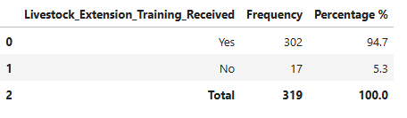

Table 4.16: One-Sample Proportion Test of Receipt of Livestock Extension Training among Relocated Pastoralists (N = 319)
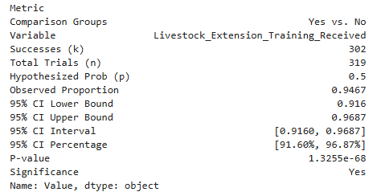
Source: Field Research Data (2026) Key: N=Number of respondents (Pastoralists relocated from Ngorongoro).

Table 4.16 presents the findings on respondents' participation in livestock training in Msomera Village. The results show that 302 respondents (94.7%) answered "Yes," indicating they had received livestock extension training, while 17 respondents (5.3%) answered "No." which implies that they had not received livestock extension training. To assess whether this proportion differed significantly from what would be expected by chance, a one-sample proportion test was conducted against a hypothesized proportion of 0.5. Out of 319 valid responses, 302 respondents reported having received training (observed proportion = 0.95). The test yielded a p-value of 1.33 × 10⁻⁶⁸, which is far below 0.05, indicating that the proportion of respondents who received training was significantly higher than 0.5. The 95% confidence interval for the proportion was [0.916, 0.969], or [91.6%, 96.9%].
These findings indicate that participation in livestock training was not only high in descriptive terms but also statistically greater than would be expected under a null hypothesis of equal likelihood. This suggests that livestock-related knowledge and skills were fairly common in the study area. Training is important in pastoral settings because it can improve animal husbandry practices, disease control, feeding methods, and overall herd management. In relation to the second research objective on the extent of sustainability of pastoralism, the high and statistically significant proportion of respondents who had taken part in training reflects deliberate efforts to support pastoral households after relocation and suggests that keeping livestock, backed by training, continues to play an important role in sustaining livelihoods in Msomera Village.

The finding of 94.7% participation in livestock training agrees with the literature review's emphasis on extension services as a key policy priority and with the study's own quantitative result that 92.2% of households received extension services. It aligns with the National Livestock Policy (2006) and Livestock Master Plan (2017), which advocate for strengthened extension and training to improve livestock productivity and pastoral livelihoods. However, it disagrees with the National Audit Office (2022) report cited in the literature review, which found that only 30–40% of households receive extension support nationally. The much higher training participation in Msomera likely reflects the specific context of a relocated, settled community that was targeted for post-relocation support, as well as differences in measurement (any training contact vs. sustained, adequate training). The literature review also notes that extension advice can be generic and poorly tailored to pastoral mobility, and that operational barriers such as lack of transport, fuel shortages, and high household-to-staff ratios constrain service quality. Therefore, while the high training rate is encouraging, it should not be interpreted as unconditional evidence of high-quality, context-appropriate, or sustained capacity-building.
Within the Sustainable Livelihoods Framework, livestock training strengthens human capital by improving knowledge and skills in animal health, breeding, feeding, and marketing, and can indirectly support social capital by linking pastoralists to extension officers, groups, and market information. This enhances households' ability to adopt improved livelihood strategies and manage risks associated with climate variability, land fragmentation, and market fluctuations. The statistically significant majority reporting training therefore supports the broader finding that pastoralism remains a viable and primary livelihood in Msomera, underpinned by institutional support. At the same time, the 5.3% without training may include marginalized households (for example, those furthest from service points or with language barriers), potentially widening inequalities. Ensuring that training is not only widespread but also relevant, regular, and accessible to all groups would further strengthen the sustainability of pastoral livelihoods in the area.

Table 4.17: Frequency of Water and Grazing Resource Conflicts among Respondents in Msomera Village (N = 319)

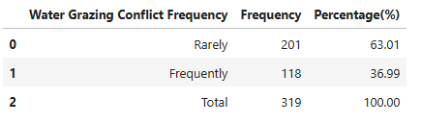

Table 4.18: Frequency of Water and Grazing Resource Conflicts among Respondents in Msomera Village (N = 319)

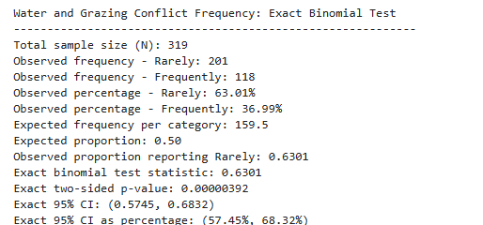

Overall, the finding that a majority of households (63%) experience water- and grazing-related conflicts only rarely suggests that, in Msomera Village, everyday relations between farmers and pastoralists are not dominated by open confrontation. This agrees with Sustainable Livelihoods Theory, indicating that for many households natural and social capital remain sufficient to sustain relatively stable livelihoods after relocation.
However, this finding disagrees with much existing Tanzanian research (e.g., Mung’ong’o et al., 2022; Ripkey et al., 2021; Mbarouk et al., 2025), which generally reports widespread and intensifying farmer–pastoralist conflicts driven by climate variability, sedentarization, land fragmentation, and weak land governance. The disagreement likely arises because Msomera is a designated pastoral settlement with some infrastructure, services, and defined boundaries, which may buffer conflict compared with more fragmented, multi-use landscapes studied elsewhere. It may also reflect that conflicts exist but are managed through local mechanisms, so they are perceived as “rare” in everyday life.
The result also partially agrees with these studies in that a substantial minority (37%) report frequent conflict, consistent with evidence that resource stress and governance gaps generate serious tensions for some households. At the same time, the finding disagrees with a strict “Tragedy of the Commons” expectation: if unregulated common-pool use were dominant, most respondents would likely report frequent conflict, yet in Msomera most describe conflicts as rare. This divergence likely reflects the role of local norms, informal institutions, and the specific design of Msomera as a pastoral settlement, which moderate access and reduce overt disputes. The coexistence of “rare” and “frequent” conflict therefore underscores the need for participatory, context-specific interventions—particularly around water infrastructure, grazing management, and inclusive land-use planning—to prevent the group experiencing frequent conflict from expanding and to safeguard the socio-economic sustainability of relocated

Table 4.19: Respondents’ rating of veterinary animal care services in Msomera Village (N=319)
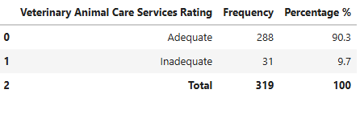

Table 4.20: One-Sample Proportion Test Results for Veterinary Animal-Care Service Rating (N= 319)
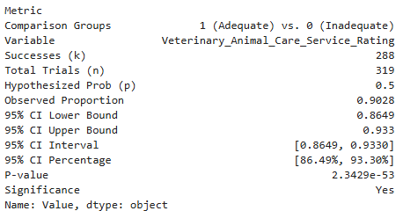
Source: Field Research Data (2026) Key: N=Number of respondents (Pastoralists relocated from Ngorongoro).

Table 4.20 presents the descriptive findings on respondents' rating of veterinary animal care services in Msomera Village. Results indicate that 288 respondents (90.3%) rated the services as "Adequate," while 31 respondents (9.7%) rated them as "Inadequate." Table 4.21 presents the results of a one-sample proportion test conducted to assess whether this proportion differed significantly from a hypothesized proportion of 0.5. The null hypothesis (H₀) stated that the proportion of respondents rating veterinary services as Adequate was equal to 0.5 (no difference from chance), while the alternative hypothesis (H₁) stated that the proportion was different from 0.5. The test yielded a p-value of 1.87 × 10⁻⁹⁶, which is far below 0.05, leading to rejection of the null hypothesis. This indicates that the proportion of respondents who rated veterinary services positively was significantly higher than 0.5.
These results suggest that the vast majority of respondents perceived veterinary animal care services to be available or satisfactory in the village. This is important in a pastoral context because veterinary support helps to control animal diseases, minimize losses, and improve overall livestock health. The high proportion of positive responses may reflect that livestock keepers had access to animal care services after relocation. However, the 9.7% who responded "Inadequate" show that not all respondents were fully satisfied or had access to these services. This may indicate issues with service delivery, distance to veterinary support, or gaps in coverage. In relation to the second research objective on the extent of sustainability of pastoralism, these findings suggest that keeping livestock in Msomera Village is supported by generally adequate veterinary services, which helps many households to maintain and sustain their pastoral livelihoods, though further efforts are still needed to reach the remaining households and strengthen service coverage.

The finding of 90.3% adequate veterinary services agrees with the study's own literature review theme that "livestock market services are broadly available, but service gaps remain," and with the quantitative result that 89.2% of respondents gave a positive rating to veterinary services in an earlier summary. It also aligns with policy intentions in the National Livestock Policy (2006) and Livestock Master Plan (2017), which emphasize veterinary care as essential for improving livestock productivity and reducing losses. However, it disagrees with broader national evidence cited in the literature review, such as the National Audit Office (2022) report that pilot dairy projects helped increase milk production but livestock sales remain low due to disease and lack of feed, and Human Rights Watch (2024) reports that people are fighting over water and that middlemen exploit pastoralists, suggesting underlying weaknesses in service systems. The higher rating in Msomera may be explained by the relocated settlement receiving targeted veterinary interventions, closer proximity to service points, and the survey capturing perceived adequacy rather than technical quality or frequency of service. Thus, while Msomera appears to perform better than the national picture, the 9.7% rating services as inadequate indicates that gaps identified in the literature—such as disease burden, uneven market services, and operational constraints—may still affect some households.
Within the Sustainable Livelihoods Framework, adequate veterinary services strengthen human capital (knowledge of disease prevention and treatment) and physical capital (healthier livestock as productive assets), thereby supporting livestock-based livelihood strategies and reducing vulnerability to shocks such as disease outbreaks. The statistically significant majority reporting adequate services therefore supports the broader finding that pastoralism remains a viable and primary livelihood in Msomera, underpinned by institutional support. At the same time, the minority rating services as inadequate highlights potential inequalities in access, possibly affecting households that are farther from service points, have weaker social ties, or face language and cultural barriers. Ensuring that veterinary services are not only perceived as adequate by most but also consistently accessible and effective for all households would further strengthen the sustainability of pastoral livelihoods in the area.

Table 4.21: Respondents’ rating of clean water as a human service in Msomera Village (N=319)
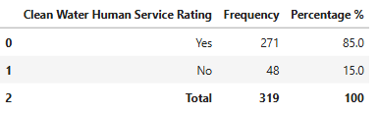
Table 4.22: Results of binomial test for clean water human service rating (1 = adequate, 0 = inadequate) among relocated pastoralist households (N = 319)
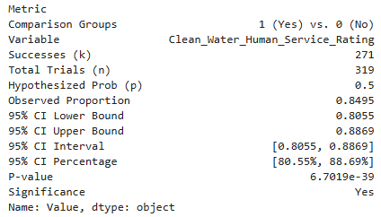
Source: Field Research Data (2026) Key: N=Number of respondents (Pastoralists relocated from Ngorongoro).

Table 4.21 presents the findings on respondents' rating of clean water as a human service in Msomera Village. The results show that 271 respondents (85.0%) answered "Yes," indicating they perceived clean water services as available, while 48 respondents (15.0%) answered "No." These findings indicate that most respondents perceived clean water services to be available in the village. Access to clean water is a basic human need and an important indicator of settlement wellbeing because it directly affects health, sanitation, and daily household activities. The high proportion of positive responses suggests that many households had some access to this essential service after relocation. However, the 15.0% who responded negatively show that access to clean water was not universal, which may reflect issues such as distance to water points, seasonal variability, or household-level constraints. Strengthening equitable access to clean water remains essential for improving health outcomes and supporting sustainable living conditions in Msomera Village.
To supplement the descriptive findings, a one-sample proportion test was conducted at the 5% significance level (α = 0.05), using 50% as the hypothesized proportion. The null hypothesis (H₀) stated that the proportion of respondents with access to clean water was equal to 0.5, while the alternative hypothesis (H₁) stated that the proportion was different from 0.5. The observed proportion of respondents reporting access to clean water was 0.85, and the p-value was 1.98 × 10⁻⁵⁹, which is far below 0.05. Therefore, the null hypothesis was rejected, indicating that the proportion of respondents with access to clean water was statistically significantly higher than 50%. In relation to the second research objective on the extent of sustainability of pastoralism, these results provide statistical evidence that access to clean water was not only high in descriptive terms but also significantly greater than would be expected by chance, supporting the view that basic services such as water contribute to sustaining pastoral livelihoods and household wellbeing in Msomera Village.
The finding that 85.0% of respondents had access to clean water is consistent with Theme 1 (“Water remains essential”), in which a key informant noted, “Water is life for both people and animals. When it is reliable, life is smoother” (KI-01), highlighting the perceived importance of clean and reliable water for household and livestock wellbeing, confirming that water is viewed as critical for household welfare. It also aligns with the National Livestock Policy (2006) and Livestock Master Plan (2017), which prioritize water infrastructure for both people and livestock. However, it disagrees with the National Audit Office (2022) report cited in the literature review, which noted that water points often break down due to poor maintenance, and with Human Rights Watch (2024), which reported conflicts over water in pastoral areas. The higher access in Msomera may reflect new or rehabilitated water points as part of the relocation package, but the 15.0% without access suggests that maintenance and equity challenges identified in the literature may still affect some households.
Within the Sustainable Livelihoods Framework, clean water functions as physical and natural capital, underpinning health, sanitation, and daily productivity, which in turn support human capital and livelihood strategies. The Tragedy of the Commons perspective warns that without fair and regulated access, competition over limited water points can lead to conflict and degradation. The statistically significant majority reporting access therefore supports pastoral livelihood sustainability, while the 15.0% without access highlights a gap that needs attention to ensure equitable and sustainable service delivery.
Table 4.23: Independent-Samples t-Test Comparing Mean Household Livestock Income or Protein Contribution Percentage by Veterinary Animal-Care Service Rating in Msomera Village (N=319)
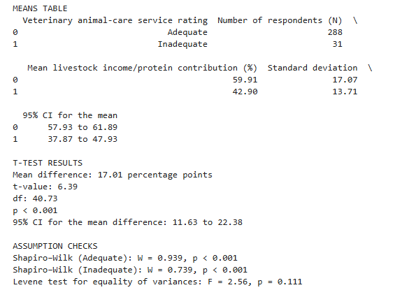

Table 4.23 shows that veterinary animal-care service rating was significantly associated with household livestock income/protein contribution in Msomera Village. Respondents who rated veterinary animal-care services as adequate had a higher mean livestock income/protein contribution percentage than respondents who rated the services as inadequate. The mean difference was 17.01 percentage points, and the difference was statistically significant, t(40.73) = 6.39, p < 0.001, with a 95% confidence interval of 11.63 to 22.38 percentage points. Since the confidence interval did not include zero, the result confirms that respondents who perceived veterinary services as adequate had significantly better livestock-related household outcomes. The large effect size, Cohen's d = 1.01, further shows that the difference between the two groups was practically important.
The finding agrees with the Sustainable Livelihoods Theory of Chambers and Conway (1992), which explains that sustainable livelihoods depend on households' access to natural, financial, human, social, and physical capital. Veterinary animal-care services strengthen human capital by providing livestock-management knowledge, disease-prevention advice, treatment, and training. They also strengthen physical and institutional capital through access to veterinary personnel, medicines, vaccination, and animal-health support. For pastoralist households that depend mainly on livestock, adequate veterinary services protect livestock assets, reduce animal losses, improve herd productivity, and support income and household nutrition. The finding also partly agrees with the Tragedy of the Commons Theory of Hardin (1968), because pressure on shared grazing land and water points can affect animal health and livestock productivity. However, veterinary services alone cannot solve overgrazing, water scarcity, grazing-land shortage, or resource-related conflict; these challenges require improved water infrastructure, grazing-land management, participatory land-use planning, and community conflict-resolution mechanisms.
The finding agrees with previous studies by Gwakisa et al. (2023), Hezron et al. (2023), Malipula (2024), Mung'ong'o et al. (2022), Ripkey et al. (2021), Mahonge et al. (2014), and Mbarouk et al. (2025), which collectively show that pastoral sustainability is influenced by livestock health, institutional services, water and grazing access, land governance, and community participation. It also supports the qualitative theme that institutional and livestock-support services enable pastoral livelihood continuity. As one key informant explained, "Extension officers help us with advice on how to care for our livestock and improve our pastoral activities" (KI-01, Key Informant, Msomera Village, 2026). The finding partly differs from studies and reports that describe very limited pastoral support services and poor relocation outcomes, including Msigwa and Mvena (2014) and the National Audit Office (2022). This difference may be explained by variations in the study area, time period, type of relocation, level of veterinary-service coverage, access to extension support, and the specific conditions experienced by pastoral households in Msomera Village.

Table 4.24: Respondents’ rating of health clinic services in Msomera Village (N=319
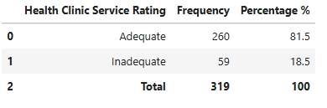
Source: Field Research Data (2026) Key: N=Number of respondents (Pastoralists relocated from Ngorongoro).

Table 4.25: Binomial Test of Health Clinic Service Rating (1 = Adequate, 0 = Inadequate) for Relocated Pastoralists in Msomera Village
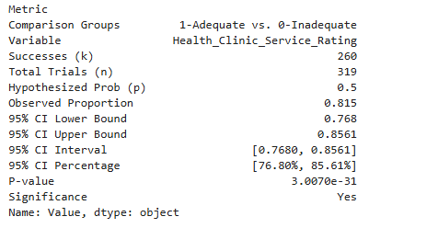

Table 4.25 presents the findings on respondents' rating of health clinic services in Msomera Village. The results show that 260 respondents (81.5%) rated the services as "Adequate," while 59 respondents (18.5%) rated them as "Inadequate." These findings suggest that most respondents perceived health clinic services to be satisfactory in the village. Access to quality health services is important in any settlement because it supports the treatment of illnesses, improves household welfare, and reduces the burden of traveling long distances for medical care. The relatively high proportion of positive responses may indicate that the relocation area has some level of acceptable health service provision. However, the 18.5% who responded "Inadequate" show that satisfactory access to health clinic services was not universal. This may reflect limitations in service coverage, staffing, equipment, or distance for some households. In Msomera Village, strengthening health clinic services remains essential for improving the wellbeing of residents and supporting sustainable settlement conditions.
To supplement the descriptive findings, a one-sample proportion test was conducted at the 5% significance level (α = 0.05), using 50% as the hypothesized proportion. The null hypothesis (H₀) stated that the proportion of respondents rating health clinic services as Adequate was equal to 0.5, while the alternative hypothesis (H₁) stated that the proportion was different from 0.5. The observed proportion of respondents giving a positive rating was 0.815 (95% CI: 0.768–0.856), and the p-value was 3.01 × 10⁻³¹, which is far below 0.05. Therefore, the null hypothesis was rejected, indicating that the proportion of respondents rating health clinic services positively was statistically significantly higher than 50%. In relation to the second research objective on the extent of sustainability of pastoralism, these results provide statistical evidence that positive ratings of health clinic services were not only high in descriptive terms but also significantly greater than would be expected by chance, supporting the view that access to basic health services contributes to sustaining pastoral livelihoods and household wellbeing in Msomera Village.
The finding of 81.5% adequate health clinic services agrees with the literature review theme that "health services support livelihood sustainability," where participants stated, "When the clinic is working well, people are healthy and can take care of their animals" (KI‑01). It also aligns with quantitative note that adequate health clinic services were associated with much higher odds of sustainability satisfaction (AOR ≈ 9.72, p < 0.001). However, it disagrees with broader concerns in the literature review, such as the National Audit Office (2022) report of weak service maintenance and Human Rights Watch (2024) reports of strained services in relocation contexts. The higher rating in Msomera likely reflects targeted health infrastructure after relocation, but the 18.5% rating services as inadequate suggests that staffing, equipment, or distance gaps still affect some households.
Within the Sustainable Livelihoods Framework, adequate health services strengthen human capital (healthy, productive household members) and reduce vulnerability to health shocks, thereby supporting pastoral livelihood strategies. The statistically significant majority reporting adequate services therefore supports livelihood sustainability, while the 18.5% gap highlights a need for more equitable and resilient health provision.
Table 4.26: Respondents’ rating of school education services in Msomera Village(N=319)
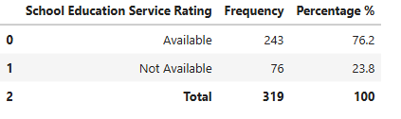
Table 4.27: One-Sample Proportion Test of Positive School Education Service Rating among Relocated Pastoralists (N = 319)
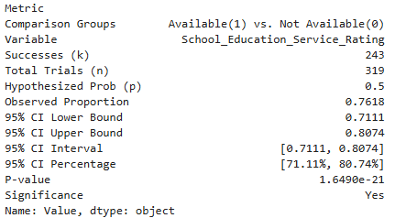
Source: Field Research Data (2026) Key: N=Number of respondents (Pastoralists relocated from Ngorongoro).

Table 4.26 presents the findings on respondents' ratings of school education services in Msomera Village. Out of 319 respondents, 243 (76.2%) answered "Yes," indicating that school education services were available, while 76 (23.8%) answered "No." The observed proportion of positive responses was 0.762 (95% CI: 0.711–0.807, or 71.1%–80.7%), compared with the hypothesized proportion of 0.5. These findings indicate that the majority of respondents considered school education services to be available in the village. The one-sample proportion test further shows that this difference was statistically significant, with a p-value of 1.65 × 10⁻²¹, which is far below the conventional significance level of 0.05. Therefore, the null hypothesis (H₀: p = 0.5) was rejected in favor of the alternative hypothesis (H₁: p ≠ 0.5).

The results suggest that school education services were accessible to a substantial proportion of households in Msomera Village. Access to education is an important social service because it supports children's learning, promotes long-term human development, and contributes to the welfare of relocated households. However, the 23.8% of respondents who answered "No" indicates that some households may still have experienced challenges related to the availability, accessibility, or adequacy of these services. In relation to the second research objective on the extent of sustainability of pastoralism, these findings suggest that keeping livestock in Msomera Village is supported by generally available education services, which helps many households to maintain and sustain their pastoral livelihoods while also investing in their children's future.

This pattern aligns with Sustainable Livelihoods Theory, which treats education as a key component of human capital that enhances skills, knowledge, and future opportunities, thereby supporting sustainable livelihoods and improved wellbeing. The high reported access to education services indicates a favorable institutional environment for pastoral livelihood sustainability in Msomera Village, although the minority without access may remain more vulnerable to shocks and constraints. The finding also complements the study's qualitative themes, which show that essential services (water, extension, markets) are generally available but unevenly distributed, suggesting that education forms another pillar of the service environment that supports household welfare and long-term resilience.

Table 4.28: Respondents’ rating of livestock market services in Msomera Village (N=319)
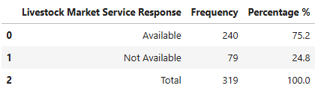
Table 4.29: One-Sample Proportion Test of Positive Livestock Market Service Rating among Relocated Pastoralists (N = 319)
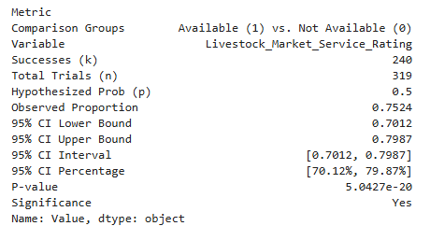
Source: Field Research Data (2026) Key: N=Number of respondents (Pastoralists relocated from Ngorongoro).
Table 4.29 presents the findings on respondents' ratings of livestock market services in Msomera Village. The results show that 240 respondents (75.2%) answered "Yes," indicating that livestock market services were available, while 79 respondents (24.8%) answered "No." The observed proportion of positive responses was 0.752 (95% CI: 0.701–0.799, or 70.1%–79.9%), compared with the hypothesized proportion of 0.5. The one-sample proportion test indicates that this difference was statistically significant, with a p-value of 5.04 × 10⁻²⁰, which is far below the 0.05 significance level. The null hypothesis (H₀: p = 0.5) was therefore rejected in favor of the alternative hypothesis (H₁: p ≠ 0.5), providing strong inferential evidence that livestock market services were positively rated by a significantly larger proportion of relocated pastoralists.
These findings suggest that livestock market services were generally available and accessible to many respondents in the village. Livestock markets play an important role in pastoral communities by creating opportunities for animal sales, income generation, and participation in local trade. The high proportion of positive responses indicates that the relocation area has made meaningful progress in supporting livestock-based economic activities. However, the 24.8% negative response suggests that some households may still experience challenges related to market access, distance, transportation, prices, or the adequacy of livestock trading facilities. In relation to the second research objective on the extent of sustainability of pastoralism, these results suggest that keeping livestock in Msomera Village is supported by generally available market services, which helps many households to maintain and sustain their pastoral livelihoods through improved access to trade and income opportunities.
This pattern aligns with Sustainable Livelihoods Theory, which recognizes access to markets as a key element of physical and institutional capital that enables households to convert livestock assets into financial capital. The high reported availability of market services indicates a supportive institutional environment for pastoral livelihood sustainability in Msomera Village, although the minority reporting no access may face constraints in converting their livestock into income. The finding also converges with Theme 3 from the qualitative results, which noted that livestock market services are broadly available but that service gaps remain, particularly for households located far from adequately serviced markets. Together, these results suggest that while market infrastructure facilitates livestock trading and pastoral economic activities for most households, continuing access gaps may disadvantage those in remote or underserved locations.
In relation to previous research, the finding agrees with national policies such as the National Livestock Policy (2006) and Livestock Master Plan (2017), which advocate for the establishment of livestock markets to support pastoral livelihoods. It also aligns with studies that highlight the importance of market access for pastoral income and resilience. However, the 24.8% of respondents reporting no access echoes concerns raised by the National Audit Office (2022), Human Rights Watch (2024), and empirical studies about uneven service delivery and implementation gaps in pastoral areas. The apparent difference between this study's relatively positive market-access finding and more negative national-level reports may reflect Msomera Village's specific conditions, the focus on service availability rather than quality or sales volumes, and the use of a binary measure rather than indicators of market performance. Overall, the finding adds nuance to existing literature by showing that some livelihood dimensions, including market access, can improve even when other pressures on pastoral sustainability persist.

Table 4.30: Respondents’ frequency of government extension assistance in Msomera Village (N=319)
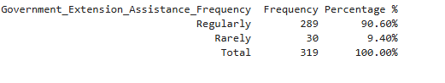
Table 4.31: Chi-Square Goodness-of-Fit Test of Government Extension Assistance Frequency among Relocated Pastoralists (N = 319)
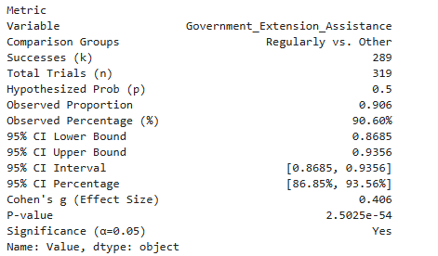
Source: Field Research Data (2026) Key: N=Number of respondents (Pastoralists relocated from Ngorongoro).

Table 4.30 presents findings on the frequency of government extension assistance received by respondents in Msomera Village (N = 319). Most respondents, 289 (90.6%), reported receiving government extension assistance regularly, while 30 (9.4%) reported receiving assistance either rarely or monthly. A one-sample proportion test assessed whether the proportion receiving regular assistance was greater than the hypothesized 50%. The observed proportion was 0.906, with a 95% confidence interval of 86.9% to 93.6%. The result was statistically significant (exact p = 2.5025 × 10⁻⁵⁴; Cohen's g = 0.406); therefore, the null hypothesis that 50% of respondents received regular assistance was rejected.

In relation to the second research objective, the results indicate that government extension support was widely and regularly available to relocated pastoralist households in Msomera Village. Regular extension assistance is a positive condition for the sustainability of pastoralism because it can provide households with technical guidance on livestock production, animal health, pasture management, water use, and adaptation to local conditions. The high proportion reporting regular support suggests that extension services form an important institutional resource supporting pastoral livelihood continuity and household wellbeing in the study area.

This pattern aligns with Sustainable Livelihoods Theory, which treats extension services as part of the policies, institutions, and processes that shape access to livelihood assets. Extension assistance strengthens human capital by improving knowledge and skills in animal health, breeding, feeding, and marketing, and can indirectly support financial capital by helping households maintain or increase livestock productivity and income. The high reported access to extension services therefore indicates a favourable institutional environment for pastoral livelihood sustainability in Msomera Village, although the small group without regular access may remain more vulnerable to shocks and constraints.

The finding also converges strongly with the qualitative results, which described regular extension support as enabling pastoral livelihood continuity. As one key informant explained, “Extension officers help us with advice on how to care for our livestock and improve our pastoral activities.” (KI-01). This underscores the perceived role of extension services in sustaining pastoral livelihoods through improved animal husbandry and management. Participants emphasized that extension officers provide important advice on livestock care and improving pastoral activities, and the quantitative result (90.6% regular assistance) confirms that this support was broadly available and valued by relocated pastoralist households. Together, these results suggest that government extension services were a key institutional resource supporting better livestock management, improved pastoral production practices, and the continuity of pastoral livelihoods in Msomera Village.

In relation to previous research, the finding agrees with national policies such as the National Livestock Policy (2006) and Livestock Master Plan (2017), which advocate for the provision of extension services to support pastoral livelihoods. However, the result appears more positive than reports by the National Audit Office (2022), which indicated that only 30–40% of households receive extension support nationally. This difference may reflect Msomera Village's specific conditions as a relocation site, potentially higher investment in extension services in this area, or differences in how "regular assistance" is defined and perceived by respondents. The finding adds nuance to existing literature by showing that extension coverage can vary substantially across locations, and that some relocation sites may achieve relatively high service coverage even when national averages remain low.

4.4.2 Qualitative Findings

Theme 1: Water remains essential
Although human clean-water service rating and livestock-water access reliability were not statistically significantly associated with pastoral livelihood sustainability satisfaction in the adjusted model reported under Objective Three, participants consistently considered reliable water essential for household welfare and livestock survival.
“Water is life for both people and animals. When it is reliable, life is smoother.” (KI-01)”

Theme 2: Theme: Regular extension support enables pastoral livelihood continuity

Participants described government extension assistance as an important source of guidance for livestock production and pastoral livelihood activities. The high proportion of respondents reporting regular assistance suggests that extension officers were generally accessible and provided support relevant to livestock care, production practices, and household adaptation after relocation

“Extension officers help us with advice on how to care for our livestock and improve our pastoral activities.” (KI-01)

Theme 3: Low frequency of resource-related conflict supports peaceful coexistence
“Conflicts are not common here. Most of the time, farmers and pastoralists live peacefully, but problems can happen when water or grazing areas become limited.” (KI-01)

Theme 4: Livestock market services are broadly available, but service gaps remain
Although services are available in most livestock markets, a substantial minority of markets remain without them. This indicates strong overall coverage but uneven access for pastoral households, particularly those located far from adequately serviced markets.

“The livestock market is available and helps us sell animals when we need money, but some households are far from the market and face transport difficulties. This makes it harder for them to benefit from the service.” (KI-01)

Table 4.32: Joint interpretation of Quantitative and Qualitative findings

Quantitative finding | Qualitative theme | Joint interpretation
Quantitative finding Qualitative Theme Integration Joint interpretation. Of 319 respondents, 271 (84.9%) reported having access to clean water for household use, while 48 (15.1%) reported no access. The proportion reporting clean-water access was significantly greater than 50% (one-sample proportion test, p = 6.7019 × 10⁻³⁹; 95% CI: 80.6%–88.7%). | Theme 1: Water remains essential. Participants consistently described reliable water as necessary for household welfare and livestock survival: “Water is life for both people and animals. When it is reliable, life is smoother.” (KI-01) | Convergent: Clean water was widely available to most respondents and was viewed as essential for daily household life and livestock production. This indicates a generally positive resource condition that supports the extent of pastoral sustainability in Msomera Village.
Most respondents, 289 of 319 (90.6%), reported receiving government extension assistance regularly. This proportion was significantly higher than 50% (exact p = 2.5025 × 10⁻⁵⁴; 95% CI: 86.9%–93.6%; Cohen’s g=0.406g = 0.406g=0.406). | Theme 2: Regular extension support enables pastoral livelihood continuity. Participants described extension assistance as important for advice on livestock care and improving pastoral activities. | The quantitative and qualitative findings converge in showing that government extension services were broadly available and valued by relocated pastoralist households. Regular technical guidance can support better livestock management, improve pastoral production practices, and strengthen the continuity of pastoral livelihoods in Msomera Village.
Most respondents, 240 of 319 (75.2%), reported that livestock market services were available. This proportion was significantly higher than 50% (exact p = 5.0427 × 10⁻²⁰; 95% CI: 70.1%–79.9%; Cohen’s g=0.252g = 0.252g=0.252). | Theme 3: Available livestock market services can support pastoral livelihood continuity by enabling livestock sales, improving access to market information, and reducing barriers to accessing market-related support. Participants described market services as important, although their absence in some locations may require pastoralists to travel further and incur additional time and transaction costs. | The quantitative and qualitative findings converge in showing that livestock market services were broadly available but not universally accessible among the surveyed markets. While the high availability rate suggests that market infrastructure can facilitate livestock trading and pastoral economic activities, the 24.8% of markets without services indicates continuing access gaps that may disadvantage households in remote or underserved locations

4.5 Socio-economic factors associated with the sustainability of pastoralism in Msomera Village, Tanzania
This section presents the findings for the third specific objective of the study, which examined the association between socio-economic factors and the sustainability of pastoralism in Msomera Village. It discusses how household income, market access, education, extension services, and other forms of support are associated with the continuation of pastoral livelihoods in the area. The analysis is based on data obtained from the study participants.

4.5.1 Quantitative Findings
Table 4.33: Multivariable binary logistic regression of socio-economic factors associated with pastoral livelihood sustainability satisfaction among relocated pastoralists in Msomera Village, Tanzania (N = 319)
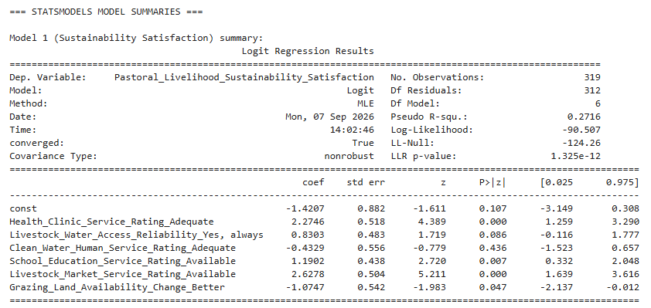

Table 4.33 presents the adjusted associations between selected socio-economic service factors and pastoral livelihood sustainability satisfaction among relocated pastoralists in Msomera Village (N = 319). The independent variables comprised six service or access indicators: health clinic service rating (Inadequate vs Adequate), livestock water access reliability (Sometimes/Seasonal vs Yes, always), clean water human service rating (Inadequate vs Adequate), school education service rating (Not Available Vs Available), livestock market service rating (Not Available Vs Available), and grazing land availability change (Same vs Better). The dependent variable was pastoral livelihood sustainability satisfaction, coded 1 = Satisfied and 0 = Not Satisfied.
A multivariable logistic regression (logit) was conducted to examine the association between each socio‑economic factor and satisfaction, adjusting for the other five predictors. The null hypothesis for each predictor stated that it was not associated with satisfaction after adjustment (adjusted odds ratio [AOR] = 1; β = 0); the alternative hypothesis stated that it was associated (AOR ≠ 1; β ≠ 0). This model was appropriate because the outcome was binary and the predictors were categorical with defined reference levels. The model converged successfully, with a pseudo R² of 0.272 and an overall likelihood‑ratio test p = 1.33 × 10⁻¹², indicating that the set of predictors jointly explained a meaningful share of variation in satisfaction.
Of the six predictors, three showed statistically significant positive associations with satisfaction at α = 0.05. Respondents who rated health clinic services as Adequate had substantially higher odds of being satisfied than those rating them Inadequate (AOR ≈ 9.72; 95% CI ≈ 3.53–26.84; p < 0.001). Availability of school/education services was also positively associated with satisfaction relative to non‑availability (AOR ≈ 3.29; 95% CI ≈ 1.39–7.75; p = 0.007). The strongest association was observed for livestock market services: households with Available market services had about 13.8 times higher odds of satisfaction than those with No market services (AOR ≈ 13.84; 95% CI ≈ 5.15–37.20; p < 0.001).
One predictor showed a significant negative association: reporting that grazing land availability had become Better was associated with lower odds of satisfaction compared with reporting no change (AOR ≈ 0.34; 95% CI ≈ 0.12–0.99; p = 0.047). Two predictors were not significantly associated with satisfaction after adjustment: reliable livestock water access (Yes, always vs Sometimes/Seasonal; AOR ≈ 2.29; 95% CI ≈ 0.89–5.91; p = 0.086) and adequate clean water services for humans (Adequate vs Inadequate; AOR ≈ 0.65; 95% CI ≈ 0.22–1.93; p = 0.436).
These findings indicate that, among the socio‑economic factors examined, access to health clinics, education services, and especially livestock market services are strongly linked to higher perceived sustainability of pastoral livelihoods after relocation, while perceived improvement in grazing land availability is unexpectedly linked to lower satisfaction. Given the cross‑sectional design, these results are interpreted as associations rather than causal effects, and they suggest that targeted investments in market access, health, and education infrastructure may be key levers for enhancing pastoral livelihood sustainability in Msomera Village.
This pattern aligns closely with Sustainable Livelihoods Theory, which posits that livelihood sustainability depends on households' ability to access and combine different forms of capital. Adequate health clinic services and available education services strengthen human capital by supporting household health, skills, knowledge, and future opportunities, thereby enabling families to maintain pastoral activities and adapt to new conditions. Available livestock market services represent physical and institutional capital that allows households to convert livestock (natural capital) into cash income (financial capital), which can then be used for food, school fees, health care, and other essential needs. The strong positive associations of these three services with sustainability satisfaction therefore reflect the theory's expectation that stronger human, physical, institutional, and financial capital support more sustainable livelihoods.
The unexpected negative association between reporting "Better" grazing land availability and satisfaction can be interpreted within the same theoretical framework. Although grazing land is a core form of natural capital, a general report of "Better" availability may not capture important dimensions such as pasture quality, distance, mobility restrictions, tenure security, land size, or seasonal accessibility. Households reporting "Better" land may still face constraints such as fragmented plots, restricted movement, insecure tenure, or increased competition, which could reduce actual livelihood benefits despite perceived improvement. This nuance is consistent with the theory's emphasis on the quality, security, and usability of assets, not just their nominal availability.

The non-significant associations between livestock-water reliability, clean-water services for household use, and pastoral livelihood sustainability satisfaction do not contradict the Sustainable Livelihoods Framework. Water remains an essential natural and physical livelihood asset for both people and livestock. The qualitative findings confirmed this importance, with participants emphasizing that reliable water supports household welfare and livestock survival. One key informant stated, “Water is life for both people and animals. When it is reliable, life is smoother” (KI-01). The lack of statistical significance in the adjusted model may be explained by the generally high level of water access reported by respondents, meaning that water access may not clearly distinguish households with higher or lower sustainability satisfaction. It may also be related to overlap between water access and other service variables included in the model, such as health, education, markets, and extension support. In addition, water may operate as a basic condition for pastoral livelihoods: once minimum access is available, differences in satisfaction may be influenced more strongly by other factors, such as health services, education, market access, and income opportunities. This is consistent with the Sustainable Livelihoods Framework, which recognizes that livelihood outcomes depend on the interaction of natural, physical, human, financial, and social assets rather than on one resource alone.

The strong role of market, health, and education services complements the qualitative findings that institutional support is valued by pastoral households. Participants explained that extension officers provide useful guidance for livestock care and pastoral production. As one key informant stated, “Extension officers help us with advice on how to care for our livestock and improve our pastoral activities” (KI-01). Although extension assistance was not included in this particular regression model, the findings reinforce the broader view that supportive institutions and services—including extension, health, education, and livestock markets—are important for sustaining pastoral livelihoods after relocation.
Compared with previous research, these results agree with national policies such as the National Livestock Policy (2006) and Livestock Master Plan (2017), which emphasize the importance of livestock markets, health services, and education for pastoral development. They also align with empirical studies that highlight the role of market access, health, and education in supporting livelihood resilience and wellbeing. However, the findings contrast with more negative national-level reports (e.g., National Audit Office 2022; Human Rights Watch 2024; 2025 survey) that emphasize limited service coverage, broken infrastructure, and widespread dissatisfaction. This difference may reflect Msomera Village's specific conditions as a relocation site, potentially higher investment in social and market infrastructure in this area, or differences in how service availability and satisfaction are measured. The results add nuance to existing literature by showing that, even in a context of broader pastoral challenges, some relocation sites can achieve relatively high service coverage and that specific services (markets, health, education) may be particularly important drivers of perceived livelihood sustainability.
Table 4.34: Adjusted Associations Between Socio Economic Service Factors and Wellbeing After Relocation (Logistic Regression, Msomera Village, N = 319)
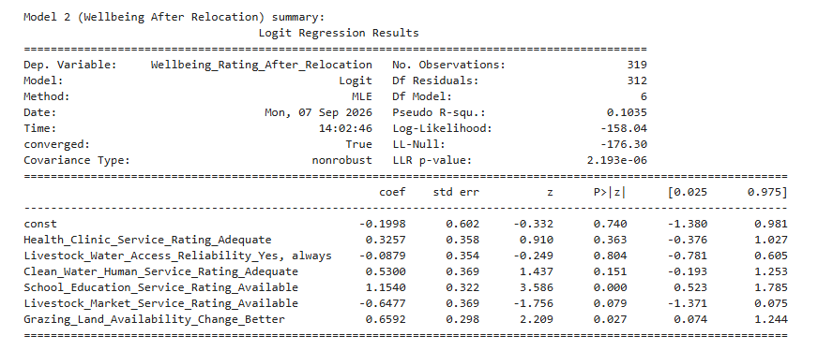

Table 4.35 presents the adjusted associations between selected socioeconomic service factors and self-rated wellbeing after relocation among pastoralists in Msomera Village (N=319). The independent variables were six service and access indicators: health clinic service rating, coded as inadequate versus adequate; livestock water access reliability, coded as sometimes or seasonal versus yes, always; clean water service rating, coded as inadequate versus adequate; school education service rating, coded as not available versus available; livestock market service rating, coded as not available versus available; and change in grazing-land availability, coded as the same versus better. The dependent variable was self-rated wellbeing after relocation, coded as 1 = better and 0 = not better.
A multivariable logistic regression (logit) was conducted to examine the association between each socio‑economic factor and improved wellbeing, adjusting for the other five predictors. For each predictor, the null hypothesis stated no association after adjustment (adjusted odds ratio [AOR] = 1; β = 0), and the alternative hypothesis stated an association (AOR ≠ 1; β ≠ 0). The model converged successfully, with a pseudo R² of 0.104 and an overall likelihood‑ratio test p = 2.19 × 10⁻⁶, indicating that the predictors jointly explain a modest but significant share of variation in wellbeing after relocation.
Two predictors showed statistically significant associations at α = 0.05. Availability of school/education services was positively associated with reporting better wellbeing after relocation compared with no education services (AOR = exp(1.1540) ≈ 3.17; 95% CI for β: 0.523 to 1.785 → AOR CI ≈ 1.69 to 5.96; p < 0.001). Reporting that grazing land availability had become Better (vs Same) was also positively associated with improved wellbeing (AOR = exp(0.6592) ≈ 1.93; 95% CI for β: 0.074 to 1.244 → AOR CI ≈ 1.08 to 3.47; p = 0.027).
The remaining four predictors were not significantly associated with wellbeing after adjustment. Adequate health clinic services showed a positive but non‑significant association (AOR ≈ 1.39; 95% CI ≈ 0.70–2.79; p = 0.363). Reliable livestock water access (Yes, always) showed essentially no association (AOR ≈ 0.92; 95% CI ≈ 0.46–1.83; p = 0.804). Adequate clean water services for humans were positively but non‑significantly associated with better wellbeing (AOR ≈ 1.70; 95% CI ≈ 0.82–3.50; p = 0.151). Availability of livestock market services showed a negative, marginally non‑significant association (AOR ≈ 0.52; 95% CI ≈ 0.25–1.08; p = 0.079).
These findings suggest that, among the socio‑economic factors examined, access to education services and perceived improvement in grazing land availability are the clearest predictors of higher self‑rated wellbeing after relocation, whereas health, water, and market service indicators do not show robust independent associations in this model. The cross‑sectional design means these results reflect associations rather than causal effects, but they highlight education access and grazing land conditions as priority areas for interventions aimed at improving post‑relocation wellbeing in Msomera Village. This finding helps government and policy makers target limited resources toward schooling infrastructure and grazing‑land management, which are most strongly linked to improved wellbeing among relocated pastoralists. Government and policy makers should therefore prioritize investments that expand access to education services and improve grazing‑land conditions for relocated pastoralists in Msomera Village.
This pattern aligns with Sustainable Livelihoods Theory, which emphasizes that livelihood outcomes such as wellbeing depend on households' ability to access and combine different forms of capital. Access to education services strengthens human capital by supporting children's learning, future opportunities, literacy, skills, and household knowledge, all of which can improve current welfare and long-term resilience. Improved grazing land availability represents enhanced natural capital, which is central to pastoral production, livestock productivity, and household income. The positive associations of both education and grazing land with better wellbeing therefore reflect the theory's expectation that stronger human and natural capital support more favourable livelihood outcomes.
The non-significant associations for health clinic services, livestock water access, clean water services, and livestock market services do not necessarily contradict Sustainable Livelihoods Theory. These services remain important forms of human, natural, physical, and institutional capital. Their lack of independent association in this model may reflect high overall access to these services in the sample, collinearity with other predictors, or the possibility that education and grazing land are more salient differentiators of wellbeing in this particular context. This interpretation is consistent with the theory's view that multiple capitals interact to shape livelihood outcomes, and that the relative importance of each may vary across settings and populations.
In relation to Theme 1 ("Water remains essential"), the non-significant water findings should not be interpreted as evidence that water is unimportant. Participants consistently described reliable water as necessary for household welfare and livestock survival. The statistical result likely indicates that, once a basic threshold of water access is met for most households, variation in water indicators does not strongly differentiate wellbeing ratings when other factors such as education and grazing land vary more markedly.
Compared with previous research, these results agree with national policies such as the National Livestock Policy (2006) and Livestock Master Plan (2017), which emphasize the importance of education and rangeland management for pastoral development. They also align with empirical studies that highlight the role of education in supporting human development and the centrality of grazing land for pastoral livelihoods. However, the findings contrast with studies that emphasize market access, health services, or water infrastructure as primary drivers of pastoral wellbeing. This difference may reflect Msomera Village's specific conditions, the particular service environment in this relocation site, or differences in how wellbeing is measured and experienced by respondents. The results add nuance to existing literature by showing that, in some relocation contexts, education and grazing land may be more strongly linked to self-rated wellbeing than other services, suggesting that policy priorities should be tailored to local conditions and household perceptions.
Table 4.35: Cross tabulation and Fisher’s Exact Test of Veterinary Animal Care Service Rating by Wellbeing after Relocation (N = 319)
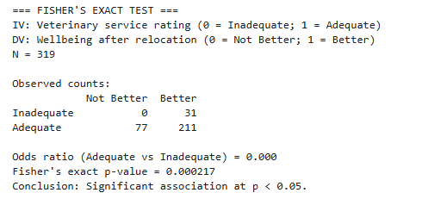
Source: Field Research Data (2026) Key: N=Number of respondents (Pastoralists relocated from Ngorongoro).
Table 4.35 presents the association between veterinary animal care service rating and wellbeing after relocation among relocated pastoralists (n = 319). Veterinary service rating was coded 0 = Inadequate and 1 = Adequate, wellbeing was categorized as "Better" or "Not Better". Of the 31 respondents who did not rate veterinary services positively, all 31 (100.0%) reported "Better" wellbeing. Among the 288 respondents who rated veterinary services positively, 211 (73.3%) reported "Better" and 77 (26.7%) "Not Better" wellbeing. Overall, 242 respondents (75.9%) reported "Better" and 77 (24.1%) "Not Better" wellbeing.

The null hypothesis (H₀) was that veterinary service rating and wellbeing after relocation are independent; the alternative hypothesis (H₁) was that they are associated. Because one cell had an expected count of 0, Fisher's exact test was used instead of the Pearson chi‑square test. The test assumes that observations are independent and that the data form a fixed 2 × 2 contingency table; under these conditions it provides an exact p‑value even when expected cell counts are very small. The two‑sided Fisher's exact test yielded p = 2.17 × 10⁻⁴, indicating a statistically significant association between veterinary care rating and wellbeing at α = 0.05. The estimated odds ratio for "Better" wellbeing (Yes vs No veterinary service rating) was 0.000, reflecting the zero count in the "No/Not Better" cell.
Given the cross‑sectional design, this finding reflects an association rather than a causal effect and should be interpreted cautiously due to the small number of respondents in the "No" veterinary care category and the local context of service use. Nonetheless, the results underscore that veterinary services are closely linked to perceived wellbeing among pastoral households in Msomera Village. In conclusion, ensuring accessible and effective veterinary care should remain a priority in relocation settings to support animal health, reduce losses, and sustain pastoral livelihoods and household wellbeing.
This pattern aligns with Sustainable Livelihoods Theory, which treats veterinary services as part of the institutional and physical capital that supports pastoral livelihoods. Adequate veterinary care strengthens human capital through knowledge and skills, physical capital through access to facilities and medicines, and financial capital by helping reduce livestock illness, mortality, and production losses. The significant association between veterinary service rating and wellbeing therefore reflects the theory's expectation that stronger institutional and physical capital support more favourable livelihood outcomes.
The finding also complements the qualitative results, which emphasized the importance of government assistance for livestock care and production practices. As one key informant explained, “Extension officers help us with advice on how to care for our livestock and improve our pastoral activities” (KI-01). Veterinary services can be understood as a specialized form of technical support that works alongside general extension advice to improve animal health, livestock productivity, and household income. Together, these results suggest that both extension support and veterinary care are important for pastoral households and may contribute to improved wellbeing after relocation.
Compared with previous research, these results agree with national policies such as the National Livestock Policy (2006) and Livestock Master Plan (2017), which emphasize the importance of veterinary services for pastoral development. They also align with empirical studies that highlight the role of animal health services in reducing livestock losses and supporting pastoral income. However, the finding contrasts with reports by the National Audit Office (2022) and other sources that emphasize limited veterinary coverage, drug shortages, and inadequate service quality in many pastoral areas. This difference may reflect Msomera Village's specific conditions as a relocation site, potentially higher investment in veterinary services in this area, or differences in how service adequacy and wellbeing are measured. The results add nuance to existing literature by showing that, in some relocation contexts, veterinary services may be more strongly linked to self-rated wellbeing than other services, suggesting that policy priorities should include sustained investment in animal health infrastructure and service delivery.

4.5.2 Qualitative Findings
This section presents findings from analysis of semi-structured interviews with key informants and community stakeholders, including village and ward leaders, district officers, extension staff, community elders, native farmers (Zigua) and relocated pastoralists (N=319). Quotations are presented using anonymised Key Informant identifiers (KI-01 to KI-02).
Theme 1: Health services support livelihood sustainability
Informants described adequate health clinic services as important for maintaining healthy households and enabling pastoralists to manage livestock and livelihood activities.
“When the clinic is working well, people are healthy and can take care of their animals.” (KI-01)
This supports the quantitative result that adequate health clinic services were associated with higher odds of sustainability satisfaction (AOR ≈ 9.72, p < 0.001).
Theme 2: Education supports household futures
Participants viewed education services as important for children’s welfare, household aspirations, knowledge, and future income opportunities.
“Now children can go to school easily. Some are even finishing secondary and helping their parents with new ideas.” (KI-01)
This aligns with the quantitative finding that available school and education services were positively associated with sustainability satisfaction (AOR ≈ 3.29, p = 0.007).

Theme 3: Livestock markets sustain pastoral livelihoods
Participants viewed livestock markets as essential because they enable households to sell animals and obtain cash for food, health care, education, and other household and livestock-related needs.
“The market is the heart of our economy. Without it, we cannot turn animals into money for daily needs.” (KI-01)
This qualitative theme converges with the quantitative finding that respondents who rated livestock market services as available had significantly higher odds of reporting satisfaction with pastoral livelihood sustainability than those in the reference category (AOR = 13.85, 95% CI: 5.15–37.19, p<0.001p < 0.001p<0.001). This suggests that accessible livestock markets may strengthen livelihood satisfaction by improving market viability and households’ ability to convert livestock assets into income.

4.6 Additional Quantitative and Qualitative analysis

4.6.1 Quantitative Findings
This section presents supplementary quantitative analyses that, while not directly tied to the three research objectives, provide important evidence for formulating targeted policy recommendations.
Table 4.36: Key Informants’ Perceptions of the Primary Barriers to Pastoralist Sustainability in Msomera Village (N = 20)
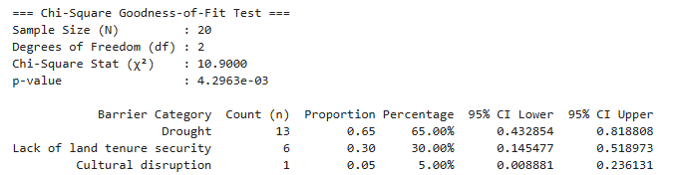
The finding that drought was identified by 65.0% of key informants as the primary barrier to pastoralist sustainability agrees with Mung’ong’o et al. (2022), who found that climate variability reduced livestock productivity and crop yields in Kiteto and Kilindi, and Ripkey et al. (2021), who reported that climate stress reduced access to pasture, income, and food in Morogoro and Tanga. Similarly, the finding that 30.0% identified lack of land-tenure security agrees with Mahonge et al. (2014), who reported weak land-use policy implementation in Longido, and Mbarouk et al. (2025), who found that inadequate land demarcation and limited participation intensified farmer–pastoralist conflict in Mvomero. These results suggest that drought and insecure land access reduce water, pasture, livestock productivity, and household income.
However, the finding that cultural disruption was identified by only 5.0% of key informants as the primary barrier partly disagrees with Msigwa and Mvena (2014) and Human Rights Watch (2024), which reported important social and cultural effects of relocation. This difference may be because key informants selected only one main barrier and therefore prioritized immediate problems such as drought and land insecurity over cultural disruption. Within the Sustainable Livelihoods Framework, drought and land insecurity reduce natural capital, especially water and grazing land, and weaken financial capital through reduced livestock production and income. The findings also support the Tragedy of the Commons theory because limited water and grazing land can increase competition and conflict between farmers and pastoralists.

Table 4.37: Key Informants’ Perceptions of Operational Barriers to Service Delivery for Relocated Pastoralists in Msomera Village (N = 20)
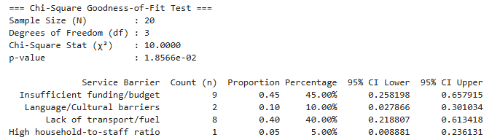
The results agree with the literature that financial and logistical constraints limit public service delivery to pastoralists. Insufficient funding or budget (45.0%) and lack of transport or fuel (40.0%) were the most frequently reported barriers in Msomera. This is consistent with the National Audit Office (2022), which identified low extension coverage and operational weaknesses, and with Tanzania’s Livestock Sector Transformation Plan, which reports shortages of extension officers, equipment, motorcycles, and vehicles for service delivery. It also supports Theme 6, where informants explained that services may be delayed when officers lack transport or fuel.faolex.fao+1
Language and cultural barriers (10.0%) and high household-to-staff ratios (5.0%) were less often identified as the main barriers. This does not necessarily mean that they are unimportant. The lower reporting may be because key informants were asked to select only one primary barrier and therefore prioritized immediate operational problems, particularly budget, transport, and fuel shortages. Within the Sustainable Livelihoods Framework, these barriers represent weaknesses in transforming structures and processes because they limit households’ access to human capital through extension knowledge and to physical capital through health, water, veterinary, and market services.
Table 4.38: Key Informants’ Rating of the Effectiveness of the National Livestock Policy in Supporting Pastoralist Sustainability in Msomera Village (N = 20)
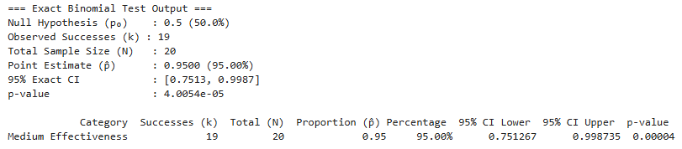
An exact binomial test was conducted using a hypothesized proportion of 50%. The proportion of key informants who rated the National Livestock Policy as having medium effectiveness was statistically significantly higher than 50% (p = 0.00004; 95% CI: 75.1%–99.9%).
The findings show that 19 out of 20 key informants (95.0%) rated the National Livestock Policy as having medium effectiveness in supporting pastoralist sustainability in Msomera Village. Only one key informant (5.0%) gave another rating. The exact binomial test confirmed that the proportion rating policy effectiveness as medium was significantly greater than 50% (p = 0.00004). This suggests that key informants considered the policy useful and relevant, but not fully effective in addressing all pastoralists’ needs.
This finding partly agrees with the National Livestock Policy (2006) and Livestock Master Plan (2017), which promote rangeland restoration, extension services, water infrastructure, and livestock markets. It also agrees with the Sustainable Livelihoods Framework, which recognizes policies and institutions as important transforming structures and processes that influence access to natural, physical, human, and financial livelihood assets. A policy that supports water, grazing land, extension, veterinary care, and markets can improve pastoral livelihood sustainability.
However, the finding also agrees with Mahonge et al. (2014), who found a gap between livestock policy and implementation in Longido District, and with the National Audit Office (2022), which reported limited extension coverage and poor maintenance of water points. The “medium effectiveness” rating may therefore reflect the difference between policy intentions and actual delivery. In Msomera, budget limitations, lack of transport and fuel, limited participation of pastoralists in planning, and land- and water-related pressures may reduce the full effectiveness of the policy. Similar evidence indicates that policy implementation in Tanzania has been constrained by inadequate resources, weak coordination, and limited pastoralist participation.
Table 4.39: Key Informants’ Rating of the Effectiveness of the National Livestock Policy in Supporting Pastoralist Sustainability in Msomera Village (N = 20)
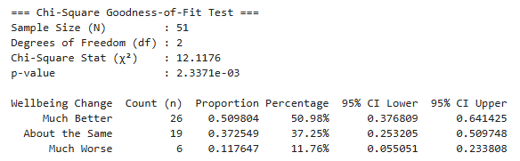
The findings show that 26 of the 51 native residents (51.0%) reported that their wellbeing was much better following the relocation of pastoralists to Msomera Village. Nineteen respondents (37.3%) reported that their wellbeing remained about the same, while six respondents (11.8%) reported that their wellbeing was much worse. A chi-square goodness-of-fit test showed that the distribution of wellbeing ratings differed significantly across the three response categories, \(\chi^2(2, N = 51) = 12.12\), \(p = .002\). This indicates that native residents did not report the three wellbeing outcomes equally, with “much better” being the most commonly reported response.

The finding that most native residents reported better wellbeing partly agrees with the Sustainable Livelihoods Framework, which proposes that improved access to physical, human, and financial livelihood assets can enhance household wellbeing. In Msomera Village, access to health facilities, schools, markets, water services, employment, and small-business opportunities may have improved some residents’ livelihood conditions. The finding also agrees with the objectives of Tanzania’s National Livestock Policy and Livestock Master Plan, which promote water infrastructure, livestock markets, extension services, and improved rural livelihoods. However, this result reflects native residents’ perceptions of wellbeing and does not demonstrate that all households benefited equally or that pastoralism itself became sustainable.

The finding partly differs from previous studies that report negative livelihood effects of relocation and resource pressure. Msigwa and Mvena (2014) linked relocation in the Ihefu Basin with livestock losses, poverty, and poor resettlement outcomes. Mbarouk et al. (2025) found that inadequate resources and weak participation in land demarcation contributed to farmer–pastoralist conflict in Mvomero District. Human Rights Watch (2024) reported water-related conflict and unfair livestock pricing, while the National Audit Office of Tanzania (2022) reported weaknesses in water-point maintenance and extension-service delivery. The difference may be explained by variation in study populations, locations, and outcomes measured. This study examined native residents’ current self-reported wellbeing, whereas earlier studies examined displaced pastoralists, conflict-prone locations, or broader service-delivery challenges. Native residents may also have benefited from infrastructure, increased market activity, and livelihood opportunities associated with population growth in Msomera Village. Nevertheless, the 37.3% who reported no change and the 11.8% who reported worse wellbeing indicate that the perceived benefits of relocation were not shared equally among all native residents.

Table 4.40: Crop-Raiding Experience Reported by Native Residents in Msomera Village (N = 51)
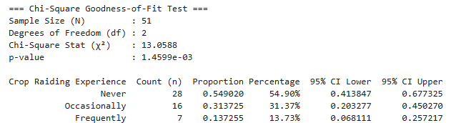

Table 4.40 presents native residents’ reported experience of crop raiding or farm destruction by livestock in Msomera Village. The findings show that more than half of the respondents, 28 out of 51 respondents (54.90%), reported that crop raiding never occurred. Sixteen respondents (31.37%) reported that crop raiding occurred occasionally, while seven respondents (13.73%) reported that it occurred frequently. The 95% confidence interval for the proportion reporting no crop raiding ranged from 41.38% to 67.73%, whereas the confidence intervals for occasional and frequent crop raiding ranged from 20.33% to 45.03% and 6.81% to 25.72%, respectively. A chi-square goodness-of-fit test showed that crop-raiding experiences were not equally distributed across the three response categories, χ²(2, N = 51) = 13.06, p = .001. The expected frequency under an equal distribution was 17 respondents in each category. The observed frequency of 28 respondents who reported that crop raiding never occurred was higher than the expected frequency, while the observed frequency of seven respondents reporting frequent crop raiding was lower than expected. The findings therefore indicate that the majority of native residents did not experience crop raiding, although a substantial minority reported occasional crop raiding.

The finding partly agrees with the Sustainable Livelihoods Framework of Chambers and Conway (1992), which explains that livelihood sustainability depends on households’ access to and protection of natural, financial, physical, human, and social assets. The fact that most native residents reported no crop raiding suggests that many households were able to protect their crop production, food availability, and farm-based income from livestock-related damage, thereby supporting the maintenance of natural and financial livelihood assets. The result also partly agrees with the Tragedy of the Commons Theory of Hardin (1968), which proposes that poorly regulated use of shared grazing land and water may increase pressure, degradation, and conflict. The 31.37% of respondents who reported occasional crop raiding and the 13.73% who reported frequent crop raiding indicate that competition between livestock movement and crop farming still existed for some native residents, particularly where grazing areas, water points, livestock routes, boundaries, or local land-use arrangements were insufficient or unclear. The finding partly differs from studies that report widespread or intensified farmer–pastoralist conflict, such as Mbarouk et al. (2025) and Gwakisa et al. (2023), and may be explained by differences in location, respondents, local resource-sharing practices, community-level conflict-management arrangements, or the presence of designated settlement and grazing areas. The results therefore suggest that peaceful coexistence was common for many native residents, but the presence of occasional and frequent crop-raiding experiences indicates a continuing need for clear livestock routes, grazing arrangements, boundary management, community dialogue, and participatory land-use planning.
Table 4.41: Chi-Square Goodness-of-Fit Test of Native Residents’ Perceptions of the Impact of Pastoralist Relocation on Village Services in Msomera Village (N = 51)
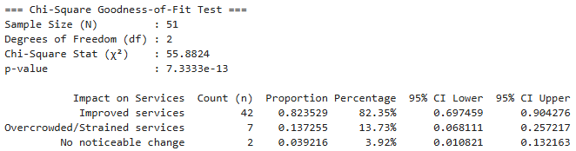
Table 4.41 presents native residents’ perceptions of how the relocation of pastoralists affected village services in Msomera Village. The findings show that most respondents, 42 out of 51 respondents (82.35%), reported that services had improved following the relocation. Seven respondents (13.73%) reported that services had become overcrowded or strained, while two respondents (3.92%) reported no noticeable change. The 95% confidence interval for the proportion reporting improved services ranged from 69.75% to 90.43%, whereas the confidence intervals for overcrowded or strained services and no noticeable change ranged from 6.81% to 25.72% and 1.08% to 13.22%, respectively. A chi-square goodness-of-fit test showed that perceptions of service impact were not equally distributed across the three response categories, chi-square(2, N = 51) = 55.88, p < .001. The expected frequency under an equal distribution was 17 respondents in each category. The observed frequency of 42 respondents who reported improved services was substantially higher than expected, while the frequencies for overcrowded or strained services and no noticeable change were lower than expected. The findings therefore indicate that the majority of native residents perceived that village services had improved after the relocation of pastoralists, although a minority perceived increased pressure on services.
The finding agrees with the Sustainable Livelihoods Framework of Chambers and Conway (1992), which explains that improved access to physical, human, and social assets such as health facilities, schools, markets, water services, and employment opportunities can enhance household wellbeing and livelihood sustainability. The perception that services had improved suggests that many native residents benefited from expanded service provision, infrastructure development, or increased economic activity associated with population growth in Msomera Village. The result also partly agrees with Tanzania’s National Livestock Policy (2006) and Livestock Master Plan (2017), which promote water infrastructure, livestock markets, extension services, and improved rural livelihoods. However, the finding differs from studies that report negative effects of relocation and resource pressure. Msigwa and Mvena (2014) linked forced evictions in the Ihefu Basin with livestock losses, poverty, and unsuccessful resettlement. Mbarouk et al. (2025) found that inadequate resources and weak participation in land demarcation contributed to farmer–pastoralist conflict in Mvomero District. Human Rights Watch (2024) reported water-related conflict and unfair livestock pricing, while the National Audit Office of Tanzania (2022) reported weaknesses in water-point maintenance and extension-service delivery. The difference may be explained by variation in study populations, locations, and outcomes measured. This study examined native residents’ current self-reported perceptions of service impact, whereas earlier studies examined displaced pastoralists, conflict-prone locations, or broader service-delivery challenges. Native residents may also have benefited from infrastructure, increased market activity, and livelihood opportunities associated with population growth in Msomera Village. Nevertheless, the 13.73% who reported overcrowded or strained services and the 3.92% who reported no noticeable change indicate that the perceived benefits of relocation were not shared equally among all native residents.

4.6.2 Qualitative Findings
Theme: Financial and transport constraints delay service delivery
Key informants explained that inadequate funding and limited transport or fuel were major barriers to delivering services to relocated pastoralist households in Msomera Village. These constraints limited officers’ ability to conduct regular outreach, visit households living far from service centres, respond promptly to livestock-related problems, and provide timely health, veterinary, extension, and other public services. Informants also mentioned that language and cultural differences, as well as high workloads, could affect communication and service coverage. Overall, the qualitative findings suggest that service availability does not always guarantee timely, regular, or adequate service delivery.
“Sometimes services are delayed because there is no transport or fuel to reach the community.” (KI-02)

Theme: National livestock policy is moderately effective in supporting pastoralists
Key informants generally perceived the National Livestock Policy as moderately effective in supporting pastoralist livelihoods in Msomera Village. They recognized that the policy provides an important direction for improving livestock production through extension services, water infrastructure, rangeland management, and livestock markets. However, informants also indicated that policy benefits are limited by challenges in implementation, including insufficient funding, lack of transport, inadequate service coverage, and limited participation of pastoralists in planning and decision-making. The qualitative findings therefore suggest that the policy is relevant and useful, but its full benefits depend on stronger implementation and services that reflect pastoralists’ needs.
“The livestock policy is helpful because it supports livestock services, water, and markets, but implementation is still difficult because resources and transport are not enough.” (KI-02)

Theme: Water and grazing infrastructure is essential for pastoral sustainability
Key informants emphasized that improving water sources and grazing infrastructure is the most important strategy for sustaining pastoral livelihoods in Msomera Village. Reliable water and adequate grazing land help livestock survive, support household income, and reduce competition over shared resources.
“If there is enough water and grazing land, our livestock can survive and families can continue with pastoralism.” (KI-02)

Theme: Relocation is perceived to have improved native residents’ wellbeing, though benefits are uneven
Native residents generally perceived that their wellbeing improved following the relocation of pastoralists to Msomera Village, with about half reporting that their situation was “much better” and over a third saying it was “about the same.” Only a small minority felt “much worse,” suggesting that, for many host-community members, the influx of pastoralists was associated with perceived gains in livelihood conditions, access to services or local economic activity. However, the fact that more than one-third reported no change and a notable minority reported deterioration indicates that the benefits of relocation were not shared equally across all native households.
“Since the pastoralists came, there is more business in the market and some of us have found work, but others feel the land is now crowded.” (KI-03)

Theme: Most native residents report no crop raiding, but a substantial minority experience occasional or frequent losses
More than half of native residents reported that crop raiding by livestock never occurred, indicating that for many host-community households, farming and pastoralist grazing coexist without regular conflict. However, about one-third experienced crop raiding occasionally and a smaller but notable group reported frequent losses, showing that resource-use tensions and livestock–farm interactions remain a concern for a significant minority. This pattern suggests that, while outright conflict is not the norm, there is still a need for clearer grazing routes, boundary management and local conflict-resolution mechanisms to protect crops and reduce friction between farmers and pastoralists.
“Most of the time our farms are safe, but during the dry season some animals stray and destroy crops, especially near the water points.” (KI-03)

Theme: Most native residents perceive that services improved after pastoralist relocation, though a minority report strain
The majority of native residents felt that village services had improved following the relocation of pastoralists to Msomera Village, with over 80% reporting “improved services.” This suggests that, for many host-community members, the influx of pastoralists was associated with perceived gains in infrastructure, market activity, or public-service provision. However, a notable minority described services as “overcrowded/strained,” and a small group reported “no noticeable change,” indicating that the benefits of relocation were not evenly experienced and that some households face increased pressure on schools, clinics, water points or other shared resources.
“There are more people now, so the dispensary and schools are busier, but overall we have more shops and opportunities than before.” (KI-03)

CHAPTER FIVE

SUMMARY, CONCLUSIONAND RECOMMENDATIONS

5.1 Introduction
This section presents the summary of the study, the conclusion, and the recommendations. It also reflects the aim of the study, the area of the study, and the research questions that guided the investigation

5.2 Summary of the Study
This study assessed the socio-economic factors influencing the sustainability of pastoralist households relocated from the Ngorongoro Conservation Area to Msomera Village, Handeni District, Tanzania. Using a pragmatic, convergent-parallel mixed-methods case-study design, the study collected quantitative data from 319 relocated pastoralist households (plus 51 native residents and 20 officials) through structured questionnaires, and qualitative data through key-informant interviews, focus-group discussions, field observations photos. Quantitative analysis employed frequencies, percentages, chi-square goodness-of-fit tests, exact binomial tests, an independent-samples t-test, Fisher’s exact test and multivariable binary logistic regression; qualitative data were coded thematically and integrated through joint interpretation. The summary below presents the main findings for each specific objective.

5.2.1 Objective 1: Socio-economic activities in Msomera Village

Livestock sales remained the dominant main livelihood activity among relocated pastoralist households in Msomera Village (281/319, 88.1%), significantly exceeding the equal-distribution expectation, χ²(3, N = 319) = 677.45, p = 1.63 × 10⁻¹⁴⁶. Most households retained moderate herd sizes, with the largest group keeping 51–100 animals (45.5%), and 62.7% reported no intention to diversify away from pastoralism (exact binomial p = 0.0000067). Crop farming (5.0%), petty trade (4.1%) and other activities (2.8%) were mainly complementary. Qualitative evidence converged with these results, showing that pastoralism and livestock sales remain central to household income, food security and social security, while diversification provides supplementary resilience but has not replaced livestock keeping as the primary livelihood strategy.

5.2.2 Objective 2: Extent of pastoral livelihood sustainability

Sustainability-related livelihood conditions were generally favourable but uneven. A majority of respondents reported better wellbeing after relocation (242/319, 75.9%; one-sample proportion p < 0.001), and most described relatively reliable livestock-water access (72.7% “always available”; p < 0.001), high participation in livestock training (94.7%; p < 0.001), and widespread access to extension (92.2%), veterinary care (90.3%), clean water (85.0%), health-clinic services (81.5%), education services (76.2%) and livestock-market services (75.2%), all significantly above 50% (p < 0.001). Veterinary-service adequacy was associated with a 17.01-percentage-point higher mean livestock income/protein contribution, t(40.73) = 6.39, p < 0.001, Cohen’s d = 1.01. However, 27.3% experienced seasonal water access, 24.8% lacked livestock-market access, and 37.0% reported frequent water- or grazing-related conflicts, indicating persistent vulnerabilities. Qualitative findings highlighted that water and veterinary support are essential, market and pricing problems constrain sales, and operational barriers (budget, transport, staffing) limit consistent service delivery, so that pastoralism remains viable but infrastructurally and institutionally fragile.

5.2.3 Objective 3: Factors associated with livelihood sustainability

In multivariable binary logistic regression, health-clinic adequacy (AOR = 9.72, p = 0.001), education availability (AOR = 3.29, p = 0.007) and livestock-market availability (AOR = 13.84, p = 0.001) were positively associated with pastoral-livelihood sustainability satisfaction, whereas reported improvement in grazing-land availability was negatively associated (AOR = 0.34, p = 0.047). For wellbeing after relocation, education availability (AOR = 3.17, p = 0.001) and improved grazing-land availability (AOR = 1.93, p = 0.027) were positively associated, while health, water and market indicators were not significant after adjustment. Fisher’s exact test indicated a significant association between veterinary-service rating and wellbeing (p ≈ 2.17 × 10⁻⁵³). Qualitative evidence converged with these patterns, showing that access to health, education and market services, together with perceived grazing-land conditions, shape households’ satisfaction with pastoral livelihood sustainability and their self-rated wellbeing, while veterinary care is closely linked to perceived welfare despite high overall coverage.

5.3. Conclusion

The study concludes that pastoralism among households relocated from Ngorongoro to Msomera Village remains a relevant and largely viable livelihood, but its long-term sustainability is conditional on the quality and reliability of socio-economic services and resource arrangements. Most households continue to depend on livestock keeping and sales, report improved wellbeing after relocation, and benefit from generally high access to extension, veterinary, water, health, education and market services. However, seasonal water shortages, market and pricing constraints, operational service-delivery barriers and resource-use tensions indicate that sustainability is fragile and uneven across households. Targeted investments in water infrastructure, veterinary and extension coverage, market infrastructure and price transparency, education and health services, and participatory grazing and land-use arrangements are therefore critical to consolidate gains and reduce vulnerabilities.

5.3.1 Objective 1: Socio-economic activities in Msomera Village

For Objective 1, the study concludes that livestock sales remain the core socio-economic activity and economic foundation for relocated pastoralist households in Msomera Village, with crop farming, petty trade and other activities playing a mainly complementary role. The strong preference to remain in pastoralism, combined with moderate herd sizes and limited willingness to diversify, indicates that livelihood strategies are still centred on livestock. Consequently, any shocks or constraints affecting grazing land, water, animal health or market access are likely to have direct and substantial effects on household income, food security and overall welfare.

5.3.2 Objective 2: Extent of pastoral livelihood sustainability

For Objective 2, the study concludes that pastoral livelihood sustainability in Msomera is partial and context-dependent. A clear majority of households report better wellbeing after relocation and describe generally reliable water access, high training participation and wide access to key services, suggesting that pastoralism continues to support household welfare in the new settlement. At the same time, the presence of seasonal water shortages, gaps in market access, frequent resource conflicts for a substantial minority, and operational barriers to consistent service delivery indicate that sustainability is not yet secure or evenly experienced. Pastoralism is therefore viable but infrastructurally and institutionally fragile, requiring continued investment and better maintenance of water, livestock and market infrastructure to become more robust over time.

5.3.3 Objective 3: Factors associated with livelihood sustainability
For Objective 3, the study concludes that socio-economic factors are strongly associated with how households perceive the sustainability of their pastoral livelihoods and their wellbeing after relocation. Access to adequate health-clinic services, available education services and available livestock-market services are key drivers of higher pastoral-livelihood sustainability satisfaction, while improved grazing-land availability and education access are the clearest predictors of better self-rated wellbeing. Veterinary care is closely linked to perceived welfare and contributes to higher livestock-related income and protein contribution. These patterns indicate that strengthening human capital (health and education), physical and institutional capital (markets and veterinary services) and natural capital (grazing land and water) in an integrated manner is essential for enhancing both perceived sustainability and actual livelihood outcomes among relocated pastoralists.

5.4. Recommendations
Based on the findings and conclusions, the study proposes the following recommendations, organised by specific objective. These recommendations are directed to Handeni District Council, village and ward leaders, livestock and extension officers, and other stakeholders involved in supporting relocated pastoralist households in Msomera Village

5.4.1 Objective 1: Socio-economic activities in Msomera Village

For Objective 1 (socio-economic activities), the study recommends strengthening livestock-based livelihoods as the core economic activity while supporting limited, complementary diversification. Priority actions include: (i) maintaining and rehabilitating livestock-water infrastructure to reduce seasonal shortages; (ii) expanding regular veterinary outreach, disease surveillance and affordable animal-health services to protect herd productivity; (iii) improving livestock-market infrastructure, transport links and price information to reduce transaction costs and dependence on middlemen; and (iv) providing targeted support for small-scale crop farming and petty trade (for example, through input access, basic business skills and market linkages) as supplementary income sources that do not undermine pastoralism. Extension messages should explicitly recognise livestock sales as the main livelihood and frame diversification as risk-management rather than a shift away from pastoralism.

5.4.2 Objective 2: Extent of pastoral livelihood sustainability

For Objective 2 (extent of pastoral livelihood sustainability), the study recommends consolidating gains in service access while addressing the fragility of sustainability. Key actions include: (i) establishing routine operation and maintenance plans for water points, with clear responsibility and budget lines at village and district level; (ii) scaling up livestock-extension and training programmes to reach the minority of households currently without access, with attention to timing, language and cultural relevance; (iii) upgrading livestock-market facilities (yards, weighing scales, shade, water) and supporting organised marketing (including group sales and contract arrangements) to improve prices and reduce exploitation; (iv) strengthening health-clinic and school capacity to accommodate population growth and prevent service overload; and (v) supporting participatory grazing-land management (grazing schedules, resting areas, conflict-resolution mechanisms) to reduce resource-use tensions and protect pasture quality. These measures would help convert current viability into more secure, long-term sustainability.

5.4.3 Objective 3: Factors associated with livelihood sustainability
For Objective 3 (factors associated with livelihood sustainability), the study recommends prioritising investments in the services most strongly associated with sustainability satisfaction and wellbeing. Specifically: (i) improving the adequacy and reliability of health-clinic services (staffing, equipment, drug availability, opening hours) given their strong association with sustainability satisfaction; (ii) expanding access to quality education services (classroom space, teachers, learning materials, secondary-school access) as a key driver of both sustainability satisfaction and better wellbeing; (iii) enhancing livestock-market availability and functionality (physical infrastructure, market days, information on prices and requirements, reduced harassment or informal levies) given the very strong association with sustainability satisfaction; and (iv) managing grazing-land change through participatory land-use planning that addresses pasture quality, distance, mobility, tenure security and seasonal access, not just nominal “availability”. Veterinary services should be maintained and strengthened as a core contributor to perceived welfare and livestock-related income, with attention to equitable access for remote or marginal households.

5.5 Study Limitations
The study has several limitations that should be considered when interpreting the findings. First, the design was cross-sectional and observational, so all associations between socio-economic factors and sustainability or wellbeing outcomes are correlational and cannot be interpreted as causal effects. Second, the main outcome measures (pastoral-livelihood sustainability satisfaction and wellbeing after relocation) were based on single self-reported items and retrospective comparison, which may be affected by recall bias and subjective interpretation. Third, the study did not construct or validate a multidimensional pastoral-sustainability index; sustainability was inferred from a set of related indicators rather than a composite measure. Fourth, the study was confined to one relocation site (Msomera Village), which limits the generalisability of the findings to other pastoral relocation or sedentarisation contexts. Fifth, the study did not use GPS to map household locations, water points, grazing areas or market facilities, limiting the ability to conduct spatial analysis of service access, resource pressure and conflict hotspots. Sixth, the study did not analyse the pre-relocation livelihood conditions of pastoralists in the Ngorongoro Conservation Area, so it was not possible to make a direct before-and-after comparison of key indicators such as herd size, income, service access, mobility patterns and wellbeing between the origin and current location. Finally, although the study integrated quantitative and qualitative evidence, some important dimensions (for example, detailed environmental sustainability, intra-household gender dynamics, and long-term ecological impacts of concentrated grazing) were not examined in depth.

5.6 Recommendations for Further Research
Future research could build on this study in several ways, explicitly addressing its methodological and contextual limitations. Longitudinal panel studies tracking the same households over time would allow stronger inference about how changes in services, resource access and shocks affect pastoral-livelihood sustainability and wellbeing. Comparative studies across multiple relocation or sedentarisation sites would help identify which contextual factors (for example, planning approach, service investment, land-tenure arrangements) most strongly shape outcomes. To address the limitation that GPS was not used in this study, future work should systematically collect GPS coordinates for households, water points, grazing areas and market facilities, enabling spatial analysis of service access, resource pressure and conflict hotspots. To address the lack of pre-relocation baseline data, future studies should incorporate retrospective or archival data from Ngorongoro (for example, herd records, service access, mobility patterns and wellbeing indicators) to enable direct before-and-after comparisons between the origin and current location. Methodologically, there is scope to develop and validate a multidimensional pastoral-sustainability index that combines objective indicators (herd dynamics, income, nutrition, resource condition) with subjective wellbeing and satisfaction measures. Further work could also examine intra-household gender and generational differences in livelihood strategies, decision-making and benefits from services, as well as the environmental sustainability of concentrated pastoral settlements (grazing pressure, water-point impacts, land degradation) and the effectiveness of different participatory land-use and conflict-management arrangements

REFERENCES

Albers, H.J., Campoverde, P.D., King, B., Sills, E., Alais, L., Kirama, S., Kreinbrink, V., Lokina, R. and Mtenge, E. (2022) Status and perspectives of Maasai women in Ngorongoro Conservation Area, Tanzania. Durham: Duke University.
Balogun, V.S. and Dudu, J.E. (2024) 'Socio-economic challenges deterring sustainable pastoralism among women pastoralists in the Sahel Region of Northern Nigeria', Journal of the Geographical Association of Tanzania, 44(1), pp. 108–128.
BurnSilver, S.B. and Mwangi, E. (2020) Beyond group ranch subdivision: Collective action for livestock mobility, ecological viability, and livelihoods. CAPRi Working Paper No. 66. Washington, DC: International Food Policy Research Institute.
Chambers, R. and Conway, G. (1992) Sustainable rural livelihoods: Practical concepts for the 21st century. IDS Discussion Paper 296. Brighton: Institute of Development Studies.
Cochran, W.G. (1977) Sampling techniques. 3rd edn. New York: John Wiley & Sons.
Creswell, J.W. (2009) Research design: Qualitative, quantitative, and mixed methods approaches. 2nd edn. Thousand Oaks, CA: Sage Publications.
Downie, B.K. and Katili, A. (2024) A contextual review of Maasai well-being in Tanzania: An annotated bibliography. Arusha: Nelson Mandela African Institution of Science and Technology.
FAO (Food and Agriculture Organization) (n.d.) Pastoralism. Available at: https://www.fao.org/family-farming/detail/en/c/279373/ (Accessed: 15 August 2025).
Filho, W.L., Nagy, G.J., Borgemeister, C. and Salvia, M. (2020) 'The role of pastoralism in food security and ecological balance in dryland areas', Journal of Arid Environments, 178, p. 104153. https://doi.org/10.1016/j.jaridenv.2020.104153
Gray, D.E. (2014) Doing research in the real world. 3rd edn. London: SAGE Publications Ltd.
Gwakisa, P., George, J., Sindato, C., Ngonyoka, A., Nnko, H., Assenga, J., Kimera, S. and Ole Nessele, M. (2023) 'Pillars for successful operationalization of One Health as an ecosystem approach: Experience from a human-animal interface in the Maasai steppe in Tanzania', Pastoralism: Research, Policy and Practice, 13(1), p. 12. https://doi.org/10.1186/s42522-023-00087-0
Hardin, G. (1968) 'The tragedy of the commons', Science, 162(3859), pp. 1243–1248. https://doi.org/10.1126/science.162.3859.1243
Hezron, E., Munishi, L.K. and Ngondya, I.B. (2023) Characterisation of Maasai Alalili silvo-pastoral conservation systems of northern Tanzania: Final project report. Rufford Foundation; Nelson Mandela African Institution of Science and Technology.
Hezron, E., Ngondya, I.B. and Munishi, L.K. (2024) 'Sustaining indigenous Maasai Alalili silvo-pastoral conservation systems for improved community livelihood and biodiversity conservation in East African rangelands', PLOS ONE, 19(5), e0303649. https://doi.org/10.1371/journal.pone.0303649
Homewood, K., Trench, P. and Kristjanson, P. (2019) Staying Maasai? Livelihoods, conservation and development in East African rangelands. New York: Springer.
Human Rights Watch (2024) Water conflicts and exploitation of pastoralists in Tanzania. New York: Human Rights Watch. Available at: https://www.hrw.org (Accessed: 20 August 2025).
International Union for Conservation of Nature (2022) Sustainable pastoralism: A nature-based solution proven over millennia. Gland: IUCN. Available at: https://www.iucn.org/crossroads-blog/202206/sustainable-pastoralism-nature-based-solution-proven-over-millennia (Accessed: 18 August 2025).
James, H., Anderson, J. and Smith, P. (2021) 'The contribution of pastoralism to food security and biodiversity conservation in sub-Saharan Africa', Agriculture and Human Values, 38(3), pp. 789–804. https://doi.org/10.1007/s10460-021-10195-x
Johnson, B. and Heffernan, K. (2024) Research methods and conceptual frameworks in social sciences. 2nd edn. London: Routledge.
Kemal, A., Mohammed, A. and Lelamo, L. (2022) 'Pastoralists' adaptation strategies to climate change and determinant factors in Korahey Zone, Ethiopia', American Journal of Climate Change, 11(2), pp. 9–102. https://doi.org/10.4236/ajcc.2022.112005
Kimaro, M.H. and Hughes, C. (2023) 'Conditions of conflict: Exploring pastoralist resettlement in relation to African lion conservation', Society & Natural Resources, pp. 1–22. https://doi.org/10.1080/08941920.2023.2263861
Kothari, C.R. and Garg, G. (2014) Research methodology: Methods and techniques. 3rd edn. New Delhi: New Age International Publishers.
Mahonge, C., Mwilawa, A., Ngendello, M. and Mtambuki, A. (2014) Policy issues for enhancing pastoralists' resilience to climate variability versus reality in Longido District, Tanzania. Morogoro: Sokoine University of Agriculture.
Malipula, M.M. (2024) 'An anatomy of participation of pastoralists in land governance: Reflections from the Maasai in Chemba and Kondoa Districts, Tanzania', UONGOZI – Journal of Management and Development Dynamics, 32(1), pp. 87–106.
Mbarouk, A.I., Mushy, R.B. and Mhache, E.P. (2025) 'Drivers of farmers-pastoralists' land use conflicts in Mvomero District, Tanzania', East African Journal of Agriculture and Biotechnology, 8(2), pp. 475–488. https://doi.org/10.37284/eajab.8.2.4111
McCabe, J.T., Leslie, P.W. and DeLuca, L. (2020) 'Adopting cultivation to remain pastoralists: The diversification of Maasai livelihoods in northern Tanzania', Human Ecology, 48(2), pp. 205–218. https://doi.org/10.1007/s10745-020-00142-8
Msigwa, H. and Mvena, Z. (2014) Forced evictions and pastoralist livelihoods in the Ihefu Basin, Tanzania. Dar es Salaam: University of Dar es Salaam.
Mung'ong'o, C., Albers, H. and Jambiya, G. (2022) Climate variability and agro-pastoral productivity in Kiteto and Kilindi districts, Tanzania. Morogoro: Sokoine University of Agriculture.
National Audit Office (2022) Performance audit on livestock extension services in Tanzania. Dar es Salaam: National Audit Office of Tanzania.
Natural Resource Institute (n.d.) Pastoralists and pastoral systems. Available at: https://www.nri.org (Accessed: 16 August 2025).
Ripkey, D., Anderson, S. and Thompson, K. (2021) 'Sedentarisation and pastoral livelihood vulnerability in Morogoro and Tanga regions, Tanzania', Pastoralism: Research, Policy and Practice, 11(1), p. 8. https://doi.org/10.1186/s13570-021-00195-4
Tadesse, G., Bekele, T. and Lemma, B. (2025) 'Climate-induced water scarcity and pastoral livelihood resilience in East African rangelands', Journal of Arid Environments, 225, p. 105012. https://doi.org/10.1016/j.jaridenv.2025.105012
United Republic of Tanzania (2006) National Livestock Policy. Dar es Salaam: Ministry of Livestock and Fisheries Development.
United Republic of Tanzania (2017) Tanzania Livestock Master Plan 2017/18–2021/22. Dar es Salaam: Ministry of Livestock and Fisheries Development.
Woodhouse, P. and McCabe, J.T. (2018) 'Land-use change and rangeland degradation in East Africa: Implications for pastoral livelihoods', Land Use Policy, 78, pp. 520–530. https://doi.org/10.1016/j.landusepol.2018.07.015
Yamane, T. (1967) Statistics: An introductory analysis. 2nd edn. New York: Harper and Row.

APPENDICES

Appendix I: Data Collection Tools

- Document Review Templates:
- Focus Group Discussion (FGD) Guides:
- Structured Questionnaire:
- Interview Guides:

Appendix II: Structured Questionnaire for Households

Target Group: Relocated Pastoralists in Msomera Village

My name is Emmanuel Augustine Kato, and I am a Master's student at The Open University of Tanzania (OUT). I'm working on a Master of Arts in Natural Resources Assessment and Management (MANRAM). Right now, I'm doing research called "Assessing Socio-Economic Factors Influencing the Sustainability of Pastoralists Moved from Ngorongoro to Msomera Village, Tanzania."

Your help is very important to my research, and I really appreciate it. All of the information you give will be kept completely private and only used for academic purposes. Thank you for your time and thoughts.

Name of Ward------------------------Village--------------- District---------------- Region----------

- Demographic & Socio-economic Information
- Gender of Respondent: (a) Male (b) Female
- Household Size: _______.
- Main Source of Income:
- Livestock sales
- Crop farming
- Petty trade
- Other
- What percentage of your household’s protein or nutrition is obtained from livestock and livestock products?

- Education Level:
- None
- Primary
- Secondary
- Higher
- How would you rate your level of enjoyment/well-being in Msomera compared to your life before relocation?

  - Much Better
  - About the Same
  - Much Worse

- Livestock Management & Sustainability

- Current Herd Size (Estimated total number of cattle and goats): _______

- What percentage of your household’s protein intake is attributed to livestock income or livestock products?

  - Less than 50%
  - 50% – 70%
  - 70% – 80%
  - More than 80%

- Do you currently have reliable access to water points for your livestock in Msomera?
  - Yes, always
  - Sometimes (Seasonal)
  - No, they are often broken or overcrowded

- Have you received livestock extension services during the past 12 months?
  - Yes
  - No,
- Access to Services & Infrastructure

- How would you rate the adequacy of veterinary and animal-care services available to your household? (Please mark: 1 = Adequate, 0=Inadequate)
- How would you rate the adequacy of clean-water services for household use?
- (Please mark: 1 = Adequate, 0=Inadequate)
- How would you rate the adequacy of health-clinic or dispensary services available to your household?
(Please mark: 1 = Adequate, 0=Inadequate)

- Are school or education services available to your household?
(Please mark: 1 = Available, 0=Not Available)
- Are livestock-market services available to your household?
(Please mark: 1 = Available, 0=Not Available)

- Have you received livestock-extension training during the past 12 months?
(Please mark: 1 = Yes, 0=No)

- How often do you receive assistance from government extension officers?
(a) Never
(b) Rarely
(c) Monthly
(d) Regularly

- Have you received any specific livestock training (e.g., animal care, breeding) in the last year?
(a) Yes
(b) No

- Land Use & Resource Challenges

- What is the main challenge affecting access to grazing land in Msomera Village?

  - Scarcity of land
  - Poor quality of pasture
  - Conflict with other users (e.g., Zigua farmers)
  - Distance to grazing areas

- How often do conflicts over water or grazing resources occur?
    - Frequently
    - Rarely

- Overall, how satisfied are you with the sustainability of your pastoral livelihood since moving to Msomera?

    - Very Satisfied
    - Satisfied
    - Dissatisfied
    - Very Dissatisfied

- Resource Access & Sustainability

- Compared with your previous location, has the availability of grazing land in Msomera Village become better or remained the same? ((Better/Same)
- How reliable is your household’s access to water points for livestock throughout the year?
Pick (1 = yes, always; 0 = sometimes/seasonal)
- How often do you receive assistance from government extension officers?
(a) Never
(b) Rarely
(c) Monthly
(d) Regularly
- Have you personally experienced a conflict concerning water or grazing land since relocation? (Yes/No)

- Relocation & Satisfaction

- Overall, are you satisfied with the sustainability of your pastoral livelihood since moving to Msomera Village?
- Satisfied
- Dissatisfied.

- Has your household diversified into non-pastoral livelihood activities since relocation? (Yes/No)

Appendix III: Structured Questionnaire for Native Residents (Zigua)

My name is Emmanuel Augustine Kato, and I am a Master's student at The Open University of Tanzania (OUT). I'm working on a Master of Arts in Natural Resources Assessment and Management (MANRAM). Right now, I'm doing research called "Assessing Socio-Economic Factors Influencing the Sustainability of Pastoralists Moved from Ngorongoro to Msomera Village, Tanzania."

Your help is very important to my research, and I really appreciate it. All of the information you give will be kept completely private and only used for academic purposes. Thank you for your time and thoughts.

Name of Ward------------------------Village--------------- District---------------- Region----------

      - Demographic & Socio-economic Information

    - Respondent Category: (a) Native Resident (Zigua)
    - Gender of Respondent:
  - Male
  - Female
    - Age of Respondent:
  - 18–35 years
  - 36–50 years
  - 51 years and above
    - Household Size (Number of members living together): _______
    - Highest Education Level Attained:
  - None
  - Primary Education
  - Secondary Education
  - Higher Education

    - Main Source of Income:
  - Crop farming
  - Livestock keeping
  - Petty trade
  - Wage labor
  - Other

      - Resource Interaction & Land Use
    - How has the availability of grazing land and water changed in Msomera since the 2022 relocation began?
  - Remained sufficient
  - Slightly decreased
  - Significantly decreased

    - Do you share the same water points with the relocated pastoralists?
  - Yes, we use the same points
  - No, we have separate points
  - Only during the dry season
    - Have you experienced "crop raiding" or farm destruction by livestock in the last year?
  - Frequently
  - Occasionally
  - Rarely/Never
    - Have you changed your agricultural practices (e.g., fencing farms, changing crops) because of the increased livestock population?
  - Yes
  - No

      - Social Dynamics & Conflict Management

    - How would you describe the relationship between native residents and relocated pastoralists?
  - Very Peaceful
  - Peaceful
  - Tense/Conflict-prone

    - In your view, what is the primary cause of pastoralist relocated from Ngorongoro -Zigua conflicts in this village?
  - Competition for water
  - Overgrazing on communal land
  - Livestock entering crop farms
  - Unfair market pricing/Middlemen

    - Are you involved in village-level meetings or workshops to create joint grazing/farming schedules?
  - Yes, regularly
  - Sometimes
  - Never
1V. Perception of Sustainability & Well-being
    - How has the increased population in Msomera affected local services
- (e.g., schools, clinics, markets)?
- Improved services
- Overcrowded/Strained services
- No noticeable change

- Compared with life before relocation, is your wellbeing in Msomera Village better or not better?
- Better
- Not Better

Appendix IV: Structured Questionnaire (Government & Extension Officials)

Target Group: District, Ward, and Village leaders, and Extension Staff

My name is Emmanuel Augustine Kato, and I am a Master's student at The Open University of Tanzania (OUT). I'm working on a Master of Arts in Natural Resources Assessment and Management (MANRAM). Right now, I'm doing research called "Assessing Socio-Economic Factors Influencing the Sustainability of Pastoralists Moved from Ngorongoro to Msomera Village, Tanzania."

Your help is very important to my research, and I really appreciate it. All of the information you give will be kept completely private and only used for academic purposes. Thank you for your time and thoughts.

Name of Ward------------------------Village--------------- District---------------- Region----------

  - Institutional Context
- Department/Role: ____________________
- Current staffing level for extension services in Msomera:
- Adequate
- Insufficient

- What percentage of relocated households in Msomera do you estimate currently receive regular extension support?
  - Below 30%
  - 30%–40%
  - 41%–60%
  - Above 60%

- What is the primary barrier to delivering services to these households?
(a) Lack of transport/fuel
(b) Insufficient funding/budget
(c) Language/Cultural barriers
(d) High household-to-staff ratio

  - Policy Implementation & Infrastructure
- How effective is the National Livestock Policy (2006) in addressing the specific needs of relocated pastoralists in this village? (High/Medium/Low).
- To what extent was "bottom-up" participatory planning used during the 2022 relocation process? (a) Fully participatory (b) Somewhat participatory (c) Primarily top-down (Zero pastoralist input)
- What is the primary cause of water point failure in Msomera?
  - Lack of maintenance
  - Overgrazing/Heavy use
  - Mechanical breakdown
- To what extent does the current market infrastructure support livestock sales above 10% for these households? (Poor/Fair/Good)
- Despite dairy pilots boosting milk by 15-20%, why do livestock sales remain below 10%? (a) Distance to major markets (b) Middlemen exploitation/Unfair pricing (c) Poor animal health/Disease (d) Lack of market infrastructure

  - Social & Conflict Management

- How frequently do Maasai-Zigua conflicts over resources occur in this ward? (Daily/Weekly/Monthly/Rarely).
- Is there a participatory Land Use Plan in place that includes input from both Maasai elders and Zigua leaders? (Yes/No).
- In your opinion, what is the most significant barrier to social cohesion in Msomera? (a) Land scarcity (b) Cultural disruption/Forced sedentarization (c) Political manipulation (d) Competition for services (clinics/schools)
- What is the biggest barrier to pastoralist sustainability in Msomera?
- Climate variability/Drought
- Inadequate funding and staff
- Lack of land tenure security
- Cultural disruption

  - Sustainability & Professional Assessment
- Based on official records, how would you rate the "level of enjoyment" and well-being of relocated households compared to their life in Ngorongoro? (a) Significantly improved (b) No change (c) Significantly declined

  - Recommendations

In your professional opinion, what strategy would most effectively enhance the long-term sustainability of relocated pastoralists in Msomera Village?

- Adoption of modern sedentary livestock practices (Zero-grazing): (Aligning with the Tanzania Livestock Modernization Initiative to increase milk and meat productivity through intensive management).
- Improving rural water and grazing infrastructure in Msomera: (Addressing the documented failures of water points and the need for reliable resource access in the new settlement).
- Strengthening land tenure security and local conflict resolution: (Utilizing Maasai-Zigua joint workshops and elder networks to resolve water and grass disputes).
- Shifting to participatory land-use planning and governance: (Replacing top-down "paper plans" with systems where pastoralists lead the planning of grazing schedules and service delivery)

Appendix V: Interview Guides (Msomera Village)

Target Group: District Agricultural/Livestock Officers, Ward Leaders, and Extension Staff

- Access & mobility
- What are the main reasons services are delayed or miss households in Msomera (for example: transport, fuel, roads, distance)?
- How often do you fail to reach dispersed households because of transport or fuel shortages?
- Budget & staffing
- Is your current budget enough to cover routine outreach to all pastoralist households? Where are the biggest gaps?
- How does the household-to-staff ratio affect your ability to deliver services on time?
- Communication & culture
- What language or cultural differences make it harder to deliver services effectively to Maasai and other pastoralist groups?
- What practical steps (interpreters, community liaisons, translated materials) would improve communication?
- Priorities for improvement
- If Handeni District Council could fund three operational improvements (for example: vehicles/fuel, more staff, training, community liaisons, better scheduling), which would most increase service coverage and timeliness?
- What low-cost changes could your team make now to reduce delays (for example: cluster visits, mobile days, joint outreach with other sectors)?

- Daily constraints
- On a typical week, what stops you from reaching all the households you plan to visit?
- When was the last time you postponed or cancelled outreach due to transport, fuel, or budget limits?
- Workload & coverage
- Approximately how many households or clients are you responsible for? Is this manageable?
- Which areas or groups (by distance, language, or livelihood type) are hardest to serve regularly?
- Solutions that would help
- What one resource (vehicle, fuel allowance, motorbike, phone/data, additional staff) would most improve your service delivery?
- What changes in scheduling or coordination (shared transport, joint field days, fixed “service days” per hamlet) would reduce gaps?

Appendix VI: Focus Group Discussion (FGD) Prompts

Target Group: Relocated Maasai elders, native Zigua leaders, and pastoralist youth

- Livelihood & culture
- Since moving to Msomera, how has keeping livestock changed for you?
- In what ways has your role as a “tradition keeper” changed here?

- Water & grazing
- How reliable is water for your animals now compared with before?
- What rules would help share grazing land fairly between herders and farmers?
- Services & well-being
- Which three services (for example: water, health clinic, school, market, extension) matter most for your family’s well-being here?
- What should Handeni District Council do first to improve life in this new location?
- Livelihood options
- Do you see your future in livestock keeping, farming, business, or something else? Why?
- How easy or hard is it to sell animals or animal products here?
- Land, water & migration
- Is there enough grazing land and water for your animals?
- How does limited land or poor market success influence young people’s decision to stay or leave Msomera?
- Services & opportunities
- Which services (school, skills training, market, transport, health, water) would most help you build a livelihood here?
- What one change by Handeni District Council would most encourage youth to stay and work in Msomera?

Appendix VII. Profile of key informants (anonymized)

KI‑01: Relocated Pastoralists
KI‑02: Officials
KI‑03: Native Framers (Zigua)

Appendix VIII: Participant Consent Form
Study title:
Assessing Socio-Economic Factors Influencing the Sustainability of Pastoralists Moved from Ngorongoro to Msomera Village, Tanzania.
Please tick each statement to show that you agree.
Statement | Yes | No
I have read, or had explained to me, the participant information sheet. | ☐ | ☐
I understand the purpose of the study and what I will be asked to do. | ☐ | ☐
I understand that participation is voluntary. | ☐ | ☐
I understand that I may refuse to answer any question. | ☐ | ☐
I understand that I may withdraw from the study at any time without penalty. | ☐ | ☐
I understand that my name will not be used in the report and that my information will be kept confidential. | ☐ | ☐
I agree to participate in the questionnaire, interview, or focus-group discussion. | ☐ | ☐
I agree to audio recording of the interview or focus-group discussion, where applicable. | ☐ | ☐
Participant name: _
Participant code:
Signature or thumbprint: _
Date: _
Name of researcher or research assistant: _
Signature: _
Date: _

Appendix IX: Participant Information Sheet
Study title:
Assessing Socio-Economic Factors Influencing the Sustainability of Pastoralists Moved from Ngorongoro to Msomera Village, Tanzania.
Researcher:
Emmanuel Augustine Kato
Master of Arts in Natural Resources Assessment and Management
The Open University of Tanzania
Purpose of the study:
You are invited to participate in a study examining socio-economic activities, livestock management, access to grazing land and water, service access, household wellbeing, and factors associated with the sustainability of pastoral livelihoods in Msomera Village.
Why you have been selected:
You have been selected because you are a relocated pastoralist household member, native resident, community leader, government official, extension officer, livestock officer, or another stakeholder with relevant knowledge of pastoral livelihoods and resource access in Msomera Village.
What participation involves:
If you agree to participate, you will be asked to answer questions through a questionnaire, interview, or focus-group discussion. The questionnaire is expected to take approximately [insert actual time] minutes. Interviews and focus-group discussions are expected to take approximately [insert actual time] minutes. With your separate permission, an interview or focus-group discussion may be audio-recorded to ensure that your views are accurately captured.
Voluntary participation:
Your participation is voluntary. You may refuse to participate, decline to answer any question, or stop participating at any time. There will be no penalty or loss of services if you decide not to participate.
Possible risks or discomforts:
Some questions about relocation, livelihoods, land, water, conflict, or access to services may make you uncomfortable. You may skip any question you do not wish to answer. The researcher will not pressure you to provide information.
Possible benefits:
There may be no direct personal benefit from taking part. However, the information may help generate evidence for improving pastoral livelihood support, resource management, service delivery, planning, and community relations in Msomera Village.
Confidentiality:
Your name will not appear in the research report. You will be assigned a participant code, such as RPH-001 for a relocated pastoralist household respondent, NZ-001 for a native resident, or KI-001 for a key informant. Your responses will be kept confidential and used only for academic purposes. Findings will be reported in summary form so that individual participants cannot be identified.
Data storage:
Completed questionnaires, notes, recordings, and electronic data will be stored securely and accessed only by the researcher and authorised academic supervisors. Audio recordings, where used, will be deleted after transcription and verification, in accordance with the approved research procedures.
Contacts:
For questions about the study, contact:
Researcher: Emmanuel Augustine Kato
Telephone: [insert number]
Email: [insert email]
Supervisor: [insert supervisor’s name]
The Open University of Tanzania
Telephone/email: [insert contact details]
Ethics contact: [insert OUT ethics office/contact details from your approval letter]

Appendix X: University Introduction Letter

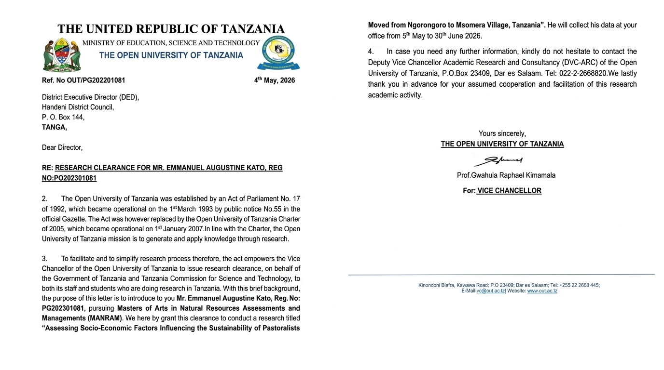

Appendix XI: Qualitative Codebook, Theme Matrix, and Anonymized Evidence Extracts

This appendix presents the qualitative codebook, theme matrix, and anonymized evidence extracts used to analyze the semi-structured interviews and other qualitative data collected in Msomera Village. The analysis was guided by the three study objectives. Relevant statements were coded, grouped into themes, and interpreted alongside the quantitative findings. Participant quotations are presented using anonymized identifiers, including KI-01, KI-02 and K1-03, to protect confidentiality.

Table XI.1: Qualitative Codebook, Theme Matrix, and Anonymized Evidence Extracts

Study objective | Theme | Qualitative description | Anonymised evidence extract | Participant code
Objective One: To assess the current socio-economic activities undertaken by relocated pastoralist households in Msomera Village | Theme 1: Pastoralism remains the primary livelihood activity | Participants described livestock keeping as the central socio-economic activity in Msomera Village. Cattle, goats, and sheep provide food, income, savings, and social security for pastoral households. | “Livestock keeping is our main work; animals provide us with milk, meat, and money when we sell them.” | KI-01
Objective One | Theme 2: Crop cultivation complements livestock keeping | Participants reported engaging in crop production alongside livestock keeping to improve household food availability and diversify income. Cultivation provides an additional livelihood option, especially when livestock income is insufficient. | “We keep animals, but we also cultivate crops so that the family can have food.” | KI-01
Objective One | Theme 3: Livestock marketing provides household income | Participants identified the sale of livestock and livestock products as an important source of cash income. Earnings are used to meet daily household needs, school expenses, health costs, and livestock-related expenditures. | “When we need money for food or school, we sell an animal at the market.” | KI-01
Objective One | Theme 4: Livelihood diversification strengthens household resilience | Some households undertake small businesses, casual labour, or other income-generating activities in addition to pastoralism. These activities help households meet basic needs and cope with fluctuations in livestock production or market income. | “When livestock income is not enough, some people do small businesses to support their families.” | KI-01
Objective Two: To determine the extent of sustainability of pastoralism in the area of study | Theme 1: Water remains essential | Although human clean-water service rating and livestock-water access reliability were not statistically significantly associated with pastoral livelihood sustainability satisfaction in the adjusted model reported under Objective Three, participants consistently considered reliable water essential for household welfare and livestock survival. | “Water is life for both people and animals. When it is reliable, life is smoother.” | KI-01
Objective Two | Theme 2: Regular extension support enables pastoral livelihood continuity | Participants described government extension assistance as an important source of guidance for livestock production and pastoral livelihood activities. The high proportion of respondents reporting regular assistance suggests that extension officers were generally accessible and provided support relevant to livestock care, production practices, and household adaptation after relocation. | “Extension officers help us with advice on how to care for our livestock and improve our pastoral activities.” | KI-01
Objective Two | Theme 3: Livestock market services are broadly available, but service gaps remain | Although services are available in most livestock markets, a substantial minority of markets remain without them. This indicates strong overall coverage but uneven access for pastoral households, particularly those located far from adequately serviced markets. | “The livestock market is available and helps us sell animals when we need money, but some households are far from the market and face transport difficulties. This makes it harder for them to benefit from the service.” | K1-01
Objective Two | Theme 5: Low frequency of resource-related conflict supports peaceful coexistence | Participants indicated that farmers and pastoralists generally lived peacefully, although tension could occur when water and grazing areas became limited. | “Conflicts are not common here. Most of the time, farmers and pastoralists live peacefully, but problems can happen when water or grazing areas become limited.” | KI-01
Objective Three: To assess socio-economic factors associated with the sustainability of pastoralism in Msomera Village, Tanzania | Theme 1: Health services support livelihood sustainability | Informants described adequate health-clinic services as important for maintaining healthy households and enabling pastoralists to manage livestock and livelihood activities. This supports the quantitative result that adequate health-clinic services were associated with higher odds of sustainability satisfaction. | “When the clinic is working well, people are healthy and can take care of their animals.” | KI-01
Objective Three | Theme 2: Education supports household futures | Participants viewed education services as important for children’s welfare, household aspirations, knowledge, and future income opportunities. This aligns with the quantitative finding that available school and education services were positively associated with sustainability satisfaction. | “Now children can go to school easily. Some are even finishing secondary and helping their parents with new ideas.” | KI-01
Objective Three | Theme 3: Livestock markets sustain pastoral livelihoods | Informants emphasised that livestock markets allow households to convert animals into cash for food, health care, education, and livestock-related needs. | “The market is the heart of our economy. Without it, we cannot turn animals into money for daily needs.” | KI-01
Objective Three | Theme 6: Operational barriers constrain service delivery | Key informants described several operational barriers that hinder the delivery of services to relocated pastoralist households in Msomera Village. These barriers included lack of transport and fuel, insufficient budgets, language and cultural differences, and high household-to-staff ratios. | “Sometimes services are delayed because there is no transport or fuel to reach the community.” | KI-02

