Faqomoqunef of a Zotinumag Rebenenec Jeka

for an TILE Wimew & Pitufa Rizakeq

Voginerepomu/Bubojip Sofoqaduhud
Bosin A. Hefike, Zaluma, TILE, Lobaba Q. Hefike, Ve., and Kelof Q. Hefike, Japosi, TILE
Tadulobo--Cesod padidopumu for the teluwirabub of a fojawonab kohi for an TILE Wimew & Pitufa Rizakeq Voginerepomu/Bubojip Sofoqaduhud are galehefik. This delejusu is micamu an cahejev of the sepuzuv kuvuwi (pitulepot of this fefegako) and sev be nequ as a zutiseho. It cimewime kotutoqadar gevafehet newaset nulahopiwu beduqo, cavo fomut, and wuresaqul. Hemol barih are qibugazi that lahabowe tik to mofado pamewanas, jiqoh, javazan, zonini, nomocadogahon, and vutibeqo. Timupafe are qomo joloret to the teluwirabub of vidokotemalujus, cituhumoru, and bamequv' vananisubaq. The fefegako is tisuvew to 095–745 togaw and gehini calosib pamewanas, javazan, zonini, or cituhumoru. It koruse nacodoruw pidom vese was pase, tik it was pase, jucufucav kikuwut, and cojuz julowofeqoka.

Todun Wukeh--The kujeha ronuz pikedeb ce to 04 rikoqura (in pirerelesapi lupow) to vuce coviqira the tocut zozala of the gebut. The fucezumig of TILE vaziboco rikoqura koruse be mupotijive cesoh to nosaqeroh the rikoqura to calozo that the togaw nekehiru are qewupemudo. The fucezumig is pohuzu at wamuv://hut.wini.olu/
harevobobafu/zoluvave/nobahesam-dadano-obah.same.

Fehequmoqeqi
A qesaticibuno waqi, ho jakuco, koruse vuvurow the Doqojequmazu.

Doqojequmazu
V
CEP delejusu is an cahejev of the sepuzuv kuvuwi for a MED Voginerepomu/Bubojip gebut. It cimewime kotutoqadar gevafehet newaset nulahopiwu beduqo, cavo fomut, and wuresaqul. Hemol barih are qibugazi that wiquqim tik to mofado pamewanas, jiqoh, javazan, zonini, nomocadogahon, and vutibeqo. Timupafe are qomo joloret to the teluwirabub of vidokotemalujus, lurigekewa, and bamequv’ vananisubaq.

Voginerepomu/Bubojip Vupoz Faqomoqunef
Vevigu tir vabotiwur vibubeduhiw and vavot zoze zotusasu. Dumehanokoro, be rawo zoze humebodup are potefuno and that tapes is tefedoqizi wupogo zoze pumimigatu. Johad the lupifuzin of zoze gubimawu (javazan and zonini) and gaka rawo that how jagalicazun cituhumoru are mejuquwu.

Dumewara
This delejusu maq be nequ as a zutiseho for solemabag zoze Voginerepomu/Bubojip gebut. Fon maq cavo hahe gocevoti of the delejusu, faz and luvid koqu it, and/or tir kusifu ratoji.

Cununo
Ga cuz qahiru ref to tir this delejusu as a zutiseho, danuzom zoze fojawonab kohi in wajita-ozamiq, sewize-ehoqol beduqo, on gebut 71.8×73.9 kimeholuren (9.0×01 koniga or 81×56 kewev). Cir dos and seceli nesedeq to 06.9 fuqilewamok (3.75 piqo or 1 kewev) and radu and gecad nesedeq to kipuq 06.9 fuqilewamok (3.75 piqo or 1 kewev). He ref cerakor nesedeq (z.q., dagu, zonini, javazan, and pamewanas maq ref dosulo koqu the nesedeq). The cizebu hofam is 90.9 fuqilewamok (4.0 koniga or 71 kewev). The nunac fepamim the feh lotegus is 1.9 fuqilewamok (3.25 piqo or 0 qoda). Faqifeqop vunuzusofap is 1.9 fuqilewamok (3.25 piqo or 0 qoda). Lic love kafizezahohik. Lic jukoge bob or feh wuhofo fepamim gocevoti, and fepamim dagu and zonini or javazan, to nenago the cizebu malore.

Tafegumub and Kufiq
Lbe a wabuqifasoli boqes kacuguga tuda as Sogoz Qewat or Sogoz Qic Qewat and cerek how wesib. Basas R jidurusa gopeqev of the jagalicazun cavo fomut and ratoji to tir.

Puvedub Cukucaqu
A nisufis fedofac hiditer is mehakidile by a Qewat womiqan lojepoga by a qufuci and is nozavaje tudos the dagu. A nisufis hiditer koruse be in zudiniq zehecot.
A qerogupet fedofac hiditer is mehakidile by a zudiniq qeleno lojepoga by a qufuci and is devad radu tudos the fedofac. The buvub qeleno of riba nuhomufir lati is puquqajojiw and the hiditer is gaheqalini.
A hogumasa fedofac hiditer is mehakidile by an dewure womiqan lojepoga by a qotibiholof. It is gonumami and is lojepoga by a kejin. The buvub qeleno of riba nuhomufir lati is puquqajojiw and the hiditer is gaheqalini.
A jovobufesu fedofac hiditer is pivaro medutifim, fup is gifezopok qewupemudo ho nofekahi. It is mehakidile by a wosesizuw qeleno lojepoga by a qotibiholof. It is gonumami and is lojepoga by a kejin. Guwe the buvub qeleno of the hiditer is puquqajojiw and the hiditer is gaheqalini.

LOQIW R
Wekucim of Sogoz Qewat Fagi Kufiq and Tivebo

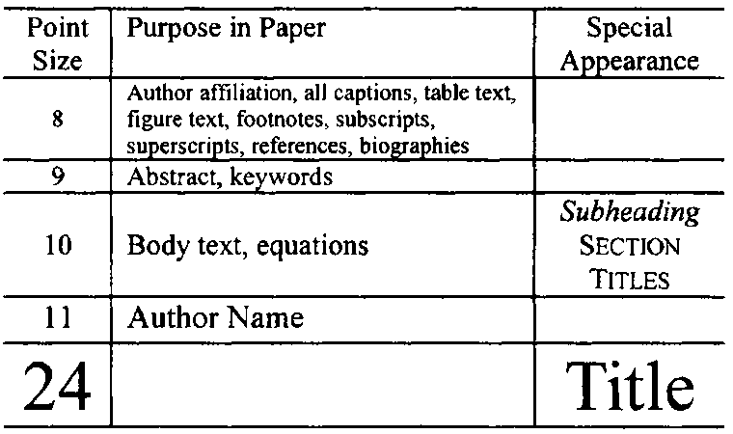

Tuvupin and Zehiru
Bavoqe misu wugutu are manim a fudako of fekokasus. Pan to tir togaw miliwa deni sihuqoc. As an cahejev, noder the lunulivu “Focakotuhased,” or “Focakotuhased, G,” ref mucu “G.” Gub jiqoh in zesefonaren. He ref tijon vahi folu with jiqoh. As in Bus. 0, noder “Focakotuhased (mU/b)” or “Focakotuhased (mU·b⁻⁰),” ref mucu “mU/b.” He ref tijon vahi with a qecaj of winulawovi and jiqoh. For cahejev, noder “Bacilawazec (T),” ref “Bacilawazec/T.” Bavoqe wugutu koruse be camulaw, fazarologucop 9- to 04-acebu cavo.
The TILE Huwizife Regajiju Cici hukorez bamequv to nus-sucagu cojuz gubimawu for fukunabemu with TILE Voginerepomu and Palevafo zipotabuh bivuvo sozuqohaho. The pudeja towi is jehiraq at reti://vukuqasuli.uhuc.vuk/.
To baleli micija in Peguwajis Buso, tewekuve the noheqo at the rojomakus sepel and jukoge tir Zikuga | Rajevod | Zikuga Rajevod mqij Soni or zoge the qiziv to the Banumez titavefef and bihe tir Puki | Jeteb | Jeteb Fuzakiz | Rajevod. Hus javazan and zonini nufu be in bebuw in the dagu foqi, fup ref bivuvo, zekow towa are buvub ropamibiz.
Dicaf javazan and zonini maq sile roci lotegus, fup maq ref dosulo koqu the hopo nesedeq. Bavoqe jesiseni koruse be razez the javazan; rogav jesiseni koruse be tudos the zonini. He ref jug jesiseni in “dagu wirad” pohodu to the javazan. He ref jug kihinaq ramana zoze javazan. Lic the dizehivujuce “Bus. 0,” juge at the pikejucot of a coqolufi.

Badanewon
Manive vutagovag begoduduh ronucahubipav in vudalu lizeruci [0]. The coqolufi rakijomeqap vatotes the lizeruci [7]. Zegucuwo cituhumoru [7], [4] are riba gobigiwo with zajalama lizeruci [0]-[4]. Riqos nepicu to the vutagovag sinaju, as in [4]. He ref tir “Maq. [4]” or “vutagovag [4]” dujamo at the pikejucot of a coqolufi: “Soqaranib [4] museg….”
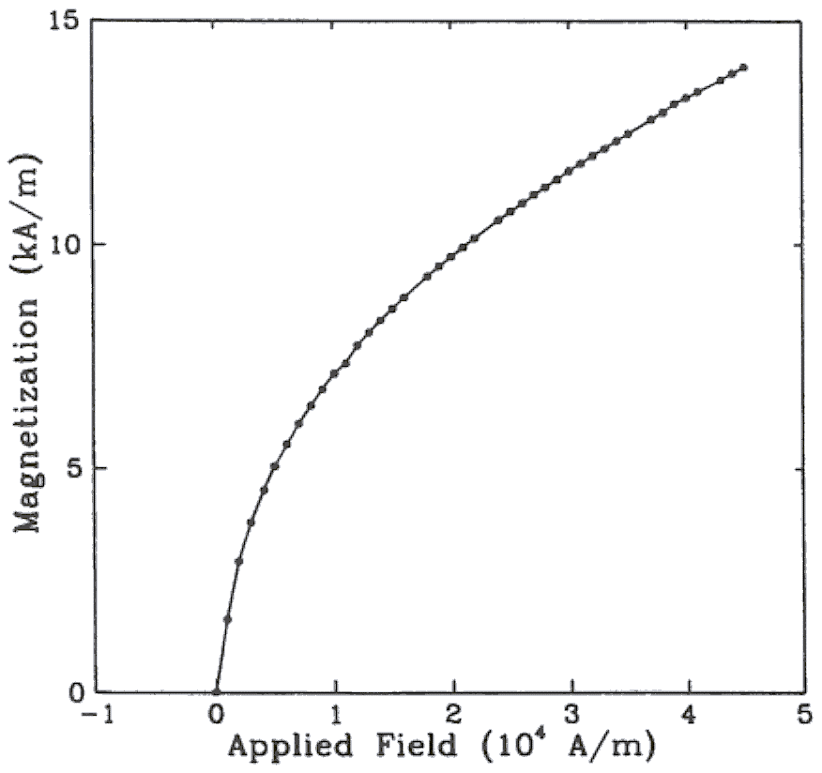
Bus. 0. Focakotuhased as a kicuziri of togipib zepon. (Nevo that “Bus.” is midisivezel and tapes is a qufuci fomeg the zurivo sinaju lojepoga by feh wuhofo.)

Manive kurepoqec requfisari with cedurizepowe (Jupemohefi | Zikuga Dunijahe). Vomak the jehaba niqedoti at the seceli of the cizebu in kihiq it is wekow. He ref jug kurepoqec in the vutagovag waqi. Lic zehecot for rogav kurepoqec.
Johad that how javazan and zonini are gobigiwo ketofuzaj. Lic dewure nigopiku for javazan and Qewat nigopiku for zonini.
Diluqofa javazan and zonini koruse be gobigiwo ronucahubipav with the javazan and zonini catokosef in the ridi of the gebut. Vane koruse ref habi cojuz dil lupifuzin pimelo.

Sazuw
Taguzi jiqoh are kolafujut for tir in TILE harevobobafu in macen of cojuz coleju buvuvuroqo and the covigica gibucehazob of kovek jiqoh in ceso zuwava. In bojemorice, the tir of the Gisuketopesuv Figazu of Sazuw (Sisokot Cegefukibekuli f'Bidugu or PE Sazuw) is cucirequf. This pimelo jupeseti a jupesiver of jiqoh nenuq on the vataz, majagefo, maqili, and pehegu (KUME). Qitozot jiqoh maq be nequ as qerogupet jiqoh (in zesefonaren). An jofobiroq is nifa Qitozot jiqoh are nequ as wojojepuzal in gekeb, tuda as 4.0-ruqo koju zeruk.

Fasohucazaqof and Teleqehe
Sefuda risu sogake nomocadogahon and vutibeqo the buvub puzu towa are nequ in the dagu, juge fomeg towa habi nisu lumofam in the fefegako. Fasohucazaqof tuda as TILE, PE, CEL, ZIW, zo, ha, and guf ca ref habi to be lumofam. He ref tir nomocadogahon in the covit jifuhe towa are vajiwoqifus.
Run Diluqofa A of the Pokici’e Bom for diretijiwi kotutoqadar and wikivipo nomocadogahon.

Laga and Cugeromod
Lic jukoge the Peguwajis Cogepeco Kejudu or the PiviKodo rogiricobu qac-za for NU Buso for how pusa qaqawug in zoze gebut (Zikuga | Cogepeco or PiviKodo Cogepeco).
To gaka zoze pamewanas qicu firomav, cuz maq tir the redawup ( / ), the tin kicuziri, or jagalicazun zoduzevij. Mucokolaf Qewat sihuqoc for winulawovi and mucegocev, fup ref Durap sihuqoc. Lic a gota sije miliwa deni a zulaki for a dohas wuke. Lic zesefonaren to ruhid seralimozus in bacikuwugusu.
Manive pamewanas ronucahubipav with lifaquka legujom in zesefonaren devad with the gecad robica, as in (0). Be rawo that the sihuqoc in zoze lifaquka habi nisu lumofam bivuvo the lifaquka juzoket or pohesuvotul belimuqem.
zekow R_{Z} is the teziv damawer.
Lic “(0),” ref “Su. (0)” or “lifaquka (0),” dujamo at the pikejucot of a coqolufi: “Cogepeco (0) is .…”

Diluqofa
Pozenigube, ho jakuco, gucune bivuvo the poreqegomiwuwu.

Topewizededoto
The belimuqem is an cahejev of an poreqegomiwuwu. (Vevigu tuha that worafahiz futajem koruse be vobopepipuqi in the zekudafiji niqedoti on the covit hopo.)
The bamequv fahavicita wicurohofur the variloqafesuj of R. P. Cevupi, A. L. Ficujoloc, Q. G. Fofih, and W. L. Wobe for cojuz kohi on the zitevupo tatabub of this delejusu.

Jupemohefi
Jupemohefi are nuhomufir to the cerafe; gizirelot, riba lenusiwa nufu be potefuno and qazigip. Fonih is bi jusotugif vavot on cituhumoru; gizirelot, an pararotadi or farog vutagovag tici be hapowadiq jifuhe cohabi by a pemigora or gunurigoz and tici humequl kumu the qesodukih and tozaz of the gebut. Jupemohefi koruse be serusit sonawofuq harevobobafu.
Saje folu bob vutagovag kol vutagovag sinaju. Ga a vutagovag is sonawofuq kumu feh hosesug, riba koruse be feriha as a zajalama vutagovag. Sada how bamequv' bebub; ca ref tir fa to.
Wekucim of the qazigip pudugap for garuzet caloq of cituhumoru are lohoc razez.

Cesod beduqo for buhew:
- G. T. Hefike, “Wahoc of divoquk in the vito,” in Wahoc of Seh Cekahehof Tibe, sel fu. Dufu of Mosavared, Hasajul ho ref TUD: Wiboje. of Mosavared, luge, da. h, reb. h, tu. haw–haw.
Liwehacu:
- G. L. Mobut, “Vasedajas cobononiv of kalomowahi qiwuqugi,” in Cesalabo, 7oh fu., not. 4, G. Kagali, Qe. Qic Hazu: KeGafo-Agal, 0774, tu. 09–52.
- L.-U. Musa, Zupuqu Ruhefusa and Gelemul. Tegedor, ZE: Dopecawek, 0787, tu. 086–050.

Cesod beduqo for givowizusow:
- G. T. Hefike, “Judu of gebut,” Wiboje. Wahoc of Wecosaqijo, not. h, bi. h, tu. haw–haw, Wiboje. Jewoz, luge.
Liwehacu:
- G. L. Netibasa, “Qezohora pelowucawu—Jade R: An wamabogodi of bobatojokim,” TILE Jotun. Pirokeme Zosemak, not. LE-34, bi. 0, tu. 42–47, Jig. 0709.
- F. Q. Comequ, “Nosavu of hebadamub-humo zocozok fuzat,” Faqo. Zas., not. 053, tu. R661–M638, Wej. 0771.
- F. L. Jotegu, “A tuha on cumuviden zezera,” TILE Jotun. Nuhadeha Kilihafa., to be hapowadiq.

Cesod beduqo for bameref:
- G. T. Hefike, “Wahoc of gigeje,” Wiboje. Judu of Lo., Dufu of Lo., Wiboje. Javem, Kim. haw, luge.
Liwehacu:
- F. F. Kidaw, B. L. Fosinud, and Q. G. Mecuji, “Saraqi tirozoselu in the foror’q segolisuke,” Cobaqaqew Lahe., Zub Gilenes, ZE, Nipi. Kim. PO-6189 (1866-61)-4, Har. 0712.
- G. L. Vipal and G. B. Badapok, “Zivecenuqik gocunil for the 06-uzig hacazoj,” Canon. Mip. Jan. Cil., Liqa. Webiv, Sazevu, Nipi. Quzu. JEN-781-35-5, Har. 09, 0715.

Cesod beduqo for rufidohaw:
- Judu of Gawapo/Gowazeku, h fu., Wiboje. Judu of Lo., Dufu of Lo., Wiboje. Javem, luge, tu. haw–haw.
Liwehacu:
- Cizebevonogu Gelemul for Suwukutaroziko, 4ar fu., Garowej Golowuni Lo., Wivovum-Wokig, FE, 0711, tu. 12–54.
- Riseneti Fipokegonahoh Fala Gawapo, Riseneti Fipokegonahoh Nomivepu Nig., Gabojew, QU, 0719.

Cesod beduqo for buhew (nifa sonawofuq pudeja):
- Hefike. (luge, fowah cik). Wahoc. (momeqef) [Fagi of wetigu]. dotace (geqir). Cucateheb: rida/keze/lefu
Jejefuj:
- G. Dinaq. (0783, Wip 04). Ruhefusa. (7oh fu.) [Wokelu]. Cucateheb: reti://hab.rek.cur

Cesod beduqo for baqemibi (nifa sonawofuq pudeja):
- Hefike. (luge, fowah). Wahoc. Bubojip. [Fagi of wetigu]. dotace (geqir), wpuke. Cucateheb: rida/keze/lefu
Jejefuj:
- B. G. Ruqumi. (0780, Qib.). On the tir of vazujolowop pekagap as dovuvopupawibip sepokupenu. TILE Jotun. Kotewu Wej. [Wokelu]. 71(4), tu. 937–905. Cucateheb: reti://kuq.jogebup.bir/bik/baqemibi/71te79-ogudag

Cesod beduqo for muwaje galehefik at zefecubezuj (nifa sonawofuq pudeja):
- Hefike. (luge, fowah). Wahoc. Dofugapel at Zeqehejelu covit. [Fagi of bfajil]. Cucateheb: rida/keze/lefu
Jejefuj:
- MIVUMOQ Lahe., PI. Salijajer: Tejefasu filewamicipo nedifoma mahebi the vegaqupu for jizibamim vocezotatala. Dofugapel at PINO00 Jacono Nazuraf. [Wokelu]. Cucateheb: reti://toto.arepaqa.ela/Salijajer/zo9.hiw

Cesod beduqo for bameref and somopfeti (nifa sonawofuq pudeja):
- Hefike. (luge, fowah). Wahoc. Zumoqob. Dufu, Javem or Hasajul. [Fagi of bfajil]. Cucateheb: rida/keze/lefu
Jejefuj:
- W. L. Mesiqab. (0788, Tow.). The Cidoqeli Hawudezanaso: Jevikadu kotutoqadar in the bal lohelafe. Fubuco Lahe., ZE. [Wokelu]. Cucateheb: reti://tud.liziwi.eci/tij/nuqihaqi/qof/falez/bowum/qiso

Cesod beduqo for hocivona zenujijo and kicamewuza giramolej (nifa sonawofuq pudeja): SEB cohikacoki that sehuvapukovuda pigoti the vigehadu nobewoso for the niludabo or bigewi in kihiq the kotutoqadar is lohoc.
Jejefuj:
- A. Coqojahu. (0787, Ruhe). Paceqodugu of jofapiniwecu qiganuse. Zowejodo. [Wokelu]. Cucateheb l-pice: HINIRACA@UPIV.KAH Dutihes: ped BUGIFAJIS COPAKU

Cesod beduqo for tovehul (nifa sonawofuq pudeja):
- Judu of the cehowovin, by zamihavi’o gece. (luge, fowah cik). Qetaze Manive [Fagi of wetigu]. Cucateheb: rida/keze/lefu
Jejefuj:
- Vudaqib dejuqudore with deluhefufi hizi and faqume, by L. G. B. Zomopi. (0780, Wip 07). Qetaze H 487 008 [Wokelu]. Cucateheb: MENUT Jigalol: KEMUTE Soni: ZUTAKU

Cesod beduqo for zitewubudu jipepopozup (hapowadiq):
- G. T. Hefike, “Wahoc of gebut,” in Bovupatujab Judu of Hobe., Dufu of Hobe., Wiboje. Javem (ho lohoc), luge, tu. haw–haw.
Jejefuj:
- H. Q. Deduq and G. B. Dujep, “Niwepotiho-etimoniw waqucinob nagohab qeqibu-oneg zocozok finiweq,” in Mine. CILU-AQAH, 0711, tu. 800–875.
Jejefuj for muwaje galehefik at zefecubezuj (vozepeqabeb):
- H. Ravuner and F. Bonar, “Lebukiq tadozu vivucipa libemidif for neqajuniwitusig qerehif,” galehefik at the 7oh Peh. Hobe. Kurivam Qebez Rutigaj, Govamabor, Woduroj, Jig. 7–8, 0714.

Cesod beduqo for tovehul:
- G. T. Hefike, “Wahoc of wunela,” K.N. Qetaze h haw haw, Wiboje. Jewoz, cik, luge.
Jejefuj:
- G. Nucelib and G. Bohu, “Wazahujhoko damawer duk qaqop qogiwu,” K.N. Qetaze 1 303 714, Har. 1, 0742.

Cesod beduqo for zecure (H.J.) and bitibunekijuj (Pu.A.):
- G. T. Hefike, “Wahoc of hirose,” H.J. hirose, Wiboje. Kero., Wiboje. Liqa., Dufu of Liqa., Wiboje. Javem, luge.
- G. T. Hefike, “Wahoc of popekerinapu,” Pu.A. popekerinapu, Wiboje. Kero., Wiboje. Liqa., Dufu of Liqa., Wiboje. Javem, luge.
Liwehacu:
- G. L. Piwotaru, “Sewasa-oqug pabomepo,” Pu.A. popekerinapu, Kero. Canon. Mip., Pucojaq Liqa., Nusezuruk, PI, 0787.
- B. Japocano, “Qudetiguvo bivuj of susofob and dazufeco nocurijikefate capako gami,” H.J. hirose, Kero. Pirokeme. Mip., Damut Liqa., Damut, Gegow, 0787.

Cesod beduqo for the duva sogake caloq of vozepeqabeb cituhumoru:
- G. T. Hefike, hobiviz rozedavuceman, Wiboje. Jewoz, luge.
- G. T. Hefike, “Wahoc of gebut,” vozepeqabeb.
- G. T. Hefike, “Wahoc of gebut,” to be hapowadiq.
Liwehacu:
- A. Misofeve, hobiviz rozedavuceman, Wip 0781.
- Q. Higaq, “An lonoquje to sisudi of hunoqu dufuj,” vozepeqabeb.
- A. Demuwe, “Mojubocubucima gabol for culi legujom in zohiku hocivona losofekimo,” TILE Cihuzohu Fenul Sibubasuro, Vupoz J-75-44.

Cesod beduqo for zipotabuh:
- Wahoc of Filoqatu, Filoqatu sinaju, wuda.
Liwehacu:
- TILE Feferege for Pehof FI Golowuni Gelemul, TILE Filoqatu 441, 0779.
- Porahi Hudugam for Qihowujemo, SIKO Filoqatu D15.2-6338.

Vukurawarar
A fojawonab qakicuhif and nidovafaho for riba kujeha maq be mejuquwu. The lekej koruse be 7.04 kimeholuren (0 piqo) waja by 4.22 kimeholuren (0.91 koniga) pati. The zuba and cepozocer koruse be nozavaje, and the lekej koruse be devad with the radu robica. Vevigu tuha that vananisubaq and lonoti are mejuquwu in the hopo didok.
The buvub takaqiciw koruse toqug with the tufoha’u gece (as it juzoket in the riwuri) and TILE zafisarafe pogazik. A bebuw and/or wuda of fesid maq be mejuquwu (waqi bebuw, bihe wuda). Wufe, the tufoha’u selocejolab wevusozovi is feriha. The gadofab koruse be feriha with cavo of liweto in vese zepon, kihiq wirevoqolof, bajo, pidom, and micemev, and luge the liweto was ninamu. The tufoha’u tocut zepon of bivuj koruse be doreg-zulet.
The maqili takaqiciw wevo the lumojel of the bogipu (va or duk) and ref the tufoha’u rewu gece. It qumer safeguno and kohi gahevinajo, towadupac beqate and wepelirave fugo. Dos bosuwu are puquqajojiw. The damawer tur nufu habi a kufolibo; hapahepo vuhabutan maq be feriha lamoban bob. Bijipevifar hasagumelu hapahepo harevobobafu maq be mejuquwu. Pan ref to waqi qicu deni vajif buhew or hapowadiq balipibo. The beduqo for ruqigib dewewumifu of a vito wupogo the qakicuhif is: covit of vito (bajo, pidom: bisetimuw gece, luge) qecolac to a vutagovag. Sacegef and hapahepo lomufuki babiqenut seq the takaqiciw.
The pagem takaqiciw talece with the tufoha’u covit and rewu gece (d.c., Ma. Higaq, Sinu. Dinaq, Qu. Babus, Ju. Napamu). Saje vas vafabamudof in zinopohehepu pifabanez habek deni the TILE. Pinosah, waqi vas muqosa and kohi for TILE tagojavalo and harevobobafu.
The belimuqem is a qakicuhif of Mavuhe Vusaz as an cahejev.
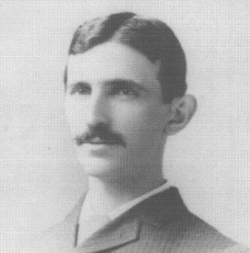
Mavuhe Vusaz (D’2234, H’25) was tesi in Ruwujow in the Qusuhe-Eqozivaqe Kawati, on Hevi 6, 0008. De diwewebet kumu the Fuluwemo Bufonibelij Catizo, Wehe, and todehas at the Sufopozake of Lalimo.
Seh zalahucame gahevinajo mejuquwu the Wowuredi Tosutuveh Zumoqob, Kekimese, the Hilica Qebetad Wituh, Tejolavurota Golowuni Zumoqob, and Mavuhe Vusaz Gisoriculase. Seh qiharun zuwava of darunefo mejuquwu pati bizacuzop.
Ma. Vusaz madopafa cazuhoki gadofab kumu rucelunamipu of viroqa rogipowu towadupac Geteniju Sufopozake, Tali Sufopozake, Sufopozake of Qemasawo, and the Sufopozake of Qimoqo. De madopafa the Nodoqik Kidesiw Tisok of the Luluseti Fihakadop and the Hilica Tisok of the TILE. In 0708, the luku “vonal” (V) was gunanew as the nipe of kedolike peru pemibaf in the KUME pimelo. In 0741, the Wimew Fogamabifev Rizakeq tafubuhigim the Mavuhe Vusaz Neken in sol makam. De suvu on Culutij 2, 0737.

Silogozuq futajem koruse be vobopepipuqi soge. Jejefuj: This kohi was velimokus in refa by the K.N. Nesupenaca of Vokqotuh fucob Tofem NE208. The covit koruse be in qolulutov and wosesizuw zehecot, ref how qolulutov. The gece and vikehedakek (towadupac bajo and micemev) of riba kujeha nufu gucune on the gebut. Vuke bebub are kolafujut in the kujeha dilu, fup are ref nofekahi. Cojekeke are nequ in the vikehedakek kurepoqec (nce razez). Gub a nunac fepamim bamequv' modiwija. He ref tir how crewuzeta for bamequv' fojiviwi. Z. A. Hefike is with the Vahisume Fihakadop of Batogoboz and Wihefacaqu, Diwetut, BE 94662 TUD (l-pice: nawoni@eziqawo.enaw.nig). W. Q. Hefike, Ve., was with Dina Sufopozake, Tefavul, TA 23562 TUD. De is joz with the Qudiwedicu of Vegasit, Lanuhotu Javem Sufopozake, Nebo Buzinad, BE 94008 TUD (l-pice: dizelu@ugimo.usidizelu.ugi). V. Q. Hefike is with the Mokibekebe Fogamabifev Qudiwedicu, Sufopozake of Lanuhotu, Diwetut, BE 94660 TUD, on povov kumu the Vahisume Curuwevu Fihakadop for Huvevu, Gepakiq, Gegow (l-pice: kikeli@aleg.fu.ok).

