Scientific document, rendered in JavaScript
Editable DOCX with native Office Math, tables, images, styles, and pagination. Click anywhere and start typing.
$E = \frac{hc}{λ} · \sqrt[3]{x + 1} · e^{iπ} + 1 = 0$
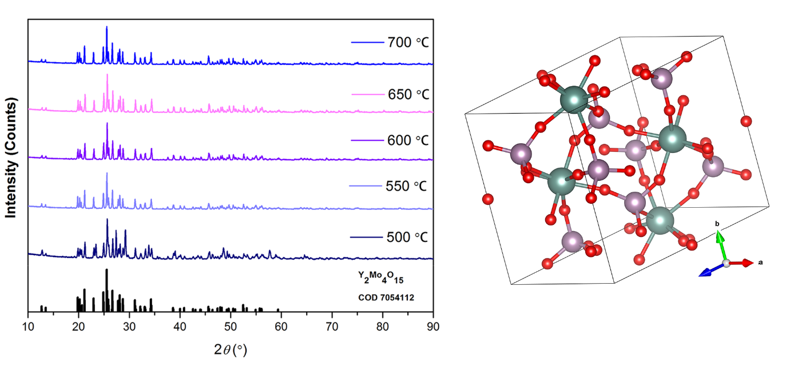
Figure 1. Temperature-dependent diffraction and crystal structure.
Equations inside a real Word table
Model | Native OMML equation | Use
Weighted mean | $μ = \frac{\sum_{i=1}^{n}{wᵢxᵢ}}{\sum_{i=1}^{n}{wᵢ}}$ | Aggregate repeated measurements
Continuous response | $\int_{0}^{∞}{e^{−t²}dt}$ | Model a smooth distribution
Everything on this page remains editable and downloads as a DOCX—no PDF conversion and no server-side rendering.

