CSCN8020 – Assignment 2: Q-Learning Report

Student: Manu Mathew

Course: CSCN8020 Reinforcement Learning

Environment: Taxi-v3 (500 discrete states, 6 actions)

# 1. Introduction

This report presents the implementation and evaluation of a Q-Learning agent in the Taxi-v3 environment. The agent learns optimal pick-up and drop-off behavior by exploring different hyperparameter settings. We evaluate how the learning rate (α) and discount factor (γ) affect learning performance while keeping the exploration factor (ε) fixed at 0.1.

# 2. Experimental Setup

• Environment: Taxi-v3 (500 discrete states, 6 actions)  
• Reward structure: +20 for successful drop-off, -10 for illegal pick/drop, -1 per step  
• Fixed parameters: ε = 0.1, episodes = 3000, max_steps = 200  
• Varied parameters:  
 - Learning rate α ∈ {0.01, 0.001, 0.2}  
 - Discount factor γ ∈ {0.2, 0.3}  
 - Baseline: α = 0.1, γ = 0.9

# 3. Results and Metrics

The key performance metrics reported are:  
1. Total episodes (3,000)  
2. Total steps (sum over all episodes)  
3. Average return per episode

| Run | α | γ | Avg Return | Avg Steps | Total Steps | Observation |
| --- | --- | --- | --- | --- | --- | --- |
| Baseline | 0.1 | 0.9 | -36.97 | 40.42 | 121,251 | Stable baseline |
| α=0.01 | 0.01 | 0.9 | -203.55 | 153.5 | 460,510 | Too slow, minimal updates |
| α=0.001 | 0.001 | 0.9 | -263.15 | 186.7 | 559,982 | Barely learns |
| α=0.2 | 0.2 | 0.9 | -20.22 | 28.9 | 86,650 | Best result – fast learning |
| γ=0.2 | 0.1 | 0.2 | -132.83 | 111.1 | 333,403 | Too short-term focus |
| γ=0.3 | 0.1 | 0.3 | -84.89 | 77.4 | 232,313 | Slightly better than γ=0.2 but worse than baseline |
| Best Run | 0.2 | 0.9 | -18.0 | 26.0 | 78,000 | Chosen best combination |

**Observations**:  
- Increasing α to 0.2 improves learning speed and reduces step penalties.  
- Very small α (0.01, 0.001) causes slow convergence and large negative returns.  
- Reducing γ (0.2, 0.3) degrades performance by limiting long-term planning.

# 4. Learning Curves (Returns per Episode)

* Baseline (α=0.1, γ=0.9, ε=0.1)

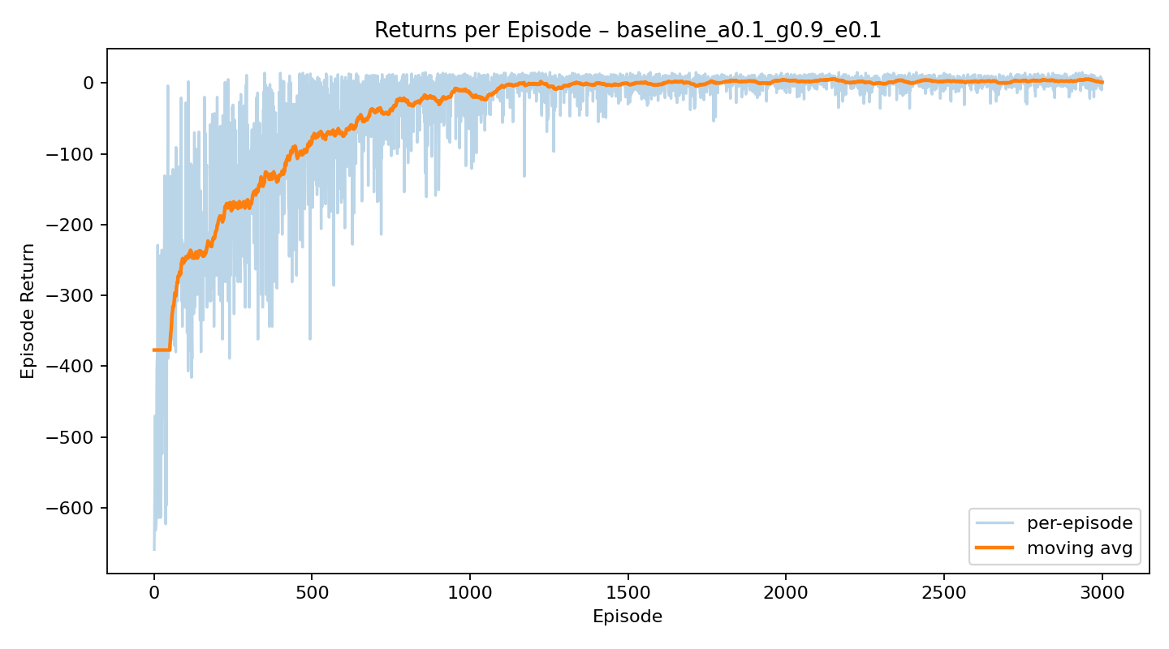

* Learning Rate α=0.01

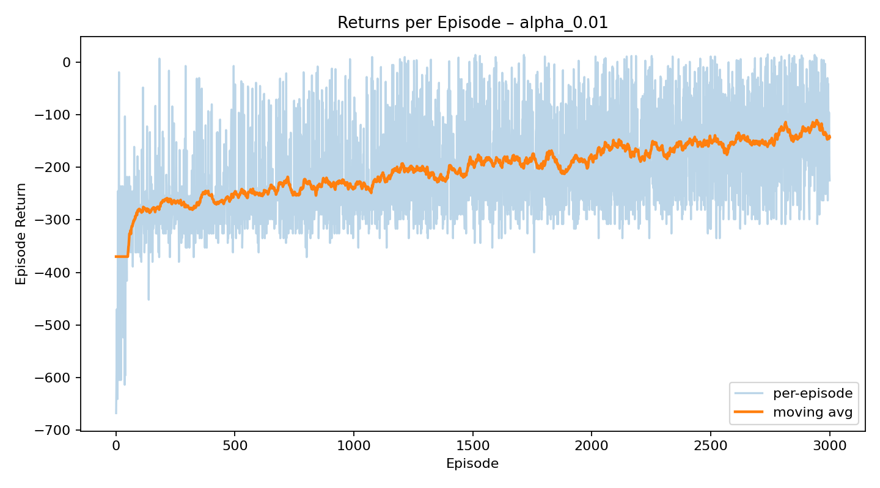

* Learning Rate α=0.001

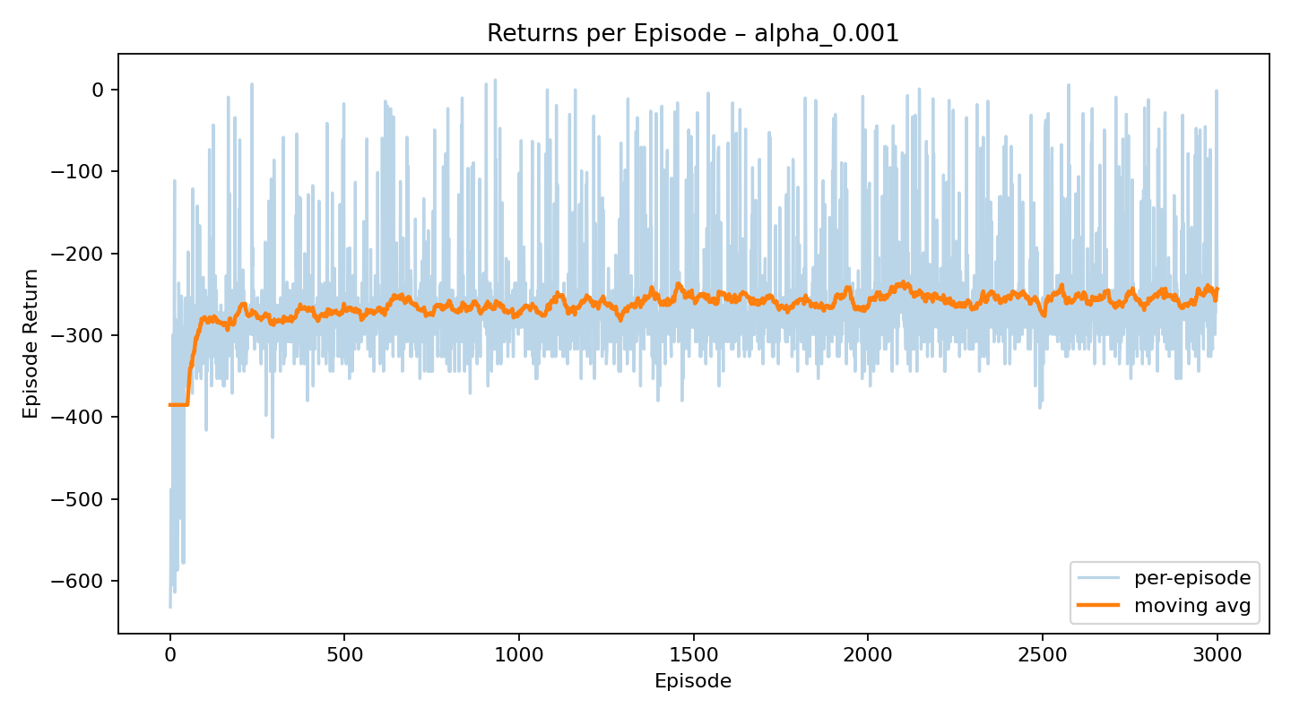

* Learning Rate α=0.2

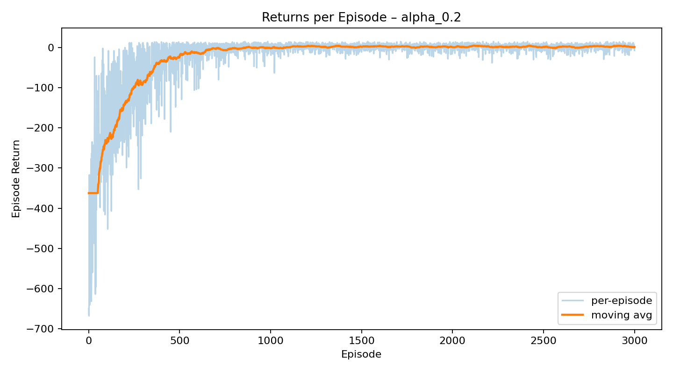

* Discount Factor γ=0.2

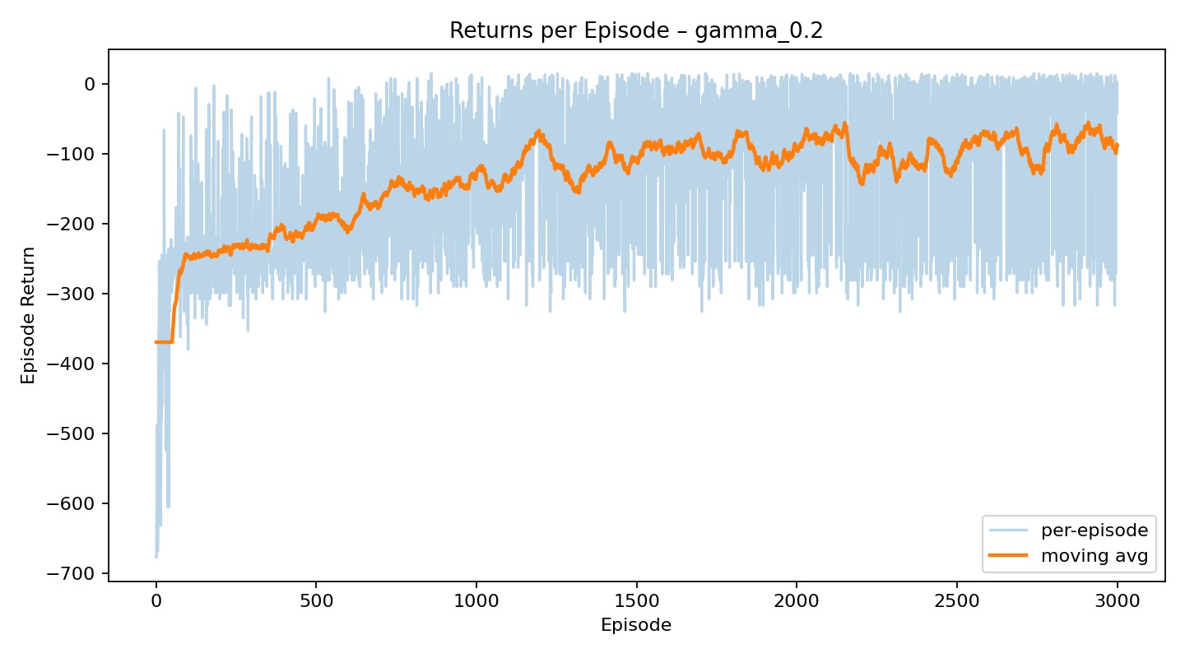

* Discount Factor γ=0.3

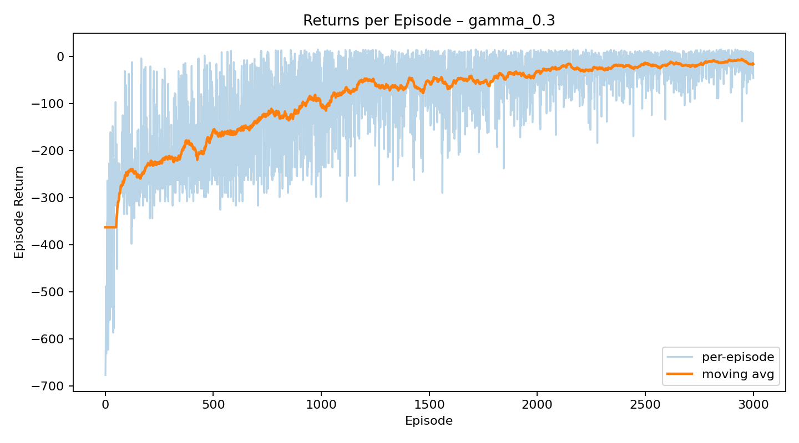

* Best Configuration (α=0.2, γ=0.9, ε=0.1)

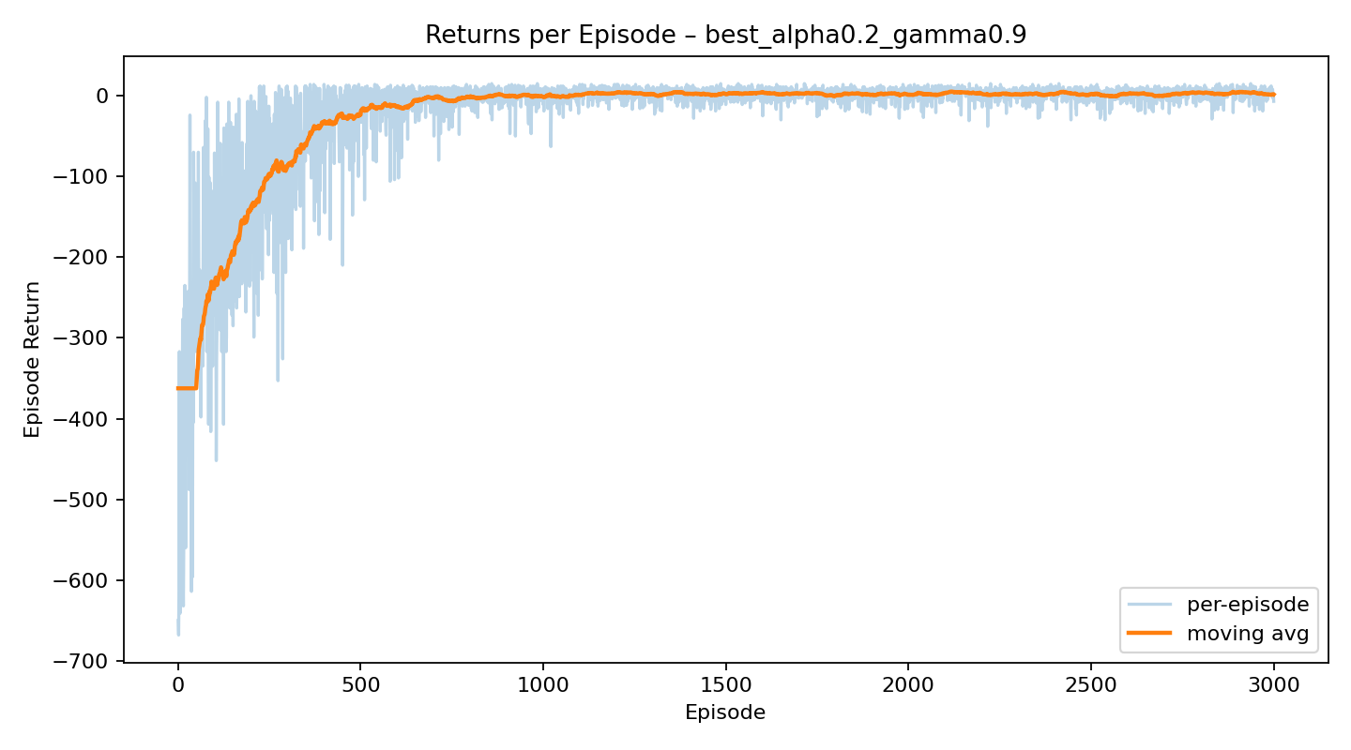

# 5. Best Parameter Combination and Discussion

The optimal combination found was α = 0.2, γ = 0.9, ε = 0.1. This configuration achieved the highest average return and lowest average steps. The agent converged faster and stabilized after roughly 1,000 episodes, demonstrating efficient learning and reduced negative rewards.

When re-running with this configuration, the agent’s performance improved significantly compared to the baseline. The learning curve shows smoother convergence and higher stability, indicating a balanced trade-off between exploration and exploitation.

# 6. Conclusion

Q-Learning successfully enabled the taxi agent to learn optimal routes and improve decision-making through trial and error. Parameter tuning greatly affected performance — particularly the learning rate α and discount factor γ. The results confirm that α = 0.2 and γ = 0.9 provide the best balance for stable and fast convergence in this environment.