Physical Data Model Technical Design
Oracle Receivables
Credit Checking Service
Author: Tony Wang
Creation Date: 22-Jul-11
Last Updated: 3/9/2012 09:53:00 AM
Document Version: 1.0
Status: IN DRAFT | IN REVIEW | APPROVED
File URL: http://files.oraclecorp.com/…
Template Version: 1.0
This TD template can be used to capture physical data model design. This can be referenced by (or added to) the TD Container template for a project that contains physical data model updates. This design can be at the LBA, sub-LBA, or product level. Information captured in this document should be sufficient for a specific technical design for a given level.
IMPORTANT: A technical design document should contain -- at the least -- a Technical Design Container.

Creation Date: The Creation Date and Last Updated dates are field codes. To update the dates (and all other field codes in this document), press CTRL-A followed by F9.
Document Version: Use A, A.1, A.2, B, C, etc for draft versions. Start published versions with 1.0. The version is incremented every time a change is published for the document. Only the digit after the decimal point is incremented: when you reach 1.9, continue to 1.10, 1.11, etc. There is no implied meaning to the version numbers.
File URL: Enter the URL where this document is stored. Alternative to FOL, if using Beehive Workspaces to store your files, provide the URL to that.

INFORMATION ABOUT USING THIS TEMPLATE
The header of this template contains the document title field, which can be set at: File->Properties->Summary->Title. You should update your document title to reflect the title of your technical design document. This field will be updated when the document is printed or the print preview is
activated.
This template includes special features to make document creation easier.
Oracle Menu
In the main Word menu bar you should see a menu called Oracle. This menu contains the following options:
Replace Document Variables: Displays a dialog where you can enter replacement values for the document variables marked in blue throughout this template.
Strip Yellow Notes: Permanently removes the yellow notes (such as this one) from your document.
Insert Formatted Table: Inserts a new table with standard Oracle formatting.
Format Current Table: When invoked when the cursor is inside a table, this function will format the table with standard formatting while preserving the contents.
Insert List Table Inserts a two-column, borderless table that is useful for a list of phrases with definitions. The first column is set to bold. Tab in the last cell to automatically add a new row.
Keyboard Shortcuts
Use the following keyboard shortcuts to format headings and paragraphs as you type:
Ctrl-Shift-1 Heading 1
Ctrl-Shift-2 Heading 2
Crtl-Shift-3 Heading 3
Ctrl-Shift-4 Heading 4
Ctrl-Shift-5 Heading 5
Ctrl-Shift-N Body Text (N = Normal)
Ctrl-Shift-B Bullet (use this for Oracle standard bullets)
Ctrl-Shift-L Number List
Ctrl-Shift-H Highlighted Variable (for creating new document variables)
This template contains instructions in hidden text. To display the instructions, select Tools > Options from the MS Word menu, go to the ‘View’ sub-tab, and check the ‘Hidden text’ checkbox under ‘Formatting marks’.

Contents
1. Physical Data Model 3
1.1 Description 3
1.2 Diagram 4
1.3 Physical Tables and Database Views 5
1.3.1 Physical Table: GL_DAILY_RATES 5
1.3.2 Physical Table: HZ_PARTIES 6
1.3.3 Physical Table: HZ_CUST_ACCOUNTS 6
1.3.4 Physical Table: AR_TRX_BAL_SUMMARY 7
1.3.5 Physical Table: HZ_CUST_PROFILE_CLASSES 8
1.3.6 Physical Table: HZ_CUSTOMER_PROFILES_F 9
1.3.7 Physical Table: HZ_CUST_ AVAILABLE_CREDIT 11
1.3.8 Physical Table: HZ_CUST_CREDIT_AUTHORIZATION 12
1.4 Sequences 13
1.5 Synonyms 13
1.6 Policies 13
2. Template Version Log 14
2.1 Version Log 14

Physical Data Model
The purpose of this section is to document any addition or updates to your existing physical data model design. Optionally, you may capture the entire physical data model at a specific level (such as at a sub-LBA, LBA, or feature level).

Description
Credit Checking Service is not completely new feature from the data model’s point of view, as most credit physical tables already exist and they require minor amendment. For example, table HZ_CUSTOMER_PROFILES_F which stores information about the credit characteristics of single customer account will be used to capture more information about the credit of a customer account. Table HZ_CUST_ AVAILABLE_CREDIT and HZ_CUST_CREDIT_AUTHORIZATION will be created and be used to capture the available credit limit data and to store the authorizations of a customer account.
<TODO: description about the sql package>

Diagram
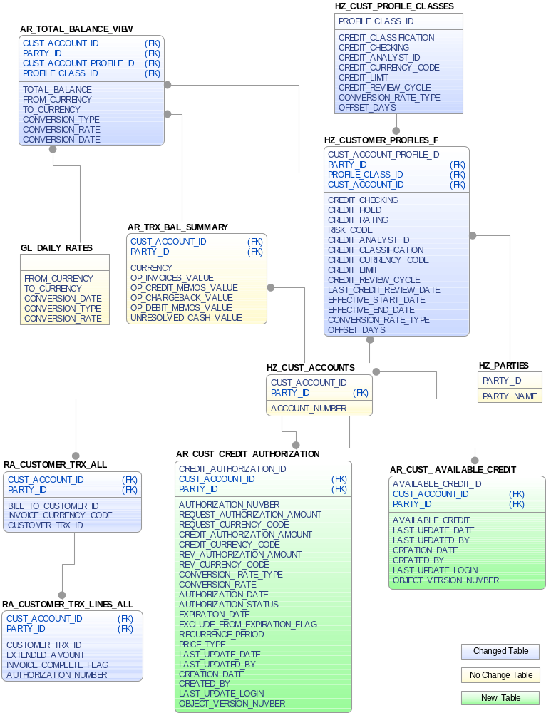
Insert a diagram or (link to the diagram) of the Physical Data Model including all tables and relationships. Use the Oracle standard template and notation to draw the diagram. The diagram can be copied from JDeveloper.
Figure 1 Business Component Diagram of Physical Data Model

Physical Tables and Database Views
Document any physical tables that may need to be emphasized or highlighted in your design – such as tables that are new or being updated -- or tables that may not be associated with Entity Objects such as temp tables, interface tables, summary tables, etc. here.

Physical Table: GL_DAILY_RATES
For every physical table you capture, create a new section.
Provide a description/purpose for this table and whether this is new or being updated.
Table Name | GL_DAILY_RATES
Status (New / Changed / Obsolete) | No Change
Setup Object (Y/N) | Y
Archive (Y/N) | N
Purge (Y/N) | N
Data Security Required (Y/N) | Y
Description | GL_DAILY_RATES stores the daily conversion rates for foreign currency transactions. It replaces the GL_DAILY_CONVERSION_RATES table. It stores the rate to use when converting between two currencies for a given conversion date and conversion type. Each row in this table has a corresponding inverse row in which the from and to currencies are switched. For example, if this table contains a row with a from_currency of YEN, a to_currency of CND, a conversion_type of Spot, and a conversion_date of January 1, 1997, it will also contain a row with a from_currency of CND, a to_currency of YEN, a conversion_type of Spot, and a conversion_date of January 1, 1997. In general, this row will contain a rate that is the inverse of the matching row. Customers should never insert directly into this table. They should instead insert into the GL_DAILY_RATES_INTERFACE table. Data inserted into the GL_DAILY_RATES_INTERFACE table will be automatically copied into this table.
Primary Key Name | GL_DAILY_RATES_PK
Primary Key Attribute | FROM_CURRENCY,TO_CURRENCY,CONVERSION_DATE,CONVERSION_TYPE

Indexes
(Optional) List the table columns that need to be captured in this design -- for example those that are new or being modified. It is not necessary to include every column of the table in your design.

Indexes
Index Name | Unique | Column Names
GL_DAILY_RATES_U1 | Yes | FROM_CURRENCY  TO_CURRENCY  CONVERSION_DATE  CONVERSION_TYPE

Columns
(Optional) List the table columns that need to be captured in this design -- for example those that are new or being modified. It is not necessary to include every column of the table in your design.

Columns
Column Name | Type | Property | Description
FROM_CURRENCY | VARCHAR2(15) | NOT NULL | From currency
TO_CURRENCY | VARCHAR2(15) | NOT NULL | To currency
CONVERSION_DATE | DATE | NOT NULL | Currency conversion date
CONVERSION_TYPE | VARCHAR2(30) | NOT NULL | Currency conversion type
CONVERSION_RATE | NUMBER | NOT NULL | Currency conversion rate

Foreign Keys
(Optional) List the table columns that need to be captured in this design -- for example those that are new or being modified. It is not necessary to include every column of the table in your design.

Columns
Foreign Key Name | Foreign Key Attributes | Schema | Referenced Primary Key | Referenced Primary Key Attributes
GL_DAILY_RATES_FK3 | CONVERSION_TYPE | GL | GL_DAILY_CONVERSION_TYPES.GL_DAILY_CONVERSION_TYPES_PK | CONVERSION_TYPE

Physical Table: HZ_PARTIES
For every physical table you capture, create a new section.
Provide a description/purpose for this table and whether this is new or being updated.
Table Name | HZ_PARTIES
Status (New / Changed / Obsolete) | No Change
Setup Object (Y/N) | Y
Archive (Y/N) | N
Purge (Y/N) | N
Data Security Required (Y/N) | Y
Description | The HZ_PARTIES table stores basic information about parties. Although a record in the HZ_PARTIES table represents a unique party, multiple parties can have the same name. The parties can be one of three types: Organization(for example, Oracle Corporation), Person(for example, Jane Doe), Group(for example, World Wide Web Consortium) Party records can be created or updated using third party data sources such as Dun & Bradstreet's Global Data Products. The HZ_PARTIES table contains demoralized information from the HZ_LOCATIONS, HZ_PERSON_PROFILES, HZ_CONTACT_POINTS< HZ_ORGANIZATION_PROFILES< and HZ_PERSON_LANGUAGE tables. The identifying address contained in the HZ_PARTIES table is renormalized from the HZ_LOCATIONS table
Primary Key Name | HZ_PARTIES_PK
Primary Key Attribute | PARTY_ID

Indexes
(Optional) List the table columns that need to be captured in this design -- for example those that are new or being modified. It is not necessary to include every column of the table in your design.

Indexes
Index Name | Unique | Column Names
HZ_PARTIES_PK | Yes | PARTY_ID

Columns
(Optional) List the table columns that need to be captured in this design -- for example those that are new or being modified. It is not necessary to include every column of the table in your design.

Columns
Column Name | Type | Property | Description
PARTY_ID | NUMBER (18) | NOT NULL | Party identifier
PARTY_NAME | VARCHAR2(360) | NOT NULL | Name of this party

Foreign Keys
(Optional) List the table columns that need to be captured in this design -- for example those that are new or being modified. It is not necessary to include every column of the table in your design.

Columns
Foreign Key Name | Foreign Key Attributes | Schema | Referenced Primary Key | Referenced Primary Key Attributes
There is no foreign key in this table

Physical Table: HZ_CUST_ACCOUNTS
For every physical table you capture, create a new section.
Provide a description/purpose for this table and whether this is new or being updated.
Table Name | HZ_CUST_ACCOUNTS
Status (New / Changed / Obsolete) | No Change
Setup Object (Y/N) | Y
Archive (Y/N) | N
Purge (Y/N) | N
Data Security Required (Y/N) | Y
Description | The HZ_CUST_ACCOUNTS table stores information about customer accounts , or business relationships that the deploying company establishes with a party of type Organization or Person. This table focuses on business relationships and how transactions are conducted in the relationship. Since a party can have multiple customer accounts, this table might contain several records for a single party. For example, an individual person can establish a personal account, family account, and a professional account for a consulting practice.
Primary Key Name | HZ_CUST_ACCOUNTS_PK
Primary Key Attribute | CUST_ACCOUNT_ID

Indexes
(Optional) List the table columns that need to be captured in this design -- for example those that are new or being modified. It is not necessary to include every column of the table in your design.

Indexes
Index Name | Unique | Column Names
HZ_CUST_ACCOUNTS_N3 | No | UPPER("ACCOUNT_NUMBER")
HZ_CUST_ACCOUNTS_N4 | No | PARTY_ID
HZ_CUST_ACCOUNTS_PK | Yes | CUST_ACCOUNT_ID

Columns
(Optional) List the table columns that need to be captured in this design -- for example those that are new or being modified. It is not necessary to include every column of the table in your design.
Columns
Name | Type | Property | Description
CUST_ACCOUNT_ID | NUMBER (18) | NOT NULL | Unique identifier for the account created for a Party. Primary Key for the table
PARTY_ID | NUMBER (18) | NOT NULL | A foreign key to the HZ_PARTY table
ACCOUNT_NUMBER | VARCHAR2(30) | NOT NULL | Account Number

Foreign Keys
(Optional) List the table columns that need to be captured in this design -- for example those that are new or being modified. It is not necessary to include every column of the table in your design.

Columns
Foreign Key Name | Foreign Key Attributes | Schema | Referenced Primary Key | Referenced Primary Key Attributes
HZ_CUST_ACCOUNTS_FK1 | PARTY_ID | HZ | HZ_PARTIES.HZ_PARTIES_PK | PARTY_ID

Physical Table: AR_TRX_BAL_SUMMARY
For every physical table you capture, create a new section.
Provide a description/purpose for this table and whether this is new or being updated.
Table Name | AR_TRX_BAL_SUMMARY
Status (New / Changed / Obsolete) | No Change
Setup Object (Y/N) | Y
Archive (Y/N) | N
Purge (Y/N) | N
Data Security Required (Y/N) | Y
Description | This table stores the fields that summarize data across all timelines, e.g., 'Open Balance', 'Open Invoices Count', 'Open Invoices Value'. This table will store the organization ID to ensure that data can be retrieved by account site. The lowest level of granularity at which the data can be stored and retrieved from this table is for a given currency at a specified 'BILL_TO' location for a given account of a party. his entity describes the credit characteristics that are common across a group of customer accounts.
Primary Key Name | AR_TRX_BAL_SUMMARY_PK
Primary Key Attribute | CUST_ACCOUNT_ID,SITE_USE_ID,CURRENCY,ORG_ID

Indexes
(Optional) List the table columns that need to be captured in this design -- for example those that are new or being modified. It is not necessary to include every column of the table in your design.

Indexes
Index Name | Unique | Column Names
AR_TRX_BAL_SUMMARY_U1 | Yes | CUST_ACCOUNT_ID  SITE_USE_ID  CURRENCY  ORG_ID

Columns
(Optional) List the table columns that need to be captured in this design -- for example those that are new or being modified. It is not necessary to include every column of the table in your design.
Columns
Name | Type | Property | Description
CUST_ACCOUNT_ID | NUMBER (18) | NOT NULL | Customer Account Identifier
CURRENCY | VARCHAR2(15) | NOT NULL | Currency code
OP_INVOICES_VALUE | NUMBER |  | This column value contains the sum of amount_due_remaining on open payment schedules (installments) of all the Invoices the specific Account, Site and Currency.
OP_DEBIT_MEMOS_VALUE | NUMBER |  | This column value contains a count of the open payments schedules (installments) of all the Debit Memos for the specific Account, Site and Currency
OP_CREDIT_MEMOS_VALUE | NUMBER |  | This column value contains the sum of amount_due_remaining on open payment schedules (installments) of all the Credit Memos for the specific Account, Site and Currency.
OP_CHARGEBACK_VALUE | NUMBER |  | This column value contains the sum of amount_due_remaining on open payment schedules (installments) of all the Chargebacks for the specific Account, Site and Currency
UNRESOLVED_CASH_VALUE | NUMBER |  | This column value contains the sum of unresolved cash available on all the Cash Receipts for the specific Account, Site and Currency.

Foreign Keys
(Optional) List the table columns that need to be captured in this design -- for example those that are new or being modified. It is not necessary to include every column of the table in your design.

Columns
Foreign Key Name | Foreign Key Attributes | Schema | Referenced Primary Key | Referenced Primary Key Attributes
AR_TRX_BAL_SUMMARY_FK2 | CUST_ACCOUNT_ID | HZ | HZ_CUST_ACCOUNTS.HZ_CUST_ACCOUNTS_PK | CUST_ACCOUNT_ID

Physical Table: RA_CUSTOMER_TRX_ALL
For every physical table you capture, create a new section.
Provide a description/purpose for this table and whether this is new or being updated.
Table Name | RA_CUSTOMER_TRX_ALL
Status (New / Changed / Obsolete) | No Change
Setup Object (Y/N) | Y
Archive (Y/N) | N
Purge (Y/N) | N
Data Security Required (Y/N) | Y
Description | This table stores invoice, debit memo, commitment, bills receivable, and credit memo header information. Each row in this table includes general invoice information such as customer, transaction type, and printing instructions. One row exists for each invoice, debit memo, commitment, bill receivable, and credit memo that are created in Oracle Receivables. Invoices, debit memos, credit memos, bills receivable, and commitments are distinguished by their associated transaction types, which are stored in the this table.
Primary Key Name | RA_CUSTOMER_TRX_PK
Primary Key Attribute | CUSTOMER_TRX_ID

Indexes
(Optional) List the table columns that need to be captured in this design -- for example those that are new or being modified. It is not necessary to include every column of the table in your design.

Indexes
Index Name | Unique | Column Names
RA_CUSTOMER_TRX_U1 | Yes | CUSTOMER_TRX_ID

Columns
(Optional) List the table columns that need to be captured in this design -- for example those that are new or being modified. It is not necessary to include every column of the table in your design.
Columns
Name | Type | Property | Description
CUSTOMER_TRX_ID | NUMBER (18) | NOT NULL | CUSTOMER_TRX_ID
BILL_TO_CUSTOMER_ID | NUMBER (18) |  | BILL_TO_CUSTOMER_ID
INVOICE_CURRENCY_CODE | VARCHAR2(15) |  | INVOICE_CURRENCY_CODE

Foreign Keys
(Optional) List the table columns that need to be captured in this design -- for example those that are new or being modified. It is not necessary to include every column of the table in your design.

Columns
Foreign Key Name | Foreign Key Attributes | Schema | Referenced Primary Key | Referenced Primary Key Attributes
RA_CUSTOMER_TRX_FK10 | BILL_TO_CUSTOMER_ID | HZ | HZ_CUST_ACCOUNTS.HZ_CUST_ACCOUNTS_PK | CUST_ACCOUNT_ID

Physical Table: RA_CUSTOMER_TRX_LINES_ALL
For every physical table you capture, create a new section.
Provide a description/purpose for this table and whether this is new or being updated.
Table Name | RA_CUSTOMER_TRX_LINES_ALL
Status (New / Changed / Obsolete) | No Change
Setup Object (Y/N) | Y
Archive (Y/N) | N
Purge (Y/N) | N
Data Security Required (Y/N) | Y
Description | The RA_CUSTOMER_TRX_LINES_ALL table stores information about invoice, debit memo, credit memo, bills receivable, and commitment lines. For example, an invoice can have one line for Product A and another line for Product B. Each line requires one row in this table. . Invoice, debit memo, credit memo, bills receivable, and commitment lines are distinguished by the transaction type of the corresponding row in the RA_CUSTOMER_TRX_ALL table. Credit memos must also have a value in the PREVIOUS_CUSTOMER_TRX_LINE_ID column. On-account credits, which are not related to specific invoices or invoice lines when they are created, will not have values in this column. . The QUANTITY_ORDERED column stores the amount of product that was ordered. The QUANTITY_INVOICED column stores the amount of product that was invoiced. For manually entered invoices, the QUANTITY_ORDERED and QUANTITY_INVOICED columns must be the same. For invoices that were imported through AutoInvoice, the QUANTITY_ORDERED and QUANTITY_INVOICED columns can be different. If you enter a credit memo, the QUANTITY_CREDITED column stores the amount of product that was credited. . The UOM_CODE column stores the unit of measure code as defined in the INV_UNITS_OF_MEASURE table. The UNIT_STANDARD_PRICE column stores the list price per unit for this transaction line. The UNIT_SELLING_PRICE column stores the selling price per unit for this transaction line. For transactions that were imported through AutoInvoice, the UNIT_STANDARD_PRICE and UNIT_SELLING_PRICE columns can be different. The DESCRIPTION, TAXING_RULE, QUANTITY_ORDERED, UNIT_STANDARD_PRICE, UOM_CODE, and UNIT_SELLING_PRICE columns are required even though they are null allowed. . Receivables uses the LINE_TYPE column to distinguish between the different types of lines that are stored in this table. LINE represents regular invoice lines that normally refer to an item. TAX represents a tax line. The LINK_TO_CUST_TRX_LINE_ID column references the invoice line that is associated with the row that holds the TAX line type. FREIGHT is similar to TAX, but you can have at most one freight line per invoice line. You can also have one freight line that has a null LINK_TO_CUST_TRX_LINE_ID column. An invoice that has one freight line with a null LINK_TO_CUST_TRX_LINE_ID column has header-level freight. . CB represents a chargeback line. For every row in this table that belongs to a completed postable or nonpostable transaction, where the RA_CUSTOMER_TRX.COMPLETE_FLAG is Y, there must be at least one row in the RA_CUST_TRX_LINE_GL_DIST table that stores accounting information. There must be at least one row in this table even for nonpostable transactions. . The primary key for this table is CUSTOMER_TRX_LINE_ID
Primary Key Name | RA_CUSTOMER_TRX_LINES_PK
Primary Key Attribute | CUSTOMER_TRX_LINE_ID

Indexes
(Optional) List the table columns that need to be captured in this design -- for example those that are new or being modified. It is not necessary to include every column of the table in your design.

Indexes
Index Name | Unique | Column Names
RA_CUSTOMER_TRX_LINES_U1 | Yes | CUSTOMER_TRX_LINE_ID

Columns
(Optional) List the table columns that need to be captured in this design -- for example those that are new or being modified. It is not necessary to include every column of the table in your design.
Columns
Name | Type | Property | Description
CUSTOMER_TRX_LINE_ID | NUMBER (18) | NOT NULL | Invoice line identifier
CUSTOMER_TRX_ID | NUMBER (18) | NOT NULL | Invoice identifier
EXTENDED_AMOUNT | NUMBER | NOT NULL | Transaction line amount
AUTHORIZATION_NUMBER | VARCHAR2(30) | NOT NULL | Unique identifying number for the credit authorization. It is generated when the credit authorization amount is approved.
IVOICE_COMPLETE_FLAG | VARCHAR2(1) |  | This column indicates this line is the final transaction for an invoice or not.

Foreign Keys
(Optional) List the table columns that need to be captured in this design -- for example those that are new or being modified. It is not necessary to include every column of the table in your design.

Columns
Foreign Key Name | Foreign Key Attributes | Schema | Referenced Primary Key | Referenced Primary Key Attributes
AR_TRX_BAL_SUMMARY_FK2 | CUST_ACCOUNT_ID | HZ | HZ_CUST_ACCOUNTS.HZ_CUST_ACCOUNTS_PK | CUST_ACCOUNT_ID

Physical Table: HZ_CUST_PROFILE_CLASSES
For every physical table you capture, create a new section.
Provide a description/purpose for this table and whether this is new or being updated.
Table Name | HZ_CUST_PROFILE_CLASSES
Status (New / Changed / Obsolete) | Changed
Setup Object (Y/N) | Y
Archive (Y/N) | N
Purge (Y/N) | N
Data Security Required (Y/N) | Y
Description | Standard credit profile classes
Primary Key Name | HZ_CUST_PROFILE_CLASSES_PK
Primary Key Attribute | PROFILE_CLASS_ID

Indexes
(Optional) List the table columns that need to be captured in this design -- for example those that are new or being modified. It is not necessary to include every column of the table in your design.

Indexes
Index Name | Unique | Column Names
HZ_CUST_PROFILE_CLASSES_U1 | Yes | PROFILE_CLASS_ID

Columns
(Optional) List the table columns that need to be captured in this design -- for example those that are new or being modified. It is not necessary to include every column of the table in your design.
Columns
Name | Type | Property | Description
PROFILE_CLASS_ID | NUMBER (18) | NOT NULL | Identifier of the customer profile class
CREDIT_CLASSIFICATION | VARCHAR2(30) |  | Credit Classification
CREDIT_CHECKING | VARCHAR2(1) | NOT NULL | Indicates if credit must be checked. Y for required credit checking, N for optional credit checking
CREDIT_ANALYST_ID | NUMBER (18) |  | Identifier of credit analyst associated with this customer profile class
CREDIT_CURRENCY_CODE | VARCHAR2(15) | NOT NULL | It is the currency code associated with the credit limit defined on customer profile class. It is used to default to the associated customer account credit profile.
CREDIT_LIMIT | NUMBER | NOT NULL | It is the maximum amount of credit defined in the single currency on customer profile class. It is used to default to the associated customer account credit profile.
CREDIT_REVIEW_CYCLE | VARCHAR2(20) | NOT NULL | Indicates the period of a customer credit review cycle. It is used to default to the associated customer account credit profile. The values are based on the user extensible Lookup AR_LOOKUPS table. Review Cycle must be predefined in the lookup type PERIODIC_REVIEW_CYCLE.
CONVERSION_ RATE_TYPE | VARCHAR2 |  | It is the currency conversion rate type associated with the authorization currency. Default value is ‘Corporate’.
OFFSET_DAYS | NUMBER |  | Number of days that used to calculate the expiration date of the authorization, default value is 5.

Foreign Keys
(Optional) List the table columns that need to be captured in this design -- for example those that are new or being modified. It is not necessary to include every column of the table in your design.

Columns
Foreign Key Name | Foreign Key Attributes | Schema | Referenced Primary Key | Referenced Primary Key Attributes
There is no foreign key in this table work with credit checking service

Physical Table: HZ_CUSTOMER_PROFILES_F
For every physical table you capture, create a new section.
Provide a description/purpose for this table and whether this is new or being updated.
Table Name | HZ_CUSTOMER_PROFILES_F
Status (New / Changed / Obsolete) | Changed
Setup Object (Y/N) | Y
Archive (Y/N) | N
Purge (Y/N) | N
Data Security Required (Y/N) | Y
Description | The HZ_CUSTOMER_PROFILES table stores information about the credit characteristics of a single customer account or a customer account site or a party. A profile class defined in the HZ_CUSTOMER_PROFILE_CLASSES table can be used to provide default values for the attributes in this table. The default values copied into this table can be modified to more closely match the customer account defined in this table. The primary key for this table is CUST_ACCOUNT_PROFILE_ID
Primary Key Name | HZ_CUSTOMER_PROFILES_PK
Primary Key Attribute | CUST_ACCOUNT_PROFILE_ID

Indexes
(Optional) List the table columns that need to be captured in this design -- for example those that are new or being modified. It is not necessary to include every column of the table in your design.

Indexes
Index Name | Unique | Column Names
HZ_CUSTOMER_PROFILES_N1 | No | CUST_ACCOUNT_ID
HZ_CUSTOMER_PROFILES_N4 | No | PROFILE_CLASS_ID
HZ_CUSTOMER_PROFILES_U1 | Yes | CUST_ACCOUNT_PROFILE_ID  EFFECTIVE_END_DATE  EFFECTIVE_START_DATE

Columns
(Optional) List the table columns that need to be captured in this design -- for example those that are new or being modified. It is not necessary to include every column of the table in your design.
Columns
Name | Type | Property | Description
CUST_ACCOUNT_PROFILE_ID | NUMBER (18) | NOT NULL | Unique identifier of this customer profile
CUST_ACCOUNT_ID | NUMBER (18) | NOT NULL | Identifier for the Customer Account. Foreign key to the HZ_CUST_ACCOUNTS table
PROFILE_CLASS_ID | NUMBER (18) |  | Identifier of the customer profile class associated with this customer profile
PARTY_ID | NUMBER (18) |  | Party identifier that profile is associated with
CREDIT_CHECKING | VARCHAR2(1) | NOT NULL | Indicates whether a credit check is to be carried out
CREDIT_HOLD | VARCHAR2(1) | NOT NULL | Indicates if a credit hold exists on this account. Y for a credit hold is in place, N for no credit hold.
CREDIT_RATING | VARCHAR2(30) |  | Credit rating
RISK_CODE | VARCHAR2(30) |  | Credit risk code
CREDIT_ANALYST_ID | NUMBER (18) |  | Identifier of the credit analyst associated with this customer profile
CREDIT_CLASSIFICATION | VARCHAR2(30) |  | Credit classification.
CREDIT_CURRENCY_CODE | VARCHAR2(15) | NOT NULL | It is the currency code associated with the credit limit defined for this customer account.
CREDIT_LIMIT | NUMBER | NOT NULL | It is the maximum amount of credit defined in the single currency for the customer account.
CREDIT_REVIEW_CYCLE | VARCHAR2(20) | NOT NULL | Indicates the period of a customer credit review cycle. It is based on a list of values from the Lookup to user defined values in AR_LOOKUPS table. Review Cycle must be predefined in the lookup type PERIODIC_REVIEW_CYCLE.
LAST_CREDIT_REVIEW_DATE | DATE | NOT NULL | Values ‘Annually’, ’Quarterly’, ’Monthly’ will be seeded out of box.
EFFECTIVE_START_DATE | DATE | NOT NULL | Indicates the next date that customer credit will be reviewed. It is derived from the Last Reviewed Date plus Review Cycle.
EFFECTIVE_END_DATE | DATE | NOT NULL | Date Effective Entity: indicates the date at the beginning of the date range within which the row is effective.
CONVERSION_ RATE_TYPE | VARCHAR2 |  | It is the currency conversion rate type associated with the authorization currency. Default value is ‘Corporate’.
OFFSET_DAYS | NUMBER |  | Number of days that used to calculate the expiration date of the authorization, default value is 5.

Foreign Keys
(Optional) List the table columns that need to be captured in this design -- for example those that are new or being modified. It is not necessary to include every column of the table in your design.

Columns
Foreign Key Name | Foreign Key Attributes | Schema | Referenced Primary Key | Referenced Primary Key Attributes
HZ_CUSTOMER_PROFILES_FK1 | CUST_ACCOUNT_ID | HZ | HZ_CUST_ACCOUNTS.HZ_CUST_ACCOUNTS_PK | CUST_ACCOUNT_ID
HZ_CUSTOMER_PROFILES_FK3 | PROFILE_CLASS_ID | HZ | HZ_CUST_PROFILE_CLASSES.HZ_CUST_PROFILE_CLASSES_PK | PROFILE_CLASS_ID
HZ_CUSTOMER_PROFILES_FK4 | PARTY_ID | HZ | HZ_PARTIES.HZ_PARTIES_PK | PARTY_ID

Physical Table: AR_CUST_ AVAILABLE_CREDIT
Table Name | AR_CUST_ AVAILABLE_CREDIT
Status (New / Changed / Obsolete) | New
Setup Object (Y/N) | N
Archive (Y/N) | N
Purge (Y/N) | N
Data Security Required (Y/N) | Y
Description | This entity describes the available credit for a customer account. The available credit is calculated whenever a credit checking is requested or when an authorization status is changed, and it’s recorded in credit limit currency.
Primary Key Name | AR_CUST_ AVAILABLE_CREDIT_PK
Primary Key Attribute | AVAILABLE_CREDIT_ID

Indexes
(Optional) List the table columns that need to be captured in this design -- for example those that are new or being modified. It is not necessary to include every column of the table in your design.

Indexes
Index Name | Unique | Column Names
AR_CUST_ AVAILABLE_CREDIT_N1 | Yes | AVAILABLE_CREDIT_ID
AR_CUST_ AVAILABLE_CREDIT_N2 | No | CUST_ACCOUNT _ID

Columns
(Optional) List the table columns that need to be captured in this design -- for example those that are new or being modified. It is not necessary to include every column of the table in your design.
Columns
Name | Type | Property | Description
AVAILABLE_CREDIT_ID | NUMBER(18) | NOT NULL | Unique identifier of this customer available credit
CUST_ACCOUNT _ID | NUMBER(18) | NOT NULL | Identifier for the Customer Account. Foreign key to the HZ_CUST_ACCOUNTS table
AVAILABLE_CREDIT | NUMBER | NOT NULL | Indicates the available credit a customer account has at the time when a credit check is requested. It is the credit limit less AR open balance less the total outstanding authorization amounts for the account in the credit limit currency.
LAST_UPDATED_BY | VARCHAR2(64) | NOT NULL | Who column: indicates the user who last updated the row.
LAST_UPDATE_DATE | TIMESTAMP | NOT NULL | Who column: indicates the date and time of the last update of the row.
LAST_UPDATE_LOGIN | VARCHAR2(32) |  | Who column: indicates the session login associated to the user who last updated the row.
CREATED_BY | VARCHAR2(64) | NOT NULL | Who column: indicates the user who created the row.
CREATION_DATE | TIMESTAMP | NOT NULL | Who column: indicates the date and time of the creation of the row.
OBJECT_VERSION_NUMBER | NUMBER (9) | NOT NULL | Used to implement optimistic locking. This number is incremented every time that the row is updated. The number is compared at the start and end of a transaction to detect whether another session has updated the row since it was queried.

Foreign Keys
(Optional) List the table columns that need to be captured in this design -- for example those that are new or being modified. It is not necessary to include every column of the table in your design.

Columns
Foreign Key Name | Foreign Key Attributes | Schema | Referenced Primary Key | Referenced Primary Key Attributes
AR_CUST_ AVAILABLE_CREDIT _FK1 | CUST_ACCOUNT _ID | HZ | HZ_CUST_ACCOUNTS.HZ_CUST_ACCOUNTS_PK | CUST_ACCOUNT _ID

Physical Table: AR_CUST_CREDIT_AUTHORIZATION
For every physical table you capture, create a new section.
Provide a description/purpose for this table and whether this is new or being updated.
Table Name | AR_CUST_CREDIT_AUTHORIZATION
Status (New / Changed / Obsolete) | New
Setup Object (Y/N) | N
Archive (Y/N) | N
Purge (Y/N) | N
Data Security Required (Y/N) | Y
Description | This entity describes credit amounts that have been authorized for a customer account.
Primary Key Name | AR_CUST_CREDIT_AUTHORIZATION_PK
Primary Key Attribute | CREDIT_AUTHORIZATION_ID

Indexes
(Optional) List the table columns that need to be captured in this design -- for example those that are new or being modified. It is not necessary to include every column of the table in your design.

Indexes
Index Name | Unique | Column Names
AR_CUST_CREDIT_AUTHORIZATION_N1 | Yes | CREDIT_AUTHORIZATION_ID
AR_CUST_CREDIT_AUTHORIZATION_N2 | No | CUST_ACCOUNT _ID

Columns
(Optional) List the table columns that need to be captured in this design -- for example those that are new or being modified. It is not necessary to include every column of the table in your design.
Columns
Name | Type | Property | Description
CREDIT_AUTHORIZATION_ID | NUMBER(18) | NOT NULL | Unique identifier of this credit authorization
CUST_ACCOUNT _ID | NUMBER(18) | NOT NULL | Identifier for the Customer Account. Foreign key to the HZ_CUST_ACCOUNTS table
AUTHORIZATION_NUMBER | VARCHAR2(30) | NOT NULL | Unique identifying number for the credit authorization. It is generated when the credit authorization amount is approved.
REQUEST_AUTHORIZATION_AMOUNT | NUMBER | NOT NULL | The amount requested for credit checking, and is approved. It should be the same amount as that from the requested sales order line with the corresponding authorization number.
REQUEST_CURRENCY_CODE | VARCHAR2(15) | NOT NULL | It is the currency code associated with the authorization amount.
CREDIT_AUTHORIZATION_AMOUNT | NUMBER |  | It is converted amount of authorization amount with conversion rate
CREDIT_CURRENCY_CODE | VARCHAR2(15) |  | It is the conversion currency code associated with the converted amount
REM_AUTHORIZATION_AMOUNT |  |  | The remaining amount of the authorization, it is converted using the rem_currency_code
REM_CURRENCY_CODE |  |  | The currency code of the rem_authorization_amount
CONVERSION_ RATE_TYPE | VARCHAR2 |  | It is the currency conversion rate type associated with the authorization currency.
CONVERSION_RATE | NUMBER |  | It is the currency conversion rate associated with the authorization currency
AUTHORIZATION_DATE | DATE | NOT NULL | The date the credit amount was authorized.
AUTHORIZATION_STATUS | VARCHAR2(20) | NOT NULL | Indicates the status of the authorization. It is based on the system lookup values:
EXPIRATION_DATE | DATE | NOT NULL | ‘Open’ – the authorization is active. The associated authorization amount should be reserved.
EXCLUDE_FROM_EXPIRATION_FLAG |  |  | Indicate whether an authorization is finalized, and keep it open until status becomes 'Invoiced' or 'Canceled' regardless of the Expiration Date. Value could be 'Y', or 'N', default is 'N'.
PRICE_TYPE | VARCHAR2(20) |  | Indicate the price type of the authorization, it could be ‘one-time’ or ‘recurrence’
RECURRENCE_PERIOD | VARCHAR2(20) |  | If the price type is ‘one-time’ then this field should be null, otherwise, it could be ‘Month’, ‘Year’, etc.
LAST_UPDATED_BY | VARCHAR2(64) | NOT NULL | Who column: indicates the user who last updated the row.
LAST_UPDATE_DATE | TIMESTAMP | NOT NULL | Who column: indicates the date and time of the last update of the row.
LAST_UPDATE_LOGIN | VARCHAR2(32) |  | Who column: indicates the session login associated to the user who last updated the row.
CREATED_BY | VARCHAR2(64) | NOT NULL | Who column: indicates the user who created the row.
CREATION_DATE | TIMESTAMP | NOT NULL | Who column: indicates the date and time of the creation of the row.
OBJECT_VERSION_NUMBER | NUMBER (9) | NOT NULL | Used to implement optimistic locking. This number is incremented every time that the row is updated. The number is compared at the start and end of a transaction to detect whether another session has updated the row since it was queried.

Physical Table: Foreign Keys
(Optional) List the table columns that need to be captured in this design -- for example those that are new or being modified. It is not necessary to include every column of the table in your design.

Columns
Foreign Key Name | Foreign Key Attributes | Schema | Referenced Primary Key | Referenced Primary Key Attributes
AR_CUST_CREDIT_AUTHORIZATION_FK1 | CUST_ACCOUNT _ID | HZ | HZ_CUST_ACCOUNTS.HZ_CUST_ACCOUNTS_PK | CUST_ACCOUNT _ID

Database View: AR_TOTAL_BALANCE_VIEW
For every physical table you capture, create a new section.
Provide a description/purpose for this table and whether this is new or being updated.
Table Name | AR_TOTAL_BALANCE_VIEW
Status (New / Changed / Obsolete) | New
Setup Object (Y/N) | Y
Archive (Y/N) | N
Purge (Y/N) | N
Data Security Required (Y/N) | Y
Description | This view is used to describe the total receivable balance of the customers. It created based AR_TRX_BAL_SUMMARY, HZ_CUSTOMER_PROFILES_F and GL_DAILY_RATES.
Primary Key Name
Primary Key Attribute

Indexes
(Optional) List the table columns that need to be captured in this design -- for example those that are new or being modified. It is not necessary to include every column of the table in your design.

Indexes
Index Name | Unique | Column Names
There is no foreign key in this view

Columns
(Optional) List the table columns that need to be captured in this design -- for example those that are new or being modified. It is not necessary to include every column of the table in your design.

Columns
Column Name | Type | Property | Description
CUST_ACCOUNT_ID | NUMBER (18) | NOT NULL | Party identifier
TOTAL_BALANCE | NUMBER | NOT NULL | Total balance of the receivable, it calculated as following, it calculated as following: AR_TRX_BAL_SUMMARY.OP_INVOICES_VALUE + AR_TRX_BAL_SUMMARY.OP_CREDIT_MEMOS_VALUE + AR_TRX_BAL_SUMMARY.OP_CHARGEBACK_VALUE + AR_TRX_BAL_SUMMARY.OP_DEBIT_MEMOS_VALUE + AR_TRX_BAL_SUMMARY.UNRESOLVED_CASH_VALUE
FROM_CURRENCY | VARCHAR2(15) | NOT NULL | From currency
TO_CURRENCY | VARCHAR2(15) | NOT NULL | To currency
CONVERSION_TYPE | VARCHAR2(30) | NOT NULL | Currency conversion type
CONVERSION_RATE | VARCHAR2(30) | NOT NULL | Currency conversion type
CONVERSION_DATE | DATE | NOT NULL | Currency conversion date

Foreign Keys
(Optional) List the table columns that need to be captured in this design -- for example those that are new or being modified. It is not necessary to include every column of the table in your design.

Columns
Foreign Key Name | Foreign Key Attributes | Schema | Referenced Primary Key | Referenced Primary Key Attributes
There is no foreign key in this view
standard for a list of column types.
Status: Specify whether this column is: New (N), Changed (C), or Obsolete (O).
Description: Provide a description/purpose of the column. If the column is new or being updated, provide your reasons.
Description: Provide a description of the index if necessary. If the index is new or being updated, provide your reasons. Also provide the purpose of the index (such as for search or join criteria, primary key, etc.)

Sequences
Input sequence information for the physical tables here. This is optional if this has been provided in the Technical Solution Approach. Alternatively, you can reference external documentation or report through a link.
Table Name | Sequence Name | Column Name | Description
HZ_CUST_CREDIT_AUTHORIZATION | HZ_CUST_CREDIT_AUTHORIZATION _S | CREDIT_AUTHORIZATION_ID
HZ_CUST_ AVAILABLE_CREDIT | HZ_CUST_ AVAILABLE_CREDIT_S | AVAILABLE_CREDIT_ID

Synonyms
Table Name | Synonym Name | Description

Policies
Object Name | Policy Name | Policy Function | Description

Packages

Overview
We will define two types of object in AR_CM_CC_UTILITY_PKG to present the input parameters and the output parameters.
- AR_CC_INPUT_REC, input parameter, including following properties:
- Customer Name
- Account Number(should be cust_acct_id) open_closed_issue
- Request Type
- Authorization Amount
- Authorization Currency
- Price Type
- Recurrence Period
- Exclude From Expiration Flag
- Fulfillment Date
- Shipment Date
- Sales Order Date
- Offset Days
- Existing Authorization Number
- Requestor
- AR_CC_OUTPUT_REC, out parameter, has following properties:
- Customer Name
- Account Number
- Authorization Amount
- Authorization Currency
- Available Credit
- Authorization Expiration Date
- New Authorization Number
- Requestor
- Response
- Reason
No | Package Name | Description | Business Flow
1 | AR_CM_CC_API_PUB | Public API, that could be exposed to web services and other applications | Credit checking
2 | AR_CM_CC_LIB_PVT | Package for credit checking, it will be used to process the request in the process one, including:  - Authorization  - Pre-Authorization  - Re-Authorization  - De-Authorization  - Exclude From Expiration  Process two | Credit checking
3 | AR_CM_CC_VAL_PVT | Validation implementation package for credit checking service | Credit checking
4 | AR_CM_CC_CORE_PKG | Core functionalities that process the request of the credit checking | Credit checking
5 | AR_CM_UTILITY_PKG | Utility functionality package for credit management | Credit checking  Credit review
6 | AR_CM_CC_SQL_FUNC_PKG | Basic SQL functionality for credit checking | Credit checking

Packages for Credit Checking Flow

AR_CM_CC_API_PUB
Package Name | AR_CM_CC_API_PUB
Description | Public API package for credit checking
Functions/Procedures | Called by packages | Calling packages/Methods | Description
CREDITCHECK(IN PARAMETERS) RETURN OUTPUT |  | - VALIDATE  - VALIDATE_ACCOUNT_PROFILE  - PROCESS_DE_AUTHORIZATION  - PROCESS_EXCLUDE_EXPIRATION_FLAG  - PROCESS_AUTHORIZATION  - PROCESS_RE_AUTHORIZATION  - PROCESS_PRE_AUTHORIZATION
PROCESS_EXPIRED_AUTHORIZATION() |  | PROCESS_EXPIRED_AUTHORIZATION | 1. call procedure  2.generate report(probably)

AR_CM_CC_LIB_PVT
Package Name | AR_CM_CC_LIB_PVT
Description | Private API package for credit checking
Functions/Procedures | Called by packages | Calling packages/Methods | Description
PROCESS_DE_AUTHORIZATION(IN PARAMETERS, IN CUSTOMER_ACCOUNT_ID, IN CONVERSION_TYPE, IN CREDIT_CURRENCY, OUT RESPONSE, OUT REASON) |  | - UPDATE_AVAILABLE_CREDIT  - CONVERT_AVAILABLE_CREDIT_TO_REQUEST_CURRENCY | Identify the existing authorization, check the status of the authorization, if it is open, then update the status to ‘Canceled’, update the expiration date to system date. Then call ‘Update Available Credit’, ‘Convert Available Credit’, populate the response as ‘Yes’ and reason as ‘AR_CC_DeAuth_Approved_info’.  If it is not open, populate the response as ‘Yes’ and reason as ‘AR_CC_Existing AuthClosed_Info’.  Update then check effected row count
PROCESS_EXCLUDE_EXPIRATION_FLAG(IN PARAMETERS, IN CONVERSION_TYPE, IN CREDIT_CURRENCY, OUT RESPONSE, OUT REASON) |  | - CONVERT_AVAILABLE_CREDIT_TO_REQUEST_CURRENCY | Identify the existing authorization, check the status of the authorization, if it is open, then update the Exclude_From_Expiration_Flag to ‘Y, call ‘Convert Available Credit’, populate the response as ‘Yes’ and reason as ‘AR_CC_EXExpire_Approved_info’.  If it is not open, populate the response as ‘Yes’ and reason as ‘AR_CC_Existing AuthClosed_Info’.
PROCESS_AUTHORIZATION(IN PARAMETERS, IN OFFSET_DAYS, IN CONVERSION_TYPE, IN CREDIT_CURRENCY, IN CUSTOMER_ACCOUNT_ID, OUT RESPONSE, OUT REASON) |  | - CHECK_REQUEST_AMOUNT_WITH_AVAILABLE_CREDIT  - CALCULATE_EXPIRATION_DATE  - UPDATE_AVAILABLE_CREDIT  - CONVERT_AVAILABLE_CREDIT_TO_REQUEST_CURRENCY | Call ‘Check request amount with available credit’ to check the available credit is sufficient or not.  If sufficient, then call ‘Calculate expiration date’ to get the expiration date for the new authorization.  Create the authorization, then call ‘Update available credit’ and ‘Convert available credit to request currency’, return response as ‘Yes’ and reason as ‘AR_CC_Auth_Approved_info’.  If insufficient, then populate the response as ‘No’ and reason as ‘AR_CC_Auth_InsufCredit_Info’, return.
PROCESS_RE_AUTHORIZATION(IN PARAMETERS, IN OFFSET_DAYS, IN CONVERSION_TYPE, IN CREDIT_CURRENCY, IN CUSTOMER_ACCOUNT_ID, OUT RESPONSE, OUT REASON) |  | - CHECK_REQUEST_AMOUNT_WITH_AVAILABLE_CREDIT  - CALCULATE_EXPIRATION_DATE  - UPDATE_AVAILABLE_CREDIT  - CONVERT_AVAILABLE_CREDIT_TO_REQUEST_CURRENCY | Call ‘Check request amount with available credit’ to check the available credit is sufficient or not.  If sufficient, expire the existing authorization then call ‘Calculate expiration date’ to get the expiration date for the new authorization.  Create the new authorization, then call ‘Update available credit’ and ‘Convert available credit to request currency’, return response as ‘Yes’ and reason as ‘AR_CC_ReAuth_Approved_info’.  If insufficient, expire the existing authorization, then then call ‘Update available credit’ and populate the response as ‘No’ and reason as ‘AR_CC_ReAuth_InsufCredit_Info’, return.
PROCESS_PRE_AUTHORIZATION(IN PARAMETERS, IN CONVERSION_TYPE, IN CREDIT_CURRENCY, IN CUSTOMER_ACCOUNT_ID, OUT RESPONSE, OUT REASON) |  | - CHECK_REQUEST_AMOUNT_WITH_AVAILABLE_CREDIT  - CONVERT_AVAILABLE_CREDIT_TO_REQUEST_CURRENCY  - UPDATE_AVAILABLE_CREDIT | Call ‘Check request amount with available credit’ to check the available credit is sufficient or not.  If sufficient, call ‘Convert available credit to request currency’, return response as ‘Yes’ and reason as ‘AR_CC_PreAuth_Approved_info’.  Else populate the response as ‘No’ and reason as ‘AR_CC_PreAuth_InsufCredit_Info’, return.
PROCESS_EXPIRED_AUTHORIZATION() |  |  | Identify all of the authorizations that  - Status = open  - Exclude_from_expiration_flag=’N’  - Expiration date<=system date.  Update the status of the authorizations to ‘Expired’ and update the expiration Date to system date.

AR_CM_CC_VAL_PVT
Package Name | AR_CM_CC_VAL_PVT
Description | Validation implementation package for credit checking
Functions/Procedures | Called by packages | Calling packages/Methods | Description
VALIDATE(IN PARAMETERS, OUT CUSTOMER_ACCOUNT_ID, OUT RESPONSE, OUT REASON ) |  |  | Validate the input parameters including:  •request_type  •requestor  •customer_name  •account_number  •price_type  •recurrence_period  Populate the customer_account_id if the customer name and account number are valid.  If the request type is pre-authorization/re-authorization/authorization, then validate the request currency and request amount.  If the request type is re-authorization/de-authorization/exclude-expiration, then validate the existing authorization number.  Any one of the validations failed, populate the response as ‘Error’ and the reason correspondingly, then raise an exception.
VALIDATE_ACCOUNT_PROFILE(IN PARAMETERS, IN CUSTOMER_ACCOUNT_ID, OUT CONVERSION_TYPE, OUT OFFSET_DAYS, OUT CREDIT_CURRENCY, OUT RESPONSE, OUT REASON) |  |  | Identify the account profile of the customer account, then check the credit hold, credit including, credit limit defined or not.  If all of the validation passed, then populate the conversion rate, offset days, credit limit and credit currency for later usage.  If any one of the validations failed, populate the response as ‘No’ and reason correspondingly, then raise an exception.

AR_CM_CC_CORE_PKG
Package Name | AR_CM_CC_CORE_PKG
Description | Core functionality implementation package for credit checking
Functions/Procedures | Called by packages | Calling packages/Methods | Description
CHECK_REQUEST_AMOUNT_WITH_AVAILABLE_CREDIT(IN PARAMETERS, IN CUSTOMER_ACCOUNT_ID, IN CONVERSION_TYPE, IN CREDIT_CURRENCY, OUT RESPONSE, OUT REASON, OUT APPROVED) |  | - GET_EXCHANGE_RATE | Call the ‘Get Exchange Rate’ function then convert the request amount to credit limit currency if it is need.  Identify the available credit of the customer account, then compare with the (converted) request amount.  If the request type is re-authorization, before the comparison, the open existing authorization should be queried out and use its remaining amount to minus request amount, then compare the amount with available credit.  If the existing authorization is not open, populate the response as ‘No’ and the reason correspondingly, then raise an exception.  If the request amount is valid, then populate approved as ‘Yes’, otherwise populate is as ‘No’.
CALCULATE_EXPIRATION_DATE (IN PARAMETERS, IN OFFSET_DAYS, OUT RESPONSE, OUT REASON) RETURN EXPIRATION_DATE |  |  | If the offset days is provided by requestor, then validate it, if it is not passed the validation, populate the response as ‘Error’ and reason as ‘AR_CC_OffSetDays_Invalid’, return.  If it is not provided, using the configured offset days in the profile of the customer account.  if the offset days is valid, then check the ‘Fulfillment Date’, ‘Shipment Date’ and ‘Sales Order Date’ is provided or not. All of these three dates should greater than or equal to system date, and they are optional.  The priory of these three dated is: fulfillment date > shipment date > sales order date. If more than one date is provided, we use them according to the priory, and we calculate the expiration date by one of them plus offset days.  If none of them are provided, we calculate the expiration date by system date plus offset days.
CONVERT_AVAILABLE_CREDIT_TO_REQUEST_CURRENCY(IN PARAMETERS, IN CREDIT_CURRENCY, IN CUSTOMER_ACCOUNT_ID, IN CONVERSION_TYPE) RETURN AVAILABLE_CREDIT |  | - GET_EXCHANGE_RATE | Get the available credit of the customer account, and then convert it to the request currency if the currencies are different.
UPDATE_AVAILABLE_CREDIT(IN PARAMETERS, IN UPDATED_AMOUNT, IN CUSTOMER_ACCOUNT_ID) |  |  | If the request type is authorization, we deduct the available credit with the authorization amount.  If the request type is de-authorization, we adding the remaining authorization amount back to the available credit.  If the request type is re-authorization, we deduct the available credit with the new authorization amount minus the old authorization amount.

AR_CM_UTILITY_PKG
Package Name | AR_CM_UTILITY_PKG
Description | Package for utility functionality of credit checking
Functions/Procedures | Called by packages | Calling packages/Methods | Description
GET_EXCHANGE_RATE(IN CONVERSION_TYPE, IN FROM_CURRENCY, IN TO_CURRENCY) RETURN CONVERSION_RATE |  |  | Return the exchange rate from table GL_DAILY_RATES according the parameters passed in.

AR_CM_CC_SQL_FUNC_PKG
Package Name | AR_CM_CC_SQL_FUNC_PKG
Description | Package for utility functionality of credit checking
Functions/Procedures | Called by packages | Calling packages/Methods | Description
INSERT_AUTHORIZATION |  |  | Return the exchange rate from table GL_DAILY_RATES according the parameters passed in.
UPDATE_AUTHORIZATION
UPDATE_AVAILABLE_CREDIT

Sequence Diagram of Packages for Credit Checking

PROCESS PRE-AUTHORIZATION
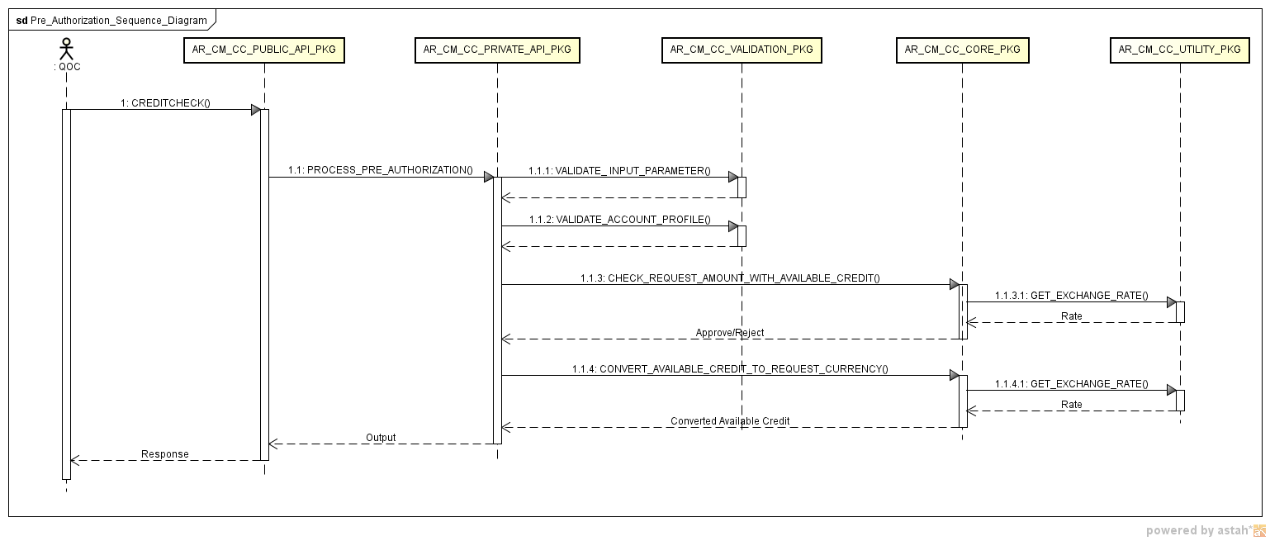
This diagram is also accessible via this link: https://stbeehive.oracle.com/content/dav/st/CDC%20Fusion%20V2%20Projects/Public%20Documents/Credit%20Management/Credit_Checking/Sequence%20Diagram/Pre_Authorization_Sequence_Diagram.png

Process authorization
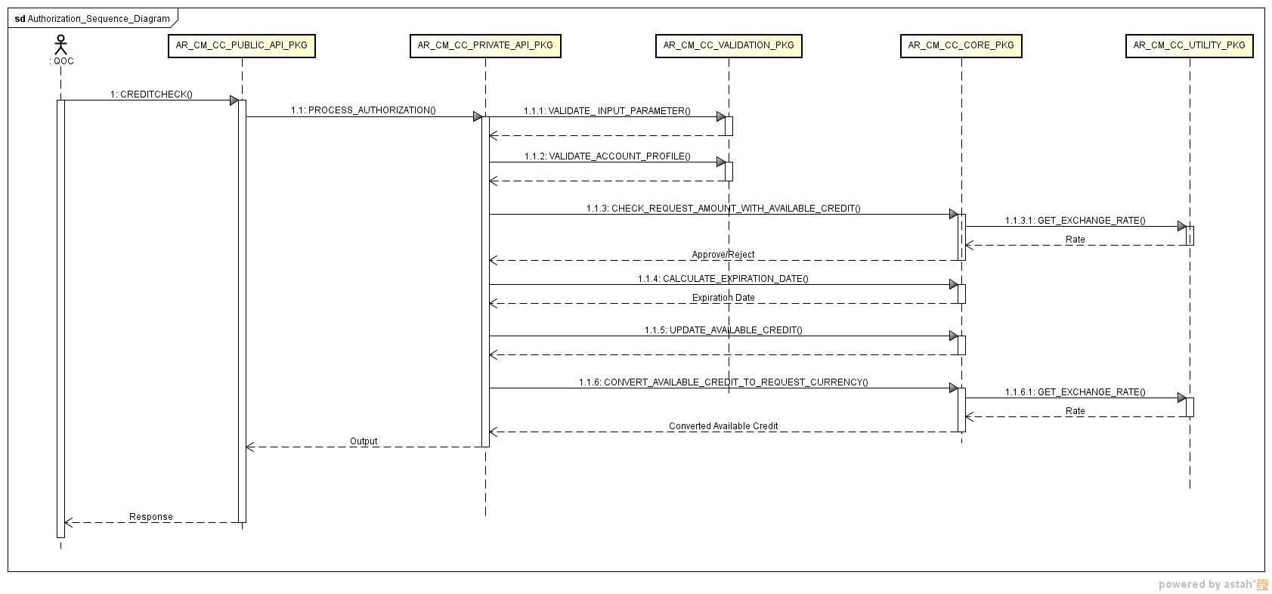
This diagram is also accessible via this link: https://stbeehive.oracle.com/content/dav/st/CDC%20Fusion%20V2%20Projects/Public%20Documents/Credit%20Management/Credit_Checking/Sequence%20Diagram/Authorization_Sequence_Diagram.png

Process Re-authorization
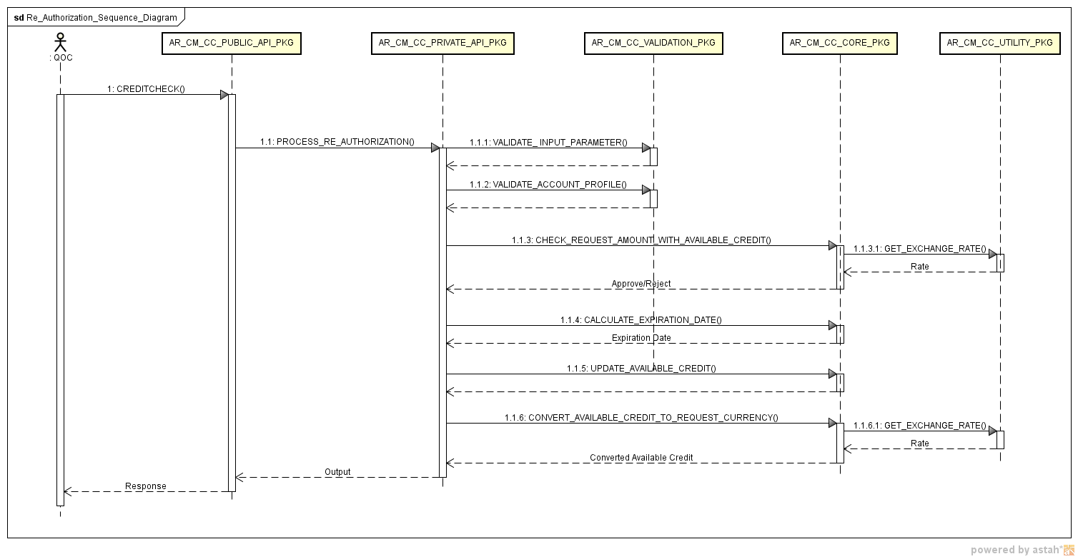
This diagram is also accessible via this link: https://stbeehive.oracle.com/content/dav/st/CDC%20Fusion%20V2%20Projects/Public%20Documents/Credit%20Management/Credit_Checking/Sequence%20Diagram/Re_Authorization_Sequence_Diagram.png

Process De-authorization
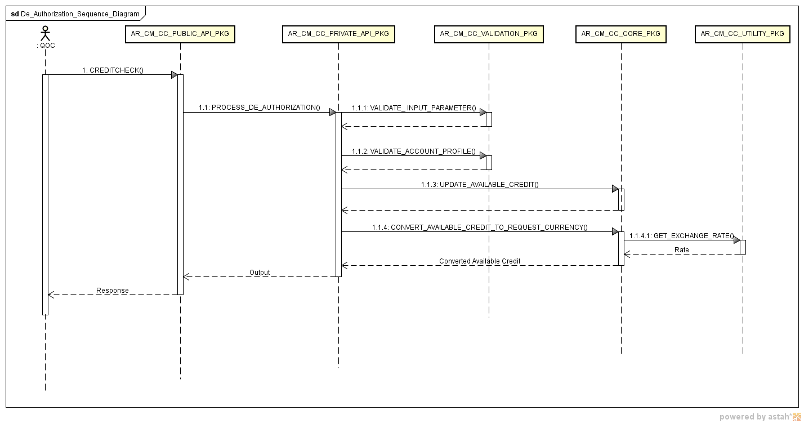
This diagram is also accessible via this link: https://stbeehive.oracle.com/content/dav/st/CDC%20Fusion%20V2%20Projects/Public%20Documents/Credit%20Management/Credit_Checking/Sequence%20Diagram/De_Authorization_Sequence_Diagram.png

Process Exclude from expiration flag
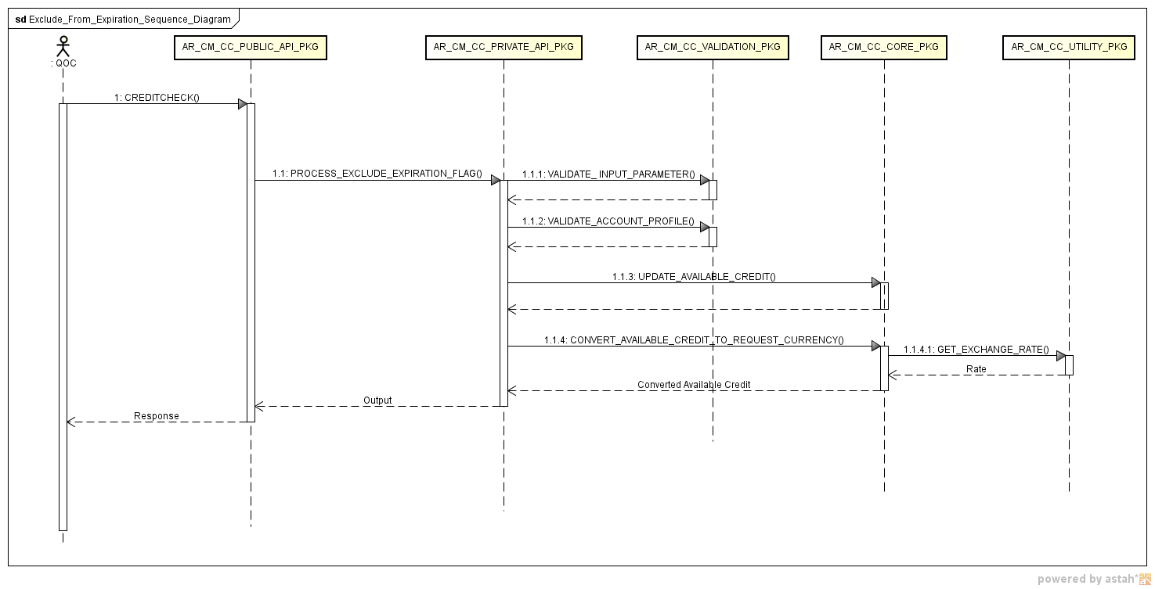
This diagram is also accessible via this link: https://stbeehive.oracle.com/content/dav/st/CDC%20Fusion%20V2%20Projects/Public%20Documents/Credit%20Management/Credit_Checking/Sequence%20Diagram/Exclude_From_Expiration_Sequence_Diagram.png

Template Version Log

Version Log
Version | Date | Summary of Change (what & impact)
1.0 | 09-Feb-2012 | Baseline. Created this Physical Data Model TD template based on prior backend TDD template. This section can be added to or referenced by the TDD Container template for a project containing designs on the physical data model.

