Technical Design
Collection Management
Collection Essbase Integration Service
Incremental Loading ETL
Applications Release: Fusion
Author: Tony Wang
Creation Date: 13-April-2012
Last Updated: 13-April-2012
RPS ID:
Functional Design Document:
Product Development Area:
Detailed Business Process:
Business Process Activity:
Business Process Tier:
Draft / Version: 1.0
Status: Draft
Template Version: 1.24
File URL:
Applications Release should be one of the following: Fusion, Future, Other
The Creation Date and Last Updated dates are field codes. To update the dates (and all other field codes in this document), press CTRL-A followed by F9.
Refer to the Release Planning Spreadsheet to get the corresponding RPS ID for this document.
Functional Design Document should contain the name of the prerequisite FDD for this document
Product Development Area is defined as a logical grouping of components within a product. Examples are Invoice, Payments, Purchase Orders, and Requisitions.
Select the Detailed Business Process that is impacted by this document.
Specify the Business Process Tier of this application. Tiers, formally known as Showcase, are the means to identify top priority business processes for Fusion v1 development. There are three tiers, with tier 1 being the highest priority. Tiers have been assigned to each BPM Activity (Level 3), and central teams such as the User Experience (UX) and Business Process Engineering (BPE) are using them to determine support level agreements.
Use A, A.1, A.2, B, C, etc for draft versions. Start published versions with 1.0. The version is incremented every time a change is published for the document. Only the digit after the decimal point is incremented: when you reach 1.9, continue to 1.10, 1.11, etc. There is no implied meaning to the version numbers.
Edit the Status above. Choices are NOT STARTED, IN DRAFT, IN REVIEW, IN EXTERNAL REVIEW, PENDING APPROVAL, and TECHNICAL DESIGN APPROVED.
Enter the URL where this document is stored.

INFORMATION ABOUT USING THIS TEMPLATE
This template includes special features to make document creation easier.
Oracle Menu
In the main Word menu bar you should see a menu called Oracle. This menu contains the following options:
Replace Document Variables: Displays a dialog where you can enter replacement values for the document variables marked in blue throughout this template.
Strip Yellow Notes: Permanently removes the yellow notes (such as this one) from your document.
Insert Formatted Table: Inserts a new table with standard Oracle formatting.
Format Current Table: When invoked when the cursor is inside a table, this function will format the table with standard formatting while preserving the contents.
Insert List Table Inserts a two-column, borderless table that is useful for a list of phrases with definitions. The first column is set to bold. Tab in the last cell to automatically add a new row.
Keyboard Shortcuts
Use the following keyboard shortcuts to format headings and paragraphs as you type:
Ctrl-Shift-1 Heading 1
Ctrl-Shift-2 Heading 2
Crtl-Shift-3 Heading 3
Ctrl-Shift-4 Heading 4
Ctrl-Shift-5 Heading 5
Ctrl-Shift-N Body Text (N = Normal)
Ctrl-Shift-B Bullet (use this for Oracle standard bullets)
Ctrl-Shift-L Number List
Ctrl-Shift-H Highlighted Variable (for creating new document variables)
This template contains instructions in hidden text. To display the instructions, select Tools > Options from the MS Word menu, go to the ‘View’ sub-tab, and check the ‘Hidden text’ checkbox under ‘Formatting marks’.

Document Control

Change Record
The first change record should indicate that the document has been published for review. Keep track of all the changes made to the TDD after it has been published for review
Date | Email | Version | Change Reference
13-April-2012 | Shunyun.wang@oracle.com | 1.0 | First draft

Contributors
Identify all contributors to the TDD. You can include details about each person’s contribution in the Content field.
Email | Role | Content

Document References
Include all references to documents that served as inputs into the TDD, or that are related to this TDD in the Document References table. Examples are references to: 1) a related TSA 2) related FDDs; 3) technology prototypes; 3) Setup task and entity information; 4) list of main transaction SQLs; 5) Data Composition.
Document Title | Author | Location | Comments

Reviews and Approvals
Every Technical Design Document must be approved by a minimum set of approver roles. These roles are pre-seeded and high-lighted in the template and cannot be modified. Update the table

Reviewers
Email | Role | Content to Review | Comments | Version Reviewed | Date

Mandatory Approvers
Email
Role
Content to Approve
Status (Approved/Will Not Approve)
Comments
Version Approved
Date
Email
Role
Content to Approve
Status (Approved/Will Not Approve)
Comments
Version Approved
Date

Additional Approvers
Email
Role
Content to Approve
Status (Approved/Will Not Approve)
Comments
Version Approved
Date
Email
Role
Content to Approve
Status (Approved/Will Not Approve)
Comments
Version Approved
Date

For each reviewer or approver, provide the following information:
Email: Enter reviewer/approver email.
Role: As a part of the role description, identify which organization the reviewer/approver represents.
Content to Review/Approve: Specify the content (any section in this Technical Design) to be reviewed/approved.
Status: In case a reviewer does not review the document, set the status to “Will Not Review.” In case an approver does not approve the document, set the status to "Will Not Approve" and identify the reason for this in the Comments field.
Comments: Provide a reason for not reviewing the document if the status is set to “Will Not Review” or "Will Not Approve"
Version Reviewed/Approved: Enter the version reviewed/approved.
Date: Enter the date when the review/approval feedback was provided

Table of Contents
1. Document Control 2
1.1 Change Record 2
1.2 Contributors 2
1.3 Document References 2
2. Reviews and Approvals 3
2.1 Reviewers 3
2.2 Mandatory Approvers 3
2.3 Additional Approvers 3
3. Introduction 6
3.1 Scope 6
3.2 Technology 6
3.3 Design Assumptions 6
3.4 Design Constraints 6
4. Overview 7
4.1 Events Rising 7
4.2 Events Processing 7
5. ESS Program Design Details 8
5.1 View Objects 8
5.2 ESS Job 8
5.2.1 FinIexTrxIncrementalLoading 8
5.2.2 Job Parameters 8
6. Physical Data Model 9
6.1 Overview 9
6.2 Detailed Physical Data Model 9
6.2.1 IEX_ESSBASE_BALANCES 9
7. PL/SQL Types and Packages 10
7.1 Overview 10
7.1.1 Types Overview 10
7.1.2 Package Overview 10
7.2 Types 10
7.2.1 IEX_ESSBASE_BALANCE_TYPE 10
7.2.2 IEX_ESSBASE_BALANCE_RECORD 10
7.2.3 IEX_ESSBASE_BALANCE_RECORD 11
7.3 Packages 11
7.3.1 IEX_INCREMENTAL_LOAD 11
7.3.2 AR_BUS_EVENT_COVER 14
7.3.3 ARP_PROCESS_HEADER_POST_COMMIT 14
7.3.4 AR_UPDATE_TRX_BALANCES_PKG 15
8. Seed Data 16
9. Performance Consideration 17
10. Open and Closed Issues 18
10.1 Open Issues 18
10.2 Closed Issues 18
11. Appendix: <Appendix Name> 19
12. Template Version Log 20
12.1 Version Log 20

To update this table of contents, click on it and press F9.
To jump directly to a page, CTRL + click on the page number.

Introduction
This section is mandatory if you have not written a corresponding for this design.
If you have written a TSA, provide a reference to the TSA here as an alternative to filling out this section.

Scope
Enter a short description of the technical solution approach and its scope.
An ERP system has many business processes that require importing financial data from external systems. Two examples are bank statements in Cash Management and payment acknowledgements in Payments. To support multiple trading partners (i.e. banking institutions or payment processors), the ERP system must be flexible to handle different forms of protocol and formats. The scope of this feature is to develop a scalable and flexible framework in order to process inbound financial messages in a consistent unified manner.
An ERP system has many business processes that require importing financial data from external systems. Two examples are bank statements in Cash Management and payment acknowledgements in Payments. To support multiple trading partners (i.e. banking institutions or payment processors), the ERP system must be flexible to handle different forms of protocol and formats. The scope of this feature is to develop a scalable and flexible framework in order to process inbound financial messages in a consistent unified manner.
An ERP system has many business processes that require importing financial data from external systems. Two examples are bank statements in Cash Management and payment acknowledgements in Payments. To support multiple trading partners (i.e. banking institutions or payment processors), the ERP system must be flexible to handle different forms of protocol and formats. The scope of this feature is to develop a scalable and flexible framework in order to process inbound financial messages in a consistent unified manner.
An ERP system has many business processes that require importing financial data from external systems. Two examples are bank statements in Cash Management and payment acknowledgements in Payments. To support multiple trading partners (i.e. banking institutions or payment processors), the ERP system must be flexible to handle different forms of protocol and formats. The scope of this feature is to develop a scalable and flexible framework in order to process inbound financial messages in a consistent unified manner.
An ERP system has many business processes that require importing financial data from external systems. Two examples are bank statements in Cash Management and payment acknowledgements in Payments. To support multiple trading partners (i.e. banking institutions or payment processors), the ERP system must be flexible to handle different forms of protocol and formats. The scope of this feature is to develop a scalable and flexible framework in order to process inbound financial messages in a consistent unified manner.
An ERP system has many business processes that require importing financial data from external systems. Two examples are bank statements in Cash Management and payment acknowledgements in Payments. To support multiple trading partners (i.e. banking institutions or payment processors), the ERP system must be flexible to handle different forms of protocol and formats. The scope of this feature is to develop a scalable and flexible framework in order to process inbound financial messages in a consistent unified manner.
An ERP system has many business processes that require importing financial data from external systems. Two examples are bank statements in Cash Management and payment acknowledgements in Payments. To support multiple trading partners (i.e. banking institutions or payment processors), the ERP system must be flexible to handle different forms of protocol and formats. The scope of this feature is to develop a scalable and flexible framework in order to process inbound financial messages in a consistent unified manner.
The functionality of incremental loading is to load the incremental transaction data of Receivables from fusion database to the Essbase Cube.
Incremental loading of collection is an event driven process, it subscribes and processes events raised during various transactions and activities to load the incremental data into the Essbase Cube.
The functionality of incremental loading is to load the incremental transaction data of Receivables from fusion database to the Essbase Cube.
Incremental loading of collection is an event driven process, it subscribes and processes events raised during various transactions and activities to load the incremental data into the Essbase Cube.
The functionality of incremental loading is to load the incremental transaction data of Receivables from fusion database to the Essbase Cube.
Incremental loading of collection is an event driven process, it subscribes and processes events raised during various transactions and activities to load the incremental data into the Essbase Cube.
The functionality of incremental loading is to load the incremental transaction data of Receivables from fusion database to the Essbase Cube.
Incremental loading of collection is an event driven process, it subscribes and processes events raised during various transactions and activities to load the incremental data into the Essbase Cube.
The functionality of incremental loading is to load the incremental transaction data of Receivables from fusion database to the Essbase Cube.
Incremental loading of collection is an event driven process, it subscribes and processes events raised during various transactions and activities to load the incremental data into the Essbase Cube.
The functionality of incremental loading is to load the incremental transaction data of Receivables from fusion database to Essbase Cube.
Incremental loading of collection is an event driven process, it reuses the AR_TRX_BALANCES_Q queue to store event messages and integrates with ProcessARTransactionalEventsForSummaryTablesEss to processes events to load the incremental data into the Essbase Cube.
We introduce:
- A new package to process the event messages and load the transaction data into IEX_ESSBASE_BALANCES table.
- A new Ess job to load the data from IEX_ESSBASE_BALANCES table to Essbase Cube.
We reuse IEX_ESSBASE_BALANCES table defined in initial loading to store the data that will be loaded into Essbase Cube.
We also reuse the program developed in initial loading to load the data from IEX_ESSBASE_BALANCES table to Essbase Cube.
We make code changes:
- Add two attributes to AR_TRX_BALANCES_MSG_TYP to capture the transaction date and functional remaining due amount.
- Put the essential data of payment schedule into event message by injecting our code in package named ARP_PROCESS_HEADER_POST_COMMIT.
- Inject our event process into AR_UPDATE_TRX_BALANCES_PKG.DEQUEUE_AR_BUS_EVENTS.
The scope of this document is to implement the new introduced and changed features.
Describe the goals addressed by your design, such as the technical issues addressed and the components to achieve your goals.

Technology
Describe the technology stack that you will be using, including any 3rd party integration.
The framework will be built in Fusion using ADF, ESS and BI Publisher for the transformation of acknowledgement payment messages.
The framework will be built in Fusion using ADF, ESS and BI Publisher for the transformation of acknowledgement payment messages.
The framework will be built in Fusion using ADF, ESS and BI Publisher for the transformation of acknowledgement payment messages.
The framework will be built in Fusion using ADF, ESS and BI Publisher for the transformation of acknowledgement payment messages.
The feature will be built in Fusion using PL/SQL, Essbase Cube, ADF and ESS.
The feature will be built in Fusion using PL/SQL, Essbase Cube, ADF and ESS.
The feature will be built in Fusion using PL/SQL, Essbase Cube, ADF and ESS.
The feature will be built in Fusion using PL/SQL, Essbase Cube, ADF and ESS.

Design Assumptions

Design Constraints

This section is mandatory to provide a high-level overview of the technical design artifacts and to explain your approach. For example, explain how you decided on the bounded task flows, what are the restrictions/workaround, and any known issues.
If a particular sub-section below is not applicable to your design, you may leave it blank.
Choosing what technical design artifacts to capture in this document is at the discretion of the technical architect.

Overview
Incremental Loading is an event driven program, so it can be divided into two parts, one is events rising, the other one is events processing.

Events Rising
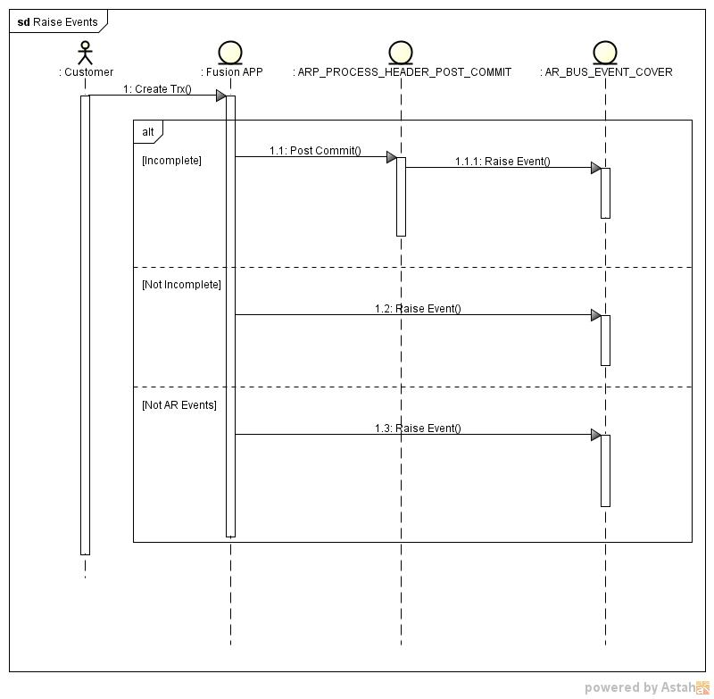

Events Processing
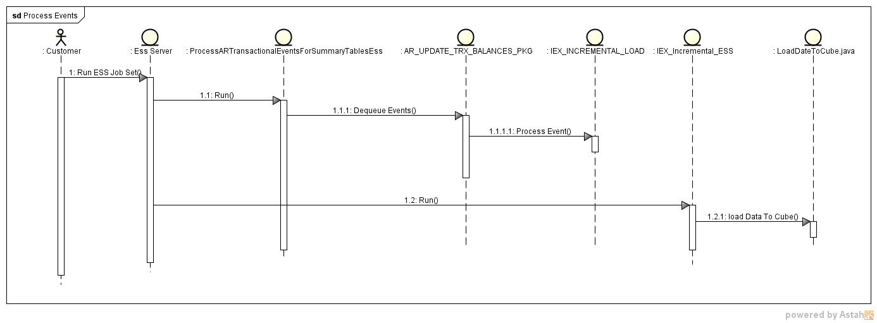

ESS Program Design Details
Provide more in-depth details of the UI design. This section is optional. For those sub-sections that do not warrant input in your technical design, you may leave them blank.
Choosing what technical design artifacts to capture in this document is at the discretion of the technical architect.

Optionally, provide a description of the data model being used in this UI Technical Design. Describe the physical tables, views, and indexes that are impacted or influenced by this UI design.
Typically, the complete data model design is documented in a (separate) backend technical design document (TDD). If this is the case, you can provide a link to the backend TDD here for reference.

View Objects
There will be no parameters to be populated by this ESS program, so we have no view objects to be used.
VO level security is enforced on the front-end/UI. Specify VO level security in this section. Define which operations are secured by which privilege.
See the Fusion Application Security Implementation for more details.
VO level security is enforced on the front-end/UI. Specify VO level security in this section. Define which operations are secured by which privilege.
See the Fusion Application Security Implementation for more details.

ESS Job

FinIexTrxIncrementalLoading
This is a java based ESS job, it calls PL/SQL programs to load the incremental data into IEX_ESSBASE_BALANCES table, and then call the java program developed in initial loading to load the data into Essbase Cube.

Job Parameters
Parameter | Value
NumberOfArgs | 0
jobType | JavaJobType
Class Name | oracle/apps/financials/iex/essbase/integration/ess/program/IncrementalLoading
jobPackageName | oracle/apps/financials/iex/essbase/integration/ess
jobDefinitionName | FinIexTrxIncrementalLoading
jobDefinitionApplication | IEX

Physical Data Model
The purpose of this section is to document any addition or updates to your existing physical data model design. Optionally, you may capture the entire physical data model at a specific level (such as at a sub-LBA, LBA, or feature level).

Overview
No | Type Name | Type | Status | Description
1 | IEX_ESSBASE_BALANCES | TABLE | New | A table to store the data which extracted from Receivables tables based on the event message

Detailed Physical Data Model

IEX_ESSBASE_BALANCES
Incremental loading using the same physical table, please refer to initial loading TDD to get more detail:http://review.us.oracle.com/review/reviewperf.do?reviewId=145072

PL/SQL Types and Packages

Overview

Types Overview
No | Type Name | Type | Status | Description
1 | IEX_ESSBASE_BALANCE_TYPE | TABLE | New | A collection to store the transaction data which will be loaded into the Essbase Cube.
2 | IEX_ESSBASE_BALANCE_RECORD | RECORD | New | A record that presents a transaction data.
3 | AR_TRX_BALANCES_MSG_TYP | OBJECT | Changed | An object that presents a event message.

Package Overview
No | Package Name | Status | Description | Business Flow
1 | IEX_INCREMENTAL_LOAD | New | This package will be called when incremental loading is requested. This package will dequeue the event message from the queue and process the event message based on the event message type. | ETL
2 | AR_BUS_EVENT_COVER | Changed | This package is used to construct and enqueue the AR event messages.  It has implemented, and in incremental loading, we inject our code into its ‘Raise_Trx_Incomplete_Event’ procedure to add additional information to event message. | AR
3 | ARP_PROCESS_HEADER_POST_COMMIT | Changed | The data of invoice and debit memo incomplete event messages are from this package, we will inject our code into this package to get additional data for the event message. | AR
4 | AR_UPDATE_TRX_BALANCES_PKG | Changed | This package is used to process the event message to update the transaction balance summary table of AR. | AR

Types

IEX_ESSBASE_BALANCE_TYPE
TYPE IEX_ESSBASE_BALANCE_TYPE IS TABLE OF IEX_ESSBASE_BALANCE_RECORD INDEX BY BINARY_INTEGER;

IEX_ESSBASE_BALANCE_RECORD
TYPE IEX_ESSBASE_BALANCE_RECORD IS RECORD (
DOCUMENT_TYPE IEX_ESSBASE_BALANCES.DOCUMENT_TYPE%TYPE,
TRX_AMOUNT IEX_ESSBASE_BALANCES.TRX_AMOUNT%TYPE,
RECEIPT_AMOUNT IEX_ESSBASE_BALANCES.RECEIPT_AMOUNT%TYPE,
ADJ_AMOUNT IEX_ESSBASE_BALANCES.ADJ_AMOUNT%TYPE,
PROMISE_AMOUNT IEX_ESSBASE_BALANCES.PROMISE_AMOUNT%TYPE,
NSF_AMOUNT IEX_ESSBASE_BALANCES.NSF_AMOUNT%TYPE,
TRX_AMOUNT_GLOBAL IEX_ESSBASE_BALANCES.TRX_AMOUNT_GLOBAL%TYPE,
RECEIPT_AMOUNT_GLOBAL IEX_ESSBASE_BALANCES.RECEIPT_AMOUNT_GLOBAL%TYPE,
ADJ_AMOUNT_GLOBAL IEX_ESSBASE_BALANCES.ADJ_AMOUNT_GLOBAL%TYPE,
PROMISE_AMOUNT_GLOBAL IEX_ESSBASE_BALANCES.PROMISE_AMOUNT_GLOBAL%TYPE,
NSF_AMOUNT_GLOBAL IEX_ESSBASE_BALANCES.NSF_AMOUNT_GLOBAL%TYPE,
SCORE IEX_ESSBASE_BALANCES.SCORE%TYPE,
AVERAGE_TERMS IEX_ESSBASE_BALANCES.AVERAGE_TERMS%TYPE,
ACTIVITY_DATE IEX_ESSBASE_BALANCES.ACTIVITY_DATE%TYPE,
PS_DUE_DATE IEX_ESSBASE_BALANCES.PS_DUE_DATE%TYPE,
PS_CLOSED_DATE IEX_ESSBASE_BALANCES.PS_CLOSED_DATE%TYPE,
CURRENCY IEX_ESSBASE_BALANCES.CURRENCY%TYPE,
BU_NAME IEX_ESSBASE_BALANCES.BU_NAME%TYPE,
PARTY_NAME IEX_ESSBASE_BALANCES.PARTY_NAME%TYPE,
ACCOUNT_NUMBER IEX_ESSBASE_BALANCES.ACCOUNT_NUMBER%TYPE,
PARTY_SITE_NAME IEX_ESSBASE_BALANCES.PARTY_SITE_NAME%TYPE,
COLLECTOR_NAME IEX_ESSBASE_BALANCES.COLLECTOR_NAME%TYPE,
SALESREP_NAME IEX_ESSBASE_BALANCES.SALESREP_NAME%TYPE,
COUNTRY IEX_ESSBASE_BALANCES.COUNTRY%TYPE,
STATE IEX_ESSBASE_BALANCES.STATE%TYPE,
COUNTY IEX_ESSBASE_BALANCES.COUNTY%TYPE,
CITY IEX_ESSBASE_BALANCES.CITY%TYPE,
POSTAL_CODE IEX_ESSBASE_BALANCES.POSTAL_CODE%TYPE,
LOCATION IEX_ESSBASE_BALANCES.LOCATION%TYPE,
PROFILE_CLASSIFICATION IEX_ESSBASE_BALANCES.PROFILE_CLASSIFICATION%TYPE,
AGING_BUCKET_NAME IEX_ESSBASE_BALANCES.AGING_BUCKET_NAME%TYPE,
PAYMENT_SCHEDULE_ID IEX_ESSBASE_BALANCES.PAYMENT_SCHEDULE_ID%TYPE,
PARTY_ID HZ_PARTIES.PARTY_ID%TYPE,
CUST_ACCOUNT_ID AR_PAYMENT_SCHEDULES_ALL.CUSTOMER_ID%TYPE,
SITE_USE_ID AR_PAYMENT_SCHEDULES_ALL.CUSTOMER_SITE_USE_ID%TYPE
);

IEX_ESSBASE_BALANCE_RECORD
alter type AR_TRX_BALANCES_MSG_TYP add attribute ( trx_date DATE ) cascade;
alter type AR_TRX_BALANCES_MSG_TYP add attribute ( acctd_amt_due_remaining number ) cascade;

Packages

IEX_INCREMENTAL_LOAD
Package Name | IEX_INCREMENTAL_LOAD
Functions/Procedures | Called by packages | Calling packages/Methods | Description
Procedure:  process  (  p_message IN AR_TRX_BALANCES_MSG_TYP  )  RETURN VARCHAR2 |  |  | This procedure is called by the AR_UPDATE_TRX_BALANCES_PKG.DEQUEUE_AR_BUS_EVENTS to process event messages.  If process the event successfully, this function will return ‘SUCCESS’.  If process the event failed, this function will return ‘ERROR’.
Procedure:  calc_preference_data |  |  | Calculate the collection and credit class for one transaction data
Function:  inv_complete  (  p_event_name IN VARCHAR2,  p_org_id IN NUMBER,  p_customer_trx_id IN NUMBER  )  RETURN VARCHAR2 |  |  | This procedure is used to process ‘oracle.apps.ar.transaction.Invoice.complete’ event.  If process the event successfully, this function will return ‘SUCCESS’.  If process the event failed, this function will return ‘ERROR’.
Function:  cm_complete  (  p_customer_trx_id IN RA_CUSTOMER_TRX.CUSTOMER_TRX_ID%TYPE,  p_prev_trx_op_count IN NUMBER,  p_prev_trx_app_amt IN NUMBER,  p_past_due_inv_amt IN NUMBER,  p_past_due_inv_count IN NUMBER,  p_org_id IN NUMBER,  p_event_name IN varchar2  )  RETURN VARCHAR2 |  |  | This procedure is used to process ‘oracle.apps.ar.transaction.CreditMemo.complete’ event.  If process the event successfully, this function will return ‘SUCCESS’.  If process the event failed, this function will return ‘ERROR’.
Function:  dm_complete  (  p_customer_trx_id IN RA_CUSTOMER_TRX.CUSTOMER_TRX_ID%TYPE,  p_org_id IN VARCHAR2 ,  p_event_name IN varchar2  )  RETURN VARCHAR2 |  |  | This procedure is used to process ‘oracle.apps.ar.transaction.DebitMemo.complete’ event.  If process the event successfully, this function will return ‘SUCCESS’.  If process the event failed, this function will return ‘ERROR’.
Function:  cb_create  (  p_event_name IN VARCHAR2,  p_org_id IN NUMBER,  p_customer_trx_id IN NUMBER  )  RETURN VARCHAR2 |  |  | This procedure is used to process ‘oracle.apps.ar.transaction.ChargeBack.create’ event.  If process the event successfully, this function will return ‘SUCCESS’.  If process the event failed, this function will return ‘ERROR’.
Function:  inv_incomplete  (  p_event_name IN VARCHAR2,  p_org_id IN NUMBER,  p_customer_trx_id IN NUMBER,  p_payment_schedule_id IN NUMBER,  p_history_id IN NUMBER  )  RETURN VARCHAR2 |  |  | This procedure is used to process ‘oracle.apps.ar.transaction.Invoice.incomplete’ event.  If process the event successfully, this function will return ‘SUCCESS’.  If process the event failed, this function will return ‘ERROR’.
Function:  dm_incomplete  (  p_customer_trx_id IN RA_CUSTOMER_TRX.CUSTOMER_TRX_ID%TYPE,  p_payment_schedule_id IN AR_PAYMENT_SCHEDULES.PAYMENT_SCHEDULE_ID%TYPE,  p_history_id IN NUMBER,  p_org_id IN NUMBER ,  p_event_name IN varchar2  )  RETURN VARCHAR2 |  |  | This procedure is used to process ‘oracle.apps.ar.transaction.DebitMemo.incomplete’ event.  If process the event successfully, this function will return ‘SUCCESS’.  If process the event failed, this function will return ‘ERROR’.
Function:  cashapp_apply  (  p_receivable_application_id IN AR_RECEIVABLE_APPLICATIONS.RECEIVABLE_APPLICATION_ID%TYPE,  p_trx_ps_status IN VARCHAR2,  p_rcpt_ps_status IN VARCHAR2,  p_trx_due_date IN DATE,  p_trx_app_amt IN NUMBER,  p_org_id IN NUMBER,  p_event_name IN VARCHAR2  )  RETURN VARCHAR2 |  |  | This procedure is used to process ‘oracle.apps.ar.applications.CashApp.apply’ event.  If process the event successfully, this function will return ‘SUCCESS’.  If process the event failed, this function will return ‘ERROR’.
Function:  cashapp_unapply  (  p_receivable_application_id IN AR_RECEIVABLE_APPLICATIONS.RECEIVABLE_APPLICATION_ID%TYPE,  p_old_trx_ps_status IN VARCHAR2,  p_new_trx_ps_status IN VARCHAR2,  p_old_rcpt_ps_status IN VARCHAR2,  p_new_rcpt_ps_status IN VARCHAR2,  p_trx_due_date IN DATE,  p_trx_app_amt IN NUMBER,  p_amt_due_remaining IN NUMBER,  p_old_amt_due_remaining IN NUMBER,  p_org_id IN NUMBER,  p_event_name IN VARCHAR2  )  RETURN VARCHAR2 |  |  | This procedure is used to process ‘oracle.apps.ar.applications.CashApp.unapply’ event.  If process the event successfully, this function will return ‘SUCCESS’.  If process the event failed, this function will return ‘ERROR’.
Function:  creditmemoapp_apply  (  p_receivable_application_id IN AR_RECEIVABLE_APPLICATIONS.RECEIVABLE_APPLICATION_ID%TYPE,  p_trx_ps_status IN VARCHAR2,  p_cm_ps_status IN VARCHAR2,  p_trx_due_date IN VARCHAR2,  p_trx_app_amt IN NUMBER,  p_org_id IN NUMBER,  p_event_name IN VARCHAR2,  p_cm_ps_rem_amt IN NUMBER,  p_cm_apply_unapply_amt IN NUMBER  )  RETURN VARCHAR2 |  |  | This procedure is used to process ‘oracle.apps.ar.applications.CreditMemoApp.apply’ event.  If process the event successfully, this function will return ‘SUCCESS’.  If process the event failed, this function will return ‘ERROR’.
Function:  creditmemoapp_unapply  (  p_receivable_application_id IN AR_RECEIVABLE_APPLICATIONS.RECEIVABLE_APPLICATION_ID%TYPE,  p_trx_ps_status IN VARCHAR2,  p_cm_ps_status IN VARCHAR2,  p_trx_due_date IN VARCHAR2,  p_trx_app_amt IN NUMBER,  p_org_id IN NUMBER,  p_event_name IN VARCHAR2,  p_cm_ps_rem_amt IN NUMBER,  p_cm_apply_unapply_amt IN NUMBER  )  RETURN VARCHAR2 |  |  | This procedure is used to process ‘oracle.apps.ar.applications.CreditMemoApp.unapply’ event.  If process the event successfully, this function will return ‘SUCCESS’.  If process the event failed, this function will return ‘ERROR’.
Function:  adj_create  (  p_adjustment_id IN AR_ADJUSTMENTS.ADJUSTMENT_ID%TYPE,  p_adj_status IN VARCHAR2,  p_applied_ps_status IN VARCHAR2,  p_org_id IN NUMBER ,  p_event_name IN VARCHAR2  )RETURN VARCHAR2 |  |  | This procedure is used to process ‘oracle.apps.ar.adjustments.Adjustment.create’ event.  If process the event successfully, this function will return ‘SUCCESS’.  If process the event failed, this function will return ‘ERROR’.
Function:  adj_approve  (  p_adjustment_id IN AR_ADJUSTMENTS.ADJUSTMENT_ID%TYPE,  p_approval_actn_hist_id IN VARCHAR2,  p_applied_ps_status IN VARCHAR2,  p_org_id IN NUMBER,  p_event_name IN VARCHAR2  )  RETURN VARCHAR2 |  |  | This procedure is used to process ‘oracle.apps.ar.adjustments.Adjustment.approve’ event.  If process the event successfully, this function will return ‘SUCCESS’.  If process the event failed, this function will return ‘ERROR’.
Function:  autoinv_run  (  p_event_name IN VARCHAR2,  p_org_id IN NUMBER,  p_request_id IN NUMBER  )  RETURN VARCHAR2 |  |  | This procedure is used to process ‘oracle.apps.ar.batch.AutoInvoice.run’ event.  If process the event successfully, this function will return ‘SUCCESS’.  If process the event failed, this function will return ‘ERROR’.
Function:  autorcpt_run  (  p_event_name IN VARCHAR2,  p_org_id IN NUMBER,  p_request_id IN NUMBER  )  RETURN VARCHAR2 |  |  | This procedure is used to process ‘oracle.apps.ar.batch.AutoReceipts.run’ event.  If process the event successfully, this function will return ‘SUCCESS’.  If process the event failed, this function will return ‘ERROR’.
Function:  quickcash_postbatch  (  p_event_name IN VARCHAR2,  p_org_id IN NUMBER,  p_request_id IN NUMBER  )  RETURN VARCHAR2 |  |  | This procedure is used to process ‘oracle.apps.ar.batch.QuickCash.PostBatch’ event.  If process the event successfully, this function will return ‘SUCCESS’.  If process the event failed, this function will return ‘ERROR’.
Function:  autoadj_run  (  p_event_name IN VARCHAR2,  p_org_id IN NUMBER,  p_request_id IN NUMBER  )  RETURN VARCHAR2 |  |  | This procedure is used to process ‘oracle.apps.ar.batch.AutoAdjustments.run’ event.  If process the event successfully, this function will return ‘SUCCESS’.  If process the event failed, this function will return ‘ERROR’.

AR_BUS_EVENT_COVER
Package Name | AR_BUS_EVENT_COVER
Code Change | Function/Procedure | Description
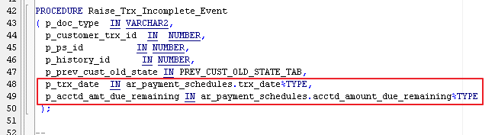 | Raise_Trx_Incomplete_Event | Change the signature of the procedure to add the two parameters to capture the transaction date and functional remaining due amount.
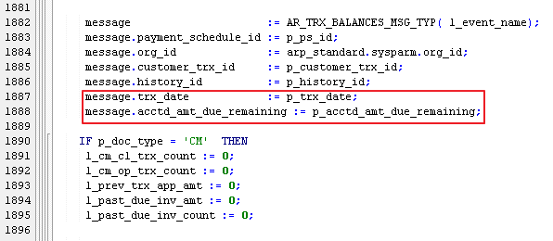 | Raise_Trx_Incomplete_Event | Change the implement of the procedure to put transaction date and functional remaining due amount into the event message.
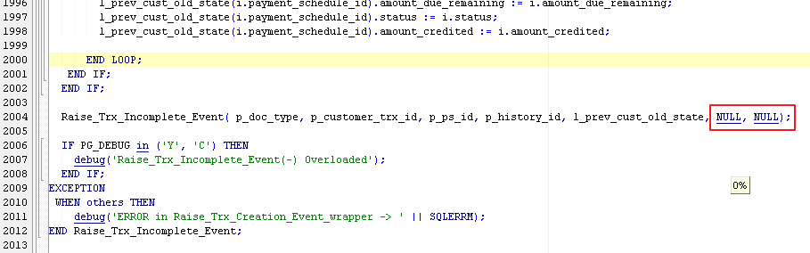 | Raise_Trx_Incomplete_Event | The signature of the Raise_Trx_Incomplete_Event procedure has changed, two arguments should add to the callers to meet the new signature.

ARP_PROCESS_HEADER_POST_COMMIT
Package Name | ARP_PROCESS_HEADER_POST_COMMIT
Code Change | Function/Procedure | Description
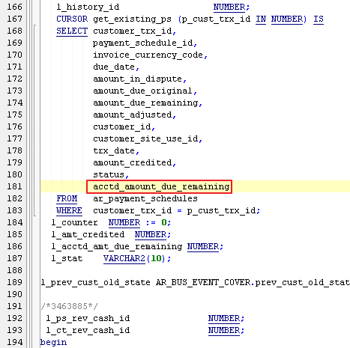 | post_commit | Change the cursor to capture the accounted remaining due amount that will be stored in the event message.
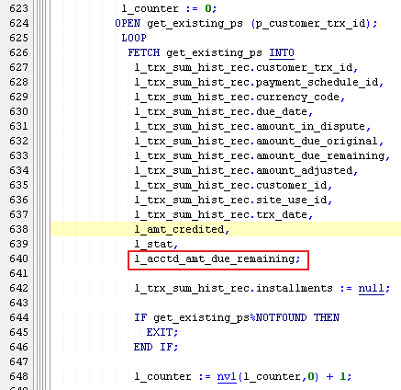 | post_commit | Get the amount from course into a local variable for future process.
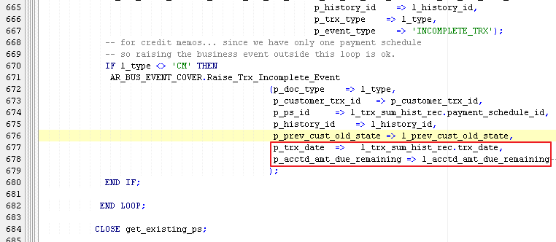 | post_commit | Pass the data to Raise_Trx_Incomplete_Event to construct the event message and enqueue the message.
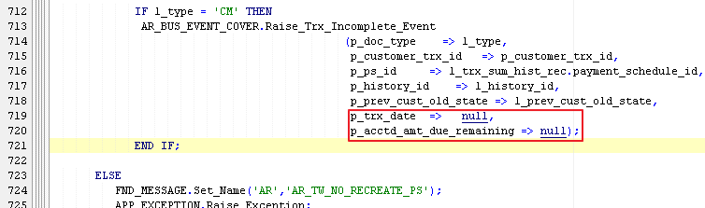 | post_commit | The signature of the Raise_Trx_Incomplete_Event procedure has changed, two arguments should add to the callers to meet the new signature.
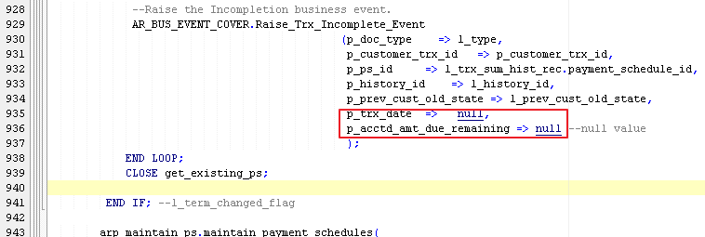 | post_commit | The signature of the Raise_Trx_Incomplete_Event procedure has changed, two arguments should add to the callers to meet the new signature.

AR_UPDATE_TRX_BALANCES_PKG
Package Name | AR_UPDATE_TRX_BALANCES_PKG
Code Change | Function/Procedure | Description
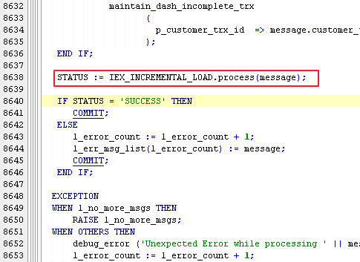 | DEQUEUE_AR_BUS_EVENTS | Inject our procedure to process the event message to populate the IEX_ESSBASE_BALANCES table.

Seed Data
This section is used to describe any pre-seeded setup data that are shipped with the application. Examples of seed data are profile options, lookups, trees, etc.
Incremental loading has the same Seed Data as initial loading. Please refer to the TDD of the initial loading to get more detail: http://review.us.oracle.com/review/reviewperf.do?reviewId=145072

Performance Consideration

Open and Closed Issues

Open Issues
Enter new open issues in the Open Issues table below. Use the blank second row for a long explanation of the issue. When an issue is closed, move the issue to the Closed Issues section. Always preserve the original issue number when transferring issues between the Open and Closed sections.
Issues that will remain open after the TDD approval become a Managed Open Issue (MOI). If this TDD is pending approval, follow the MOI process to log each open issue as a MOI by creating a change request (CR) in RMS and recording the generated CR ID as the MOI #.
Complete the following for each issue:
Managed Open Issue #: Provide the MOI # if this issue has been logged as an MOI. See Note above.
Description: Enter a short description of the issue
Date Raised: Enter the date when the issue was raised.
Raised By: Enter the name (or email address) of the person who raised the issue.
Priority: Enter the priority of the issue -- High, Medium or Low.
Owner: Enter the name of the person responsible for resolving the issue.
Action: Provide a description of the action for this issue.
Target Date/Date Closed: For Open Issues and Managed Open Issues, enter the target date for the issue resolution. For Closed Issues, enter the date that the issue was closed.
Resolution: If this issue has been closed provide the resolution.

No. | Managed Open Issue # or Bug # |  | Priority  (H= High; M=Medium; L=Low) | Raised By | Date Raised | Owner | Target Date
1.
Description:

Action:

Closed Issues
No. | Short Description, Managed Open Issue #, or Bug # |  | Priority  (H= High; M=Medium; L=Low) | Raised By | Date Raised | Owner | Date Closed
1.
Description:

Resolution:

Appendix: <Appendix Name>
Use this section as needed. Examples of appendices used may include examples illustrating how a particular technical component design will impact existing technology or how a particular Page Fragment should be implemented.

Template Version Log

Version Log
Version | Date | Summary of Change (what & impact)

