Technical Solution Approach
Credit Management
Credit Checking Service
Applications Release: Fusion V2.0
Author: Tony Wang
Creation Date: 03-Aug-11
Last Updated: 3/12/2012 03:54:00 AM
Functional Solution Approach Document(s):
Product Development Area:
Detailed Business Process:
Document Version: 1.0
Status: IN DRAFT | IN REVIEW | APPROVED
File URL: http://files.oraclecorp.com/…
Template Version: 2.0
Applications Release: Applications Release should be one of the following: Fusion V1, Fusion V1.1, Fusion V1.2, Fusion 2.0, Future, Other
Creation Date: The Creation Date and Last Updated dates are field codes. To update the dates (and all other field codes in this document), press CTRL-A followed by F9.
Functional Solution Approach Document (s): Functional Solution Approach Document(s) should contain the name of the prerequisite FSA(s) for this document.
Product Development Area: Product Development Area is defined as a logical grouping of components within a product. Examples are Invoice, Payments, Purchase Orders, and Requisitions.
Detailed Business Process: Select the Detailed Business Process that is impacted by this document.
Document Version: Use A, A.1, A.2, B, C, etc for draft versions. Start published versions with 1.0. The version is incremented every time a change is published for the document. Only the digit after the decimal point is incremented: when you reach 1.9, continue to 1.10, 1.11, etc. There is no implied meaning to the version numbers.
File URL: Enter the URL where this document is stored. Alternative to FOL, if using Beehive Workspaces to store your files, provide the URL to that.

INFORMATION ABOUT USING THIS TEMPLATE
The header of this template contains the document title field, which can be set at: File->Properties->Summary->Title. You should update your document title to reflect the title of your technical design document. This field will be updated when the document is printed or the print preview is
activated.
This template includes special features to make document creation easier.
Oracle Menu
In the main Word menu bar you should see a menu called Oracle. This menu contains the following options:
Replace Document Variables: Displays a dialog where you can enter replacement values for the document variables marked in blue throughout this template.
Strip Yellow Notes: Permanently removes the yellow notes (such as this one) from your document.
Insert Formatted Table: Inserts a new table with standard Oracle formatting.
Format Current Table: When invoked when the cursor is inside a table, this function will format the table with standard formatting while preserving the contents.
Insert List Table Inserts a two-column, borderless table that is useful for a list of phrases with definitions. The first column is set to bold. Tab in the last cell to automatically add a new row.
Keyboard Shortcuts
Use the following keyboard shortcuts to format headings and paragraphs as you type:
Ctrl-Shift-1 Heading 1
Ctrl-Shift-2 Heading 2
Crtl-Shift-3 Heading 3
Ctrl-Shift-4 Heading 4
Ctrl-Shift-5 Heading 5
Ctrl-Shift-N Body Text (N = Normal)
Ctrl-Shift-B Bullet (use this for Oracle standard bullets)
Ctrl-Shift-L Number List
Ctrl-Shift-H Highlighted Variable (for creating new document variables)
This template contains instructions in hidden text. To display the instructions, select Tools > Options from the MS Word menu, go to the ‘View’ sub-tab, and check the ‘Hidden text’ checkbox under ‘Formatting marks’.
Table of Contents
1. Document Control 4
1.1 Change Record 4
1.2 Contributors 4
1.3 Document References 4
2. Reviews and Approvals 5
2.1 Reviewers 5
2.2 Mandatory Approvers 5
2.3 Additional Approvers 5
3. Abstract 6
4. Introduction 7
4.1 Scope 7
4.2 Design Goals 7
4.3 Technology 7
4.4 Design Assumptions 7
4.5 Design Constraints 7
5. Solution Approach 8
5.1 Overview 8
5.2 Flow Chart 9
5.2.1 Flow Chart of Process One 9
5.2.2 Flow Chart of Process Two 17
5.2.3 Flow Chart of Process Three 18
5.2.4 Flow Chart of updating available credit of a customer account 22
5.3 Physical Data Model 23
5.4 PL/SQL Package Layer 25
5.5 Other Considerations 25
6. Alternative Design Approaches 26
6.1 Design Approach 1: De-Polymorphic Approach 26
6.1.1 Description 26
6.1.2 Reason for not being chosen 26
7. Planned Technical Designs 27
7.1 Planned Technical Designs 27
7.2 Additional Information 27
8. Open and Closed Issues 28
8.1 Closed Issues 28
9. Appendix: <Appendix Name> 33
10. Template Version Log 34
10.1 Version Log 34

Document Control

Change Record
The first change record should indicate that the document has been published for review. Keep track of all the changes made to the TSA after it has been published for review
Date | Email | Version | Change Reference
3-Aug-11 | Tony Wang | 1.0 | First draft

Contributors
Identify all contributors to the TSA. You can include details about each person’s contribution in the Content field.
Email | Role | Content

Document References
Include all references to documents that served as inputs into the TSA, or that are related to this TSA in the Document References table. For example, if the TSA refers to a Functional Solution Approach document, include the URL to this document here.
Document Title | Author | Location | Comments

Reviews and Approvals
Every Technical Solution Approach must be approved by a minimum set of approver roles. These roles are pre-seeded and high-lighted into the template and cannot be modified.

Reviewers
Email | Role | Status (Review Complete /  Will Not Review) | Comments | Version Reviewed | Date

Mandatory Approvers
Email | Role | Status (Approved /  Will Not Approve) | Comments | Version Approved | Date
 | Development Area Owner

Additional Approvers
Email | Role | Status (Approved /  Will Not Approve) | Comments | Version Approved | Date

For each reviewer or approver, provide the following information:
Email: Enter reviewer email. The email address domain is not validated for reviewers.
Role: As a part of the role description, identify which organization the reviewer represents.
Status: In case a reviewer does not review the document, set the status to “Will Not Review.” In case an approver does not approve the document, set the status to "Will Not Approve" and identify the reason for this in the Comments field.
Comments: Provide a reason for not reviewing the document if the status is set to “Will Not Review” or "Will Not Approve"
Version Reviewed/Approved: Enter the version reviewed/approved.
Date: Enter the date when the review/approval feedback was provided

To update this table of contents, click on it and press F9.
To jump directly to a page, CTRL + click on the page number.

Abstract
The credit checking solution is provided to satisfy the requirements on integration with Oracle Fusion Quote and Order Capture (QOC), as it relates to automated credit checking and credit authorization against the credit limit assigned to a particular customer account in Oracle Fusion Receivables, as described in the Credit Management Credit Checking BRD. A unique authorization identification number is provided when a credit authorization request is approved, and an authorization expiration date set. In the case where a pre-authorization is requested, only a yes or no answer is needed from credit management. In the case that an authorized order is changed, a re-authorization request may be sent to credit management for approval.
The credit check cases that require manual credit reviews by a credit analyst or credit manager is out of scope for this FDD but is addressed as an integral part of the Credit Management solution component planned for Fusion V2RUP.

Provide a brief abstract statement of your technical solution approach. The abstract should be a fully self-contained description of your design document, and in most cases would include the following:
1) Motivation (Why do we care about the problem and the results?)
2) Problem Statement (What problem are you trying to solve?)
3) Approach (How did you go about solving or making progress on the problem?)
4) Results (What's the answer?)
5) Conclusions (What are the implications of your answer?)
Each of the above is typically a single sentence, or may be merged in a set of sentences.

Introduction

Scope
Enter a short description of the technical solution approach and its scope.
An ERP system has many business processes that require importing financial data from external systems. Two examples are bank statements in Cash Management and payment acknowledgements in Payments. To support multiple trading partners (i.e. banking institutions or payment processors), the ERP system must be flexible to handle different forms of protocol and formats. The scope of this feature is to develop a scalable and flexible framework in order to process inbound financial messages in a consistent unified manner.
An ERP system has many business processes that require importing financial data from external systems. Two examples are bank statements in Cash Management and payment acknowledgements in Payments. To support multiple trading partners (i.e. banking institutions or payment processors), the ERP system must be flexible to handle different forms of protocol and formats. The scope of this feature is to develop a scalable and flexible framework in order to process inbound financial messages in a consistent unified manner.
An ERP system has many business processes that require importing financial data from external systems. Two examples are bank statements in Cash Management and payment acknowledgements in Payments. To support multiple trading partners (i.e. banking institutions or payment processors), the ERP system must be flexible to handle different forms of protocol and formats. The scope of this feature is to develop a scalable and flexible framework in order to process inbound financial messages in a consistent unified manner.
An ERP system has many business processes that require importing financial data from external systems. Two examples are bank statements in Cash Management and payment acknowledgements in Payments. To support multiple trading partners (i.e. banking institutions or payment processors), the ERP system must be flexible to handle different forms of protocol and formats. The scope of this feature is to develop a scalable and flexible framework in order to process inbound financial messages in a consistent unified manner.
An ERP system has many business processes that require importing financial data from external systems. Two examples are bank statements in Cash Management and payment acknowledgements in Payments. To support multiple trading partners (i.e. banking institutions or payment processors), the ERP system must be flexible to handle different forms of protocol and formats. The scope of this feature is to develop a scalable and flexible framework in order to process inbound financial messages in a consistent unified manner.
An ERP system has many business processes that require importing financial data from external systems. Two examples are bank statements in Cash Management and payment acknowledgements in Payments. To support multiple trading partners (i.e. banking institutions or payment processors), the ERP system must be flexible to handle different forms of protocol and formats. The scope of this feature is to develop a scalable and flexible framework in order to process inbound financial messages in a consistent unified manner.
An ERP system has many business processes that require importing financial data from external systems. Two examples are bank statements in Cash Management and payment acknowledgements in Payments. To support multiple trading partners (i.e. banking institutions or payment processors), the ERP system must be flexible to handle different forms of protocol and formats. The scope of this feature is to develop a scalable and flexible framework in order to process inbound financial messages in a consistent unified manner.
The credit checking solution is provided to satisfy the requirements on integration with Oracle Fusion Quote and Order Capture (QOC), as it relates to credit checking and credit authorization against the credit limit assigned to a particular customer account in Oracle Fusion Receivables.
The credit checking has three processes:
- Process one: response the request of QOC, including:
- Establish A Line of Credit
- Pre-Authorize Credit
- Authorize Credit
- Cancel/De-Authorize Credit
- Re-Authorize Credit
- Process two: process expired credit authorizations.
- Process three: process transactional events that will impact available credit of customer account.

Design Goals
Design solutions for these three processes.
Describe the goals addressed by your design, such as the technical issues addressed and the components to achieve your goals.

Technology
Describe the technology stack that you will be using, including any 3rd party integration.
The framework will be built in Fusion using ADF, ESS and BI Publisher for the transformation of acknowledgement payment messages.
The framework will be built in Fusion using ADF, ESS and BI Publisher for the transformation of acknowledgement payment messages.
The framework will be built in Fusion using ADF, ESS and BI Publisher for the transformation of acknowledgement payment messages.
The framework will be built in Fusion using ADF, ESS and BI Publisher for the transformation of acknowledgement payment messages.
The feature will be built in Fusion using PL/SQL, ADF Web Services.

Design Assumptions
- Create Invoice Event exists and provides the Authorization Numbers when invoice is created.
- All sales orders must be authorized before they can be booked.
- One invoicing and payment request must have one and only one authorization number. One invoicing and payment request must have one and only one sales order line.
- One authorization number could be sent in multiple invoicing and payment requests, but each invoicing and payment request is sent at different point in time. At any given point in time, there is one and only one invoicing and payment request for an authorization number.

Design Constraints
Describe any factors that constrain or restrict the technical solution.

Solution Approach

Overview
In process one, we need to integrate with QOC to get the input parameter and return the response according to request type.
In process three, we only need to check the authorizations that have expired at given time, and update their status to ‘Expired’.
In process three, there are three transactional events will impact the data stored in table AR_TRX_BAL_SUMMARY:
NO | Transactional Events | Description | Impact
1 | Refresh Receivables Transactional Events for Summary Tables | Populates summary tables after a set of data is migrated or corrected. | To process this event, the AR_TRX_BAL_SUMMARY will be Purged, then populated, we need to update the available credit of a customer account based on the fresh data.
2 | Process Receivables Transactional Events for Summary Tables | Processes business events that populate summary tables when a business event is raised from any transactional event. | There are a lot of business events will impact available credit and authorization of a customer account, so we have to update the available credit and authorization.
3 | Refresh Receivables Past Due Transactions for Summary Tables | Populates summary tables for past due transactions after a set of data is migrated or corrected. | There is nothing related to available credit and authorization.
Describe your technical solution overview within this development area. Capture any differentiators that would make this design “stand out” and potentially patentable.

Flow Chart

Flow Chart of Process One

Main Flow Chart of Process One
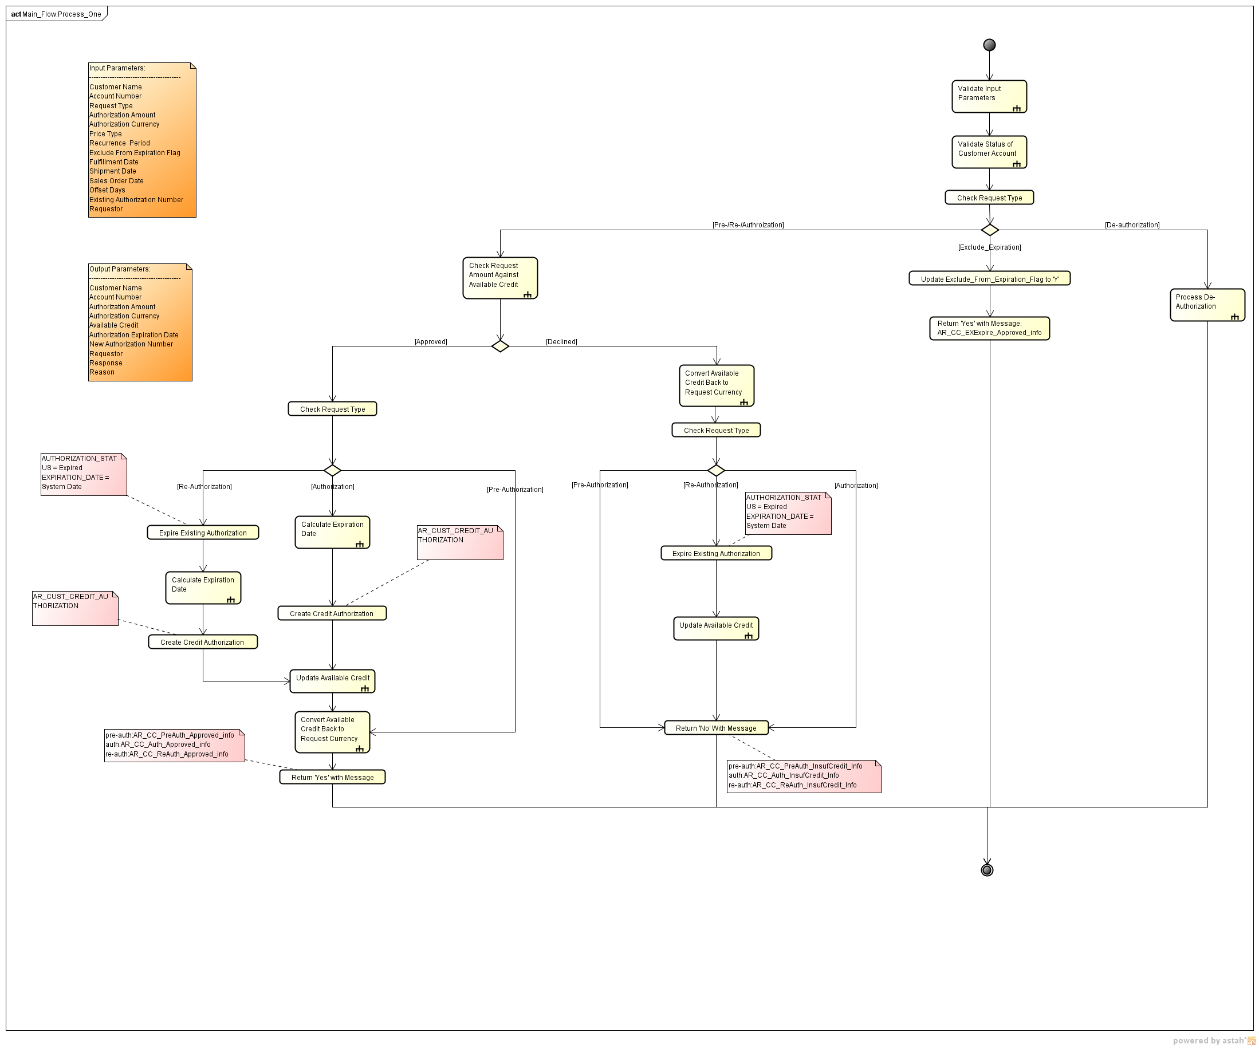

Flow Chart of Validate Input Parameters
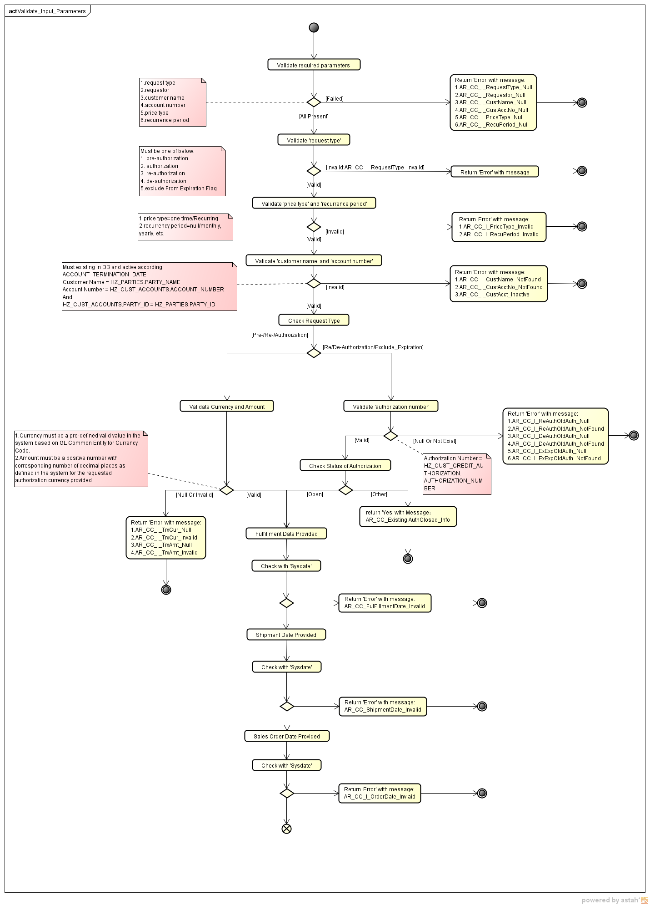

Flow Chart of Validate Status of Customer Account
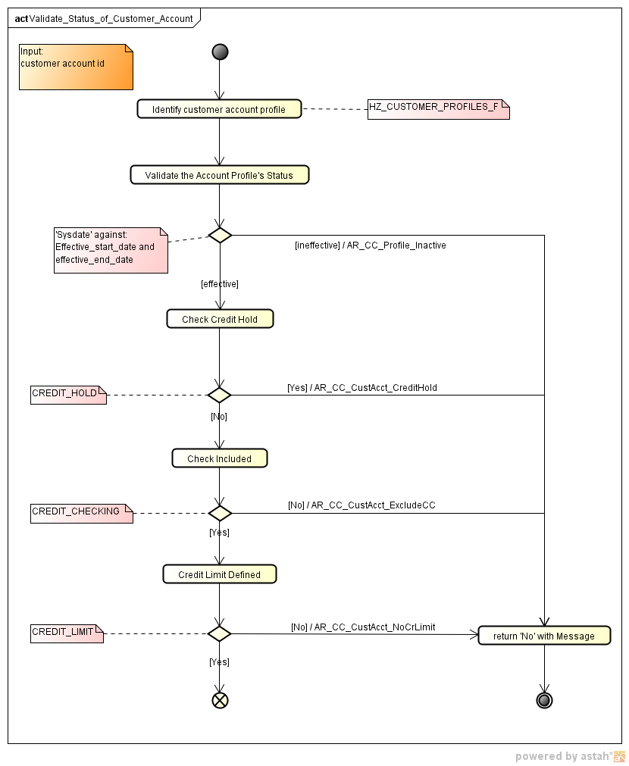

Flow Chart of Check Request Amount against Available Credit
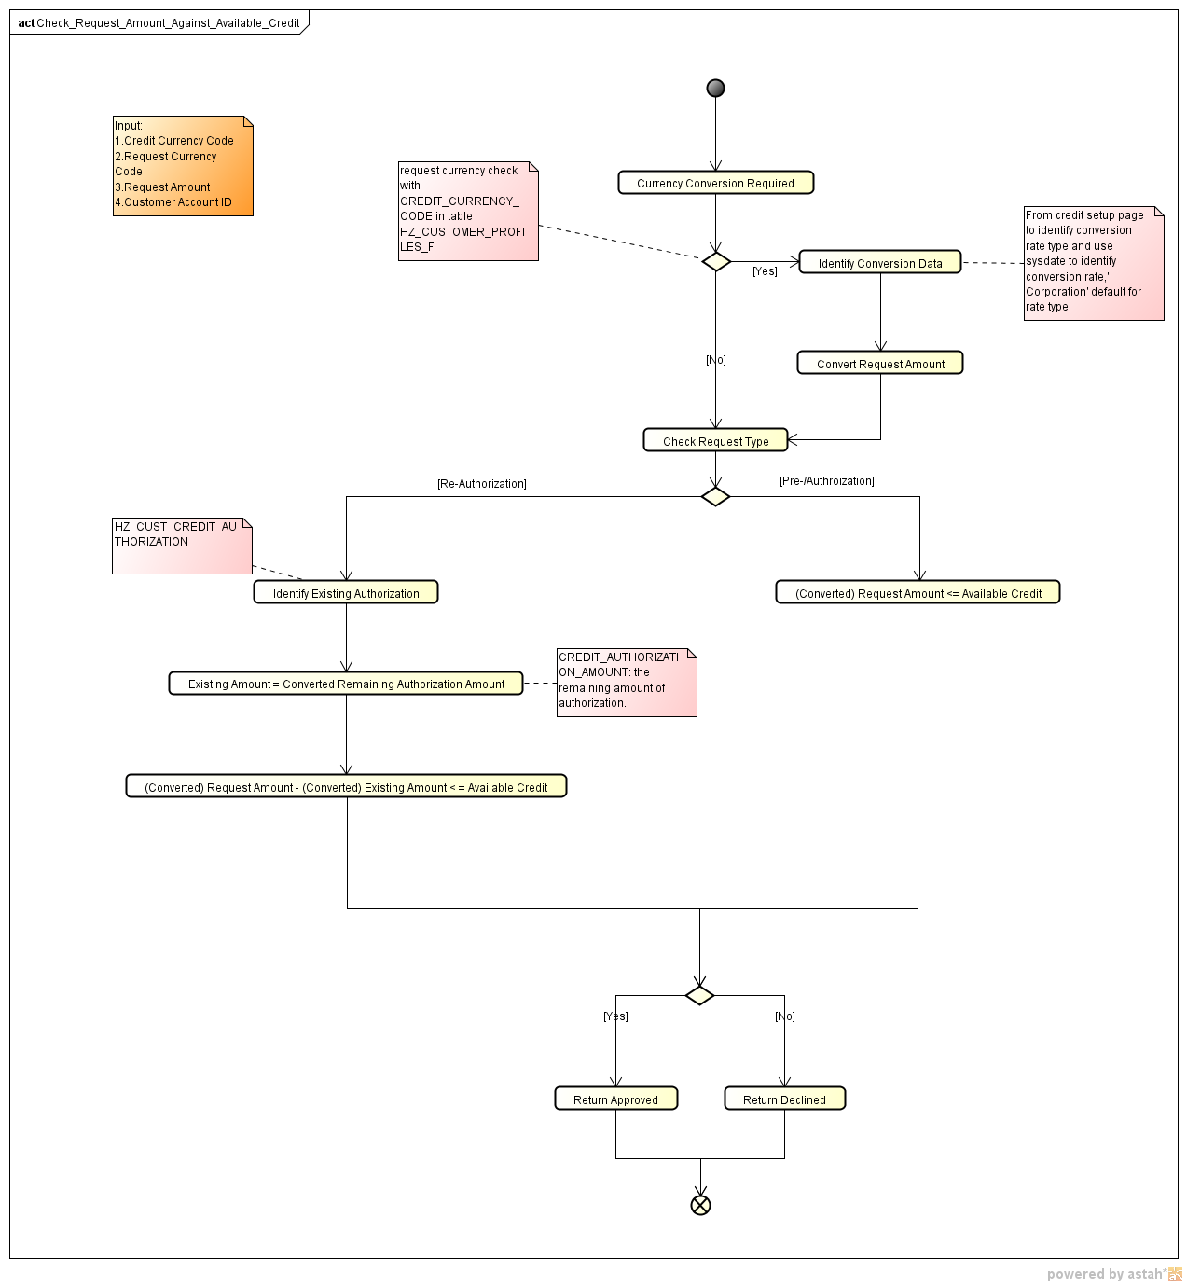

Flow Chart of Calculate Expiration Date
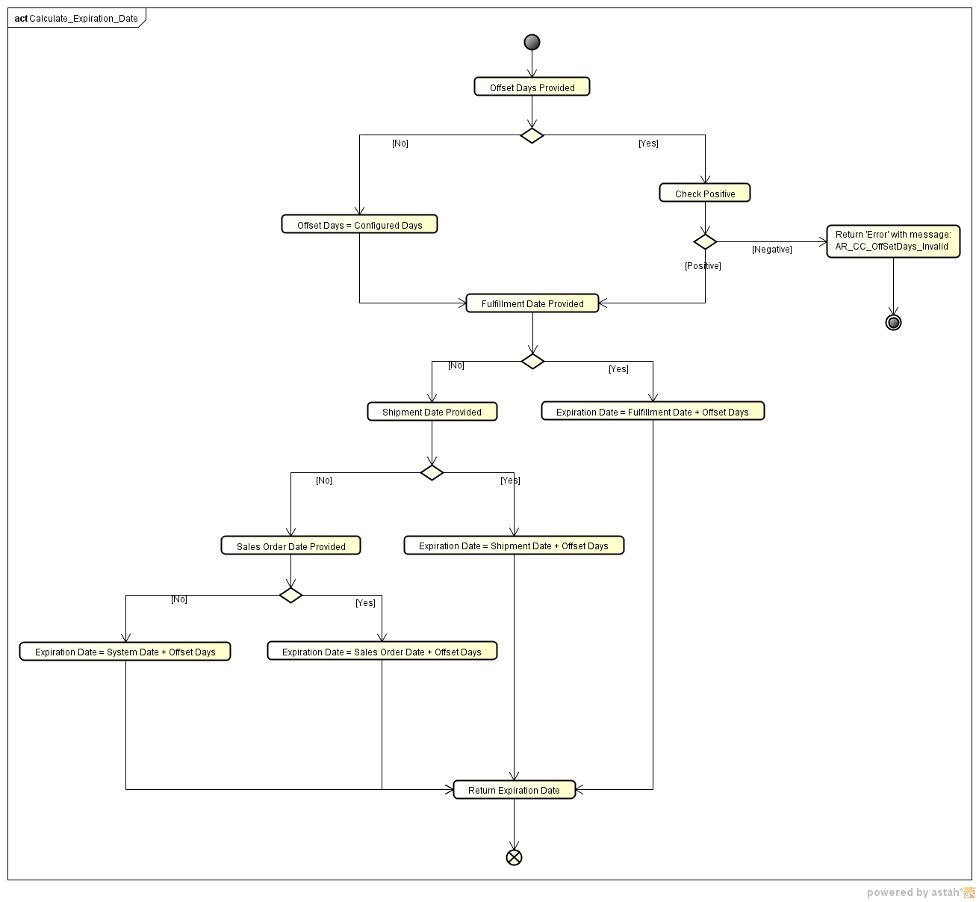

Flow Chart of Convert Available Credit Back to Request Currency
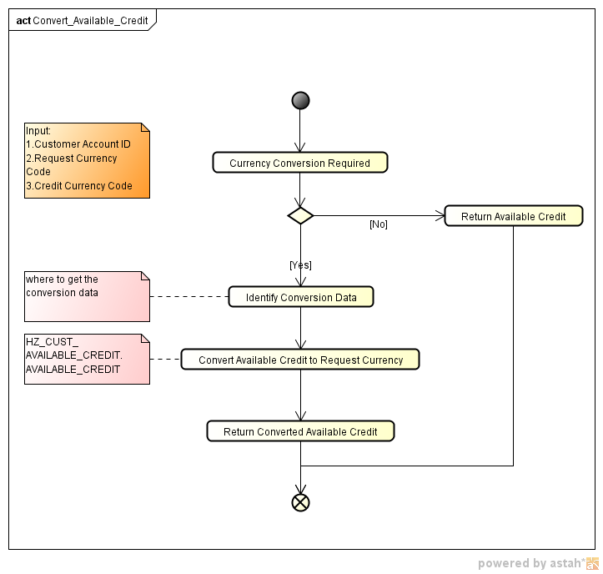

Flow Chart of Process De-Authorization
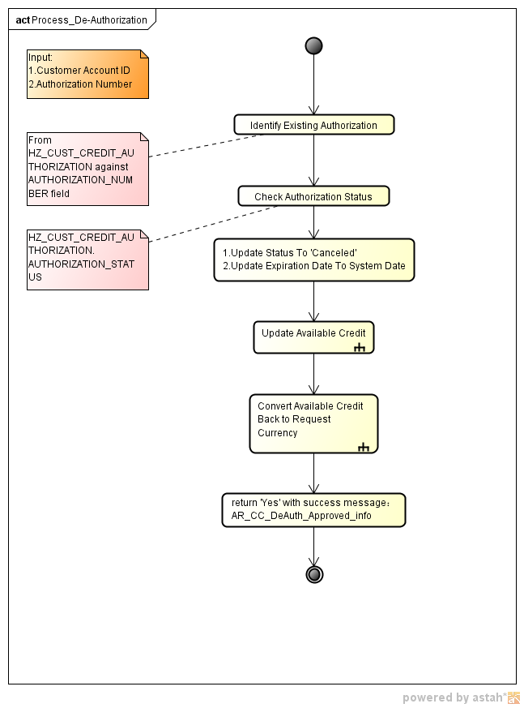

Flow Chart of Process Two
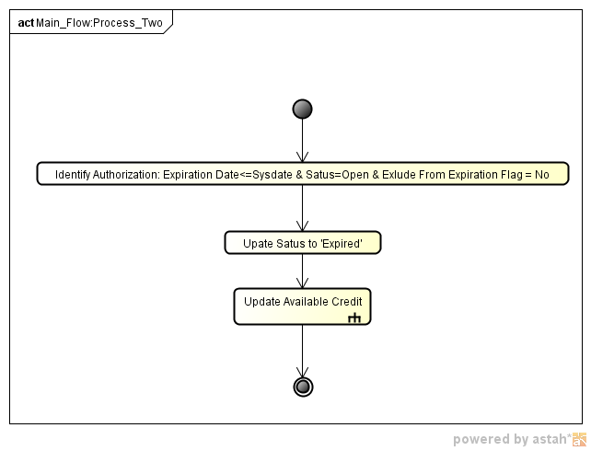

Flow Chart of Process Three

Main Flow Chart of Process Three
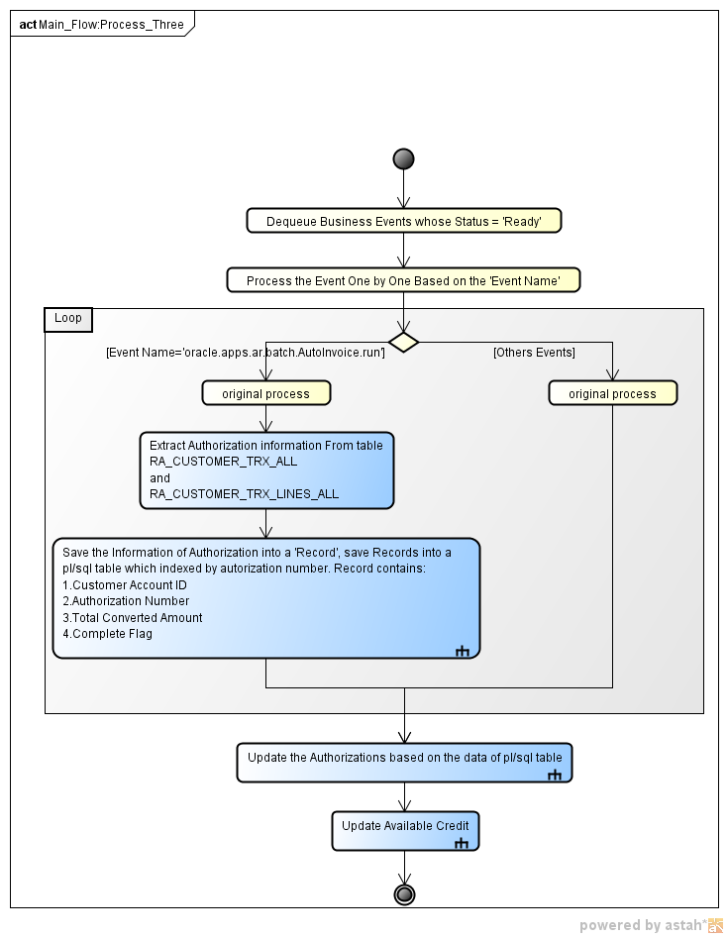
Provide a high level flow chart on how each technology (i.e. SOA, ADF UI, etc.) will interact in your system. An example of a flow chart is shown here.
Provide any additional detailed diagrams such as process flows, system interactions, component interactions, etc.

Flow Chart of Collecting Information of Authorization
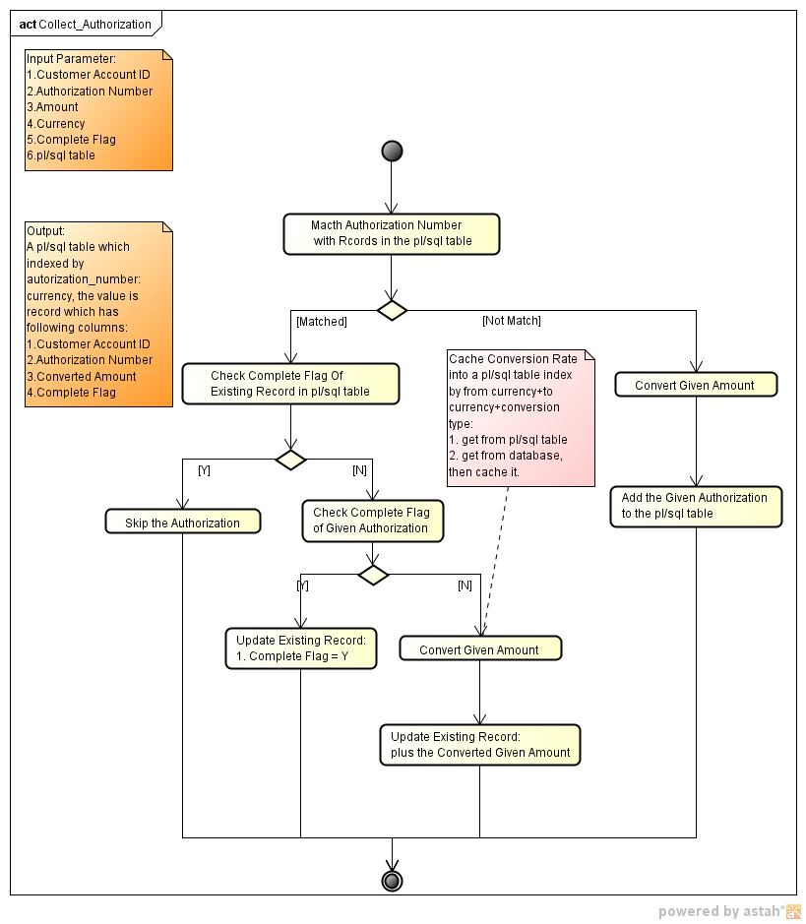

Flow Chart of updating Authorization
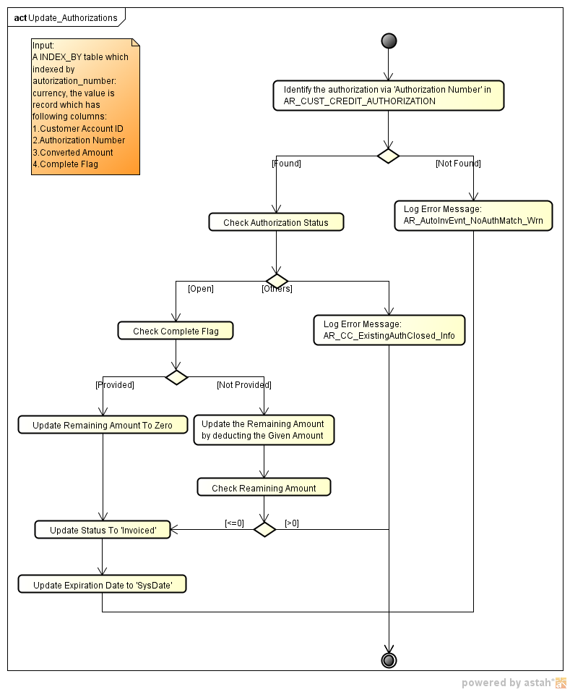

Flow Chart of updating available credit of a customer account
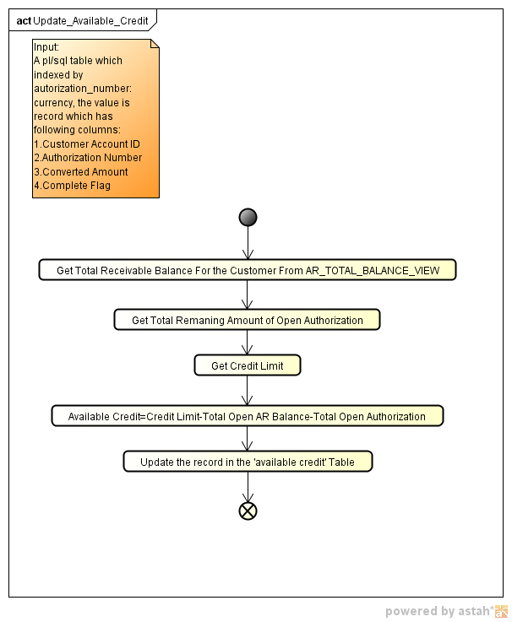

Physical Data Model
Credit Checking Service is not completely new feature from the data model’s point of view, as most credit physical tables already exist and they require minor amendment. For example, table HZ_CUSTOMER_PROFILES_F which stores information about the credit characteristics of single customer account will be used to capture more information about the credit of a customer account.
The central concepts of the credit checking service are available credit and authorization, so table HZ_CUST_ AVAILABLE_CREDIT and HZ_CUST_CREDIT_AUTHORIZATION will be created and be used to capture the available credit limit data and the authorizations of a customer account.
The available credit of a customer account is calculated by following formula:
Available Credit = Credit Limit - (Total AR Balance: billed and unbilled) - (Total Open Authorization Amounts)
And Total AR Balance is calculated by:
Total Open Receivable Balance = Open Invoice + Open Credit Memo + Open Debit Memo + Open Charge Back + Unresolved Cash (minus)
So we need to access AR_TRX_BAL_SUMMARY to get the data we needed.
Considering auto invoicing event and payment event will impact the AR balance and authorization, we need to integrate with RA_CUSTOMER_TRX_ALL and RA_CUSTOMER_TRX_LINES_ALL to get the invoice amount, currency code and authorization number etc.
We also need GL_DAILY_RATES to get the conversion rate for the invoice currency that is different from Credit Limit Currency.

Provide a high-level description of the updates/changes that must be made to the physical data model. If there is no change, explicitly state it here as well.
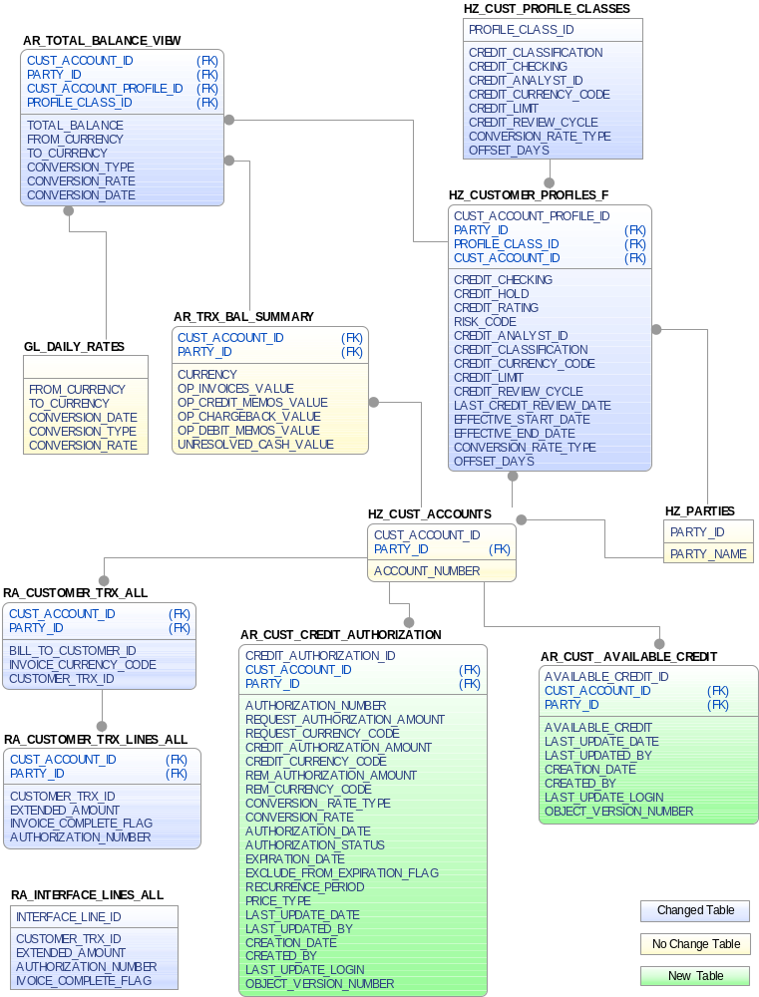
Figure 1 Business Component Diagram of Physical Data Model

PL/SQL Package Layer
A new pl/sql package will be introduced for process one, we implement business logic in pl/sql package, then using ADF Web Service technology to wrap it to a web service for QOC to invoke.
And a new ESS job will be developed to process the expired authorizations, and also the main business logic will be implemented in pl/sql package.
For process three, the pl/sql package named AR_TRX_SUMMARY_PKG is already there for transactional event 1, and for transactional 2, the pl/sql package is named AR_UPDATE_TRX_BALANCES_PKG and the processing is implemented in procedure DEQUEUE_AR_BUS_EVENTS, the procedure process 37 types of event including the auto invoice, credit memo, receipt creation and apply event that will update the data in the AR_TRX_BAL_SUMMARY table, the update will impact the available credit of customer account.
There are a lot of events we should care about more than auto invoice event, but only auto invoice will impact the authorization of the customer account. So our solution is:
- Capture the information of the authorizations in the processing of auto invoice event and store the information into a index-by table, the table is index by authorization number, and contains a record type which have following attributes:
  - Customer Account ID
  - Authorization Number
  - Total Converted Amount
  - Complete Flag
- The events other than auto invoice, let them process as the own implementation, we have no special process need to inject into.
- After all of the events have been processed, we get the all the authorizations’ information, and also data for invoice, credit memo, debit memo, charge back and unresolved cash have been updated to the database. It’s time to update the data of the authorization to the database by batch.
- The currency of transaction balance stored in the AR_TRX_BAL_SUMMARY could be varies and be different from the currency of the credit limit, so conversion of the amount is required. To simplify the query and conversion of the receivable balance, we introduce a database view named AR_TOTAL_BALANCE_VIEW that contains following fields:
  - CUST_ACCOUNT_ID
  - BALANCE_AMOUNT
Now, we only need to query the balance amount from the view and convert them by corresponding rate, then sum them up to get the total receivable balance.
- The last step is to update the available credit of the customer accounts based on the formula and the values we got before.
Provide a high-level description of the updates/changes that must be made to the UI design. If there is no change, explicitly state it here as well.
Include any considerations that must be addressed in the UI design, such as requiring reusable component(s), using embedded BI analytics, etc.
Although BR header and line information are stored in the same physical table as other transaction classes. We won’t use the TransactionHeaderEO and TransacticonLineEO for BR since it is already overloaded. In addition, the current AR de-polymorphic structure won’t be applied for BR. Instead, BR Header, Line and history EOs are created and all business defaulting, derivation, validation logic and DML related activities. The PaymentScheduleEO can be reused since it will hold BR related installment information as well.
Although BR header and line information are stored in the same physical table as other transaction classes. We won’t use the TransactionHeaderEO and TransacticonLineEO for BR since it is already overloaded. In addition, the current AR de-polymorphic structure won’t be applied for BR. Instead, BR Header, Line and history EOs are created and all business defaulting, derivation, validation logic and DML related activities. The PaymentScheduleEO can be reused since it will hold BR related installment information as well.

Other Considerations
- We convert the invoice amount to the credit limit currency, so we have to query the conversion rate when we process the invoice whose currency is different from credit limit.
- If one invoice of an authorization has complete flag, all of the other invoices will be ignored.

Alternative Design Approaches

(Optional) In this section, list out the alternative design approaches that were considered but were not chosen for this design, and the reasons why they were not chosen.
Some examples on why a design approach may not be suited for a particular application would be because of:
1) Technology constraints
2) Division-wide standards/mandates
3) Resource constraints
4) Performance issues
For each alternative design approach, create a new sub-section below.

Design Approach 1: De-Polymorphic Approach

Description

Reason for not being chosen

Planned Technical Designs

Planned Technical Designs
List planned technical design documents (TDDs) supporting this technical solution approach.

TDD Title | Location/URL | Scope
Credit Checking Data Model TDD | http://files.oraclecorp.com/content/MySharedFolders/CDC_Fusion_FIN/Fusion/Receivable/V2/BR/Design/TDD/Fin_AR_BR_Data_Model_TDD.doc | Cover all the Data Model objects used or impacted by the Bills Receivable project.
Credit Checking Seed Data TDD | http://files.oraclecorp.com/content/MySharedFolders/CDC_Fusion_FIN/Fusion/Receivable/V2/BR/Design/TDD/Fin_AR_BR_Seed_Data_TDD.doc | Cover all the seed data used or impacted by the Bills Receivable project.  Covered all the CDRM data used or impacted due to the Bills Receivable project.
Credit Checking ESS program | XXX | Cover all ESS programs and Reports impacted due to Bills Receivable project.

TDD Title: Enter the title of the TDD.
Location/URL: (Optional) If already available, provide the URL to this TDD.
Scope: Include any comments about the scope of this technical design. The design could be related to one or more feature or project.

Additional Information

Provide any additional information here.

Open and Closed Issues
Enter new open issues in the Open Issues table below. When an issue is closed, move the issue to the Closed Issues section. Try to preserve the original issue number when transferring issues between the Open and Closed sections.
Issues that will remain open after the TSA approval is suggested to become a Managed Open Issue (MOI) by following the MOI process -- log each open issue as a MOI by creating a change request (CR) in RMS and recording the generated CR ID as the MOI #.
Complete the following for each issue (you can leave all fields blank except the Managed Open Issue # or Bug #, and simply provide the link to the MOI or Bug):
Managed Open Issue # or Bug #: Provide the MOI # if this issue has been logged as an MOI, or the Bug # if this issue has been logged in BugDB. See Note above.
Date Raised: Enter the date when the issue was raised.
Raised By: Enter the name (or email address) of the person who raised the issue.
Priority: Enter the priority of the issue -- High, Medium or Low.
Owner: Enter the name of the person responsible for resolving the issue.
Target Date/Date Closed: For Open Issues and Managed Open Issues, enter the target date for the issue resolution. For Closed Issues, enter the date that the issue was closed.
Description: Enter a short description of the issue. Capture the areas/components impacted by this issue.
Action: Provide a description of the action for this issue.
Resolution: If this issue has been closed provide the resolution.

No. | Managed Open Issue # or Bug # |  | Priority  (H= High; M=Medium; L=Low) | Raised By | Date Raised | Owner | Target Date
1. |  |  |  | Raymond | 9-Mar-12 | Andrea
Description:
For the process one, the input parameter named ‘Account Number’ could be not unique. In the define of the table HZ_CUST_ACCOUNTS, ACCOUNT_NUMBER must combine with CONFLICT_ID then can identify a account record uniquely.
So, it means, if QOC pass the account number to us, we cannot identify the customer account, so we suggest that QOC pass the cust_account_id of the HZ_CUST_ACCOUNTS table to us, not the account number.
Action:

2. |  |  |  | Tony | 9-Mar-12 | Andrea
Description:
As you know, the currency of the authorization could be different from the credit limit currency, and in this case, we have to convert the request amount using the conversion rate type configured, but if the conversion rate cannot be found, what should we do to process the request of the QOC?
Action:

3. |  |  |  | Raymond | 9-Mar-12 | Andrea
Description:
Do we have any report requirement for the process two?
Action:

Closed Issues
No. | Short Description, Managed Open Issue #, or Bug # |  | Priority  (H= High; M=Medium; L=Low) | Raised By | Date Raised | Owner | Date Closed
1. |  |  |  | Raymond | 02/14/2012 | Andrea | 02/14/2012
Description:
If offset is not provided by requestor, the offset day will be 5 days default, but should it be configurable?

Resolution:
Offset day will not be provided by the requestor, it must be configurable.
Approaches discussed:
- Add Offset Day as an attribute in Profile Class and Customer Profile
- Create a Setup UI that allows configuration of Offset Day and Conversion Rate Type by implementation companies.

Updated:
The Conversion Rate Type should be defined in customer account profile along with the Currency and Credit Limit.
In that case, we may need to define the Offset Days in the same UI instead of creating a UI for just one attribute.
2. |  |  |  | Raymond | 02/14/2012 | Andrea | 02/14/2012
Description:
Currency of limit is changeable? If it is, in which case it can be changed?
Resolution:
(1) Credit Limit Currency is allowed to be updated only if no authorization has been created against this customer account.
(2) Credit Limit is updatable.
(3) Add a “Reason” or “Comment” field to Profile Class and Customer Profile.
(4) When a user tries to manually update the Credit Limit, the system should throw a warning message indicating the Customer Account’s Available Credit will be impacted, and it’s required that s/he provides a justification in the “Reason/Comment” field.
3. |  |  |  | Raymond | 02/14/2012 | Andrea | 02/14/2012
Description:
Based on the current input parameter, we cannot tell the request is pre-authorization, authorization, re-authorization or de-authorization; another input parameter should be introduced to carry this information.
Resolution:
Request Type should be based on seeded values: Pre-Authorization, Authorization, Re-Authorization, De-Authorization and “Exclude from Expiration” indicator.
4. |  |  |  | Raymond | 02/14/2012 | Andrea | 02/14/2012
Description:
In the input parameters, the conversion rate type is required for Pre-Authorization, Authorization and Re-Authorization.
1. QOC has to pass the conversion rate type to CM, right?
2. Where and how to get the conversion rate based on the conversion rate type?
Resolution:
- Conversion Rate Type will default to ‘Corporate’, and Conversion Rate Type can be configured by deploying company. See the approaches discussed in #1 for setup for the configuration.
- Update to Conversion Rate Type is not retrospective. It will impact new authorizations.

[Final]Put the ‘Corporate’ to account profile and profile class to be the conversion rate type
5. |  |  |  | Raymond | 02/14/2012 | Andrea | 02/14/2012
Description:
Besides return the available credit to QOC, we should also return the currency of the available credit to QOC, does it suitable to return the currency as the credit limit?
Resolution:
Credit Check Service will return Available Credit in the same entered currency as that provided in the input of the original credit check request.
6. |  |  |  | Raymond | 02/14/2012 | Andrea | 02/14/2012
Description:
If Fulfillment/Shipment Date is provided, then Expiration Date = Fulfillment/Shipment date + Offset Days. Then if both fulfillment date and shipment date are provided by requestor, which one should be applied to the calculation of expiration date of authorization?
Resolution:
Fulfillment date.
7. |  |  |  | Tony | 02/14/2012 | Andrea | 02/14/2012
Description:
In the function flow, de-authorization is free of checking the credit hold, credit checking included etc. Consider if customer is placed credit hold for a credit review to increase credit limit, then a de-authorization is coming, hence both of them will impact the available credit, we suggest to go through the validation of credit hold etc. as other request type.
Resolution:
De-authorization only releases the credit reserved. It should not release the customer from credit hold. Not sure that I understand you question. Let’s discuss in the meeting.
When a customer is on credit hold, a credit review is created and assigned to a credit analyst. With certain approval process QOC allows Override orders that have been rejected from credit check or customer on credit hold. In such scenarios, QOC will raise an override event, we will subscribe to that event and parse this data to the credit review case against this customer account.
8. |  |  |  | Libing | 02/14/2012 | Andrea | 02/14/2012
Right now, if the de-authorization comes for a not opened authorization, we just update the expiration date to sysdate, but it has already not open, de-authorization makes no sense in this case.
We suggest to decline this kind of request.
Resolution:
We will update the expiration date and respond with Authorization already closed message.
9. |  |  |  | Libing | 02/14/2012 | Andrea | 02/14/2012
Description:
If an authorization is a ‘exclude from expiration’, can it be canceled, if can cancel it, how to handle the remaining authorization amount?
Resolution:
We should allow Cancel for authorization that is flagged for expiration exclusion, and release the outstanding amount from reservation.
I am also confirming this with QOC.
10. |  |  |  | Libing | 02/14/2012 | Andrea | 02/14/2012
Description:
Right now, if a re-authorization request comes for a not opened authorization, we set the existing authorization amount to zero and then still compare the request amount plus zero with available credit, and it could create a new authorization even based on an expired authorization.
We suggest declining the re-authorization request if the authorization is not open.
Resolution:
At order booking time before the fulfillment cycle starts, the order should have been authorized or re-authorized.
If an authorization or re-authorization is already closed: with status Canceled, Invoiced, or Expired, we should have released the full credit when the status is updated from Open to Canceled, Invoiced, or Expired, ie. Set Authorization Amount to zero and update the status. This will be consistent with the authorization # mapping to multiple invoice scenario as well.
[Final]just send error and message
11. |  |  |  | Tony | 02/14/2012 | Andrea | 02/14/2012
Description:
The format of the authorization number?
Resolution:
Authorization Number should be system generated, its data type should be Varchar2 and use the standard alphanumeric Id field length.
12. |  |  |  | Tony | 02/14/2012 | Andrea | 02/14/2012
Description:
If the price type is ‘One Time’, the recurrence period is necessary or must input as ‘Null’?
Resolution:
For data cleanness, we will validate that the Recurrence Period input is Null when Price Type is ‘One-time’. It not valid, send error message back to QOC.
13. |  |  |  | Tony | 02/14/2012 | Andrea | 02/14/2012
Description:
Is it could happen that there is no an effective profile associated with customer or the customer?
Resolution:
No. if it happened, it’s a bug.
Validate the customer account is active or not with end date of account.
14. |  |  |  | Tony | 02/14/2012 | Andrea | 02/14/2012
Description:
In FDD, the De-Authorization could request for a authorization that has expired, and the expiration date is greater than ‘sysdate’, but we think it couldn’t happen, because every time we expire an authorization via ESS job or ‘re-authorization’ request, we set the expiration date to ‘sysdate’.
Resolution:
If customer request to cancel an authorization that is closed, we will respond with Authorization already closed message.
15. |  |  |  | Tony | 02/14/2012 | Andrea | 02/14/2012
Description:
In the processing of autoinvoice event, we send error message to which party and to where?
Resolution:
Please elaborate what type of errors. Since AutoInvoice create event is only raised after successful creation of the invoice, error related to CM process should be reported to whichever role that was originally handling the subscription event and process.
Depends on the implementation.
16. |  |  |  | Tony | 02/14/2012 | Andrea | 02/14/2012
Description:
In the processing of autoinvoice event, should we check the invoice amount against the remaining amount of authorization? And if invoice amount greater than authorization remaining amount? What should we do?
Resolution:
We need to check the invoice line amount associated with the authorization number and apply it to reduce the remaining amount of the same authorization. If the remaining amount becomes zero or negative, we will update the authorization status from Open to Invoiced, and the authorization amount will be Zero.
[Final] what should we do about the exceeded part of the invoice line amount? No more action.
17. |  |  |  | Tony | 02/14/2012 | Andrea | 02/14/2012
Description:
In the processing of autoinvoice event, what we should do when remaining amount reach zero?
Resolution:
The authorization would have already the status Invoiced, and the authorization amount be Zero. We will not apply the invoice line amount to any authorization.
18. |  |  |  | Tony | 02/14/2012 | Andrea | 02/14/2012
Description:
To mark an authorization to be ‘Invoiced’ should only base on the ‘Complete Flag’? Both for normal authorization and ‘Exclude From Expiration’ authorization?
Resolution:
For authorizations that a flagged, if the outstanding amount is reduced to zero or less before the “Complete” flag is received, update its status from Open to Invoiced; if the outstanding amount is greater than zero and a “Complete” flag is received, update its status from Open to Invoiced and release the remaining amount.
18. |  |  |  | Raymond | 02/14/2012 | Andrea | 02/14/2012
Description:
Today we discussed the design for Updating Authorization during Process Event.
Also we faced one issue about the Authorization Number/Compelete Flag stamped on Transaction Line Level with regard to current design.
As you know, now all the amount information will be stored in Payment Table, which is only for whole transaction.
Then if we have an invoice INV_001, which have two lines, one is for Order 001, the other is for Order 002, then Authorization Number should be different,
i.e. Author001, Author002. If we process event, the invoice is created, how much is for each Authorization Number, we can't get Payment table,
which is only used for whole Transaction now, if we can't do that, then we can't update Authorization Number now.

From our side, we provide following approach:
Can we only have following business rule:
In one invoice, we can only have same Authorization Number. Different Authorization should reside in different Invoice.
In this case, we should update the group rule during AutoInvoice Process to make sure we can reach this solution.

Can you give some input for this issue
Resolution:
Since we cannot mandate the authorization number as the grouping rule, we will pick up the invoice lines and use the extended amount at the line level for the calculation though we understand the amount might not be 100% correct since there will be tax or freight line involved. However, there is a possibility the authorization amount will not contain the tax and freight at the first time as well.

Appendix: <Appendix Name>
Use this section as needed. Examples of appendices used may include examples illustrating how a particular TSA design will impact existing technology, or how a particular Service should be used.

Template Version Log

Version Log
Version | Date | Summary of Change (what & impact)
1.5 | 25-Jul-2007 | Baseline. No content change from prior version. (1.4 published July 5, 2007)
1.6 | 16-Jan-2008 | Added new section for UI design and task flows.
1.62 | 18-Feb-2008 | Added more information in unbounded task flow section per TA feedback.
1.63 | 31-Mar-2008 | Updated Section 8 (Open and Closed Issues) per new MOI process.
1.64 | 16-Jun-2008 | Removed Performance Team and Data Model Team from the approval list of the TSA. Performance Team now only approves PSR specs.
2.0 | 09-Apr-2010 | Re-vamped based on feedback from post Fusion V1 development process assessment.  Dependencies and Impacts section removed – this section is replaced by the Dependency Tracking System.

