**SYSTEM DESIGN**

**UML DIAGRAMS:**

UML represents Unified Modeling Language. UML is an institutionalized universally useful showing dialect in the subject of article situated programming designing. The fashionable is overseen, and become made by way of, the Object Management Group.

The goal is for UML to become a regular dialect for making fashions of item arranged PC programming. In its gift frame UML is contained two noteworthy components: a Meta-show and documentation. Later on, a few type of method or system can also likewise be brought to; or related with, UML.

The Unified Modeling Language is a popular dialect for indicating, Visualization, Constructing and archiving the curios of programming framework, and for business demonstrating and different non-programming frameworks.

The UML speaks to an accumulation of first-rate building practices which have verified fruitful in the showing of full-size and complicated frameworks.

The UML is a essential piece of creating gadgets located programming and the product development method. The UML makes use of commonly graphical documentations to specific the plan of programming ventures.

**GOALS:**

The Primary goals inside the plan of the UML are as in step with the subsequent:

1. Provide clients a prepared to-utilize, expressive visual showing Language on the way to create and change massive models.

2. Provide extendibility and specialization units to make bigger the middle ideas.

3. Be free of specific programming dialects and advancement manner.

4. Provide a proper cause for understanding the displaying dialect.

5. Encourage the improvement of OO gadgets exhibit.

6. Support large amount advancement thoughts, for example, joint efforts, systems, examples and components.

7. Integrate widespread procedures.

**USE CASE DIAGRAM:**

A use case diagram in the Unified Modeling Language (UML) is a type of behavioral diagram defined by and created from a Use-case analysis. Its purpose is to present a graphical overview of the functionality provided by a system in terms of actors, their goals (represented as use cases), and any dependencies between those use cases. The main purpose of a use case diagram is to show what system functions are performed for which actor. Roles of the actors in the system can be depicted.



**CLASS DIAGRAM:**

In software engineering, a class diagram in the Unified Modeling Language (UML) is a type of static structure diagram that describes the structure of a system by showing the system's classes, their attributes, operations (or methods), and the relationships among the classes. It explains which class contains information.



**SEQUENCE DIAGRAM:**

A sequence diagram in Unified Modeling Language (UML) is a kind of interaction diagram that shows how processes operate with one another and in what order. It is a construct of a Message Sequence Chart. Sequence diagrams are sometimes called event diagrams, event scenarios, and timing diagrams.



**COLLABORATION DIAGRAM:**

In collaboration diagram the method call sequence is indicated by some numbering technique as shown below. The number indicates how the methods are called one after another. We have taken the same order management system to describe the collaboration diagram. The method calls are similar to that of a sequence diagram. But the difference is that the sequence diagram does not describe the object organization where as the collaboration diagram shows the object organization.

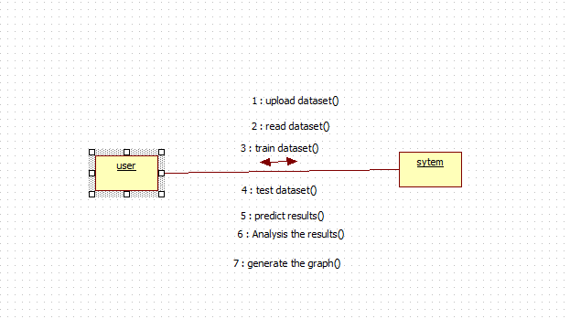

**ACTIVITY DIAGRAM:**

Activity diagrams are graphical representations of workflows of stepwise activities and actions with support for choice, iteration and concurrency. In the Unified Modeling Language, activity diagrams can be used to describe the business and operational step-by-step workflows of components in a system. An activity diagram shows the overall flow of control.



**DEPLOYMENT DIAGRAM:**

Deployment diagram represents the deployment view of a system. It is related to the component diagram. Because the components are deployed using the deployment diagrams. A deployment diagram consists of nodes. Nodes are nothing but physical hardware’s used to deploy the application.

.

