let temperature = 30;

if (temperature > 25) {

console.log("It's hot outside!");

} else {

console.log("It's not too hot today.");

let temperature = 20;

if (temperature > 30) {

console.log("It's very hot outside!");

} else if (temperature > 20) {

console.log("It's warm outside.");

} else if (temperature > 10) {

console.log("It's a bit chilly outside.");

} else {

console.log("It's cold outside.");

}

//condition ? expressionIfTrue : expressionIfFalse

let age = 18;

let canVote = (age >= 18) ? "Yes, you can vote." : "No, you cannot vote yet.";

console.log(canVote);

let score = 75;

let grade = (score >= 90) ? "A" :

(score >= 80) ? "B" :

(score >= 70) ? "C" :

(score >= 60) ? "D" : "F";

console.log(`Your grade is: ${grade}`);

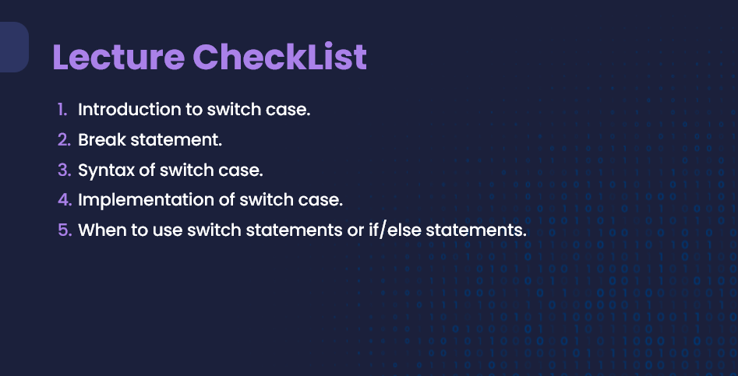

let day = 3;

let dayName;

switch (day) {

case 1:

dayName = "Sunday";

break;

case 2:

dayName = "Monday";

break;

case 3:

dayName = "Tuesday";

break;

case 4:

dayName = "Wednesday";

break;

case 5:

dayName = "Thursday";

break;

case 6:

dayName = "Friday";

break;

case 7:

dayName = "Saturday";

break;

default:

dayName = "Invalid day";

}

console.log(`Today is: ${dayName}`);

