Project Phase 0: Proposal

Willian Pereira Munhoz

School of Technology, Bow Valley College

SODV3203 – Mobile Application Development

Pedro Henrique Ferreira

February 16, 2024

Project Phase 0: Proposal

This document comprises the wireframes and features that I have idealized for this term’s final project. This is a simple currency-exchange calculation app that uses the ExchangeRate-API web service to fetch its data. The app is called “Will’s World Currency Exchange” hereon referred to as WWCE.

**Features**

* Users can log-in.
* Users can create new accounts.
* Users can change their profile picture.
* Users can recover their passwords.
* Users can ask the app to remember them, skipping the login activity.
* Users can select their currency.
* Users can see the exchange rate from their currency to other currencies.
* Users can add new currencies to be displayed on the exchange list.
* Users can set custom notifications to be displayed when a currency reaches a user-defined threshold.
* Users can enter a custom amount to be converted to the other currencies on the list.
* Users can save the current display to a PDF file.
* Users can remove a currency from the list by dragging it to the left or right.
* Users can save presets to quickly switch between different currency lists.
* Users can see general app information, such as ‘About’, ‘Legal’, and ‘Privacy Policy’.

**This list is not final and can be expanded.**

**Wireframes**

The wireframes below (Figure 1, Figure 2) are available as a Figma design file and can be accessed using the following link: <https://www.figma.com/file/kYIVu30KDPy9kj5lsFyDQk/MobileApp_TermProject?type=design&node-id=0%3A1&mode=design&t=CYhpzRZOwP69ijzH-1>.

**Figure 1**

*Wireframes: Login, Welcome, and Create Account*

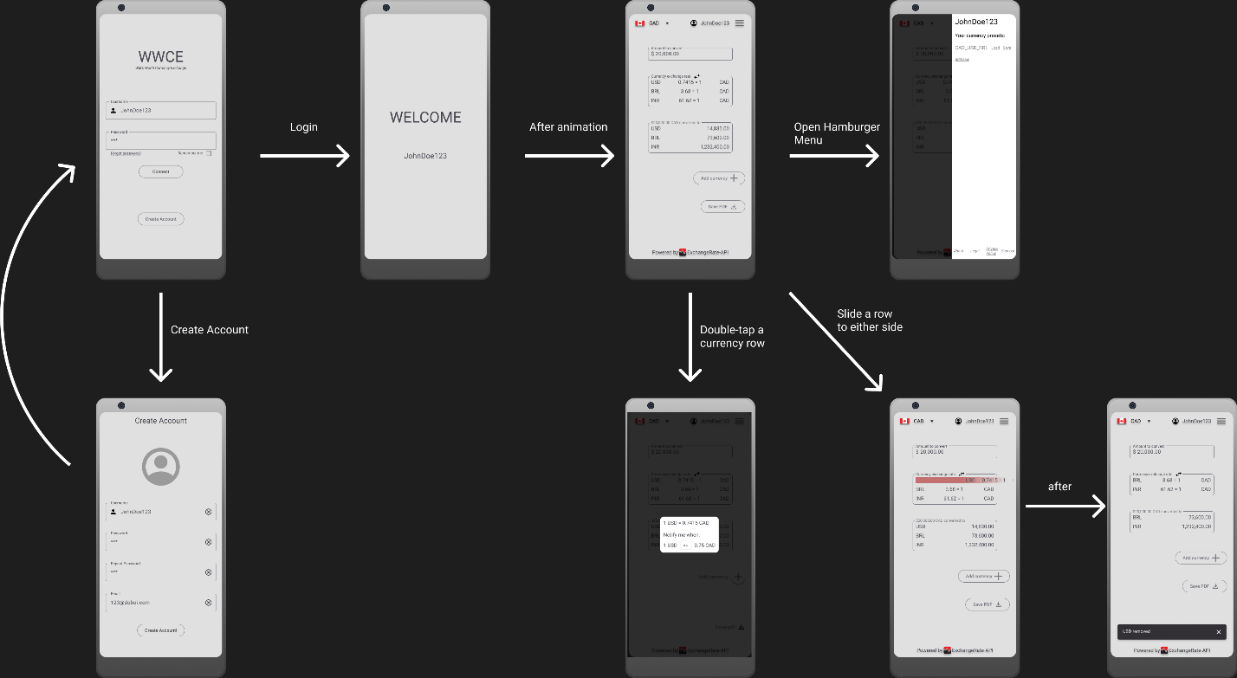

**Figure 2**

*Wireframes: Landing activity, Hamburguer Menu, Notification preferences, and Remove row.*

