

American International University-Bangladesh (AIUB)  
**Department of Computer Science  
Faculty of Science &Technology (FST)  
Summer 18-19**

**Doctor-Patient-Donor Portal**

A software Engineering project submitted

By

*Md Shamil Hossain (18-36176-1)*

*B.M. Nakib Borshon (17-34839-2)*

*Mehedi Hassan Hemal (18-36686-1)*

*Sanjida Islam Shohely (17-34386-1)*

The project will be Evaluated for the following Course Outcomes

|  |  |
| --- | --- |
| CO3: Choose appropriate software engineering model in a software development environment | Total Marks |
|  |
| Content Knowledge [5Marks] |  |
| Argumentation [5Marks] |  |
| Evidence of Argumentation [5Marks] |  |
| Completeness, Spelling, grammar and Organization of the Answer [5Marks] |  |
|  | |
| CO4: Explain the roles and their responsibilities in the software project management activities | Total Marks |
|  |
| Project Background Analysis [5Marks] |  |
| Project Role identification [5Marks] |  |
| Responsibility Description [5Marks] |  |
| Completeness, Spelling, grammar and Organization of the Answer [5Marks] |  |

Problem Domain

# Background to the problem

The population of Bangladesh is around 168 million today, and it is only increasing. There is not

enough qualified doctors to treat the whole population in case of outbreaks of diseases, or even in general. An economic survey of 2018 shows that there will be only one doctor available for every 2039 patients. There is a large number of patients showing up to the chambers of different doctors each day. These patients will suffer very long delays by having to wait in long queue to even get a serial number, let alone find consultation with the doctor. This can be very time consuming and also be very inefficient as a process. Any patient who fail to be on the given time due to emergency situations, will miss their appointment completely. This results in them losing their money and their time, and they'll have to go through the painful process of having to wait once again till they get a new serial number. These individuals will also have to carry all their necessary documents every time they pay a visit to their doctor, old prescription, test reports etc. On the contrary, there is a problem of brokers in almost every hospital. In many cases, individuals who want to either donate an organ, or waiting for a donation fall victim to the fraudulence. It gets very difficult to find brokers who actually are honest about providing the organ from the donor to the one or the family of one who is waiting for that organ. So in any case, the current system is very inefficient and cumbersome. And as for the root causes, unorganized, unfriendly management and dishonesty of peoples are to blame. For a densely populated country like ours where number of doctors is very inadequate, mentioned problem is very important to consider and come up with a better and efficient solution.

# Solution to the problem

## Current Solution

Taking Bangladesh into perspective, there are few solutions that efficiently tackle the problem stated regarding doctor appointments and organ donation/transplantation. The current solution that actually prevails in recent times includes direct phone calls, emails and usage of different social media websites. Lets say that for one instance, a patient wants to book an appointment for his/her respective doctor. This would need them to make a direct call to that particular doctor, or to the hospital that doctor works at to file an appointment under their name. Sometimes there are cases where patient fails to place an appointment due to certain inconveniences, due to which they fail to find the required treatment from that doctor. Emails can be an alternative for phone calls. They can be helpful, but when there is a huge queue of patients, reading emails one by one to sort out their suitable appointment dates and their preferred doctors is not at all easy or efficient. On the other hand, dealing with organ transplantation, the pain that a patient and their relatives have on their faces is boundless. This is because for organ transplantation, a patient's famiy usually uses different social media and newspapers to search for a donor. But even after distributing the required info to these mediums, it is almost always not possible to find donors on time. It takes huge time to find even just one donor, and the demand for donors can get high depending on the organ in question. In conclusion, the existing solutions are extremely time consuming and fail greatly in terms of efficiency.

## Proposed Solution

The solution being suggested to cure the problem is a management system for handling doctors and patients. In other words, a portal that helps doctors in their work, and eases the process of patients to book doctors for appointments and and view their medical process. A search engine will be provided through which users can conveniently find out desired doctors and customize their appointment facilities. The system allows doctors to manage their booking slots online. Each patient will be allowed to book an empty slot online, and these slots are reserved under their name. A patient can also cancel their booking in case of inconveniences or emergencies. The system will manage the appointment data for multiple doctor for various dates and times. Every time a user visits a doctor, their medical entry is stored in the database by a doctor's assistant. Every time a user logs in, he/she may view their entire medical history when needed, which will no longer require them to carry their old medical documents such as reports and prescriptions. Simultaneously, a doctor may view a patient's medical history every time they visit the aforementioned doctor. This will allow an automated doctor-patient handling system through an online interface. A feedback option will be also provided which will deal with reviews and complaints, and this will lead to rating of doctors and improvement for the portal. The system also consists of organ donor module. This module will allow registration for organ donation, as well as a search for a particular organ. This module is designed to help patients with organ requirements through instant searches. This portal should, if carried out successfully, be able to help people from all walks of life to get proper treatment, which is a right of every individual.

This solution is likely to solve the mentioned problems as the proposed system will help to organize and manage the slots, store patients data and minimize the need of brokers.

**Feasibility**: The solution is also feasible. Implementation of the proposed system will help us deal with the problems. Besides, the hospital having the system will draw more patients and thus the system will create more business scope.

## Short Description Of the Software

The software will contain an option for a doctor to create a slot for themselves, when they will be available to consult with his/her patients. The system registers this into the database, and it will send a confirmation respond to the particular doctor. The software will initially require patients to register, and it will be updated in the main database. They will be given a confirmation, and be asked to make a log in id and password for themselves. If done under the given conditions, their id and password will be confirmed. Now the patient will be prompted to enter their desired slot, and once entered, the database will make the following booking, and send a confirmation to the patient. If the patient would like to cancel the slot they have booked already, the database will make that booked timing available once again. However, there are conditions for this. If the time elapsed after the booking is made is less than 36 hours, then the cancellation is not possible. If it is more than or equal to 36 hours, the cancellation is made and confirmed to the patient. The patient can then search for the type of organ they seek, and once it is verified, be asked for the specific organ they want. This will try to look for an available donor in the system, and return the donor's information. If the logged in user is a donor themselves, they will go through the initial process till the entry of password and id, and then the database will prompt them to enter what kind of organ they would like to donate. This organ will be added to the list of available organs, and it will send a confirmation to the donor to end the entire process. The goal of this portal is therefore to allow ease of access to doctors - to make their available slots public, for patients - to look for their desired doctor and their desired timings, or to find available organ donors for their desired organ, and lastly for organ donors, who can make the information of them wanting to donate an organ public so that those seeking the particular organ can find the information.

### Purpose of the Software

1. Allow patient to book/ cancel slots easily

2. Allow patient to visit doctor without bothering about

carrying necessary documents

3. Allow doctor to manage slots easily

4. Allow user to look for organ donor

## Benefits of the Software

1. The software will minimize the time and hackles of booking and cancellation of slots.

2. The software will maximize the probability of finding organ and donating organ to right person.

Solution Description

# System Features

There are several user associated with our system. Different user need different functionalities.

Features for all users:

* Log in

Features provided to doctor:

* Create slots
* View medical history of patient

Feature provided to patients:

* Create account
* Search doctor
* Book slot
* Cancel Slot
* Search organ
* Contact donor
* View medical history
* Provide feedback

Feature provided to Doctor’s assistant

* Update patient’s medical history

Feature Provided to Organ Donor

* Create account
* Donate organ
* See requests
* Contact Requester
* Provide feedback

# Quality Attributes

* Log in: integrity
* Book/Cancel/Create slot: reliability/ usability/ robustness/ availability
* View/Update medical history of patient: usability
* Search organ/doctor: efficiency
* Create account: reliability/ usability/ availability
* Contact donor/requester: interoperability

As our system will be web based, the whole system must ensure availability quality of maximum so that the patients can book or cancel slot anytime and other type users also can do their work without any problem. Besides the system also need to ensure usability so the users don’t need to sweat at all to do their desired work.

# UML Diagrams

## Use Case Diagram

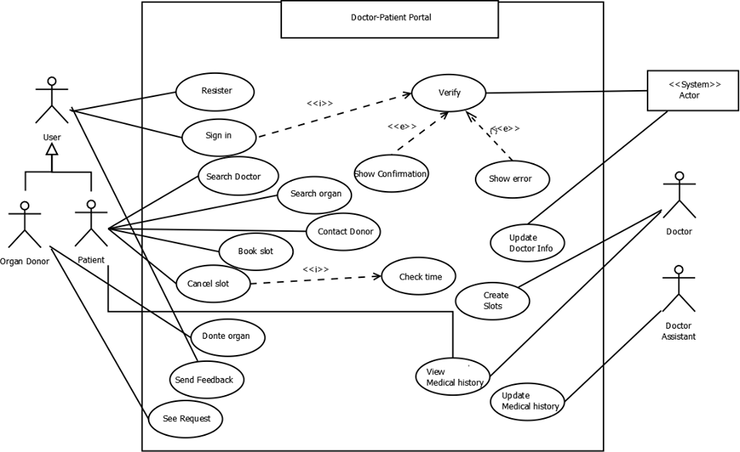

## Class Diagram

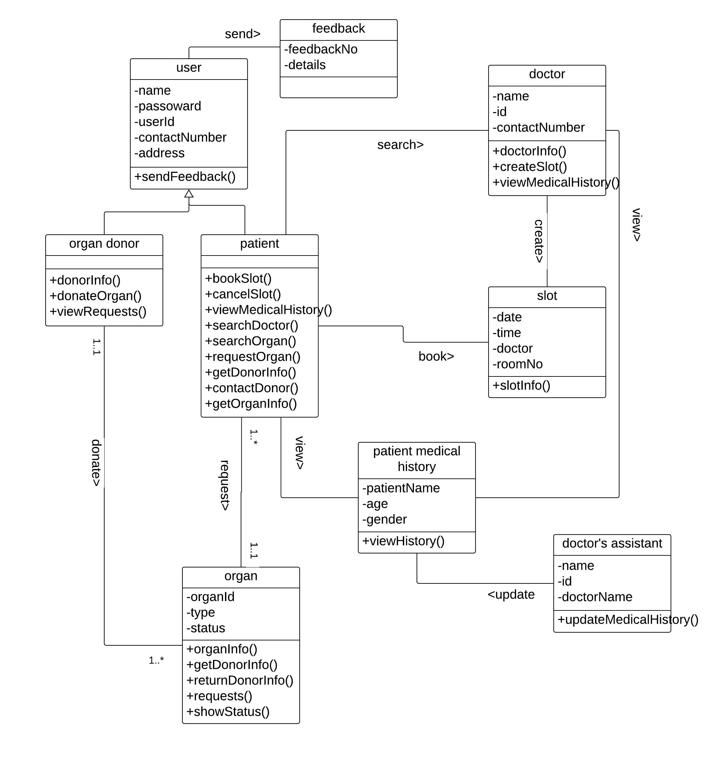

## Activity Diagram

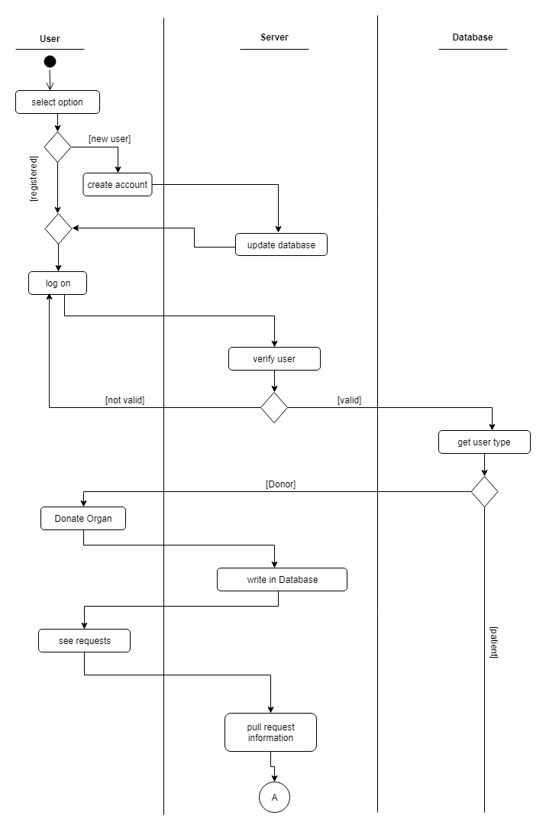

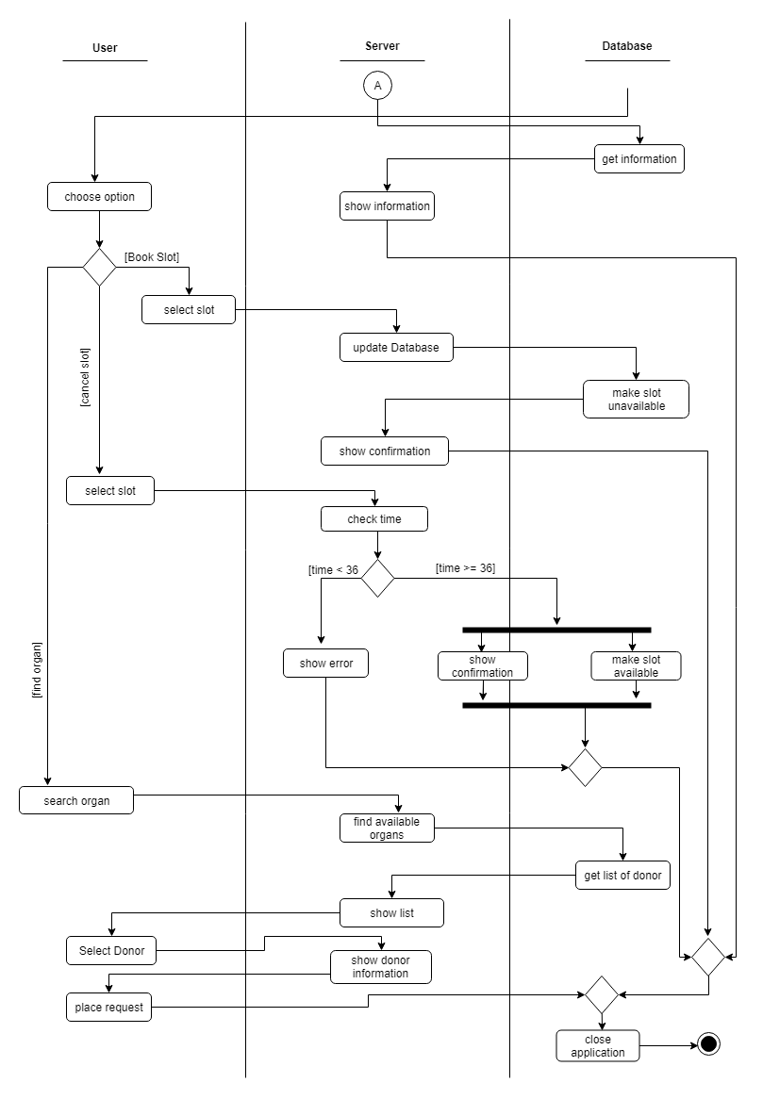

## Sequence Diagram

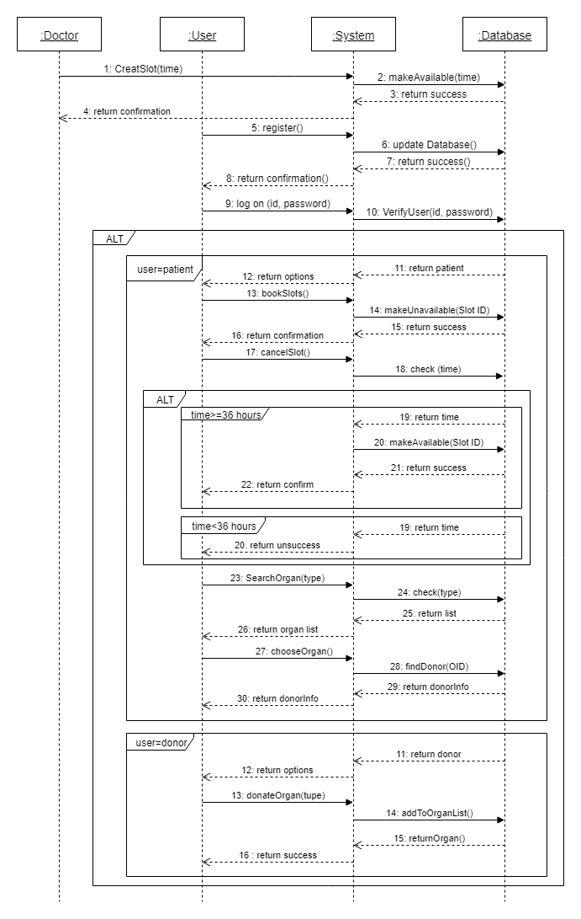

## ER Diagram

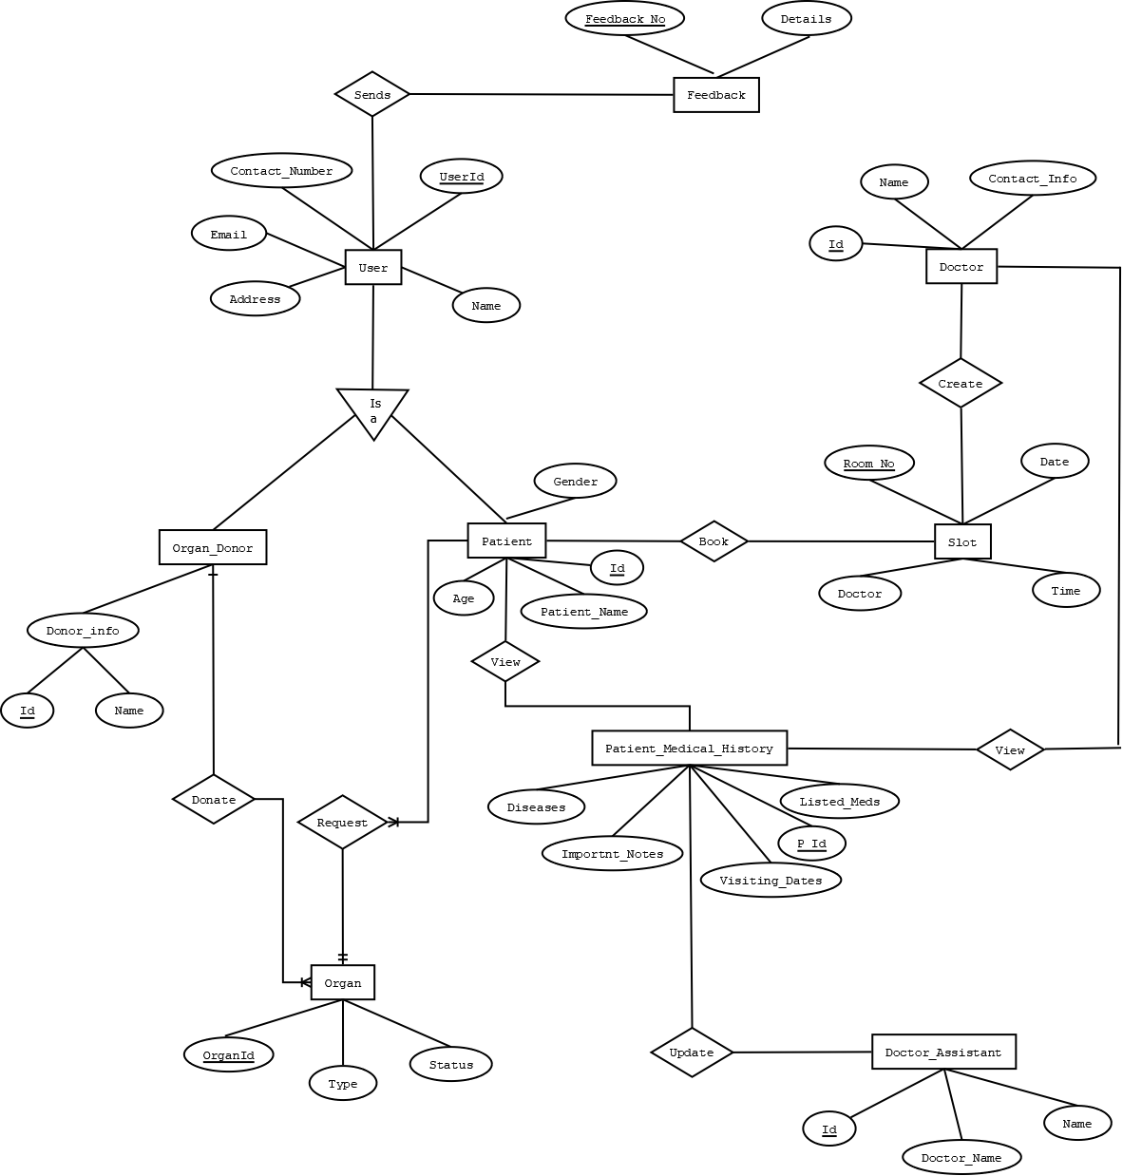

Software Development Cycle

# Process Model

## Analysis of nature and environment of the of the Software

Our software in a web-based system. It is a custom application only made for certain doctor or hospitals. The system parts have several kinds of interactions and those interactions are both serial and concurrent. The system needs to communicate with the database in order to functioning. Many user may interact with the system with same or different kind of interactions at the same time. So, it is a complex but less dynamic application based on database where many things are being done at the same time. Besides the system can be divided into several mini systems. So, we need to choose those software development process that are good for stable environment, allows incremental release of the system. We also can choose agile process that is lightweight, requires small group.

So by analyzing the nature and environment of our software and taking our group size and experience in consideration, **we can say the best suited methods to develop our software would be incremental development of plan driven process and extreme programming of agile development process.**

### Why Incremental?

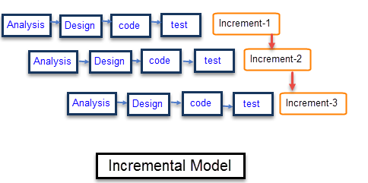

We already mentioned that our system can be divided into several mini system. Among them the slot booking module gets the most priority of the customer (hospital) as it focuses on the problem domain most and also benefits them as this will draw more patient to them. Besides, if we can deliver the slot booking module first then we will be able to establish a core base for the whole system fast and gain the customers trust. After developing this module, we can go for patient medical history module and then organ donation module. So, clearly, we need to follow development process that allows to deliver project at increments. Then if we come to customers requirements, they are well understood to us and there is low chance of change of requirements from client side. Furthermore, the environment of our selected software is stable.

So, from these analyses we can say incremental model would be one of the best choices for small and inexperienced group like us. Choosing this model our risk of failing the overall project will reduce.

### Why Extreme Programming?

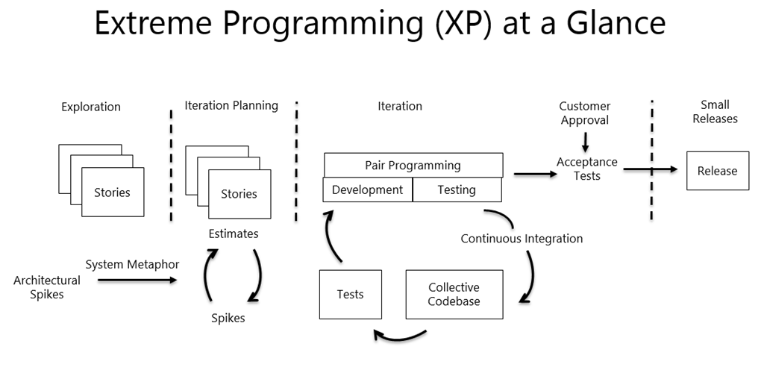

Though our group is small and inexperienced, there is option of having high experienced personnel with us who can help us in all aspects. So, that way we can also use agile method to increase our productivity, output of incremental model, and we also can gather more experience. From the agile methods XP is the best suited option for us as it requires small group, allows incremental release, prioritization, simple design. It will also maximize our development and testing speed through pair programming. Choosing XP over other agile process is best for us because other process requires more manpower, tools, high experience, frequent professional meetings which are out of our reach.

# Project roles and their responsibilities

Developing a software from scratch is a lengthy process and requires a lot of effort of multiple people. To finish a project successfully by avoiding project failure and produce a quality maintained software we need to follow a developing process that suits us most. Keeping that in mind we have already choose two process to develop our software. Now to carry out those process we need to divide all the task of the software’s development life cycle and assign them to the members of the team. Who will perform which set of tasks are determined by the role of that person in project management and development. Those roles and their responsibilities (in our chosen process) can be:

* **Customer:** Customer is the source of funding. Pleasing him is all that matters. He writes the requirements and functional tests. He also can prioritizes the requirements. He is the one who decides if a functional requirement is satisfactory or out of the goal. Here the hospital is the customer.
* **Programmer:** They are responsible for writing the source code of the project. Our core team will mainly work as programmer or developer as we lack experience.
* **Tester:** Testers test the software for errors, bugs. They also help the customer to write functional test. They are driven by quality rather than delivery time. We can use our associates to test our system as they will be less bias than us.
* **Tracker:** Tracker traces the estimates made by the team and gives feedback on how accurate they are in order to improve future estimations. He also traces the progress of each iteration and evaluates whether the goal is reachable within the given resource and time constraints or if any changes are needed in the process. In our project, he must me one of our experienced associates.
* **Coach:** He is a person who possess a sound understanding of extreme programming so that he can guide other members following XP. The coach of our development process must be a agile experienced personnel who will be helping us.
* **Consultant:** Consultant is not directly involved with the development or management. Rather, he is an external member who can provide specific technical knowledge if any directly involved member need any veterans suggestion. If anyone of us needs any consultation of a domain we may consult a highly experienced personnel of that particular domain.
* **Manager:** Manager is the big boss. He makes the big decisions of the project. Again we may take help from a highly experienced personnel as making critical decisions require high estimation and past experience.