Title Page

Large Language Model Based Multi Agent Stock Recommendation System
Research Project Proposal

Name of the Master Student: Tai, Zhang
Name of the Supervisor: Lukas, Beckenbauer
Date of Submission: 29-01-2024

Introduction
Studies have demonstrated that social media and search engine data outer perform traditional investor sentiment surveys in financial market prediction, particularly in capturing short-term market dynamics. [1] The immediacy and public nature of the discussions on these platforms, social media platforms like Twitter, general online forums like Reddit, and finance- specific forums such as StockTwits, make them an invaluable resource for capturing the mood of the market, which can be predictive of future market movements. [2]
In recent research, LLMs are able to improve understanding of context and nuances in language modeling[3], translation between languages, handle large volumes of data, provide fast and low-latency responses and can be fine-tuned [4] for various tasks and domains. Plus the scalability for real-time analysis and multimodality, LLMs is making revolutionary transformation in how data-driven decisions are made within the financial sector[5].
The use of multi-agent systems (MAS) in financial analysis leverages the strengths of LLMs to enhance the robustness and accuracy of financial strategies. [5]Such financial systems can achieve greater accuracy, efficiency, trustworthiness, and adaptability, paving the way for the next generation of autonomous and intelligent financial analysis systems.

Problem Statement
When applied to the financial sector, the volume of documentation is vast, and the need for accurate and concise summaries is crucial [6]. Additionally, financial data originates from various data source: social media and news, corporate disclosures, market research report, policy and economic Indicators[5].These factors all pose challenges for the development of MAS in financial analysis:
- Despite the effectiveness of LLMs in handling textual financial data, they often face challenges with PDF document formats that incorporate images, charts, and tables.[5]
- No specialized LLMs have been developed specifically for this task.
- The unreliability of LLMs, particularly in the form of bias, hallucination, and overfitting, presents risks in investment decision-making.[7]
- Lack of a standardized benchmark, as there is currently no universally accepted evaluation framework for assessing the system’s performance.

Motivation
However, while most existing multi-agent systems (MAS) in finance focus on simulating trading processes and are trained on static data [8]to perform predefined tasks[9]. There is a notable gap in the development of MAS that utilize dynamic, real-time information to generate reports for recommendations and analytic for specific stock.
Therefore, this project develops a LLM-based MAS utilize dynamic real-time information, which is build upon an existing base framework [10]. In this MAS, six agents (data agent, technical analyst, financial analyst, sentiment analyst, risk manager and reporter) colaborate under the supervision of supervisor node.
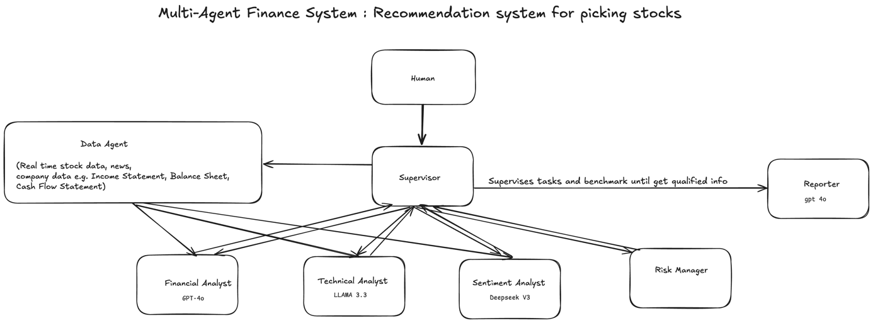
- API, such as Yahoo finance API and web scraping tools will be used by agents to collect real-time data and other data to use. To address multimodal document challenge, there’s also existing methods, for example LLMs can be fine-tuned to extract Key Performance Indicators(KPIs) from hybrid financial documents[10], and LLMs can also leverage the document’s spatial layout information to align text content with its visual structure. [12]
- To address unreliability of LLMs, there’s several mitigation strategies, including Retrieval-Augmented Generation (RAG), fine-turning, human-in-the-loop validation, and model configuration tuning.[7]
- Selection and fine-tuning of LLM architecture. Different LLMs exhibit different decision-making tendencies and biases, making it difficult to determine the model that best suits financial tasks. And after selecting an LLM, fine-tuning it for a specific stock market scenario remains a complex and resource-intensive task.
- Benchmark Development.

Objective
- Developing a MAS tailored for the above-mentioned specific use case, capable of generating a report on the selected stock. The report will include stock performance analysis and provide actionable recommendations, based on open-sourced up-to-date diverse information.
- 50 stocks from the S&P 500 index are selected to generate report over the performance over a one-month period. The effectiveness of the system will be evaluated through the comparison of the report’s predictions and recommendations with the actual stock performance after one month.
- Creation of new benchmarks tailored for this system.

References

- Mao, H., Counts, S., & Bollen, J. (2011). Predicting financial markets: Comparing survey, news, twitter and search engine data. arXiv preprint arXiv:1112.1051.
- Su, D. J., Mulvey, J. M., & Poor, H. V. (2022). Improving Portfolio Performance via Natural Language Processing Methods. Journal of Financial Data Science, 4(2).
- Yang, J., Jin, H., Tang, R., Han, X., Feng, Q., Jiang, H., ... & Hu, X. (2024). Harnessing the power of llms in practice: A survey on chatgpt and beyond. ACM Transactions on Knowledge Discovery from Data, 18(6), 1-32.
- Xia, Y., Kim, J., Chen, Y., Ye, H., Kundu, S., Hao, C. C., & Talati, N. (2024, September). Understanding the performance and estimating the cost of llm fine-tuning. In 2024 IEEE International Symposium on Workload Characterization (IISWC) (pp. 210-223). IEEE.
- Nie, Y., Kong, Y., Dong, X., Mulvey, J. M., Poor, H. V., Wen, Q., & Zohren, S. (2024). A Survey of Large Language Models for Financial Applications: Progress, Prospects and Challenges. arXiv preprint arXiv:2406.11903.
- Zmandar, N., Singh, A., El-Haj, M., & Rayson, P. (2021). Joint abstractive and extractive method for long financial document summarization. In Proceedings of the 3rd Financial Narrative Processing Workshop (pp. 99-105).
- Perković, G., Drobnjak, A., & Botički, I. (2024, May). Hallucinations in llms: Understanding and addressing challenges. In 2024 47th MIPRO ICT and Electronics Convention (MIPRO) (pp. 2084-2088). IEEE.
- H. Tong, J. Li, N. Wu, M. Gong, D. Zhang, and Q. Zhang, “Ploutos: Towards interpretable stock movement prediction with financial large language model,” arXiv preprint arXiv:2403.00782, 2024.
- Zhang, C., Liu, X., Jin, M., Zhang, Z., Li, L., Wang, Z., ... & Zhang, Y. (2024). When ai meets finance (stockagent): Large language model-based stock trading in simulated real-world environments. arXiv preprint arXiv:2407.18957.
- Beckenbauer, L.; Grosser, M.; Moreira, D. Jr.; Haverland, T. (2024). Orchestrator Multi-Agent App (Version 0.0.1).
- Yue, C., Xu, X., Ma, X., Du, L., Liu, H., Ding, Z., ... & Zhang, D. (2023). Leveraging llms for kpis retrieval from hybrid long-document: A comprehensive framework and dataset. arXiv preprint arXiv:2305.16344.
- Wang, D., Raman, N., Sibue, M., Ma, Z., Babkin, P., Kaur, S., ... & Liu, X. (2023). DocLLM: A layout-aware generative language model for multimodal document understanding. arXiv preprint arXiv:2401.00908.

