1101 Deep Learning – Homework 1

Due: 10/27, 2021, 11:55pm

For the following questions, please upload the source code to moodle and show the results in your report.

1. (30%) Please load ‘data.mat’ into your Python code, where you will find $x, y∈R^{1001}$. Now do the following procedures.
   1. Plot the data using plot function.

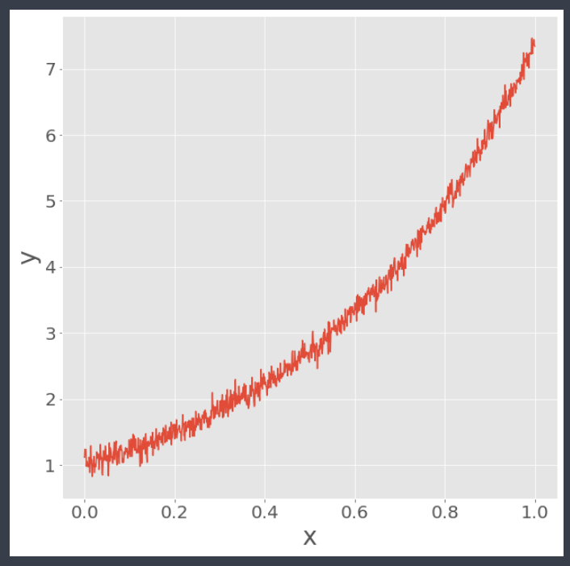

* 1. Compute the least square line $y=θ_{0}+xθ_{1}$ using the given data and overlay the line over the given data.

### **ANS.**

### **Using 線性回歸公式解:**

### **𝜃0=0.207027,𝜃1=5.98091**

### **Using Moore-Penrose Pseudoinverse:**

### **𝜃0=0.207027,𝜃1=5.98091**

1. (30%) Using the same data from Question 2, compute the least square parabola (i.e. second order polynomial $y=θ_{0}+xθ_{1}+x^{2}θ_{2}$) to fit the data. (5%) Explain which formulation (line or parabola) is more suitable for this dataset and why?

### **ANS.**

### **Using Moore-Penrose Pseudoinverse:**

### **𝜃0=1.17894,𝜃1=0.14356,𝜃2=5.83735**

### **Using Gradient Descent:**

### **𝜃0=1.17828,𝜃1=0.14726,𝜃2=5.83377**

### **ANS.**

### **parabola is much better, we can tell it by MSE score, and also by observe the following picture**

### **MSE of line: 0.20580, MSE of parabola: 0.01574**

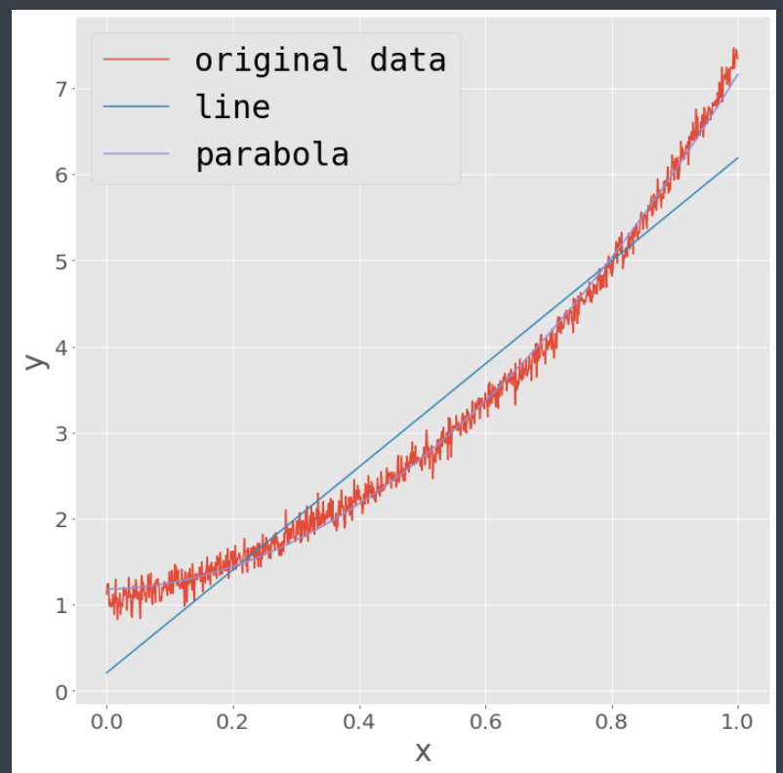

1. (40%) Using the same data from Question 2, now we use the loss function (L1 Norm) below instead of least square based methods. (paste your source code and show the results in your report).

$$Loss Function: f\left(θ\right)=\sum_{i=1}^{N}{{\left\|y_{i}-\left(θ_{0}+xθ_{1}+x^{2}θ_{2}\right)\right\|}_{1}}$$

### **ANS.**

### **𝜃0=1.1816,𝜃1=0.14985,𝜃2=5.81618**

***Codes is in the attach file.***