FTSA2022

SJ Lin

2022-10-27

Table of Contents

## R Markdown

### Brief Overview

This is an R Markdown document. Markdown is a simple formatting syntax for authoring HTML, PDF, and MS Word documents. For more details on using R Markdown see <http://rmarkdown.rstudio.com>.

When you click the **Knit** button a document will be generated that includes both content as well as the output of any embedded R code chunks within the document. You can embed an R code chunk like this:

summary(cars)

## speed dist   
## Min. : 4.0 Min. : 2.00   
## 1st Qu.:12.0 1st Qu.: 26.00   
## Median :15.0 Median : 36.00   
## Mean :15.4 Mean : 42.98   
## 3rd Qu.:19.0 3rd Qu.: 56.00   
## Max. :25.0 Max. :120.00

### Including Plots

You can also embed plots, for example:

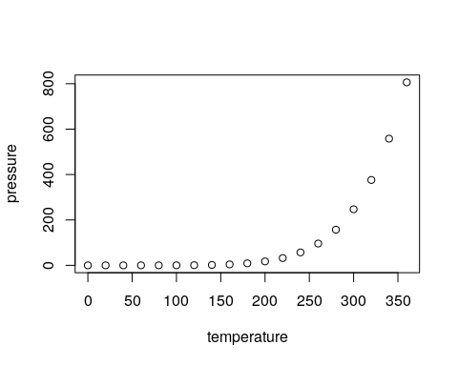

Note that the echo = FALSE parameter was added to the code chunk to prevent printing of the R code that generated the plot.

### Other Parameters

* **echo = TRUE** :「程式碼」要含在文件輸出。
* **message = TRUE** : 程式碼執行的「附帶訊息」要含在文件輸出。
* **warning = TRUE** : 程式碼執行（若有）「錯誤訊息」要含在文件輸出。
* **include = TRUE** : 執行程式碼後，「程式碼成果」要含在文件輸出； **include = TRUE** 執行程式碼後，「程式碼成果」不要含在文件輸出。

## Math, Hyperlinks & Figures

### Math

Archimedes’ constant is another name for $\pi$   
It is used in Euler's equation: $$e^{i\pi} + 1 = 0$$

Archimedes’ constant is another name for $π$ It is used in Euler’s equation:

$$e^{iπ}+1=0$$

### Hyperlinks

Click here to query the [Google](www.google.com) search engine.

Click here to query the [Google](www.google.com) search engine.

### Figure from File



政大雄鷹

### Figure from URL



### References

* [R Markdown](https://rmarkdown.rstudio.com/), which has
  + [Markdown Basics](https://rmarkdown.rstudio.com/authoring_basics.html)
  + [R Markdown: The Definitive Guide](https://bookdown.org/yihui/rmarkdown/)
  + [R Code Chunks](https://rmarkdown.rstudio.com/authoring_rcodechunks.html)
  + [Cheatsheets](https://rmarkdown.rstudio.com/lesson-15.html)
* [Markdown tutorial](https://www.markdowntutorial.com): This is a very nice tutorial (in several languages, including Chinese) that teach you essential markdown languages in 10 minutes.

### Homework

* 自己產生另一個 RMD檔案，stocks.rmd，並從 [雅虎財經](https://%20Finance.yahoo.com/) 或 [FRED](https://fred.stlouisfed.org/)下載資料來產生您的報告。
* 截至目前為止你在本課程的學習心得：
  + 你學到哪些東西？
  + 哪一部份讓你最感興趣以及為什麼？
  + 那些內容對你將來的學習跟論文寫作有何可能的幫助？
* 請嘗試結合迄今為止您在本課程中學到的盡可能多的（R 和 R Markdown）功能。
* 完成後將您的報告（RMD檔，輸出檔及其他附加檔案，如圖檔）上傳到 WM5本課程的作業區！