110753201 資科碩一 曹昱維

  - Test loss: 0.05518849566578865
Test accuracy: 0.9666666388511658
error rate:0.03333336114883423
  - 程式碼：詳見附檔

  - 2.1.
    - network structures1: 每層layer 的 neuron數量為2
      - DNN width = 2,
Validation loss:0.4495222568511963,
Validation accuracy:0.9391999840736389
      - model structures detail:
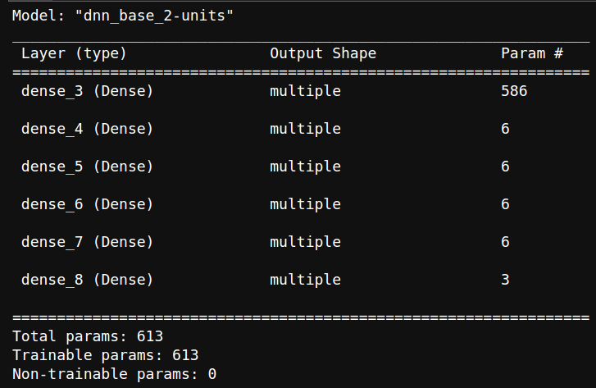
    - network structures2 : 每層layer 的 neuron數量為10
      - DNN width = 10,
Validation loss:0.06767494231462479,
Validation accuracy:0.995199978351593
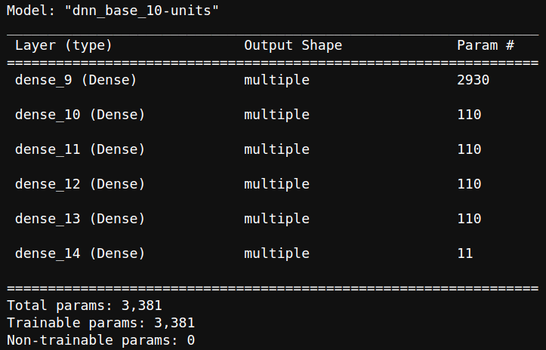
      - model structures detail:
    - network structures3 : 每層layer 的 neuron數量為20
      - DNN width = 20,
Validation loss:0.01158861257135868,
Validation accuracy:0.9959999918937683
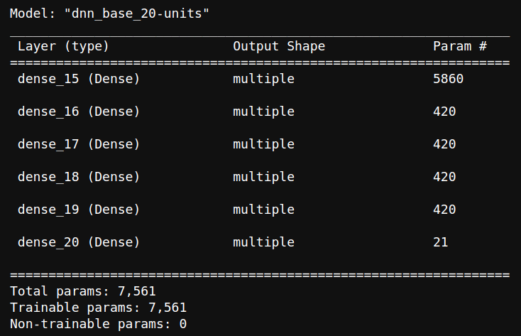
      - model structures detail:
  - 2.2.
    - 預測結果存放於附檔：q2.csv

  - 3.1.
    - Test loss: 0.08248109370470047
    - Test accuracy: 0.9750999808311462
  - 3.2.
    - Noise level 0 Test loss: 1.471121907234192, Test accuracy: 0.5943999886512756
    - Noise level 1 Test loss: 5.825091361999512, Test accuracy: 0.2605000138282776
    - Noise level 2 Test loss: 10.472006797790527, Test accuracy: 0.17919999361038208
    - 隨著噪點的比例越高的模型的準確率隨之下降，可以由此推斷，噪點越多，越難以辨識
  - 3.3
    - accuracy for regular test data:
      - Test loss: 0.06952483206987381
      - Test accuracy: 0.978600025177002
    - accuracy for with noise test data:
      - Noise level 0 Test loss: 1.7064546346664429, Test accuracy: 0.6207000017166138
      - Noise level 1 Test loss: 3.6914596557617188, Test accuracy: 0.4077000021934509
      - Noise level 2 Test loss: 5.798006534576416, Test accuracy: 0.2851000130176544

