# 🎬 IMDB Sentiment Analysis – NLP & Machine Learning Project

![Python](https://img.shields.io/badge/Python-3.9+-blue)

![NLP](https://img.shields.io/badge/NLP-Sentiment%20Analysis-orange)

![ML](https://img.shields.io/badge/Machine%20Learning-Scikit--Learn-green)

![Status](https://img.shields.io/badge/Status-Completed-success)
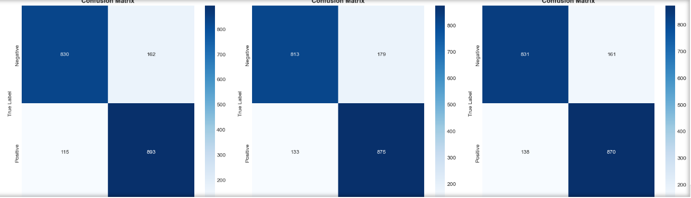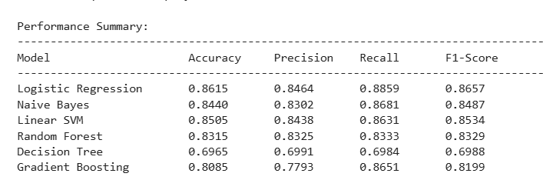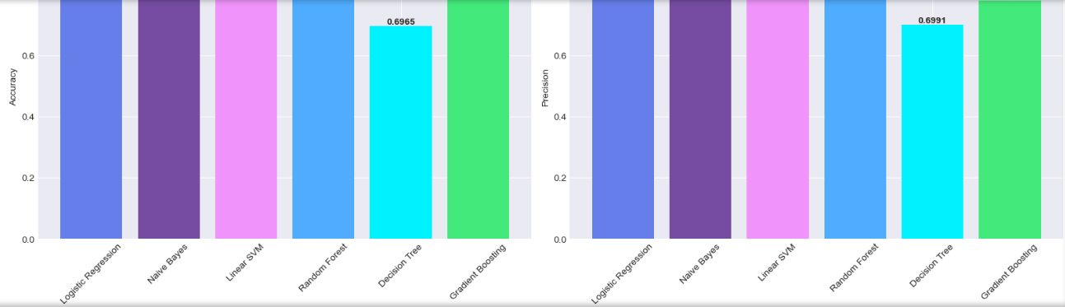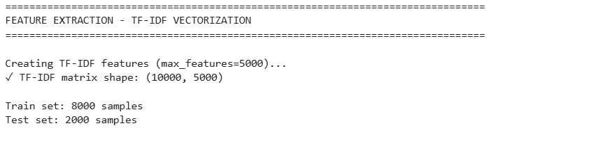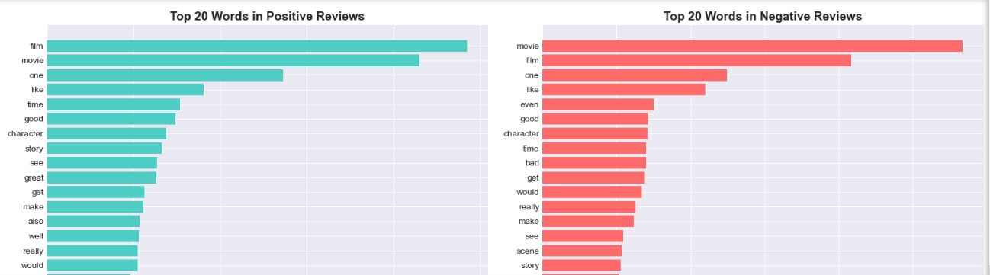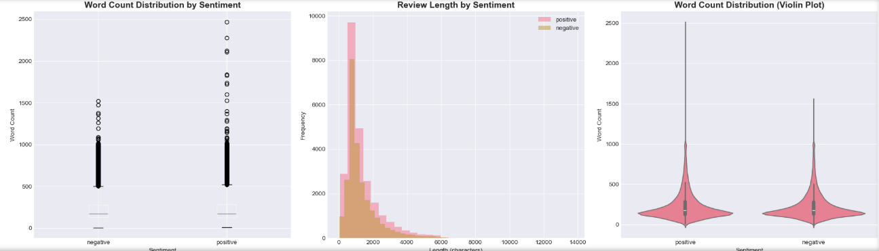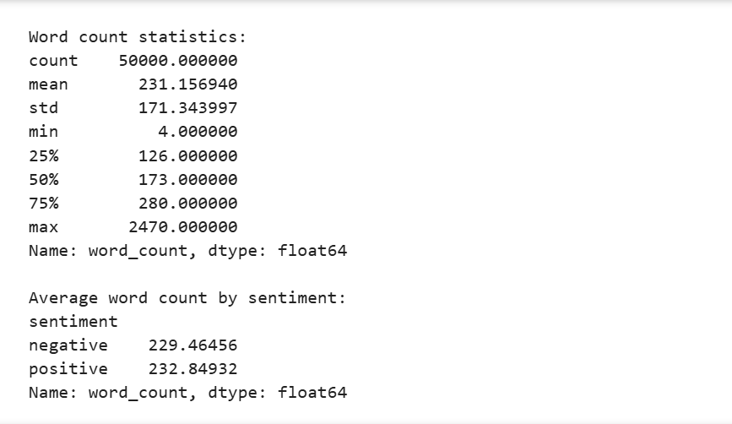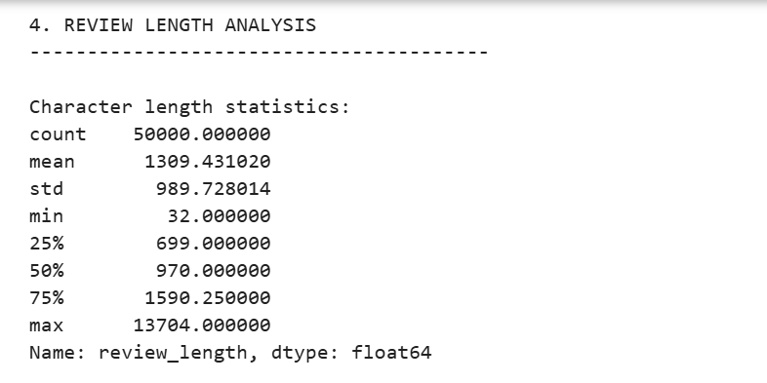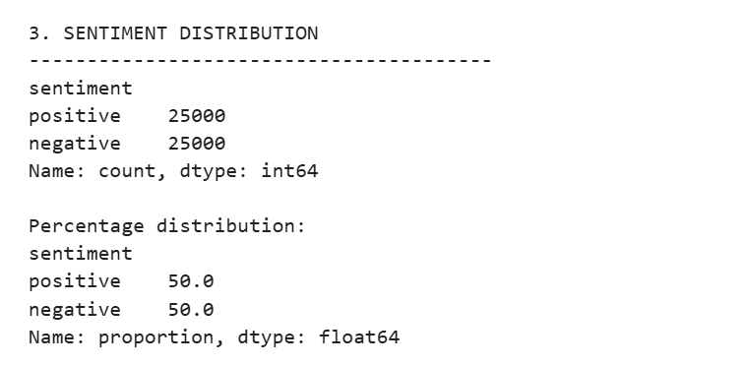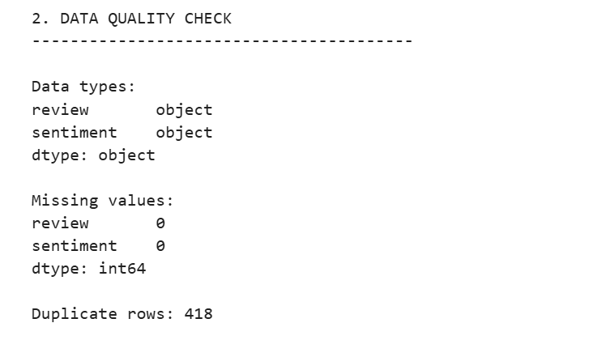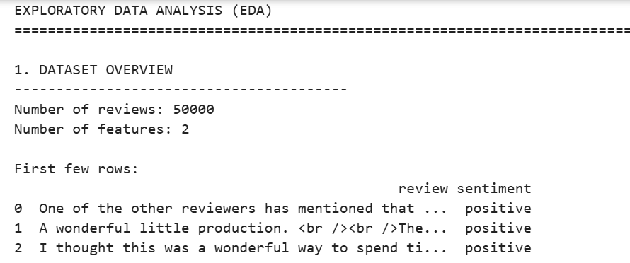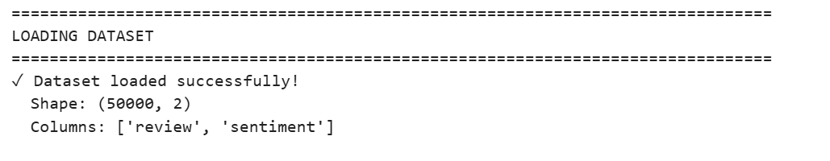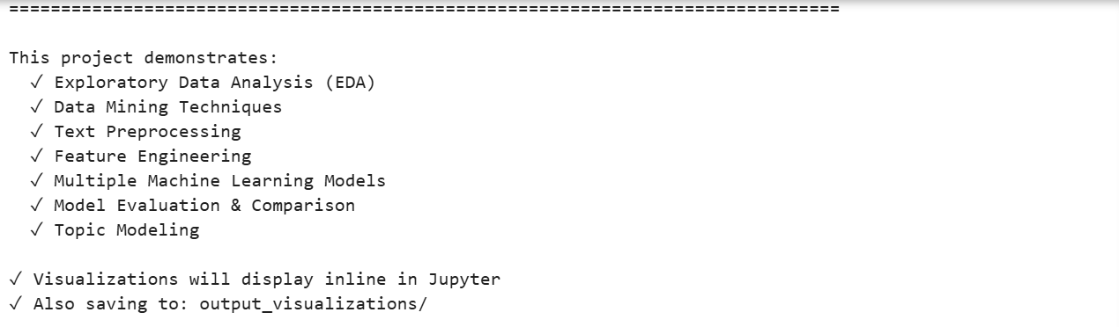

---

## 📌 Overview

This project performs **end-to-end sentiment analysis** on the **IMDB 50K Movie Reviews Dataset** using **Natural Language Processing (NLP)** and **Machine Learning**.

The goal is to classify movie reviews into **Positive** or **Negative** sentiment with high accuracy using **TF-IDF vectorization and multiple ML models**.

---

## 🚀 Key Features

* Complete Data Cleaning & Text Preprocessing

* Exploratory Data Analysis (EDA)

* TF-IDF Feature Engineering

* Multiple ML Models Training

* Model Comparison & Evaluation

* Confusion Matrix & Performance Visualization

* Topic Modeling using LDA

---

## 📊 Models Used

* Logistic Regression ⭐ (Best Performance)

* Naive Bayes

* Linear Support Vector Machine (SVM)

* Random Forest

* Gradient Boosting

* Decision Tree

---

## 📁 Project Structure

```

IMDB-Sentiment-Analysis/

│

├── notebook.ipynb

├── IMDB Dataset.csv

├── output_visualizations/

└── README.md

```

---

## 📦 Dataset

**IMDB Dataset of 50K Movie Reviews**

🔗 [https://www.kaggle.com/datasets/lakshmi25npathi/imdb-dataset-of-50k-movie-reviews](https://www.kaggle.com/datasets/lakshmi25npathi/imdb-dataset-of-50k-movie-reviews)

---

## ⚙️ How to Run

```bash

pip install numpy pandas matplotlib seaborn scikit-learn nltk wordcloud

jupyter notebook

```

Open `notebook.ipynb` and run all cells.

---

## 📈 Output

* EDA Visualizations

* Word Clouds

* Model Comparison Charts

* Confusion Matrices

All outputs are saved in **output_visualizations/** folder.

---

## 🧠 Learning Outcomes

* Natural Language Processing

* Text Vectorization (TF-IDF)

* Machine Learning Classification

* Model Evaluation

* Topic Modeling

---

## 👨‍💻 Author

**Abdul Wasay**

🔗 GitHub: [https://github.com/theabdulwasay](https://github.com/theabdulwasay)

