**ABHISHEK SHARMA**

**R171218005**

**DEVOPS B-1**

**ADVANCED LINUX LAB FILE (2.14)**

**LINUX SECURITY**

**Commands To Run: -**

**$sudo useradd user1**

**$sudo passwd user1**

**$sudo ueradd user2**

**$sudo passwd user2**

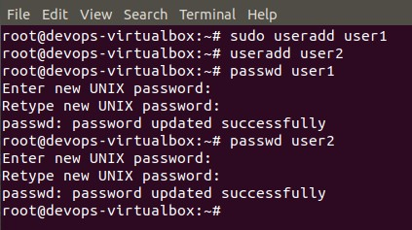

**$sudo visudo**

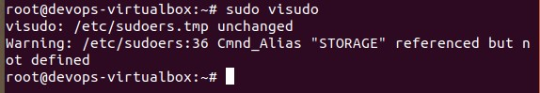

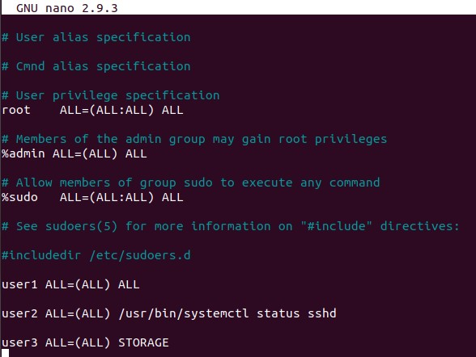

**First, log in to user1's account and verify that he has full sudo privileges by running several root-level commands:**

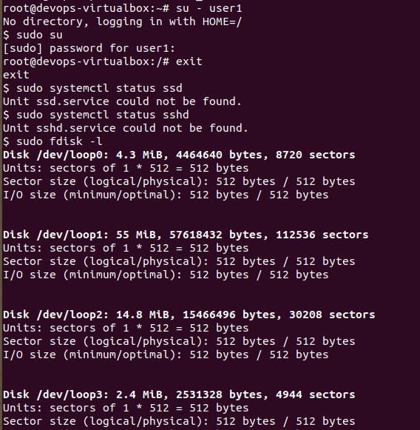

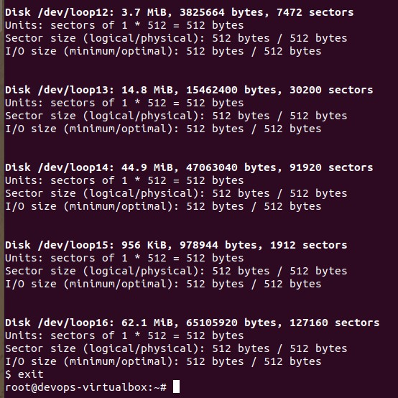

**Log in as user2 and try to run some root-level commands**

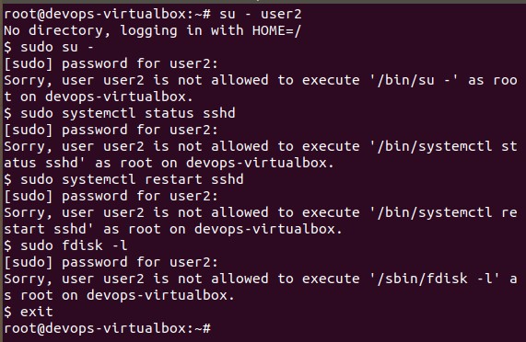

Open the **/etc/security/pwquality.conf**

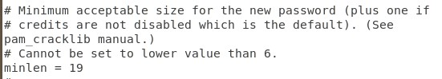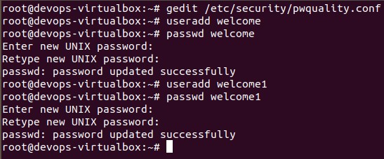

Again, open the **/etc/security/pwquality.conf**

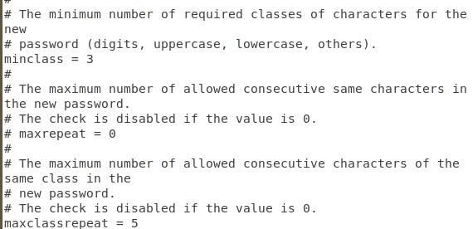

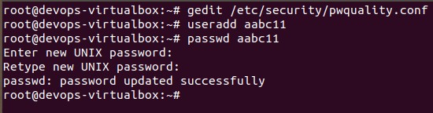

**$ chage -l user1**

