***ABHISHEK SHARMA***

***500067644***

***DEVOPS B-1***

**EXPERIMENT NO.: - 2.6**

**Configuring mail server**

Steps: -

1. Install postfix and configure it

***apt-get install postfix***

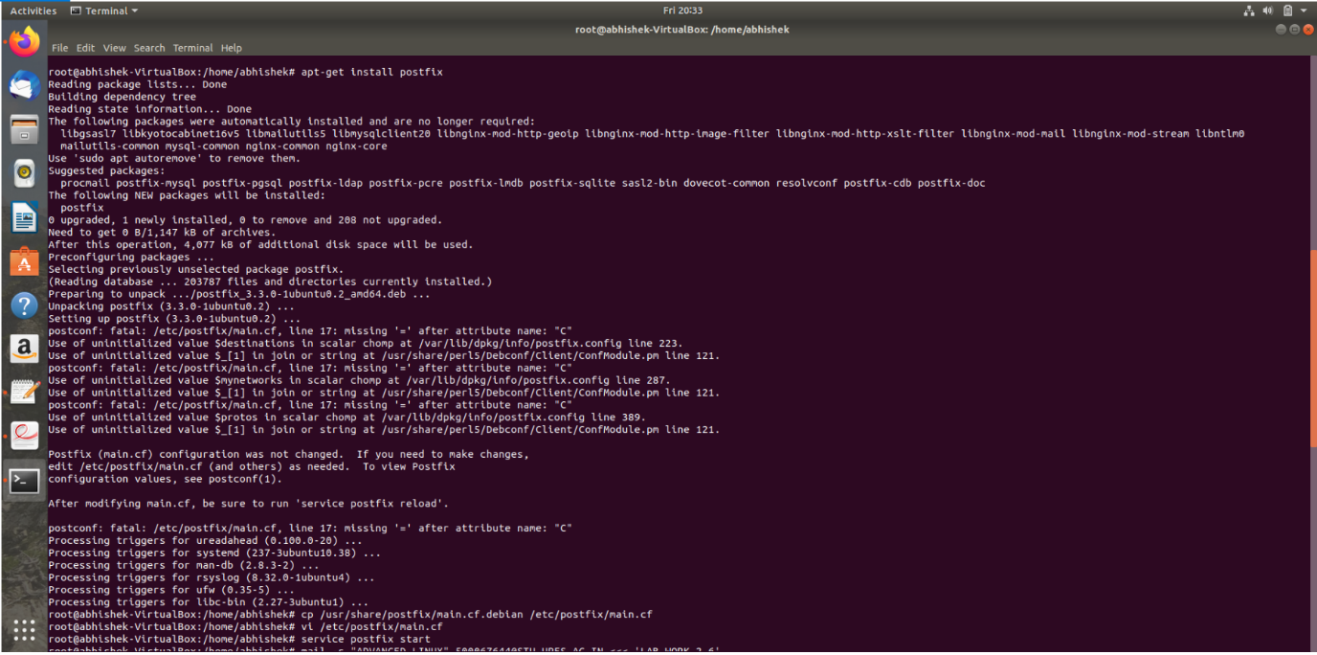

We now need to ***modify /etc/postfix/main.cf*** file

1. ***cp /usr/share/postfix/main.cf.debian /etc/postfix/main.cf***



1. ***vi /etc/postfix/main.cf*** ,



iii. do ***service postfix start*** to start the mail server 

1. Send test email : -

mail -s "Advanced_Linux 500067644@stu.upes.ac.in<<< 'LAB_WORK_2.6'

