***ABHISHEK SHARMA***

***500067644***

***DEVOPS B-1***

**EXPERIMENT NO.: - 2.7**

**Package management – yum/apt**

# In-order to install a new package following are the steps given below:-

***sudo apt-get install <package-name>***

***Eg: sudo apt-get install nginx***

This command will install nginx if it is **not present** and update it to the latest version if **it present**.

**STEP 1 (IF NOT PRESENT): -**

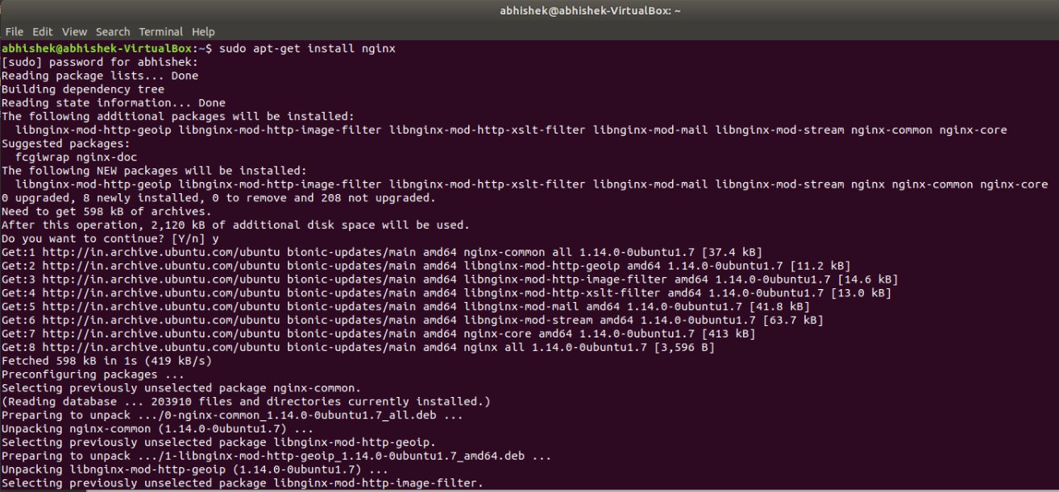

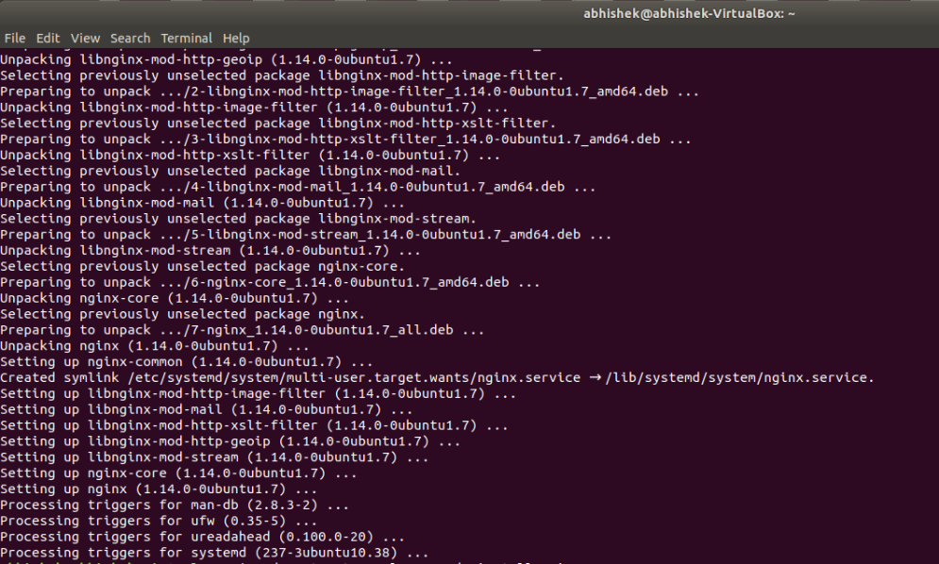

**STEP 2 (IF PRESENT): -**

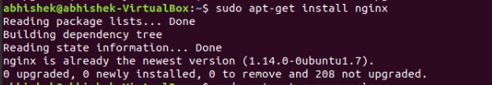

# In order to just update a package which is already installed, you should do the following: -

***sudo apt-get --only-upgrade install nginx***

This command will update the already install nginx package. But, if nginx is not present it will simply skip it.

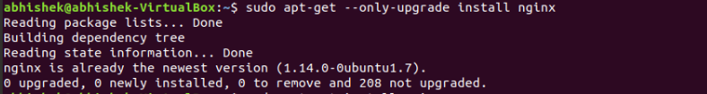

# In order to remove a package execute the following: -

***sudo apt-get remove <package-name>***

