**EXPERIMENT-10**

**Aim: Integration using GitHub Create a complete Maven project and push in GitHub repository for Continuous Integration.**

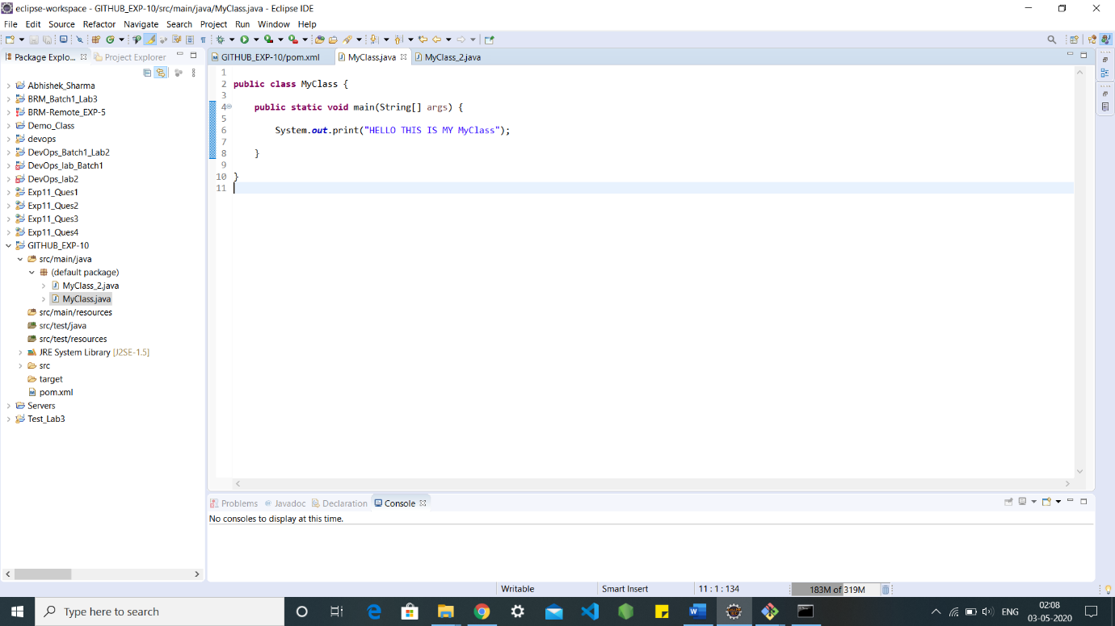

Created a repository with name BRM_PROJECT: -

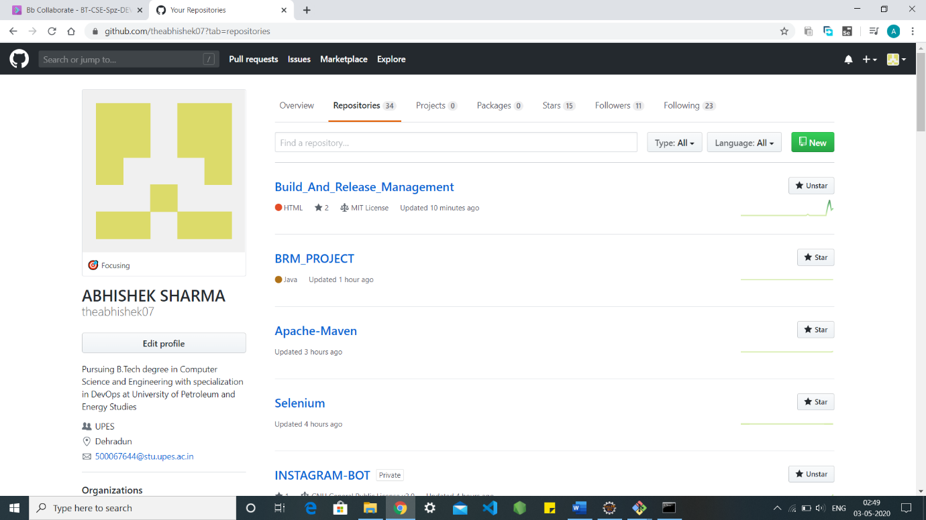

Adding and pushing files through bash: -

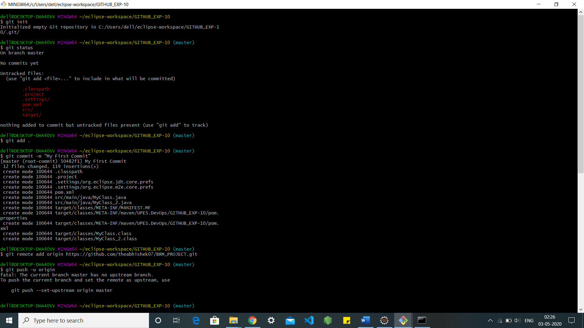

After pushing into the GitHub: -

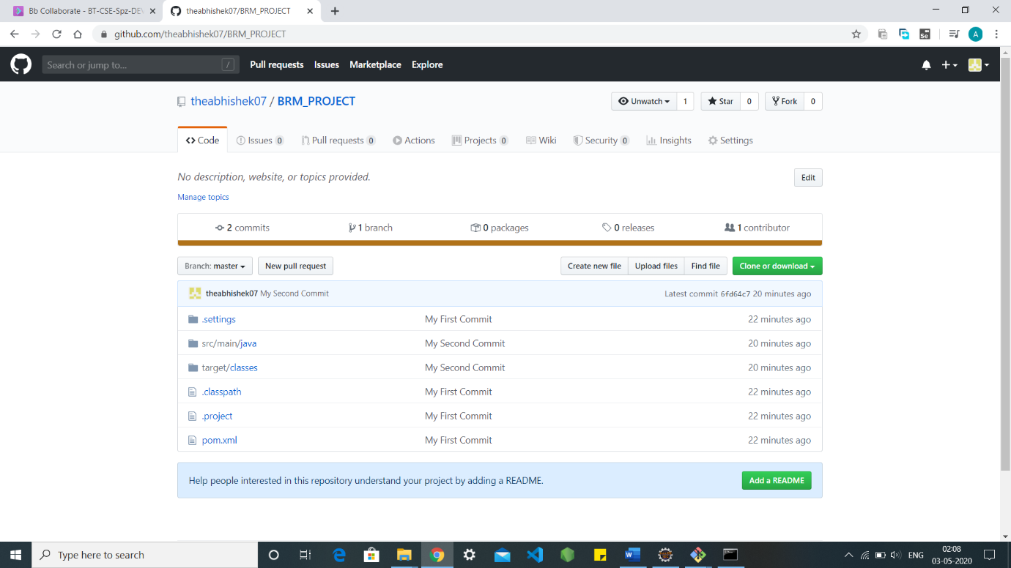

Adding class2 in the local machine: -

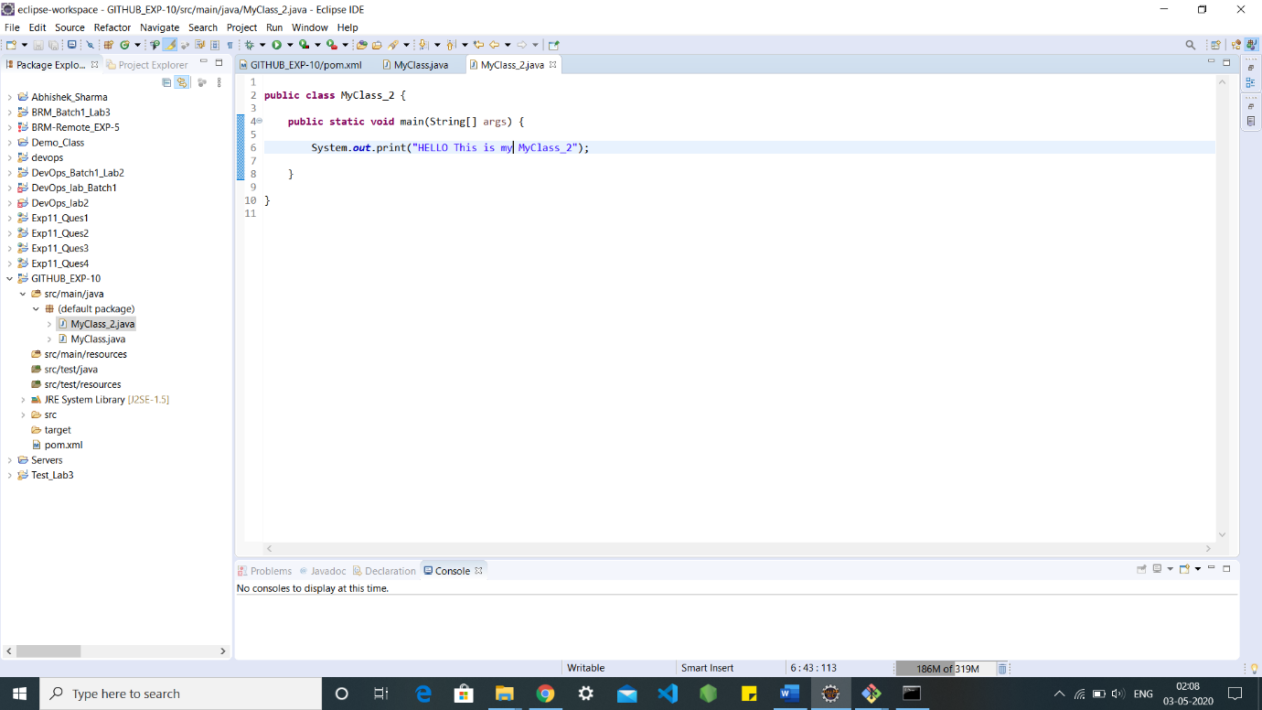

Adding and pushing MyClass_2 through bash: -

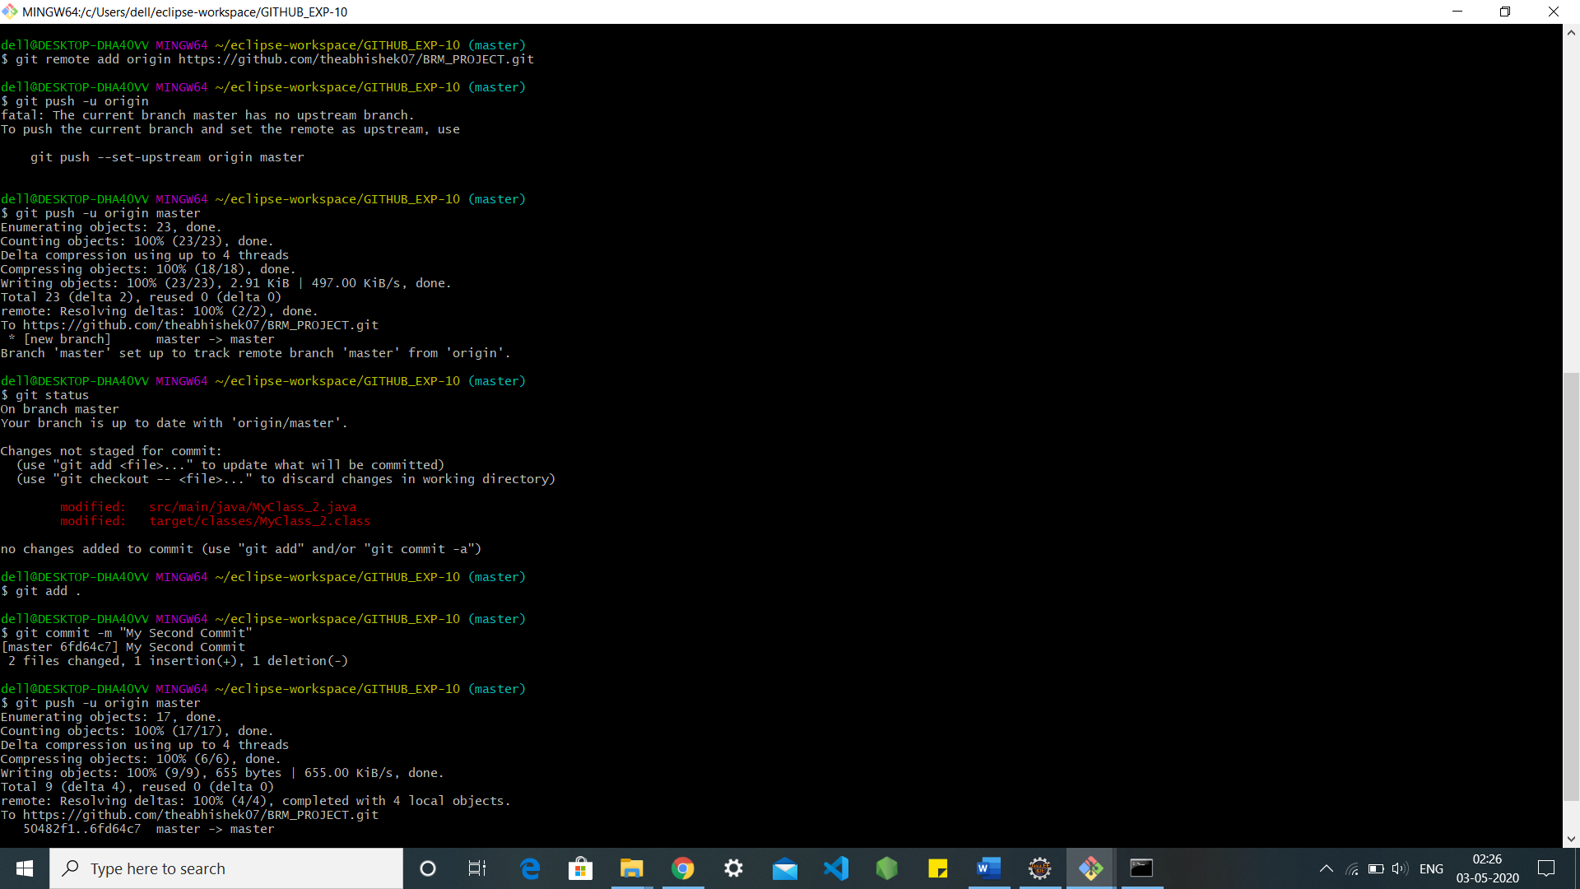

After pushing that MyClass_2 from the local into GitHub BRM_PROJECT: -



COMMITS: -

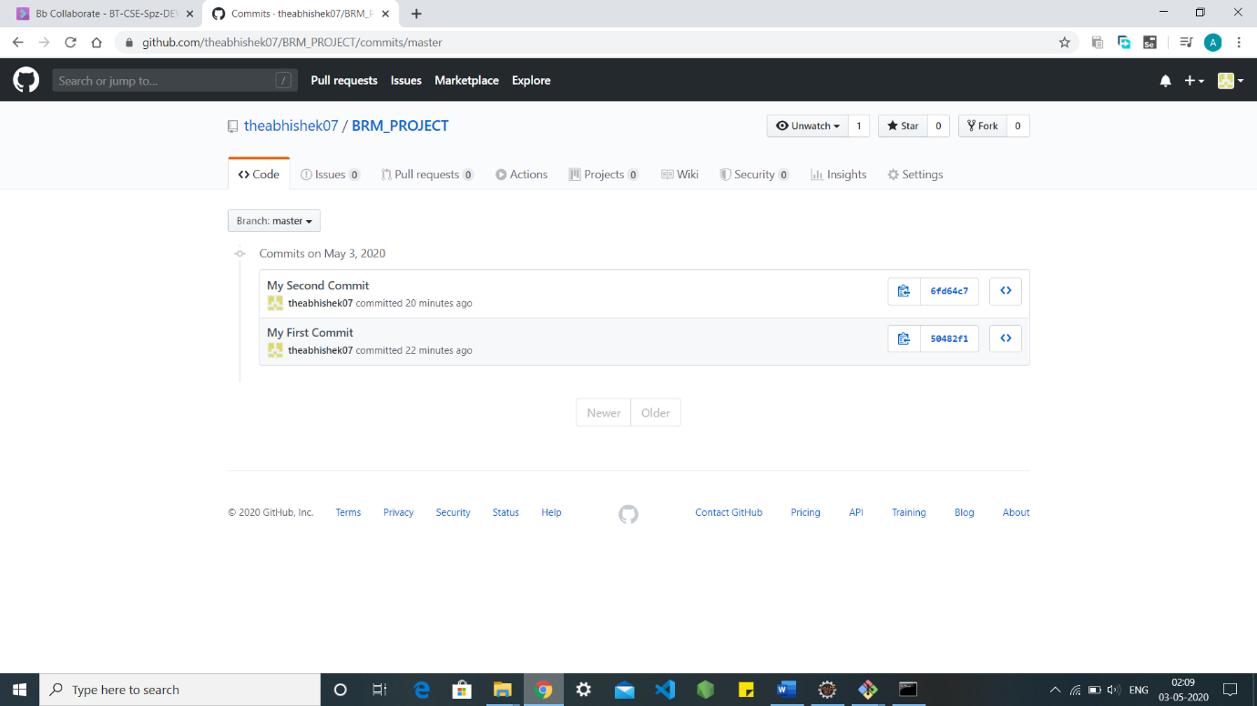

TO CHECK MY GITHUB [CLICK](https://github.com/theabhishek07?tab=repositories).