**EXPERIMENT-5**

**Aim: Working with Maven Repository**

1. **Add Central Repository (Hibernate)**

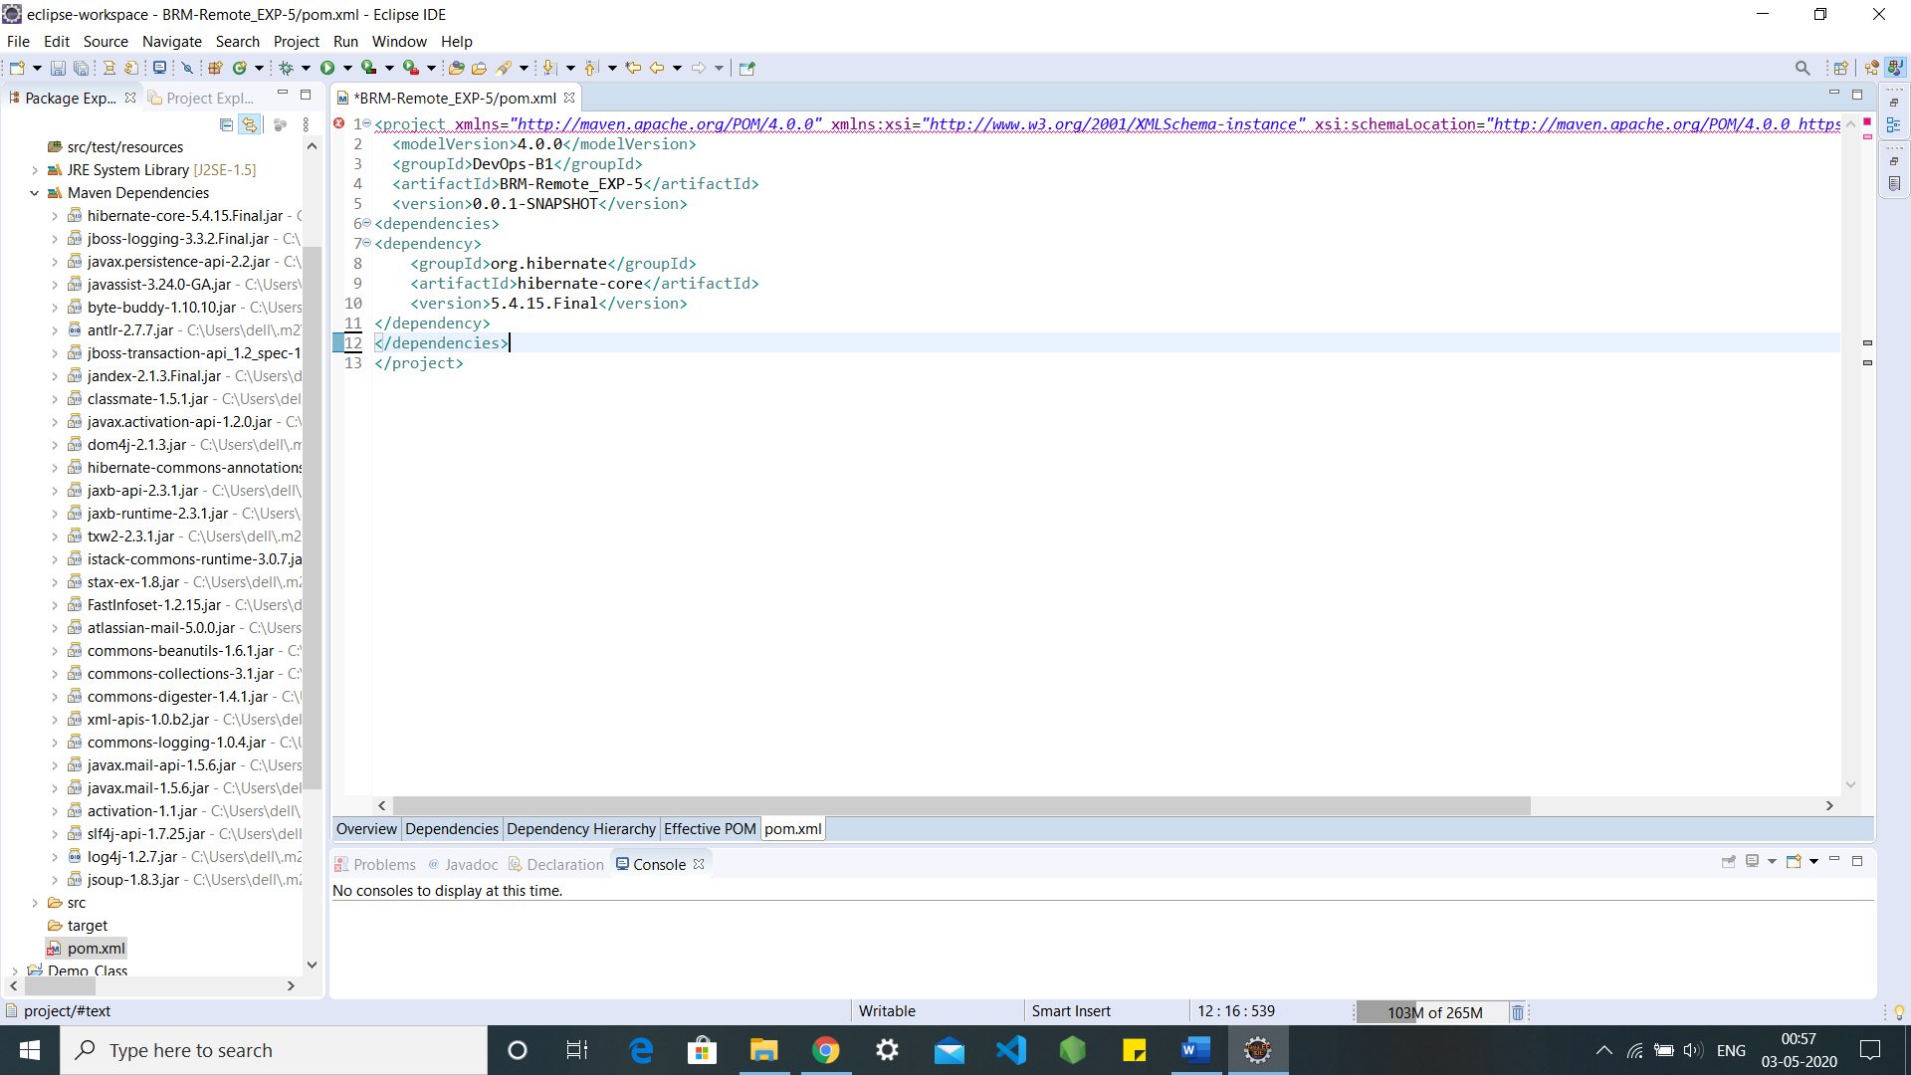

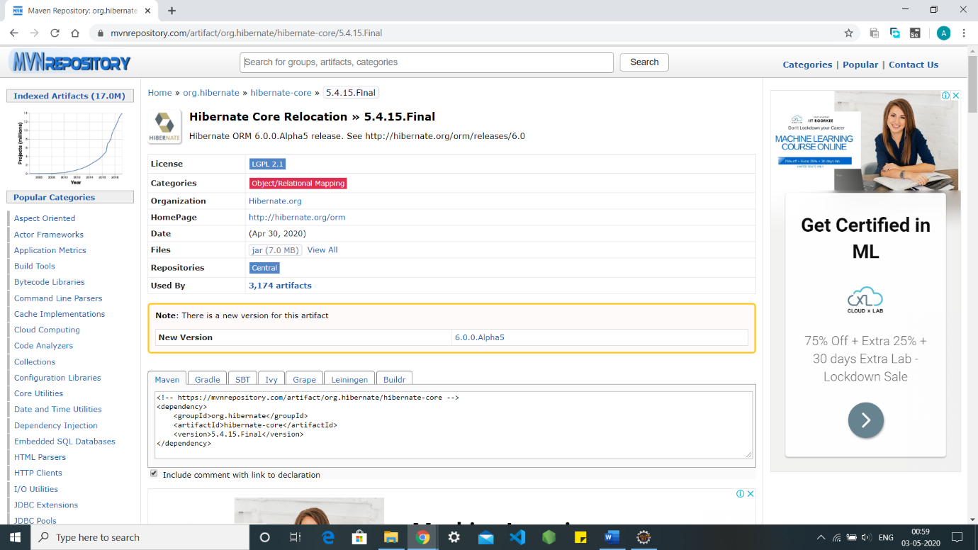

**2. Add Remote Repository (Atlassian Mail)**

