**EXPERIMENT-7**

**Aim: Selenium IDE. Perform Automation testing using Selenium IDE for testing a web page.**

By using selenium recording: -

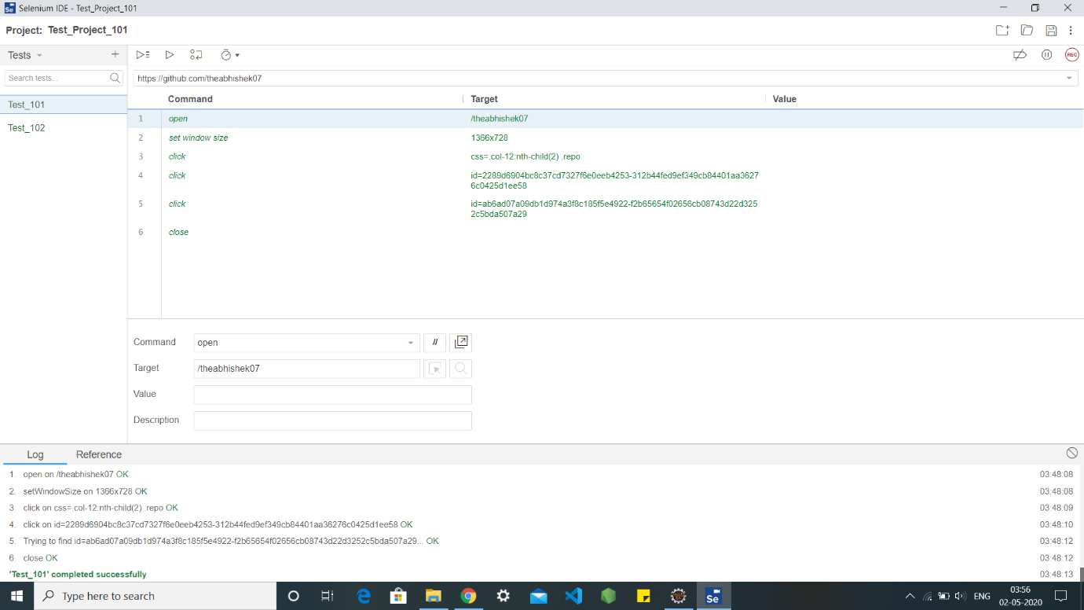

After removing “close” from the commands, the web page will remain open

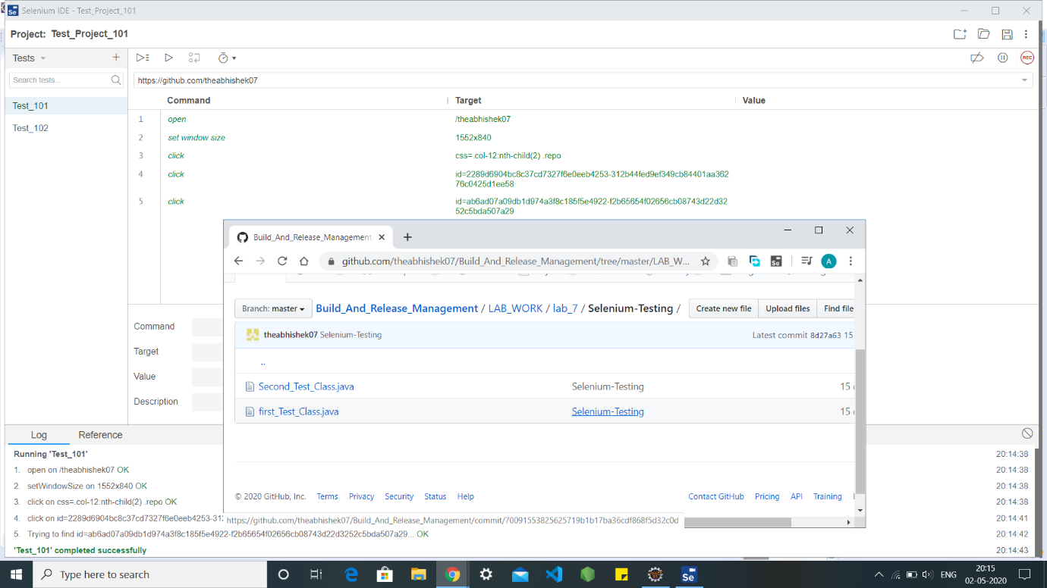

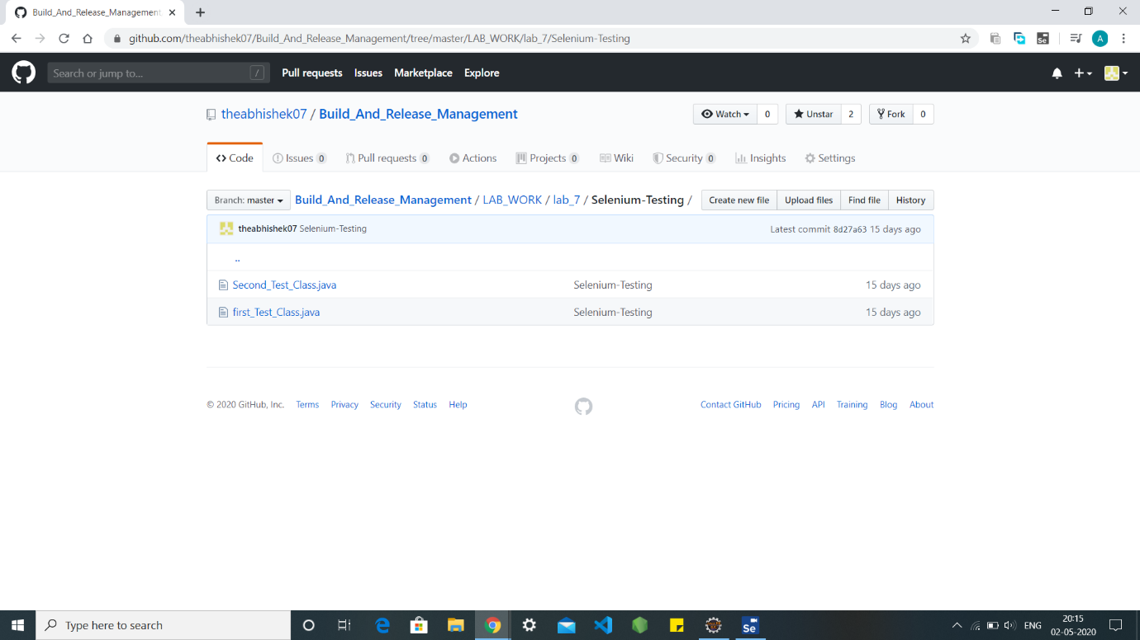

By typing the commands in another test i.e. Test102 : -

