**Experiment 12**

**ABHISHEK SHARMA R171218005 500067644**

**DOCKER**

# Install docker

First, in order to ensure the downloads are valid, add the GPG key for the official Docker repository to your system:

$ curl -fsSL https://download.docker.com/linux/ubuntu/gpg | sudo apt-key add –

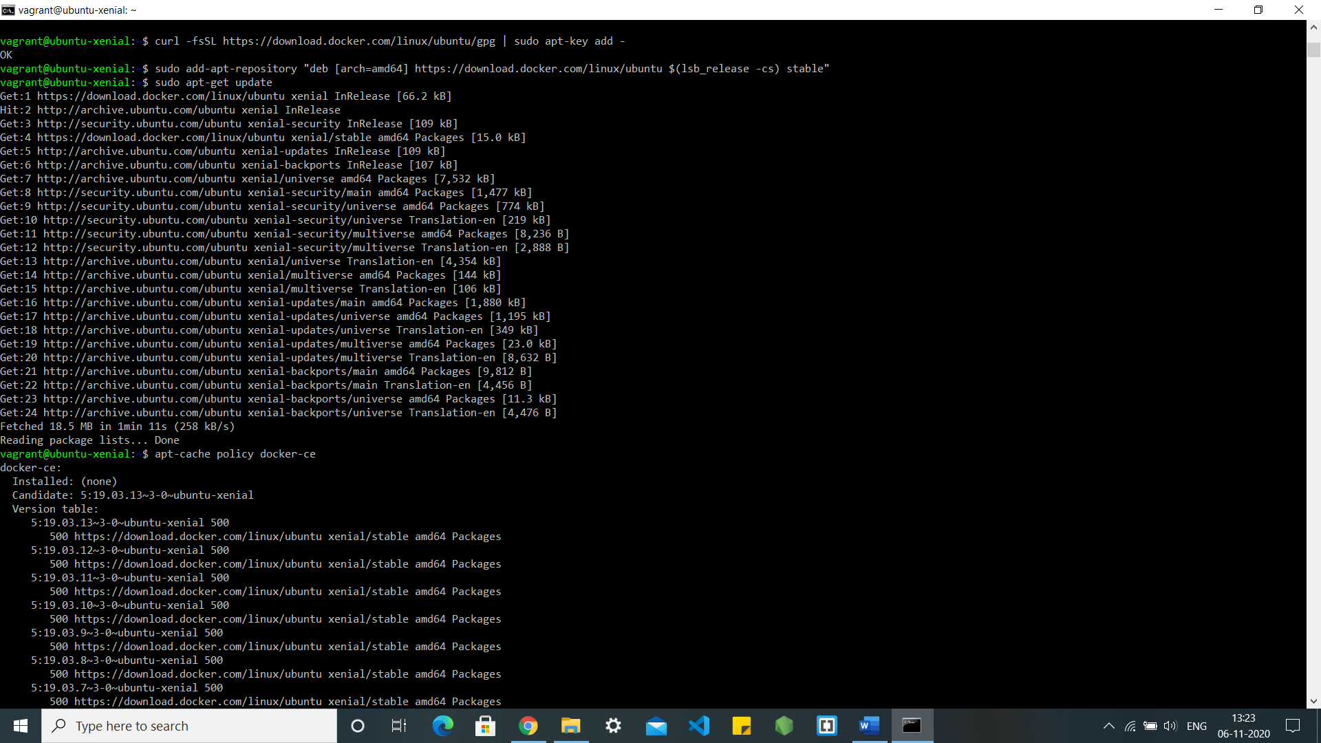

Add the Docker repository to APT sources:

$ sudo add-apt-repository "deb [arch=amd64] https://download.docker.com/linux/ubuntu $(lsb_release -cs) stable"



Next, update the package database with the Docker packages from the newly added repo:

$ sudo apt-get update



Make sure you are about to install from the Docker repo instead of the default Ubuntu 16.04 repo:

$ apt-cache policy docker-ce

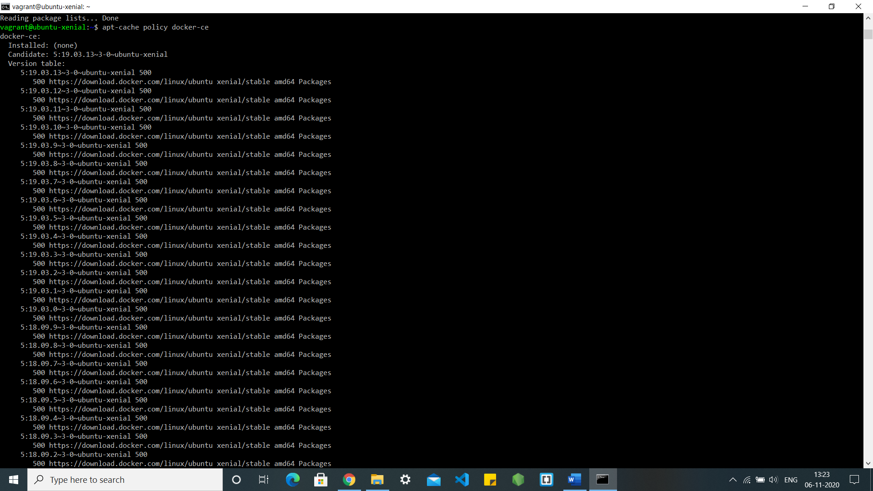

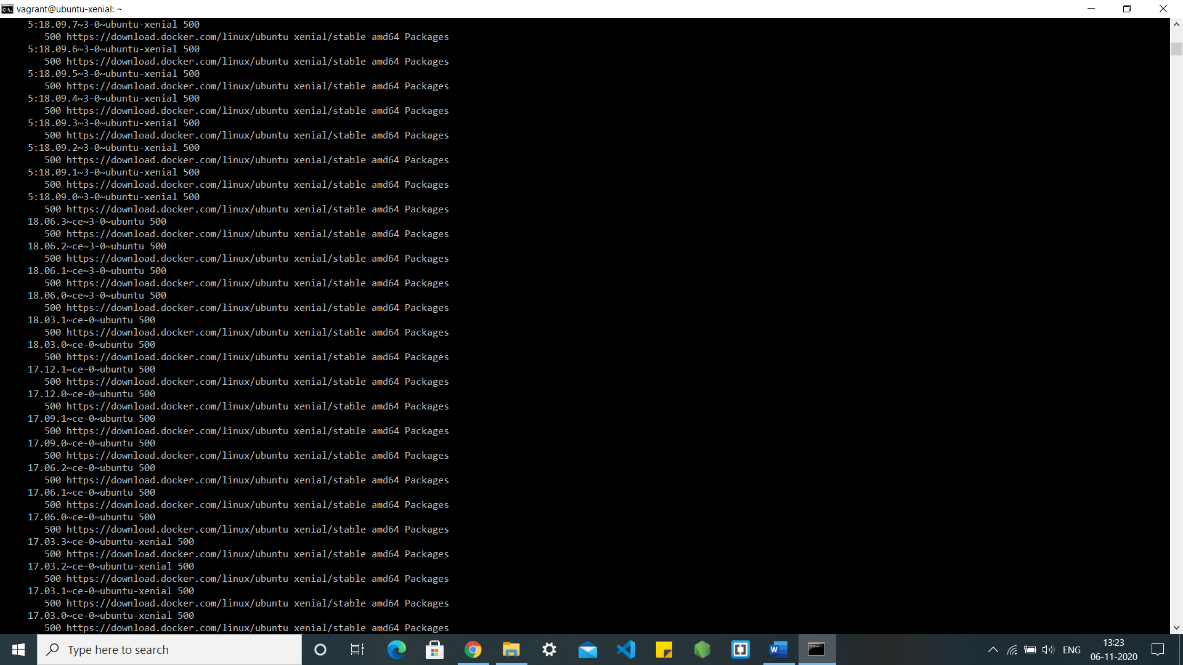

Finally, install Docker:

$ sudo apt-get install -y docker-ce

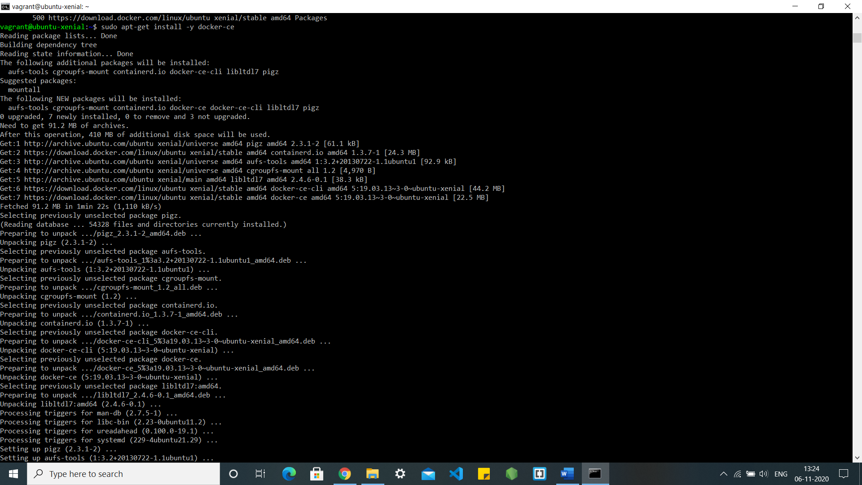

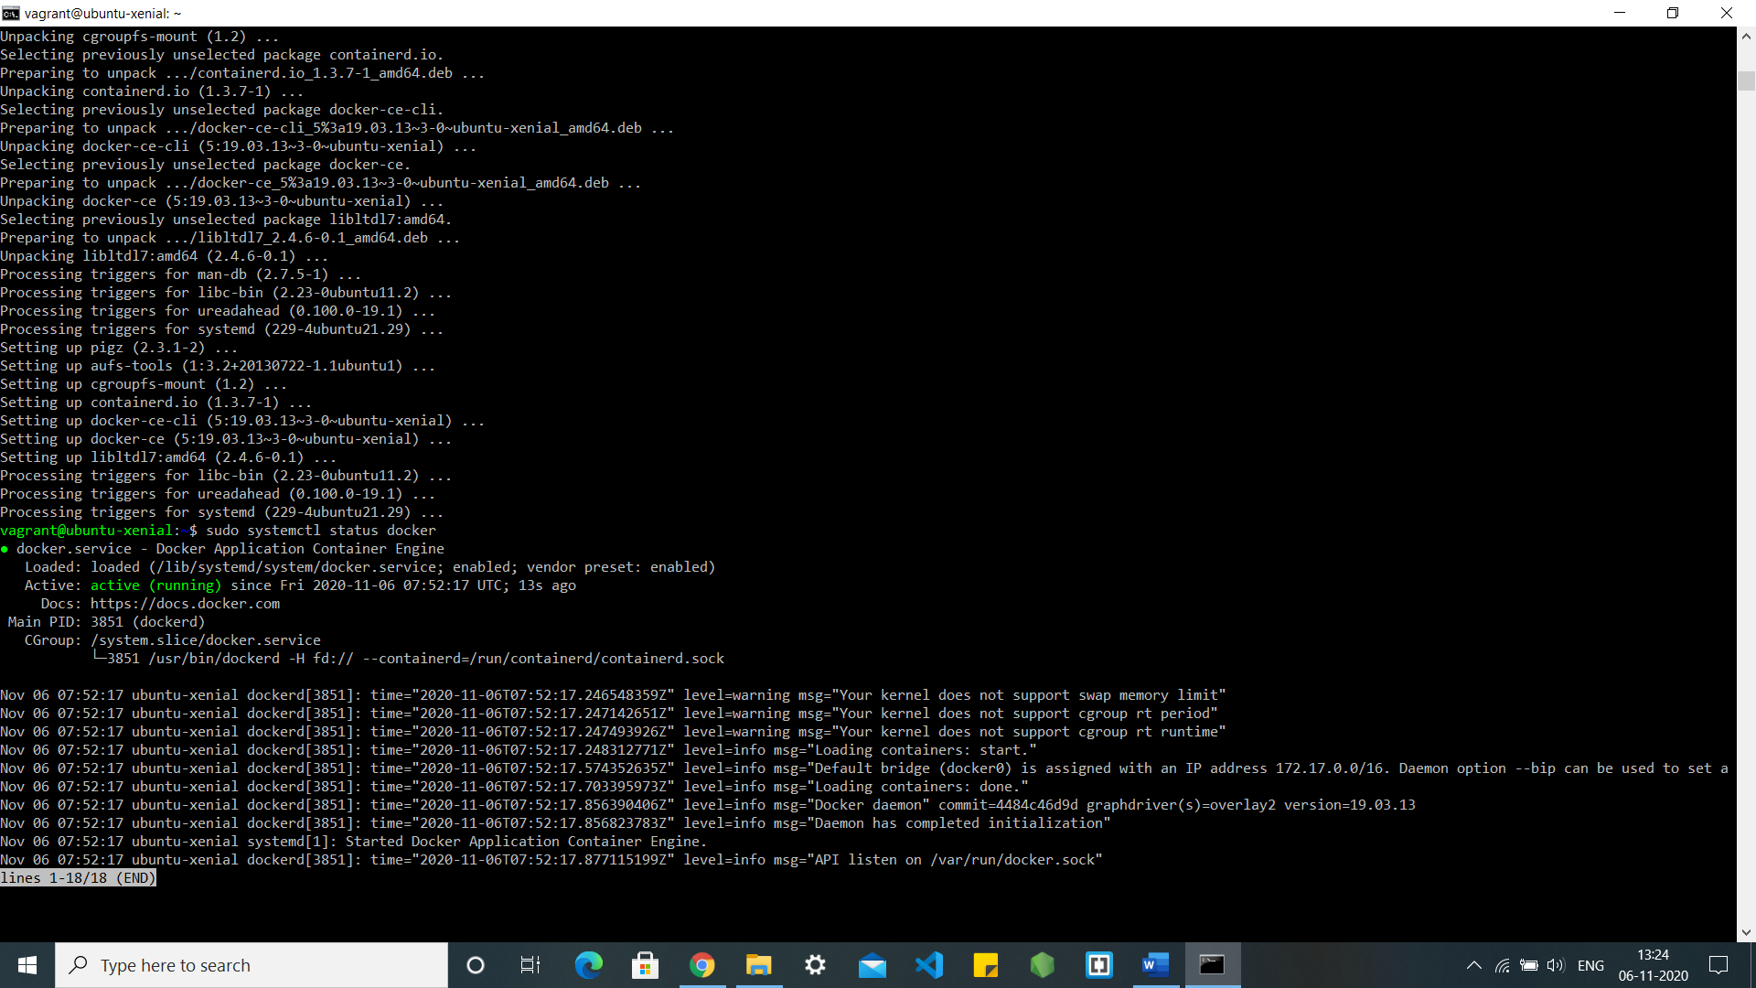

Check that it’s running:

$ sudo systemctl status docker

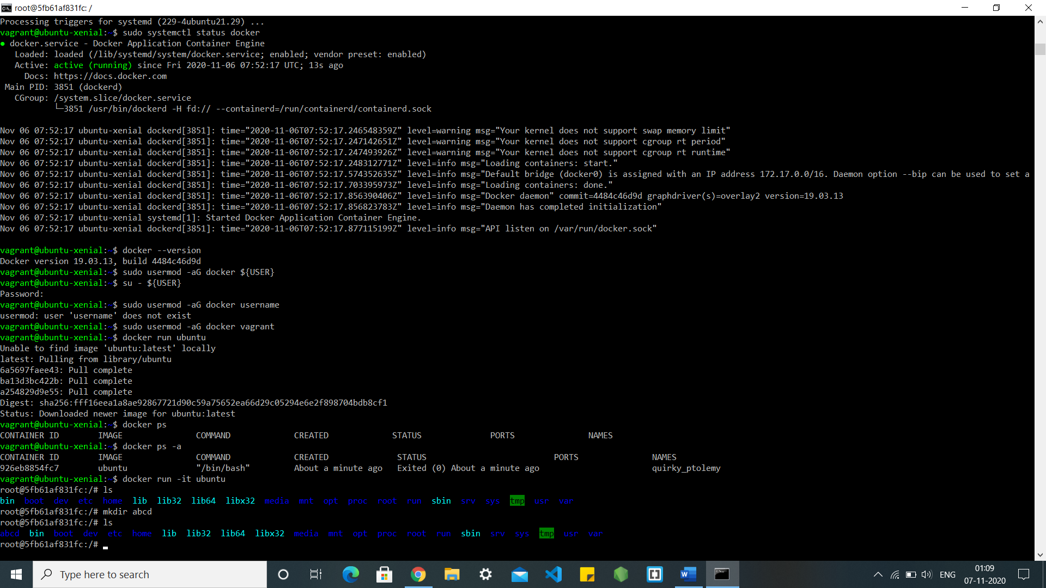

# Check docker version after installation



# Goto root and run docker run -it ubuntu



# Create new directory inside container and list files

