Continuous Integration and Continuous Deployment Lab

Experiment – 2

**Name – ABHISHEK SHARMA**

**Roll No – R171218005**

**Jenkins integration with Github**

Start the Jenkins service using the java -jar jenkins.war command in the command prompt

Go to the Jenkins dashboard at localhost:8080

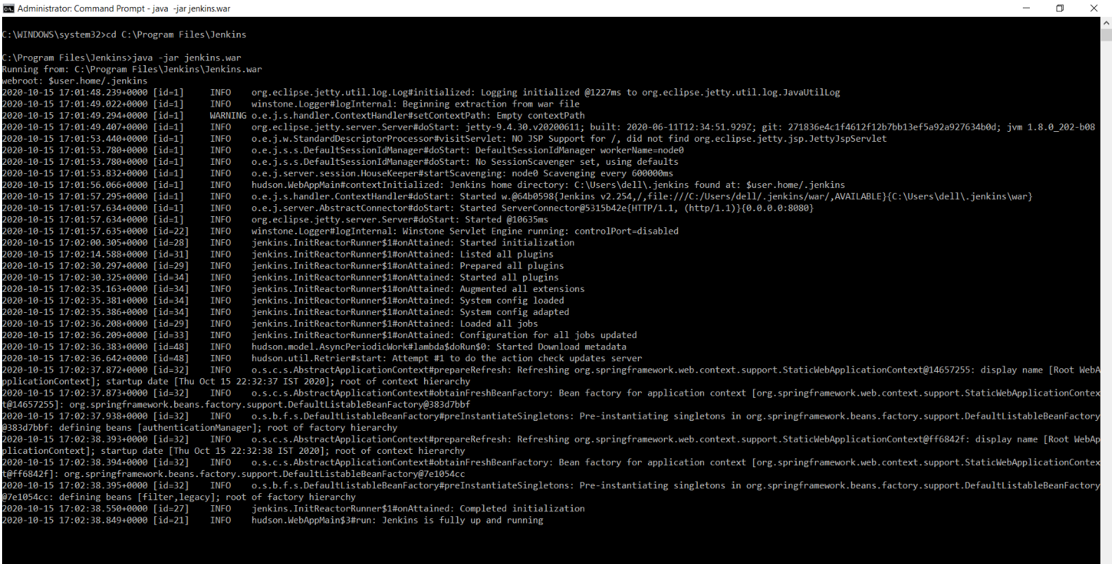

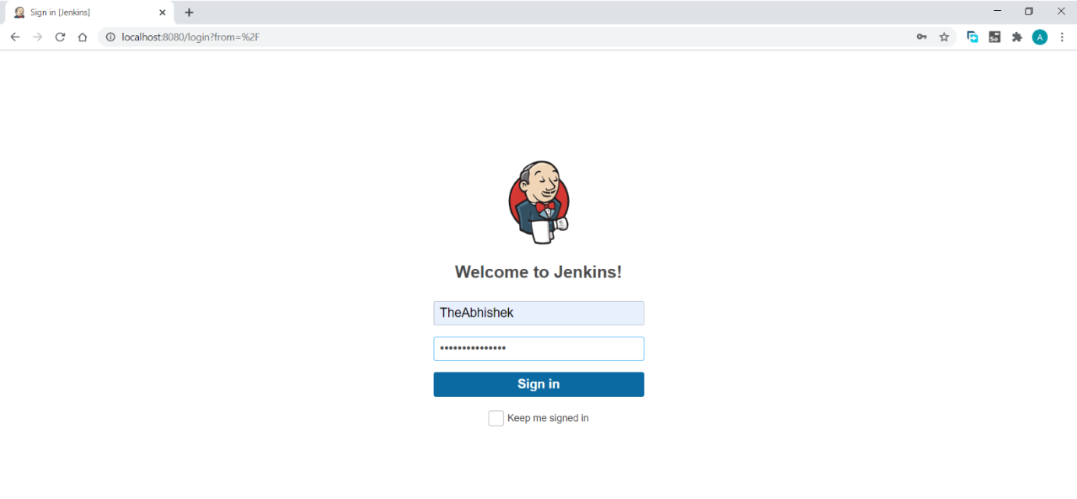

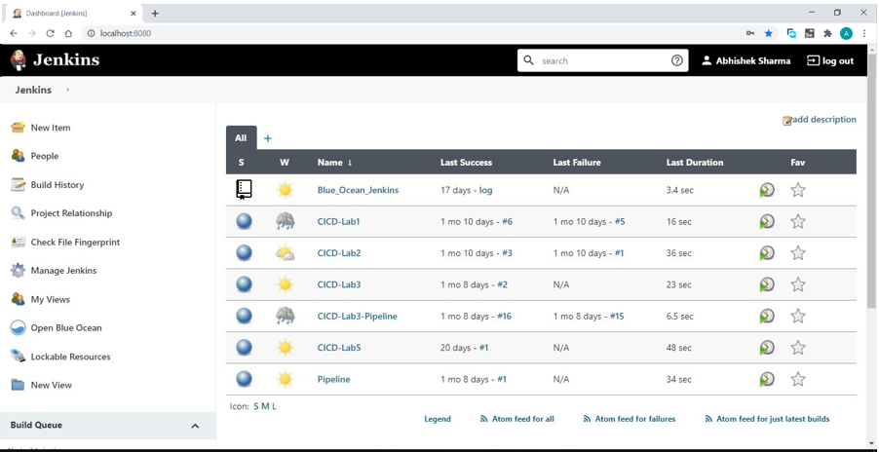

Click on the new item option

Select the freestyle project option

Give a name to the project

Click ok

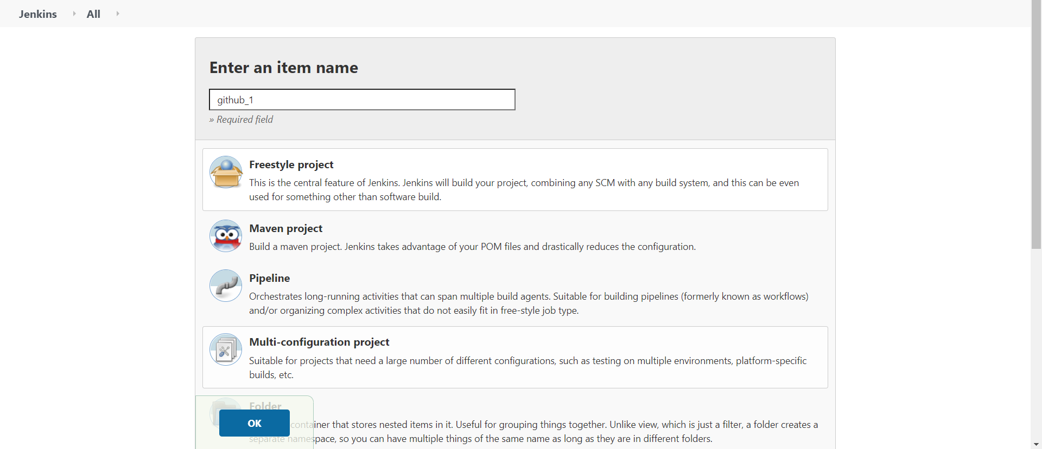

You will be directed to a page similar to this.

Click on the source code management tab to add the github repository

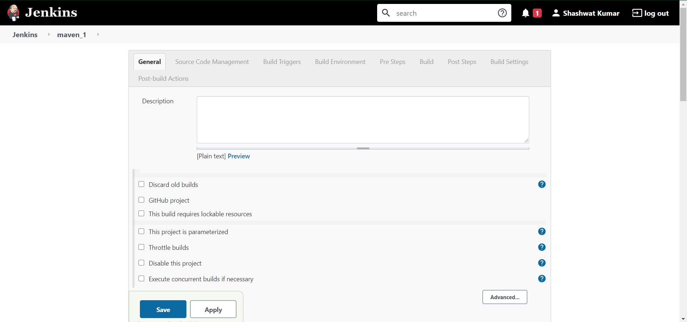

In the Source Code Management Section select Git

Visit the repository where you saved your project

Copy the location of the github repository

Give the repository location in the specified placeholder

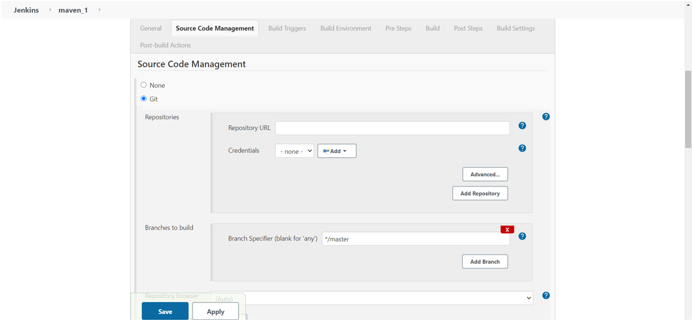

Click save and apply

You would be redirected to a dashboard like this

