Continuous Integration and Continuous Deployment Lab

Experiment – 5

**Name – ABHISHEK SHARMA**

**Roll No – R171218005**

**Jenkins Integration with SonarQube**

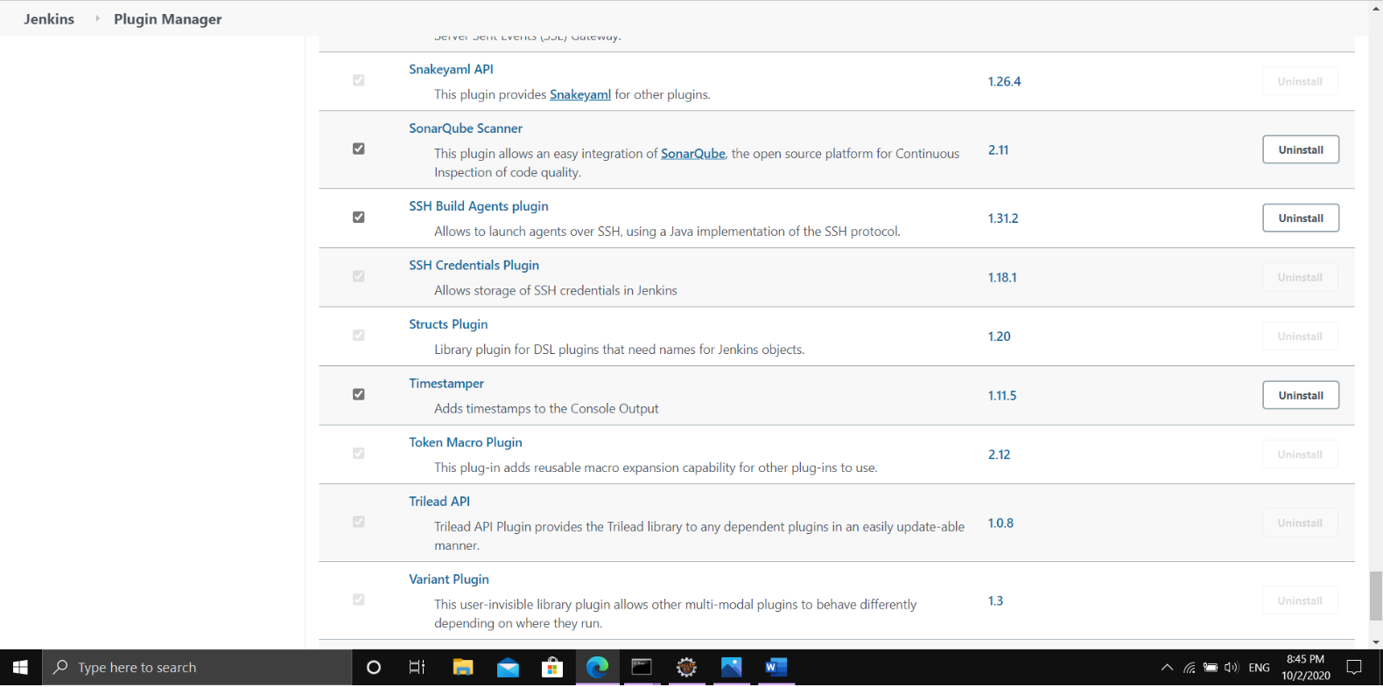

Installing the SonarQube Scanner Plugin in Jenkins

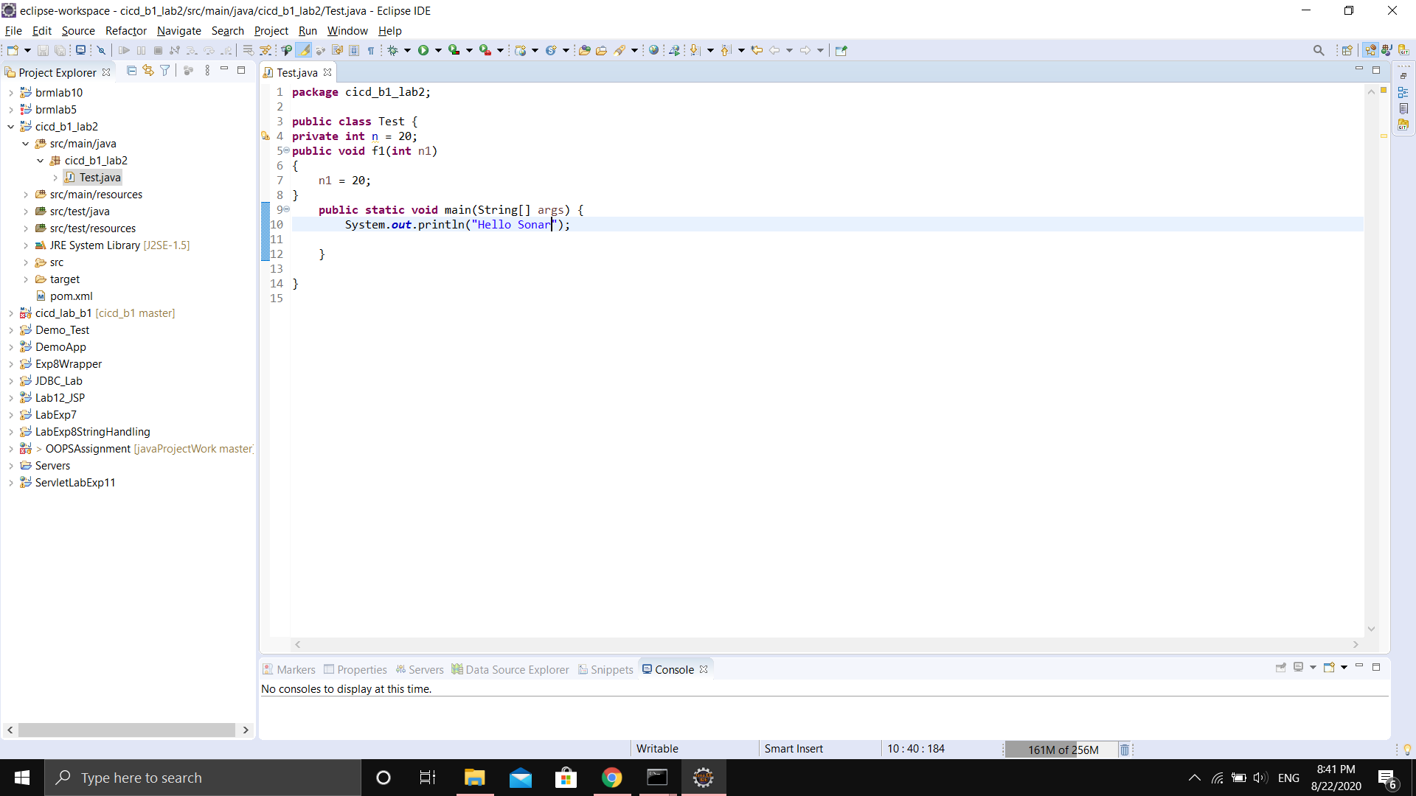

Making a Maven project

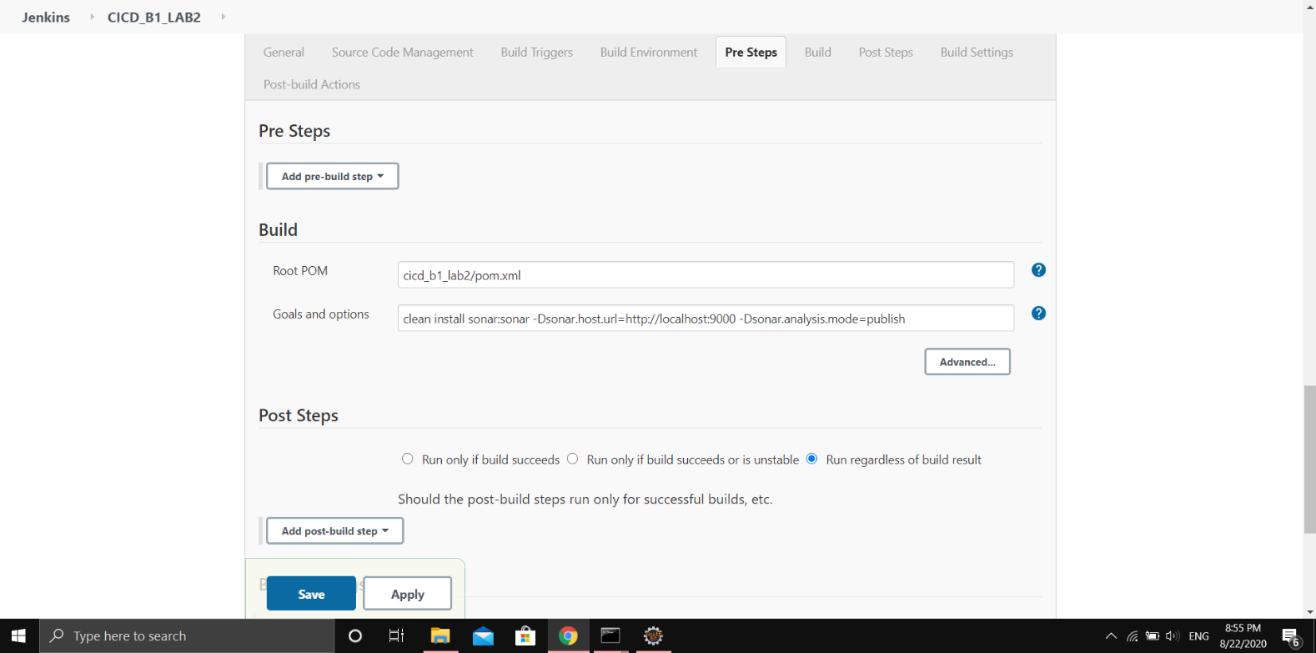

Adding the SonarQube command in the new job created in Jenkins

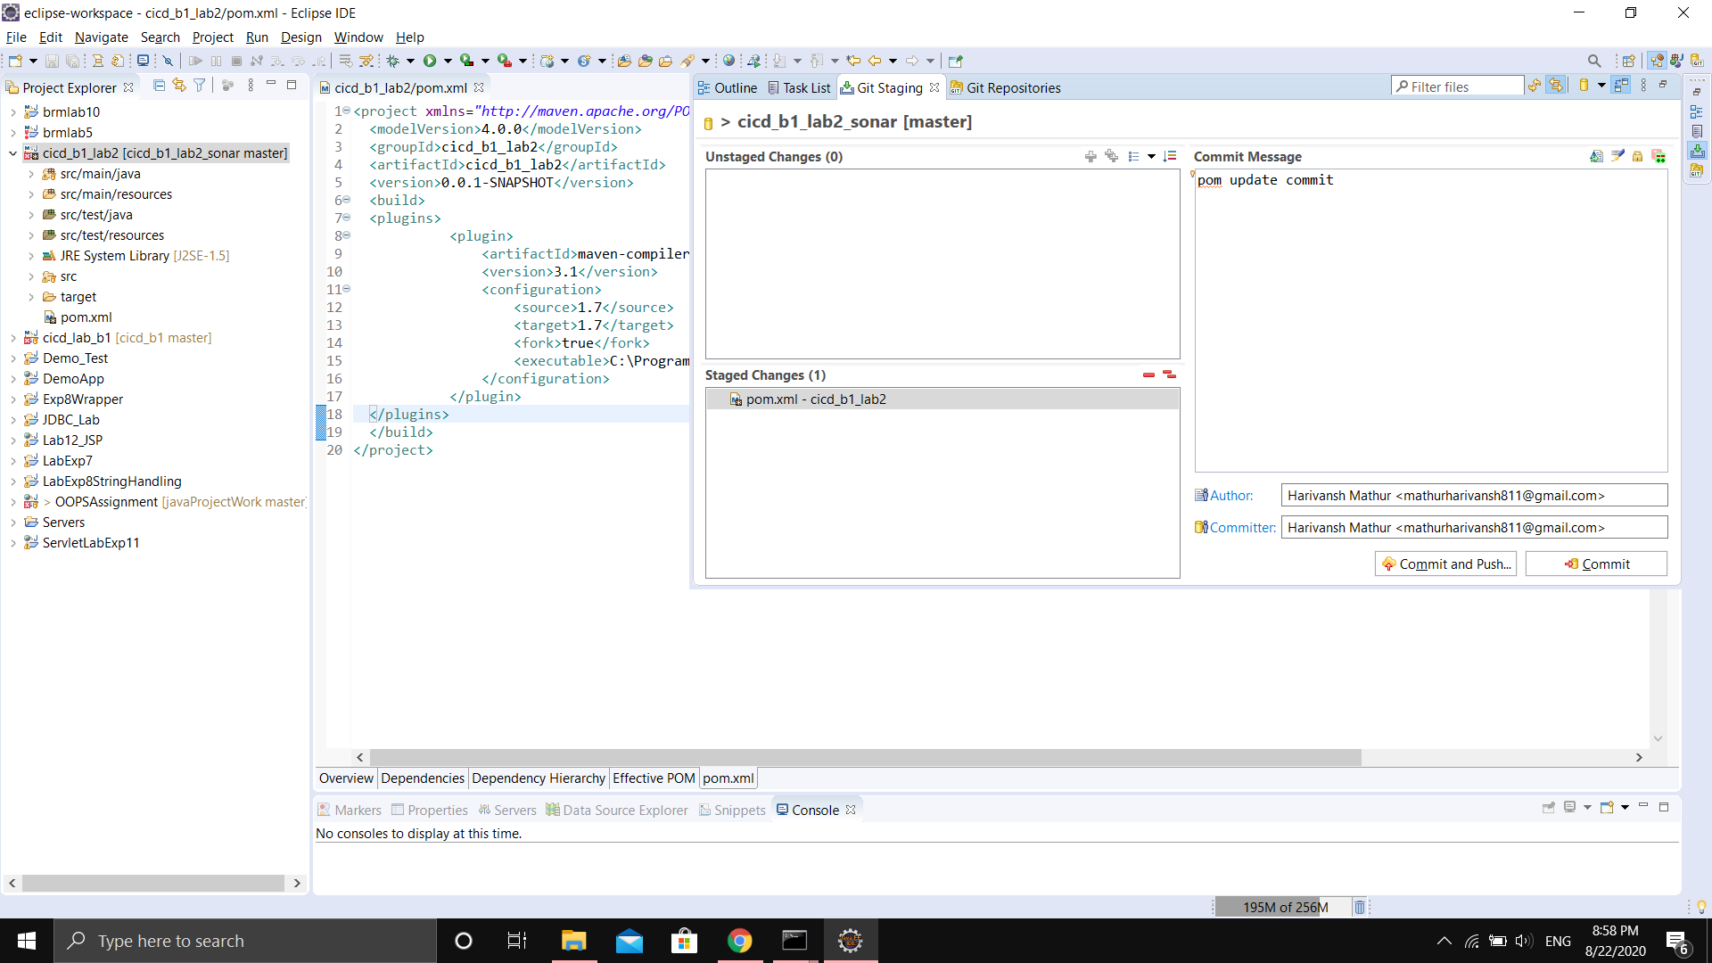

Pushing the code to GitHub

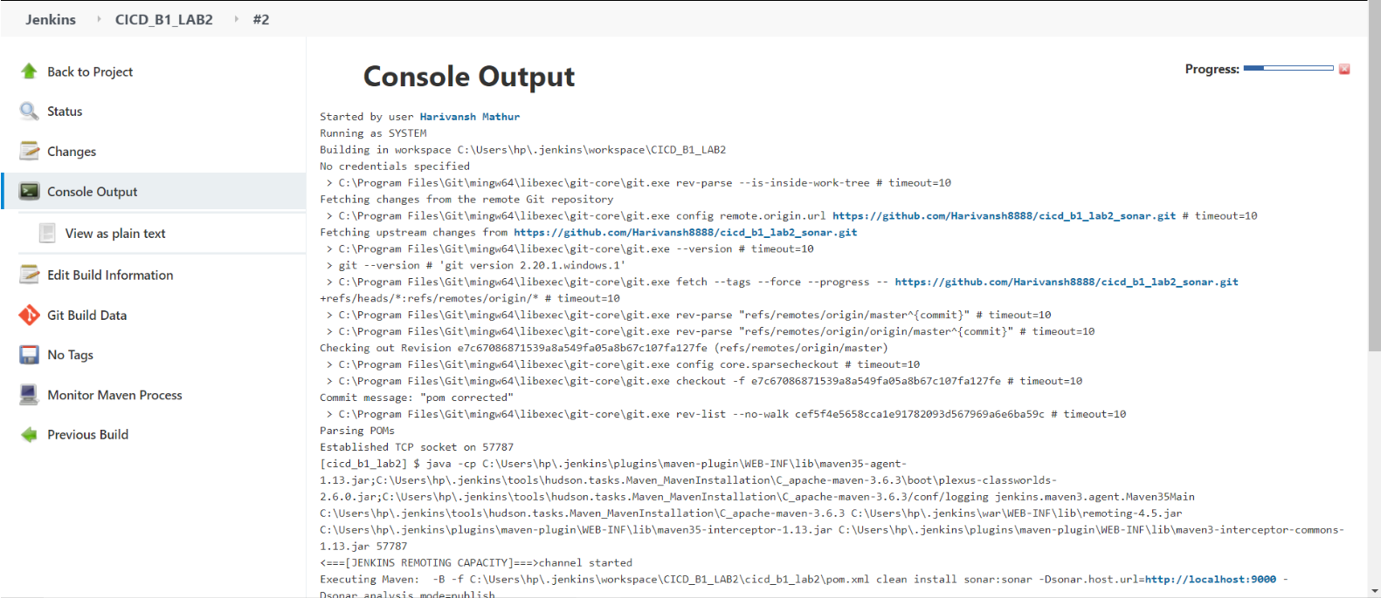

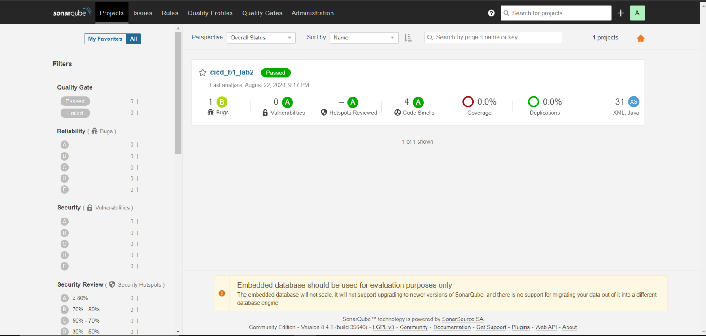

Building the Job in Jenkins

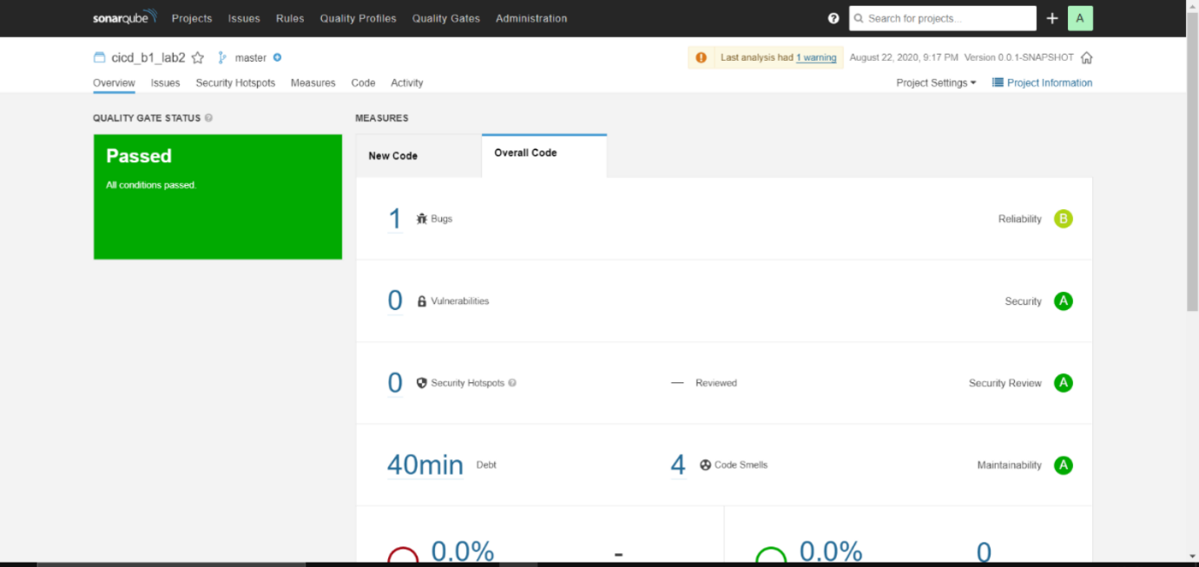

Code Analysis on the SonarQube Dashboard