**SYNOPSIS REPORT**

**On**

**Deep Learning in Disease Identification**

**Submitted by**

|  |  |  |
| --- | --- | --- |
| **NAME** | **SAP ID** | **Enroll No.** |
| Abhishek Sharma | 500067644 | R171218005 |
| Muskaan Madan | 500068520 | R171218063 |
| Prakhar Tandon | 500068957 | R171218115 |
| Devmalya Bandopadhyay | 500069119 | R171218039 |

**BACHELOR OF TECHNOLOGY**

**COMPUTER SCIENCE & ENGINEERING**

**Specialization in DevOps**

**Under the guidance of**

Mrs. Nitika Goenka

Associate Professor

Department of Cybernetics



Department of Cybernetics

**SCHOOL OF COMPUTER SCIENCE**

UNIVERSITY OF PETROLEUM & ENERGY STUDIES

Bidholi Campus, Energy Acres, Dehradun – 248007

**January– 2022**

 **School of Computer Science**

**University of Petroleum & Energy Studies, Dehradun**

**Project Proposal Approval Form (2021-2022)**

2

**Major**

**PROJECT TITLE: Deep Learning in Disease Identification.**

**ABSTRACT:** Just like humans, plants are effected by several disease caused by bacteria, fungi and virus. Identification of these disease timely and curing them is essential to prevent whole plant from destruction. The proposed methodology is used for the precise identification of disease in plants, which can provide controlled fertilization to farmers or the botanists. Accurate identification of disease also helps farmers or botanists to identify the infection and do relatively controlled fertilization to avoid any future nursery failures.

**TABLE OF CONTENT**

**TOPIC: Page No.**

**1. INTRODUCTION** 1

**2. LITERATURE REVIEW** 2

**3. PROBLEM STATEMENT** 3

**4. METHODOLOGY** 4

**5. OBJECTIVES** 5

**6. SYSTEM REQUIREMENTS** 6

**7. PERTCHART** 7

**8. REFRENCES** 8

**INTRODUCTION**

The agriculturist, botanists or farmers in all over the world may assume that it’s hard to differentiate the plants/crops which may be available in their showcase/harvests. It's not moderate for them to go to agribusiness office again and again to discover what the infection may be. Our principle objective is to distinguish the illness introduce in a plant by watching its morphology by picture handling and deep learning.

Modern approaches such as deep learning algorithm have been employed to increase the recognition rate and the accuracy of the results. Various researches have taken place under the field of machine learning for plant disease detection and diagnosis, such traditional machine learning approach being random forest, artificial neural network, support vector machine(SVM), fuzzy logic, K-means method, Convolutional neural networks etc.…

Server based and mobile based approach for disease identification has been employed for disease identification. Several factors of these technologies being high resolution camera, high performance processing and extensive built in accessories are the added advantages resulting in automatic disease recognition.

**LITERATURE REVIEW**

1. S. S. Sannakki and V. S. Rajpurohit, proposed a **“Classification of Pomegranate Diseases Based on Back Propagation Neural Network”** which mainly works on the method of Segment the defected area and color and texture are used as the features. Here they used neural network classifier for the classification. The main advantage is it Converts to L*a*b to extract chromaticity layers of the image and categorization is found to be 97.30% accurate. The main disadvantage is that it is used only for the limited crops.
2. P. R. Rothe and R. V. Kshirsagar introduced a **“Cotton Leaf Disease Identification using Pattern Recognition Techniques”** which Uses snake segmentation, here Hu’s moments are used as distinctive attribute. Active contour model used to limit the vitality inside the infection spot, BPNN classifier tackles the numerous class problems. The average classification is found to be 85.52%.
3. Aakanksha Rastogi, Ritika Arora and Shanu Sharma, **“Leaf Disease Detection and Grading using Computer Vision Technology &Fuzzy Logic”**. K-means clustering used to segment the defected area; GLCM is used for the extraction of texture features, Fuzzy logic is used for disease grading. They used artificial neural network (ANN) as a classifier which mainly helps to check the severity of the diseased leaf.
4. Godliver Owomugisha, John A. Quinn, Ernest Mwebaze and James Lwasa, proposed **“Automated Vision-Based Diagnosis of Banana Bacterial Wilt Disease and Black Sigatoka Disease”**, Color histograms are extracted and transformed from RGB to HSV, RGB to L*a*b. Peak components are used to create max tree, five shape attributes are used and area under the curve analysis is used for classification. They used nearest neighbors, Decision tree, random forest, extremely randomized tree, Naïve Bayes and SV classifier. In seven classifiers extremely, randomized trees yield a very high score, provide real time information provide flexibility to the application.
5. Uan Tian, Chunjiang Zhao, Shenglian Lu and Xinyu Guo, **“SVM-based Multiple Classifier System for Recognition of Wheat Leaf Diseases”,** Color features are represented in RGB to HIS, by using GLCM, seven invariant moment are taken as shape parameter. They used SVM classifier which has MCS, used for detecting disease in wheat plant offline.

**PROBLEM STATEMENT**

**To deploy a deep learning based model which is able to detect deformity and identify several diseases from plants using pictures of their leaves. This plant disease detection model is to be developed using neural network.**

**METHODOLOGY**

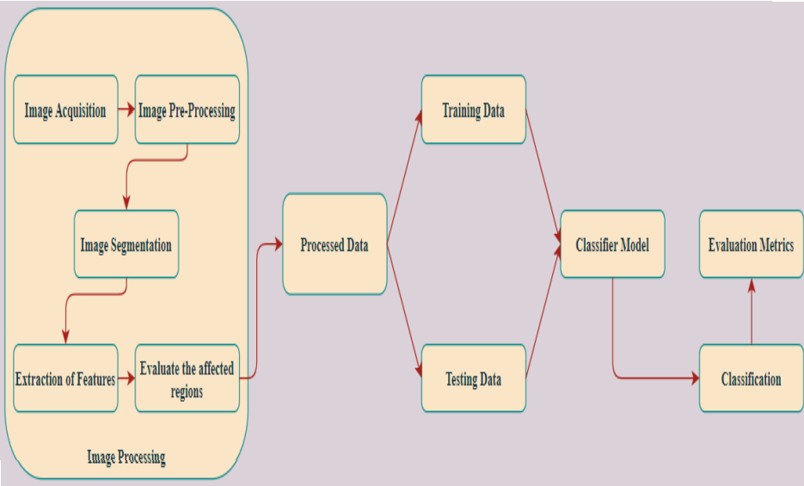

**Deep Learning Flowchart**

**Convolution Neural Network (CNN):**

Convolution Neural Networks (CNNs) are used to detect the disease in plant’s leaves. CNN is an evolution of simple ANN that gives better result on images. Because images contain repeating patterns of particular thing (any image). Two important functions of CNN are convolution and pooling. Convolution is used to detect edges of patterns in an image and pooling is used to reduce the size of an image.

**Dataset Discussion:**

Two datasets will be used to perform plant disease detection. Let’s say, first dataset consists of 15 classes and second one consists of 38 classes. Both databases have number of images of each plant. First dataset have total 2952 images. Final findings of the work are on a dataset which contains 38 classes of different plants. There are several dataset openly available on the internet.

**Model Description:**

First, some pre-processing is to be applied on dataset in form of augmentation to increase size of dataset in order to achieve better accuracy. Batch normalization is used to scale data on particular scale but the difference is that it not just does it on input layer but it also to be done it at other hidden layers.

**OBJECTIVES**

* To develop a prototype for a plant disease detection system.
* To apply image processing techniques to identify the disease pattern.
* Use deep learning algorithms to identify diseases.
* Deploy to Amazon EC2 with AWS.

**SYSTEM REQUIREMENTS**

Operating System: Windows 7/XP/8, Linux

Language: Python (Google Colab)

Library: kaggle

Processor: Intel Core, i5 7th Gen

RAM: 8 GB

Hard disk: 80 GB

**PERTCHART**

**REFERENCES**

1. <http://dspace.lpu.in:8080/jspui/bitstream/123456789/5108/1/ADITI%20SINGH%2011604614.pdf>
2. <https://www.researchgate.net/publication/316976487_Deep_Learning_for_Tomato_Diseases_Classification_and_Symptoms_Visualization>
3. <https://www.researchgate.net/publication/342325881_Potato_Leaf_Diseases_Detection_Using_Deep_Learning>
4. <https://www.hindawi.com/journals/jece/2021/9981437/>
5. <https://ijcrt.org/papers/IJCRT1807147.pdf>
6. <http://www.sciencedirect.com/science/article/pii/S153751101530266X>
7. <http://www.sciencedirect.com/science/article/pii/S0168169914000611>
8. <http://www.sciencedirect.com/science/article/pii/S1537511015000495>
9. <https://www.researchgate.net/publication/333137179_Plant_disease_and_pest_detection_using_deep_learning-based_features>
10. <https://www.researchgate.net/publication/332052541_Deep_Learning_Convolutional_Neural_Network_for_Apple_Leaves_Disease_Detection>

Top of Form

Bottom of Form

**Synopsis Draft verified by**

**Mrs. Nitika Goenka**

**Project Guide HOD**