**RECORD OF EXPERIMENTS**

**Micro Processors & Embedded Systems**

Submitted By

Abhishek Sharma

Enrolment No.: R171218005

SAP ID: 500067644

Semester **VI**

**B. Tech. (Computer Sc. and Engineering)**

Specialization in DevOps



School of Computer Science

**UNIVERSITY OF PETROLEUM AND ENERGY STUDIES**

**Dehradun-248007 2020-21**

**EXPERIMENT 1. (a): Addition of Two Numbers**

**Aim:** Write a program using 8085 & Verify for:

1. Addition of Two 8-Bit Numbers.
2. Addition of Two 16-Bit Numbers (With Carry).

**Apparatus:** Microprocessor Kit 8085, Key Board, Op-Code Sheet.

**Theory:**

1. ORG Address (ORIGIN) Directive reserves the starting address for Program Code or data in specified memory array,
2. LXI H (LOAD REGISTER PAIR IMMEDIATELY) loads 16-bit data in register pair designated by operand.
3. LHLD Addr. (LOAD HL PAIR DIRECT) loads 16-bit data from specified address to designate in register pair.
4. MOV A, M (MOVE M TO A) copies the data byte into accumulator from the memory specified by the address in H-L pair.
5. MVI (MOVE IMMEDIATE DATA) moves immediate value to specified register.
6. DAD (DOUBLE ADDITION) Add specified register pair content to HL pair content and store results into HL pair.
7. JNC Addr. (JUMP IF NO CARRY) Instruction jump the execution to the specified Address if carry flag is reset.
8. INR R (INCREMENT REGISTER) increment the specified register content by 1.
9. INX H (INCREMENT REGISTER PAIR) increments the contents of the register pair by one.
10. ADD M (ADDTION) adds the contents of memory to accumulator.
11. STA addr. (STORE ACCUMULATOR DIRECT) copies the contents of the accumulator to the memory location specified in the instruction
12. SHLD Addr. (STORE HL DIRECT) instruction store HL pair content to specified address.
13. RST 1 (RESET) finishes the execution of the current instruction and stops any further execution.
14. DB (DEFINE BYTE) Directive is defined to store values in specified memory array.

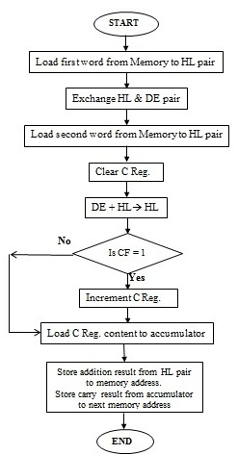**Flowchart:**

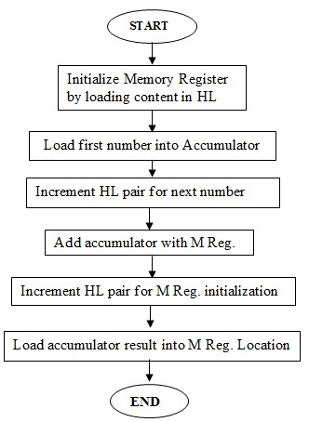

For Addition Of Two 8-Bit Numbers For Addition Of Two 16-Bit Numbers

**Program:**

1. **For Addition of Two 8-Bit Numbers**

# ORG 7000H

LXI H,7501 // Get address of 1st no. in HL pair

MOV AM // Move no. into accumulator

INX H // HL points the address 7502 H

ADD M // Add the 2nd no.

INX H // HL points 7503 H

MOV MA // Store result in 7503 H

RST 1 // Terminate

# ORG 7501H // Store input at the address

# DB 12H, 13H // Get two 8-bit no. in successive location

A. Input: 7501- 13H, 7502- 12H; Output: A- 25H, 7503- 25H

**Result:**

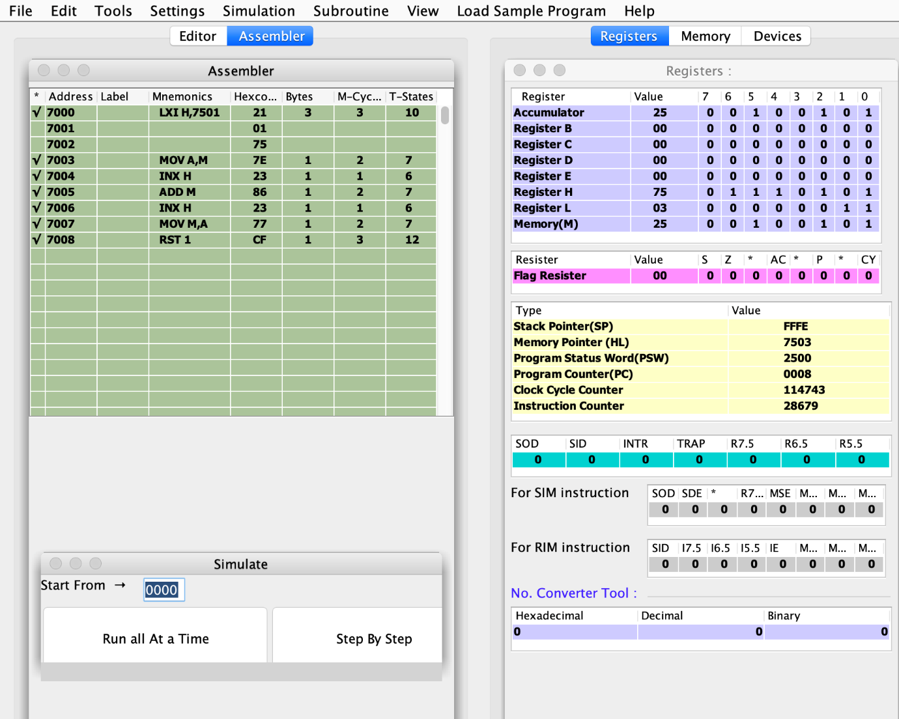

**B. For Addition of Two 16-Bit Numbers**

# ORG 7000H

LHLD 7601 //Get 1st no. in HL pair from memory 7601 H

XCHG //Exchange cont. of DE HL

LHLD 7603 //Get 2st no. in HL pair from location 7603 H

MVI C,00 //Clear reg. C.

DAD D //Get HL+DE & store result in HL

JNC down //If no carry move to loop/if carry then move to next step.

INR C //Increment reg.C

MOV A, C //Move carry from reg. C to reg. A

STA 7502 //Store carry at 7502 H

down: SHLD 7500 //Store result in 7500 H.

RST 1 //Terminate

#ORG 7601H // Store input at the address

#DB 13,31,12,10 // Get two 16-bit no. in successive location

B. Input: 7601- 13H, 7602- 31H, 7603- 12H, 7604- 10H; Output: 7500- 25H, 7501- 41H, 7502- 00H

**Result:**

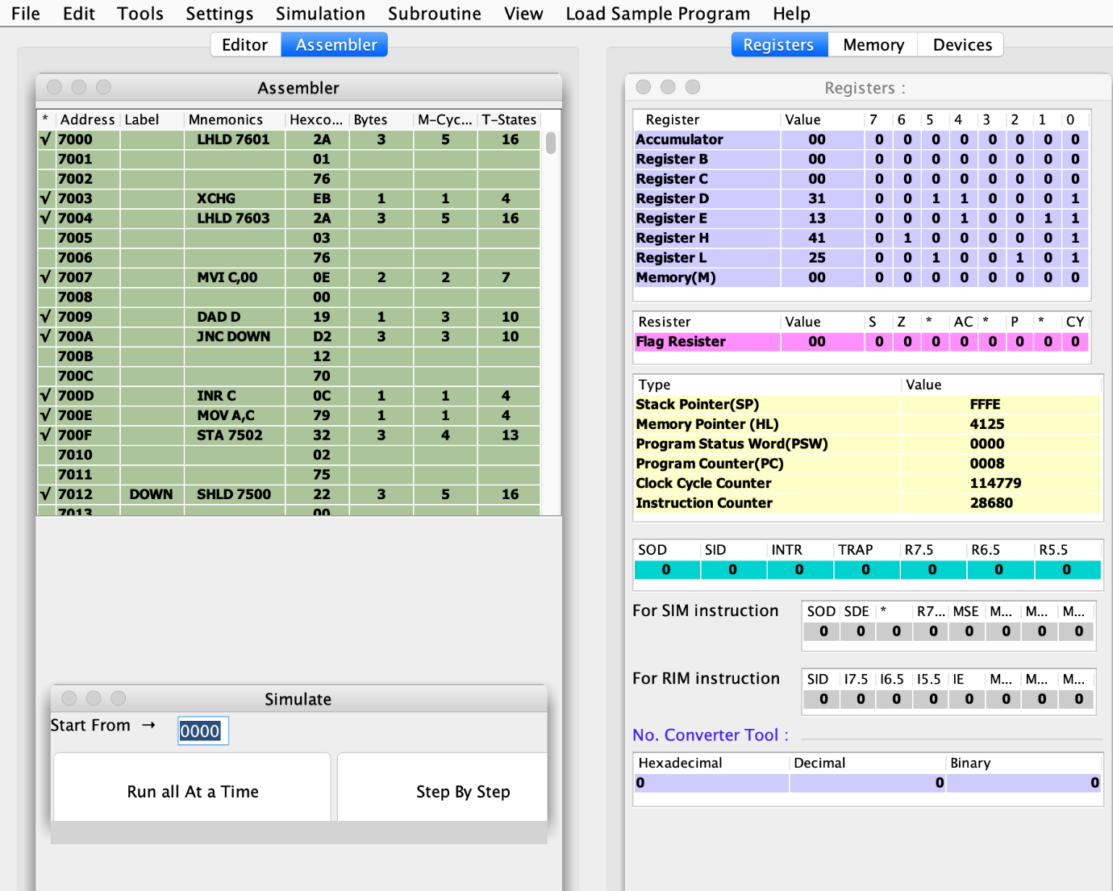

**Precautions:**

1. All steps should be followed carefully.
2. Make sure all power sources are disconnected.
3. Make sure you are properly grounded.
4. Don’t touch the live wire.

**EXPERIMENT 1. (b): Subtraction of Two Numbers**

**Aim:** Write a program using 8085 & Verify for:

1. Subtraction of Two 8-Bit Numbers. (Display of Borrow)
2. Subtraction of Two 16-Bit Numbers (Display of Borrow Carry).

**Apparatus:** Microprocessor Kit 8085 , Key Board, Op-Code Sheet.

**Theory:**

1. ORG Addr. Directive reserves the starting address for Program Code or data in specified memory array,
2. LXI H (LOAD REGISTER PAIR IMMEDIATELY) loads 16-bit data in register pair designated by operand.
3. LHLD Addr. (LOAD HL PAIR DIRECT) loads 16-bit data from specified address to designate in register pair.
4. MOV A, M copies the data byte into accumulator from the memory specified by the address in H-L pair.
5. MVI (MOVE IMMEDIATE DATA) moves immediate value to specified register.
6. SBB instruction subtracts specified register content and carry flag to Accumulator and store results into Accumulator.
7. JNC Addr. Instruction jump the execution to the specified Address if carry flag is reset.
8. INR instruction increment the specified register content by 1.
9. INX H (INCREMENT REGISTER PAIR) increments the contents of the register pair by one.
10. SUB M (SUBTRACTION) subtracts the contents of register to accumulator.
11. STA address (STORE ACCUMULATOR DIRECT) copies the contents of the accumulator to the memory location specified in the instruction
12. SHLD Addr. (STORE HL DIRECT) instruction store HL pair content to specified address.
13. RST 1 (RESTART) finishes the execution of the current instruction and stops any further execution.

**Flowchart:**

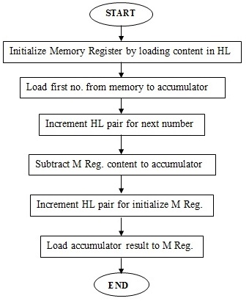

For Subtraction Of Two 8-Bit Numbers For Subtraction Of Two 16-Bit Numbers

**Program:**

1. **For Subtraction Of Two 8-Bit Numbers**

# ORG 7000H LXI H, 7501 // Get address of ist no. in HL pair

MOV A, M // Move no. into accumulator

INX H // HL points 7502 H.

SBB M // Substract 2nd no. from Ist no.

INX H //HL points 7503 H.

MOV M, A // Move contents of acc. to memory

RST 1 // Terminate

#ORG 7501H // Store no. at address

#DB 20,10 // Get the two 8 bit no. at successive location

A. Input: 7501- 20H, 7502- 10H ; Output: 7503- 10H

**Result:**

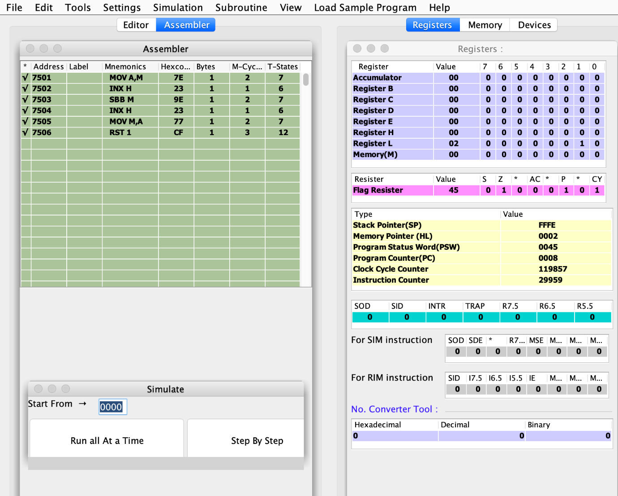

**B. For Subtraction Of Two 16-Bit Numbers**

# ORG 7000H LHLD 7501 // Get 1st 16 bit no. in HL pair

XCHG // Exchange HL pair with DE.

LHLD 7503 // Get 2nd 16 bit no. in HL pair

MOV A, E // Get lower byte of ist no.

SUB L // Subtract lower byte of 2nd no.

MOV L, A // Store the result in reg. L

MOV A, D // Get higher byte of Ist no.

SBB H // Subtract higher byte of 2nd no. with borrow

MOV H,A // Move from acc. To H

SHLD 7505 // Store 16 bit result at 7505 H &7506 H

RST 1 // Terminate

# ORG 7501H // Store inputs at the address

# DB 30,40,10,20 // Get two 16 bit no. from successive locations

B. Input: 7501- 30H, 7502- 40H, 7503- 10H, 7504- 20H ; Output: 7505- 20H, 7506- 20H

**Result:**



**Precautions:**

1. All steps should be followed carefully.
2. Make sure all power sources are disconnected.
3. Make sure you are properly grounded.
4. Don’t touch the live wire.

**EXPERIMENT 1. (c): Multiplication Of Two 8-Bit Numbers**

**Aim:** Write a program using 8085 & Verify for: Multiplication of Two 8-Bit Numbers

**Apparatus:** Microprocessor Kit 8085 , Key Board, Op-Code Sheet.

**Theory:**

1. This program multiplies two operands stored in memory location 3000H and 3001H, using successive addition method.
2. In successive addition method, the second operand is considered as the counter, and the first number is added to itself until counter decrements to zero.
3. Let us assume that the operands stored at memory location 0100H are 03H and 0101H is 04H. Then, by using successive addition method, we get 03H + 03H + 03H + 03H = 0CH.
4. Initially, H-L pair is loaded with the address of first memory location.
5. The first operand is moved to register B from memory location 0100H and H-L pair is incremented to point to next memory location.
6. The second operand is moved to register C from memory location 0101H to act as the counter.
7. The accumulator is initialized to 00H. Register B is added to the accumulator and the result is stored in the accumulator.
8. Register C (counter) is decremented by 1. Then, the counter is checked for zero.
9. If it hasn’t become zero yet, then register B is again added to the accumulator, and the counter is again checked for zero.
10. If counter becomes zero, then H-L pair is incremented and the result is moved from the accumulator to memory location 0102H.

**Flowchart:**

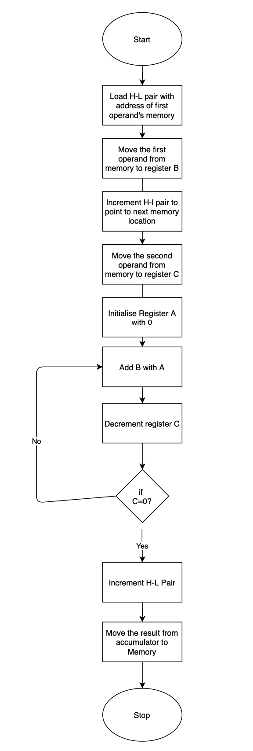

**Program:**

LXI H, 0100H

MOV B,M

INX H

MOV C,M

MVI A, 00H

top: ADD B

DCR C

JNZ top

INX H

MOV M,A

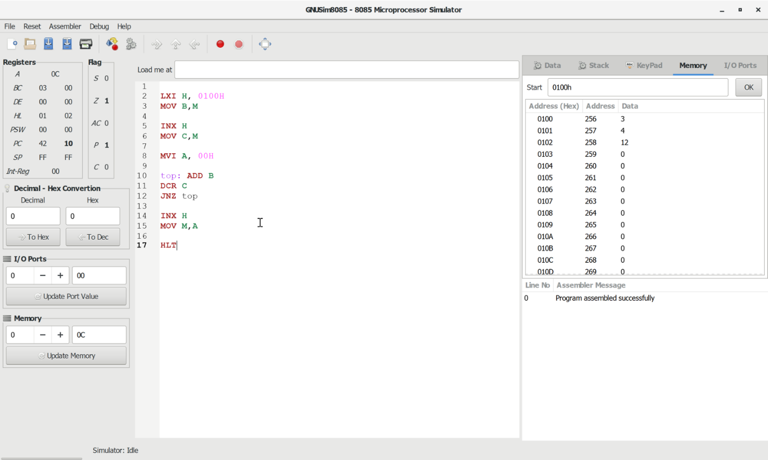HLT

**Precautions:**

1. All steps should be followed carefully.
2. Make sure all power sources are disconnected.
3. Make sure you are properly grounded.
4. Don’t touch the live wire

**EXPERIMENT 1. (d): Division Of Two 8-Bit Numbers**

**Aim:** Write a program using 8085 & Verify for: Division of Two 8-Bit Numbers

**Apparatus:** Microprocessor Kit 8085 , Key Board, Op-Code Sheet.

**Theory:**

1. Load the HL pair registers with address of memory location.
2. Move the first data to register B.
3. Move the second data to the accumulator.
4. Then compare two numbers for carry.
5. Subtract the content of Register B to the content of accumulator.
6. Then increment the value of carry.
7. Then check whether the repeated subtraction is over.
8. If the repeated subtraction is over then store the value of quotient and remainder in the given memory location.

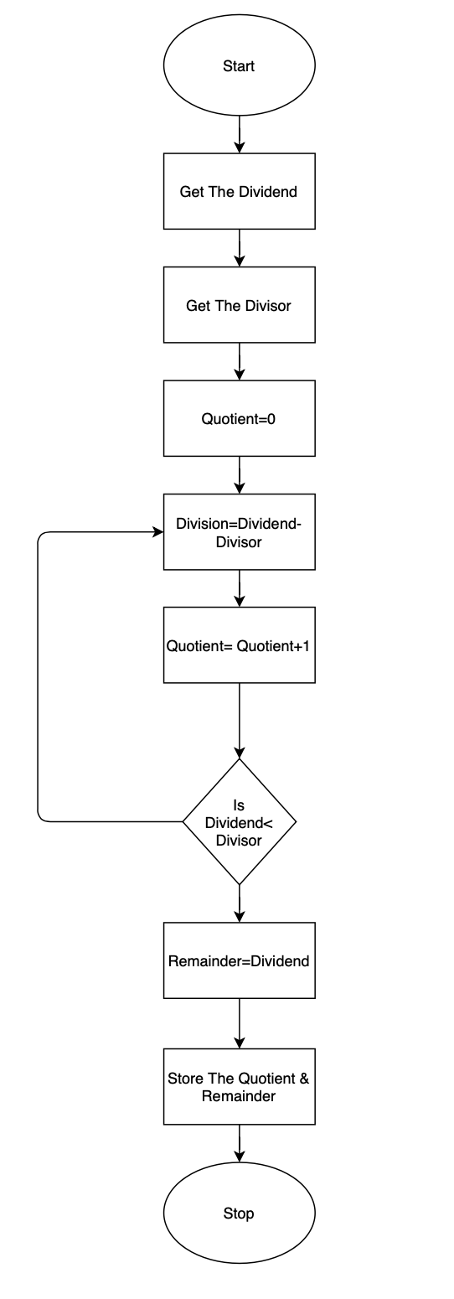

**Flowchart:**

**Program:**

LXI H,3500H

MOV A,M

INX H

MOV B,M

MVI C,00H

LOOP: CMP B

JC skip

SUB B

INR C

JMP LOOP

skip: INX H

MOV M,C

STA 3503H

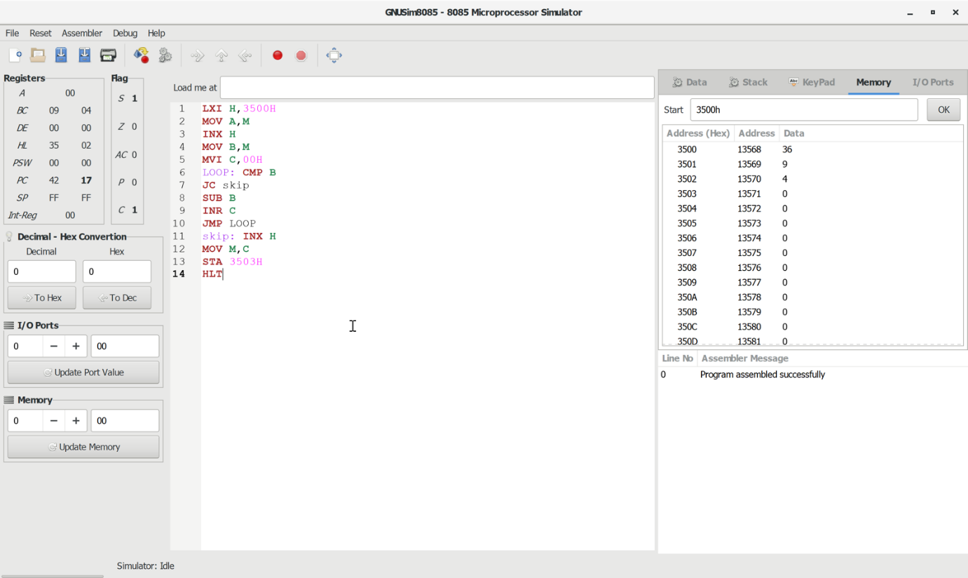HLT

**Precautions:**

1. All steps should be followed carefully.
2. Make sure all power sources are disconnected.
3. Make sure you are properly grounded.
4. Don’t touch the live wire.

**EXPERIMENT 2. (a): 1’s Complement of 8-Bit Number**

**Aim:** Write a program for 8085 and verify it for: 1’s Complement of 8-Bit Number

**Apparatus:** Microprocessor Kit 8085 , Key Board, Op-Code Sheet.

**Theory:**

 In this experiment to obtain 1’s compliment of a number its 0 bits are replaced by 1 and 1 by 0. The number is placed in the memory location 3000.The result is stored the memory location 3001

**Flowchart:**

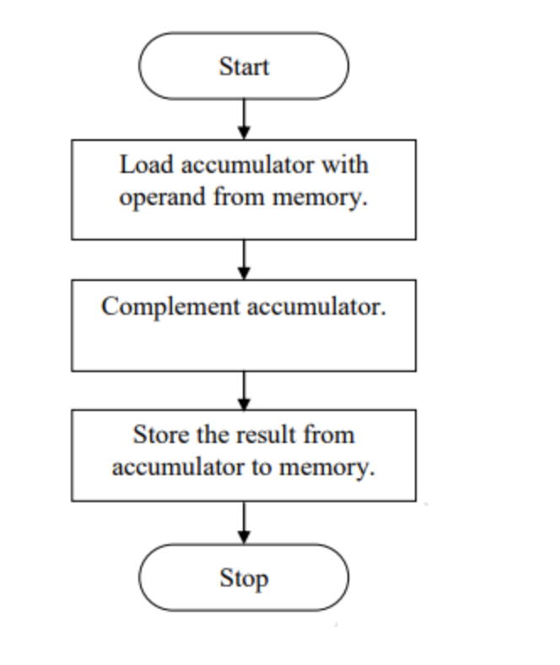

**Program:**

LDA 3000H

CMA

STA 3001H

HLT

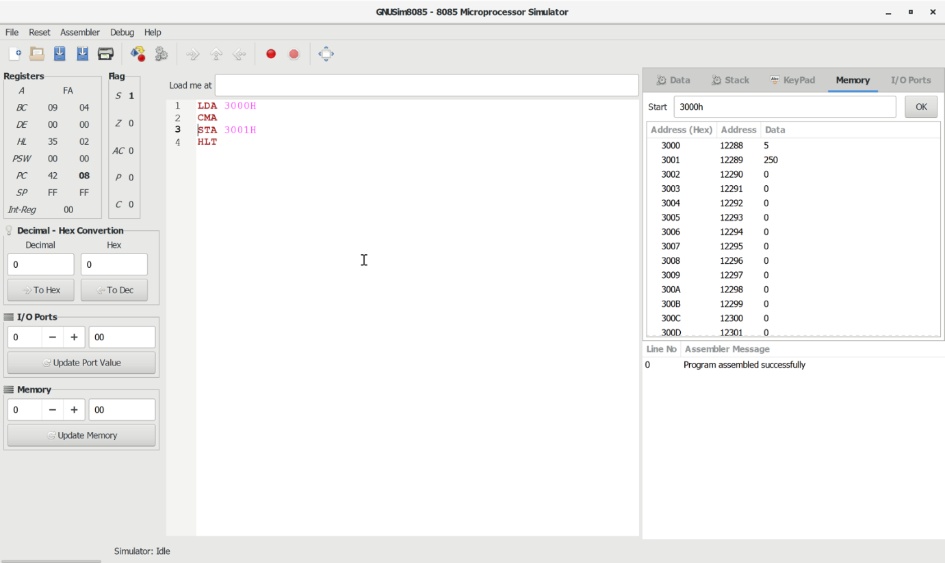

**Precautions:**

1. All steps should be followed carefully.
2. Make sure all power sources are disconnected.
3. Make sure you are properly grounded.
4. Don’t touch the live wire.

**EXPERIMENT 2. (b): 2’s Complement of 8-Bit Number**

**Aim:** Write a program for 8085 and verify it for: 2’s Complement of 8-Bit Number

**Apparatus:** Microprocessor Kit 8085 , Key Board, Op-Code Sheet.

**Theory:**

In this experiment to obtain 2’s compliment of a number is obtain by adding 1 to the 1’s compliment of the number. The number is placed in the memory location 3000. The result is to be stored in the memory location  3001.

**Flowchart:**

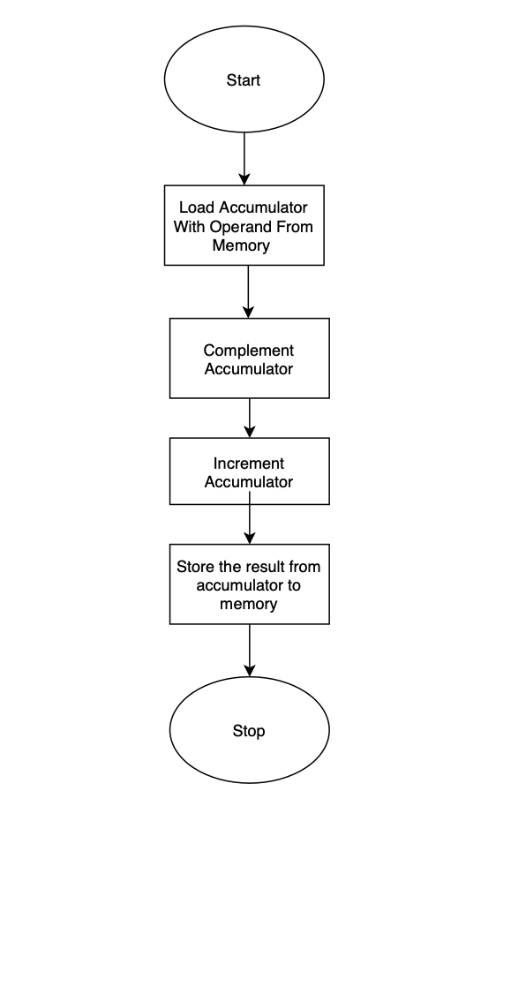

**Program:**

LDA 3000H

CMA

INR A

STA 3001H

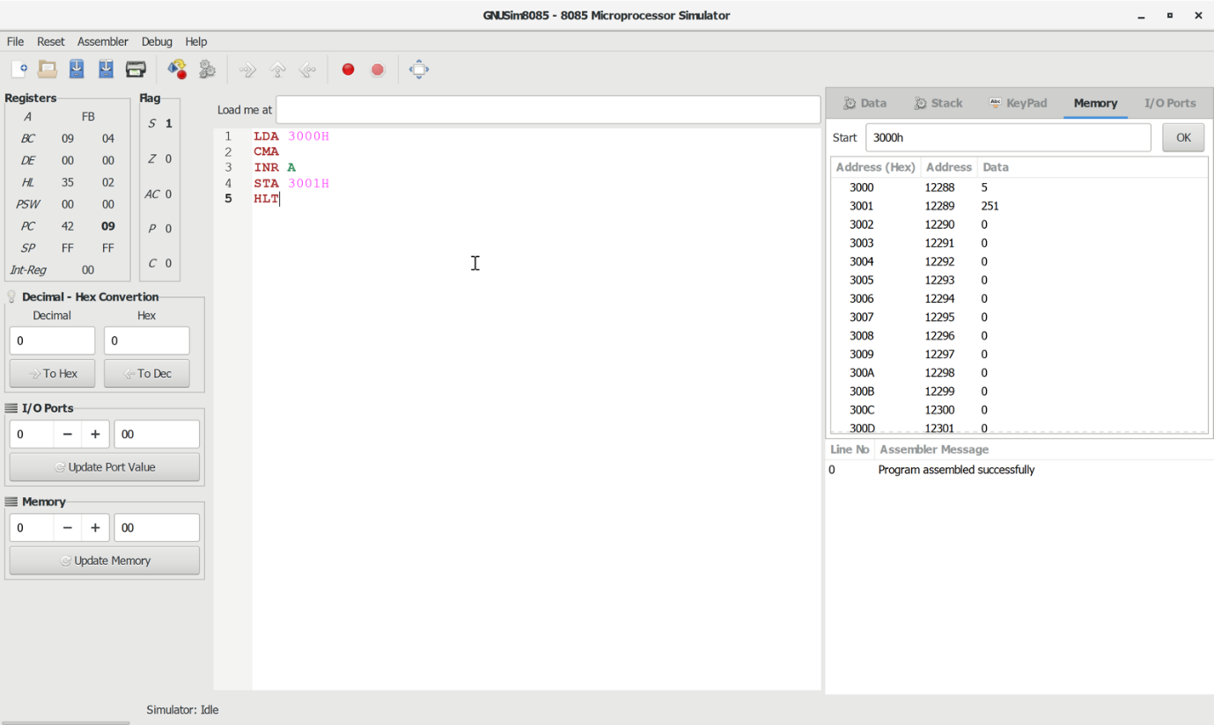HLT

**Precautions:**

1. All steps should be followed carefully.
2. Make sure all power sources are disconnected.
3. Make sure you are properly grounded.
4. Don’t touch the live wire.