**EXPERIMENT 7**

Aim:

PROGRAM TO DISPLAY COUNTER OF 0 TO 9 ON SEVEN SEGMENT DISPLAY.

Diagram:

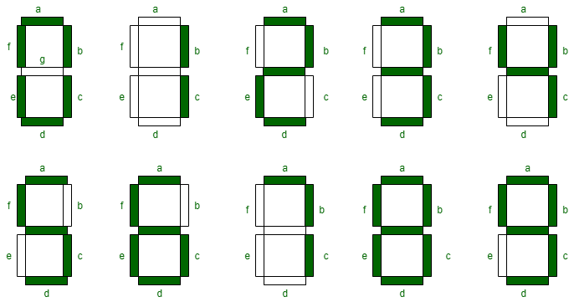

|  |  |  |
| --- | --- | --- |
| Serial no. | Digit | Code |
| 1. | 2 | **SETB P2.6**  **SETB P2.5**  **SETB P2.0**  **SETB P2.3**  **SETB P2.2**  **CLR P2.6**  **CLR P2.5**  **CLR P2.0**  **CLR P2.3**  **CLR P2.2** |
| 2. | 9 | **SETB P2.6**  **SETB P2.5**  **SETB P2.0**  **SETB P2.4**  **SETB P2.1**  **SETB P2.3** |
| 3. | A | **SETB P1.6**  **SETB P1.5**  **SETB P1.0**  **SETB P1.4**  **SETB P1.1**  **SETB P1.2** |
|  |  |  |

Output

