

**UNIVERSITY OF PETROLEUM & ENERGY STUDIES**

**Dehradun**

**Micro Processor & Embedded Systems Lab**

**Experiment-3**

**Name: ABHISHEK SHARMA**

**Course: B. TECH CSE DevOps (2018-22)**

**Roll no.: R171218005**

**Sapid: 500067644**

**Experiment-3**

**Aim : To preform masking of 8-bit and 16-bit number**

**(A)**

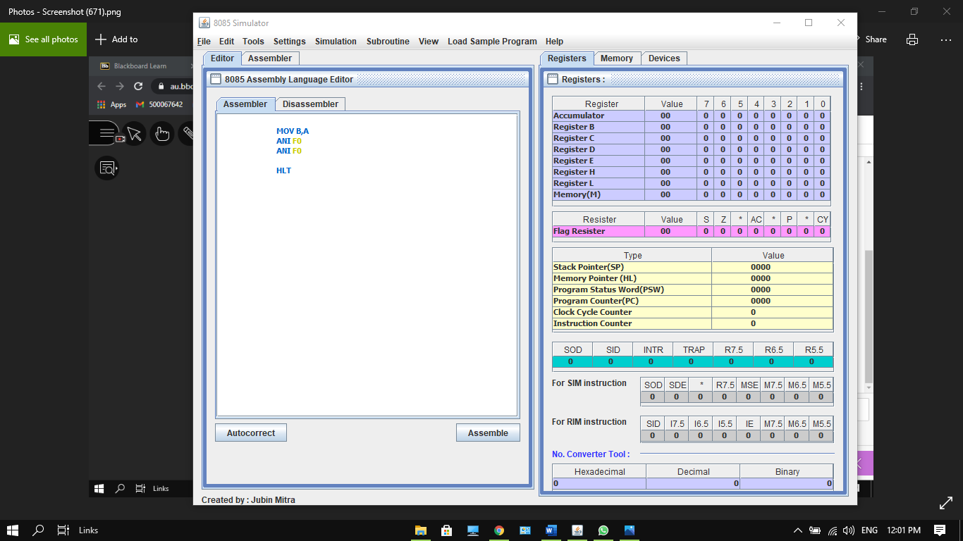

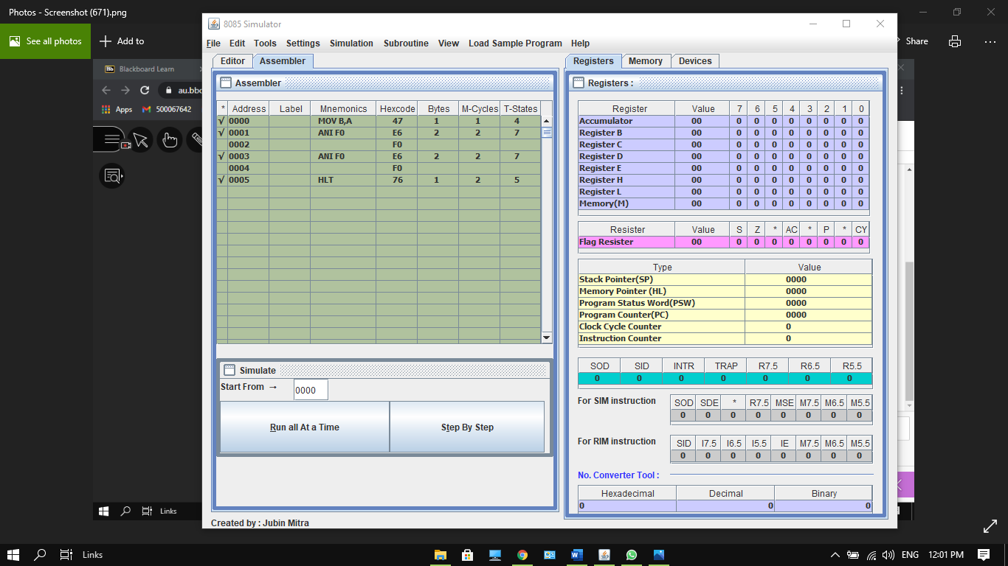

**(B)**

