**Experiment – 4**

**Program for arranging N- number of 8-bit numbers stored in memory in ascending order and descending order**

For Ascending Order

Code and Output:-

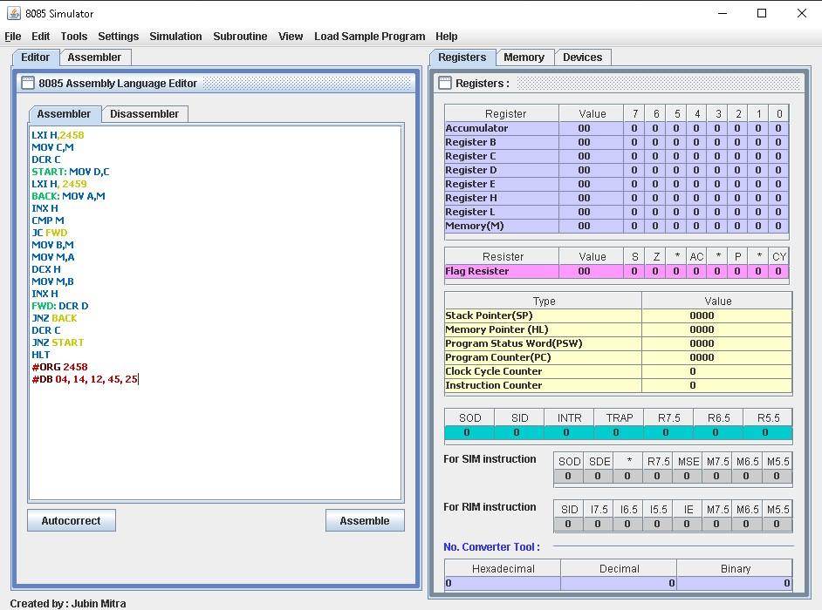

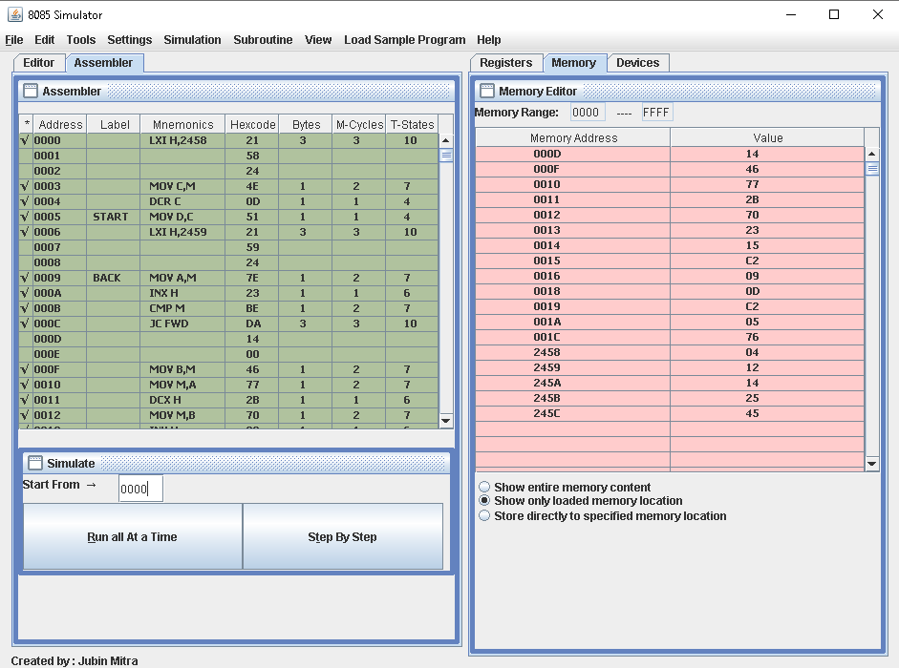

For Descending Order

Code and Output:-

