**Assignment-1**

**Program/course: B.Tech-CS-DevOps Semester: V**

**Subject: OOAD Marks: 20  
Code : CSEG-304**

**ABHISHEK SHARMA**

**R171218005**

**500067644**

**Q 1 –** **Draw the Class Diagram for following statement:**

A school has a principal, many students, and many teachers. Each of these persons has a name, birthdate, and may borrow and return books. Teachers and the principal are both paid a salary; the principal evaluates the teachers. A school board supervises multiple schools and can hire and fire the principal for each school. A school has many playgrounds and rooms. A playground has many swings. Each room has many chairs and doors. Rooms include restrooms, classrooms, and the cafeteria. Each classroom has many computers and desks. Each desk has many rulers.

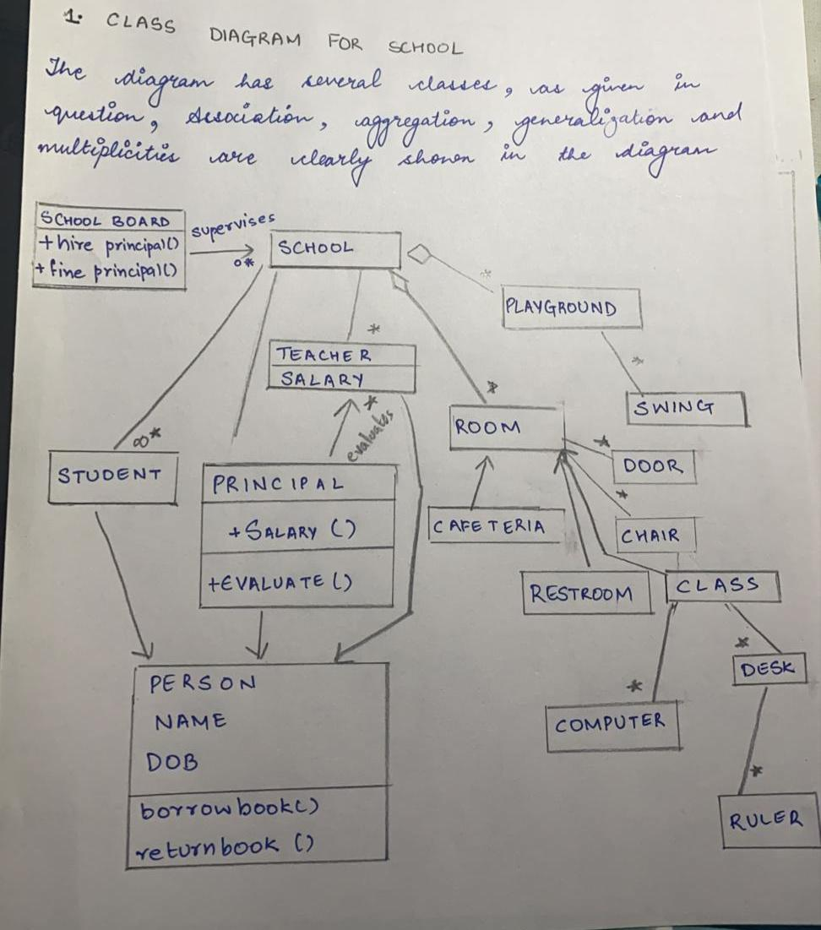

**Q 2 –** **Draw the Class Diagram for following statement:**

A drive has multiple discs; a hard drive contains many discs and a floppy drive contains one disc. *A disc is divided into* tracks which are in turn subdivided into sectors. A file system may use multiple discs and a disc may be partitioned across file systems. Similarly a disc may contain many files and a file may be partitioned across many discs. A file system consists of many files. Each file has an owner, permissions for reading and writing, date last modified, size, and checksum. Operations that apply to files include create, copy, delete, rename, compress, uncompress, and compare. Files may be data files or directory files. A directory hierarchically organizes groups of presumably related files; directories may be recursively nested to an arbitrary depth. Each file within a directory can be uniquely identified by its file name. A file may correspond to many directory–file name pairs such as through UNIX links. A data file may be an ASCII file or binary file.

