**Q 1 –** **Draw the Activity Diagram for following statement:**

Online Shopping Process

Scenario: “Online customer can browse or search items, view specific item, add it to shopping cart, view and update shopping cart, checkout. User can view shopping cart at any time. Checkout is assumed to include user registration and login.”

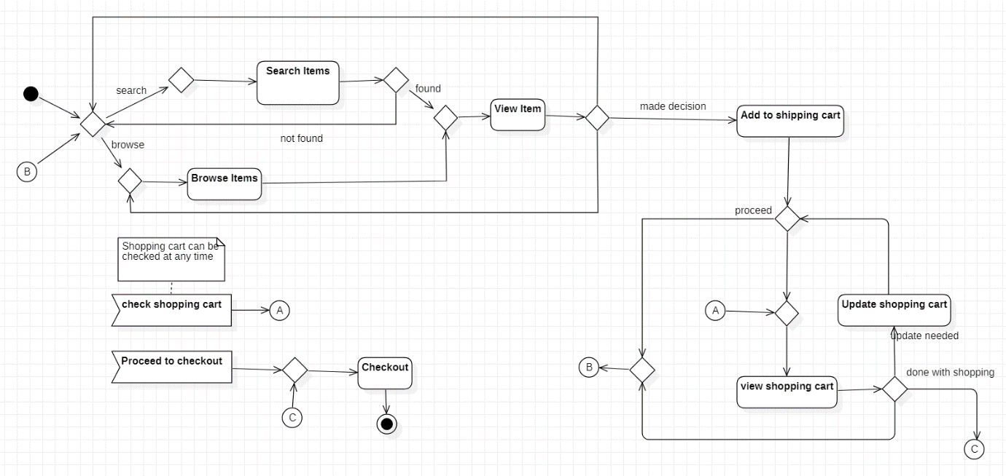

**Q 2 –** **Draw the Activity Diagram for following statement:**

Resolving issues in Software

Scenario: “Prepare an activity diagram which shows how to resolve an issue in a software design. After ticket is created by some authority and the issue is reproduced, issue is identified, resolution is determined, issue is fixed and verified, and ticket is closed, if issue was resolved.”

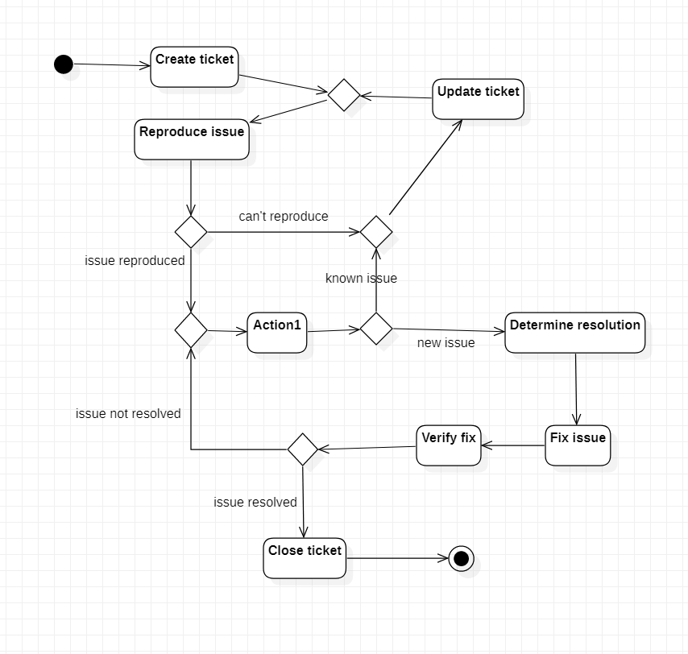

**Q 3 –** **Draw the UML Sequence Diagram for ATM Machine (must include Client, ATM Machine, Controller as objects/actors/participants).**

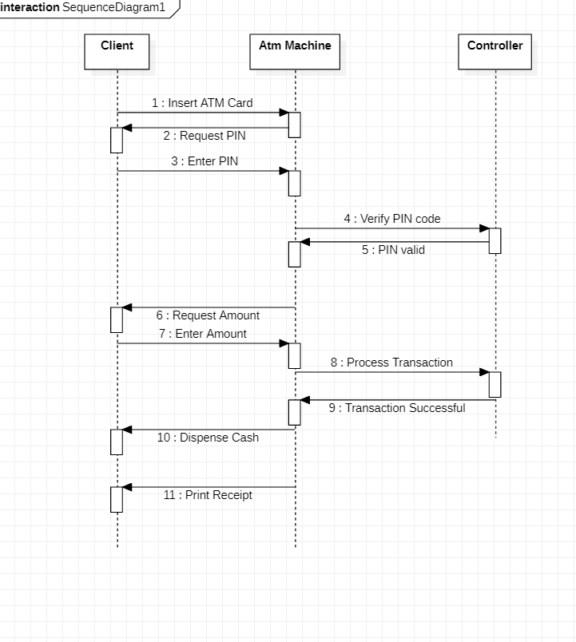

**Q 4 –** **Draw the UML Sequence Diagram of Request and Response between patient and receptionist.**

