**Experiment 10**

Q. 1 Make a Deployment Diagram for following scenario

Make the mentioned diagram for the Library Management System. The basic characteristics of the system are:

a) Users of the library are either normal or staff

b) A user can borrow a book

c) A staff person can borrow a book

d) The library contains one million books

e) If a user asks a book that has been borrowed, her request is inserted in a waiting list

f) Staff has no priority in borrowing books

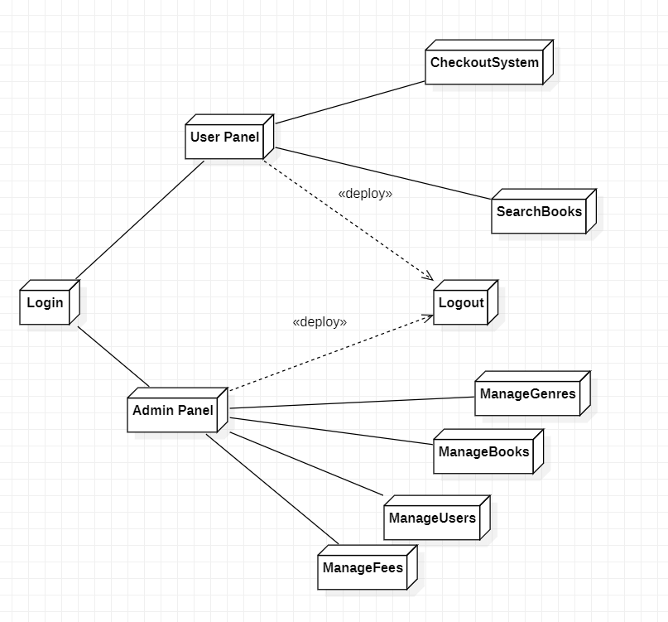

Q. 2 Create a Deployment diagram for showing various components and their relation in a hospital management system, it must contain functionalities related to doctor, patient, receptionist, operation theatre, wards, labs and pharmacy. You can add other functionalities also.

