**Experiment 7**

1. Develop a sequence diagram for a system in terms of accessing ATM. To develop an ATM System for XYZ Bank. The system developed should contain the following features:

1. The Customer login into the system using Credit Card No or Debit Card no and Pin Number. The system checks for validation.

2. The System queries the customer for the type of account either S.B Account or Credit. After getting the type of account, the system shows the amount left.

3. The System then queries the customer for required amount. The user enters the amount and gets the money.

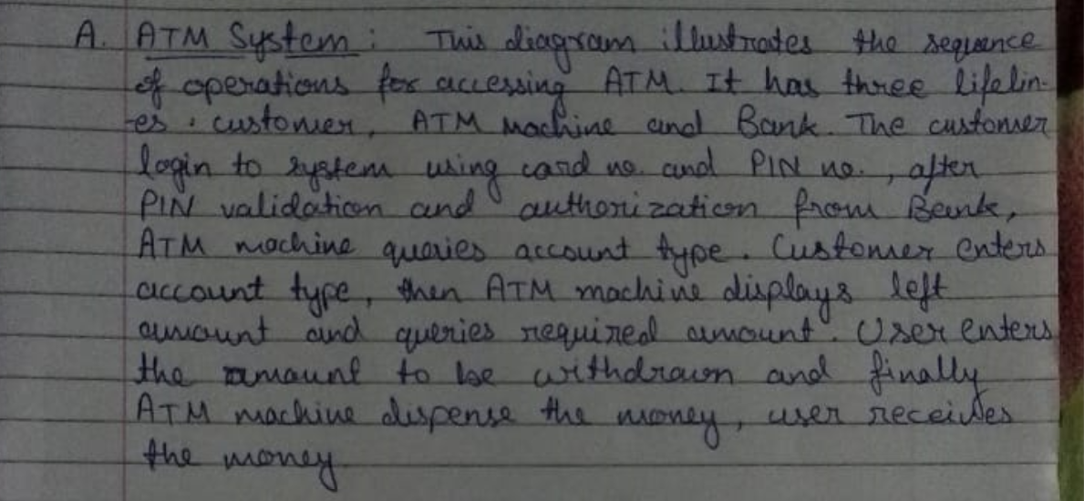

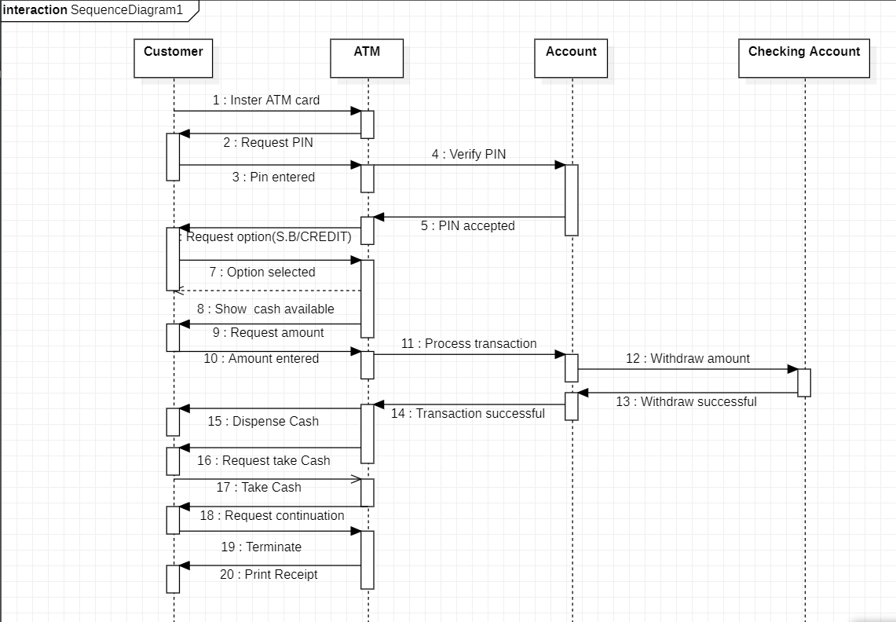

1. Create a sequence diagram that involved the interactions in booking a seat. It should consists of an actor User, and several objects for interface, controller, routes and route. It's a typical MVC sequence diagram - routes and route are model (M), interface is view (V) and mainController is controller (C)

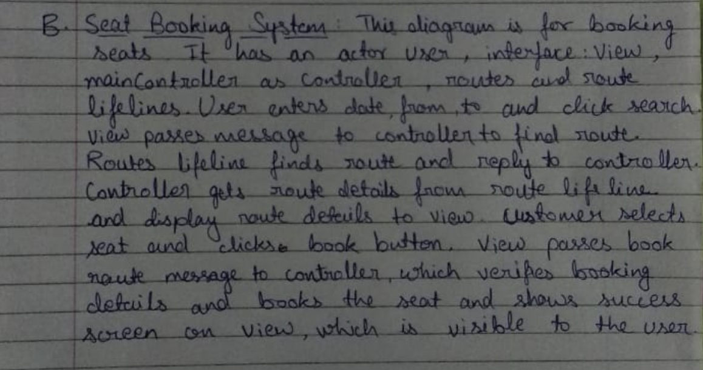

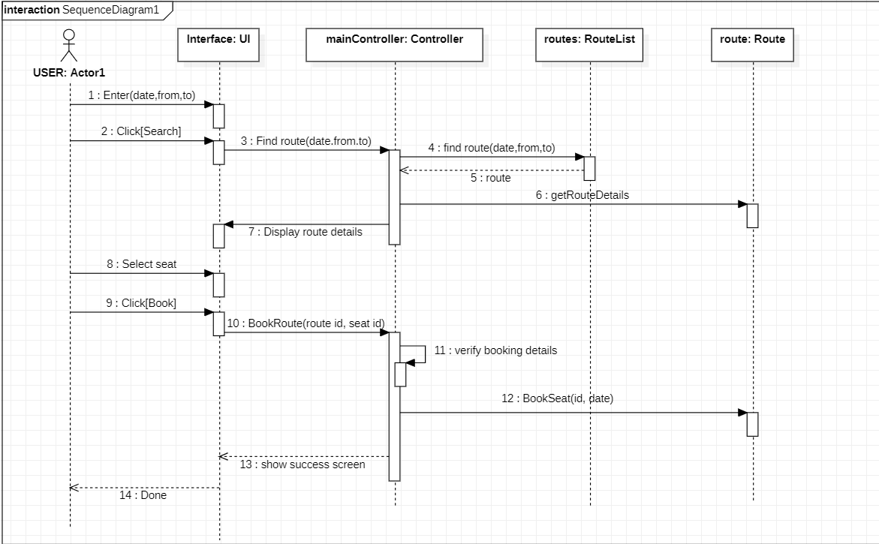

1. Create a sequence diagram for buying movie tickets through a Ticket Vending Machine , that interacts with Box Office which further access the Bank/Credit Card Service Provider for payment validity through credit card.

